Wireless broadband masterplan for the  
Socialist Republic of Viet Nam

*October 2012*



The wireless broadband masterplan for the Socialist Republic of Viet Nam has been prepared as part of ITU wireless broadband master plan project for countries in the Asia-Pacific region in conjunction with the Korean Communications Commission (KCC). ITU would like to thank the Korean Communications Commission for supporting the IUT wireless broadband master plan project for countries in the Asia-Pacific region and in particular for Viet Nam. The project objectives are to:

• carry out an assessment of existing policy and regulatory frameworks with a view to facilitate deployment of wireless broadband technologies taking into account convergence trends and provide recommendations for future requirement in selected pilot countries;

• demand side assessment and take up of applications, content and services that are envisaged by the users with wireless broadband in Asia-Pacific region in general and the four pilot countries in particular; and

• examine key policy and regulatory issues including but not limited to licensing, spectrum access/interconnection, deployment of new technologies, rollout out obligations, incentive based regulation, infrastructure sharing, universal service obligations etc. in each selected pilot countries and provide concrete recommendations to promote broadband wireless services vis-à-vis identified national priorities and international best practices.

This report was prepared by ITU experts Mr Scott W Minehane, and Mr Rajesh Mehrotra with extensive input from the ITU Regional Office for Asia and the Pacific and Mr Kim Kikwon. For this masterplan, the ITU experts gratefully acknowledge the assistance of Dr Tran Tuan Anh, the nominated national expert and the Viet Nam Telecommunications Authority (VNTA) and the Ministry of Information and Communications (MIC), Viet Nam. Mr Minehane also acknowledges the assistance of the staff of Windsor Place Consulting in the preparation of this report.

 ITU 2012

All rights reserved. No part of this publication may be reproduced, by any means whatsoever, without the prior written permission of ITU.

# Executive summary

This report has been prepared for the purposes of providing an analysis of the current state of the Viet Nam wireless broadband capability and to provide recommendations for the development of effective wireless broadband technology. It also considers key regulatory aspects for the provision of wireless broadband services.

The Government of Viet Nam is committed to a national strategy to strengthen the information and communication technology sector in Viet Nam with countrywide broadband information infrastructure, where access the Internet will be predominantly via wireless broadband[1]. As such wireless broadband – both terrestrial and in more remote mountainous parts of the country satellite services – is essential to the economy and social fabric of Viet Nam and its people.

Given the Viet Nam success in driving one of the world’s highest rates of mobile penetration, the challenge now is to embrace convergence and facilitate the use of broadband by this large installed base of mobile subscribers. This requires both infrastructure – provided on a cost effective manner so that prices are affordable – and content. On both fronts, there remain challenges.

Firstly in relation to infrastructure, more needs to be done in order to provide the most cost-effective solutions. Technology neutrality is a widely accepted principle for the efficient allocation of spectrum and ought to be embraced by the regulatory frameworks. The deployment of W-CDMA utilising the 900 MHz band and LTE wireless technology at 700 MHz (when available) and 1800 MHz (now) with the capability of reaching the highest number of people should be seen as a priority for Viet Nam and is endorsed under this wireless broadband masterplan. Satellite services – perhaps with a local cellular or Wi-Fi hotspot can also provide a critical role in addressing the digital divide in more remote areas of the country. Additional spectrum allocations to secure preferably 840 MHz in total aggregate spectrum will also be required to support the Viet Nam wireless revolution.

Secondly, on content, while Viet Nam has many companies developing mobile applications (apps) and similar, much more can be done at governmental level to facilitate the transformation of the country including the development of Vietnamese language content.

The recommendations in this masterplan are focused on achieving the maximum gains in terms of coverage and capacity, and on ensuring that the further development of broadband services can be achieved in a short period of time.

Key considerations include:

• the economic and social importance of broadband and its role in improving productivity and providing information and services;

• the structure of the telecommunications market and the current regulatory framework;

• the growing demand for broadband services and the considerable future spectrum requirements;

• the transition from a spectrum management approach to a more liberalised model, and the need to deal with such regulatory changes; and

• key technologies, including GSM, W-CDMA, satellite, and LTE.

With these considerations in mind, this wireless broadband masterplan reaches the following conclusions:

1. There is a need to encourage better and more affordable wireless broadband services by promoting competition between existing and new operators, including facilitation of new entrants for 4G services (using the 2.6 GHz spectrum) which have the ability to become mobile virtual network operators (MVNOs) on the existing 2G/3G networks. Consistent with global precedents, it is suggested that the Viet Nam Telecommunications Authority (VNTA) should also consider spectrum caps to avoid spectrum hoarding among large operators.
2. Flexible rights of use may also be instituted for key wireless spectrum allocations on a technology-neutral basis including W-CDMA at 900 MHz and LTE at 1800 MHz to improve affordability and coverage of higher speed wireless broadband services.
3. Given future spectrum needs, it is critical that the migration from analogue to digital television occurs on schedule. This is a key risk which will need to be managed. The use of the digital dividend (700 MHz) spectrum will facilitate affordable wireless broadband services many times over.
4. A review of the current band plan for the 2.3 GHz band is recommended as minimum allocations of 30 MHz may not be the most efficient use of that spectrum band.
5. Minimum spectrum allocation for wireless services in Viet Nam should preferably be 840 MHz in 2020. These challenging spectrum availability targets are achievable if the digital dividend is secured.

# Table of contents

Page

Executive summary i

1 Introduction 1

1.1 Project background 1

1.2 Structure of the masterplan 1

2 Broadband: Global and regional context 2

2.1 UN Millennium Development Goals 3

2.2 Broadband Commission 4

2.3 ITU ICT Development Index and the link to growth 6

2.4 ASEAN ICT Masterplan 2015 6

2.5 Other global developmental trends in broadband policy and regulation 7

3 Viet Nam and the wireless broadband market 8

3.1 Current market structure and competition 9

3.1.1 Fixed services 10

3.1.2 Mobile services 10

3.2 Current retail market structure 12

3.3 Current policy objectives / initiatives 13

3.4 Regulatory framework 14

3.5 Spectrum utilisation 15

4 Medium to long term goals to optimise wireless broadband for Viet Nam 17

4.1 Global mobile data traffic growth 17

4.2 Estimating future wireless broadband growth in Viet Nam 19

5 Key considerations for the wireless broadband masterplan 20

5.1 Enabling the wireless broadband end-to-end ecosystem 20

5.2 Policy and regulatory aspects 21

[5.2.1 Migration from a legacy model of spectrum management to a more flexible use  
model 21](#_Toc338239907)

5.2.2 Permitting technology neutral licensing and spectrum use 24

[5.2.3 Promoting wireless sector competition by instituting spectrum caps and mandated  
MVNO models 26](#_Toc338239909)

5.2.4 Other regulatory issues 27

5.3 Technology aspects 27

5.3.1 GSM and W-CDMA 28

5.3.2 LTE 30

5.3.3 WiMAX 31

5.3.4 Why LTE is the recommended technology following 3G/W-CDMA? 31

Page

5.3.5 Wireless offloading 33

5.3.6 The role for satellite 36

5.4 Spectrum management aspects 37

5.4.1 Securing the digital dividend spectrum 38

5.4.2 Band plans for the 2.3 GHz and 2.6 GHz spectrum bands 41

5.4.3 Spectrum needs and frequency arrangements based on technology selection 42

5.4.5 Additional preferred spectrum bands for use as ‘spectrum insurance’ 44

6 Facilitating applications and content 44

6.1 Stimulating the content sector in emerging economies 44

6.1.1 Educate content entrepreneurs 44

6.1.2 Subsidise content production 46

6.1.3 Regulatory options 46

6.2 Direct government action and leadership 46

7 Conclusions and recommendations 48

Appendix A – ASEAN 2015 ICT Masterplan 50

Appendix B – [National strategy to strengthen the information and communication technology  
sector in Viet Nam 52](#_Toc338239939)

Appendix C – Spectrum caps in key global markets (as at December 2011) 54

Appendix D – Summary of regulation of MVNOs in selected country markets 57

Appendix E – Frequency arrangements for implementation of IMT 61

Appendix F – Foreign regulator estimates of spectrum needed for mobile services 67

List of acronyms and abbreviations 69

# 1 Introduction

## 1.1 Project background

Based on an objective assessment of needs and priority, the Socialist Republic of Viet Nam (Viet Nam) was one of the four countries (the others being, Myanmar, Samoa and Nepal) selected by the International Telecommunication Union (ITU) for which ITU developed national pilot wireless broadband masterplans. The ITU publication Guidelines for the preparation of national wireless broadband masterplans for the Asia Pacific region provides the reference framework for the development of a generic national wireless broadband development. It was used extensively in the development of this report.

While Viet Nam was one of two Association of South East Asian Nations (ASEAN)[2] members selected as a pilot country for the development of a wireless broadband masterplan, it has the largest population of any country selected and is unique among the four selected countries in that it is not a least developed country (LDC).[3] Furthermore, the Viet Nam telecommunications sector – especially the mobile sector – has shown remarkable growth such that by the end of January 2011 there were more than 118 million mobile phone subscribers in the country with a mobile teledensity of more than 130. The challenge going forward is to migrate these mainly voice subscribers into subscribers which use a full suite of voice, and wireless broadband services.

As such, this report forms an important input into the broader policies and strategies of the government so as to address the digital divide in Viet Nam and to develop the implementation plans to ensure that Viet Nam reaches the goals it has set itself to strengthen the information and communication technology sector in Viet Nam. These policies are being developed by the Ministry of Information and Communications (MIC)[4] and the Viet Nam Telecommunications Authority (VNTA)[5] during 2012.

## 1.2 Structure of the masterplan

This wireless broadband masterplan comprises six main topics of analysis and recommendations:

(i) broadband: global and regional context (section 2);

(ii) overview of Viet Nam and the wireless broadband market (section 3);

(iii) medium to long term goals to optimise wireless broadband (section 4);

(iv) key considerations of the wireless broadband masterplan (section 5);

(v) facilitating applications and content (section 5);

(vi) conclusions and recommendations including a roadmap (section 6).

# 2 Broadband: Global and regional context

There is now almost a global consensus on the importance of broadband to a market’s economic growth and the social interaction of citizens. The ability to access and provide data rich applications and content has become a pre-requisite for global trade and is fast becoming a necessary component of interaction between members of the public as well as government. While broadband connectivity is simply a means of accessing and providing data in as fast a manner as possible, its role has been identified as of high enough importance for it to warrant the characterisation of a ‘human right’.[6]

Aside from the practical benefits broadband, such as greatly enhanced ease of accessing and providing data-rich content, numerous studies have documented the positive relationship between broadband access and national prosperity. A World Bank study emphasised the importance of broadband penetration for developing economies having concluded that every 10 per cent increase in broadband penetration provides a 1.38 per cent increase in GDP. [7]

Likewise other consultant studies have shown the benefits of broadband services to national economies, including Windsor Place Consulting’s study which projects a 1.12 per cent boost to Malaysian GDP by 2020 as part of the modelling the impact of Malaysia’s HSBB project[8] and Booz & Company found that 10 per cent higher broadband penetration in a specific year is correlated with 1.5 per cent greater labour productivity growth over the next five years.’[9]

Broadband networks are able to deliver a host of applications and services that other mediums are simply not capable of. These services include:

• e-commerce;

• e-banking;

• e-government;

• e-education;

• paper-less work;

• improved education/training; and

• telemedicine/e-health.

Given these factors, broadband and improving broadband is now an international focus of development work including by the United Nations (UN),[10] ITU and UNESCO.[11] This has resulted in broadband targets being incorporated with the UN’s Millennium Development Goals and the prompting the creation of the Broadband Commission as a joint undertaking of ITU and UNESCO.

## 2.1 UN Millennium Development Goals

The UN Millennium Development Goals (MDGs) comprise eight specific targets for developing nations to achieve by 2015.[12] Telecommunications and broadband falls with the eighth goal of developing a global partnership for development with sub-target 8(F) stating that ‘In cooperation with the private sector, make available the benefits of new technologies, especially information and communications’.

Measured against the agreed indicators by the number of fixed telephones, mobile cellular subscriptions and the number of Internet users per 100 population, significant progress has been made globally (see Figure 1) and as described more fully later in this report even more successes have been achieved in Viet Nam.

Figure 1: *Fixed telephone lines and mobile cellular subscriptions - Internet users - broadband subscriptions (per 100 inhabitants)*

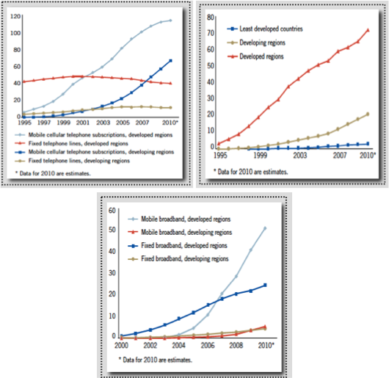

*Source: UN Millennium Development Goals Report, telecommunications indicators 2011*[13]

Notwithstanding the successes in Viet Nam including the number of internet users rising to 30.65 per 100 population at the end of 2010, the number of broadband internet subscribers at 4.20 per 100 population remain low. As broadband in Viet Nam, like voice before it, is going personal and moving to become a go anywhere/anytime service, a wireless broadband masterplan is consistent with the MDG targets and critical in helping address any policy gaps.

## 2.2 Broadband Commission

Until recently, broadband policy was largely the domain of national governments and the focus of regional initiatives. However, creation of the Broadband Commission for Digital Development in May 2010, a joint effort by ITU and UNESCO, is clear evidence of a shifting paradigm. The Commission was set up with the aim of engaging in *advocacy and high-level thought leadership to demonstrate that broadband networks:*

*• are basic infrastructure in a modern society – just like roads, electricity or water;*

*• are uniquely powerful tools for accelerating progress towards the MDGs;*

*• are remarkably cost-effective and offer impressive returns-on-investment (ROI) in both developed and developing economies alike;*

*• underpin all industrial sectors and are increasingly the foundation of public services and social progress;*

*• need to be promoted by governments in joint partnership with industry, in order to reap the full benefits of broadband networks and services.*[14]

Within the context of the masterplan, these conclusions and regulatory considerations are important as they provide both guidance and clarity. With respect to these considerations, the masterplan will be consistent with the focus of the Commission and its recommendations/policies.

The Commission debated the possible way of defining broadband and conceded that delineations such as upstream/downstream speeds are arguably inadequate due to rapid technological advances. Instead, they believed that focus on core concepts, such as *always-on* service (the user isn’t required to make a new connection to the server each time) and *high capacity* (capable of carrying lots of data per second) would be preferred alternatives as they would not be as constraining or subject to frequent revision.[15]

In the *Broadband: A Platform for Progress* report, the Commission discussed a range of issues for governments to consider when deploying broadband networks. Conclusions that emerged from the report included, *inter alia*:

• infrastructure policy should be goal oriented and not focused on particular technologies;

• pricing or other access barriers should be removed;

• associations between infrastructure and a type of service should be avoided;

• infrastructure sharing is beneficial and should be encouraged; and

• fibre-optic networks are likely the preferred backhaul network solution, but depending on national geography / topology, may need to be complemented by wireless infrastructure.[16]

The report identifies a number of considerations to be taken into account by governments and regulators in developing economies that are grappling with the challenges associated with increased broadband access. There are a number of areas in this regard that are of particular relevance to this masterplan. These are summarised in Table 1.

Table 1: Broadband challenges

|  |  |  |
| --- | --- | --- |
| No. | Issue | Details |
| 1. | **Attracting investment in broadband** | This may include:  • reducing investment / regulatory barriers;  • encourage infrastructure sharing;  • introducing innovative spectrum management mechanisms; and  • amending regulatory frameworks to eliminate discriminatory rules that favour one company/industry over another. |
| 2. | **Addressing persistent gaps in the market** | It is recognised that in cases where infrastructure deployment is highly expensive or impractical, the government may need to be proactive in addressing bottlenecks. Authorities also need to maintain cognisance over possible adverse implications of hyper-competition, which may dampen sector investment. The universal service fund (USF) may pose challenges as changing definition of services may require the government to address issues of which entities are required to contribute. |
| 3. | **Funding broadband** | The Commission stated that true access gap (a shortfall between market-based measures and universal access) may need to be addressed in circumstances where there is evidence that regulatory incentives and lower-cost network alternatives are not enough to encourage supply in certain instances. Governments may address these issues vis-à-vis remedies relating to issuing special licences in defined locations, funding local community initiatives, providing direct financial support to operators or mandating the deployment of broadband access networks. [17] |

The Commission endorsed the ‘Broadband Challenge’ in October 2011 whereby broadband connectivity was recognised as a human right and a crucial driving force behind economic growth. Importantly, governments were urged to adopt policy platforms that would facilitate broadband network deployment and service uptake. Member States were advised against retaining policies that would limit market entry and tax ICT services unnecessarily. Governments were encouraged to promote coordinated standards of interoperability and achieve maximum utility for scare radio spectrum. It was seen as necessary to review existing regulatory and legislative frameworks, many of which reflect outmoded 20th century models and ensure that information flows are free and unhindered.[18]

The Commission adopted a set of four broadband targets to be achieved by 2015:

(i) all countries should have a national broadband plan / strategy or include broadband in their universal access / service definitions;

(ii) entry level broadband services should be made affordable in developing countries through adequate regulation and market forces (for example, amounting to less than 5 per cent of average monthly income);

(iii) forty per cent of households in developing countries should have Internet access;

(iv) Internet user penetration should reach 60 per cent worldwide, 50 per cent in developing countries and 15 per cent in least developed countries.

It should be noted that ITU is optimistic that all of these targets will be either met or exceeded by 2015. In the case of Viet Nam, more challenging targets are required as broadband and internet usage in Viet Nam is close to such minimum targets already.

## 2.3 ITU ICT Development Index and the link to growth

According to ITU analysis, there is a strong correlation between the development and maturity of a country’s ICT infrastructure and economic growth. This relationship is even more prominent in emerging economies.

The ICT Development Index (IDI) is intended to provide insight into the level and evolution overt time of national ICT development, progress in ICT development, the digital divide and development potential of ICT. It represents an amalgamation of data measuring ICT access, usage and skills.

The 2011 edition of the ITU report *Measuring the Information Society*[19] shows that Viet Nam increased its IDI score by 28 per cent from 2.76 in 2008 to 3.53 in 2010, thereby ranking 81 out of 152 nations assessed. This increase is largely explained by the improvement in mobile broadband penetration from nearly zero in 2008 to 13 subscriptions per 100 inhabitants in 2010. Mobile-cellular penetration in Viet Nam is one of the highest in the world, growing from 87 per cent in 2008 to 175 per cent by the end of 2010.

## 2.4 ASEAN ICT Masterplan 2015

Being a full member of the regional grouping, Viet Nam has committed to the ASEAN 2015 ICT Masterplan[20]. The ICT Masterplan is a broad, overarching policy-framework that is intended to guide ICT development in ASEAN Member States over the next five years.

ASEAN Member States have committed to a single strategic vision of enabling social and economic integration and facilitating the transformation into a single market. By 2015, the following key outcomes have been set:

(i) ICT as an engine of growth for ASEAN countries;

(ii) recognition for ASEAN as a global ICT hub;

(iii) enhanced quality of life for peoples of ASEAN; and

(iv) contribution toward ASEAN integration.

Of particular relevance to this masterplan are a number of sub-components within the ‘strategic thrusts’ of the ASEAN Masterplan that ought to have implications for the Viet Nam wireless broadband policy. These include, *inter alia*:

• creating a conducive environment where businesses can grow leveraging ICT;

• ensuring affordable broadband access for every member of the community;

• ensuring affordable and seamless e-services, content and applications;

• improve broadband connectivity; and

• review of universal service obligations and similar policies.

The ASEAN ICT Masterplan 2015 is expected to be implemented over a five-year period. However, these initiatives will not be implemented concurrently, but rather according to priority and complexity. For a more detailed overview of the ASEAN Masterplan including a discussion of relevant initiatives and timeline, please refer to Appendix A**.**

## 2.5 Other global developmental trends in broadband policy and regulation

In recent years, several key trends have emerged with respect to broadband policy and regulation. Governments around the globe have become increasingly cognisant about the importance of high-speed networks and their link to economic growth. As a consequence, there has been a substantial increase in government participation and intervention within the ICT sector. Broadly speaking, this intervention consists of:

• the encouragement of private sector participation via improved access arrangements, simplified licensing and deregulation;

• the development of national broadband plans/policies;

• financial support in the form of subsidies, tax breaks, grants and loan assistance;

• expanding the scope of universal service obligations (USO) to encompass broadband services;

• updating regulatory regimes to take into account the convergence of media and communications; and

• redirecting universal service funds (USFs) to enable broadband in rural/isolated/low-income areas.

In addition, regulators are coming to terms with the need to prepare for a material increase in the demand for scarce spectrum. Global spectrum management arrangements are evolving to meet changing patterns of use and demand for spectrum. Following a trend that began in Australia, Japan, the United States, and New Zealand, steps are being taken to reduce the involvement of government and let market mechanisms govern the allocation and destination of use of spectrum including:

• allocating spectrum through price-based selection processes – especially auctions – or alternative proxy methods to impose apparatus charges which reflect the value of the spectrum;

• the owners of spectrum rights are increasingly free to decide which technology to use and which services to provide with it;

• in line with spectrum liberalization, the introduction of spectrum trading in some markets is allowing spectrum rights to be allocated via market mechanisms to the users that value it the most; and

• the increasing prevalence of spectrum leasing arrangements which allows a spectrum owner to sub-lease, part or all of their allocated frequencies.

# 3 Viet Nam and the wireless broadband market

Viet Nam is located in south-east Asia on the Indochina Peninsula with China to the North, Lao P.D.R. to the North-west and Cambodia to the South-west (Figure 2). With 86 million inhabitants, Viet Nam is one of the most populous nations in South East Asia and the thirteenth most populous country in the world.

Figure 2: Viet Nam map and geography[21]

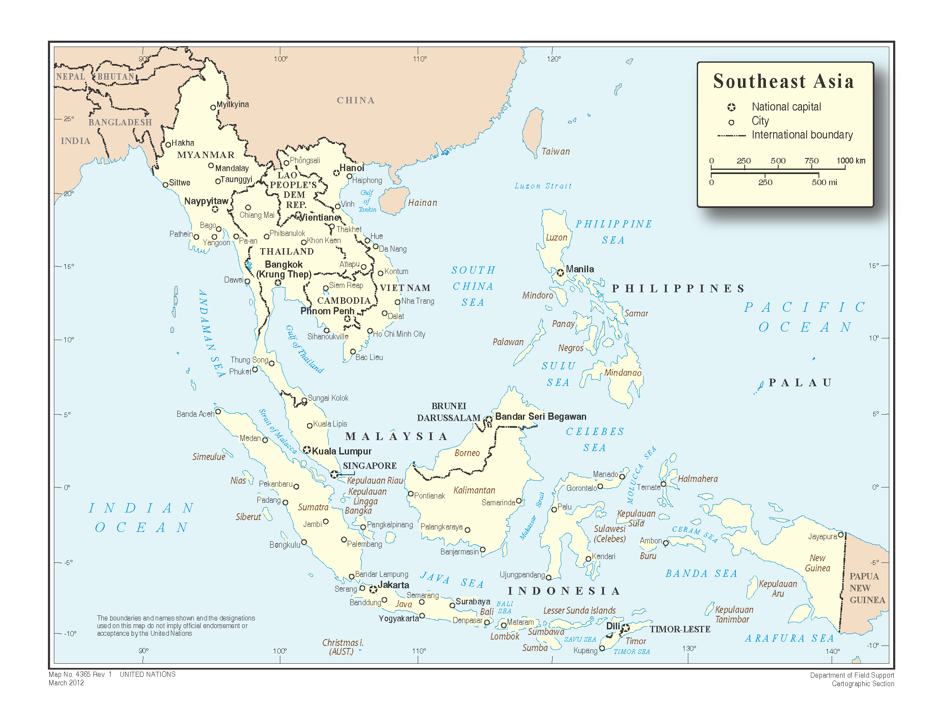

Source: [www.un.org/Depts/Cartographic/english/htmain.htm](http://www.un.org/Depts/Cartographic/english/htmain.htm)

Viet Nam has experienced strong economic growth over the past 15 years following the government commitment to economic liberalisation since the 1986 “*Doi Moi”* (Renovation) policy focusing on market oriented economic management. This has included restructuring to build a multi-sector economy, financial monetary and administrative reform, and the development of external economic relations.[22]

GDP per capita has increased ten-fold since 1993 (2010 USD 1 168 estimate).[23] According to the most recent IMF assessment, GDP growth from 2011-2013, will average 6.5 per cent, a growth rate consistent with the nation’s medium term average GDP growth.[24]

As of 2010, the unemployment rate was a low 2.7 per cent, as the country continues to experience significant growth. The consumer price index (CPI) has fluctuated widely over the medium term, peaking at 23.1 per cent in 2008, while falling to a mere 0.9 per cent in 2010.[25] Over 30 per cent of the nation lives in urban areas. The composition of economic actively has seen agriculture steadily decline in importance with industry assuming the role as engine of the Viet Nam economy. In 2010, their respective share of total output have been computed as agriculture (20.6 per cent), industry (41.1 per cent) and services (38.3 per cent).

Viet Nam has experienced sustained depreciation against the US dollar for most of the last decade (in 2010, USD 1 averaged VND (Vietnamese Dong) 18 621). However, such depreciation has not yet eased a sustained and persistent trade deficit. [26]

The government support for ICT has boosted the country's ICT status. This has resulted in Viet Nam moving up to 81st position with an ICT Development Index (IDI) with an increase from 2.76 in 2008 to 3.53 in 2010, coinciding with the official launch of 3G services at the end of 2009 which has contributed to an increase of more than twice the number of mobile subscriptions in the last two years, from 87 to 175 per 100 inhabitants.

While offering a promising economic climate, Viet Nam continues to face significant challenges in regards to broadband access, especially in rural areas (where approximately 70 per cent of the population resides). As of 2008, less than 1 per cent of rural households had any type of Internet access. Most businesses use the Internet for basic needs such as email or research. Today, productivity-enhancing applications, enabled by broadband technology, such as e-commerce and e-government, are still not widely used.[27]

Liberalisation of the telecommunications sector has however led to emerging competition. At present, there are 11 enterprises providing infrastructure with 15 per cent of mobile subscribers utilising 3G/W-CDMA technology.

Rapid deregulation has arguably also contributed to a hyper-competitive telecommunications market, resulting in a recent World Bank report on the broadband market to state that there has been overlapping investment and duplication of infrastructure. The World Bank report also highlighted that thin profit margins are eroding the ability of operators to make further Capex commitments to improve networks.

## 3.1 Current market structure and competition

Viet Nam possesses an extremely competitive telecommunications sector with a number of fixed, mobile, and mobile virtual network (MVNO) operators. From 2006 – 2010, sector revenue increased by over three times to almost USD 10 billion. This was largely driven by mobile and Internet services revenue. In contrast, revenue from fixed services has fallen from USD 600 million to USD 211 million.[28]

There is no shared national broadband network instead the MIC has granted 11 enterprises licences to build network infrastructure although in practice only three companies have built telecommunications network infrastructure on a national scale, and the networks are interconnected with each other. The number of market participants is shown in Table 2.

Table 2: Number telecom and Internet service providers in Viet Nam

|  |  |  |
| --- | --- | --- |
|  | 3/2009 | 12/2010 |
| Number of fixed telephone operators | 8 | 10 |
| Number of 2G mobile operators | 7 | 7 |
| Number of 3G mobile operators | 5 | 5 |
| Number of mobile virtual network operators | 2 | 2 |
| Number of ISPs | 90 | 80 |

Source: *Viet Nam Information and Communications Technology Whitebook 2011’*

From 2008 to 2010, international Internet bandwidth rates increased from 50 064 Mbit/s to 134 420 Mbit/s. Following the completion of the third Asia-America Gateway (AAG) in November 2009, Viet Nam now has connectivity to three international gateways. The AAG connects Asia to America by way of a submarine cable with 500 Gbit/s capacity.

### 3.1.1 Fixed services

As is common with emerging economies, and now a range of developed economies mobile services in Viet Nam have a significantly higher penetration then fixed services (Table 3). This gulf has widened with fixed telephone penetration falling substantially since 2009.

Table 3: Fixed and mobile telephone penetration

|  |  |  |
| --- | --- | --- |
|  | Fixed | Mobile |
| Number of subscribers (million) | 14.37 | 111.57 |
| Subscribers per 100 population | 16.45 | 127.68 |

Source: *Viet Nam Information and Communications Technology Whitebook 2011*

The fixed broadband internet market in Viet Nam is dominated by ADSL technology, with 3.6 million ADSL subscribers by the end of 2010. FTTx and cable TV broadband accounts for less than 5 per cent of total fixed broadband subscriptions. In terms of wireless broadband, a number of trial WiMAX licences have been issued and pilots are being carried out throughout different locations in the country. There is however no major commercial deployment of WiMAX as yet.

### 3.1.2 Mobile services

Viet Nam has an impressive growth history for mobile network. The process began early in 1993 and today with over 170 per cent mobile penetration they have achieved the distinction to be among one of the 17 world economies that have succeeded in having a mobile penetration rate of 150 per cent or more.[29]

Viet Nam has been aggressively expanding its national infrastructure and growing its subscriber bases across all market segments. Progress in developing the mobile market has been especially impressive. Mobile networks now cover the entire country and Viet Nam was one of the early countries to deploy GSM technology. CDMA technology has been used since 2002 and from late 2009, 3G mobile networks based on W-CDMA technology are being deployed by four licensees.

Figure 3 summarises the Viet Nam mobile development history.

Figure 3: Summary of the Viet Nam mobile development history[30]

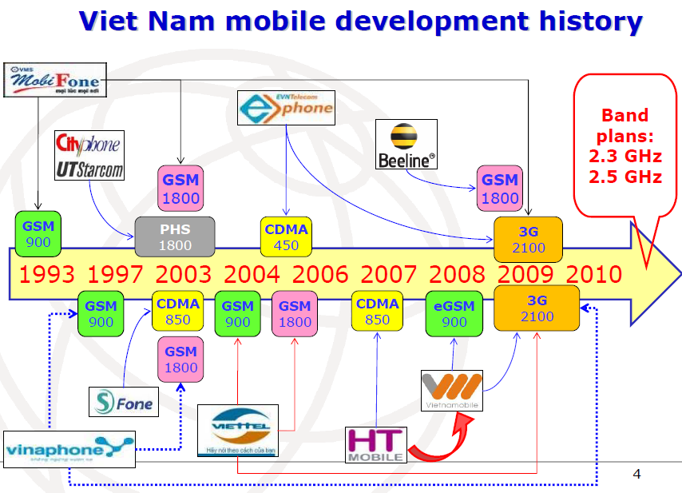

Source: ITU Regional Workshop on IMT – June 2010

Table 4 highlights mobile data forecasts in Vietnam.

Table 4: Mobile data forecasts for Viet Nam

|  |  |  |  |  |  |  |  |
| --- | --- | --- | --- | --- | --- | --- | --- |
|  | 2008 | 2009 | 2010 | 2011f | 2012f | 2013f | 2014f |
| No. of mobile phone subscribers ('000) | 69 070 | 110 800 | 155 522 | 184 492 | 200 187 | 213 521 | 224 312 |
| No. of mobile phone subscribers/100 inhabitants | 79.6 | 125.9 | 174.4 | 204.1 | 218.5 | 230.0 | 238.4 |
| No. of mobile phone subscribers/100 fixed line subscribers | 524.1 | 612.2 | 963.8 | 1 136.7 | 1 240.1 | 1 330.8 | 1 415.6 |
| No. of 3G phone subscribers ('000) | 0 | 4 000 | 8 000 | 12 000 | 19 000 | 29 000 | 38 000 |
| 3G market as % of entire mobile market | 0 | 3.6 | 5.1 | 6.5 | 9.5 | 13.6 | 16.9 |

*Source: ITU, BMI*

In the 3G mobile sector, seven candidates were identified via beauty contest and four 3G licences were awarded on 15 September 2009. 3G services were launched in Viet Nam by Vinaphone on 12 October 2009, Mobifone on 15 December 2009, and Viettel on 25 March 2010.

Figure 4 highlights the 3G (W-CDMA) obligations of mobile operators[31].

Figure 4: 3G/W-CDMA obligations of mobile operators in Viet Nam

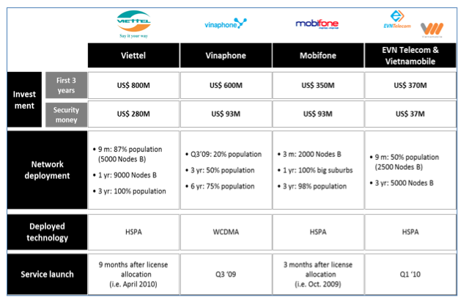

Source: infoDev

In August 2009, a mobile virtual network operator licence was awarded to Indochina Telecom, as the country's first MVNO operator. Indochina offers services to customers via the 3G and 2G networks of Viettel. Subsequently in June 2010, the regulator has awarded the ninth mobile licence to Viet Nam Multimedia Corporation (VTC). Under the terms of the licence, VTC is permitted to establish a network and supply 3G mobile services based on sharing wireless frequency bands with EVN Telecom. In addition, VTC is allowed to provide domestic roaming services applicable over GM networks and have its own prefix.

In September 2010, the MIC granted 4G licences to five operators: VNPT, Viettel, FPT Telecom, CMC and VTC. According to the MIC, the operators will be required to participate in an auction in order to be granted 4G licences, and would be able to transfer the frequency bands after receiving the licensee. The licence terms enable the licensees to operate LTE network over a trial period of 12 months.

## 3.2 Current retail market structure

Table 5 below details the current competitive state of the Viet Nam mobile telecommunications market with VNPT and Viettel the major market players. While competitive, the government owns and controls the majority of the telecommunications sector and in some circumstances forms partnerships with foreign telecommunications operators.

Table 5: State of competition in mobile telecommunications market, 2010[32]

| Brand | | Mobile Business Lines | Market Share (subscribers) % | Description |
| --- | --- | --- | --- | --- |
| Viettel | Screen shot 2012-01-24 at 1 | GSM  3G | 34.7* | A state-owned enterprise, operated by the Ministry of Defence. Acquired EVN Telecom and its infrastructure on 1 January 2012. |
| Mobifone | Screen shot 2012-01-24 at 1 | GSM  3G | 27.2 | Controlled by VNPT. |
| Vinaphone | Screen shot 2012-01-24 at 1 | GSM  3G | 27.2 | Controlled by VNPT. |
| S-Telecom | Screen shot 2012-01-24 at 1 | CDMA | 4.7 | Acquired by Saigon Postel Corporation (SPT) in 2010. |
| Hanoi Telecom | Screen shot 2012-01-24 at 1 | GSM  3G | 4.1 | In partnership with Hutchison. |
| GTEL | Screen shot 2012-01-24 at 1 | GSM | 2.2 | Operates network in partnership with Russia’s Vimpelcom. |
| Dong Duong Telecom | Screen shot 2012-01-24 at 1 | MVNO | - | Subsidiary of Dong Duong, an infrastructure company. |
| VTC | Screen shot 2012-01-24 at 1 | MVNO | - | Subsidiary of Vietnam Posts and Telecommunications Corp |

* EVN Telecom acquired by Viettel on 1 January 2012.

Evidence suggests that the competition in the Viet Nam market for mobile services is price-based. According to a 2009 Frost & Sullivan report, revenue growth was projected to slow rapidly from 2009-11, a reduction from 40 to approximately 2 per cent. The World Bank/*info*Dev report on broadband in Viet Nam stated that “intense competition has resulted in price wars threatening long-term sustainability.” Consequently, there needs to be specific measures undertaken in regards to enabling a greater degree of sharing of both infrastructure and resources between operators and possible government involvement in the event of market failure.

## 3.3 Current policy objectives / initiatives

The key telecommunications policy is formally set out in the Prime Minister's Decision No. 158/2001/QD-TTg of 18 October 2001, which ratifies the VNPT development strategy until 2010 and orientation until 2020. This policy decision provides a comprehensive range of sector development objectives and targets, along with key underlying strategies for their achievement.

Box 1: Viet Nam policy objectives and initiatives

The other policies include *inter alia*:

• The Strategy on Viet Nam information and communication technology development to 2010 and orientations towards 2020 (Prime Minister's Decision No. 246/2005/QD-TTg on 6 October 2005);

• The Planning on development of Telecommunications and Internet until 2010 (Prime Minister's Decision No. 32/2006/QD-TTg on 7 February 2006);

• The Planning on development of Information and Communication Technology in the Central key economic region up to 2010 and orientations towards 2020 (Decision No. 13/2007/QD-BBCVT on 15 June 2007 of MIC Minister, on behalf of Prime Minister);

• The Planning on development of Information and Communication Technology in the Southern key economic region up to 2010 and orientations towards 2020 (Decision No. 14/2007/QD-BBCVT on 15 June 2007 of MIC Minister, on behalf of Prime Minister);

• The Planning on development of Information and Communication Technology in the Northern key economic region up to 2010 and orientations towards 2020 (Decision No. 15/2007/QD-BBCVT on 15 June 2007 of MIC Minister, on behalf of Prime Minister);

• The Planning on Digital Content Safety to 2020 (Prime Minister's Decision No. 63/QD-TTg on 13 January 2010);

• • Prime Minister's Decision No. 22/2009/QD-TTg on 16 February 2009 approving of transmission planning, radio broadcasting, television until 2020;

• Prime Minister's Decision No. 125/2009/QD-TTg on 23 October 2009 on the planning of national radio frequency; and

• Prime Minister's Decision No. 1755/QD-TTg on 22 September 2010 approving of the national strategy to strengthen the information and communication sector in Viet Nam.

Viet Nam does not have a separate broadband development policy and broadband is covered in the policies relating to network infrastructure, technology of providing services, and contents for socio-economic development.

The Prime Minister signed Decision No. 1755/QD-TTg to approve the national strategy to strengthen the information and communication technology sector in Viet Nam on 22 September 2010. The strategy reflects the political determination of Viet Nam and the government in developing ICT industry to keep pace with regional and international standards. The annual growth rate of the ICT industry income is to reach at least two to three times the growth rate of the GDP, and the contribution of ICT industry to GDP should be 8 to 10 per cent by 2020. Please refer to Appendix Bfor a more detailed explanation of the strategy.

## 3.4 Regulatory framework

In terms of the law, the key legislations and subsidiary legislations that have been issued include *inter alia*:

• Law on Telecommunication (No. 41/2009/QH12) issued by the National Assembly on 23 November 2009;

• Law on Radio Frequency (No. 42/2009/QH12) issued by the National Assembly on 23 November 2009;

• Government Decree No. 28/2009/ND-CP issued on 20 March 2009, on the regulation and sanctioning of administrative violations in the management, provision and use of services and electronic information on the Internet; and

• Government Decree No. 25/2011/ND-CP dated 6 April 2011 detailing and guiding the implementation of a number of articles of the Telecom Law.

In 2009, the National Assembly issued a Law on Telecommunication and a Law on Radio Frequency which took effect in July 2010. The purpose of the laws is to encourage all economic and private sectors to develop their telecommunication services, investments and infrastructure.

Highlights of the Law on Telecommunicationare as follows:

• aims to both encourage investment in the telecommunications industry and to bring the current telecommunications law in line with the Vietnam World Trade Organization (WTO) commitments in the sector;

• expansion of the category of those who are allowed to participate in the telecommunications sector in that all organisations established under the Law of Enterprise have the right to provide telecommunication services and establish telecommunication infrastructure;

• sets out new methods of managing telecommunication resources, especially the high commercial value bands, the licences for which shall be mainly granted through examination or auction;

• organisations or individuals who obtain their rights through an auction shall be entitled to transfer the said rights to another party at their discretion;

• foreign investment regulation shall be in line with the Vietnam WTO commitments whereby joint venture enterprises with foreign capital majority will be allowed to carry out telecommunications business lines but shall be prohibited from investing in telecommunications infrastructure.

Highlights of the Law on Radio Frequencyare as follows:

• the law consolidates the numerous regulations currently governing the licences for wireless radio frequencies;

• clearly define the ways and means by which wireless radio frequencies may be exploited for profit in order to both promote growth in the area and generate revenue. There shall only be one government body authorised to manage and licence wireless radio frequencies for the whole country, and will come under the management of the Ministry of Information and Communication;

• introduces two new ways by which a member of the public may obtain the right to use a wireless radio frequency namely via auction and examination. These methods will however only be available in relation to high value bands or where the usage demand exceeds the supply capacity as determined by the MIC; and

• sets out provisions in relation to the standard and technical specifications of wireless radio frequencies, and clearly defines the responsibility of those who use or exploit wireless radio frequencies for complying with the regulations on safety of electric radiation.

## 3.5 Spectrum utilisation

The Authority of Radio Frequency Management (ARFM) established in 1993, is tasked with *inter alia* frequency planning, formulation of the National Frequency Allocation Plan (NFAP), channelling plans as per the ITU-R Recommendations, frequency assignments and issue of radio licences, monitoring of the radio spectrum to check adherence with licensed parameters and also for physical inspection of licensed radiocommunication hardware and international frequency coordination. The positioning of the ARFM within the MIC is as shown in Figure 5.

Figure 5: Structure of the MIC

**Government**

**Other Ministries**

**MIC**

**Intl. Relation Dept.**

**......**

**Authority of Radio Frequency Management (ARFM)**

**Financial Planning Dept.**

**Regional Office**

**Authority of**

**Telecommunications**

**Science Tech Dept.**

**Science Tech Dept.**

**Human Resources Dept.**

**Inspector Dept.**

**Informatic industry Dept.**

**Authority of Information and**

**Communications Application**

Source: ITU

ARFM has carried out band planning to identify suitable spectrum blocks for different service providers of IMT services in Vietnam. This identification is done keeping in view the NFAP for Viet Nam.

Allocations have been made on a first come-first served basis as well as ‘beauty contest’ or spectrum auction (as per the stipulations in the Radio Law). In the normal case frequency blocks have been identified for each operator to ensure enough bandwidth for efficient operation keeping in view the technology neutrality aspect.

The band planning for mobile operators carried out by ARFM is depicted in Figure 6.

Figure 6: ARFM mobile band planning

**453.08 457.37 463.08 467.37 MHz**

CDMA

(EVN Telecom)

**1x 4.29 MHz**

CDMA

(EVN Telecom)

**1x 4.29 MHz**

MS

FS

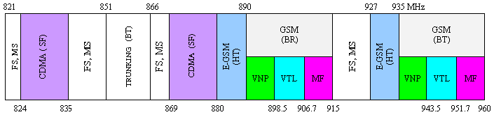

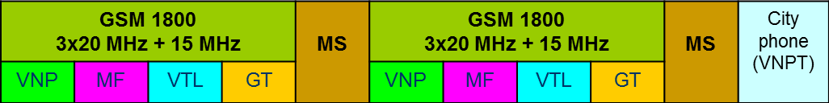

**1900 1935 1965 2010 2110 2140 2170**

**IMT-2000**

**TDD**

**IMT-2000**

**TDD**

**MSS**

**MSS**

**MF**

**VTL**

**EVN**

**HTC**

**VNP**

**MF**

**VTL**

**EVN**

**HTC**

**VNP**

**1920 1950 1980 2025 2125 2155 2200 MHz**

# 4 Medium to long term goals to optimise wireless broadband for Viet Nam

## 4.1 Global mobile data traffic growth

Based on global statistics the number of wireless broadband subscribers has exceeded the number of fixed broadband subscribers and will continue on an explosive growth path following current growth estimates. According to the Cisco *Visual Networking Index Global Mobile Data Traffic Forecast* overall mobile data traffic is expected to grow to 10.8 Exabytes (1 Exabyte=1018 bytes) per month by 2016 as shown in Figure 7.

Figure 7: Overall mobile data traffic growth 2011 – 2016,

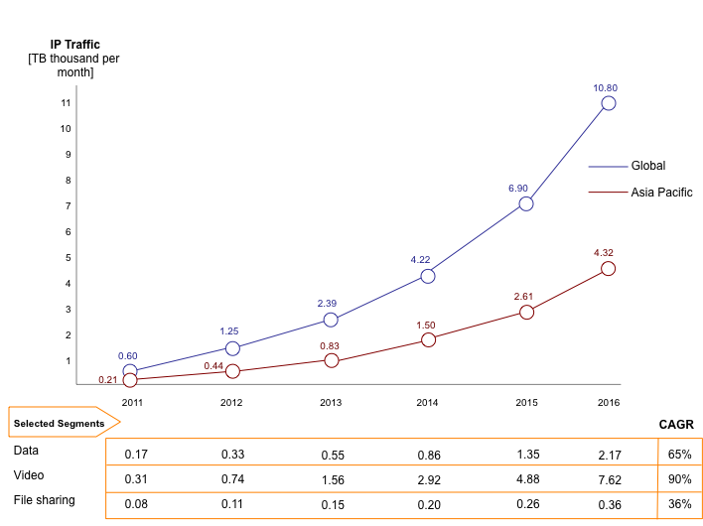

Source: Cisco, VNI Report, 2012

As the industry embraces mobile broadband, data demand on the network is increasing rapidly, and operators need to find a cost efficient way to continue providing the service. A ten-fold increase in mobile data traffic could translate to less than 10 per cent increase in revenue for operators. LTE serves as the common migration path for all existing mobile standards to address the cost challenge (see Figure 8).

Figure 8: Benefits of LTE: decoupling revenue and traffic

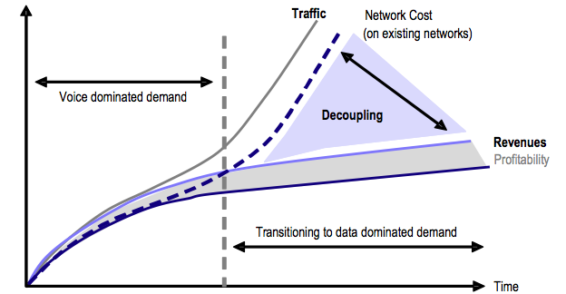

Source: UBS, 2009[33]

## 4.2 Estimating future wireless broadband growth in Viet Nam

According to the MIC, the country’s total number of Internet broadband subscribers was estimated to reach 4.2 million subscribers by the end of November 2011, a year-on-year increase of 16.3 per cent. In addition, the number of Internet users nationwide was estimated by the MIC to total about 32.2 million users, a year-on-year increase of 20.1 per cent against the figure in the same time last year.[34] These figures equate to an approximate broadband population penetration of 4.5 per cent and an approximate internet population penetration of nearly 36 per cent.

In relation to wireless broadband in Viet Nam, while there is a perception that 3G services have not been growing rapidly as expected in the country, data would suggest that growth is faster than perceived. In particular, it should be noted that:

• 3G connections in Viet Nam surpassed 20 million in Q2 2011, representing around 18 per cent of the total base of that time of 121 million. It is now likely to be higher than 25 per cent.[35] This take-up figure is a comparable to most developed mobile markets and it is double the world average of just under 10 per cent.[36]

• As at July 2011, Vinaphone states that data services revenue now accounts for over 5 per cent of its total network revenue. It notes that it has 7 million unique mobile data users a month with average data usage running at 7 MB per user per day. The operator predicts a 108 per cent growth in data traffic between 2009 and 2014 (CAGR), with mobile video accounting for about two thirds of its traffic by this point.[37]

• As of 2010, 9 per cent of young people in Viet Nam, a nine-fold increase from 2009, use data on their mobile devices, while the older adult population grew from none in 2009 to 3 per cent in 2010.[38]

• Growth in data services is being supported by substantial increases in international connection bandwidth as shown in Figure 9.

Figure 9: International Internet bandwidth in Viet Nam

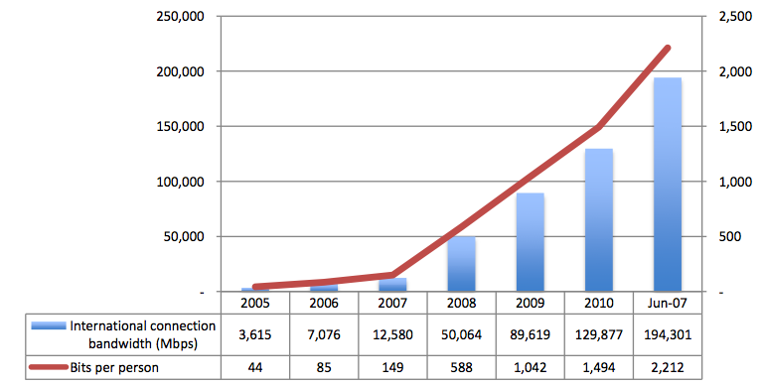

Source: VNNIC[39]   
Note: the last column is for June 2011, not 2007

By way of comparison the *UMTS Forum Report 44: Mobile traffic forecasts 2010-2020* in 2011 stated that the daily mobile traffic per mobile broadband and dongle subscriptions for a representative western European country in 2010 were 10 MB for mobile broadband and 26.7 MB for dongles per day in 2010. As such, smartphone usage in 2010 was only 30 per cent below European averages.

As the UMTS Forum Report forecasted that a typical European, by 2015, would see a per user daily consumption of 155 MB for mobile broadband, and 265 MB for dongle use, then if users were to use only 30 per cent less, mobile networks in Viet Nam will need to be dimensioned to handle over 100 MB for mobile broadband and 185 MB for dongles use in 2015.

While these high levels are predicated on content being available (see section 6), all elements of the wireless broadband ecosystem will need to be upgraded and invested in to cater for such demand which is rising at 20 per cent per annum in terms of subscribers and much more in terms of traffic. This includes new capacity networks utilising LTE and backhaul connectivity.

# 5 Key considerations for the wireless broadband masterplan

## 5.1 Enabling the wireless broadband end-to-end ecosystem

The key elements of this masterplan enable the end-to-end ecosystem which provides connectivity and content to consumers (Figure 10). While the focus is necessarily on the customer access networks, this masterplan examines five key factors which are critical in facilitating the broadband penetration in Viet Nam:

(i) policy and regulatory aspects (section 5.2);

(ii) technology aspects (section 5.3);

(iii) spectrum management aspects (section 5.4);

(iv) international connectivity (section 5.5);

(v) facilitating content and applications (section 6).

Figure 10: End-to-end broadband connectivity

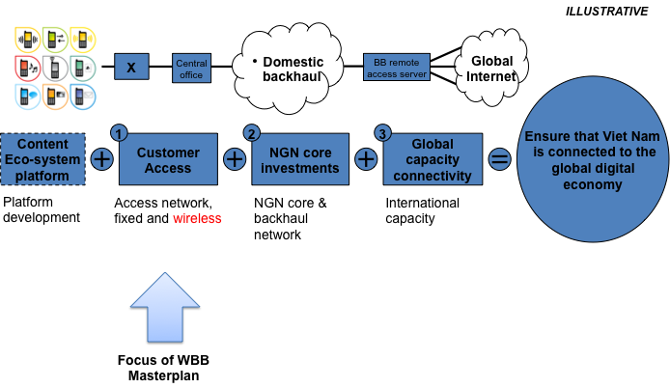

Source: ITU

## 5.2 Policy and regulatory aspects

Firstly, it is acknowledged that following the passage of new sector legislation a year or so ago, the regulatory structures in Viet Nam are rapidly improving with the creation of the VNTA within the Ministry of Information and Communications in late 2011. This follows the earlier establishment of the ARFM in 1993. While the VNTA reports to the Deputy Minister of the MIC, the VNTA has a degree of autonomy. The VNTA has moved to separate offices and is currently negotiating with the Finance Ministry for a separate budget which should provide even more independence going forward.

This is not to say that improvements cannot be made to provide greater regulatory certainty, facilitate further investment in the sector and promote broadband services generally and wireless broadband services specifically. From the review of the existing policy and regulatory, there are three major areas as well as some minor areas where changes could be made. These are namely:

(i) migration from a legacy model of spectrum management to a more flexible use model;

(ii) permitting technology neutral licensing and spectrum use;

(iii) promoting wireless sector competition by instituting spectrum caps and mandated MVNO models.

### 5.2.1 Migration from a legacy model of spectrum management to a more flexible use model

Globally there is a major transition occurring between the legacy model of spectrum management and a liberalised model. It is recommended that Viet Nam embrace such changes and manage them. This means a flexible use model with spectrum trading rights and mechanisms which allocate spectrum to their best use (Figure 11). In this context part of the challenge is managing the transition.

Figure 11: Transition to market based liberalized spectrum management models

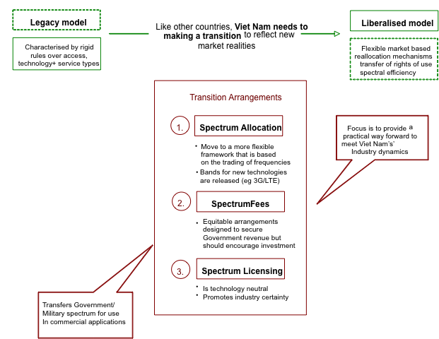

Source: Windsor Place Consulting, 2010

It is important that the ARFM (and to the extent it involves VNTA) embrace a strong set of spectrum management principles in its dealings with industry, consumers and other internal stakeholders. In recognising that spectrum is a scarce resource that needs to be managed effectively and efficiently, the delegates to the ITU Global Symposium of Regulators (GSR)[40] drafted a set of best practice guidelines for spectrum management to promote broadband access. The GSR 2005 ten point set of guidelines continues the tradition of best practices agreed to at the GSR conferences in 2003 and 2004 on promotion of universal access, and low cost broadband services. A summary of the 2005 GSR guidelines are set out in Table 6.

Table 6: GSR best practice guidelines for spectrum management

| No | Guideline objectives | Key Provisions |
| --- | --- | --- |
| 1. | **Facilitate the deployment of innovative broadband services and technologies** | • Reduce unnecessary restrictions on spectrum use  • Adopt harmonised frequency plans defined by ITU-R recommendations[41]  • Reduce or remove regulatory barriers to market entry  • Ensure operators have access to as wide a choice as possible for spectrum |
| 2. | **Promote transparent and non-discriminatory spectrum management policies** | • Consult widely and publicly  • Implement stable decision making processes  • Publish forecasts of spectrum usage and allocation needs  • Publish frequency allocation plans and overview of assigned spectrum  • Clearly define and implement stable and predictable spectrum authorisation rules and decision-making processes and procedures |
| 3 | **Embrace technology neutrality** | • Facilitate spectrum use for fixed and mobile services  • Provide guidelines to mitigate inter-operator interference  • Adapt to technological convergence and avoid picking winners |
| 4 | **Adopt flexible use measures for wireless broadband services** | • Avoid onerous rollout and coverage obligations  • Licence conditions that allow operators to provide a full range of converged services  • Provide incentives for smaller new operators to deploy infrastructure at low cost  • Adopt lighter regulation for rural and isolated areas  • Allow secondary spectrum trading  • Promote spectrum sharing |
| 5 | **Ensure affordability** | • Set reasonable spectrum fees  • Design tender or auction processes to ensure affordability of services |
| 6. | **Optimise spectrum availability** | • Facilitate the effective and timely access to spectrum  • Spectrum pricing should not be pushed up due to restrictive supply  • Accommodate new and emerging technologies |
| 7. | **Manage spectrum efficiently** | • Ensure reliance on market forces, economic incentives and technical innovation  • Allocate spectrum in an economically efficient manner  • Promote and encourage usage of spectrum efficient technologies |
| 8. | **Ensure a level playing field** | • Prevent spectrum hoarding: regulators should set a maximum limit to the amount of spectrum one operator may obtain |
| 9. | **Harmonise regional and international standards and practices** | • Reflect global technical and security standards in national arrangements  • Ensure inter-operability for global roaming  • Implement policies and allocations that are consistent with regional and global best practice and standards |
| 10. | **Adopt a broad approach to promote access** | • Introduce supporting regulatory measures such as competitive safeguards, open access and universal service incentives  • Lower or remove import duties on broadband wireless access equipment  • Coordinate spectrum management policy and practice with other regulatory instruments (i.e. competition and trade policy, universal service measures etc.) |

Source: ITU, GSR 2005 Best Practice Guidelines for Spectrum Management to Promote Broadband Access, [www.itu.int/bestpractices](http://www.itu.int/bestpractices)

### 5.2.2 Permitting technology neutral licensing and spectrum use

The core basis of a technology neutral spectrum is that any service should be provided through any kind of technology in any frequency band, and the use of spectrum can be changed at any time. That is, the actual use of the spectrum is not specified. For example, in Australia, spectrum licences can be used with any technology and for any use so long as emission limits are observed. Examples include W-CDMA utilising the 900 MHz (Box 2) and LTE utilising the 1800 MHz bands (see Figure 12).

Box 2: W-CDMA deployment at 900 MHz

According to the GSA as at 29 January 2012 there are 40 commercial UMTS900 networks (HSPA or HSPA+) launched in the 900 MHz spectrum. These include at least 25 countries with UMTS900 deployments including Australia, Bulgaria, Croatia, Estonia, Faroe Islands, Finland, France, Germany, Ghana, Greenland, Hong Kong (China), Iceland, Latvia, New Zealand, Poland, Qatar, Romania, Russia, Slovenia, South Africa, Spain, Switzerland, United Kingdom, Ukraine and Venezuela.

Figure 12: LTE-FDD deployment at 1800 MHz

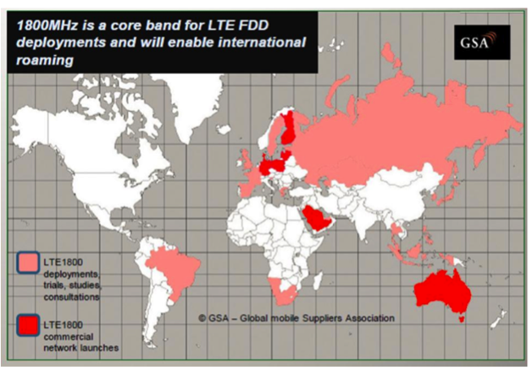

Source: GSA, Embracing the 1800MHz opportunity: Driving mobile forward with LTE in the 1800MHz band, 25 November 2011

In practice, a number of issues arise the key one being interference problems. The technical framework for the band which helps to define the licence impose constraints on licensees which effect their usage choices in that spectrum licences are therefore not entirely technology neutral but are designed with ITU allocations and available technologies in mind.

Basically, these types of licences authorise the use of spectrum whereby licences are free to use any device and technology within their spectrum provided that such devices comply with the conditions of the licences and guidelines established for the corresponding bands. Unfortunately, use of frequency bands is often not the same around the world. Also frequency bands are subject to replanning in the longer term.

Technology neutral licences were pioneered in New Zealand with the system of management rights and in Australia, with the introduction of spectrum licences. Since then:

• in the United Kingdom, Ofcom has developed a technology neutral licensing approach called Spectrum Usage Rights;[42]

• in the United States, some types of licences have conditions that allow considerable flexibility over spectrum use;[43]

• in Europe, the Radio Spectrum Policy Group has developed the Wireless Access Policy for Electronic Communications Services concept in an attempt to move towards greater flexibility. It provides a framework for the provision of electronic communications services within a given set of bands, where the services may be offered on a technology and service neutral basis. In fact, policy in the European Union embraces the principles of technology neutrality and service neutrality.[44]

The key elements of technology neutral spectrum licences are as follows:

• the licensee can use any technology to provide any service in any frequency band, and the use of the radio frequency spectrum can be changed at any time;

• the licensee must observe emission limits; and

• the licensee must manage interference (both in-band interference[45] and out-of-band interference[46]) between radiocommunications devices and services operating under other licences in the radio frequency spectrum bands.

### 5.2.3 Promoting wireless sector competition by instituting spectrum caps and mandated MVNO models

#### Imposing spectrum caps

Consideration should be given to imposing spectrum caps and rules to avoid spectrum hoarding by one or two major mobile operators taking into consideration the total frequency owned by the mobile operators for LTE and broadband. In addition, imposition of pro-competitive safeguards including spectrum caps will address the significant market power which operators, particularly VNPT and Viettel have in relation to existing 2G services which will otherwise be carried forward into new wireless technologies. Such rules could apply to future spectrum bands.

Such spectrum caps are a mechanism used by regulators in a number of foreign jurisdictions to improve market competition, secure benefits for users, and avoid hoarding of spectrum. In fact, a large number of country markets are imposing, or considering imposing, caps for wireless broadband (including digital dividend spectrum) even where such caps were abolished or not favoured over the past few years as detailed in Appendix C. Such markets include Asia as well as Australia, Europe and North America.

For example, operators with a disproportionate share of 900/1800 MHz spectrum should be precluded from securing more than 20 per cent of future 2.3 and 2.6 GHz spectrum auctions unless they are will be hand back and/or trade existing spectrum blocks. Likewise a single operator should not be entitled to hold more than one-third of the major cellular spectrum band allocations (i.e. in the key IMT bands – namely 700, 800, 900, 1800, 2100, 2300 and 2600 MHz spectrum bands).

#### Mandating MVNOs

While the concept of mobile virtual network operator (MVNO) has been prevalent in other countries since 1990s, the MVNO model has gained recent popularity, including in Viet Nam in relation to 3G services. The MVNO model remains attractive for new players with potential entrants cutting across industries with majority non-telco based operators such as media companies, retailers and financial institutions.[47]

Where mandated MVNO access is required by regulation in foreign markets, MVNOs have emerged as strong and vibrant competitors in markets for mobile communications services. There are good international precedents for such an approach. Examples of these foreign precedents – which including emerging and Asian markets – are detailed in Appendix D.

While it is true that many regulatory jurisdictions have previously adopted a ‘light-touch’ approach, favouring commercially negotiated agreements between wireless operators and MVNOs, a growing number of regulatory jurisdictions have mandated that wireless operators provide mandated access for MVNOs, whether through one-time or on-going regulation. This is especially in the case of LTE and 4G services which would require the right to provide MVNO services – both voice and data over one of the existing 2G/3G networks in order to offer a compelling product to consumers.

In summary, there are a number of key objectives – including policy, industry and technical developments in favour of promoting and regulating MVNOs in Viet Nam. These include:

(a) promote greater wireless broadband competition including service competition;

(b) promote greater cellular mobile (voice) competition including from potential 4G players;

(c) acknowledge that radio frequency spectrum is a bottleneck and an entry barrier to potential new competitors; and

(d) facilitate the future possible entry of a range of data only MVNO providers in Viet Nam including for machine to machine (M2M) communication.

Regulating MVNOs is likely to lead to increased offering of innovative service bundles to different segments of the population and to facilitate downstream innovations by mobile network providers in response to an MVNO market entry. This is in the interest of end users.

### 5.2.4 Other regulatory issues

In addition to the above major regulatory issues, a range of other issues need to be addressed to optimise wireless broadband deployment and take up in Vietnam. These include infrastructure sharing which is current being reviewed by the VNTA, securing the digital dividend which is discussed in section 5.4.1, and tariff regulation for wireless broadband services.

It is recommended that the role of VNTA as facilitator to create an enabling environment and gradual reliance on market mechanisms needs to be reinforced. This includes *inter alia* ensuring a predictable and transparent regulatory framework, and collecting and publishing quarterly of statistics from operators to ensure decision makers have the latest ICT figures.

In addition, while beyond the scope of this masterplan, the substantial fall in fixed line (PSTN) penetration in Viet Nam even though there is substantial investment in fibre to the home (FTTH) warrants future investigation and review. There would seem to be a case for separating the fixed line business from the mobile business similar to the demerger of Telekom Malaysia (fixed) and Celcom (mobile to become part of Axiata[48]) in September 2007.[49] This was done concurrently with the announcement of the high speed broadband (HSBB) project under a Public-Private Partnership (PPP) agreement between Telekom Malaysia and the Malaysia Government. This would mean the fixed network business has focused management, key performance indicators (KPIs) relating to the non-mobile business.

## 5.3 Technology aspects

While ITU advocates a technology-neutral approach, this does not mean that a particular mobile technology is preferred over another. What a technology-neutral approach does is to ensure that operators are not hamstrung into continuing supplying a particular service when cheaper and more efficient substitutes are available. When selecting a mobile technology and deploying it in a designated frequency band, it is important to consider whether the said technology is harmonised. Harmonised technology ensures interoperability and cheaper telecommunications equipment. This section will address the issues relating to technology harmonisation and canvas the major mobile technologies available for Viet Nam.

The great benefit of lower spectrum ranges is increased propagation, which means broadband services are capable of reaching a larger geographic area and a higher number of people. This is particularly important for Viet Nam given its varied terrain, which will rely on the greater range achieved by lower frequencies to ensure maximum coverage (see comparison in Figure 13).

The aim of the government and the VNTA should be to exploit the technological benefits of the lowest frequency bands as much as possible (e.g. including the 700 MHz and 1800 MHz bands) for the deployment of LTE technology. This will ensure that the country has the capacity to take advantage of 4G broadband services and the growth that is expected to take place in this area. In the following sections we examine GSM, W-CDMA, LTE, WiMAX, wireless offload and satellite technologies.

Figure 13: A comparison of different access technologies

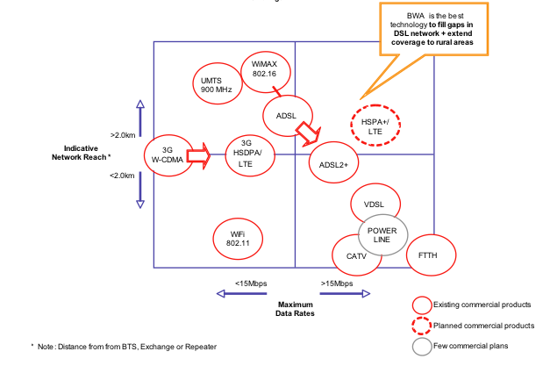

Source: ITU

### 5.3.1 GSM and W-CDMA

#### GSM

Key wireless services in Viet Nam operate on a range of bands reflecting either vendor support or other factors. Spectrum allocations are consistent with the majority of countries worldwide.

In the transition from 2G to 3G a number of standards have been developed, which are categorized as 2.5G. These are add-ons to the 2G standards and mainly focus on deployment of efficient IP connectivity within the mobile networks. Data access is provided by General Packet Radio Service (GPRS) and offers throughput rates of up to 40 kbit/s. As of Q2 2010, there were over 4.42 billion GSM subscriptions.[50]

#### W-CDMA/HSPA

W-CDMA is the access scheme defined by ITU to be the main technical platform for UMTS or Third Generation Mobile services. W-CDMA services are to operate within the following frequency bands: 1920 MHz – 1980 MHz and 2110 MHz – 2170 MHz. ITU selected W-CDMA as one of the global telecom systems for the new IMT-2000 3G mobile communications standard. In the W-CDMA interface, different users can simultaneously transmit at different data rates and data rates can even vary in time. W-CDMA is capable of delivering up to 384 kbit/s in outdoor environments and up to 2 Mbit/s in fixed indoor environment. W-CDMA is currently at release 9.

High Speed Packet Access (HSPA) is a set of technologies that allow W-CDMA operators to run their networks at broadband speeds. Peak downlink and uplink throughput is at 14.4 and 5.7 Mbit/s, respectively. HSPA+, which harnesses MIMO (multiple in, multiple out), enables peak data rates of up to 42 Mbit/s.

The roadmap for wireless technology evolution from GSM to W-CDMA to LTE services is shown in Figure 14.

Figure 14: Wireless Technology Roadmap

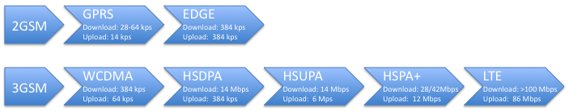

Source: Ericsson and Qualcomm, 2009.

As of January 2012, there are reportedly 241 HSPA+ network commitments with 187 HSPA+ networks having been launched. Total subscribers amount to 822.4 million (including 469 million HSPA subscribers).[51]

As case studies show (Box 3), the cost of 3G coverage with UMTS900 can save operators between 50 to 70 per cent of mobile network costs (including Capex and Opex) versus UMTS2100. UMTS900 can more cost effectively provide 3G and mobile broadband services in rural and regional areas. There is also an added benefit of improved indoor coverage.

Using the existing GSM infrastructure makes sense to achieve a rapid transition to widespread wireless broadband in Viet Nam. The VNTA could permit the early use of GSM900 band to provision W-CDMA at 900 MHz.

Box 3: Case study: Optus UMTS900 Network

*In 2008, Australian carrier Optus launched the world’s largest UMTS900 network. With almost 1 000 base stations, the network covers over 96 per cent of the population.*

*Given Australia’s population distribution, fixed broadband penetration is relatively low and demand for wireless broadband high. Optus recognised this as an opportunity to compete with Telstra’s national coverage and decided to expand its 3G network to enable high-speed data services. Optus had launched a UMTS2100 network in 2005, but UMTS900 was recognised as more cost effective for rural areas.*

***Deployment***

*Recognising the potential of UMTS900 to economically extend coverage to low-density areas, the regulator (ACMA) quickly approved the deployment.*

*From a strategic perspective, Optus chose to focus on areas where GSM usage was lower. It used its existing network infrastructure, overlaying coverage on existing 2G base stations and in urban areas, co-locating with UMTS2100.*

***Results***

*The use of UMTS900 technology enabled Optus to deliver a better quality network at a lower cost, with each base station covering a greater geographical area than UMTS2100 due to reduced path-loss. Using UMTS2100 to achieve the same coverage outcomes would have cost at least AUD 800 million. With UMTS900, capital expenditure was reduced to less than AUD 500 million.*

*In addition, the deployment delivered unexpected benefits to the 2G service. When re-farming the 900MHz spectrum, Optus’ focus on site optimisation led to increased 2G performance in some cases.*

### 5.3.2 LTE

LTE is the latest standard in the mobile network technology evolution that follows from the GSM/EDGE and UMTS/HSPA network technologies. It is a project of the 3rd Generation Partnership Project (3GPP).[52] The current LTE specification Release 9 provides downlink peak rates of at least 100 Mbit/s, an uplink of at least 50 Mbit/s. LTE supports scalable carrier bandwidths, from 1.4 MHz to 20 MHz and supports both frequency division duplexing (FDD) and time division duplexing (TDD). The next step for LTE evolution is LTE-Advanced and is currently being standardized in 3GPP Release 10.

In October 2010, ITU accepted and officially designated LTE-Advanced as an IMT-Advanced (4G) technology, while the 3GPP published Release 10 of the LTE standard in March 2011 and has frozen the set of features for LTE-Advanced.[53] One of the major reasons for aligning LTE with the call for IMT-Advanced is that IMT conforming systems were candidates for the spectrum bands identified at WRC07. Such moves made LTE a truly global standard compared with the fragmentation of earlier wireless standards. Commercialisation of LTE-Advanced systems are expected in the 2014-15 timeframe.

In January 2012, ITU confirmed the status of LTE-Advanced and Wireless MAN-Advanced technologies were both granted IMT-Advanced technology status by ITU (Box 4).

Box 4: ITU announcement on 4G technology

*In January 2012, LTE-Advanced and Wireless MAN-Advanced technologies were both granted IMT-Advanced technology status by ITU. After undergoing evaluation by ITU and meeting the specification requirements, the technologies are now officially accorded 4G status.[54]*

*ITU is responsible for setting mobile technology standards worldwide. The approval signifies the next stage in the evolution of LTE, which is set to deliver vast improvements in speed and efficiency.*

*The new technology will be significantly faster than 3G, with speeds above 100 Mbit/s. It will also make more efficient use of radio-frequency spectrum, meaning higher data transfers will be possible with a lower bandwidth requirement. The new technology will facilitate the growing demand for data transfer over mobile networks.*

According to the GSA, as of January 2012 there are 226 LTE network commitments in 76 countries and 59 pre-commitment trials. There were approximately 3.6 million subscriptions at this time. By 2015, an expected 744.2 million will subscribe to LTE.[55]

### 5.3.3 WiMAX

WiMAX is the popular name of IEEE802.16 standard. It serves as both a fixed and wireless access technology. Coverage of 50 km and capacity of around 70 Mbit/s is a reality with this technology. It is, however, important to note that the capacity offered over long distances is only a fraction of the maximum capacity, and WiMAX as access technology is offered in distances of 5 to 10 km. WiMAX is thought of by some as a good complementary / competitive infrastructure to traditional broadband. Another important aspect is that 70 Mbit/s will only be achieved if frequency bandwidth of 20 MHz is allocated and assigned by the local authorities. Many regulators will probably assign smaller frequency bands to the potential WiMAX operators. A competing technology to the mobile version of WiMAX (IEEE.802.16e) is LTE.

By mid-2011, global subscribers (including fixed WiMAX) were said to number approximately 20 million. Mobile WiMAX subscribers are expected to rise to 59 million by 2015.[56]

### 5.3.4 Why LTE is the recommended technology following 3G/W-CDMA?

LTE is acknowledged as the next step for a superior mobile broadband experience, targeting capacity and data rate enhancements to support new services and features requiring higher levels of capability and performance. LTE will enhance more demanding applications such as interactive TV, mobile video blogging, advanced games and professional services with significantly higher uplink and downlink data rates, supported by the necessary network architecture and technology enhancements.

Most importantly as shown in Figure 15, LTE is more spectral efficient than other air interface technologies. As such, LTE reduces the cost per GB delivered which is essential for addressing the mass market, and supports a full IP based network and harmonisation with other radio access technologies.

In a survey of major operators, the great majority (some 88 per cent) indicated that they were already considering LTE upgrades for their next generation networks, with likely deployments in 2011 and beyond. This is consistent with the fact that LTE has had rapid global acceptance with 49 commercial LTE networks having been launched in 29 countries, some 226 operators in 76 countries are investing in LTE, and there are 59 pre-commitment trials in 17 more countries. It is also expected that at least 119 LTE networks will be in commercial service in 53 countries by the end of 2012.[57]

Figure 15: Summary of downlink spectral efficiencies for various air interfaces and antenna schemes

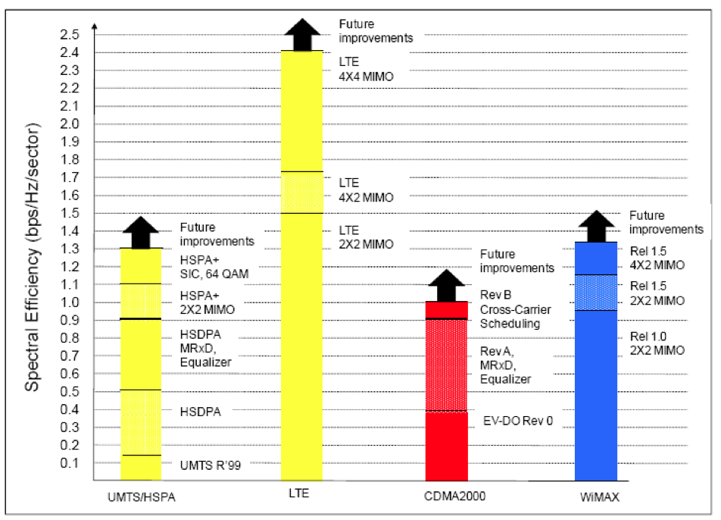

Source: 3G Americas, MIMO and Smart Antennas for 3G and 4G Wireless systems, Practical Aspects and Deployment Considerations, May 2010, page 58

A possible complication in relation to voice over LTE seems to have been resolved with the first VoLTE call on commercial network (namely Verizon) in the world occurring in February 2011. It is expected that VoLTE should be widely available globally in 2012.

More broadly, there are a number of steps to provide optimal voice services on LTE networks and devices. Firstly, the current approach is to use dual radiophones that utilise the 2G networks in the mobile phone for all voice calls. Secondly, voice calls will be provided over LTE with circuit switch fall back (CSFB) to the 2G networks where necessary (e.g. no coverage). Lastly the ultimate approach will be to adopt Single Radio Voice Call Continuity (SRVCC) for VoLTE, which uses an IP Multimedia Subsystem (IMS) system for call anchoring and handover and is based on a third party call control mechanism. This allows a mobile phone with an on-going voice call to transition to the circuit-switch domain in the event of loss of LTE coverage. An IMS-based SRVCC provides QoS control, flexible charging, and better user experience. The options for addressing on LTE networks are detailed in Figure 16.

Figure 16: Options for addressing voice on LTE

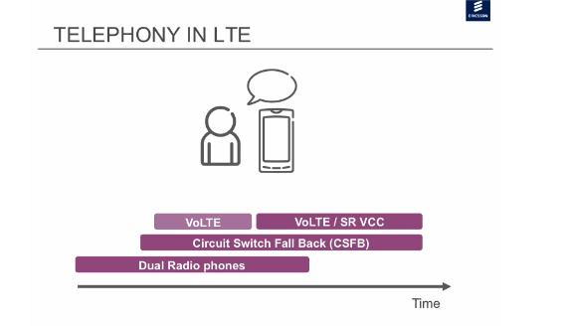

Source: Informa Telecoms & Media and Ericsson, LTE Early Launch Strategies: Who and Why? Webinar, 21 June 2011

### 5.3.5 Wireless offloading

As wireless data and broadband services grow in Viet Nam, the VNTA should to safeguard the quality of wireless services by encouraging operators adopting network offloading techniques. These include Wi-Fi offloading, Femtocell deployment, smart repeaters, and distributed antenna systems.[58]

Network offloading should be facilitated by VNTA policy as it alleviates capacity constraints and is a sensible allocation of spectrum resources. Specifically, the ability to utilise open access spectrum (such as 2.4 and 5 GHz) to support those small number of cell sites/locations which face congestion has considerable merit. An analysis of the potential use of off-loading techniques should form part of the needs and valuation models for additional spectrum.

We examine the two major network offloading techniques in detail focusing Wi-Fi and Femtocell deployment. These techniques are used in urban environments where typically the demand is the greatest. It is suggested that Wi-Fi is preferred ahead of femtocell deployment especially if optical fibre network infrastructure exists in that required locations.

#### Wi-Fi off-loading

Offload can be defined as utilising complementary technologies for delivering data originally targeted for 2G, 3G and future 4G networks. Wi-Fi technologies[59] which were ubiquitous in computing, has been utilized extensively in that role. More specifically the proliferation of smartphones and tablet computers with built in Wi-Fi is driving the demand for, and therefore the expansion of, public Wi-Fi networks.

There are three types of Wi-Fi off-loading (Figure 17) depending on the degree of coupling between the cellular mobile and Wi-Fi networks:

• **Tight coupling**. This utilises 3GPP Enhanced Generic Access Network (EGAN) architecture as it specifies rerouting of cellular network signalling through Wi-Fi access networks. This makes the Wi-Fi access network as a de-facto 3GPP RAN. This technology is better known as Unlicensed Mobile Access (UMA). In the beginning, it was targeted to improve indoor coverage for the voice service in 2G networks. In 3GPP later releases GAN architecture was extended to cover also 3G packet data protocols, and hence is now referred to as EGAN architecture.

• **Loose coupling**. 3GPP has also specified an alternative approach called Interworking Wireless LAN (IWLAN) architecture and it is a solution to transfer IP data between a mobile device and operator’s core network through a Wi-Fi access. In the IWLAN architecture, a mobile device opens a VPN/IPsec tunnel from the device to the dedicated IWLAN server in the operator’s core network to provide the user either an access to the operator’s walled-garden services or to a gateway to the public Internet. With loose coupling between the networks the only integration and interworking point is the common authentication architecture. Currently, it is not possible to initiate a call on a Wi-Fi network and continue the call on a 3G network.

• **No Coupling**. This is the most straightforward way to offload data to the Wi-Fi networks. It results in there being a direct connection to the public Internet. It means that there is no need for interworking standardisation. For mere web access there is no added value to route the data through the mobile operator’s RAN and core network.

Figure17: Wi-Fi offloading (referred to as HNB-GW) implementation

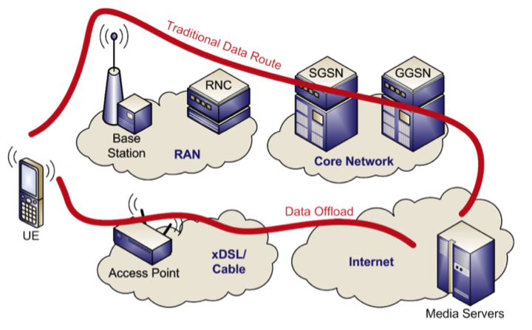

Source: Coleago, 2010

While Wi-Fi is being deployed, it is still in its evolution phase and technological developments are ensuring that it will play a key role in future offloading solutions. Several enabling features are development phases (see also Figure 18):

(i) ***Secure Authentication***: This authentication is inbuilt into SIM cards and will mean that subscribers are granted exclusive access to their operator’s Wi-Fi.

(ii) ***Wi-Fi Handover***: This will enable the seamless transition between different Wi-Fi cells.

(iii) ***3G/4G Handover***: This is a key development area and is being actively pursued. It will enable the automatic transfer of devices from 3G/4G networks to Wi-Fi.

#### Possible deployment of Femtocells

Femtocells are low-power wireless access points (a home Node B) that operates using licensed spectrum to connect standard mobile devices to a mobile operator’s network using xDSL, fibre or cable broadband connections (Figure 18). Femto cells address:

• Coverage and quality of service issues (i.e. providing “five-bar” voice quality). To reduce customer churn, operators offer femtocells to improve voice coverage indoors, with the aim to reduce that churn and improve the customer experience.

• Higher mobile data capacity (where Wi-Fi is not used). Such higher capacity and data net throughputs are ultimately limited by backhaul to the femto cell in most cases.[60]

Figure 18: Femtocell (referred to has HNB-GW) implementation

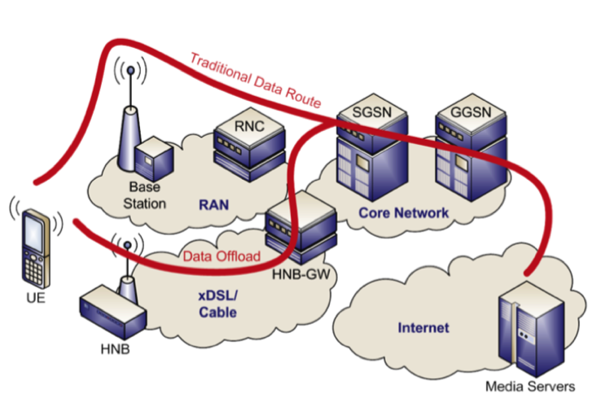

Source: Coleago, 2010

Currently, according to industry commentators, Informa, as at the end of March 2011, 20 mobile operators have already deployed femtocells in their networks and 34 operators have committed to their launch.[61]

Operators’ femtocell business models are expected to evolve from using it as a technology to fill a structural gap in network strategies to a base from which to generate new revenue streams. The revenue opportunity will arise as femtocells start to take a role into the connected home and office environments, controlling different devices using different services, content and applications (assuming such services can be monetorised). Femtocells also form the first part of the new self-organising network (SON) and transform the potential of small cells by providing a practical preview of core LTE functionality.

It is recommended that ARFM facilitate the possible future deployment of femtocells in Viet Nam by:

(i) ensuring the femtocells (which are in essence a Home Node B) are not chargeable as a separate cell site under the spectrum regulations; and

(ii) developing practical approaches to lawful interception of traffic generated on femtocells.

### 5.3.6 The role for satellite

Satellites are valuable part of the broadband infrastructure strategy. They are able to provide ubiquitous connectivity and are very well suited for areas which are either underserved or unserved by terrestrial networks. They are able to augment and combine with terrestrial network and once launched can accelerate the availability of high-speed Internet services in such areas. As an added bonus, satellite communication does not have any last mile issues and can provide a high degree of reliability in the event of disasters etc.

There has also been recent technological innovation in relation to satellite technology, similar in a way to wireless broadband communications. The new generation of satellite broadband systems known as HTS (High Throughput Satellite) have a number of new features:

• spot beam technology, where switchable beams illuminate much smaller areas (100s of km2 instead of 1000 km2);

• beam coverage forms a honeycomb / cellular pattern with frequency reuse;

• this concept of frequency reuse drastically increases overall capacity;

• use of Ka band leads to smaller antenna dishes; and

• satellite broadband services with frequency reuse, faster speeds and smaller dish antennas in Ka band drive down the costs to a much lower level.

HTS demand is likely to exceed 530 Gbit/s by 2019. *C*ore HTS applications include satellite broadband access, broadband VSAT backhaul and mobility as shown in Figure 19.

Figure 19: Global HTS bandwidth demand by application



Source: [www.nsr.com/](http://www.nsr.com/)

## 5.4 Spectrum management aspects

ITU has been a driving force for over two decades for the development of global broadband mobile telecommunication system. International Mobile Telecommunications (IMT), supported by fixed telecommunications networks (e.g. PSTN/Internet) provides access by means of one or more radio links to a wide range of telecommunications services.

IMT is the generic ITU name for 3G/4G technologies. Radio spectrum below 1 GHz is optimum for the needs of developing countries, due to the ability to serve larger rural areas from a single cell site compared to spectrum above 2 GHz. The 2007 World Radio Conference made valuable strides in identifying additional spectrum for IMT, both below 1 GHz and above 2 GHz. The concept of identifying spectrum for potential use by IMT, in the ITU Radio Regulations, gives global equipment manufacturers some guidance on the range of frequency bands in which IMT services are likely to be deployed, leading to economies of scale and minimizing product costs. The identification “for those administrations wishing to deploy IMT” allows use by other services to which the spectrum is allocated and does not convey any priority for IMT over those other radio-based services. Appendix F details those IMT allocated bands.

IMT-Advanced provides a global platform on which to build the next generations of mobile services – fast data access, unified messaging and broadband multimedia – in the form of exciting new interactive services and applications. New studies/techniques are leading to increased spectrum utilization and spectrum efficiency and allowing spectrum resources to be shared between users. Those objectives are detailed in Box 5.

Box 5: Objectives for the efficient management of spectrum

Efficient management of the radio spectrum is a key component for the promotion of broadband access. In planning the implementation of IMT, the following objectives are desirable:

• to ensure that frequency arrangements for the implementation of IMT have longevity, yet allow for the evolution of technology;

• to facilitate the deployment of IMT, subject to market considerations and to facilitate the development and growth of IMT;

• to minimize the impact on other systems and services within, and adjacent to, the bands identified for IMT;

• to facilitate worldwide roaming of IMT terminals;

• to integrate efficiently the terrestrial and satellite components of IMT;

• to optimize the efficiency of spectrum utilization within the bands identified for IMT;

• to enable the possibility of competition;

• to facilitate the deployment and use of IMT, including fixed and other special applications in developing countries and in sparsely populated areas;

• to accommodate various types of traffic and traffic mixes;

• to facilitate the continuing worldwide development of equipment standards;

• to facilitate access to services globally within the framework of IMT;

• to minimize terminal costs, size and power consumption, where appropriate and consistent with other requirements;

• to facilitate the evolution of pre-IMT-2000 systems to any of the IMT terrestrial radio interfaces and to facilitate the on-going evolution of the IMT systems themselves;

• to afford flexibility to administrations, as the identification of several bands for IMT allows administrations to choose the best band or parts of bands for their circumstances;

• to facilitate determination, at a national level, of how much spectrum to make available for IMT from within the identified bands;

• to facilitate determination of the timing of availability and use of the bands identified for IMT, in order to meet particular user demand and other national considerations;

• to facilitate development of transition plans tailored to the evolution of existing systems;

• to have the ability for the identified bands, based on national utilization plans, to be used by all services having allocations in those bands;

• to enforce licensing conditions and adherence to licensed technical parameters; and

• to effect cross border coordination to eliminate / mitigate cross border interference situations.

### 5.4.1 Securing the digital dividend spectrum

Given that digital TV is many times more efficient than analogue, the shift from analogue to digital TV transmission is freeing up the scarce radio spectrum. Globally, this freed up spectrum, called the digital dividend, is offering a unique opportunity to expand the availability of wireless broadband services to a much wider range of subscribers. The spectrum for terrestrial television is therefore being reorganised to accommodate newer and more efficient digital TV services especially below 1 GHz (470 to 862 MHz) that is ideal for covering rural areas.[62] The digital dividend has the potential to enhance the broadband coverage many times over.

The digital dividend could also provide crucial low-frequency spectrum for the deployment of next-generation rural broadband, and steps to make this spectrum available for use by different technologies are welcomed.

The cost of deploying next-generation wireless broadband to rural areas could be reduced drastically if sufficient digital dividend and ‘refarmed’ spectrum was made available for wireless broadband.

Refarming the analogue TV spectrum could stimulate the LTE market and bring dramatic improvements to mobile broadband, digital dividend spectrum could help wireless broadband to complement or compete with fixed-line broadband. Digital dividend spectrum is, and should be a key driver for LTE deployments worldwide. Indeed, not only is it a unique opportunity for wireless operators to capture much needed additional spectrum for LTE deployment, it also offers the potential to accelerate the availability of broadband services to customers in traditionally underserved markets.

Additionally, because this spectrum has such attractive technical features, it can help ensure that operators can address the broadband demand – including services in the home – in a very cost-effective manner.

UHF bands IV and V (470 – 862 MHz) for TV have the potential for providing the digital dividend. There are recommendations on policy, regulation, technologies, network planning, customer awareness and business planning for the smooth introduction of DTTB (Digital Terrestrial Television Broadcasting) and MTV (Mobile Television).

Given the dominant position of cellular mobile services in Viet Nam now and wireless broadband in the future, the need for additional spectrum in the 700 MHz band (i.e. the digital dividend) with the migration to digital TV is profound. Spectrum will be needed sooner rather than later compared to other markets. As such, Viet Nam is proposing a two stage digital dividend process. Its structure and time frame for the release is shown in Figure 20.

Figure 20: The two stage digital dividend proposed by Viet Nam

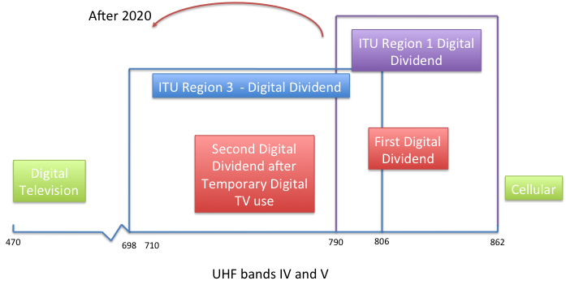

Final Digital Dividend – After 2020

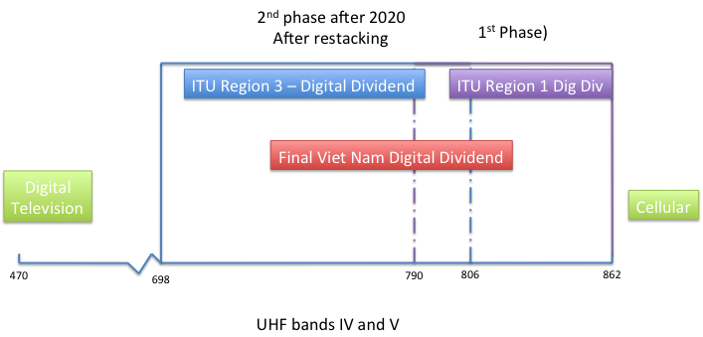

Source: ITU

The analogue television switch off roadmap and its staged nature is detailed in Figure 21.

Figure 21: Staged nature of the digital television migration process in Viet Nam

**Analogue TV Switch-Off Roadmap**

**12/2020**

**12/2017**

**12/2015**

**12/2016**

5 central cities

DTV

DTV

DTV

DTV

ATV

ATV

ATV

**2011**

**12/2015**

**12/2020**

ATV

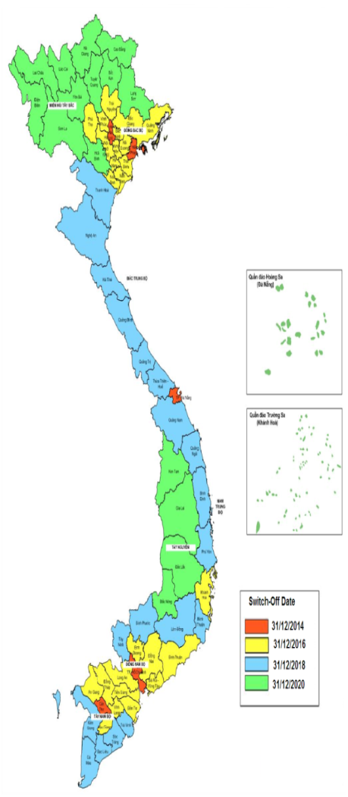

**12/2017**

Source: ITU

### 5.4.2 Band plans for the 2.3 GHz and 2.6 GHz spectrum bands

Based on its current frequency arrangements and consistent with the recommendation ITU-R M.1036-3[63], the ARFM in Viet Nam has carried out the band planning for the 2300 to 2400 MHz (for TDD) and 2500 to 2690 MHz bands (for TDD and FDD). These are depicted in Figure 22 and Figure 23.

While such band plans are consistent with applicable global best practice, this masterplan considers that given the global deployment of TD-LTE networks in 2.3 GHz band including in key markets like China, India, Indonesia and Australia, early consideration should be given to reviewing this band plan by the ARFM for this spectrum band for TD-LTE. In particular, 30 MHz allocations are not consistent with a use of the band for TD-LTE and 10-20 MHz allocations may be sought by mobile operators in the near future.

Figure 22: 2.3-2.4 GHz band plan –TDD

A

**2300 2330 2360 2390 2400**

B

C

Guard Band

Source: Circular No 26/2010/TT-BTTTT - 24/11/2010

Figure 23: 2.5-2.69 GHz band plan- TDD and FDD



Guard bands

Source: Circular No 27/2010/TT-BTTTT - 24/11/2010

### 5.4.3 Spectrum needs and frequency arrangements based on technology selection

Rec. ITU-R M.1768 contains the methodology for calculation of spectrum requirements for the future development of the terrestrial component of IMT-2000 and systems beyond IMT-2000. This generic methodology can be used for differing market for a range of cellular system architectures. Specifically, the technical process of estimating spectrum requirements for mobile communications has to be based on four essential issues namely:

• definition of services;

• market expectations;

• technical and operational framework; and

• spectrum calculation algorithm.

There is little doubt that Viet Nam market like other global markets needs greater allocations of spectrum to wireless/cellular services in order to support the efficient provisioning of services (at affordable prices) and to support the country’s economic growth. While the optimal timing to secure additional spectrum needs to be ascertained the extended time period in which to facilitate new spectrum releases will always make this difficult to do perfectly.

In the case of Viet Nam given its high cellular mobile penetration, its growing broadband (including wireless broadband) penetration, and its failing PSTN teledensity, it is difficult to independently forecast the likely demand for wireless and wireless broadband services with any certainty. For the longer term (up to 2020), this masterplan assesses the overall spectrum requirements in a manner consistent with ITU-R Report M.2078 (2006).[64]

It is therefore recommended that the minimum spectrum allocation for cellular mobile services in Viet Nam should be at least 760 MHz in 2020 and preferably 840 MHz (Figure 25), a significant increase from the approximately 390 MHz it currently allocates to mobile services. Figure 24 only shows the first digital dividend and not the second which will be able in 2020 and beyond.

Figure 24: Viet Nam suggested allocation targets for mobile spectrum until 2020

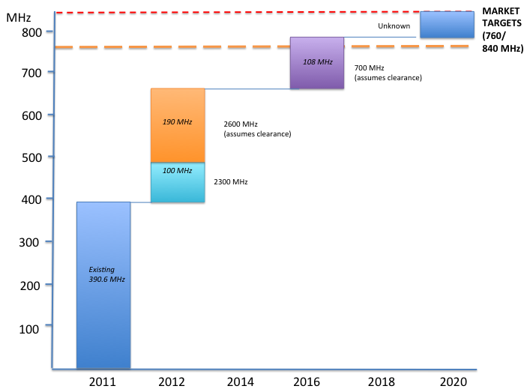

Source: ITU

As spectrum requirements in Viet Nam are akin to developed country markets such minimum spectrum requirements have been benchmarked against foreign regulator studies in the United States, United Kingdom, and Australia (see Appendix F) and are broadly consistent.[65]

These targets are considered realistic even though the demand for wireless services will be high, as there is likely to be somewhat a demand lag in Viet Nam markets compared with developed country markets. In addition, to achieve these targets levels of spectrum allocation means securing the digital dividend (after the switchover to digital television) which will not be an easy or straightforward process given the number of policy and consumer issues needing to be resolved.

Importantly, many of the allocations can occur at lower spectrum bands below 2 GHz (and particularly below 1 GHz). This will mean a faster deployment with greater coverage in mountainous, regional and semi-rural Viet Nam.[66] It should also mean more affordable services given lower cost structures.

### 5.4.5 Additional preferred spectrum bands for use as ‘spectrum insurance’

Given the growth of wireless services globally and in Viet Nam over the past five years, it is possible that the demand may be underestimated again. There is even a bold view expressed by one major mobile operator that all spectrum below 5 GHz will be devoted to wireless broadband within five years.[67] Certainly if the Ericsson vision of more than 50 billion connected devices[68] is correct then more spectrum than any regulator is proposing globally, will be required.

Having said that, this masterplan recommends that the ARFM review making available three additional spectrum bands in longer term. These, based on the approaches of international regulators and/or industry preference are – 1.5 GHz, 3.3 to 3.8 GHz[69] in addition to a second digital dividend in the 700 MHz band which has already been discussed. Such additional spectrum provides a ‘spectrum insurance’ for Viet Nam should one be necessary.

# 6 Facilitating applications and content

## 6.1 Stimulating the content sector in emerging economies

It is arguable that there is a circular relationship between applications/content and broadband uptake. The higher the penetration of broadband services, the more data /content rich applications consumers demand; whilst the more attractive and relevant applications/content are, the more consumers will demand broadband in order to participate in those markets.

There are a number of means through which the government can intervene in order to create an enabling environment for content production industries and ultimately drive demand for their services.

### 6.1.1 Educate content entrepreneurs

Governments can work to stimulate the domestic content sector by educating their national ICT workforce with the set of skills and outlook that are necessary for the requisite innovation and technical expertise required for the market to expand.

New courses at existing technical/educational institutions may be developed so as to encompass issues associated with applications/content. It may be necessary for the government to train teachers/trainers with a range of input skills for content production (e.g. graphic design, animation, information technology). An example from Australia is shown in Box 6. Overseas expertise may need to be harnessed for the training of a skilled and dynamic workforce in areas such as management, finance and creative process development.

Box 6: Digital media courses at the Australian Film Television and Radio School[70]

The Australian Film Television and Radio School (AFTRS) offers a number of specialist postgraduate courses within the digital media field of study.

A Graduate Certificate in 3D Animation provides “a comprehensive, specialist course designed to develop the professional skills of digital artists through production-focused learning….[and] course provides a thorough grounding in the art of 3D animation using AutoDesk Maya software.

The course offers a number of modules aimed at giving students a grounding in both the technical and business side of the 3D animation sector:

• 3D Graphics Fundamentals;

• Character Animation Foundations;

• Collaborative;

• Creative Research;

• Industry Brief;

• Introduction to Running Your Own Creative Business; and

• Key Figures in Animation

…”

The government may also consider incorporating a workforce training requirement (as possible subsidies) as part of its national employment policy the Ministry of Labour, Invalids and Social Affairs announced in January 2012 that it aimed to create 1.6 million new jobs and vocational training for 1 900 people over the next 12 months.[71] It is easy to envisage the inclusion of this important policy in the nation’s next labour plan.

The government should also be open to obtaining overseas assistance in developing appropriate competency/skill measures and standards/certification.

Box 7 below highlights foreign investor interest in this market in Viet Nam. Facilitating a business climate that is open and attractive to foreign investment in this market segment may obviate the need for the government to make substantial financial commitments to improving the domestic content market.

Box 7: NTT Docomo invests USD 18 million in Viet Nam content industry

*In August 2011, Japan’s NTT Docomo announced that it had acquired a 25 per cent stake in Viet Nam’s VMG Company, a mobile content platform provider, for USD 18 million. NTT Docomo saw strong prospects for growth in the Viet Nam application / content sector and believed that VMG, the nation’s largest content provider, was an attractive target through which to reap maximum benefit from this market and expand its presence in Southeast Asia.*

### 6.1.2 Subsidise content production

In order to improve the supply of content, financial tools such as direct outlays and tax measures may be employed by the government. Each tool possesses unique policy design issues that must be properly addressed prior to implementation.

With respect to the provision of digital content, the government has opted to issue subsidies in the past. Decision No. 56/2007QD-TTg of May 3 2007, Approving the Program on Development of Vietnam’s Digital Content Industry to 2010, saw the establishment of a of USD 78 million fund sourced from national and provincial governments as well as private sector contributions. Assuming that the government opts for a funding mechanism which is consistent with the previous programme, the relevant Ministries will be delegated the authority to allocate the monies which will be issued at the project’s content level. The relevant authorities will need to determine the appropriate area in the value chain where the subsidy should occur on a case-by-case basis.[72]

### 6.1.3 Regulatory options

Regulatory measures provide the means to stimulate content production with relatively low direct costs to governments. For example, local content rules may provide a domestic content quota – in Australia, this was a key driver behind the early development of content production.

As discussed in section 6.1.2, policy design issues, such as the location on the value chain where the intervention occurs and preferences for the type of content development will need to be considered.

## 6.2 Direct government action and leadership

Governments can take the lead to develop and deploy online/wireless services. If there exists good access to bandwidth and devices, online and wireless delivery can be a highly cost effective to provide information about government services and some of the services themselves in a much more equitable manner. Initiatives should not be limited to national governments: regional and local government can provide important and useful information to local residents and businesses.

Specifically, assessing the sophistication of a government’s online presence based on four stages of e-government evolution namely emerging presence, enhanced presence, transactional presence, and connected presence Viet Nam only scored 0.30 where the value of 1.00 is the highest.[73] Viet Nam’s ranking in ASEAN while above Indonesia, was below Thailand, the Philippines, Malaysia and Singapore as shown in Table 7.

Table 7: E-government web measure 2009

|  |  |  |
| --- | --- | --- |
| Country | E-government web measure | Secure internet services (per million) |
| **South Korea** | 1.00 | 1,140.4 |
| **United States** | 0.94 | 1,443.3 |
| **Canada** | 0.88 | 1,236.6 |
| **Australia** | 0.77 | 1,760.9 |
| **United Kingdom** | 0.77 | 1,395.7 |
| **Singapore** | 0.69 | 523.1 |
| **Japan** | 0.67 | 650.2 |
| **Malaysia** | 0.63 | 42.2 |
| **Germany** | 0.55 | 873.5 |
| **HIGH INCOME** | 0.46 | 905.1 |
| **Philippines** | 0.39 | 6.6 |
| **China** | 0.37 | 1.9 |
| **India** | 0.37 | 2.2 |
| **Thailand** | 0.33 | 13.4 |
| **VIETNAM** | 0.30 | 3.1 |
| **WORLD** | 0.26 | 155.7 |
| **MIDDLE INCOME** | 0.26 | 8.8 |
| **Indonesia** | 0.24 | 2.1 |
| **Cambodia** | 0.14 | 1.6 |
| **EAST ASIA AND PACIFIC** | 0.13 | 3.2 |
| **Laos** | 0.08 | 0.8 |
| **Myanmar** | 0.08 | 0.1 |

*Source: World Bank, The Little Data Book on Information and Communication Technology, 2011*

In addition, the MIC recently identified six key content areas to be developed for the mass market, four of which are commercially generated: mobile network services, online games, online advertising and e-commerce.[74]

# 7 Conclusions and recommendations

Globally, the early stages of the mobile broadband revolution occurred in 2006/07 as key enablers, primarily around technology, began to converge. These enablers will continue to drive mobile broadband’s rapid adoption and market share gains from fixed technologies, such as DSL. As indicated by the US Federal Communications Commission (FCC) broadband wireless services are having profound economic and social consequences even in developed country markets:

*“Wireless mobility has become central to the economic, civic, and social lives of … [our citizens]. We are now in the midst of a transition from reliance on mobile voice services to increasing use of and reliance on mobile broadband services, which promise to connect [our] citizens in new and deeper ways … [the] mobile wireless market will be essential to realizing the full benefits to … consumers and channeling investment toward vitally important national infrastructure. A vibrant mobile wireless market is also essential to driving innovation, not only within the mobile market itself, but also in markets – current and future – for which wireless mobility is a key enabler.”[75]*

For Viet Nam, which has a national strategy to transform the ICT sector with countrywide broadband information infrastructure, the stakes are even greater. Unless there are substantial readjustment in investment priorities, the predominant way by which people will access the Internet will be via wireless broadband (albeit such services require significant fixed network infrastructure in terms of optical fibre backhaul and international submarine capacity). As such wireless broadband – both terrestrial and in more remote mountainous parts of the country satellite services - is essential to the economy, and social fabric of Viet Nam and its people.

Given the laudable success in driving one of the world’s highest mobile penetration rates, the challenge now is to embrace convergence and facilitate the use of broadband by this large installed base of mobile subscribers. This requires both infrastructure – provided on a cost effective manner so that prices are affordable and content – which is demanded by subscribers and useful. On both fronts there remain challenges.

Firstly in relation to infrastructure, more needs to be done in order to provide the most cost-effective solutions. Technology neutrality is, and ought to be a widely accepted principle for the efficient allocation of spectrum and ought to be embraced by the regulatory frameworks. The deployment of W-CDMA utilising the 900 MHz band and LTE wireless technology at 700 MHz (when available) and 1800 MHz (now) with the capability of reaching the highest number of people should be seen as a priority for Viet Nam and is endorsed under this masterplan. Satellite services – perhaps with a local cellular or Wi-Fi hotspot can also provide a critical role in addressing the digital divide in more remote areas of the country. Additional spectrum allocations to secure at least 840 MHz in total aggregate spectrum will also be required to support the Viet Nam wireless revolution on a timely basis.

Secondly, on content, while Viet Nam has many companies developing mobile apps and similar much more can be done at the governmental level to facilitate the transformation of the country including the development of Vietnamese language content.

## Roadmap for the government/regulator: Action items and timelines

The recommended key milestones and actions for the MIC, the VNTA and the ARFM are detailed in Table 8 and Figure 25. It is important that active monitoring be undertaken by the VNTA and the ARFM to address the action items and to facilitate targets as provided for this masterplan and the broader broadband policy once it is formulated and endorsed by government.[76]

Table 8: Key recommended action items

|  |  |
| --- | --- |
| Date | Target |
| Q2,2012 | 2.6 GHz spectrum licensing |
| Q3,2012 | Review of 2.3 GHz band plan |
| Q4,2012 | Review implications of W-CDMA @ 900 MHz and LTE @ 1800 MHz |
| Q1,2013 | 4G (2.6 GHz) spectrum licensing |
| Q1,2013 | Mandated MVNO framework promulgated |
| 2015 | Government broadband/Internet adoption targets for 2015 met |
| 2016 | Release of first digital dividend for LTE / LTE-Advanced @ 700 MHz |
| 2020 | Government broadband/Internet adoption targets for 2020 met |
| 2020+ | Second digital dividend |

Figure 25: Recommended timeline for action

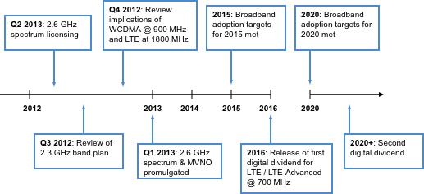

Source: ITU

# Appendix A

# ASEAN 2015 ICT Masterplan

The following section elaborates on four of the six areas of the ASEAN 2015 ICT Masterplan which have direct implications for the wireless broadband masterplan.[77]

# Strategic thrusts for ICT policy

## I. Economic transformation:

Members are to create a conducive business environment that helps to attract trade, investment and entrepreneurship in the ICT sector. Leveraged investment in ICT will consequently be a driving force for growth in other key economic sectors.

Creating an enabling business environment necessitates the development of a framework to facilitate transparent and harmonised ICT regulations. Within the context of developing a Wireless Broadband Masterplan, this action is significant is it will require the regulatory authorities of pilot nations to be cognisant of the regulatory practices in neighbouring states and implement new policies / regulations in such a way so as to maintain consistency with ASEAN nations.

## II. People engagement and empowerment

A focus on people engagement and empowerment is intended to devote resources to the improvement of quality of life for ASEAN peoples through affordable ICT – especially in low income / remote areas where ICT access is considered to be a luxury. Member States have committed to ensuring access to affordable and seamless e-services, content and applications. This is to take the form of providing incentives / grants to promote such services. The value of wireless broadband lays in part through its ability to seamlessly access such services and applications in a convenient and highly practical manner. The promotion of these services will enhance the attractiveness for wireless broadband technology for users and operators alike.

## III. Infrastructure development

Infrastructure development is a key component of ASEAN’s ICT policy and is recognised as necessary for the successful implementation of the other strategic thrusts. Member States have committed to establishing an ASEAN Broadband Corridor. This will be achieved through a number of means including:

i. identifying and developing locations in ASEAN Member States which offer quality broadband connectivity;

ii. enabling seamless usage of broadband services and application across the ASEAN region to improve connectivity and services; and

iii. promoting the diversity of international connectivity among ASEAN Member States.

An ASEAN Internet Exchange Network has also been scheduled for completion. This will be achieved by establishing a regulator / operator forum to develop a platform to enable intra-ASEAN internet traffic and facilitating peering amongst ASEAN internet access providers to reduce costs and improve latency.

## IV. Bridging the digital divide

Another important strategic thrust relates to the acknowledgment of imbalance of development amongst ASEAN Member States. This therefore necessitates a range of initiatives to be adopted that are focused on closing this development gap. Member States have agreed to review their USO / similar policies with a view towards including IT components and training as a part of USO funding. Furthermore, Members need to ensure that ICT infrastructure covered under USO is broadband Internet capable. This will likely have positive implications for policies geared towards the deployment of mobile broadband infrastructure as it opens the door to a new avenue of funding.

Figure A1: Timeline

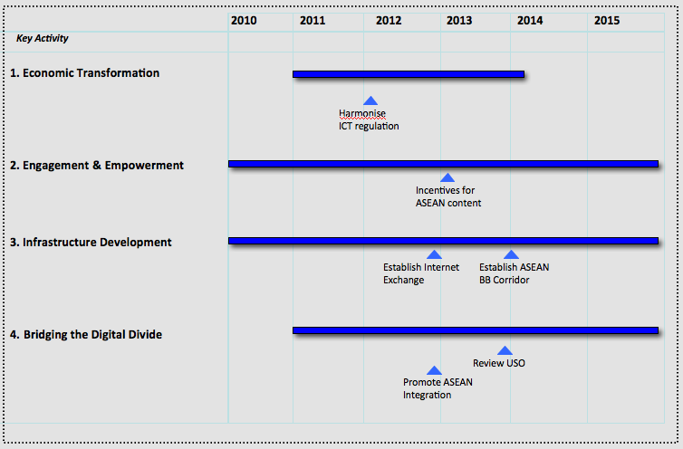

Source: ITU

# Appendix B

# National strategy to strengthen the information and communication technology sector in Viet Nam[78]

All related ministries and agencies are responsible for the implementation of the strategy, with the Ministry of Information and Communications (MIC) playing the leading role, and is responsible for building detailed implementation plans, monitoring and facilitating the implementation across the country. The MIC has been working actively in implementing the strategy and there are already positive signs with contributions on ideas and proposals of specific projects from domestic and foreign enterprises.

The key objectives of the strategy are:

• to develop ICT human resources to international standards;

• to build ICT industry, especially software industry, digital content industry and IT services;

• to become a leading economic sector so as to contribute significantly to GDP growth and exports;

• to set up a broadband information infrastructure in the whole country;

• to apply IT effectively in all socio-economic aspects, and national security and defence.

Steering views of the strategy are:

• accelerating the development of Viet Nam's ICT on the basis of ensuring continuity with creative measures, targeting higher objectives with higher speed;

• reasonably developing on the basis of optimising internal resources and taking advantage of international knowledge and resources;

• efficiently utilizing the state budget, attracting more investment from local and foreign enterprises; and

• applying highest priorities and preferences in accordance with the law on the development of high technology, research and training for IT parks, research and training institutions and all enterprise individuals who provide IT products and services.

The strategy has identified six groups of tasks focussing on issues such as:

• developing ICT human resource;

• developing ICT industry;

• continuing to develop and improve the telecommunications and IT infrastructure;

• building and deploying suitable supporting solutions for providing digital information to households;

• applying IT effectively in government agencies, enterprises and the society;

• strengthening research capacity in the ICT sector;

• mastering gradually and developing technologies for creating new products.

The strategy also stated six solutions namely:

• enhancing information dissemination regarding the strategy;

• promoting the socialization of investment in ICT, especially in the development of broadband telecommunications infrastructure;

• providing investment incentives for priority areas;

• building and improving institutional frameworks;

• establishing a specific mechanism and renewing policies; and

• promoting international cooperation.

# Appendix C

# Spectrum caps in key global markets (as at December 2011)

| Country | Spectrum Caps? | Details |
| --- | --- | --- |
| Belgium | Yes  (for 2.6 GHz) | Belgium adopted a different approach to freeing spectrum in the 2.6 GHz band for wireless broadband services than its European counterparts. The regulator, BIPT, opted to issue for blocks of 2 x 15 MHz with 2 x 5 MHz blocks at the end of the paired bands. BIPT has imposed a paired spectrum cap of 2 x 20 MHz, but the cap does not extend to the unpaired spectrum. |
| Canada | Being re-considered | In 2010, the regulator, Industry Canada, released two Consultation Papers on the reallocation of the 700 MHz and 2.6 GHz bands. The 700 MHz paper raised the possibility of introducing spectrum caps to prevent ‘excessive concentration’ (i.e. hoarding of spectrum). The regulator recognised that ‘setting the right cap is essential.’ Three options were canvassed:  (a) spectrum to be auctioned in individual bands (700 MHz separately from 2500 MHz);  (b) a combination of spectrum to be auctioned in both bands (700 MHz and 2500 MHz); and  (c) a combination of spectrum to be auctioned as well as existing spectrum holdings in all or a subset of bands available for commercial mobile systems (cellular, PCS, AWS, BRS), e.g. spectrum holdings below 1 GHz.  In their responses, larger operators were largely opposed to the imposition of spectrum caps. Bell Mobility submitted that, *inter alia*, spectrum caps were not required given the developed state of Canada’s mobile market and the absence of a cap in other mobile broadband bands (they were previously rescinded in 2004). |
| France | Yes  (for 800 MHz and 2.6 GHz) | In May 2011, the Government of France auctioned the 800 MHz digital dividend band. Four lots of a total of 30 MHz were allocated for 4G services. Operators were limited to a maximum of 2 x 15 MHz. The move was criticised by some industry analysts because the cap effectively meant that a leading operator was able to corner 50 per cent of the best spectrum in one auction.  In September 2011, the 2.6 GHz band was auctioned via sealed bid. The cap in this band was 2 x 30 MHz. The remaining spectrum in the 800 MHz band will be auctioned following the end of analogue services. Operators generally supported the spectrum caps. Smaller operators have been wary of FT Orange further increasing their mobile market dominance and believed that caps were the best way of reducing its market share. |
| Germany | Yes  (for 800 MHz) | In 2010-11, the Government in Germany completed the reallocation of digital dividend spectrum. In the 800 MHz band, 2 x 30 MHz of bandwidth was auctioned. A spectrum cap of 2 x 10 MHz was implemented. Caps were not mandated for concurrent auctions in the 1800 MHz and 2.6 GHz bands |
| Hong Kong (China) | Yes  (for 2.3, 2.5/2.6 GHz) | The auction of wireless broadband spectrum in Hong Kong has been occurring on a staggered basis. In 2009, 195 MHz of spectrum was auctioned from the 2.3 GHz and 2.5/2.6 GHz bands. The regulator, OFTA, imposed a spectrum cap of 30 MHz. The cap was imposed because OFTA would not accept the prospect of only having one operator that was capable of operating wireless broadband services. A 30 MHz cap was believed to be sufficient for an operator to provide a territory-wide service of acceptable quality. In March 2011, OFTA, announced the upcoming auction of three residual unpaired 30 MHz blocks in the 2.3 GHz band for wireless broadband services following a number of expressions of interest from operators. A cap of 30 MHz was re-implemented.  OFTA announced auctions of the 850 MHz, 900 MHz and 2 GHz bands for wireless broadband would occur in February 2011. There were no spectrum cap requirements in this auction. |
| Netherlands | Yes  (for 2.6 GHz) being considered for 800 MHz | The Ministry for Economic Affairs opted to impose differential caps on entrants and incumbents during the 2.6 GHz band auctions. Bidders were subject to caps of between 5 – 40 MHz, which was dependent on their spectrum portfolios in other bands (e.g. 900 MHZ, 1800 MHz and 2.1 GHz). The Dutch Parliament directed the implementation of these differential caps with the intention of promoting new market entrants.  The Ministry sought advice on this issue of spectrum caps for the 800 MHz band. They are considering at the very least the suitability of spectrum caps (possible 2 x 20 MHz) on sub 1 GHz spectrum. Such a cap was said to be appropriate in circumstances where there was a risk of asymmetric spectrum assignments that would have the effect of threatening competition. The auction will occur in late 2011 – early 2012. |
| Singapore | Yes  (for 2100 MHz) | In 2010, the regulator, IDA, auctioned 3G spectrum in the 2100 MHz band. The Auction Rules specified that ‘no bidder which is a member of the SingTel Group, StarHub Group or M1 Group may bid for or be granted a 3G Spectrum Right (2010) in respect of more than two…lots in this Auction’. Three lots of 2 x 5 MHz were up for auction.  An auction for 4G spectrum in the 1800 MHz band for 2 x 5 MHz lots was conducted in March 2011. There were no caps imposed on this spectrum. |
| South Korea | Yes | The rules of the auction in Q3, 2011 dictated that no mobile network operator could acquire spectrum in more than one band. The results were Korea Telecom (KT) won 10 MHz in the 800 MHz band for KRW 261 billion (USD 245 million), SK Telecom (SKT) won 20MHz in the 1800 MHz band for KRW 995 billion (USD 933 million) and LG Uplus won 20 MHz in the 2100 MHz band for KRW 445.5 billion (USD 412 million).  Basically the two dominant mobile operators were barred from competing for spectrum in the 800 MHz and 1800 MHz band for competitive reasons. It is also possible that in a future digital dividend auction the Korea regulator (KCC) may lay down spectrum cap rules to prevent any operator from acquiring relatively inequitable spectrum holdings. |
| Spain | Yes  (for 800 MHz) | Like most EU nations, Spain has been progressing with the reallocation of spectrum following the move from analogue television services. In June 2010, the government announced that it intended to reallocate the 800, 900 1800 and 2600 MHz band for wireless broadband. The Ministry for Industry, Tourism and Communications (MITYC) held the auction for 4G spectrum in August 2011. The cap for the 800 MHz band was set at 2 x 20 MHz. |
| Sweden | Yes  (for 800 MHz) | Sweden concluded its reallocation of digital dividend spectrum in the 800 MHz band between February and March 2011. Successful bidders were bound by a demanding obligations intended to aid in the achievement of the ‘Broadband Strategy for Sweden’. Caps of 2 x 10 MHz were imposed and a total of 2 x 60 MHz was allocated to wireless broadband. |
| United Kingdom | Proposed for 800 MHz and 2.6 GHz | Ofcom is finalising its plan for the auction of the digital dividend 800 MHz and the 2.6 GHz bands, following its recent announced delay. In its May 2011 Consultation Paper, Ofcom proposed a cap of 2 x 27.5 MHz for sub-1 GHz spectrum and a total limit of 2 x 105 MHz mobile spectrum. The decision as a plus for Three UK, which had lobbied hard for the imposition of spectrum caps. They argued that the January 2011 re-allocation of 2G spectrum was highly advantageous for Vodafone, O2 and Everything Everywhere. |
| United States | Yes, (until 2003, now screening threshold applies) | Until 2003 the FCC mandated spectrum caps as a means of ensuring effective competition during the developing phase of the mobile market. Operators were capped at 2 x 45 MHz spectrum within a designated geographic area. At the time, total mobile spectrum was 180 MHz. Other limitations on spectrum ownership enforced by the FCC were:  • the aggregation of broadband PCS spectrum (40 MHz cap);  • cellular / PCS cross ownership – a cap of 10 MHz PCS spectrum for an operator within its service area; and  • cellular cross-interest rules on the ownership interest of cellular operators in overlapping geographic areas.  Spectrum caps were rescinded in 2003. Auctions since then have seen the FCC follow a ‘screening guideline’ of 70 MHz (later raised to 95 MHz following the 700 MHz band auction) where an operator may be subject to review if they exceed that threshold.  Controversy arose following the 700 MHz wireless broadband spectrum auctions in late 2010. Smaller rural operators claimed that incumbents like AT&T were positioned to exercise their dominant market power and effectively exclude them from the mobile market. In January 2011, the Rural Telecommunications Group sought an injunction from AT&T from acquiring 700 MHz assets from a small Pennsylvanian provider and Qualcomm. They have asked the FCC to limit licensees from controlling more than 110 MHz below the 2.3 GHz band. The result of this action is pending.  This issue of wireless competition and control over spectrum was examined as part of the review of the proposed AT&T and T-Mobile merger which ultimately resulted in AT&T declining to proceed with the merger. |

*Source: Windsor Place Consulting analysis 2011*

# Appendix D

# Summary of regulation of MVNOs in selected country markets

| Country | MVNO access and other requirements |
| --- | --- |
| Brazil | • In December 2010, the Brazilian National Telecommunications Agency (ANATEL) approved the ‘Regulation on the Exploitation of Personal Mobile Services via Virtual Networks’ following stakeholder consultation.  • The regulatory framework provides a model which allows for MVNOs to operate as ‘agents’ or virtual network licensees. An agent represents the mobile service provider through the establishment of an agreement ratified by ANATEL. A virtual network licensee falls within the legislation’s definition of telecommunications service and, consequently, all applicable rules. The new dichotomy will likely prove beneficial for non-telecommunications service providers because the agent’s activity is not defined as a ‘telecommunications service’ thereby providing scope for non-telcos to enter the market.  • The regulation deregulates the activity of agents. A key feature includes the removal of the requirement for agents to have prior qualification with ANATEL. |
| Denmark | • In 2000, Denmark introduced mandatory wholesale access after determining that two of its mobile network operators (MNOs), TDC and Sonofon possessed significant market power  • This followed regulatory complaints stemming from a 1998 attempt by a Norwegian MNO to negotiate an access agreement with Sonofon that was denied.  • While the MNOs remain the central market players, the MVNOs have acquired a combined market share of over 26 per cent. This is notwithstanding that in 2006, the regulations were withdrawn; deemed unnecessary under the revised EC guidelines. Denmark now has no MVNO related regulation after initially facilitating their access. |
| Hong Kong (China) | • OFTA, the Hong Kong (China) regulator chose to make MVNO access a condition of the awarding of 3G MNO licences.  • In 2001, OFTA required 3G licensees to open up 30 per cent of their networks to MVNOs unaffiliated with licensees. This allowed an unlimited number of MVNO licenses to be issued at uniform prices, with no account taken of the scale of the MVNO network.  • The objective of non-discriminatory access was supported by requirements that qualifying MVNOs be granted access to the same features that the MNO is able to provide to its customers, such as data rates. Furthermore, MNOs must treat MVNO traffic on a non-discriminatory basis. |
| India | • The Telecom Regulatory Authority of India (TRAI) published its recommendations on MVNOs in August 2008, in response to a consultation by the Department of Telecommunications.  • Driven by the objective of maintaining the exponential growth in telephone connections over the previous few years, TRAI felt that MVNOs had an important role to play in the India market.  • Based on a survey of other markets, the regulator decided on a light-touch, enabling approach to regulation, where the relationship between MNO and MVNO would be determined by market forces.  • The Authority did, however, reserve the right to intervene, without giving further detail as to the appropriate circumstances.  • Final approval for MVNO entry was granted by the Indian government in February 2009. |
| Japan | • In October 2008, the Japan Ministry of Information and Communications (MIC) published its mobile revitalisation plan, requiring mobile operators to reach interconnection agreements with MVNOs and publish their agreed tariffs.  • This followed resistance from the three major mobile operators.  • At the time of the announcement, 33 companies were engaged in MVNO activity in Japan, with most simply wholesaling mobile data services at a discount.  • The two new 2.5-GHz licensees launched in 2009 are obligated to open their networks to MVNOs under the terms of their licences |
| Jordan | • In late 2008, Jordan introduced a regulatory framework for the provisioning of MVNO services. While the focus is on commercial arrangements, the Telecommunications Regulatory Commission (TRC) has granted MVNO licensees the right to negotiate “fairly and without unfair discrimination or preferences in order to obtain access to the MNO’s underlying network infrastructure and Telecommunications System.”  • The regulations provide further protection to MVNOs by prohibiting host MNOs from undertaking win-back campaigns for the first six months that the MVNO provides services to customers.  • The TRC has issued MVNO licences to Friendi Group and i2. |
| Korea | • As a condition of issuing WiBro licences to three operators in 2005, the Ministry of Information and Communications required that the licensees provide 30 per cent of their network capacity to MVNOs either three years after the launch of their WiBro services or once the total number of WiBro subscribers reached 5 million. Until then, no MVNOs would be permitted to operate in South Korea. This never came into effect.  • In March 2010, the Korea National Assembly passed a bill paving the way for MVNO entry in an attempt to reduce call charges. It came into effect in September 2010.  • On account of its dominance, SK Telecom will be required to provide resale services. |
| Israel | • The government announced its intention to permit the entry of MVNOs in early 2009.  • Regulations were introduced making it harder for affiliates of existing licensees to enter the mobile services market. These changes precluded NetVision from acquiring an MVNO licence because it was a sister company of Cellcom, an existing mobile operator. |
| Macedonia | • Approval for the provisioning of MVNO services was first suggested by the Macedonia Government in September 2010. In a statement issued by the Minister wrote that MVNO services were to be facilitated by a reduction in interconnection fees.  • Two months later, WTI Macedonia was confirmed as the country’s first MVNO. |
| Mexico | • In October 2009, Mexico's Federal Telecommunications Commission (Cofetel) indicated it was currently developing new regulation to boost the entrance of MVNOs on the local market. According to Cofetel commissioner Jose Luis Peralta, the rules seek to simplify the MVNO authorization process and address issues such as number portability and customer service.  • The announcement appears to have been inspired by the fact that no MVNOs have entered the Mexican market, despite the fact that MVNOs are provided for under the existing telecommunications rules. |
| Norway | • Dominant operator Telenor is required by the Norwegian Post and Telecommunications Authority to provide MVNOs with access. |
| Pakistan | • The provisioning of MVNO services was first addressed by the Pakistan Telecommunications Authority (PTA) in 2004.  • In 2007, the regulator published a framework addressing the rights and responsibilities of MVNOs to be addressed in any commercial agreement.  • Commercial agreements between MNOs and MVNOs must be submitted to the PTA. Once approved, the MVNO has 30 days to submit a licence application, along with a USD 5 million application fee.  • Draft regulations were released in 2009. These regulations specify the conditions for licence issue and procedure to be followed by applicants. |
| Singapore | • In 2001, the Infocomm Development Authority (IDA) issued a Decision paper on the regulatory approach to 3G MVNOs.  • The paper emphasised the regulator’s decision process in balancing the desirability of MVNO entry against the potential distortion of commercial decision making that would result from regulatory intervention.  • Thus, the IDA took the decision to intervene only in the case of unduly restrictive or anti-competitive practices as defined in the Telecom Competition Code. |
| Saudi Arabia | • In November 2011, the Communications and Information Technology Minister, Muhammad Jameel Mulla, announced that the government had no plans to license additional mobile networks in the country but will permit the launch of MVNO based services.  • Three MVNO licences were granted and intended to take effect from 2012. This was interpreted as a sign of the government believing that focus should be turned away from infrastructure development and towards price and service competition.  • Article 11 of the Telecom Act Bylaws provides the Minister with wide-ranging authority to grant mobile service licences. |
| Spain | • In January 2006, the European Commission endorsed the Spanish regulator, ‘Comisión del Mercado de las telecomunicaciones’’ (CMT) plan to force Spain’s three incumbent MNOs, Telefónica, Vodafone and Amena to grant access to their networks at ‘reasonable prices’.  • CMT’s justification for the intervention was the ‘common interest’ of the MNOs to prevent MVNOs from entering into the market and maintain their high profits. Retail mobile prices are high in Spain, and the EC accepted CMT’s submission that the lack of competition in the markets for access and call origination is a likely cause.  • The regulations required incumbent MNOs to offer wholesale access to technologies integral to the interoperability of services, devise a means of sharing the use of installations, offer services necessary for interoperability of extreme services with those offered to users, give access to operating support systems and other, similar information systems and enable network interconnection. CMT also set a two month time limit for negotiations between each of the three MNOs and potential MVNOs. |
| Thailand | • The Thai regulator, the National Telecommunications Commission (NTC) announced plans to issue three 3G licences in September. The licences, in the 2100 MHz band will feature 15 MHz of spectrum and be valid for 15 years.  • While the NTC board has approved the licence conditions, they are not yet finalised, and will be subject to a public hearing on June 25.  • A key licence term will require holders to allocate 40 per cent of their network capacity for leasing to MVNOs. An MVNO will be able to lease network capacity from just one licence holder at a time.  • Currently there is only one 3G operator in Thailand, State-owned TOT, which happens to be operating under the MVNO framework.  • However, the passage of the Frequency Allocation Law in 2010, threw existing practice into doubt. Section 46(2) of the law requires NBTC licence holders to use their spectrum to operate only their own business and cannot let others user their spectra to provide services on their behalf.  • The NTC reportedly stated that they now believe that the power to grant MVNO licences has been revoked following the release of this policy. |
| Viet Nam | • The Viet Nam Ministry of Information and Communications has licensed a number of MVNO licensees to utilise the infrastructure of the existing 3G operators. The first MVNO licence was issued in April 2009, with subsequent licences being issued in September 2009. |

*Source: Windsor Place Consulting analysis of industry sources, 2012*

# Appendix E

# Frequency arrangements for implementation of IMT

Recommendation ITU-R M.1036-4[79] dealing with Frequency arrangements for implementation of the terrestrial component of International Mobile Telecommunications (IMT) in the bands identified for IMT in the Radio Regulations (RR)’ provides guidance on the selection of transmitting and receiving frequency arrangements for the terrestrial component of IMT systems.

The frequency arrangements are recommended from the point of view of enabling the most effective and efficient use of the spectrum to deliver IMT services – while minimizing the impact on other systems or services in these bands – and facilitating the growth of IMT systems.

General considerations regarding technological aspects:

• IMT (IMT-2000 and IMT-Advanced) radio interfaces currently include two modes of operation – frequency division duplex (FDD) and time division duplex (TDD).

• There are benefits in the use of both FDD and TDD modes in the same band; however, this usage needs careful consideration to minimize the interference between the systems, especially, if flexible FDD/TDD boundaries are selected, there may be a need for additional filters in both transmitters and receivers, guard bands that may impact spectrum utilization, and the use of various mitigation techniques for specific situations.

*•* That selectable/variable duplex technology is considered to be one technique that can assist in the use of multiple frequency bands to facilitate global and convergent solutions. Such a technology could bring further flexibility that would enable IMT terminals to support multiple frequency arrangements.

• When frequency arrangements cannot be harmonized globally, a common base and/or mobile transmit band would facilitate the development of terminal equipment for global roaming. A common base transmit band, in particular, provides the possibility to broadcast to roaming users all information necessary to establish a call.

• Guard bands for IMT systems should be minimized to avoid wasting spectrum.

• When developing frequency arrangements, current and future advances in IMT (e.g. multimode/multiband terminals, enhanced filter technology, adaptive antennas, advanced signal processing techniques, techniques associated with cognitive radio systems, variable duplex technology and wireless connectivity peripherals) may facilitate more efficient use and increase overall utilization of radio spectrum.

• On the aspect of frequency availability it is recommended that administrations make available the necessary frequencies for IMT system development in a timely manner.

|  |  |
| --- | --- |
| The frequency bands identified for IMT services (that accommodate all the technologies) are shared bands with footnotes: | |
| Band (MHz) | Radio Regulation Footnotes identifying the band for IMT |
| 450-470 | 5.286AA |
| 694-790/698-806*/790-862*, 806 - 960 | ADD 5.3XX, MOD 5.313A, MOD 5.317A |
| 1 710–1 885, 1 885-2 025 | 5.384A, 5.388 |
| 2 110-2 200 | 5.388 |
| 2 300-2 400 | 5.384A |
| 2 500-2 690 | 5.384A |
| 3 400-3 600 | MOD 5.430A, 5.432A, 5.432B, 5.433A |
| World Radio Conference - 1992  World Administrative Radio Conference –2000  World Administrative Radio Conference – 2007  World Administrative Radio Conference – 2012 (Allocation shall enter into force immediately after WRC-15) | |

* 790-862 MHz (Allocation for Region 1 and 3)

698-790 MHz (Allocation for Region 2 and 9 countries in Region 3: Bangladesh, China, Rep. of Korea, India, Japan, New Zealand, Papua New Guinea, Philippines and Singapore)

By taking these Radio Regulations footnotes and relevant resolutions into account, administrations have the flexibility to decide on using these bands at the national level according to each administration’s evolution/migration plan.

A minimized number of globally harmonized frequency arrangements in the bands identified for IMT‑2000 by one or more conferences will:

• facilitate worldwide compatibility; and

• facilitate international roaming.

|  |
| --- |
|  |

Annex 1 (Sections 1 to 6) of Recommendation ITU-R M.1036-4 describes the frequency arrangements for implementation of IMT in the bands identified for this service in the Radio Regulations (RR).

The order of the frequency arrangements does not imply any priority. Administrations may implement any of the recommended frequency arrangements to suit their national conditions. Administrations may implement all or part of each frequency arrangement.

It is noted that Administrations may implement other frequency arrangements (for example, arrangements which include different duplex schemes, different FDD/TDD boundaries, etc.) to fulfil their requirements. These administrations should consider geographical neighbouring deployments as well as matters related to achieving economies of scale, facilitating roaming, and measures to minimize interference.

Administrations should take into account the fact that some of the different frequency arrangements in the same band have an overlap of base station transmitter and mobile station transmitter bands. Interference problems may result if different frequency arrangements with such overlaps are implemented by neighbouring administrations.

Annex 1 describes ten frequency arrangements for the implementation of IMT in the band 450-470 MHz. The number of frequency arrangements help to accommodate incumbent operations, while maintaining a common uplink/downlink structure (uplink in the lower 10 MHz, downlink in the upper 10 MHz) for FDD arrangements.

The recommended frequency arrangements for implementation of IMT in the band 698‑960 MHz are summarized in Table E.1 and in Figure E.1.

Table E.1: Paired frequency arrangements in the band 698-960 MHz

|  |  |  |  |  |  |
| --- | --- | --- | --- | --- | --- |
| Frequency arrangements | Paired arrangements | | | | Un-paired arrangements (e.g. for TDD) (MHz) |
| **Mobile station transmitter (MHz)** | **Centre gap (MHz)** | **Base station transmitter (MHz)** | **Duplex separation(MHz)** |
| **A1** | 824-849 | 20 | 869-894 | 45 | None | |
| **A2** | 880-915 | 10 | 925-960 | 45 | None | |
| **A3** | 832-862 | 11 | 791-821 | 41 | None | |
| **A4** | 698-716  776-793 | 12  13 | 728-746  746-763 | 30  30 | 716-728 | |
| **A5** | 703-748 | 10 | 758-803 | 55 | None | |
| **A6** | None | None | None |  | 698-806 | |

Figure E.1: Frequency arrangements for the 698 to 960 MHz band











Due to different usages in 698-960 MHz between regions, – no common solution is possible.

In the arrangement A3, reversed duplex direction (mobile transmit in upper band and base transmit in lower band provides better conditions for coexistence with the lower adjacent broadcasting service.

In arrangement A4, administrations can use the band solely for FDD or TDD, or some combination of FDD and TDD. Administrations can use any FDD duplex spacing or FDD duplex direction. However, when administrations choose to deploy mixed FDD/TDD channels with a fixed duplex separation for FDD, the duplex separation and duplex direction as shown in A4 are preferred.

In A5, 2 x 45 MHz FDD arrangement uses sub blocks with dual duplexer solution and conventional duplex arrangement. Internal guard bands of 5 MHz and 3 MHz are provided at the lower and upper edge of the band for better co-existence with adjacent radio communication services.

In A6, taking into account the external 4 MHz guard band (694-698 MHz), a minimum internal guard-band of 5 MHz at the lower edge (698 MHz) and 3 MHz at the upper edge (806 MHz) needs to be considered.

Frequency arrangements in the band 1710-2200 MHz are depicted in the Figure E.2.

Figure E.2: Frequency arrangements in the 1710-2200 MHz band

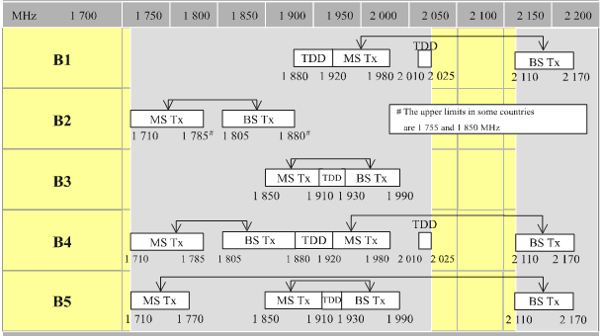

Source: ITU

In bands 1710-2025 MHz and 2110-2200 MHz three basic frequency arrangements (B1, B2 and B3) are already in use by public mobile cellular systems including IMT. Based on these three arrangements, different combinations of arrangements are recommended as described in B4 and B5.

Frequency arrangements in the band 2300-2400 MHz and 2500-2690 MHz are summarised in Figure E.3.

Figure E.3: Frequency arrangements in the 2300-2400 and 2500-2690 MHz bands





Source: ITU

Table E.2 and Figure E.4 below describe frequency arrangements for the band 3400 to 3600 MHz.

Table E.2: Frequency arrangements in the 3400 to 3600 MHz bands

|  |  |  |  |  |  |  |
| --- | --- | --- | --- | --- | --- | --- |
| Frequency arrangements | Paired arrangements | | | | Un-paired arrangements  (e.g. for TDD) (MHz) | |
| **Mobile station transmitter (MHz)** | **Centre gap (MHz)** | **Base station transmitter (MHz)** | **Duplex separation (MHz)** |
| **F1** |  |  |  |  | 3400 - 3600 |
| **F2** | 3410 - 3490 | 20 MHz | 3510-3590 | 100 MHz | None |

Figure E.4: Frequency arrangements in the 3400-3600 MHz band

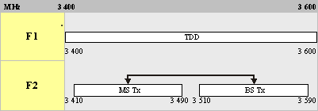

Source: ITU

# Appendix F

# Foreign regulator estimates of spectrum needed for mobile services

Foreign markets and regulators are also grappling with forecasting the quantum of spectrum needed for wireless services in the future given the significant -uptake in demand. In three major studies in 2011, regulators in the United States, Australia and the United Kingdom carried out analysis to determine the amount of spectrum that is needed in their markets for wireless broadband services.[80]

Such analysis challenges the ITU spectrum demand forecasts principally because the ITU-R report did not provide an easily applied methodology for particular countries to apply to their individual country circumstances. Furthermore, technical change in the past four years has been rapid and further advancements in wireless technology in the period from now until 2020 need to be taken account of.

The **first study** is from the United States. In last year’s FCC Staff Technical Paper entitled *Mobile Broadband: The Benefits Of Additional Spectrum,* October 2010[81] it was concluded that mobile broadband services are experiencing significant growth, driven by consumer demand for mobile data and that even with substantial investment, it is likely that mobile data demand will exhaust spectrum resources within the next five years. As existing US spectrum allocations are currently comparatively low, the paper goes on to state that a spectrum deficit approaching 300 MHz is likely by 2014, and that the benefit of releasing additional spectrum is likely to exceed USD 100 billion.

The current US focus seems to be on releasing 120 MHz of additional frequency from the UHF and VHF television bands for wireless broadband. To this end the FCC asked to look at more spectrally efficient ways of providing the distribution of TV broadcast services using wireless broadband. This resulted in a paper for Ericsson that digital TV broadcasting, which in the US utilises 300MHz of spectrum, could be delivered over LTE networks using Multimedia Broadcast/Multicast Service (MBMS) technology in just 28 per cent of this spectrum.[82]

The **second study** is from the United Kingdom. In February 2011, consultants Real Wireless prepared a Study entitled *Report for Ofcom: 4G Capacity Gains*[83]for the UK telecommunications regulator, Ofcom, on issues associated with the capabilities and potential of 4G technologies as well as topological improvements to wireless networks that will be necessary to expand supply in the medium term.

Ofcom initiated the study as the exponential growth in mobile broadband penetration had prompted it to examine and which necessary rectify growing capacity concerns associated with the use of scarce spectrum.

The study makes a number of significant observations about the spectral efficiency of 4G technologies over 2G and 3G services. It queries previous studies on 4G network-capacity improvements over 3G which it considers which rely heavily on the accuracy of forecasting models. In contrast they emphasise the importance of network topology to improving capacity. They consider that this would take the form of more numerous cells, smaller cells and wireless offloading techniques. In overall terms, the consultants detail a strong case for LTE as the most spectrum efficient technology as detailed in Table F1 below.

Table F1: Real wireless findings for spectrum efficiency for 3G and 4G network   
in ITU Urban macrocell test case[84]

|  |  |  |  |  |  |  |  |  |  |
| --- | --- | --- | --- | --- | --- | --- | --- | --- | --- |
|  | WCMA (Rel-99) | HSPA (R5) | HSPA (R6) | HSPA+ (R7) | LTE (R8) | LTE-A (R10) | WiMAX (Rel-1) | WiMAX (Rel1.5) | WiMAX (Rel-2) |
| **Low end** | 0.19 | 0.28 | 0.41 | 0.41 | **1.12** | **2.09** | 0.83 | 1.17 | 2.03 |
| **Typical** | 0.19 | 0.45 | 0.68 | 0.68 | **1.32** | **2.60** | 1.18 | 1.41 | 2.41 |
| **High end** | 0.19 | 0.50 | 0.76 | 1.13 | **2.08** | **5.44** | 1.60 | 2.60 | 4.31 |

**In the third study, i**n May 2011, the Australian Media and Communications Authority (ACMA) published two papers, *‘Towards 2020 – Future spectrum requirements for mobile broadband’* and *‘The 900 MHz band – Exploring Opportunities’*,[85] that outlined possible approaches to effectively meet growing demand for mobile broadband. ACMA predicts an enormous 500x increase in data demand from 2007 to 2020 with nearly 1100 MHz of spectrum being estimated to be required to meet demand. In Australia, additional spectrum as detailed in Table F.2 has been earmarked for mobile broadband services to address this spectrum demand.

Figure F.2: Preferred wireless broadband and possible uses for candidate bands

|  |  |
| --- | --- |
| Band | Possible Uses |
| 850 MHz | • LTE / LTE Advanced |
| 1.5 GHz | • W-CDMA – HSPA / HSPA+  • LTE / LTE Advanced  • WiMAX TDD/FDD |
| Mobile Satellite | • Embargo in place. Prevents applications for apparatus licences for fixed and mobile services in 1980-2010 MHz and 2170-2200 MHz bands |
| 1675-1710 MHz | • Will monitor FCC’s progress. Indication that Met Sat services will be significantly affected by introduction of mobile broadband in this band. |
| 2010-2025 MHz | • LTE / LTE Advanced  • W-CDMA – HSPA / HSPA+ |
| 3.3 GHz | • FDD  • TDD |
| 3.4 GHz | • WiMAX FDD/TDD  • LTE / LTE Advanced |
| 3.8 GHz | • WiMAX FDD/TDD  • WiFi (TDD)  • LTE / LTE Advanced |
| 4.2 GHz + | • Considering bands between 4.2 – 6 GHz  • This spectrum is suited for in-home services and Femtocell offloading. |

# List of acronyms and abbreviations

3GPP The 3rd Generation Partnership Project

ACMA Australia Communications and Media Authority

APT Asia Pacific Telecommunity

ARFM Authority of Radio Frequency Management, Viet Nam

ARPU Average Revenue per User

AWS Advanced Wireless Services

BWA Broadband Wireless Access

EGAN 3GPP Enhanced Generic Access Network

FCC US Federal Communications Commission

FDD Frequency Division Duplexing

GCF Global Certification Forum

GPRS General Packet Radio Service

GSM Global System Mobile

HetNets Heterogeneous Networks

HSPA High Speed Packet Access

ITU International Telecommunication Union

ITU-R ITU Radiocommunication Sector

IWLAN Interworking Wireless LAN

LTE Long Term Evolution

M2M Machine to Machine

MBMS Multimedia Broadcast/Multicast Service

MDGs Millennium Development Goals

MIC Ministry of Information and Communications of the Socialist Republic of Viet Nam

MVNO Mobile Virtual Network Operator

OOB Out-of-band

PPP Public private partnership

PSTN Public Switched Telephone Network

RAN Radio Access Network

RLANS Radio Local Area Networks

SMS Short Message Service

SON Self Organising Network

TDD Time Division Duplexing

UMA Unlicensed Mobile Access

UMTS Universal Mobile Telecommunications System

VNTA Viet Nam Telecommunications Authority

WBB Wireless Broadband

W-CDMA Wideband Code Division Multiple Access

Wi-Fi Wireless Fidelity

WiMAX Worldwide Interoperability for Microwave Access

WRC-07 World Radiocommunications Conference 2007

WRC-12 World Radiocommunications Conference 2012

WRC-15 World Radiocommunications Conference 2015 (scheduled)

1. Although, such services will also require significant fixed network infrastructure in terms of optical fibre backhaul and international submarine capacity.
2. See [www.asean.org](http://www.asean.org)
3. See [www.unohrlls.org/](http://www.unohrlls.org/)
4. See [www.mic.gov.vn](http://www.mic.gov.vn)
5. See [www.vnta.gov.vn](http://www.vnta.gov.vn)
6. [www.broadbandcommission.org/Documents/Broadband_Challenge.pdf](http://www.broadbandcommission.org/Documents/Broadband_Challenge.pdf)
7. Christine Zhen-Wei Qiang and Carlo M. Rossotto with Kaoru Kimura, Chapter 3 Economic Impacts of Broadband, in World Bank, Information and Communication for Development 2009: Extending Reach and Increasing Impact (IC4D2009).
8. Windsor Place Consulting, A high level cost benefit analysis of Malaysia’s broadband deployment, Melbourne, 17 December 2007
9. Booz & Company “*Digital Highways: The Role of Governments in 21st Century Infrastructure* (2009)
10. See [www.un.org](http://www.un.org)
11. See [www.unesco.org](http://www.unesco.org)
12. These are namely: (1) Eradicate extreme poverty and hunger; (2) Achieve universal primary education; (3) Promote gender equality and empower women; (4) Reduce child mortality; (5) Improve maternal health; (6) Combat HIV / AID, malaria and other diseases; (7) Ensure environmental sustainability; and (8) Develop a global partnership for development.
13. <http://mdgs.un.org/unsd/mdg/News.aspx?ArticleId=59>
14. <www.broadbandcommission.org/about/overview.aspx>
15. [www.broadbandcommission.org/Reports/Report_2_Executive_Summary.pdf](http://www.broadbandcommission.org/Reports/Report_2_Executive_Summary.pdf)
16. *Ibid.*
17. *Ibid.*
18. [www.broadbandcommission.org/Documents/Broadband_Challenge.pdf](http://www.broadbandcommission.org/Documents/Broadband_Challenge.pdf)
19. [www.itu.int/net/pressoffice/backgrounders/general/pdf/5.pdf](http://www.itu.int/net/pressoffice/backgrounders/general/pdf/5.pdf)
20. [www.aseansec.org/documents/ASEAN%20ICT%20Masterplan%202015.pdf](http://www.aseansec.org/documents/ASEAN%20ICT%20Masterplan%202015.pdf)
21. The boundaries and names shown and the designations used on this map do not imply official endorsement or acceptance by the ITU.
22. Thien Vinh, *Vietnam Business since joining the WTO*, 2011, page 121
23. [www.adb.org/Documents/Books/Key_Indicators/2011/pdf/VIE.pdf](http://www.adb.org/Documents/Books/Key_Indicators/2011/pdf/VIE.pdf)
24. [www.imf.org/external/pubs/ft/weo/2011/02/pdf/text.pdf](http://www.imf.org/external/pubs/ft/weo/2011/02/pdf/text.pdf)
25. [www.adb.org/Documents/Books/Key_Indicators/2011/pdf/VIE.pdf](http://www.adb.org/Documents/Books/Key_Indicators/2011/pdf/VIE.pdf)
26. *Ibid.* 
27. See *World Bank: Broadband in Vietnam: Forging its own Path*, 2011
28. MIC, *Viet Nam Information and Communications Technology Whitebook* 2011
29. These 17 economies are: Anguilla, Finland, Maldives, Kuwait, St Kitts and Nevis; Oman, Russia, Surinam, Libya, Vietnam, Cayman Islands, Antigua and Barbuda, Panama, Montenegro, Saudi Arabia, Hong Kong (China), and Macao (China). Source: Report ITU-R M.2243 – (11/2011): Assessment of the global mobile broadband deployments and forecasts for IMT. Available at: [www.itu.int/pub/R-REP-M.2243-2011](http://www.itu.int/pub/R-REP-M.2243-2011)
30. Available at: [*www.itu.int/ITUD/asp/CMS/Events/2010/IMT/S5_Mr_LeVanTuan.pdf*](http://www.itu.int/ITUD/asp/CMS/Events/2010/IMT/S5_Mr_LeVanTuan.pdf)
31. For more information see [www.infodev.org/en/Document.1127.pdf](http://www.infodev.org/en/Document.1127.pdf)
32. Viet Nam Information and Communications Technology: White Book, 2011, and *info*Dev: Broadband in Vietnam: Forging its own Path, 2011 ([www.infodev.org/en/Document.1127.pdf](http://www.infodev.org/en/Document.1127.pdf))
33. UBS Investment Research, *Asia Telecom Sector: LTE Implications for Asian Mobile operators*, 25 June 2009.
34. See <http://english.mic.gov.vn/ICTcountry/news/Trang/Vietnammobilesubscribersgainsmorethan116million.aspx>
35. This has been achieved despite carriers operating in a price-sensitive market where the vast majority of subscribers (over 85 per cent) are prepaid.
36. See [www.asymco.com/2011/12/13/global-smartphone-penetration-below-10/](http://www.asymco.com/2011/12/13/global-smartphone-penetration-below-10/)
37. See [www.wirelessintelligence.com/analysis/2011/07/smartphones-spark-mobile-internet-boom-in-vietnam](http://www.wirelessintelligence.com/analysis/2011/07/smartphones-spark-mobile-internet-boom-in-vietnam)
38. Nielsen, *Mobile Youth Around the World*, December 2010.
39. Extracted from World Bank: *Broadband in Vietnam: Forging its own Path*, 2011, page 18
40. [www.itu.int/ITU-D/treg/Events/Seminars/GSR/index.html](http://www.itu.int/ITU-D/treg/Events/Seminars/GSR/index.html)
41. Refer to the list of ITU-R Recommendations on IMT at [www.itu.int/ITU-R/index.asp?category=information&rlink=imt-advanced-rec&lang=en](http://www.itu.int/ITU-R/index.asp?category=information&rlink=imt-advanced-rec&lang=en). Harmonised frequency plans are contained in ITU-R Recommendation M.1036-4 (March 2012).
42. The new 4G licences for 250 MHz of new bandwidth to be auctioned by Ofcom in the first half of 2012 will be technology neutral.
43. For example, the Personal communications Services licences whereby the licensee is free for the most part to provide any service – fixed, mobile, private, common carrier, etc. and is free to use any technology to do so.
44. "Technological neutrality" means applying no constraints or prescriptions on choices of technology or equipment, within the bounds of compatibility and interference avoidance. "Service neutrality" means the spectrum holder can choose what service to offer using its spectrum rights.
45. In-band interference can be caused over large distance by co-channel (same frequency) emissions from transmitters operated under area-adjacent apparatus or radio frequency spectrum licences.
46. Out-of-band interference occurs when transmitters and receivers operate close together in terms of the two main variables that determine their degree of isolation from each other: distance and/or frequency separation.
47. There is no uniform definition on what constitutes MVNO. According to ITU, the term mobile virtual network operator (MVNO) is defined as "*an operator that offers mobile services but that does not own its own radio frequency".* MVNOs are basically resellers who do not own any telecommunications infrastructure or spectrum, purchase airtime at wholesale rates from mobile network operators and resells wireless subscriptions (and other value added services) under its own brand to the subscribers. MVNOs today have however gone beyond a simple reseller to being a full or "heavy" MVNO capable of providing a compelling mix of service to end users.
48. See [www.axiata.com](http://www.axiata.com)
49. See <http://axiata.listedcompany.com/newsroom/Ann__Dec_10_.pdf> and <http://announcements.bursamalaysia.com/EDMS/annweb.nsf/8b25383a269fcce548256d79001af770/482568ad00295d0748257364000627ab/$FILE/Ann(Sept%2028).pdf>
50. [www.gsacom.com//downloads/charts/GSM_market_share_global.php4](http://www.gsacom.com//downloads/charts/GSM_market_share_global.php4)
51. [www.gsacom.com/news/gsa_fastfacts.php4](http://www.gsacom.com/news/gsa_fastfacts.php4)
52. The 3rd Generation Partnership Project (3GPP) is collaboration between groups of telecommunications associations, to make a globally applicable third generation 3G mobile phone system specifications within the scope of the IMT-2000 project of ITU. 3GPP specifications are based on evolved GSM specifications. 3GPP standardization encompasses Radio, Core Network and Service architecture. See [www.3gpp.org](http://www.3gpp.org) and for LTE specifically see [www.3gpp.org/article/lte](http://www.3gpp.org/article/lte)
53. 3GPP is setting the Release 11 requirements in 2011 with its completion scheduled for late 2012.
54. ITU, *IMT-Advanced standards announced for next-generation mobile technology*, media release, 18 January 2012
55. [www.gsacom.com/news/gsa_fastfacts.php4](http://www.gsacom.com/news/gsa_fastfacts.php4) and [www.electronics-eetimes.com/en/lte-subscribers-to-account-for-10-percent-share-by-2015.html?cmp_id=7&news_id=222910064](http://www.electronics-eetimes.com/en/lte-subscribers-to-account-for-10-percent-share-by-2015.html?cmp_id=7&news_id=222910064)
56. www.fiercewireless.com/story/wimax-forum-trumpets-20m-global-subscribers/2011-08-17 and [www.eweek.com/c/a/Enterprise-Networking/Mobile-WiMax-Subscribers-to-Reach-59-Million-by-2015-Report-442841/](http://www.eweek.com/c/a/Enterprise-Networking/Mobile-WiMax-Subscribers-to-Reach-59-Million-by-2015-Report-442841/)
57. GSA, *GSM/3G Market/Technology Update,* 5 January 2012.
58. For the purposes of this paper we do not assess another data offload technique/technology known as Integrated Mobile Broadcast (iMB). iMB which a mobile wireless technology that enables broadcast of content has not been broadly embraced and is unlikely to be utilised in Asia.
59. Wi-Fi is the marketing-friendly term for the 802.11 family of wireless networking standards. It got its start with 802.11b with a data-transfer speed of 11 Mbit/s. Next came 802.11g at 54 Mbit/s, then the present fastest standard, 802.11n has a top speed of 450 Mbit/s.
60. In mid-2009, the Femto Forum released a research paper which found that the cost savings associated with offloading as little as 1.4GB of HSPA data per month via a femtocell from macro cellular network would justify an operator offering a subscriber a free femtocell.
61. Informa, *Learning from the Femtocell and Wi-Fi Pioneers: Best practice in operator go-to- market strategy, Webinar*, 18 May 2011
62. In so far as the Radio Regulations are concerned, the frequency band 698-790 MHz has allocation for IMT in Region 2 and in 9 countries in Region 3 namely Bangladesh, China, Rep. of Korea, India, Japan, New Zealand, Papua New Guinea, Philippines and Singapore. The band 790-862 MHz has allocation for IMT in Region 1 and 3. Having said that, WRC-12 made allocations for Region 1 in the band 694-790 refer to the Footnote ADD 5.3XX in the Final Acts for the WRC-12.
63. See March 2012 version at: [www.itu.int/rec/R-REC-M.1036-4-201203-I/en](http://www.itu.int/rec/R-REC-M.1036-4-201203-I/en)
64. See ITU-R Report M.2078 *Estimated spectrum bandwidth requirements for the future development of IMT-2000 and IMT-Advanced*, 2007
65. However, it ought to be noted that those advanced countries are expanding the allocations to wireless broadband services to an aggregate spectrum total of 1,000 MHz and above.
66. For example, recent trials by Singtel Optus in Australia of the 700MHz spectrum found that it deliver LTE coverage over a distance twice that achievable using 1800MHz.

    The Singtel Optus 700MHz trial saw peak upload speeds of 32Mbps, and demonstrated LTE coverage at some 13 kilometres from a single tower, compared to around 3-6 kilometres over currently available 1800MHz spectrum. See Communications Day, 19 March 2012.
67. See comments of Mr Brian Miller, General Manager, Spectrum management and Policy, Telstra regulatory affairs, at the ACMA Radio Communications Conference 2011, Sydney, 26 May 2011. Press reports available at [www.theaustralian.com.au/australian-it/telecommunications/telstra-forecasts-mobile-broadband-spectrum-needs/story-fn4iyzsr-1226063451605](http://www.theaustralian.com.au/australian-it/telecommunications/telstra-forecasts-mobile-broadband-spectrum-needs/story-fn4iyzsr-1226063451605)
68. See Ericsson, White paper, *More than 50 billion connected devices*, February 2011.
69. Please refer to Appendix F.
70. See [www.aftrs.edu.au](http://www.aftrs.edu.au)
71. <http://news.xinhuanet.com/english/business/2012-01/09/c_131350873.htm>
72. [Viet Nam 2007-10 Digital Content Policy](https://docs.google.com/viewer?a=v&q=cache:NkkhP123HEEJ:english.mic.gov.vn/vbqppl/Lists/Vn%20bn%20QPPL/Attachments/6173/111058420.pdf+program+on+development+of+vietnam's+digital+content+industry+to+2010&hl=en&pid=bl&srcid=ADGEEShwzXNGM1nZbTj1KMeBGTkkH5)
73. E-government Web measure index measures the level of sophistication of a government’s online presence based on four stages of e-government evolution: emerging presence, enhanced presence, transactional presence, and connected presence. A value of 0 indicates the lowest presence, a value of 1 the highest. Data listed for 2009 are for 2010. (United Nations Department of Economic and Social Affairs and United Nations Public Administration Network)
74. See [www.idc.com/about/viewpressrelease.jsp?containerId=prVN22661111](http://www.idc.com/about/viewpressrelease.jsp?containerId=prVN22661111)
75. FCC, Notice of Inquiry, *Annual Report and Analysis of Competitive Market Conditions With Respect to Mobile Wireless including Commercial Mobile Services*, Docket FCC 09-67, released 27 August 2009, page 2
76. Consideration should also be given to facilitating the manufacture of wireless broadband technologies including both network and devices in Viet Nam but such issues are not covered in this report.
77. See also www.aseansec.org/documents/ASEAN%20ICT%20Masterplan%202015.pdf
78. http://moj.gov.vn/vbpq/en/Lists/Vn%20bn%20php%20lut/View_Detail.aspx?ItemID=10749
79. [www.itu.int/rec/R-REC-M.1036-4-201203-I/en](http://www.itu.int/rec/R-REC-M.1036-4-201203-I/en)
80. The German regulator the Bundesnetzagentur has also released (on 6 July 2011) papers assessing further spectrum needs as part of its review of the current allocation of existing 900 and 1800 MHz spectrum. See [www.bundesnetzagentur.de/SharedDocs/Downloads/EN/BNetzA/PressSection/PressReleases/2011/110706FrequencyUse.pdf?__blob=publicationFile](http://www.bundesnetzagentur.de/SharedDocs/Downloads/EN/BNetzA/PressSection/PressReleases/2011/110706FrequencyUse.pdf?__blob=publicationFile).
81. This was preceded by a Wireless Association in the USA (CTIA) study which estimated in 2009, that the US needs at least 800 MHz of additional bandwidth for mobile broadband services within the next six (6) years.
82. See Ericsson, 2011 IEEE International Symposium on Dynamic Spectrum Access Networks (DySPAN), *Spectrum Requirements for TV Broadcast Services using Cellular Transmitters*, Available at [www.ericsson.com/res/thecompany/docs/journal_conference_papers/wireless_access/p22-huschke.pdf](http://www.ericsson.com/res/thecompany/docs/journal_conference_papers/wireless_access/p22-huschke.pdf)
83. Version 1.5, 27 January 2011
84. See page 11
85. ACMA states that the 900 MHz band is identified as premium spectrum due to its ability to carry signals over long distances and penetrate walls. Presently, the band is being used for a variety of services including CMTS, digital CMTS (GSM), point-to-point and land mobile.