|  |  |
| --- | --- |
| **Radiocommunication Study Groups** |  |
|  |  |
|  |  |
| Source: Document 5D/TEMP/420(Rev.1) |  |
| **23 October 2017** |
| **English only** |
| Working Party 5D | |
| AN OPEN-SOURCE IMPLEMENTATION OF  RECOMMENDATION ITU-R M.2101 | |
|  | |

# 1 Introduction

Agenda item 1.13 of WRC-19 considers the identification of frequency bands between 24.25‑86 GHz for the future development of International Mobile Telecommunications (IMT).

Resolution **238 (WRC-15)** invites ITU-R to conduct sharing and compatibility studies to support eventual identification of IMT in these bands. Administrations are also invited to submit contributions to ITU-R and participate actively in these studies.

Under this scope, the modelling and simulation of IMT networks and systems for use in sharing and compatibility studies should be based on the methodology contained in Recommendation ITU-R M.2101 “*Modelling and simulation of IMT networks and systems for use in sharing and compatibility studies*”, under the responsibility of Study Group 5.

This information document presents an example of open-source implementation of Recommendation ITU-R M.2101 that can be used in the sharing and compatibility studies that have been conducted by Task Group 5/1. This implementation is a free software, which means that users are free to run, copy, distribute, study, change and make improvements. No sharing study is presented in this contribution, although the software can already be used to support studies between IMT and FSS, for example. Instead, IMT system modelling is briefly described and some IMT performance indicators are shown for the sake of comparison with other implementations. The tool is available on the Working Party 5D SharePoint [website](http://www.itu.int/en/ITU-R/study-groups/rsg5/rwp5d/Pages/default.aspx).

# 2 The open source simulation tool

In order to contribute actively with ITU-R studies, the Spectrum, Orbit and Broadcasting Division of the Brazilian National Telecommunication Agency (ANATEL) has been leading a collaborative project for the development of an open-source simulation tool called SHARC (simulator for SHARing and Compatibility studies). This is a free software that complies with the framework proposed by Recommendation ITU-R M.2101 for modelling and simulation of IMT systems.

The focus of this simulator is the modeling of IMT systems, taking into account several characteristics of these systems such as: heterogeneous networks, antenna beamforming, distribution of base stations and user equipments, power control, resource-blocks allocation, and other parameters.

This simulation tool can be used to support sharing and compatibility studies between IMT and other radiocommunication services or systems, like fixed-satellite service (FSS), high-altitude platform system (HAPS), fixed point-to-point links, among others.

SHARC is a free software licensed under the GNU Affero General Public License v3.0 (AGPL‑3.0), which means that the users have the freedom to run, copy, distribute, study, change and improve the software.

The participation on the simulator development project does not require any financial commitment and so far the project has received many valuable contributions from local universities and independent entities.

The programming language that was chosen for the simulation development was Python and the source code is hosted in GitHub (<https://github.com/SIMULATOR-WG/SHARC>). Instructions on how to configure the development environment and run simulations are also available on simulator’s web page in GitHub.

# 3 Simulator development methodology

A Scrum-based methodology is adopted for the development of the software. The resources provided by GitHub platform may be used to manage the implementations of the features, to report bugs and to manage the overall software development.

In order to ensure software quality, different kinds of tests are taken, including:

– unit tests: classes are individually tested using the Python’s unit-test framework;

– benchmarking of individual modules: plots are created to individually validate and verify the implementation of modules (ex.: plot and antenna pattern and compare with a reference plot that is provided by an ITU-R recommendation);

– integration tests: once modules are individually tested and verified, their integration is tested to ensure that communication works properly. In some cases, a single snapshot of a simplified network is performed;

– benchmarking of reference results: simulation results of SHARC can be compared with results provided by other implementations.

# 4 Simulation parameters

This section presents simulation parameters for a reference urban macro scenario. This is only one of the possible scenarios that can be easily configured in the simulator through the appropriate input parameters.

## 4.1 Network topology

The considered network topology is urban macro, where 3-sector base stations (BS) are deployed in fixed positions on a regular grid. The user equipment (UEs) are distributed within the sector coverage area and the distance between a BS and UE is modelled by a Rayleigh distribution with scale parameter $σ_{d}=32 m$. The azimuth between them follows a normal distribution, truncated within the $±60°$ range, with mean $μ_{a}=0°$ and standard deviation $σ_{a} =30°$. Elevation angles of user equipment are assumed to be uniformly distributed within the ±90° range. Azimuth angles that define UEs orientation range between -60° and 60° in the direction of the base station. Figure FIGURE 1 shows an example of the IMT network topology.

FIGURE 1

IMT network topology

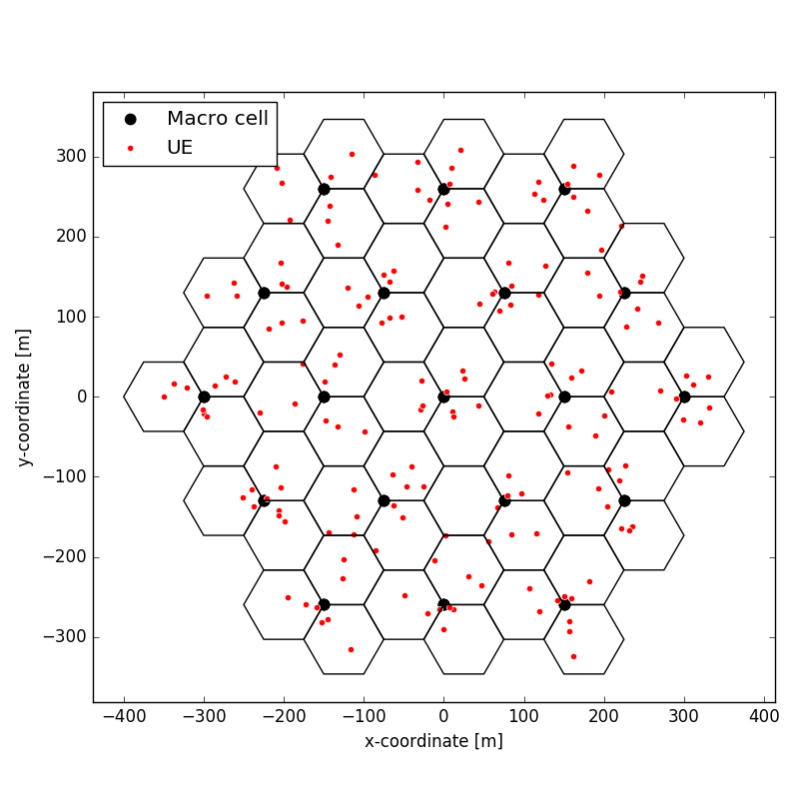

## 4.2 Antenna beamforming

Both IMT base stations and user equipments use antenna beamforming according to the model provided in Recommendation ITU-R M.2101. This model consists of several identical radiating elements in the yz-plane, having the same individual radiation pattern and with a certain separation distance. The beam direction is calculated by a weighting function. Figure 2 shows examples of 8×8 and 4×4 antenna arrays that are used by base stations and user equipment, respectively.

FIGURE 2

IMT base station and user equipment antenna patterns

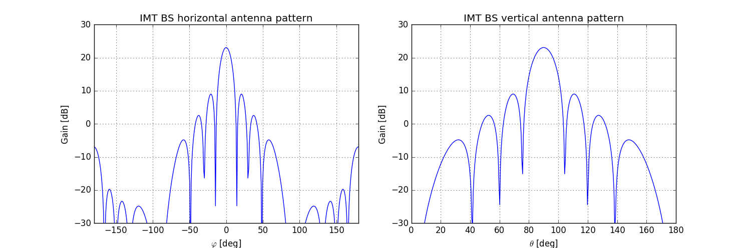

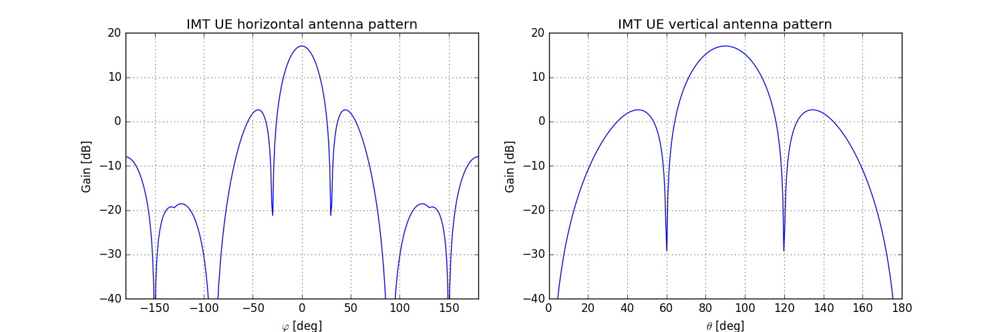

## 4.3 Simulation parameters

Table 1 summarizes the simulation parameters, including the parameters of the path loss model that was used in this case.

TABLE 1

Simulation parameters

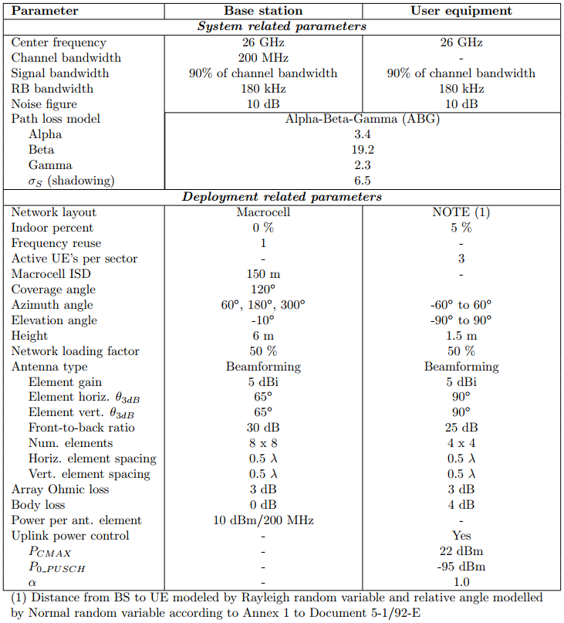

# 5 Simulation results

This section presents some IMT key performance indicators for the simulation scenario described in the previous sections. These results are comparable with the ones provided by other independent implementations and previously presented in Document 5D/645, here attached.



## 5.1 IMT downlink results

FIGURE 3

CDF of base station antenna gain towards user equipment

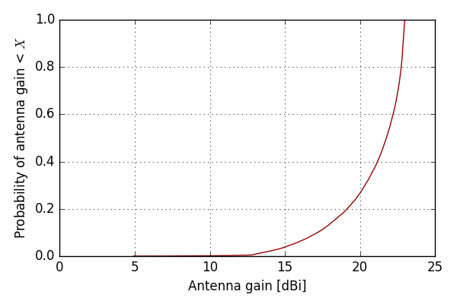

FIGURE 4

CDF of downlink SNR

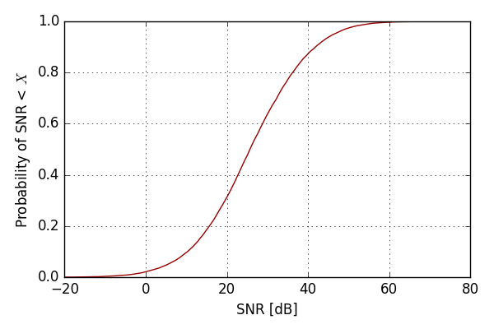

FIGURE 5

CDF of downlink SINR

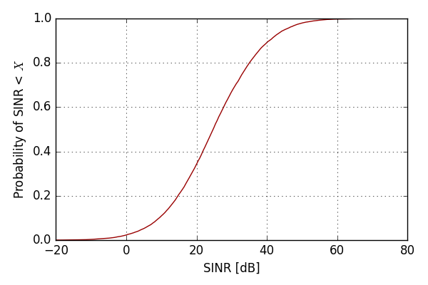

## 5.2 IMT uplink results

FIGURE 6

CDF of user equipment antenna gain towards base station

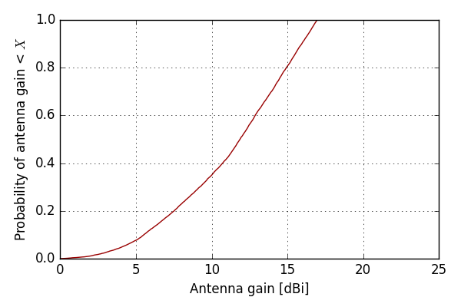

FIGURE 7

CDF of user equipment transmit power

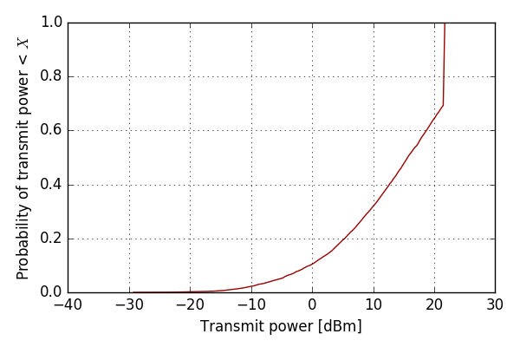

FIGURE 8

CDF of uplink SINR

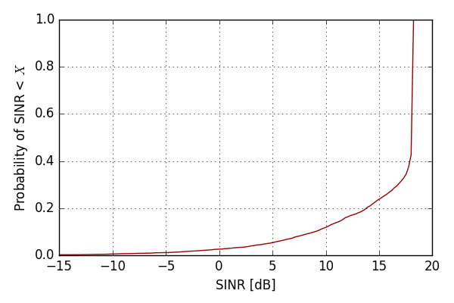

# 6 Conclusions

This document presents an open-source implementation of Recommendation ITU-R M.2101. Since it is a free software, users have freedom to run the program as they wish, as well as study the source code and make changes. Some IMT results indicate that this simulator provides results which are comparable with the ones provided by other implementations.

**Contact:** Questions about this open-source implementation can be raised to Mr. Edgar Souza ([edgar@anatel.gov.br](mailto:edgar@anatel.gov.br)).

Disclaimer: this open-source implementation tool is provided “AS IS” WITH NO WARRANTIES, EXPRESS OR IMPLIED, INCLUDING BUT NOT LIMITED TO, THE WARRANTIES OF MERCHANTABILITY, FITNESS FOR A PARTICULAR PURPOSE AND NON-INFRINGMENT OF INTELLECTUAL PROPERTY RIGHTS and neither the Developer (or its affiliates) nor the ITU shall be held liable in any event for any damages whatsoever (including, without limitation, damages for loss of profits, business interruption, loss of information, or any other pecuniary loss) arising out of or related to the use of or inability to use this tool.

______________