Telecommunication Standardization
Bureau
Geneva, 2 May 2012

Ref:  Tel:  Fax: | TSB Circular 277  +41 22 730 6828  +41 22 730 5853 | - To Administrations of Member States of the Union;  - To ITU-T Sector Members;  - To ITU-T Associates;  - To ITU-T Academia;
E-mail: | tsbdir@itu.int | Copy:  - To the Chairmen and Vice-Chairmen of ITU-T Study Groups;  - To the Chairmen and Vice-Chairmen of ITU-R WP 5A and ITU-R WP 5D;  - To the Director of the ITU Radiocommunication Bureau;  - To ISO TC 204, ISO TC 22, ARIB, ATIS, CCSA, ETSI, IEEE, ISACC, SAE, TIA, TTA, TTC, UNECE.

Subject: | Collaboration on ITS Communication Standards meeting  Unterschleissheim/Munich (Germany), 26 June 2012

Dear Sir/Madam,
It is my pleasure to invite you to the third meeting of the Collaboration on ITS (Intelligent Transport Systems) Communication Standards on Tuesday, 26 June 2012 at BMW Training Academy in Unterschleissheim/Munich, Germany, at the kind invitation of BMW. This meeting will be collocated with the fifth meeting of the Focus Group on Driver Distraction (27-28 June 2012).
The intent of the Collaboration is to provide a globally recognized forum for the creation of an internationally accepted, globally harmonized set of ITS communication standards of the highest quality in the most expeditious manner possible to enable the rapid deployment of fully interoperable ITS communication-related products and services in the global marketplace.
Participation in the Collaboration is open to:
- representatives of ITU Member States, Sector Members, Associates and Academia, and any individual from a country which is a member of ITU who wishes to contribute to the work,
- any individual from a national, regional or international SDO who wishes to contribute to the work.
In particular, national, regional and international SDOs are encouraged to participate and to apply to join the Collaboration Management.
The terms of reference of the Collaboration and results of the last meeting are reproduced at http://itu.int/en/ITU-T/extcoop/cits/.
The Collaboration meeting will open at 0930 hours on 26 June 2012. No registration fee is required for participating in this meeting.
Discussions will be held in English only.
Registration: To enable TSB to make the necessary arrangements concerning the organization of the meeting, please register for the Collaboration on ITS Communication Standards meeting
(26 June 2012) via the on-line form available at http://www.itu.int/reg/tmisc/3000399.
Meeting documents: Participants intending to submit a document for discussion at the meeting should send that document using the template available at http://itu.int/en/ITU-T/extcoop/cits/ to tsbcits@itu.int before 20 June 2012. “Late or unannounced” documents will be accepted only with the consensus of the meeting participants, or otherwise deferred to a subsequent meeting.
Remote Participation: You can participate remotely at the Collaboration on ITS Communication Standards meeting. As a remote delegate you will be able to hear discussions, see documents and presentations and interact with the remote meeting host. If you wish to participate as a remote delegate, you need to register in advance at http://www.itu.int/reg/tmisc/3000399. Remote participation instructions will be made available on the Collaboration website.
For your convenience, practical information about the meeting venue and how to reach it is reproduced as Annex 1.
Visa: We would remind you that citizens of some countries are required to obtain a visa in order to enter and spend any time in Germany. The visa must be requested and obtained from the office (embassy or consulate) representing Germany in your country or, if there is no such office in your country, from the one that is closest to the country of departure. Please be aware that visa approval might take time so kindly make your visa request as soon as possible.

Yours faithfully,

Malcolm Johnson
Director of the Telecommunication
Standardization Bureau

Annex: 1

ANNEX 1
(to TSB Circular 277)
Practical Information

- Venue

BMW Trainingsakademie
Röntgenstraße 7
85716 Unterschleissheim
Germany

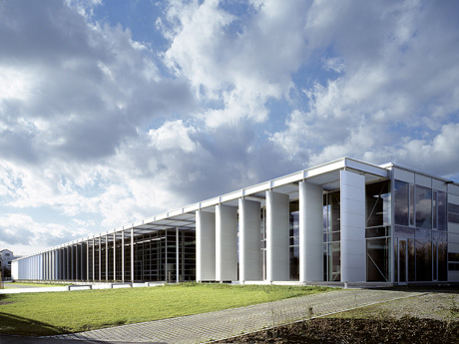

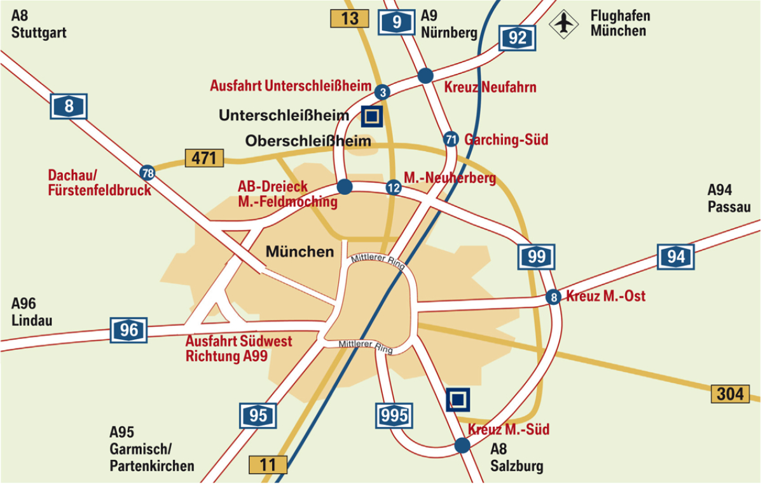

- Public transport

From the airport by train (S-Bahn):
- In the Airport central building (marked with “Z”) take the “S1”-Train -direction Munich - and get off at Unterschleissheim (5th stop, single ticket: 7,50 EURO)
- Then take regional bus 219 B. From the stop Röntgenstrasse it is only a few minutes’ walk to BMW Trainingsakademie or hotel Victor’s or Dolce.
- (Alternatively, take a taxi from the S1-Stop Unterschleissheim)

Alternatively take a taxi from the airport (about 21 km, 20 minutes).
- Hotels

Victor's Residenz-Hotel Munich

Keplerstrasse 14

85716 Unterschleissheim

Tel: +49 (0) 89 / 321 030 9

Fax: +49 (0) 89 / 321 038 99

E-Mail: info.muenchen@victors.de

Website: www.victors.de/deutsch/hotels/hotel/index.php?standort=Muenchen

There is a quota of 20 rooms reserved at this hotel, which is just opposite the Trainingsakademie from the 25th (arrival) until 29th (departure) of June. The reservation quota expires on 15 May 2012.

Single room incl. breakfast: 88 Euro / room / night
Double room incl. breakfast: 118 Euro / room / night

Individual reservation and payment at the hotel is obligatory for the participants.

Another hotel about 400m from the Trainingsakademie is:

Dolce Hotel Munich

Andreas-Danzer-Weg 1

85716 Unterschleissheim

Tel: +49 (0) 89 / 370 530 0

Website: www.dolcemunich.com

Reservation is on your own responsibility
- Restaurants in Unterschleissheim

Sapori

Bezirksstraße 5, Unterschleissheim
Tel: +49 (0) 89 / 321 200 55

www.sapori-m.de

Gasthaus Alter Wirt

Hauptstraße 36, Unterschleissheim
Tel: +49 (0) 89 / 370 734 0
www.alterwirt-ush.de

L´Albatros
Hauptstrasse 40, Unterschleissheim
Tel: +49 (0) 89 / 310 692 6

www.lalbatros.de

Athene
Max-Planck-Strasse 7, Unterschleissheim
Tel: +49 (0) 89 / 310 955 3

www.athene-unterschleissheim.de

Golden Palast
Landshuter Straße 22, Unterschleissheim
Tel: +49 (0) 89 / 370 641 661

www.goldenpalast-ush.de

- Host contact person

Name: Dr Joachim Scholten
E-Mail: Joachim.Scholten@bmw.de
Tel: +49 (0) 89 / 382 323 12
____________

