Telecommunication Standardization
Bureau
Geneva, 4 July 2012

Ref:  Tel:  Fax: | TSB Circular 298  +41 22 730 6828  +41 22 730 5853 | - To Administrations of Member States of the Union;  - To ITU-T Sector Members;  - To ITU-T Associates;  - To ITU-T Academia;
E-mail: | tsbcits@itu.int | Copy:  - To the Chairmen and Vice-Chairmen of ITU-T Study Groups;  - To the Chairmen and Vice-Chairmen of ITU-R WP 5A and ITU-R WP 5D;  - To the Director of the ITU Radiocommunication Bureau;  - To ISO TC 204, ISO TC 22, ARIB, ATIS, CCSA, ETSI, IEEE, ISACC, SAE, TIA, TTA, TTC, UNECE.

Subject: | Collaboration on ITS Communication Standards meeting  Tokyo (Japan), 21 August 2012

Dear Sir/Madam,
It is my pleasure to invite you to the fourth meeting of the Collaboration on ITS (Intelligent Transport Systems) Communication Standards on Tuesday, 21 August 2012 at Shiba kouen Denki Building in Tokyo, Japan, at the kind invitation of Telecommunication Technology Committee (TTC). This meeting will be collocated with the sixth meeting of the Focus Group on Driver Distraction (22-23 August 2012).
The intent of the Collaboration is to provide a globally recognized forum for the creation of an internationally accepted, globally harmonized set of ITS communication standards of the highest quality in the most expeditious manner possible to enable the rapid deployment of fully interoperable ITS communication-related products and services in the global marketplace.
Participation in the Collaboration is open to:
- representatives of ITU Member States, Sector Members, Associates and Academia, and any individual from a country which is a member of ITU who wishes to contribute to the work,
- any individual from a national, regional or international SDO who wishes to contribute to the work.
In particular, national, regional and international SDOs are encouraged to participate and to apply to join the Collaboration Management.
The terms of reference of the Collaboration and results of the last meeting are reproduced at http://itu.int/en/ITU-T/extcoop/cits/.
The Collaboration meeting will open at 0900 hours on 21 August 2012. No registration fee is required for participating in this meeting.
Discussions will be held in English only.
Registration: To enable TSB to make the necessary arrangements concerning the organization of the meeting, please register for the Collaboration on ITS Communication Standards meeting
via the on-line form available at http://itu.int/reg/tmisc/3000430.
Meeting documents: Participants intending to submit a document for discussion at the meeting should send that document using the template available at http://itu.int/en/ITU-T/extcoop/cits/ to tsbcits@itu.int before 14 August 2012. “Late or unannounced” documents will be accepted only with the consensus of the meeting participants, or otherwise deferred to a subsequent meeting.
Remote Participation: You can participate remotely at the Collaboration on ITS Communication Standards meeting. As a remote delegate you will be able to hear discussions, see documents and presentations and interact with the remote meeting host. If you wish to participate as a remote delegate, you need to register in advance at http://itu.int/reg/tmisc/3000430. Remote participation instructions will be made available on the Collaboration website.
For your convenience, practical information about the meeting venue and how to reach it is reproduced as Annex 1.
Visa: We would remind you that citizens of some countries are required to obtain a visa in order to enter and spend any time in Japan. The visa must be requested and obtained from the office (embassy or consulate) representing Japan in your country or, if there is no such office in your country, from the one that is closest to the country of departure. Please be aware that visa approval might take time so kindly make your visa request as soon as possible.

Yours faithfully,

Malcolm Johnson
Director of the Telecommunication
Standardization Bureau

Annex: 1

ANNEX 1
(to TSB Circular 298)
Practical Information
- Venue
TTC
Shiba kouen Denki Building
1-1-12, Shiba kouen, Minato-ku
Tokyo 105-0011, Japan
Tel: +81 3 3432 1551
http://www.ttc.or.jp/e/intro/map/
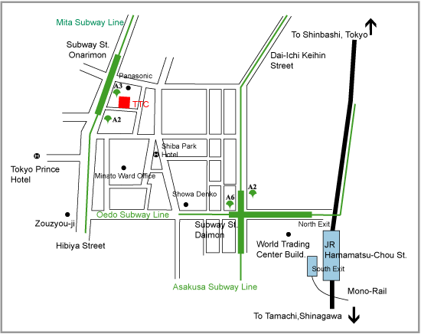
- Transport
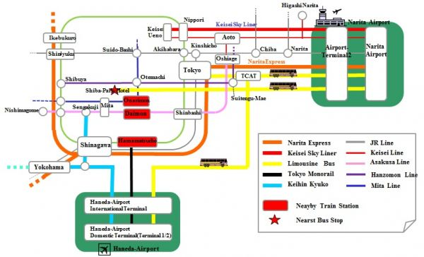

From Narita Airport
- By taxi: Use the map to describe the location of TTC to taxi driver. About JPY 21,950-22,130 plus highway toll, about 50min.

- By limousine bus:
- Narita Airport - Shiba Park Hotel (take Narita Airport - Shiba-Area Bus). JPY 3,000, about 90-145min, 6-8 services/day.
- Narita Airport - Tokyo Station (take Narita Airport - Tokyo Station and Nihonbashi Bus). JPY 3,000, about 75-110min, 2-3 services/hour.
- Narita Airport - TCAT (Tokyo City Air Terminal) (take Narita Airport -TCAT Bus). JPY 2,900, about 60-90min, 3-6 services/day.

- By train:
- JR NaritaExpress (Narita Airport - Tokyo) (Reservation Seat Only). JPY 2,940, about 60min, 2 services/hour.
- Keisei-Skyliner (Narita Airport - Nippori) (Reservation Seat Only). JPY 2,400, about 36min, 1-2 services/hour.
- Keisei commuter train (Narita Airport - Daimon). Take for Haneda Airport, Nishimagome, or Misakiguchi Train. JPY 1,100-1,280, about 80-90min, 2-3 services/hour.

From Haneda Airport
- By taxi: Use the map to describe the location of TTC to taxi driver. About JPY 6,290-6,380 plus highway toll, about 40min.
- By train/monorail:
- Tokyo Monorail (Haneda Airport International Building (Hamamatsucho), JPY 470, about 16min.
- Keikyu-Line (Haneda Airport International Terminal - Daimon). Take train direct to Asakusa-Line (e.g. for Aoto, Inba-Nihonidai, Narita, or Narita-Airport train). JPY 510, about 20-30min.
From Tokyo Station
- By taxi (please use the map to describe the location of TTC to taxi driver) about JPY 1,250 , about 20min.
- By train: JR Yamanote-Line or Keihin Tohoku-Line (Tokyo - Hamamatsucho) direction Shinagawa, etc. JPY 150, about 6min.
From Nippori Station
- By taxi (please use the map to describe the location of TTC to taxi driver) about JPY 3,230, about 30min.
- By train: JR Yamanote-Line or Keihin Tohoku-Line (Nippori-Hamamatsucho) direction Tokyo, Shinagawa, etc. JPY 160, about 17min.
From TCAT
- By taxi (please use this map to describe the location of TTC to taxi driver) about JPY 1,790, about 20min.
- By subway: From Suitengumae Station (Z10) (Directly connected to TCAT) of Tokyo metro Hanzomon Line, direction Shibuya, etc. Exchange to (Toei) Mita Line at Otemachi Station (Z8/I9). Direction Mita, Hiyoshi, Megro, etc. Stop Station Onarimon (I6). JPY 260, about 19min.
- Please note: Commuter Lines will be very crowded in rush hours (7:00-9:30 and 17:00-20:00)
- Airport Access
See http://www.ttc.or.jp/e/intro/airport/
- Hotels
Shiba Park Hotel
Address: 1-5-10 Shiba kouen, Minato-ku, Tokyo. 105-0011
Phone : +81 33433 4141
Fax +81 33433 4142
http://en.shibaparkhotel.com/
Locations of TTC office and Shiba Park Hotel: TTC office is only about 100m to the north from Shiba Park Hotel as shown in the map above.
Tokyo Prince Hotel
Address: 3-3-1 Shiba kouen, Minato-ku, Tokyo. 105-8560
Phone : +81 33432 1111
http://www.princehotels.com/en/tokyo/
Locations of TTC office and Tokyo Prince Hotel: TTC office is only about 100m to the east from Tokyo Prince Hotel as shown in the map above.
- Host contact person
Name: Mr Yukio YAMANAKA, The Telecommunication Technology Committee (TTC)
E-mail: i3cinfo@ttc.or.jp
Tel: +81-3-3432-1551
Fax: +81-3-3432-1553
____________

