مكتب تقييس الاتصالات
 |  | جنيف، 22 أكتوبر 2014
المرجع: | التصويب 1 للرسالة TSB Collective letter 1/SG2RG-ARB
الهاتف:  الفاكس:  البريد الإلكتروني: | +41 22 730 5855  +41 22 730 5853  tsbsg2@itu.int | إلى:  - إدارات الدول الأعضاء في الاتحاد،  - أعضاء قطاع تقييس الاتصالات في الاتحاد،  - المنتسبين إلى قطاع تقييس الاتصالات المشاركين في أعمال لجنة الدراسات 2،  - الهيئات الأكاديمية المنضمة إلى قطاع تقييس الاتصالات،  - المكتب الإقليمي للمنطقة العربية التابع للاتحاد الدولي للاتصالات.
الموضوع: | الاجتماع الثاني للفريق الإقليمي للمنطقة العربية التابع للجنة الدراسات 2 لقطاع تقييس الاتصالات (SG2RG-ARB)، مدينة الكويت (دولة الكويت)، 25 نوفمبر 2014،  من الساعة 14:00 إلى الساعة 15:30
حضرات السادة والسيدات،
تحية طيبة وبعد،
يرجى ملاحظة أن الاجتماع الثاني للفريق الإقليمي للمنطقة العربية التابع للجنة الدراسات 2 لقطاع تقييس الاتصالات (SG2RG-ARB) سوف يعقد في فندق Crowne Plaza Kuwait وليس في فندق Regency Kuwait كما أعلن سابقاً في الرسالة الجماعية لمكتب تقييس الاتصالات 1/SG2RG-ARAB المؤرخة 26 سبتمبر 2014.
وينطبق هذا التعديل أيضاً على الاجتماعات التالية للات‍حاد التي ستعقد في نفس المكان: المنتدى الاقتصادي والمالي الإقليمي للاتصالات/تكنولوجيا المعلومات والاتصالات الذي ينظمه قطاع تنمية الاتصالات للمنطقة العربية، والمنتدى الإقليمي للتقييس الذي ينظمه الاتحاد في المنطقة العربية، واجتماع الفريق الإقليمي للمنطقة العربية التابع للجنة الدراسات 3 لقطاع تقييس الاتصالات (SG3RG-ARB)، واجتماع الفريق الإقليمي للمنطقة العربية التابع للجنة الدراسات 5 لقطاع تقييس الاتصالات (SG5RG-ARB).
وبالتالي، يرجى الاستعاضة عن "الملحق C" بالملحق الوارد أدناه.
وستبقى تواريخ عقد الاجتماعات بدون أي تعديل.
وأرجو أن تقبلوا اعتذارنا إذا كان لهذا التعديل أن يتسبب في أي إزعاج لكم.
وتفضلوا بقبول فائق التقدير والاحترام.
مالكولم جونسون
مدير مكتب تقييس الاتصالات
الملحقات: 1
ANNEX C
(to TSB Collective letter 1/SG2RG-ARB)
Practical information for participants
- Venue
Hotel Regency Kuwait
Al Bida'a, Al Tawoon Street, Salmiya
Email: info@theregencykuwait.com
Telephone: +965 2576 66 66
Fax: +965 2576 69 99
Website: http://www.theregencykuwait.com/default-en.html

2. About Kuwait City
Kuwait City is the capital and largest city of Kuwait. It has a population of 2.38 million in the metropolitan area. Located at the heart of the country on the shore of the Persian Gulf, and containing Kuwait's parliament, most governmental offices, the headquarters of most Kuwaiti corporations and banks, it is the political, cultural and economic center of Kuwait. Kuwait City is considered a Beta - Global city.
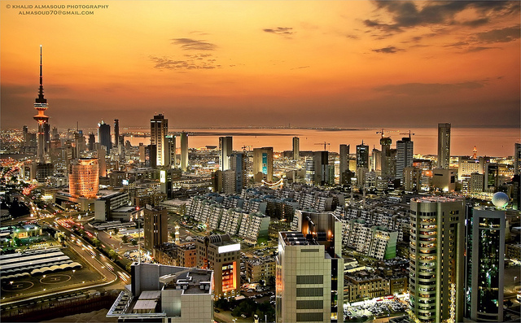
Kuwait City’s trade and transportation needs are served by Kuwait International Airport, Mina Al-Shuwaik (Shuwaik Port) and Mina Al Ahmadi (Ahmadi Port) 50 kilometres (31 miles) to the south, on the Persian Gulf coast. Kuwait City is ranked as one among the 25 largest GDP cities in the world along with New York, Tokyo, Moscow, Mumbai and other financial hubs including Singapore and Dubai.
3. Weather
Kuwait City has a hot desert climate and is one of the hottest cities in summers on earth. Its winters are warm with very little rainfall. Sand storms are quite frequent in mid-year.
The weather in November is moderate and approximate temperatures will vary between 20º-25ºC. Rain frequency does increase around November.
4. Hotel Accommodation
Hotel Regency Kuwait (also meeting venue for the events)
The Regency offers 203 luxurious rooms including 51 suites, as well as the largest meetings and convention facilities in Kuwait. It is a short 15 minute drive from Kuwait’s International Airport and close to the main downtown district of Kuwait City.
The white marble lobby with its 22 meter tall glass atrium offers beautifully landscaped ocean and garden views. This is where families and businessmen gather to sample light refreshments, savor refined pastries and enjoy a selection of gourmet coffees/teas at Regency Gourmet or simply sit on the sun terrace to enjoy The Regency's High Tea and gorgeous vistas.
Shady summer lounge areas are provided in summer and three swimming pools give guests a chance to cool off, while a further two pools are provided exclusively for female guests. In line with Sharia’a ethics, men and women are required to use conservative swimwear in the pools. The Ladies’ Lounge is the only one of its kind in Kuwait and provides a unique all-ladies rendezvous for special events or simply relaxation whether by the pool, in the lounge or by the beautiful beach.
The Regency is well known across Kuwait and the entire Gulf region for its extensive conference and banqueting facilities totalling over 8,000 square meter. A diverse range of meeting rooms are equipped with the latest technology including high speed Wi-Fi. The hotel’s versatility means it is prized for large-scale weddings, high level conferences and social events.
Website: http://www.theregencykuwait.com/default-en.html
Address: Al Bida'a, Al Tawoon Street, Salmiya
Email: info@theregencykuwait.com
Telephone: +965 2576 66 66
Fax: +965 2576 69 99

ROOM TYPE | ROOM RATE
Single Room | 60 KD per night + 15% service + shuttle service from/to the airport

Check In Time: 14:00 hours
Check Out Time: 12:00 noon
Credit Cards Accepted: Visa Card, Master Card, JCB International, American Express, and Diners Club

Recommended hotels location map:

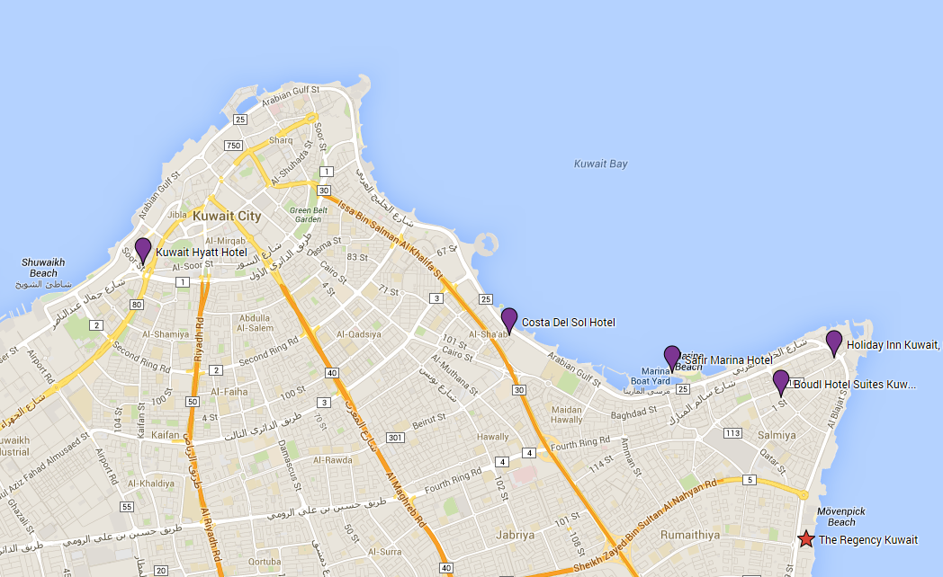

Other Recommended Hotels
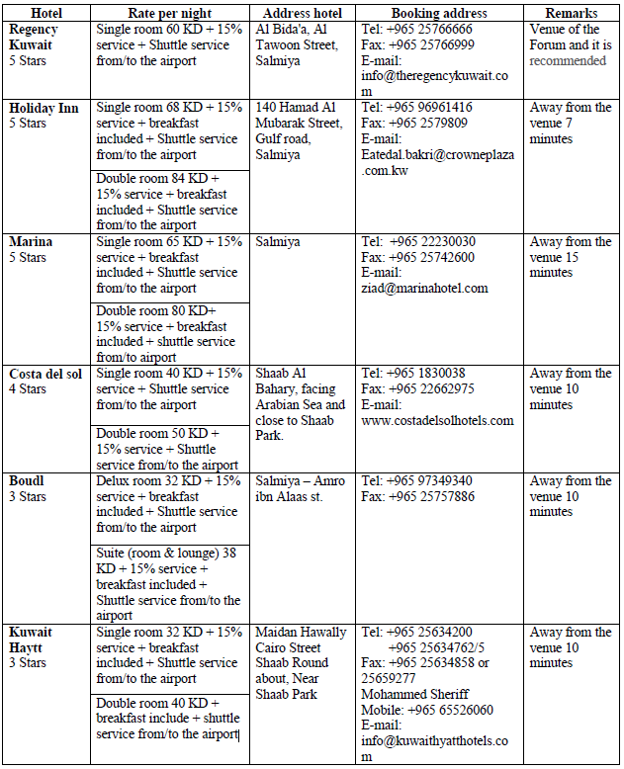

5. Visa Information
A valid passport & visa are required to enter The State of Kuwait except for nationalities from the following countries that will be issued entry permits upon arrival at the airport in the state of Kuwait:
United states of America, New Zealand, Australia, Canada, Germany, France, Luxembourg, Belgium, Netherlands, Japan, Norway, Sweden, Austria, Switzerland, Greece, Ireland, Portugal, Denmark, Vatican, Monaco, Spain, Finland, Tolkhstein, SanMarino, Andorra, Iceland, Hong Kong, Malaysia, Singapore, South Korea, China.

Each participant is requested to consult the Kuwaiti Embassy in his/her country of origin to obtain the visa.
Please note that the invitation letter will be circulated to all Kuwaiti Embassies abroad, in order to facilitate the procedures for obtaining a valid visa, furthermore, you can contact the hotel or the tour company you chose to apply for the visa at the following official website:
http://www.e.gov.kw/MOI_en/Pages/ServiceContent/V2693StateVisit.aspx

Should you have any queries regarding obtaining a valid visa or need further assistance please feel free to contact:

Mr. Ali Alsalem
Public Relations Dept.
Tel: + 965 969 665 04
Fax: +965 249 274 85
E-mail: al.salem@hotmail.com

Very Important Note:
To facilitate the procedures for obtaining a visa, you should send a copy of your passport [data page and validity of the passport page (special visas countries)] and send it at the above mentioned fax and E-mail.

Official Working hours:
Working days: Sunday - Thursday (From 8.00 am to 2.00 pm)
Weekends: Friday & Saturday (holidays)
6. Transportation from Airport to Hotel
In order to secure reception at the airport and transportation to hotels, participants are requested to fill the hotel reservation form (Form 2) and send it to the hotels, which they chose for accommodation.

The Ministry of Communications will provide transportation only from the hotels to the forum's venue and vice versa.

Tariff for Kuwait airport taxi services ranges between KD 4 for areas near the airport and KD 20 for border areas.

Regarding mobile taxis the fare will be according to the odometer.

Taxi fares in Kuwait city ranges between 2.5 - 3.5 KD.

There are two companies in Kuwait that run public buses: Kuwait Public Transport Company (KPTC) and City Bus, operating around 50 routes.

City Buses are slightly more expensive with prices around 150 - 250 fils for most trips. Travel on KPTC Buses range from as little as 50 - 150 fils.
7. Time zone
UTC/GMT + 0300 hours

8. Currency
The national currency of Kuwait is the “Kuwaiti Dinar (KD, KWD)”.
Banking hours are from 8.30am to 3.00pm, from Sunday to Thursday. Some branches open from 4pm to 6pm.

The exchange rate in Kuwait is pegged to the dollar, other currencies rate can be consulted at http://www.oanda.com/currency/converter/ or http://www.xe.com/ .

As of September 2014:
1 Euro = 0.383 KWD (approx.).
1 US$ = 0.282 KWD (approx.).
9. Electricity (voltage used)
AC power voltage in Kuwait is 240V/50 Hz. Find below used outlets (UK plug):

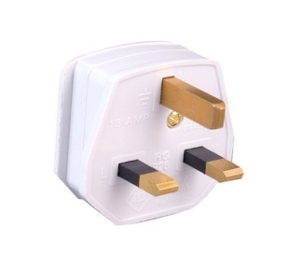

10. General Information
Government: | Constitutional Monarchy
Emir: | Sabah al-Sabah
Crown Prince: | Nawaf al-Sabah
Prime Minister: | Jabber Al-Hamad al-Sabah
Area: | 17’820 sq.km.
Population: | 4,044,500 (approx.)
Capital: | Kuwait City
Language: | Arabic

______________

