国 际 电 信 联 盟
电信标准化局
 |  |  | 2017年4月20日，日内瓦
文号： | 电信标准化局第18号通函  电信标准化局讲习班/MA |  | 致：  - 国际电联成员国主管部门；  - ITU-T部门成员；  - ITU-T部门准成员；  - ITU-T学术成员
联系人： | Martin Adolph
电话： | +41 22 730 6828
传真： | +41 22 730 5853
电子  邮件： | tsbworkshops@itu.int |  | 抄送：  - ITU-T各研究组正副主席；  - 电信发展局主任；  - 无线电通信局主任；  - 国际电联驻曼谷亚太区域代表处主任；  - 国际电联驻雅加达地区办事处主任
事由： | 国际电联/新加坡信息通信媒体发展管理局“通信如何改变汽车和交通运输讲习班”（2017年7月6日，新加坡），暨“智能交通系统通信标准协作会议”（2017年7月7日，新加坡）
尊敬的先生/女士：
1 我谨通知您，新加坡信息通信媒体发展管理局（IMDA）与国际电信联盟（ITU）将于2017年7月6日举办“通信如何改变汽车和交通运输”讲习班，随后将于2017年7月7日召开“智能交通系统通信标准协作”会议。
这两项活动均将在新加坡新达城会展中心（Suntec Convention and Exhibition Centre）举行。
讲习班将于活动第一天09:30开始。与会者的注册工作将自08:30开始。有关会议厅的详细信息将在现场和注册处提供。
2 国际电联成员国、部门成员、部门准成员和学术机构以及愿参加此工作的来自国际电联成员国的任何个人均可参加。这里所指的“个人”亦包括作为国际、区域和国家组织成员的个人。参加讲习班及智能交通系统通信标准协作会议不收取任何费用，但亦不发放与会补贴。讨论仅使用英文。
3 智能交通系统（ITS）和自动驾驶正在迅速向大规模商业化发展且越来越得到市场的认可。高度自动化—实现完全自动驾驶所需的倒数第二步—预计可在2020年前上路，有望大幅提高道路安全性，减少拥堵和排放并提高个人移动性。
2017年7月6日，国际电联/IMDA讲习班将从技术、商业和监管角度研究联网汽车领域取得的进展。特别是，会议将探讨联网汽车和自动驾驶的连接选择、汽车通信网络安全，以及人工智能和机器学习在未来交通系统中发挥的作用。
讲习班日程草案将在网站http://itu.int/en/ITU-T/extcoop/cits/Pages/201707.aspx上发布。凡有新信息或修改信息，该网站将不断更新。请与会者定期查看更新内容。
2017年7月7日，ITS通信标准协作会议将讨论ITS通信标准的现状和未来的道路。会议的议程草案和文件将在网站http://itu.int/go/ITScomms上发布。如需远程参会，请提出申请（请于2017年6月21日前联系tsbcits@itu.int）。
两项国际活动的目标受众包括政府代表、决策机构和监管机构、汽车生产厂商的技术人员和决策人员、原始设备制造商、供应商、网络运营商和服务提供商、分析师和市场研究人员、从事标准化工作的技术专家、公众中感兴趣的人士等。
4 附件A介绍了会议的一般信息。
5 为便于IMDA和国际电联为组织讲习班进行必要安排，请您通过http://itu.int/reg/tmisc/3000972在线表格尽早、但不迟于2017年6月21日进行注册。请注意，讲习班参加者的预注册仅以在线方式进行。
6 我在此谨提醒您，一些国家的公民需要获得签证才能入境新加坡并在此逗留。签证必须向驻贵国的新加坡代表机构（使馆或领事馆）申请领取。如贵国没有此类机构，则请向驻离贵国最近的国家的此类机构申请并领取。需要东道国出具邀请函协助申请签证的与会者，请参阅附件B详细信息。敬请注意，签证审批可能需要一些时间，故请尽早，但不迟于2017年6月5日前提交申请。

顺致敬意！

电信标准化局主任
李在摄
附件：2件

ANNEX A

PRACTICAL INFORMATION
(to TSB Circular 18)

Meeting Venue
The meeting will be held at Suntec Singapore Convention & Exhibition Centre. Detailed information concerning the meeting rooms will be available onsite.
The address of the venue is as follows:
Suntec Singapore
Convention & Exhibition Centre
1 Raffles Boulevard
Singapore 039593
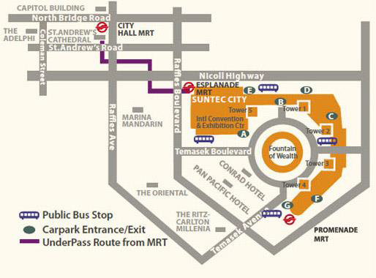

Transportation and site information
Transportation:
The venue is approximately 20km from Singapore Changi Airport and it takes about 20 minutes by car from Singapore Changi Airport to the venue.

Public Taxi

Public Taxi is readily available at all terminals at Singapore Changi Airport.

All taxis are metered. Fares must be charged according to the taxi meter, plus applicable surcharges. More information can be found here: http://www.taxisingapore.com/taxi-fare/

Public Train (Mass Rapid Transit, MRT)
  - The train station is accessible by foot from Terminal 2 or Terminal 3.
  - To get to the city, transfer to the westbound train at Tanah Merah station. The last train that connects to the last westbound train at Tanah Merah station leaves Changi Airport station at 11.18pm. All the trains and gantries at the stations are luggage-friendly.
  - Suntec Singapore Convention & Exhibition Centre is accessible via Promenade station, Esplanade station or City Hall station.

Passports and Visas
Generally, foreigners who do not require visas for entry and are visiting Singapore as tourists may be given up to 30-day social passes upon their arrival in Singapore. All foreign visitors entering Singapore must have a valid passport. Visitors from countries whose citizens require a visa should at the earliest time and well in advance of travel apply for a visa at a Singapore Embassy or consulate. Please visit the following website to check if you require a visa for entry into Singapore: http://www.ica.gov.sg/
For an introduction letter, please see Annex B.

Climate – during July
Monthly average values of the temperature and precipitation in Singapore are given in the table below:
 | July
Average Max Temperature | 30C / 86F
Average Minimum Temperature | 24C / 75F
Average Precipitation | 170mm

http://www.nea.gov.sg/weather-climate

Hotels
Hotels close to the venue:
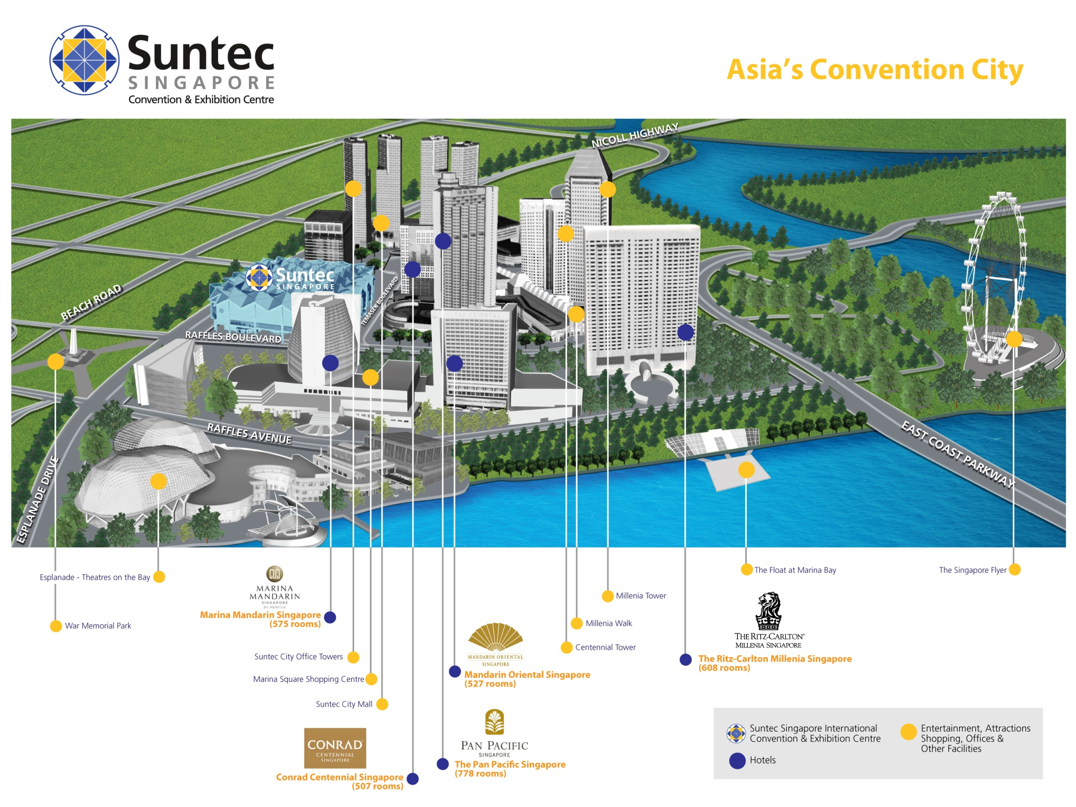
- Conrad Centennial Singapore
2 Temasek Boulevard, Singapore 038982
Website : www.conradhotels.com
- Marina Mandarin Singapore
6 Raffles Boulevard, Marina Square, Singapore 039594
Website : www.meritushotels.com
- Mandarin Oriental Singapore
5 Raffles Avenue, Marina Square, Singapore 039797
Website : www.mandarinoriental.com
- Pan Pacific Singapore
7 Raffles Boulevard, Marina Square, Singapore 039595
Website : www.panpacific.com
- Ritz-Carlton Millenia Singapore
7 Raffles Avenue, Singapore 039799
Website : www.ritzcarlton.com

Internet access and wireless coverage
All meeting rooms will have a wireless network with access to the Internet. Every guest room offers a high-speed Internet access for free. The access to Internet will be granted using the LAN technologies listed below:
- Wireless via WiFi: 802.11bgn and 802.11ac – Both accessible on 2.4GHz and 5GHz

Technical assistance
In case you have any technical problem at the venue (e.g. connecting to internet, finding meeting rooms etc.) please contact for help:
- Mr Edwin Low (Edwin_KF_low@imda.gov.sg).

Electricity
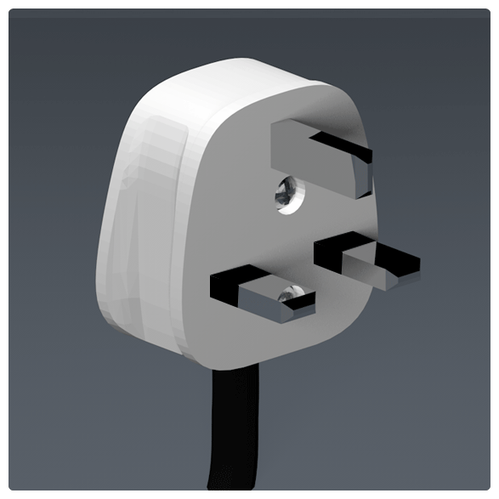
Singapore’s voltage is 220-240 volts AC, 50 cycles per second. Most hotels can provide visitors with a transformer, which can convert the voltage to 110-120 volts 60 cycles per second. The power plugs used in Singapore are of the three-pin, square shaped type.

Useful information
Currency exchange
The currency in Singapore is the Singapore Dollar. Apart from banks and hotels, money can be changed wherever the sign “Licensed Money Changer” is displayed. Most shopping complexes have a licensed money changer. Visitors are discouraged from changing money with unlicensed money changers
Online exchange rates are shown at: http://www.xe.com/
Exchange rate as of 18 April 2017:
US Dollar: 1$ | 1.3977 SGD
Euro: 1€ | 1.4941 SGD

Additional information
Tipping: Tipping is not very common in Singapore. It is prohibited at the airport and discouraged at hotels and restaurants, as most have already added a 10% service charge to the bill. Taxi drivers do not get tipped.
Time Zone: GMT+8:00.
Emergency Number: In case of emergency please dial 999.
For more information about Singapore, please visit www.yoursingapore.com.

Contact persons
Infocomm Media Development Authority of Singapore (IMDA)
10 Pasir Panjang Road
#10-01
Singapore (117438)

Mr Edwin Low
E-mail: Edwin_kf_low@imda.gov.sg

Or

Ms Eunice Lim
E-mail: Eunice_lim@imda.gov.sg

ANNEX B
INVITATION LETTER REQUEST FORM
(to TSB Circular 18)
All foreign visitors entering Singapore must have a valid passport. Visitors from countries whose citizens require a visa should at the earliest time and well in advance of travel apply for a visa at a Singapore Embassy or consulate. You may need a letter of invitation from the Singapore host, which you will need to present to the Embassy/Consulate in your area in order to obtain your visa. The visa must be requested as soon as possible and at least four (4) weeks before the start date of the meeting and obtained from the office (embassy or consulate) representing Singapore in your country or, if there is no such office in your country, from the one that is closest to the country of departure. In order to obtain the invitation letter, please:
- Register for the events as described above;
- Fill out the form below;
- Provide the electronic copy of your passport (the name, date of birth, nationality, passport number, valid date of passport, etc. must be seen clearly);
- Send as email attachments to edwin_kf_low@ida.gov.sg, Eunice_lim@ida.gov.sg and Cc tsbcits@itu.int. Please mention your registration number and use the subject “Invitation letter request for ITU/IMDA events”.
Company
Applicant Information |  |  |  | Mr Miss Ms Mrs
 |  |  |  | Date of birth :
 |  |  |  | Place of Issue:
 | Date of Issue: |  |  | Date of Expiry:
 | Marital Status:
 | If the country in which you'll obtain your visa is different from your nationality, please indicate it here:
Address | Telephone Number:  Fax Number:  E-mail:
Note
Date of arrival in Singapore |  |  | Date of departure from Singapore
Please do not forget to attach a copy of your passport photograph page before sending.
In order to receive an invitation letter, your information should be provided to the host before 5 June 2017.

