International telecommunication union
Telecommunication Standardization Bureau
 |  |  | Geneva, 20 April 2017
Ref: | TSB Circular 18  TSB Workshops/MA |  | To:  - To Administrations of Member States of the Union;  - To ITU-T Sector Members;  - To ITU-T Associates;  - To ITU Academia
Contact: | Martin Adolph
Tel: | +41 22 730 6828
Fax: | +41 22 730 5853
E-mail: | tsbworkshops@itu.int |  | Copy:  - To the Chairman and Vice-Chairmen of ITU-T Study Groups;  - To the Director of the Telecommunication Development Bureau;  - To the Director of the Radiocommunication Bureau;  - To the Director of the ITU Regional Office for Asia and the Pacific, Bangkok;  - To the Head of ITU Area Office in Jakarta
Subject: | ITU/IMDA Workshop on How Communications will Change Vehicles and Transport (Singapore, 6 July 2017); and  Meeting of the Collaboration on ITS Communication Standards (Singapore, 7 July 2017)
Dear Sir/Madam,
1 I would like to inform you that the Info-communications Media Development Authority of Singapore (IMDA) and the International Telecommunication Union (ITU) will convene a workshop on How Communications will Change Vehicles and Transport on 6 July 2017 and a meeting of the Collaboration on ITS Communication Standards on 7 July 2017.
Both events will take place at Suntec Convention and Exhibition Centre, Singapore.
The workshop will open at 0930 hours on the first day. Participant registration will begin at 0830 hours. Detailed information concerning the meeting rooms will be available onsite and provided at the registration desk.
2 Participation is open to ITU Member States, Sector Members, Associates and Academic Institutions and to any individual from a country which is a member of ITU. This includes individuals who are also members of international, regional and national organizations. Participation in the workshop and the meeting of the Collaboration on ITS Communication Standards is free of charge. There will be no fellowships. The discussions will be held in English only.
3 Intelligent transport systems (ITS) and automated driving are fast moving toward widespread commercialization and market acceptance. High levels of automation – the penultimate step to fully automated driving – are expected on the road by 2020 and hold great promise to improve road safety, reduce congestion and emissions, and increase the accessibility of personal mobility.
On 6 July 2017, the ITU/IMDA workshop will examine advances in the area of vehicle communications, from the perspectives of technology, business, and regulation. Sessions will discuss, inter alia, connectivity options for connected vehicles and automated driving; cybersecurity for automotive communications; and the role to be played by artificial intelligence and machine learning in future transport systems.
A draft programme of the workshop will be published at http://itu.int/en/ITU-T/extcoop/cits/Pages/201707.aspx. This website will be regularly updated as new or modified information become available. Participants are requested to check regularly for new updates.
On 7 July 2017, the meeting of the Collaboration on ITS Communication Standards will review the state of ITS communication standards and discuss the road ahead. A draft agenda and meeting documentation will be made available at http://itu.int/go/ITScomms. Remote participation in the meeting will be possible on request (please contact tsbcits@itu.int before 21 June 2017).
The target audience of these international events includes government representatives, policymakers and regulators; technical staff and decision makers at vehicle manufacturers, OEMs, suppliers, network operators and service providers; analysts and market researchers; technical experts involved in standardization; and members of the interested public.
4 General information about the meeting is set forth in Annex A.
5 To enable IMDA and ITU to make the necessary arrangements concerning the organization of the workshop, I should be grateful if you would register via the online form http://itu.int/reg/tmisc/3000972 as soon as possible, but not later than 21 June 2017. Please note that pre-registration of participants for workshops is carried out exclusively online.
6 I would remind you that citizens of some countries are required to obtain a visa in order to enter and spend any time in Singapore. The visa must be obtained from the office (embassy or consulate) representing Singapore in your country or, if there is no such office in your country, from the one that is closest to the country of departure. Participants who require a letter of invitation from the host to facilitate their visa application are requested to refer to Annex B for detailed information. Please be aware that visa approval might take time so kindly send your application as soon as possible and no later than 5 June 2017.
Yours faithfully,

Chaesub Lee
Director of the Telecommunication
Standardization Bureau
Annexes: 2

ANNEX A

PRACTICAL INFORMATION
(to TSB Circular 18)

Meeting Venue
The meeting will be held at Suntec Singapore Convention & Exhibition Centre. Detailed information concerning the meeting rooms will be available onsite.
The address of the venue is as follows:
Suntec Singapore
Convention & Exhibition Centre
1 Raffles Boulevard
Singapore 039593
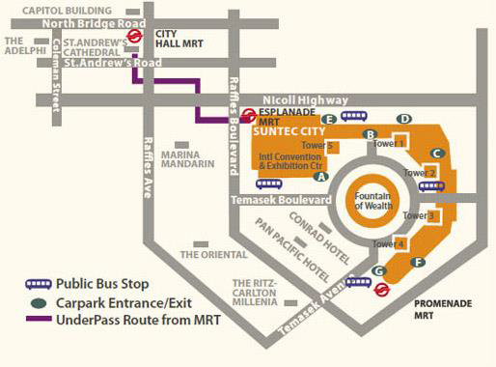

Transportation and site information
Transportation:
The venue is approximately 20km from Singapore Changi Airport and it takes about 20 minutes by car from Singapore Changi Airport to the venue.

Public Taxi

Public Taxi is readily available at all terminals at Singapore Changi Airport.

All taxis are metered. Fares must be charged according to the taxi meter, plus applicable surcharges. More information can be found here: http://www.taxisingapore.com/taxi-fare/

Public Train (Mass Rapid Transit, MRT)
  - The train station is accessible by foot from Terminal 2 or Terminal 3.
  - To get to the city, transfer to the westbound train at Tanah Merah station. The last train that connects to the last westbound train at Tanah Merah station leaves Changi Airport station at 11.18pm. All the trains and gantries at the stations are luggage-friendly.
  - Suntec Singapore Convention & Exhibition Centre is accessible via Promenade station, Esplanade station or City Hall station.

Passports and Visas
Generally, foreigners who do not require visas for entry and are visiting Singapore as tourists may be given up to 30-day social passes upon their arrival in Singapore. All foreign visitors entering Singapore must have a valid passport. Visitors from countries whose citizens require a visa should at the earliest time and well in advance of travel apply for a visa at a Singapore Embassy or consulate. Please visit the following website to check if you require a visa for entry into Singapore: http://www.ica.gov.sg/
For an introduction letter, please see Annex B.

Climate – during July
Monthly average values of the temperature and precipitation in Singapore are given in the table below:
 | July
Average Max Temperature | 30C / 86F
Average Minimum Temperature | 24C / 75F
Average Precipitation | 170mm

http://www.nea.gov.sg/weather-climate

Hotels
Hotels close to the venue:
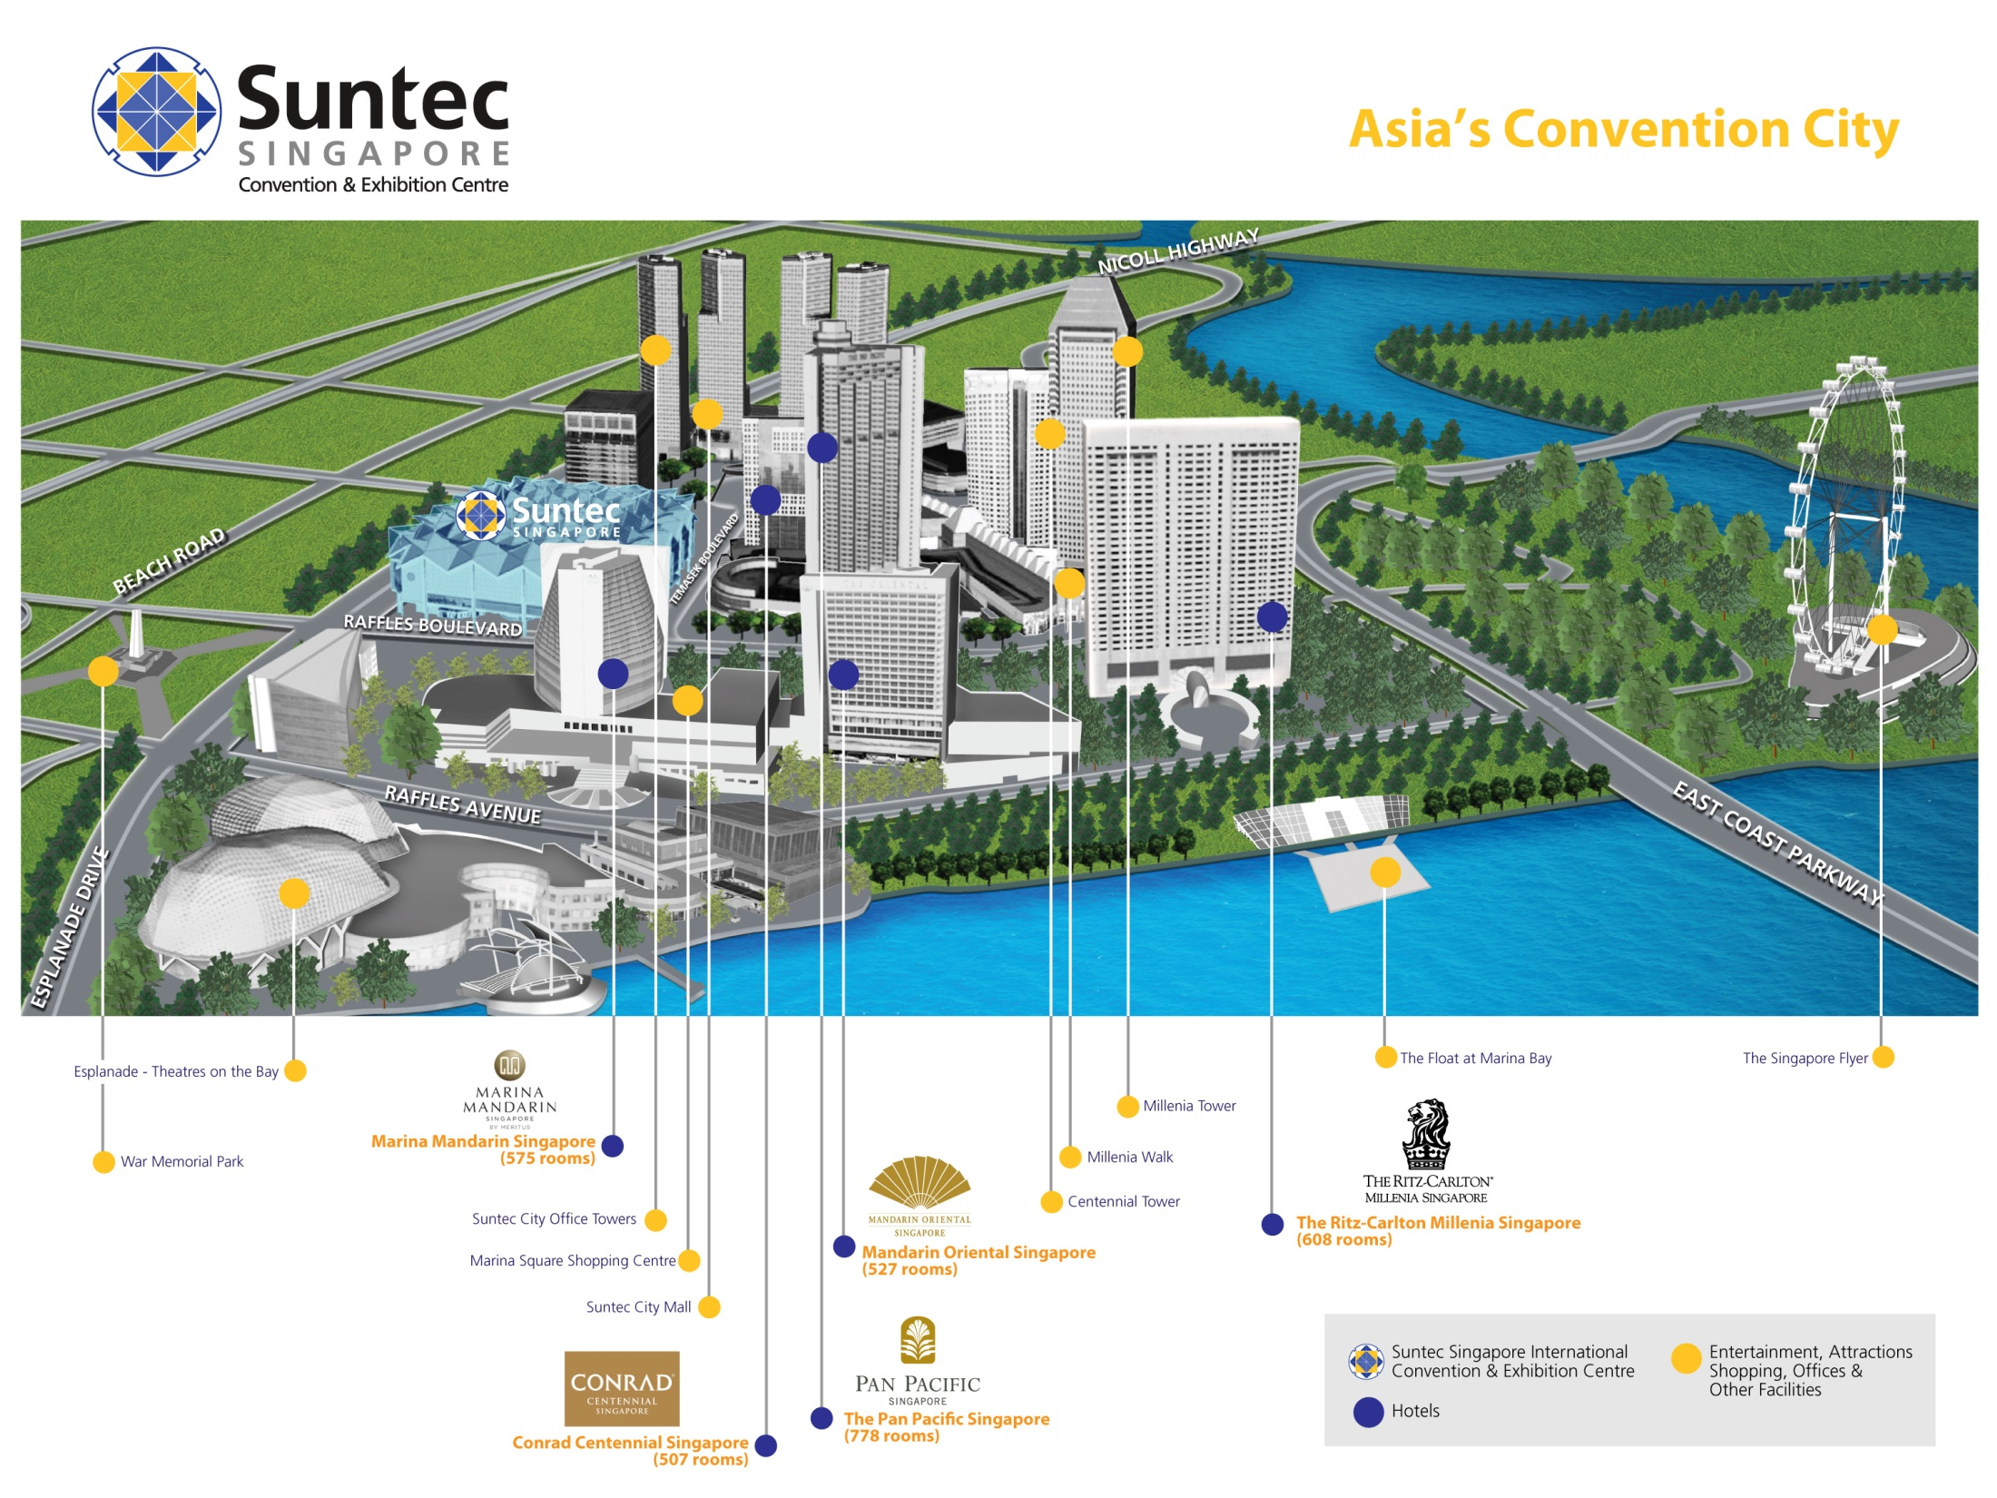
- Conrad Centennial Singapore
2 Temasek Boulevard, Singapore 038982
Website : www.conradhotels.com
- Marina Mandarin Singapore
6 Raffles Boulevard, Marina Square, Singapore 039594
Website : www.meritushotels.com
- Mandarin Oriental Singapore
5 Raffles Avenue, Marina Square, Singapore 039797
Website : www.mandarinoriental.com
- Pan Pacific Singapore
7 Raffles Boulevard, Marina Square, Singapore 039595
Website : www.panpacific.com
- Ritz-Carlton Millenia Singapore
7 Raffles Avenue, Singapore 039799
Website : www.ritzcarlton.com

Internet access and wireless coverage
All meeting rooms will have a wireless network with access to the Internet. Every guest room offers a high-speed Internet access for free. The access to Internet will be granted using the LAN technologies listed below:
- Wireless via WiFi: 802.11bgn and 802.11ac – Both accessible on 2.4GHz and 5GHz

Technical assistance
In case you have any technical problem at the venue (e.g. connecting to internet, finding meeting rooms etc.) please contact for help:
- Mr Edwin Low (Edwin_KF_low@imda.gov.sg).

Electricity
Singapore’s voltage is 220-240 volts AC, 50 cycles per second. Most hotels can provide visitors with a transformer, which can convert the voltage to 110-120 volts 60 cycles per second. The power plugs used in Singapore are of the three-pin, square shaped type.

Useful information
Currency exchange
The currency in Singapore is the Singapore Dollar. Apart from banks and hotels, money can be changed wherever the sign “Licensed Money Changer” is displayed. Most shopping complexes have a licensed money changer. Visitors are discouraged from changing money with unlicensed money changers
Online exchange rates are shown at: http://www.xe.com/
Exchange rate as of 18 April 2017:
US Dollar: 1$ | 1.3977 SGD
Euro: 1€ | 1.4941 SGD

Additional information
Tipping: Tipping is not very common in Singapore. It is prohibited at the airport and discouraged at hotels and restaurants, as most have already added a 10% service charge to the bill. Taxi drivers do not get tipped.
Time Zone: GMT+8:00.
Emergency Number: In case of emergency please dial 999.
For more information about Singapore, please visit www.yoursingapore.com.

Contact persons
Infocomm Media Development Authority of Singapore (IMDA)
10 Pasir Panjang Road
#10-01
Singapore (117438)

Mr Edwin Low
E-mail: Edwin_kf_low@imda.gov.sg

Or

Ms Eunice Lim
E-mail: Eunice_lim@imda.gov.sg

ANNEX B
INVITATION LETTER REQUEST FORM
(to TSB Circular 18)
All foreign visitors entering Singapore must have a valid passport. Visitors from countries whose citizens require a visa should at the earliest time and well in advance of travel apply for a visa at a Singapore Embassy or consulate. You may need a letter of invitation from the Singapore host, which you will need to present to the Embassy/Consulate in your area in order to obtain your visa. The visa must be requested as soon as possible and at least four (4) weeks before the start date of the meeting and obtained from the office (embassy or consulate) representing Singapore in your country or, if there is no such office in your country, from the one that is closest to the country of departure. In order to obtain the invitation letter, please:
- Register for the events as described above;
- Fill out the form below;
- Provide the electronic copy of your passport (the name, date of birth, nationality, passport number, valid date of passport, etc. must be seen clearly);
- Send as email attachments to edwin_kf_low@ida.gov.sg, Eunice_lim@ida.gov.sg and Cc tsbcits@itu.int. Please mention your registration number and use the subject “Invitation letter request for ITU/IMDA events”.
Company
Applicant Information |  |  |  | Mr Miss Ms Mrs
 |  |  |  | Date of birth :
 |  |  |  | Place of Issue:
 | Date of Issue: |  |  | Date of Expiry:
 | Marital Status:
 | If the country in which you'll obtain your visa is different from your nationality, please indicate it here:
Address | Telephone Number:  Fax Number:  E-mail:
Note
Date of arrival in Singapore |  |  | Date of departure from Singapore
Please do not forget to attach a copy of your passport photograph page before sending.
In order to receive an invitation letter, your information should be provided to the host before 5 June 2017.

