国 际 电 信 联 盟
电信标准化局
 |  |  | 2017年10月10日，日内瓦
文号： | 电信标准化局第56号通函  TSB Workshops/SP |  | 致：  - 国际电联成员国主管部门；  - ITU-T部门成员；  - ITU-T部门准成员；  - 国际电联学术成员
联系人： | Stefano Polidori
电话： | +41 22 730 5858
传真： | +41 22 730 5853
电子  邮件： | stefano.polidori@itu.int |  | 抄送：  - ITU-T各研究组正副主席；  - 电信发展局主任；  - 无线电通信局主任
事由： | 智能交通系统通信标准协作会议及  电信行业协会/国际电联“自主交通 – 通信将如何改变车辆和交通”讲习班  2017年12月5-6日，美国弗吉尼亚州阿灵顿
尊敬的先生/女士：
1 谨在此通知您，电信行业协会（TIA）与国际电信联盟（ITU）将于2017年12月6日召开智能交通系统通信标准协作（CITS）会议，在此之前将于2017年12月5日举办电信行业协会/国际电联“自主交通 – 通信将如何改变车辆和交通”讲习班。
两项活动均在以下地址举行：1320 North Courthouse Road, Suite 200, Arlington, VA 22201, United States。
讲习班将于12月5日14:00开始。与会者的注册工作将自13:00开始。
CITS会议将于12月6日09:00开始。与会者的注册工作将自08:00开始。
2 智能交通系统（ITS）和自动驾驶正迅速向大规模商业化发展并且日益得到市场认可。高度自动化（实现全自动驾驶的倒数第二步）预计可在2020年前上路，有望大幅提高道路安全性，减少拥堵和排放并提高个人移动性。
3 2017年12月5日，电信行业协会/国际电联“自主交通 – 通信将如何改变车辆和交通”讲习班将汇集来自汽车业、服务提供商和网络基础设施界的思想领袖，讨论在自主交通通信基础设施方面的需求和进展以及自主性在改变生活方式和商业运作方式的同时带来的影响。活动自12月5日下午开始，首先进行主题演讲以及有关自主交通的技术、商业和经济方面的专题讨论会，随后举行联谊酒会。
为便于电信行业协会就讲习班的组织做出必要安排，希望您能通过TIA网站http://www.tiaonline.org/autonomous-transportation进行注册。
讲习班的日程草案及其他信息亦将在此网站提供。
4 2017年12月6日，ITS通信标准协作会议将审查ITS通信标准的现状，并讨论未来发展方向。
为便于国际电联和电信行业协会就智能交通系统通信标准协作会议的组织做出必要安排，希望您能通过TIA网站或此网址尽早、但不迟于2017年11月30 日进行注册。请注意，与会者的预注册仅以在线方式进行。与会者可在会议当天现场注册。
会议可提供远程参会服务。如希望远程参会，请通过电子邮件（stefano.polidori@itu.int）做出说明，联系Stefano Polidori索取远程参会须知。
国际电联成员国、部门成员、部门准成员和学术机构以及来自国际电联成员国的任何个人均可参加。这里所指的“个人”亦包括作为国际、区域和国家组织成员的个人。
参加智能交通系统通信标准协作会议不收取任何费用，但亦不发放与会补贴。讨论将仅用英文进行。
议程草案、会议文件和补充信息将在ITS通信标准协作网站http://itu.int/go/ITScomms上发布。
5 会场附近的酒店一览表及其他后勤信息见附件A和B。
6 在此谨提醒您，一些国家的公民需要获得签证才能入境美国并在此逗留。签证必须向驻贵国的美国代表机构（使馆或领事馆）申请领取。如贵国没有此类机构，则请向驻离出发国最近的国家的此类机构申请并领取。如需邀请函，请见附件C。

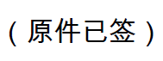
顺致敬意！

电信标准化局主任
李在摄

附件：3件

附件A
Practical Information for Participants

1 Event venue
Telecommunications Industry Association
Address: 1320 North Courthouse Road, Suite 200, Arlington, VA 22201, United States
Tel.: +1 703 907 7701
Fax: +1 703 907 7727
E-mail: mwaters@tiaonline.org
Website: http://www.tiaonline.org/

2 Hotels
The list of proposed hotels may be found in Annex B. Preferential rates have been obtained with Hilton Garden Inn.

3 Arrival and transportation
Arrival
Local airports: Ronald Regan National Airport (DCA), Washington Dulles International Airport (IAD)
Transportation to/from the airport
- Taxi
It is about a 7-minute drive from Ronald Regan National Airport ($20 US) and 30-minute drive from Washington Dulles International Airport ($50 US) to TIA depending on traffic conditions. Taxis are always available.
- Subway (Metro)
Take the Metro Blue Line toward Largo Town Center at Ronald Regan National Airport and transfer to the Orange Line toward the Vienna Station and then exit at the Courthouse Station.

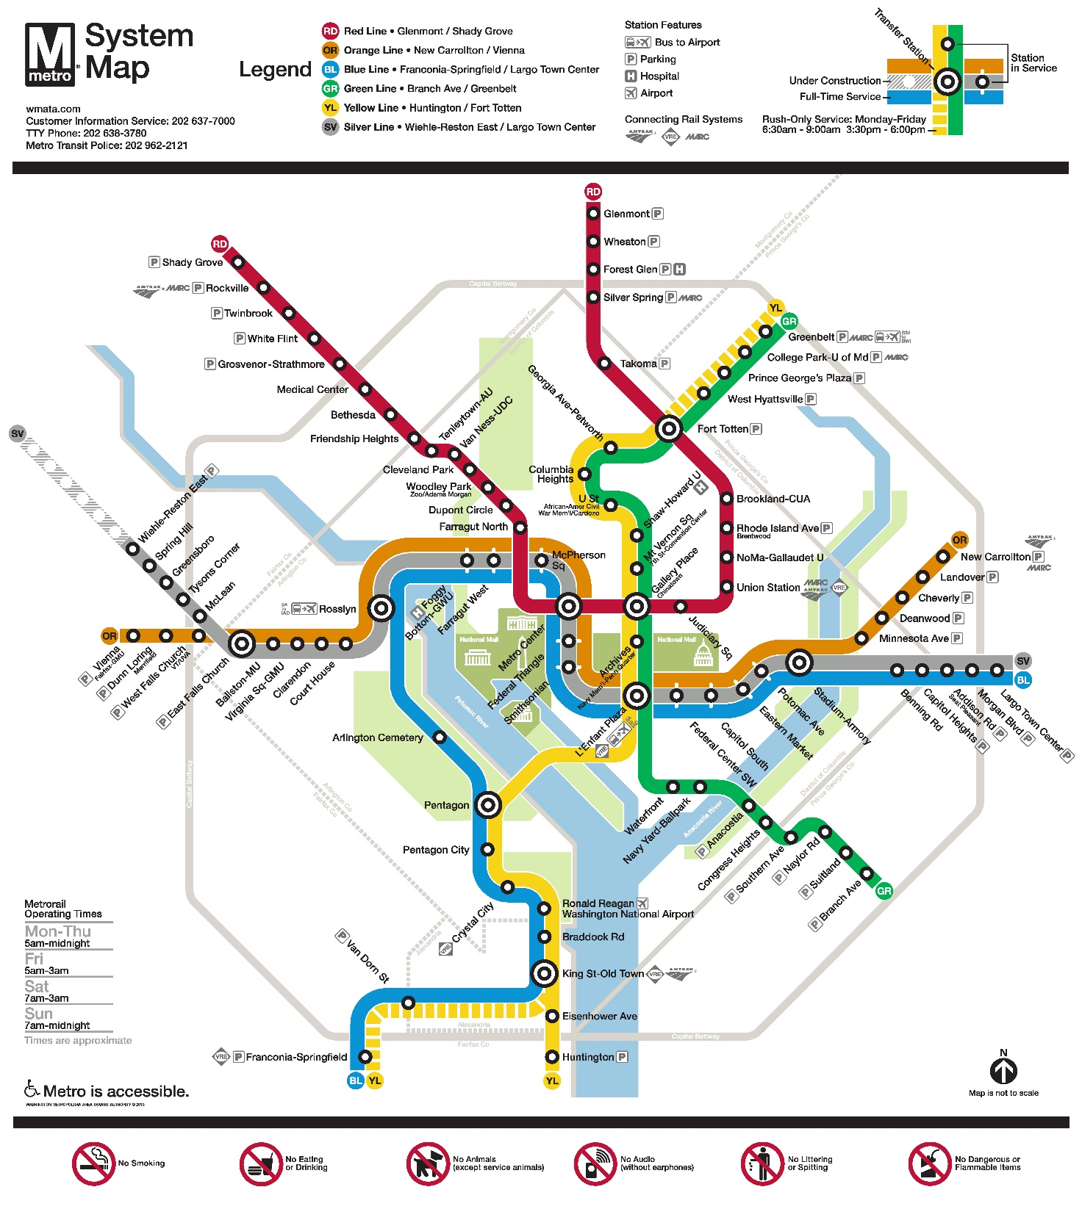

4 Visa – Formalities for entering the United States
For United States visa information, please visit the following website: https://travel.state.gov/content/visas/en.html

5 Currency exchange
The currency in the United States is the $ or USD. Businesses accept most major credit cards. Only the United States Dollar (USD) is accepted at stores and restaurants.

6 Language
The meeting’s official working language will be English.

7 Climate
For information on climate please click here: http://www.weather.com/weather/today/l/22201:4:US

8 Local time
Standard time zone: UTC/GMT -5.

9 Telecommunications
The country code for the United States is +1. The main frequency bands used in the United States of America in communications are GSM850, GSM1900, 3G (850/1900 and 1700/2100) and 4G (Verizon USA 4G, Sprint Clearwire WiMAX and T-Mobile 4G). For you to better understand what frequencies are used by what standard, here is some data:
700MHz – this band is used with 3G and 4G technologies and 698-806MHz frequencies. It is planned to be used for GSM frequency in the future as well
GSM800 – not exactly a GSM but SMR iDEN technology that uses 806-824MHz and 851-869MHz frequencies, though soon it may also be used for CDMA
GSM850 – main cellular band in USA used with GSM, CDMA and 3G technologies. Uses 824-849MHz and 869-894MHz frequencies
GSM1900, or PCS – secondary cellular band in USA used with the same GSM, CDMA and 3G technologies but with 1850–1910MHz and 1930–1990MHz frequencies
AWS – used for 3G and 4G technologies on 1710–1755MHz and 2110–2155MHz frequencies
BRS/EBS – used for 4G technology with 2496–2690MHz frequencies
Although the main frequency band that was used in USA in the first place was 800MHz (AMPS); it is now replaced with GSM850 as the new primary cell phone call band.

10 Electricity
Mainly used in the USA, 2 pins, Type A (not grounded) and Type B (grounded) 15 A, almost always 100 – 127 V, and socket compatible with plug type A/B.
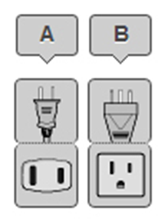
Please be sure you have the right adapter.

11 Health
For medical emergencies, there is a major hospital named Virginia Hospital Center near the TIA Headquarters in Arlington, VA. If you have any emergency, please dial 911.

12 Internet connectivity
Free WLAN will be available at the meeting venue. Payment may be required at certain hotels.

13 Contact
For any questions, please contact:
Florence Sumaray
TIA Director of Marketing
Phone: +1 703-907-7471
Mobile: +1 301-717-9063
Email: fsumaray@tiaonlone.org

Note:
For general information about the Washington DC area please visit: http://washington.org/

附件B
List of Hotels

Hilton Garden Inn
1333 n. Courthouse Road,
Arlington, VA 22201
(703) 528-4444
For reservations by phone, please use corporate ID: n2841868
Website: https://secure3.hilton.com/en_us/gi/reservation/book.htm?execution=e1s1

Hyatt Place Arlington/Courthouse Plaza
2401 Wilson Blvd, Arlington, VA 22201
(703) 243-2494
Website: www.hyatt.com

Residence Inn by Marriott Arlington Courthouse
1401 n Adams St, Arlington, VA 22201
(703) 312-2100
Website: www.marriott.com

附件C
Invitation Letter Request Form

Meeting of the Collaboration on ITS Communication Standards and Workshop on How Communications will Change Vehicles and Transport
5-6 December 2017, Arlington, VA, USA
To enter the United States for the meetings indicated above, you may need a letter of invitation from the host, which you will need to present to the Embassy/Consulate of the United States in your area in order to obtain your visa. In order to obtain the invitation letter, please:
- Fill out the form below
- Send it to (please reference “Invitation letter request for ITS meeting” as the subject):
Florence Sumaray
Telecommunications Industry Association (TIA)
fsumaray@tiaonlone.org
(It is recommended to scan your passport page and e-mail to us so that it is visible and can be used.)
Fax number: +1 703 907 7727 (if your passport page is photocopied and enlarged)

Company
Applicant  information |  |  |  | Mr Ms Mrs
 | Date of birth :
 | Is this your first visit to United States? |  |  | __ Yes ___ No
 | If the country in which you'll obtain your visa is different from your nationality, please indicate it here:
Address
Place to visit after entry | In this case, it is Washington, DC by default.
Date of arrival in the  United States |  |  | Date of departure from the  United States
(Please do not forget to attach a copy of your passport photograph page before sending)
Your information should be sent out before 1 November 2017.

______________

