International telecommunication union
Telecommunication Standardization Bureau
 |  |  | Geneva, 10 October 2017
Ref: | TSB Circular 56  TSB Workshops/SP |  | To:  - Administrations of Member States of the Union;  - ITU-T Sector Members;  - ITU-T Associates;  - ITU Academia
Contact: | Stefano Polidori
Tel: | +41 22 730 5858
Fax: | +41 22 730 5853
E-mail: | stefano.polidori@itu.int |  | Copy to:  - The Chairmen and Vice-Chairmen of ITU-T Study Groups;  - The Director of the Telecommunication Development Bureau;  - The Director of the Radiocommunication Bureau
Subject: | Meeting of the Collaboration on ITS Communication Standards, and  TIA/ITU Workshop on Autonomous Transportation - How Communications will Change Vehicles and Transport  5-6 December 2017, Arlington, Virginia, United States
Dear Sir/Madam,
1 I would like to inform you that the Telecommunications Industry Association (TIA) and the International Telecommunication Union (ITU) will convene a meeting of the Collaboration on ITS Communication Standards (CITS) on 6 December 2017 preceded by a TIA/ITU Workshop on Autonomous Transportation - How Communications will Change Vehicles and Transport on 5 December 2017.
Both events will take place at 1320 North Courthouse Road, Suite 200, Arlington, VA 22201, United States.
The workshop will open on 5 December at 1400 hours. Participants’ registration will begin at 1300 hours.
The CITS meeting will open on 6 December at 0900 hours. Participants’ registration will begin at 0800 hours.
2 Intelligent transport systems (ITS) and automated driving are fast moving toward widespread commercialization and market acceptance. High levels of automation – the penultimate step to fully automated driving – are expected on the road by 2020 and hold great promise to improve road safety, reduce congestion and emissions, and increase the accessibility of personal mobility.
3 On 5 December 2017, the TIA/ITU Workshop on Autonomous Transportation - How Communications will Change Vehicles and Transport will be comprised of thought leaders from automotive, service provider and network infrastructure communities to discuss needs and advancements in autonomous transportation communications infrastructure, as well as the impact of autonomy as it transforms our lives and businesses. The event starts the afternoon of
5 December with a keynote presentation and panels on the technology, business and economics of Autonomous Transportation, followed by a networking reception.
To enable TIA to make the necessary arrangements concerning the organization of the workshop, I should be grateful if you would register on the TIA website, http://www.tiaonline.org/autonomous-transportation.
Please also see this website for a draft programme and additional information about the workshop.
4 On 6 December 2017, the meeting of the Collaboration on ITS Communication Standards will review the state of ITS communication standards and discuss the road ahead.
To enable ITU and TIA to make the necessary arrangements concerning the organization of the Collaboration on ITS Communication Standards meeting, I should be grateful if you would register from the TIA website or at this URL as soon as possible, but no later than 30 November 2017. Please note that pre-registration of participants is carried out exclusively online. Participants will be able to register on-site on the day of the meeting.
Remote participation will be possible. If you wish to attend remotely, please indicate that and contact Stefano Polidori at stefano.polidori@itu.int to request the remote participation instructions.
Participation is open to ITU Member States, Sector Members, Associates and Academic Institutions and to any individual from a country which is a member of ITU. This includes individuals who are also members of international, regional and national organizations.
Participation in the meeting of the Collaboration on ITS Communication Standards is free of charge. No fellowships will be provided for this meeting. The discussions will be held in English only.
A draft agenda, meeting documents and additional information will be made available on the Collaboration on ITS Communication Standards website, http://itu.int/go/ITScomms.
5 A list of hotels in proximity to the meeting venue and other logistical information are available in Annexes A and B below.
6 I would remind you that citizens of some countries are required to obtain a visa in order to enter and spend any time in the United States. The visa must be obtained from the office (embassy or consulate) representing the United States in your country or, if there is no such office in your country, from the one that is closest to the country of departure. Should you need an invitation letter please see Annex C below.
Yours faithfully,
(signed)
Chaesub Lee
Director of the Telecommunication
Standardization Bureau
Annexes: 3

ANNEX A
Practical Information for Participants

1 Event venue
Telecommunications Industry Association
Address: 1320 North Courthouse Road, Suite 200, Arlington, VA 22201, United States
Tel.: +1 703 907 7701
Fax: +1 703 907 7727
E-mail: mwaters@tiaonline.org
Website: http://www.tiaonline.org/

2 Hotels
The list of proposed hotels may be found in Annex B. Preferential rates have been obtained with Hilton Garden Inn.

3 Arrival and transportation
Arrival
Local airports: Ronald Regan National Airport (DCA), Washington Dulles International Airport (IAD)
Transportation to/from the airport
- Taxi
It is about a 7-minute drive from Ronald Regan National Airport ($20 US) and 30-minute drive from Washington Dulles International Airport ($50 US) to TIA depending on traffic conditions. Taxis are always available.
- Subway (Metro)
Take the Metro Blue Line toward Largo Town Center at Ronald Regan National Airport and transfer to the Orange Line toward the Vienna Station and then exit at the Courthouse Station.

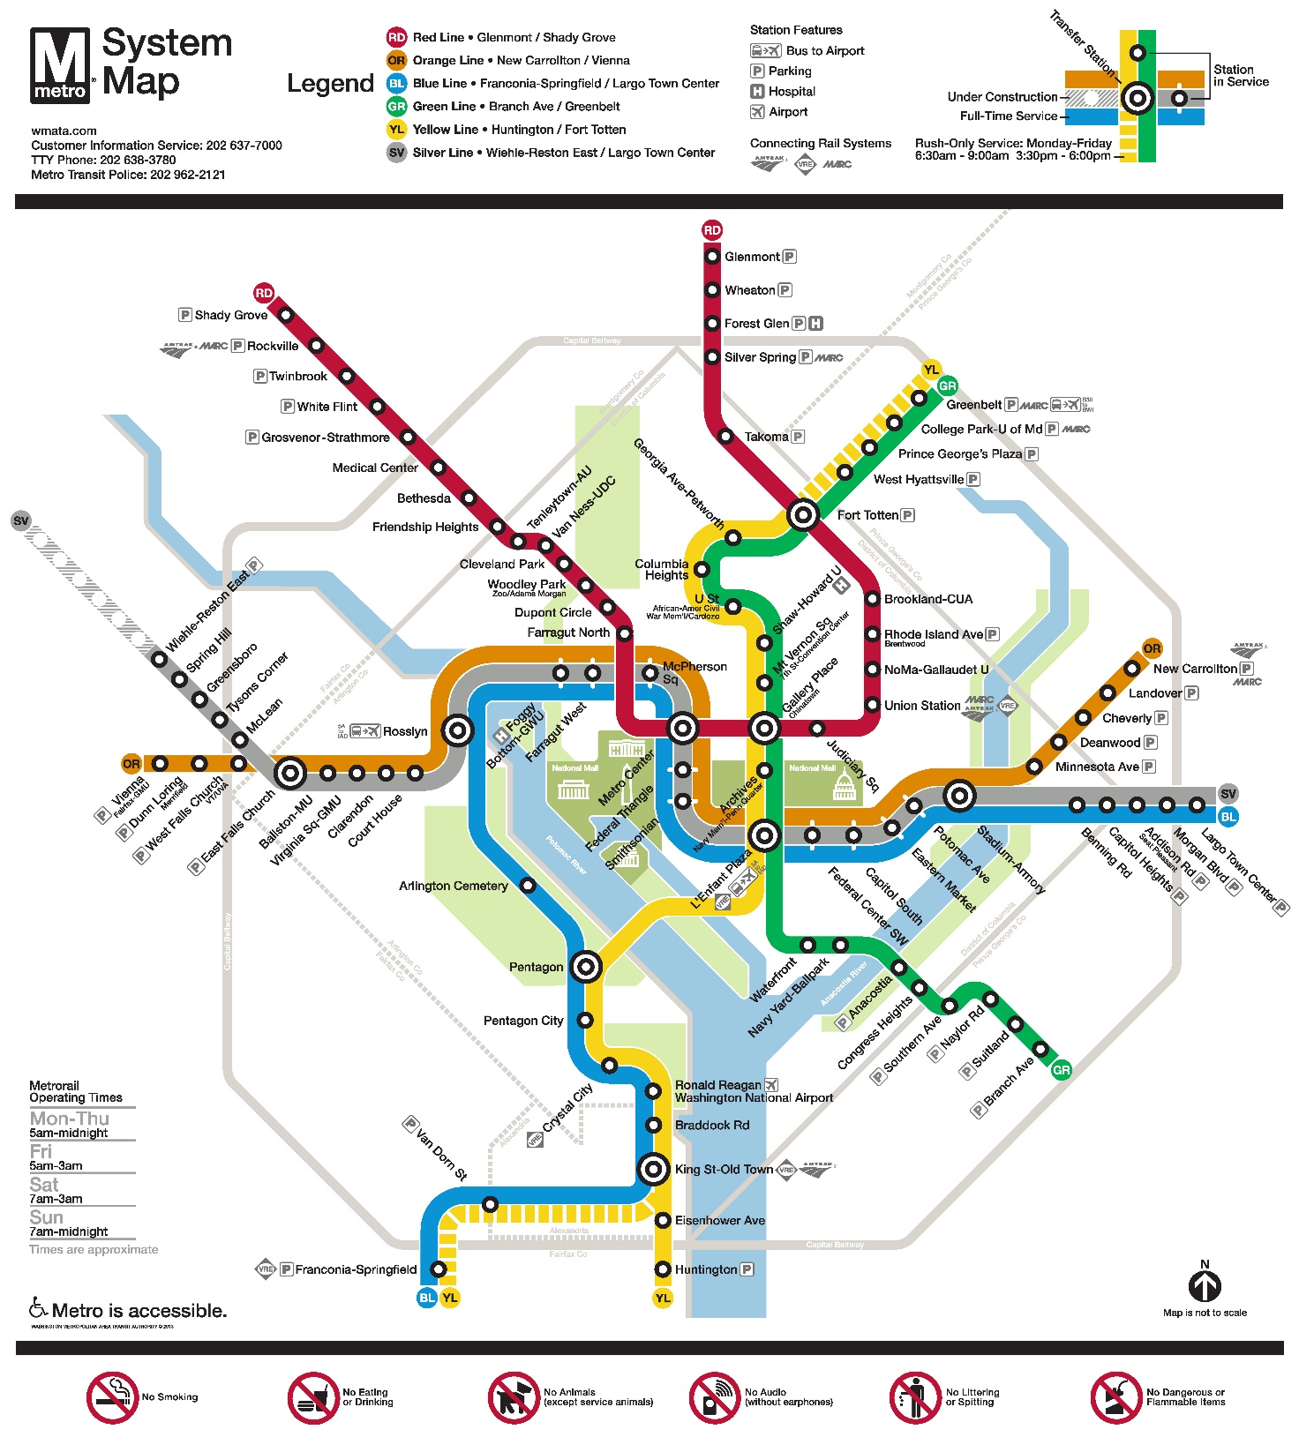

4 Visa – Formalities for entering the United States
For United States visa information, please visit the following website: https://travel.state.gov/content/visas/en.html

5 Currency exchange
The currency in the United States is the $ or USD. Businesses accept most major credit cards. Only the United States Dollar (USD) is accepted at stores and restaurants.

6 Language
The meeting’s official working language will be English.

7 Climate
For information on climate please click here: http://www.weather.com/weather/today/l/22201:4:US

8 Local time
Standard time zone: UTC/GMT -5.

9 Telecommunications
The country code for the United States is +1. The main frequency bands used in the United States of America in communications are GSM850, GSM1900, 3G (850/1900 and 1700/2100) and 4G (Verizon USA 4G, Sprint Clearwire WiMAX and T-Mobile 4G). For you to better understand what frequencies are used by what standard, here is some data:
700MHz – this band is used with 3G and 4G technologies and 698-806MHz frequencies. It is planned to be used for GSM frequency in the future as well
GSM800 – not exactly a GSM but SMR iDEN technology that uses 806-824MHz and 851-869MHz frequencies, though soon it may also be used for CDMA
GSM850 – main cellular band in USA used with GSM, CDMA and 3G technologies. Uses 824-849MHz and 869-894MHz frequencies
GSM1900, or PCS – secondary cellular band in USA used with the same GSM, CDMA and 3G technologies but with 1850–1910MHz and 1930–1990MHz frequencies
AWS – used for 3G and 4G technologies on 1710–1755MHz and 2110–2155MHz frequencies
BRS/EBS – used for 4G technology with 2496–2690MHz frequencies
Although the main frequency band that was used in USA in the first place was 800MHz (AMPS); it is now replaced with GSM850 as the new primary cell phone call band.

10 Electricity
Mainly used in the USA, 2 pins, Type A (not grounded) and Type B (grounded) 15 A, almost always 100 – 127 V, and socket compatible with plug type A/B.
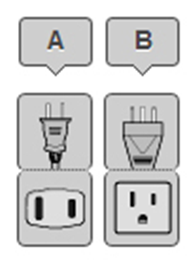
Please be sure you have the right adapter.

11 Health
For medical emergencies, there is a major hospital named Virginia Hospital Center near the TIA Headquarters in Arlington, VA. If you have any emergency, please dial 911.

12 Internet connectivity
Free WLAN will be available at the meeting venue. Payment may be required at certain hotels.

13 Contact
For any questions, please contact:
Florence Sumaray
TIA Director of Marketing
Phone: +1 703-907-7471
Mobile: +1 301-717-9063
Email: fsumaray@tiaonlone.org

Note:
For general information about the Washington DC area please visit: http://washington.org/

ANNEX B
List of Hotels

Hilton Garden Inn
1333 n. Courthouse Road,
Arlington, VA 22201
(703) 528-4444
For reservations by phone, please use corporate ID: n2841868
Website: https://secure3.hilton.com/en_us/gi/reservation/book.htm?execution=e1s1

Hyatt Place Arlington/Courthouse Plaza
2401 Wilson Blvd, Arlington, VA 22201
(703) 243-2494
Website: www.hyatt.com

Residence Inn by Marriott Arlington Courthouse
1401 n Adams St, Arlington, VA 22201
(703) 312-2100
Website: www.marriott.com

ANNEX C
Invitation Letter Request Form

Meeting of the Collaboration on ITS Communication Standards and Workshop on How Communications will Change Vehicles and Transport
5-6 December 2017, Arlington, VA, USA
To enter the United States for the meetings indicated above, you may need a letter of invitation from the host, which you will need to present to the Embassy/Consulate of the United States in your area in order to obtain your visa. In order to obtain the invitation letter, please:

- Fill out the form below
- Send it to (please reference “Invitation letter request for ITS meeting” as the subject):
Florence Sumaray
Telecommunications Industry Association (TIA)
fsumaray@tiaonline.org
(It is recommended to scan your passport page and e-mail to us so that it is visible and can be used.)
Fax number: +1 703 907 7727 (if your passport page is photocopied and enlarged)

Company
Applicant  information |  |  |  | Mr Ms Mrs
 | Date of birth :
 | Is this your first visit to United States? |  |  | __ Yes ___ No
 | If the country in which you'll obtain your visa is different from your nationality, please indicate it here:
Address
Place to visit after entry | In this case, it is Washington, DC by default.
Date of arrival in the  United States |  |  | Date of departure from the  United States
(Please do not forget to attach a copy of your passport photograph page before sending)
Your information should be sent out before 1 November 2017.
___________________

