国 际 电 信 联 盟
电信标准化局
 |  |  | 2018年5月30日，日内瓦
文号： | 电信标准化局第89号通函  TSB Workshops/SP |  | 致：  - 国际电联成员国主管部门；  - ITU-T部门成员；  - ITU-T部门准成员；  - 国际电联学术成员
联系人： | Stefano Polidori
电话： | +41 22 730 5858
传真： | +41 22 730 5853
电子  邮件： | tsbevents@itu.int |  | 抄送：  - ITU-T各研究组正副主席；  - 电信发展局主任；  - 无线电通信局主任
事由： | 智能交通系统国际论坛（ITS-2018）和ITS通信标准协作（CITS）会议，  2018年9月6-7日，中国南京
尊敬的先生/女士：
1 我谨在此通知您，中国智能交通系统（ITS）行业联盟（C-ITS）与国际电信联盟（ITU）将于2018年9月6-7日在中国南京举办智能交通系统国际论坛（ITS-2018）– “通信将如何改变车辆和交通”，该论坛将与ITS通信标准协作（CITS）会议在同一地点举办。
两项活动的地址如下：
南京会展中心
(Lake Home Hotel)
No. 1528 Shuanglong Ave, 211100 Jiangning, China

1 背景
为实现智能交通系统（ITS），汽车行业与信息通信技术（ICT）不断融合。毋庸置疑，这将为造福行业、消费者和政府机构带来新的商机和新的格局。为支持一系列智慧城市解决方案，开发创新技术的新手段层出不穷。这将为实现旨在提高道路安全水平，减少拥塞并加强城市居民的连通性和移动性的更智能交通系统创造条件。
但是，两个迥然不同的行业如何通过寻找合作的途径，将联网汽车创新带来的安全性惠及到每个人？
在智能交通系统领域，自动驾驶不断走向商业化。伴随着汽车能源领域的创新，实现无人驾驶车辆上路的创新已在规划之中。国际社会正在关注环境挑战并希望通过减少排放缓解气候变化。令人向往的未来智能交通系统必须具备自主和环保车辆，以替代燃料为动力并利用先进的汽车技术，同时可望加强老人和残疾人的个人无障碍移动通行。

2 智能交通系统国际论坛（ITS-2018）
将于2018年9月6-7日举办的智能交通系统国际论坛（ITS-2018）– 通信将如何改变车辆和交通 – 将汇聚来自汽车和ICT行业、学术界和政府的代表，从技术和政策角度探讨智能交通系统的现状和未来。
此次国际论坛将探索电信和智能交通系统之间的关系，展示面向下一代移动性的研究。论坛还将分析政府和私营部门在加强连通性和网络安全性方面发挥的关键作用以及在新能源和人工智能领域开展研究的重要性。
论坛将于9月6日9时30分开始，开幕式之后将举办多场技术会议，初步议程见以下附件A。
包含会务和最新议程的更多信息可从以下网站在线查询：http://itu.int/go/ITSforum/2018。

3 ITS通信标准协作（CITS）会议
2018年9月7日下午举办的ITS通信标准协作（CITS）会议将审查ITS通信标准的现状，并讨论未来发展方向。
CITS会议将为开展协作，交流信息并向专家通报最新ITS标准提供机遇。相关标准化机构的代表将应邀向CITS会议提交有关各机构ITS标准化情况报告。这些进展报告应通过tsbcits@itu.int发送至Stefano Polidori先生（国际电联）。
议程草案、会议文件以及更多信息可查询CITS网站：https://www.itu.int/go/cits。

4 注册和其他会务信息
为便于东道国为组织这些活动进行必要的安排，请您尽快、但不迟于2018年8月6日通过以下URL进行注册：
为出席智能交通系统国际论坛（ITS-2018）：
– 国际与会者可通过国际电联网站（http://itu.int/go/ITSforum/2018）注册；
– 本地与会者可通过本地网站（仅提供中文）（http://www.itsforum.cn）注册。
为出席ITS通信标准协作（CITS）会议：
– 请在CITS网站（https://www.itu.int/go/cits）注册。
请注意，与会者的预注册仅以在线方式进行。与会者可在会议当天现场注册，但需采用在线方式。
CITS会议可提供远程参会服务。如希望远程参会，请在注册时注明并定期通过活动网站查询最新信息。
国际电联成员国、部门成员、部门准成员和学术机构以及来自国际电联成员国的任何个人均可参加。这里所指的“个人”亦包括作为国际、区域和国家组织成员的个人。
参加会议不收取任何费用，但会议亦不发放与会补贴。讨论将仅用英文进行。
会场附近的酒店一览表及其他会务信息（包括签证信息）见活动网站和以下附件B。

在此谨提醒您，一些国家的公民需要获得签证才能入境中国并在此逗留。签证必须向驻贵国的中国代表机构（使馆或领事馆）申请领取。如贵国没有此类机构，则请向驻离出发国最近的国家的此类机构申请并领取。如需邀请函，请见以下附件B。

顺致敬意！

（原件已签）

电信标准化局主任
李在摄

ANNEX A

Draft Program

International Forum on ITS (ITS-2018)

“How communications will change vehicles and transport”

(6-7 September 2018, Nanjing, China)
Day 1: (6 September)
0930 – 1100 | Opening ceremony  (Plenary room)
Coffee Break
Session 1 – Plenary presentations
(Plenary room)
1130 – 1300
Lunch Break
1400 – 1530 | Session 2A* – ITS Policy and ITS Industry evolution  (Room A) | Session 2B* – New Energy Vehicles and Intelligent Connected Vehicles  (Room B)
Coffee break
1600 – 1730
Day 2: (7 September)
0930 – 1100 | Session 3A* – Intelligent transport infrastructure  (Room A) | Session 3B* – ITS for smart cities  (Room B)
Coffee break
1130 – 1300
Lunch Break
1400 - 1730 | A technical visit for attendees will be organized by the host  (TBD) | Meeting of the “Collaboration on ITS Communication Standards” (CITS)  (Room C)
* NOTE: Sessions 2A and 2B, as well as Sessions 3A and 3B run in parallel in different rooms

ANNEX B

LOGISTICS, VISA AND OTHER PRACTICAL INFORMATION

International Forum on ITS (ITS-2018)
(Nanjing, China, 6-7 September 2018)
- Meeting venue
Jiangning Exhibition Center, Nanjing
Tel：+86-25-5210-8111
Fax：+86-25-8103-1436
Address：No. 1528 Shuanglong Ave, 211100 Jiangning, China
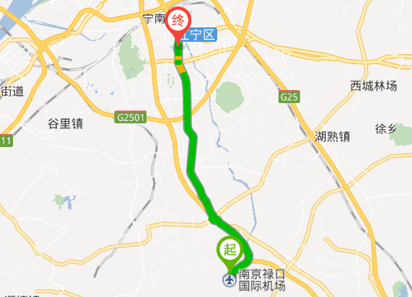
NanJingLukou International Airport
Venue
- Transportation and venue information
31 km to Lukou International Airport; 6 km to Nanjing South railway station; 20 km to the Nanjing railway station.
Once you arrive at the Lukou International Airport, you may reach the venue by:
1) Taxi: 20 mins by car
– Nanjing Lukou airport service telephone number: (international calls: +86-25-968890 / local calls: 025-968890)
You may ask the staff about taxi services. Please find below a map of the arrival level facilities at the airport.
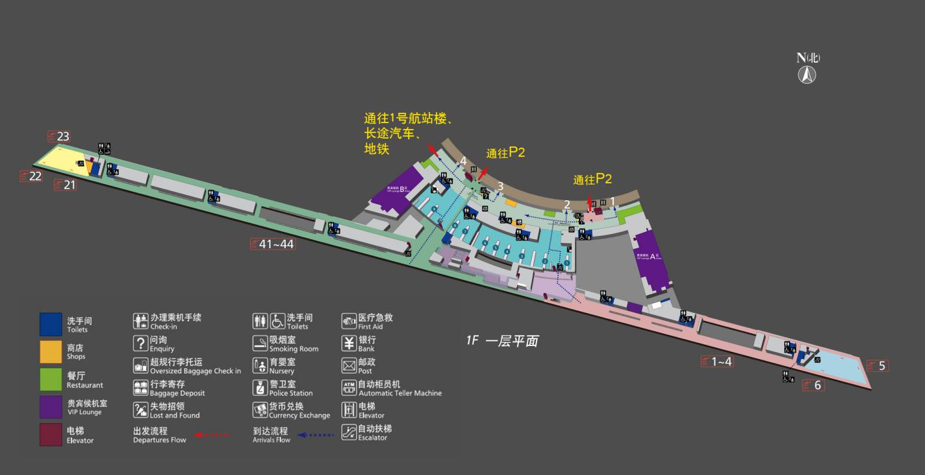
Enquiry
Enquiry
Access to P2
Access to P2
Access to Terminal 1, coach, subway
2) Subway:
– Take Line S1 from Nanjing Lukou International Airport to Nanjing South Railway Station
– Transfer to Line 1 (from Nanjing South Railway Station to Shengtai Road).
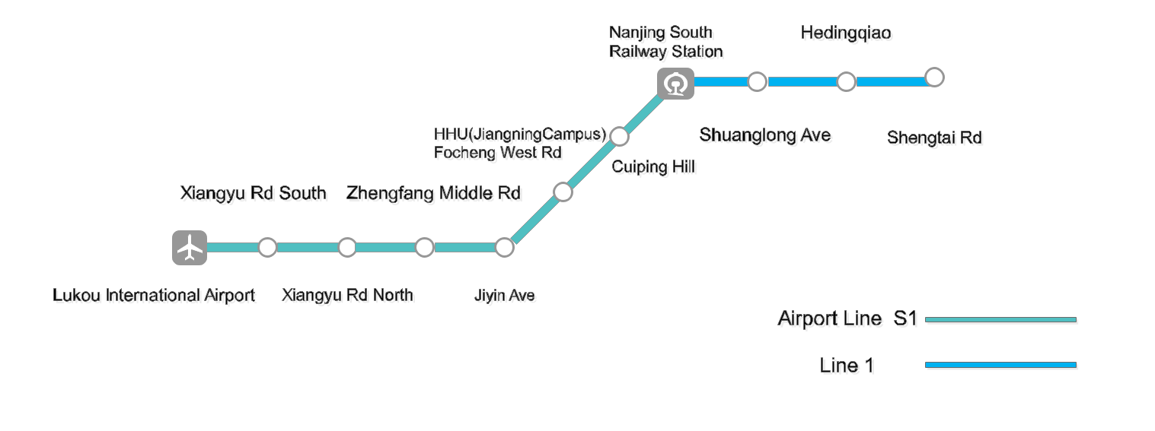
- Climate (early September in Nanjing)
Monthly average values of the temperature and precipitation in Nanjing are given in the table below:
 | September
Average max temperature | 27C / 80F
Average minimum temperature | 19C / 66F
Average precipitation | 82 mm
For further information on climate please click here (in Chinese here).
- Passports and Visas
All foreign visitors entering China must have a valid passport. Visitors from countries whose citizens require a visa should apply for a visa at the Chinese Embassy or Consulate in your area as early as possible and well in advance of travel.
You may need a letter of invitation from the Chinese host, which you will need to present to the Chinese Embassy/Consulate in your area in order to obtain your visa. The visa must be requested as soon as possible and at least one month before the start date of the meeting and obtained from the office (Embassy or Consulate) representing China in your country or, if there is no such office in your country, from the one that is closest to the country of departure.
In order to receive an invitation letter, your request should reach the host at the following
e-mail: chenhui.xu@c-its.org before 6 July 2018. Please:
- Fill out Form 1 below
- Provide an electronic copy of your passport (name, date of birth, nationality, passport number, expiration date of passport, etc. must be clearly visible)
- Provide the electronic copy of previous Chinese visas and records if you have been to China before
- Send the info in a), b) and c) as e-mail attachments to chenhui.xu@c-its.org ; please mark as reference in the subject:
“Invitation letter request for joint ITU/C-ITS international Forum on ITS (6-7 Sept 2018)”.
Please do not forget to attach a legible copy of your passport photograph page before sending.

Form 1 – Form to be filled out to request a visa support letter:
Company
Applicant Information |  |  |  | Mr Miss Ms Mrs
 |  |  |  | Date of birth :
 |  |  |  | Place of Issue:
 | Date of Issue: |  |  | Date of Expiry:
 | Marital Status:
 | If the country in which you'll obtain your visa is different from your nationality, please indicate it here:
Address | Telephone Number:  Fax Number:  E-mail:
Note
Date of arrival in China |  |  | Date of departure from China
- List of recommended hotels
5.1 Lake Home (the closest to the Venue)
http://www.lakehome.cn/
Hotel Reservations: +86-25-52108111
Address: No. 1528 Shuanglong Ave, 211100 Jiangning, Nanjing
The distance from Lake Home to the meeting venue is approximately 20 m.
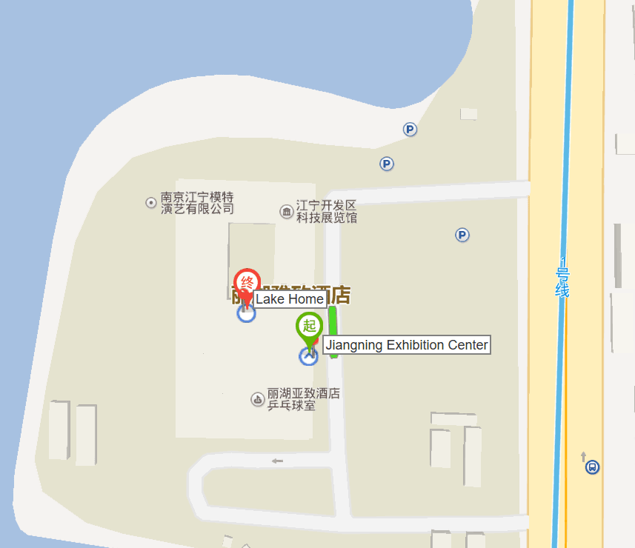

5.2 Marriott Nanjing South Hotel
https://www.marriott.com/hotels/travel/nkgsc-marriott-nanjing-south-hotel/
Hotel Reservations: +86-4001181585
Address: No. 1519 Shuanglong Avenue, 211100 Jiangning, Nanjing
The distance from Marriott Nanjing South Hotel to the meeting venue is approximately 0.42km
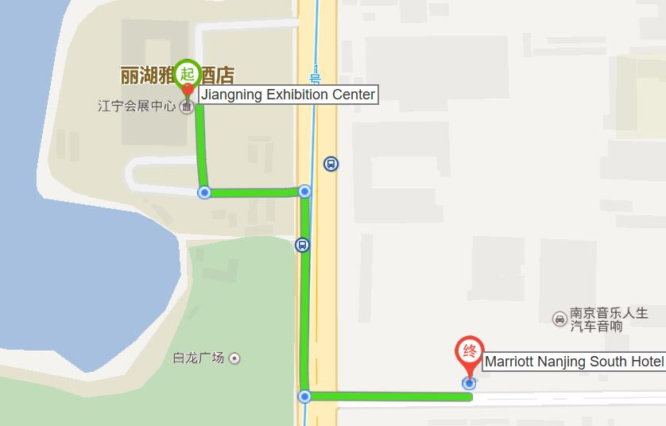
5.3 Jingling Resort
http://jinlingresortnanjing.com/
Hotel Reservations: +86-025-52107666
Address: No. 8 East Jiahu Road, 211100 Jiangning, Nanjing
The distance from Jingning Resort to the meeting venue is approximately 1.1km
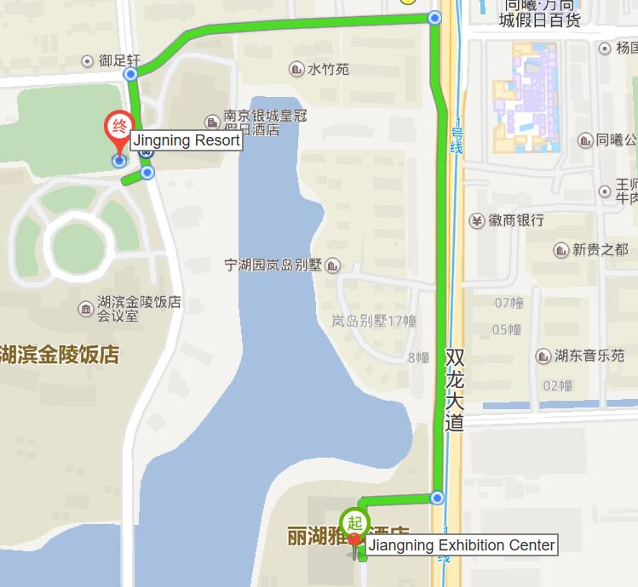
5.4 Crowne Plaza Nanjing Jiangning
https://www.ihg.com/crowneplaza/hotels/us/en/nanjing/nkgnj/hoteldetail
Hotel Reservations: +86-025-81038888
Address: No. 9 East Jiahu Road, 211100 Jiangning, Nanjing
The distance from Crowne Plaza Nanjing Jiangning to the meeting venue is about 1.1 km.
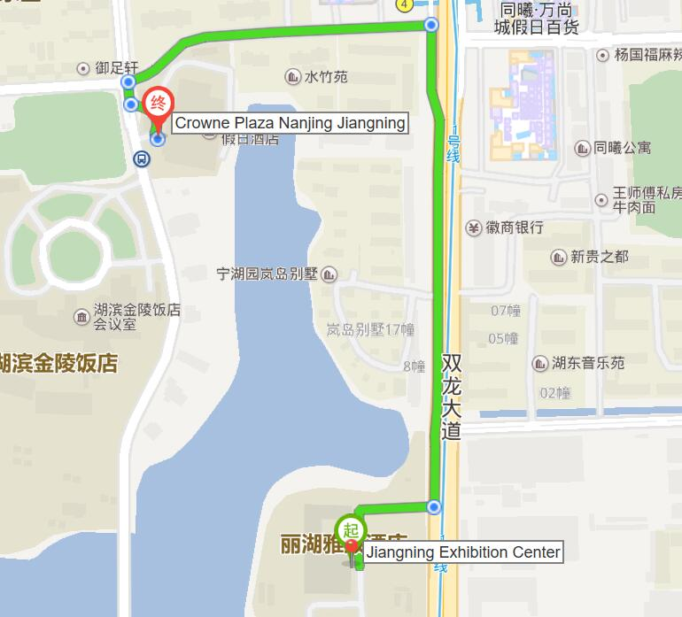

- Internet access and wireless coverage at the venue
All meeting rooms will have a wireless network with access to the Internet. Every guest room offers high-speed Internet access free of charge. Internet access will be provided using the LAN technologies listed below:
Wireless via Wi-Fi: IEEE 802.11a/n on 5.8 GHz and 802.11g/n on 2.4 GHz.
- Technical assistance
In case you have any technical problems at the venue (e.g., connecting to Internet, finding meeting rooms, etc.) please contact for help:
Mr Wang Yan: +86- 025-86125106, ynwy17@163.com
- Electricity
The electricity in China is generally 220V, 50 Hz. Please make sure you have the proper adapter.
Chinese standard
Such sockets are common in China, Australia, New Zealand and many other countries.
- Currency exchange

The currency in China is the RMB Yuan (￥). The exchange rate of US$ and RMB is around 6.878. Please check the currency exchange rate in the local bank system or use the following link as a reference: http://www.xe.com/
- Additional information
10.1 Mobile phone: GSM and CDMA, WCDMA, TD-SCDMA, LTE services provided by China Mobile, China Unicom and China Telecom.
10.2 Tipping: Tipping is not necessary.
10.3 Time Zone: GMT+8:00.
10.4 Emergency Number: In case of emergency, please dial 110.
10.5 Sightseeing: For more information see http://www.gonanjingchina.com/
- Registration
International participants may register online on the ITU website:
http://itu.int/go/ITSforum/2018
Also, a registration form (in Chinese only), tailored for local participants, is available on the following webpage: http://www.itsforum.cn.
- Contacts
For any questions, please contact:
Mr Wang Yan
Phone: +86-025-86125106
Mobile: +86-13515103083
E-mail: ynwy17@163.com
For general information, please visit: http://itu.int/go/ITSforum/2018 and http://www.itsforum.cn.
______________

