International telecommunication union
Telecommunication Standardization Bureau
 |  |  | Geneva, 30 May 2018
Ref: | TSB Circular 89  TSB Workshops/SP |  | To:  - Administrations of Member States of the Union;  - ITU-T Sector Members;  - ITU-T Associates;  - ITU Academia
Contact: | Stefano Polidori
Tel: | +41 22 730 5858
Fax: | +41 22 730 5853
E-mail: | tsbevents@itu.int |  | Copy to:  - The Chairmen and Vice-Chairmen of ITU-T Study Groups;  - The Director of the Telecommunication Development Bureau;  - The Director of the Radiocommunication Bureau
Subject: | Meeting of the International Forum on ITS (ITS-2018) and the Collaboration on ITS Communication Standards (CITS), Nanjing, China, 6-7 September 2018
Dear Sir/Madam,
I would like to inform you that the ITS Industry Alliance (C-ITS) of China and the International Telecommunication Union (ITU) will convene a meeting of the International Forum on Intelligent Transport Systems (ITS-2018) – How Communications will Change Vehicles and Transport – co-located with the meeting of the Collaboration on ITS Communication Standards (CITS), 6-7 September 2018, Nanjing, China.
Both these events will take place at:
Jiangning Exhibition Center, Nanjing
(Lake Home Hotel)
No. 1528 Shuanglong Ave,211100 Jiangning, China
1 Background
To achieve Intelligent Transport Systems (ITS), the vehicle industry and the information and communication technology (ICT) industry continue to converge. Undoubtedly, this will provide new business opportunities and new scenarios to the benefit of the industry, as well as consumers and government agencies. Fresh approaches are expected to grow to develop innovative technologies to support a range of smart city solutions; this will enable more intelligent transport systems aiming at better road safety, reduced traffic congestion, and increased connectivity and mobility for urban dwellers.
But how can these two very different industries find ways to collaborate to extend the benefits of connected vehicle innovation safely to everyone?
In this ITS landscape, automated driving is moving towards commercialization. The innovations leading to driverless vehicles on the road are planned in parallel to innovations in the field of vehicles' energy. The international community is attentive to the environmental challenges and aims to reduce the emissions to mitigate climate change. The future ITS can only be imagined with autonomous and environmentally friendly vehicles, powered by alternative fuels and advanced vehicle technologies, also aiming to increase the accessibility of personal mobility to the elderly and persons with disabilities.
2 International Forum on ITS (ITS-2018)
From 6-7 September 2018, the International Forum on Intelligent Transport Systems (ITS-2018) – How Communications will Change Vehicles and Transport – will bring together representatives of the vehicle and ICT industries, academia, and governments to discuss the status and future of intelligent transport systems, from a technical and policy point of view.
This International Forum will explore the relationship between telecommunication and ITS showcasing research towards next generation mobility. It will also analyse the crucial roles of governments and the private sector in enhancing connectivity and cybersecurity as well as the importance of studies in the field of new energy and artificial intelligence.
The event starts in the morning of 6 September at 0930 hours with an opening ceremony followed by technical sessions. See ANNEX A below for a preliminary program.
More information, including logistics and an updated program, will be available online at: http://itu.int/go/ITSforum/2018
3 Collaboration on ITS Communication Standards (CITS)
The afternoon of 7 September 2018, the meeting of the Collaboration on ITS Communication Standards (CITS) will review the state of ITS communication standards and discuss the road ahead.
The CITS meeting provides an opportunity to collaborate, exchange information and keep experts updated on ITS standardization. The representatives of various involved standards bodies are invited to submit to the CITS meeting a status report on ITS standardization ongoing in their respective organizations. These progress reports should be sent to Mr Stefano Polidori (ITU) at tsbcits@itu.int.
A draft agenda, meeting documents and additional information will be made available on the CITS website at: https://www.itu.int/go/cits.
4 Registration and other logistics information
To enable the host to make the necessary arrangements concerning the organization of these events, I should be grateful if you would register as soon as possible, but no later than 6 August 2018, at the following URLs:
To attend the International Forum on ITS (ITS-2018):
– International participants may register on the ITU website:
http://itu.int/go/ITSforum/2018.
– Local participants may register on the local website (in Chinese only)
http://www.itsforum.cn.
To attend the meeting of the Collaboration on ITS Communication Standards (CITS):
– Please register on the CITS website:
https://www.itu.int/go/cits.
Please note that pre-registration of participants is carried out exclusively online. Participants will be able to register on-site on the day of the meeting. However, online registration is requested.
Remote participation will be possible for the CITS meeting. If you wish to attend remotely, please indicate so when registering and check the event websites periodically for new updates.
Participation in these events is open to ITU Member States, Sector Members, Associates, and Academic Institutions and to any individual from a country which is a member of ITU. This includes individuals who are also members of international, regional, and national organizations.
Participation is free of charge. No fellowships will be provided for these meetings. The discussions will be held in English only.
A list of hotels in proximity to the meeting venue and other logistical information, including visa information, can be found on the event websites and in ANNEX B below.
I would remind you that citizens of some countries are required to obtain a visa in order to enter and spend time in China. The visa must be obtained from the office (embassy or consulate) representing China in your country or, if there is no such office in your country, from the one that is closest to the country of departure. Should you need an invitation letter, please see ANNEX B below.
Yours faithfully,
(signed)
Chaesub Lee
Director of the Telecommunication
Standardization Bureau

ANNEX A

Draft Program

International Forum on ITS (ITS-2018)

“How communications will change vehicles and transport”

(6-7 September 2018, Nanjing, China)
Day 1: (6 September)
0930 – 1100 | Opening ceremony  (Plenary room)
Coffee Break
Session 1 – Plenary presentations
(Plenary room)
1130 – 1300
Lunch Break
1400 – 1530 | Session 2A* – ITS Policy and ITS Industry evolution  (Room A) | Session 2B* – New Energy Vehicles and Intelligent Connected Vehicles  (Room B)
Coffee break
1600 – 1730
Day 2: (7 September)
0930 – 1100 | Session 3A* – Intelligent transport infrastructure  (Room A) | Session 3B* – ITS for smart cities  (Room B)
Coffee break
1130 – 1300
Lunch Break
1400 - 1730 | A technical visit for attendees will be organized by the host  (TBD) | Meeting of the “Collaboration on ITS Communication Standards” (CITS)  (Room C)
* NOTE: Sessions 2A and 2B, as well as Sessions 3A and 3B run in parallel in different rooms

ANNEX B

LOGISTICS, VISA AND OTHER PRACTICAL INFORMATION

International Forum on ITS (ITS-2018)
(Nanjing, China, 6-7 September 2018)

Meeting venue
Jiangning Exhibition Center, Nanjing
Tel：+86-25-5210-8111
Fax：+86-25-8103-1436
Address：No. 1528 Shuanglong Ave, 211100 Jiangning, China
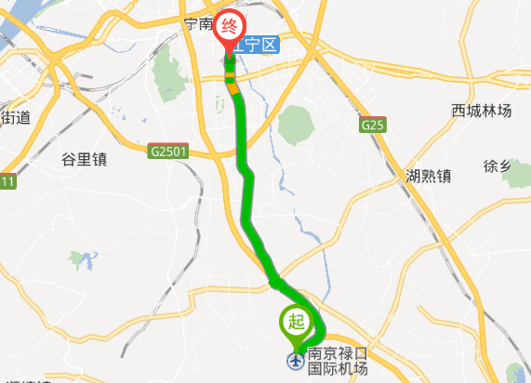
NanJingLukou International Airport
Venue

Transportation and venue information
31 km to Lukou International Airport; 6 km to Nanjing South railway station; 20 km to the Nanjing railway station.
Once you arrive at the Lukou International Airport, you may reach the venue by:
1) Taxi: 20 mins by car
– Nanjing Lukou airport service telephone number: (international calls: +86-25-968890 / local calls: 025-968890)
You may ask the staff about taxi services. Please find below a map of the arrival level facilities at the airport.
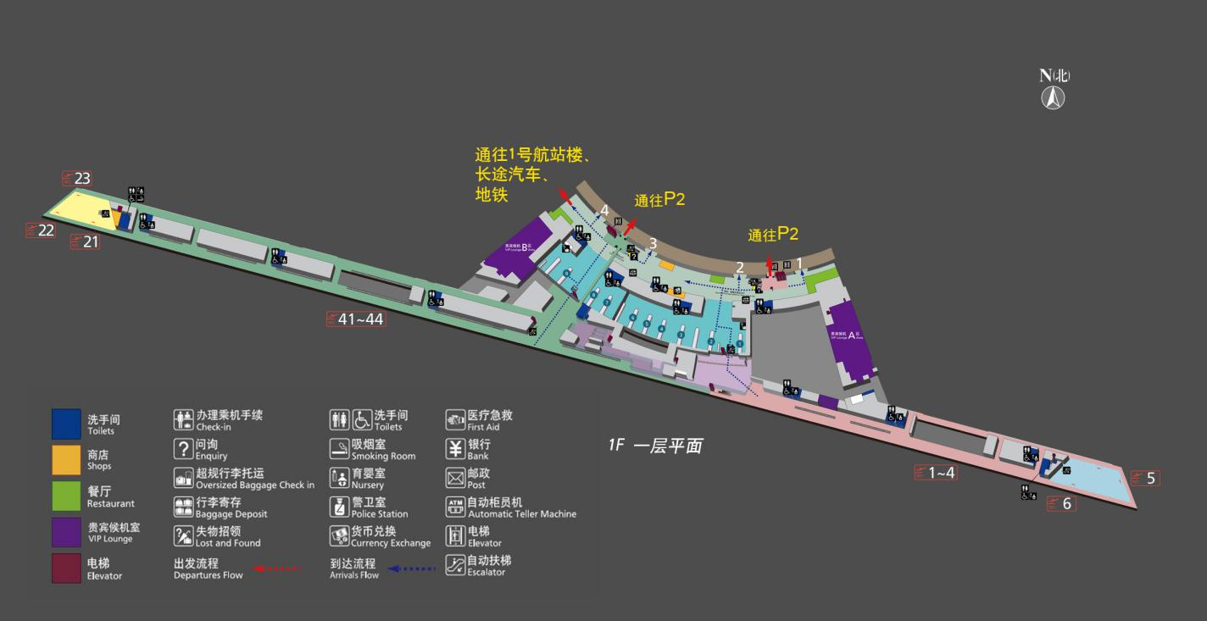
Enquiry
Enquiry
Access to P2
Access to P2
Access to Terminal 1, coach, subway
2) Subway:
– Take Line S1 from Nanjing Lukou International Airport to Nanjing South Railway Station
– Transfer to Line 1 (from Nanjing South Railway Station to Shengtai Road).
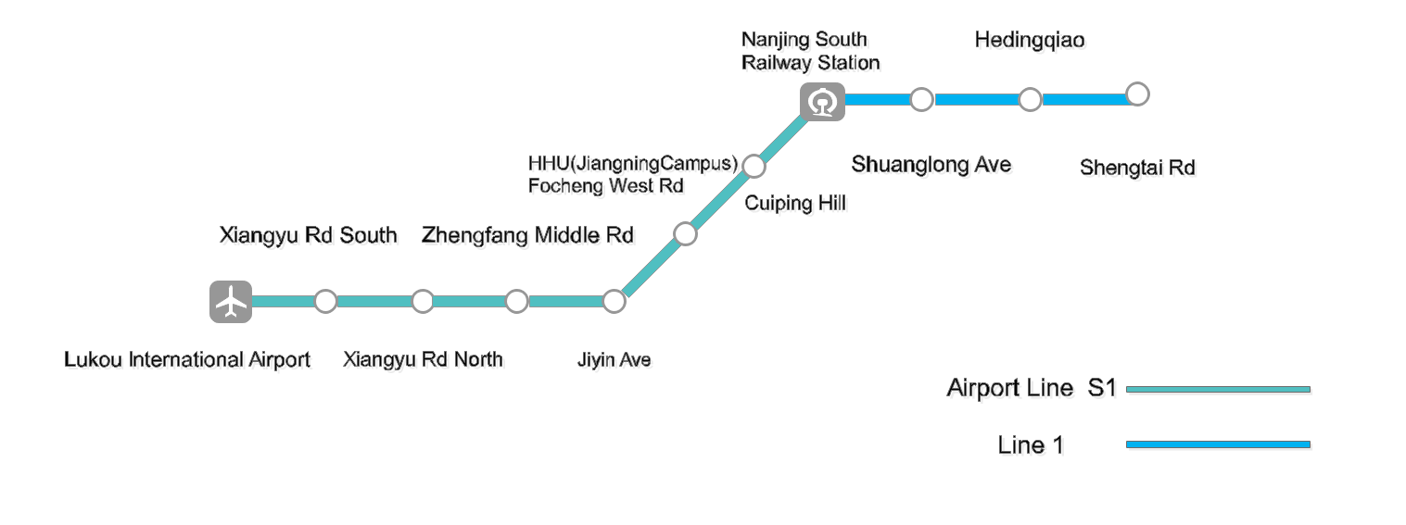

Climate (early September in Nanjing)
Monthly average values of the temperature and precipitation in Nanjing are given in the table below:
 | September
Average max temperature | 27C / 80F
Average minimum temperature | 19C / 66F
Average precipitation | 82 mm
For further information on climate please click here (in Chinese here).

Passports and Visas
All foreign visitors entering China must have a valid passport. Visitors from countries whose citizens require a visa should apply for a visa at the Chinese Embassy or Consulate in your area as early as possible and well in advance of travel.
You may need a letter of invitation from the Chinese host, which you will need to present to the Chinese Embassy/Consulate in your area in order to obtain your visa. The visa must be requested as soon as possible and at least one month before the start date of the meeting and obtained from the office (Embassy or Consulate) representing China in your country or, if there is no such office in your country, from the one that is closest to the country of departure.
In order to receive an invitation letter, your request should reach the host at the following
e-mail: chenhui.xu@c-its.org before 6 July 2018. Please:
- Fill out Form 1 below
- Provide an electronic copy of your passport (name, date of birth, nationality, passport number, expiration date of passport, etc. must be clearly visible)
- Provide the electronic copy of previous Chinese visas and records if you have been to China before
- Send the info in a), b) and c) as e-mail attachments to chenhui.xu@c-its.org ; please mark as reference in the subject:
“Invitation letter request for joint ITU/C-ITS international Forum on ITS (6-7 Sept 2018)”.
Please do not forget to attach a legible copy of your passport photograph page before sending.

Form 1 – Form to be filled out to request a visa support letter:
Company
Applicant Information |  |  |  | Mr Miss Ms Mrs
 |  |  |  | Date of birth :
 |  |  |  | Place of Issue:
 | Date of Issue: |  |  | Date of Expiry:
 | Marital Status:
 | If the country in which you'll obtain your visa is different from your nationality, please indicate it here:
Address | Telephone Number:  Fax Number:  E-mail:
Note
Date of arrival in China |  |  | Date of departure from China

List of recommended hotels
5.1 Lake Home (the closest to the Venue)
http://www.lakehome.cn/
Hotel Reservations: +86-25-52108111
Address: No. 1528 Shuanglong Ave, 211100 Jiangning, Nanjing
The distance from Lake Home to the meeting venue is approximately 20 m.
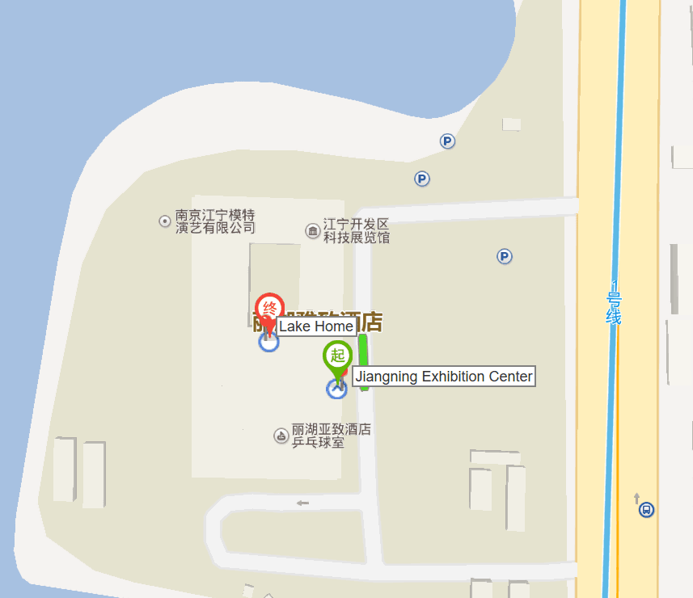

5.2 Marriott Nanjing South Hotel
https://www.marriott.com/hotels/travel/nkgsc-marriott-nanjing-south-hotel/
Hotel Reservations: +86-4001181585
Address: No. 1519 Shuanglong Avenue, 211100 Jiangning, Nanjing
The distance from Marriott Nanjing South Hotel to the meeting venue is approximately 0.42km
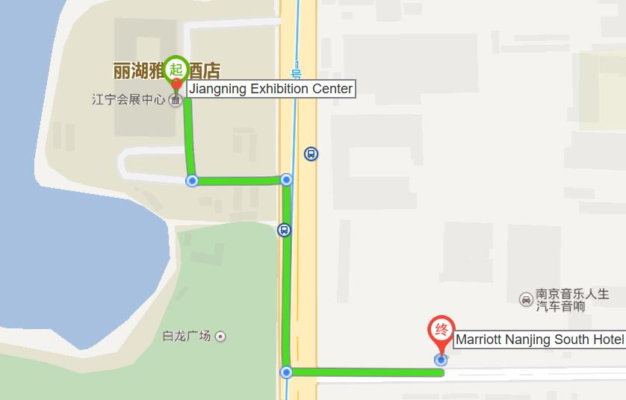
5.3 Jingling Resort
http://jinlingresortnanjing.com/
Hotel Reservations: +86-025-52107666
Address: No. 8 East Jiahu Road, 211100 Jiangning, Nanjing
The distance from Jingning Resort to the meeting venue is approximately 1.1km
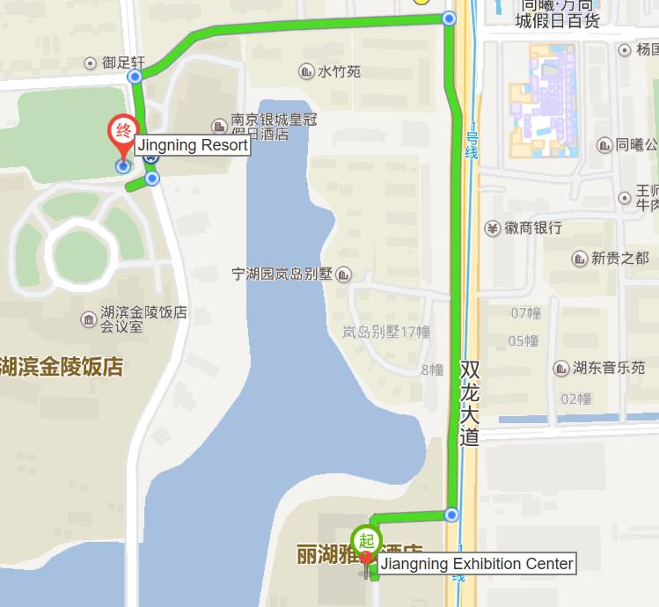
5.4 Crowne Plaza Nanjing Jiangning
https://www.ihg.com/crowneplaza/hotels/us/en/nanjing/nkgnj/hoteldetail
Hotel Reservations: +86-025-81038888
Address: No. 9 East Jiahu Road, 211100 Jiangning, Nanjing
The distance from Crowne Plaza Nanjing Jiangning to the meeting venue is about 1.1 km.
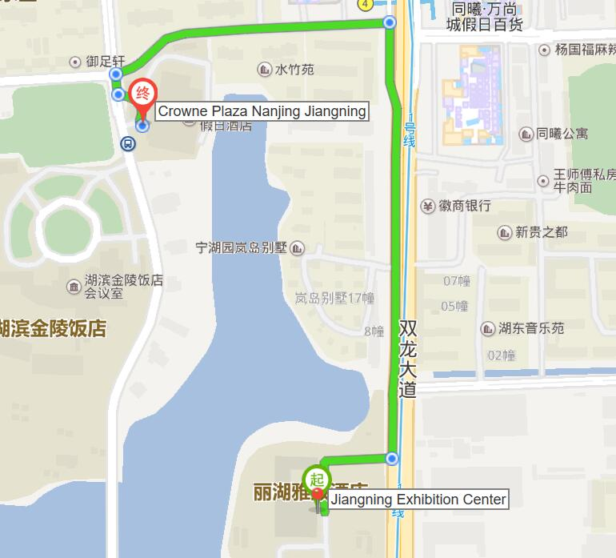

Internet access and wireless coverage at the venue
All meeting rooms will have a wireless network with access to the Internet. Every guest room offers high-speed Internet access free of charge. Internet access will be provided using the LAN technologies listed below:
Wireless via Wi-Fi: IEEE 802.11a/n on 5.8 GHz and 802.11g/n on 2.4 GHz.

Technical assistance
In case you have any technical problems at the venue (e.g., connecting to Internet, finding meeting rooms, etc.) please contact for help:
Mr Wang Yan: +86- 025-86125106, ynwy17@163.com

Electricity
The electricity in China is generally 220V, 50 Hz. Please make sure you have the proper adapter.
Chinese standard
Such sockets are common in China, Australia, New Zealand and many other countries.

Currency exchange

The currency in China is the RMB Yuan (￥). The exchange rate of US$ and RMB is around 6.878. Please check the currency exchange rate in the local bank system or use the following link as a reference: http://www.xe.com/

Additional information
10.1 Mobile phone: GSM and CDMA, WCDMA, TD-SCDMA, LTE services provided by China Mobile, China Unicom and China Telecom.
10.2 Tipping: Tipping is not necessary.
10.3 Time Zone: GMT+8:00.
10.4 Emergency Number: In case of emergency, please dial 110.
10.5 Sightseeing: For more information see http://www.gonanjingchina.com/

Registration
International participants may register online on the ITU website:
http://itu.int/go/ITSforum/2018
Also, a registration form (in Chinese only), tailored for local participants, is available on the following webpage: http://www.itsforum.cn.

Contacts
For any questions, please contact:
Mr Wang Yan
Phone: +86-025-86125106
Mobile: +86-13515103083
E-mail: ynwy17@163.com
For general information, please visit: http://itu.int/go/ITSforum/2018 and http://www.itsforum.cn.
_________________

