International telecommunication union
Telecommunication Standardization Bureau
 |  |  | Geneva, 10 August 2023
Ref: | Corrigendum 1 to  TSB Collective letter 3/20  SG20/CB |  | - To Administrations of Member States of the Union;  - To ITU-T Sector Members;  - To ITU-T Associates of Study Group 20;  - To ITU Academia
Tel: | +41 22 730 6301
Fax: | +41 22 730 5853
E-mail: | tsbsg20@itu.int
Web: | https://itu.int/go/tsg20
Subject: | Meeting of Study Group 20 and events; Arusha, 12-22 September 2023
Dear Sir/Madam,
We would like to inform you that for the ITU-T Study Group 20 (Internet of things (IoT) and smart cities and communities (SC&C)) opening plenary (13 September 2023), SG20 plenary and liaison statement session (20 September 2023) and closing plenary (22 September 2023) that will take place in Arusha, Tanzania, only the webcast will be provided.
All other sessions are supported by interactive remote participation on a best effort. In order to access sessions remotely, delegates must register for the meeting.
Participants should be aware that, as per usual practice, the meeting will not be delayed or interrupted because of a remote participant’s inability to connect, listen, or be heard, at the Chairman’s discretion. If the voice quality of a remote participant is considered insufficient, the Chairman may interrupt the remote participant and may refrain from giving the participant the floor until there is indication that the problem is resolved.
I wish you a productive and enjoyable meeting.
Yours faithfully,  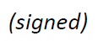  Seizo Onoe  Director of the Telecommunication  Standardization Bureau | 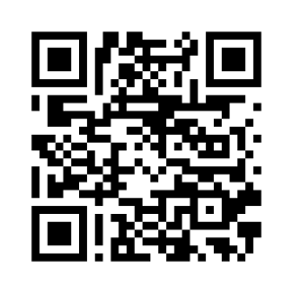 ITU-T SG20
 | Latest meeting information

