 | INTERNATIONAL TELECOMMUNICATION UNION  TELECOMMUNICATION  STANDARDIZATION SECTOR  STUDY PERIOD 2022-2024 |  |  |  | TSAG-TD467
 |  |  |  |  | TSAG
 |  |  |  |  | Original: English
Question(s): |  |  | RG-WM |  | Geneva, 22-26 January 2024
TD
Source: |  |  | Rapporteur, TSAG Rapporteur group on working methods
Title: |  |  | New draft Recommendation ITU-T A.JCA "Joint coordination activities: Establishment and working procedures"
Contact: |  | Olivier Dubuisson  Orange  France |  | E-mail: olivier.dubuisson@orange.com
Contact: |  | Mr Stefano Polidori  TSB; Secretary RG-WM |  | E-mail: stefano.polidori@itu.int

Abstract: | At the ad hoc session, Monday 22 Jan 2024, 1745-1930, it was agreed that Rec. ITU-T A.1, clause 5 on JCAs will be moved to a new Recommendation A.JCA. It was further agreed that both A.1-rev and A.JCA will be processed as a bundle (i.e. determination, TAP consultation and approval together).
Action: RG-WM is invited to discuss this document (focussing on text which is not green-highlighted) with the goal to determine both ITU-T A.1-rev and A.JCA (for TAP consultation) at this TSAG meeting.

Text in yellow-highlighted boxes is a proposal from the ITU-T A.1-rev editor for a compromise text considering the different proposals in previous boxes. It is suggested to take this text as a basis for discussion.
Green-highlighted text has already been reviewed and is considered to have been agreed by consensus. Consequently, the meeting will concentrate on clauses that are not green-highlighted.
Recommendation ITU-T A.JCA
Joint coordination activities:
Establishment and working procedures
Summary
A Joint Coordination Activity (JCA) is formed to coordinate activities on topics of relevance across ITU-T study groups. They report their progress either to TSAG or to a particular study group. JCAs do not write Recommendations. Their working methods are documented in this Recommendation.
Keywords
Joint coordination activities.

1 Scope
A joint coordination activity is a tool for management of the work programme of ITU-T when there is a need to address a broad subject covering the area of competence of more than one study group (see also [WTSA Res. 22]). A JCA may help to coordinate the planned work effort in terms of subject matter, time-frames for meetings, collocated meetings where necessary and publication goals including, where appropriate, release planning of the resulting Recommendations.
The establishment of a JCA aims mainly at improving coordination and planning. The work itself will continue to be conducted by the relevant study groups and the results are subject to the normal approval processes within each study group. A JCA may identify technical and strategic issues within the scope of its coordination role, but will not perform technical studies nor write Recommendations. A JCA may also address coordination of activities with recognized standards development organizations (SDOs) and forums, including periodic discussion of work plans and schedules of deliverables. The study groups take JCA suggestions into consideration as they carry out their work.

2 References
The following ITU-T Recommendations and other references contain provisions which, through reference in this text, constitute provisions of this Recommendation. At the time of publication, the editions indicated were valid. All Recommendations and other references are subject to revision; users of this Recommendation are therefore encouraged to investigate the possibility of applying the most recent edition of the Recommendations and other references listed below. A list of the currently valid ITU-T Recommendations is regularly published. The reference to a document within this Recommendation does not give it, as a stand-alone document, the status of a Recommendation.
[WTSA Res. 1] WTSA Resolution 1 (Rev. Geneva, 20226), Rules of procedure of the ITU Telecommunication Standardization Sector.
[WTSA Res. 2] WTSA Resolution 2 (Rev. Geneva, 2022), ITU Telecommunication Standardization Sector study group responsibility and mandates.

3 Definitions

3.1 Terms defined elsewhere
This Recommendation uses the following terms defined elsewhere:
3.1.1 work item: [b-ITU-T A.1]: An assigned piece of work, which is identifiable with a Question and which has specific or general objectives, which will result in a product, usually a Recommendation, for publication by ITU-T.
3.1.2 work programme: [b-ITU-T A.1]: A list of work items that are owned by a study group.

3.2 Terms defined in this Recommendation
None.

4 Abbreviations and acronyms
This Recommendation uses the following abbreviations and acronyms:
JCA Joint Coordination Activity

5 Conventions
None.

6 Establishment and working procedures
6.1 Any group (study group or TSAG) may propose that a JCA be established. The proposal to establish a JCA should first be discussed within the proposing group's management team, then among the relevant study group chairs and the TSAG chair. Discussions may be held with external SDOs and forum leaders. Figure 6-1 provides a schematic of the alternatives in proposing and approving the creation of a JCA.

AFCP/35A30/1:
If the subject of the JCA is under the responsibility and mandate of the study group (as described in [WTSA Res.2]) proposing the establishment of the JCA then the study group may establish a JCA on its own authority. If a study group meeting is pending within the next two months, then an electronic notification4 proposing the JCA, including the terms of reference (including scope, objectives and anticipated lifetime) and the chair, is published four weeks prior to the study group meeting, giving opportunity for the membership to give their position at the meeting. If this is done at least four weeks prior to the study group meeting, following the resolution of any comments, the JCA may be established by the study group by consensus at its meeting. If a study group meeting is not pending within the next two months, then an electronic notification as above is sent for the membership to give their position by electronic response. If the notification is sent less than four weeks before the study group meeting, no decision is taken at the study group meeting; the decision may be taken four weeks after the notification, excluding the meeting time. If necessary, the proposal is adjusted taking into consideration comments received and made available to the study group electronically for decision with a further four-week interval. If there are no substantive comments, the JCA is considered approved. TSAG will be informed for review, possible comment, and endorsement. TSAG may consider the terms of reference of the JCA in the context of the overall work programme of ITU-T and may provide comments to modify the terms of reference.
6.1.1 If the study group proposing the establishment of the JCA has been designated as the lead study group by WTSA or TSAG according to Section 2 of [WTSA Res. 1], and if the subject is under their responsibility and mandate as described in [WTSA Res. 2], then the study group may establish a JCA on its own authority.
a. If a study group meeting is pending within the next two months, then an electronic notification proposing the JCA, including the terms of reference (with scope, objectives and anticipated lifetime) and the chair, is published at least four weeks prior to the study group meeting, giving opportunity for the membership to give their position at the meeting. Following the resolution of any comments, the JCA may be established by the study group by consensus at its meeting.
b. If a study group meeting is not pending within the next two months, then an electronic notification as above is sent for the membership to give their position by electronic response.
c. If the notification is sent less than four weeks before the study group meeting, no decision is taken at the study group meeting; the decision may be taken four weeks after the notification, excluding the meeting time. If necessary, the proposal is adjusted taking into consideration comments received and made available to the study group electronically for decision with a further four-week interval. If there are no substantive comments, the JCA is considered approved.
TSAG will be informed for review, possible comment, and endorsement. TSAG may consider the terms of reference of the JCA in the context of the overall work programme of ITU-T and may provide comments to modify the terms of reference.

AFCP/35A30/1:
Where the subject for the JCA is a broad subject potentially falling under the responsibility and mandate of a number of study groups as described in [WTSA Res. 2], then the proposal has to be made available to the membership for consideration. If a TSAG meeting is pending within the next two months, then an electronic notification⁵ proposing the JCA, including the terms of reference (including scope, objectives and anticipated lifetime) and the chair, is published four weeks prior to the TSAG meeting, giving opportunity for the membership to give their position at the meeting. If this is done at least four weeks prior to the TSAG meeting, following the resolution of any comments, the JCA may be established by TSAG by consensus at its meeting. If a TSAG meeting is not pending within the next two months, then an electronic notification as above is sent for the membership to give their position by electronic response. If the notification is sent less than four weeks before the TSAG meeting, no decision is taken at the TSAG meeting; the decision may be taken four weeks after the notification, excluding the meeting time. If necessary, the proposal is adjusted taking into consideration comments received and made available to the membership electronically for decision with a further four-week interval. If there are no substantive comments, the JCA is considered approved. The decision includes the designation of the group responsible (a study group or TSAG), the terms of reference (including scope, objectives and anticipated lifetime) and the chair.
6.1.2 Where the lead study group has not yet been designated by WTSA or TSAG for the subject, or where the subject for the JCA is a broad subject potentially falling under the responsibility and mandate of a number of study groups as described in [WTSA Res. 2], then the proposal has to be made available to the membership for consideration.
a. If a TSAG meeting is pending within the next two months, then an electronic notification proposing the JCA, including the terms of reference (with scope, objectives and anticipated lifetime) and the chair, is published at least four weeks prior to the TSAG meeting, giving opportunity for the membership to give their position at the meeting. This electronic notification should be sent to the general e-mail reflector for the potentially involved study groups and TSAG, and should also be a TD to the next meeting of TSAG. Following the resolution of any comments, the JCA may be established by TSAG by consensus at its meeting.
b. If a TSAG meeting is not pending within the next two months, then an electronic notification as above is sent for the membership to give their position by electronic response.
c. If the notification is sent less than four weeks before the TSAG meeting, no decision is taken at the TSAG meeting; the decision may be taken four weeks after the notification, excluding the meeting time. If necessary, the proposal is adjusted taking into consideration comments received and made available to the membership electronically for decision with a further four-week interval. If there are no substantive comments, the JCA is considered approved.
The decision includes the designation of the group responsible (a study group or TSAG), the terms of reference (with scope, objectives and anticipated lifetime) and the chair.

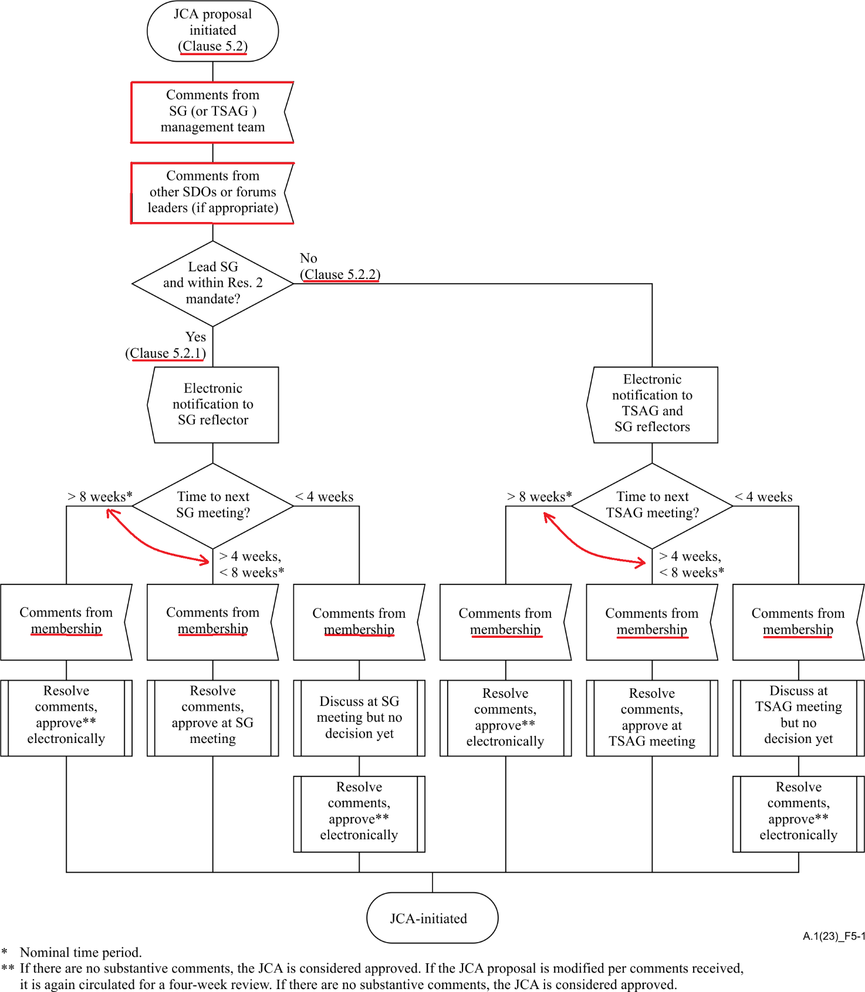
Figure 6-1 – Alternatives in proposing and approving the creation of a JCA
6.2 JCAs are open, but (to restrict their size) should primarily be limited to official representatives from the relevant study groups that are responsible for work covered by the scope of the JCA. A JCA may also include invited experts and invited representatives of other SDOs and forums, as appropriate. All participants should confine inputs to a JCA to the purpose of the JCA.
6.3 The establishment of a JCA is to be announced in a TSB circular, which should include the terms of reference of the JCA, the chair of the JCA, and the study group responsible for the JCA.
6.4 JCAs should work primarily by correspondence and electronic meetings. Any physical meeting considered necessary should be convened by the chair of the JCA. Physical meetings should be supported by conferencing capabilities where possible, and both physical and electronic meetings should be scheduled as far as practicable at times that will provide maximum opportunity for broad participation. It is anticipated that physical meetings will be in conjunction with the involved study group meetings (in which case it is reflected in the collective letter for that study group) as far as practicable, but if a separate meeting is to be held, it is to be announced at least four weeks in advance by an (electronic) collective invitation letter.
6.5 Inputs to the work of a JCA should be sent to the JCA chair and to the concerned TSB counsellor, and the latter will make these available to the members of the JCA.
6.6 JCAs may submit proposals to the relevant study groups to achieve alignment in the development of related Recommendations and other deliverables by the respective study groups. A JCA may also issue liaison statements.
6.7 JCA input and output documents (see clause 1), and reports are made available to the ITU-T membership. Reports are issued after each JCA meeting. TSAG may monitor JCA activities through these reports.
6.8 TSB will provide support for a JCA, within available resource limits.
6.9 A JCA may be terminated at any time if the involved study groups agree that the JCA is no longer required. A proposal to do so, including justification, may be submitted by any study group involved or by TSAG, and examined for decision by the study group responsible for the JCA, after consulting the involved study groups and TSAG (via electronic means, if a TSAG meeting is not pending in the near future). A JCA will be reviewed at the first TSAG meeting following the WTSA. A specific decision must be taken on the continuation of the JCA, potentially with adjusted terms of reference.

Bibliography
[b-ITU-T A.1] Recommendation ITU-T A.1 (???), Working methods for study groups of the ITU Telecommunication Standardization Sector.
_______________________

This electronic notification should be sent to the general e-mail reflector for the proposing study group and should also be a TD to the next meeting of the study group.

