 |  | International Telecommunication Union
 |  | ITU-T | Technical Paper
 |  | TELECOMMUNICATION  STANDARDIZATION SECTOR  OF ITU |  | (11 July 2014)
SERIES H: AUDIOVISUAL AND MULTIMEDIA SYSTEMS
Infrastructure of audiovisual services – Communication procedures

HSTP-H810
Introduction to the ITU-T H.810 Continua Design Guidelines

Summary
Continua is a non-profit, open industry organization of healthcare and technology companies joining together in collaboration to improve the quality of personal healthcare. Continua is dedicated to establishing a system of interoperable personal connected health solutions with the knowledge that extending those solutions into the home fosters independence, empowers individuals and provides the opportunity for truly personalized health and wellness management.
On 19 December 2013, an important milestone for global e-health standardization was achieved with final approval of a new global standard that will better enable interoperability between e-health devices. The standard – Recommendation ITU-T H.810 – contains Continua Design Guidelines (CDG) providing "Interoperability design guidelines for personal health systems". The CDG provide for end-to-end, plug-and-play connectivity in personal connected health devices, which are based on global industry standards for interoperability.
Devices such as wireless blood pressure cuffs, weight scales and a wide range of activity trackers can play a critical role in the prevention and improved management of chronic conditions such as diabetes, hypertension and heart disease. Establishing global interoperability standards will stimulate innovation and nourish the personal connected health ecosystem. For manufacturers, standards will decrease time-to-market, reduce development costs and increase efficiencies. In particular they will enable quicker, less expensive integration to electronic medical records (EMR) or health information exchange (HIE) platforms.
To enable this interoperability, Continua publishes and maintains a set of design guidelines that references industry standards and specifications, providing clarity around implementing these specifications and ensuring consistent implementation through product certification. Continua is the only industry organization that has successfully defined such interoperability guidelines for personal connected health devices.
Continua Design Guidelines employs near field communications (NFC) for its touch area network, Bluetooth Classic and Bluetooth Low Energy for its personal area network, and ZigBee for its local area network. The industry standard IEEE Exchange Protocol was chosen because it provides transport agnostic essential data structures necessary to ensure accurate and comprehensive understanding of the measured data upstream. Furthermore, it simplifies FDA approval of devices maintaining the IEEE protocols.
A wide area network interface employs Integrating the Healthcare Enterprise (IHE) profiles to facilitate sharing of personal health data across departmental and institutional boundaries [20 (pp. 87-94)]. The WAN interface standardizes around the data payload, message exchange framework, and security. The resulting interoperability simplifies the integration and consolidation of multiple data streams into a single database.
A health records network interface employs HL7 standards which are the world's most widely used standards for the exchange, management, and integration of electronic healthcare information for clinical and administrative purposes. Continua implements a continuity of care document-based personal health monitoring record because of its ability to meet current and anticipated future requirements and its growing adoption in the health record community.
A test and certification regime ensures interoperable personal connected health solutions are compliant with the Continua Design Guidelines
As Continua moves into the mobility space, it is important for mobile device manufacturers and cellular network operators to understand the selected health standards, specifications and implementation to properly assess their impact to mobile product designs and network performance. Just as important, mobile device manufacturers and network operators are strongly encouraged to work with the mobile healthcare community the help it leverage the efficiencies designed into mobile devices and cellular networks.
Change Log
This document contains Version 1 of the ITU-T Technical Paper "Introduction to the ITU-T H.810 Continua Design Guidelines" approved at the ITU-T Study Group 16 meeting held in Sapporo, Japan, 11 July 2014.

Editor: | Michael J. Kirwan  Continua  USA | Tel: +1-913-207-8226  Fax: +1-913-207-8226  Email: mkirwan@continuaalliance.org

CONTENTS
Page
1 Scope 1
2 References 1
3 Abbreviations 2
4 Glossary 4
5 Introduction 6
6 System overview 7
7 Local area networks interface 8
7.1 Common interface considerations 8
7.2 Touch area network interface 9
7.3 Personal area network interface 10
7.4 LAN interface 10
8 Wide area network interface 11
8.1 Data payload 11
8.2 Message exchange framework 13
8.3 Security 14
9 Health records network interface 14
9.1 Messaging infrastructure and transport 15
9.2 Messaging and transport 16
9.3 Data and transport 16
9.4 Security 16
9.5 Consent management and enforcement 17
10 Continua test & certification program 17
10.1 Conformance testing 17
10.2 Interoperability testing 17

List of Figures
Page
Figure 1: Current Continua architecture 8
Figure 2: TAN/PAN/LAN interface stack diagram 9
Figure 3: WAN scope 11
Figure 4: Sample PCD-01 message [21] 13
Figure 5: HRN scope 15

ITU-T Technical Paper HSTP-H810
ITU-T Technical Paper
Introduction to the ITU-T H.810 Continua Design Guidelines

Summary
The purpose of this technical paper is to provide a high level overview of the Continua Design Guidelines, an introduction to each of the standards and specifications that were chosen by its members to be part of the design guidelines, and the rationale behind their selection. The reader is invited to read the Continua Design Guidelines itself for a comprehensive understanding.

Scope
Local area network technologies are briefly summarized along with their rationale for selection as these are more broadly understood in the electronics industry. Overviews of the WAN and HRN interfaces and their standards selection and rationale are elaborated as they are less well understood by newcomers to the healthcare industry and to the Continua Design Guidelines.

References
- Bluetooth SIG, Personal Health Devices Transcoding White Paper, v1.4.
<https://www.bluetooth.org/DocMan/handlers/DownloadDoc.ashx?doc_id=272346>
- ITU-T H.810 (2013), Interoperability design guidelines for personal health systems.
<http://itu.int/ITU-T/H.810>
- ISO/IEEE 11073-20601:2010, Health informatics — Personal health device communication — Part 20601 – Application profile – Optimized exchange profile.
<http://www.iso.org/iso/catalogue_detail.htm?csnumber=54331>
- ANSI/Health Level Seven (2005-04), HL7 Clinical Document Architecture, Release 2.0.
<http://www.hl7.org/documentcenter/private/standards/cda/r2/cda_r2_normativewebedition2010.zip>
- Health Level Seven (2007-04), HL7 Implementation Guide for CDA Release 2: Continuity of Care Document (CCD). A CDA implementation of ASTM E2369-05.
<http://www.hl7.org/Library/General/HL7_CCD_final.zip>
- Health Level Seven (2010-10), HL7 Implementation Guide for CDA Release 2: Personal Healthcare Monitoring Report, DSTU Release 1.1.
<http://www.hl7.org/documentcenter/public/standards/dstu/CDAR2_IG_PHMRPTS_R1.1_DSTU_2010OCT.zip>
- Health Level 7 (2007), HL7 Messaging Standard Version 2.6.
<http://www.hl7.org/documentcenter/private/standards/V26/HL7_Messaging_v26_PDF.zip>
- Integrating the Healthcare Enterprise (2012-08), IHE Patient Care Device Technical Framework – Revision 2.0. Volume 1: Integration Profiles.
<http://www.ihe.net/Technical_Framework/upload/IHE_PCD_TF_Rev2-0_Vol1_FT_2012-08-16.pdf>
- Integrating the Healthcare Enterprise (2012-08), IHE Patient Care Device Technical Framework – Revision 2.0. Volume 2: Transactions.
<http://www.ihe.net/Technical_Framework/upload/IHE_PCD_TF_Rev2-0_Vol2_FT_2012-08-16.pdf>
- IHE IT Infrastructure (ITI), Technical Framework Supplement: Document Digital Signature 2009-2010. Trial Implementation Supplement.
<http://www.ihe.net/Technical_Framework/upload/IHE_ITI_TF_Supplement_Digital_Signature-2009-08-10.pdf>
- Integrating the Healthcare Enterprise (2009-08), IHE IT Infrastructure Technical Framework, Volume 1 (ITI TF-1): Integration Profiles, Revision 6.0.
<http://www.ihe.net/Technical_Framework/upload/IHE_ITI_TF_6-0_Vol1_FT_2009-08-10-2.pdf>
- Integrating the Healthcare Enterprise (2009-08), IHE IT Infrastructure Technical Framework, Volume 2 (ITI TF-2), Revision 6.0 (in particular its Appendix V, Web Services for IHE Transactions).
<http://www.ihe.net/Technical_Framework/upload/IHE_ITI_TF_6-0_Vol2x_FT_2009-08-10.pdf>
- Integrating the Healthcare Enterprise (2009-08), IHE IT Infrastructure Technical Framework, Volume 1 (ITI TF-1): Integration Profiles, Revision 6.0.
<http://www.ihe.net/Technical_Framework/upload/IHE_ITI_TF_6-0_Vol1_FT_2009-08-10-2.pdf>
- Integrating the Healthcare Enterprise (2009), IHE IT Infrastructure (ITI) Technical Framework Volume 1 (ITI TF-1) Integration Profiles, Revision 6.0, IHE Cross-Enterprise Document Media Interchange (XDM) profile.
- Integrating the Healthcare Enterprise (2011-08), IHE IT Infrastructure Technical Framework, Supplement for Trial Implementation - Document Encryption (DEN).
<http://www.ihe.net/Technical_Framework/upload/IHE_ITI_Suppl_DEN_Rev1-1_TI_2011-08-19.pdf>
- ISO 27000 (2012), Information technology - Security techniques - Information security management systems - Overview and vocabulary.
- Bluetooth SIG, Personal Health Devices Transcoding White Paper, v1.4. <https://www.bluetooth.org/DocMan/handlers/DownloadDoc.ashx?doc_id=272346>
- OASIS/WS-I (2006-04), Basic Profile Version 1.1.
<http://www.ws-i.org/Profiles/BasicProfile-1.1.html>
- OASIS/WS-I (2007-03), WS-I Basic Security Profile Version 1.0.
<http://www.ws-i.org/Profiles/BasicSecurityProfile-1.0.html>
- Benson, T. (2012), Principles of Health Interoperability HL7 and SNOMED. 2nd ed.
<http://www.springer.com/public+health/book/978-1-4471-2800-7>
- Integrating the Healthcare Enterprise (2012-08), IHE IT Infrastructure Technical Framework, Supplement for Trial Implementation - Pulse Oximetry Integration (POI).
<http://www.ihe.net/Technical_Framework/upload/IHE_PCD_Suppl_POI.pdf>

Abbreviations
ADT | Admit Discharge Transfer
AHD | Application Hosting Device
BLE | Bluetooth Low Energy
BSP | Basic Security Profile
CCD | Continuity of Care Document
CCR | Continuity of Care Record
CD | Compact Disc
CDA | Clinical Document Architecture
CDG | ITU-T H.810 Continua Design Guidelines
DEC | Device Enterprise Communication
DEN | Document Encryption
DICOM | Digital Imaging and Communications in Medicine
DSG | Document Digital Signature
ebXML | Electronic Business XML
EHR | Electronic Health Record
HDP | Health Device Profile
HIMSS | Healthcare Information and Management System Society
HL7 | Health Level 7
HRN | Health Records Network
HTTP | Hypertext Transport Protocol
IHE | Integrating the Healthcare Enterprise
IIHI | Individually Identifiable Health Information
IP | Internet Protocol
IT | Information Technology
ITI | IT Infrastructure
LAN | Local Area Network
MDC | Medical Device Communication
MIME | Multi-Purpose Internet Mail Extensions
MTOM | Message Transmission Optimization Mechanism
NFC | Near-Field Communications
OBX | Observation Report
PAN | Personal Area Network
PCD | Patient Care Device
PHD | Personal Health Device
PHDC | Personal Healthcare Device Class
PHM | Personal Health Monitoring
PHMR | Personal Health Monitoring Record
PIX | Patient Identifier Cross-Reference
POC | Point of Care
RIM | Registry Information Model; Reference Information Model
RSNA | Radiological Society of North America
S-MIME | Secure – MIME
SAML | Security Assertion Markup Language
SIG | Special Interest Group
SNOMED | Systemized Nomenclature of Medicine Clinical Terms
SOAP | Simple Object Access Protocol
TAN | Touch Area Network
TCP | Transport Control Protocol
TF | Technical Framework
TLS | Transport Layer Security
USB | Universal Serial Bus
W3C | World Wide Web Consortium
WAN | Wide Area Network
WS | Web Services
WS-I | Web Services – Interoperability
XDM | Cross-Enterprise Document Media Interchange
XDR | Cross-Enterprise Document Reliable Interchange
XDS | Cross-Enterprise Document Sharing
XDS.b | Cross-Enterprise Document Sharing-b
XML | Extensible Markup Language
XUA | Cross-Enterprise User Assertion
ZIP | Compressed File Format

Glossary
CCD | The continuity of care document establishes a rich set of templates representing the typical sections of a summary record, and expresses these templates as constraints on CDA. These same templates for vital signs, family history, plan of care, and so on can then be reused in other CDA document types, establishing interoperability across a wide range of clinical use cases.
CCR | The ASTM continuity of care record was designed and implemented as a standard for a comprehensive data summary that aggregates data from multiple sources, health care records, medical legal documents, and health care encounters to form a comprehensive overall clinical picture of a patient's current and relevant historical health care status.
CDA | The HL7 clinical document architecture is intended as an expression of intact documents and not explicitly designed for filtering and providing views onto data. It defines the specific structure and semantics for any clinical document for purposes of exchange.
HL7 | Health Level 7 is a not-for-profit, ANSI-accredited standards developing organization dedicated to providing a comprehensive framework and related standards for the exchange, integration, sharing, and retrieval of electronic health information that supports clinical practice and the management, delivery, and evaluation of health services.
IEEE 11073 | The IEEE 11073 Health informatics – Medical / health device communication family of standards enables agents to interconnect and interoperate with managers and with computerized healthcare information systems. The communication profile defined in this standard takes into account the specific requirements of personal health agents and managers, which are typically used outside a clinical setting (e.g., mobile or in a person's home) [3].
IHE | Integrating the Healthcare Enterprise is an implementation framework, not a standard. It works to ensure that all required information for medical decisions is accurate and available to healthcare professionals. It defines a technical framework for the implementation of established messaging standards to achieve specific clinical goals.
PHMR | The personal health monitoring report carries personal healthcare monitoring information that is transmitted as notes and raw data, including representation of measurements captured by devices.
PHR | The personal healthcare record is patient-centric software application that allows individual patient/consumer to enter, store, and organize personal health information.
PIX | The patient identifier cross-reference profile supports the cross-referencing of patient identifiers from multiple patient identifier domains. These cross-referenced patient identifiers can then be used by "identity consumer" systems to correlate information about a single patient from sources that "know" the patient by different identifiers. This allows a clinician to have more complete view of the patient information.
XDM | The cross-enterprise document media interchange provides document interchange using a common file and directory structure over several standard media. This permits the patient to use physical media to carry medical documents. This also permits the use of person-to-person email to convey medical documents.
XDR | The cross-enterprise document reliable interchange integration profile is focused on providing a standards-based specification for managing the interchange of documents that healthcare enterprises (anywhere from a private physician to a clinic to an acute care in-patient facility) have decided to explicitly exchange using a reliable point-to-point network communication. It complements the XDS integration profile when a sharing infrastructure is not needed.
XDS | Cross-enterprise document sharing enables a number of healthcare delivery organizations belonging to cooperate in the care of a patient by sharing clinical records in the form of documents as they proceed with their patients' care delivery activities. XDS registries store metadata used to retrieve documents from XDS repositories. XDS is the core specification of a group of related IHE specifications and profiles.
XDS.b | The cross-enterprise document sharing-b core profile that facilitates the registration, distribution, and access across health enterprises of patient electronic health records based on use of the web services and ebXML Reg/Rep standards that are consistent with the current developments and best practices in the industry.
XUA | The cross-enterprise user assertion provides a means to communicate claims about the identity of an authenticated principal (user, application, system, etc.) in transactions that cross enterprise boundaries. The XUA profile supports enterprises that have chosen to have their own user directory with their own unique method of authenticating the users, as well as others that may have chosen to use a third party to perform the authentication.

Introduction
Continua is a pioneer in establishing standards-based guidelines and security for connected health technologies such as smart phones, gateways, and remote monitoring devices. Its activities include a certification and brand support program, events and collaborations to support technology and clinical innovation, as well as outreach to employers, payers, governments, and care providers. With almost 200 member companies reaching across the globe, Continua is comprised of technology, medical device, and healthcare industry leaders and service providers dedicated to making personal connected health a reality.
Continua publishes and maintains the Continua Design Guidelines (CDG) that provide a set of clearly defined interfaces that enable the secure flow of medical data among sensors, gateways, and end services, removing ambiguity in underlying standards to ensure a consistent and interoperable ecosystem of personal connected health devices. To ensure reliable interoperability it also contains additional implementation guidelines that further clarify these standards and specifications by reducing options in the underlying standard or specification or by adding a feature missing in the underlying standard or specification.
As the healthcare ecosystem embraces the end-to-end interoperability of a personal connected health service, the Continua Design Guidelines incorporate standards covering machine-to-machine communications for medical devices (IEEE standards) and higher business-level languages for enterprise-level electronic health data exchange (HL7 and IHE standards). The Continua Design Guidelines are an excellent reference for members and design houses familiar with IEEE 11073, HL7, and IHE families of standards and specifications. However, additional context may be very helpful to design houses and cellular network operators new to the healthcare industry to better understand the content and rationale behind the selected standards and specifications.
Continua Design Guidelines employs Bluetooth Classic and Bluetooth Low Energy for its personal area network (PAN), ZigBee for its local area network (LAN), and recently added near field communications (NFC) for its touch area network (TAN). These transport technologies were selected based primarily on member contributions and their growing popularity in the consumer electronics space. The industry standard IEEE Exchange Protocol was chosen because it provides the essential data structures necessary to ensure accurate and comprehensive understanding of the measured data to upstream interfaces.
The wide area network (WAN) Interface standardizes around the data payload, message exchange framework, and security. The data payload specifies the IHE PCD-01 transaction to communicate personal care device data. The message exchange framework is defined around the IHE infrastructure technical framework. The WAN security guidelines are based on ISO 27000 and mechanisms similar to the IHE cross enterprise user assertion profile. These specifications were chosen because they are an integral part of the IHE technical framework. Likewise, patient consent preferences are expressed using the HL7 CDA R2 consent directive.
The health records network (HRN) interface is a term coined by Continua to describe the electronic health records interface employing an HL7 CDA R2 CCD-based personal health monitoring record (PHMR). A continuity of care document (CCD)-based PHMR was chosen because of its ability to meet current and anticipated future requirements and its growing adoption in the health record community. Continua recognizes that PHMRs are likely to be passed between businesses with established relationships and communication protocols and so provides more general guidance when specifying messaging, data, security, integrity, authentication, consent management, and consent enforcement.
Continua employs a test and certification regime to ensure personal connected health devices are compliant with the Continua Design Guidelines.

System overview
The objective of the Continua Design Guidelines is to enable medical device manufacturers to design and certify sensors, gateways, and electronic health record (EHR) systems that will interoperate over wired and wireless local area and wide area networks with sensors, gateways, and EHR systems from a broad range of manufacturers. It is fully expected that this approach will enable scale on the levels enjoyed by the mobile industry where device choice is an absolute customer right that is granted by the vigorous implementation of standards across the ecosystem.
Continua developed and defined a black-box on-the-wire architecture (defines only that which is transmitted between devices) at the data and transport layers that helps ensure interoperability between sensors, hubs, service platforms, and electronic health record systems manufactured by a variety of vendors. To realize this interoperability Continua has defined a standard architecture based on four components (see Figure 1):
- The personal area network device – such as a blood pressure meter, pedometer, or personal alarm.
- The application hosting device – which may be a cell phone, PC, or specialist device.
- The wide area network device – typically a telehealth remote monitoring service platform.
- The health record – typically a physician's electronic health record.
ITU-T H.810 set out the requirements for the interfaces between these components. To accommodate a range of requirements the guidelines provide for a range of different transport options for interfaces between the personal area network (PAN) device and the application hosting device (AHD). The local area networks interface employs IEEE 11073 over Classic Bluetooth, NFC, USB, and ZigBee to communicate sensor data to an application hosting device (e.g., gateway or hub). Bluetooth LE utilizes IEEE 11073 compatible Bluetooth low energy (BLE) protocols to communicate sensor data. The wide area networks interface employs IHE PCD-01 packaged in SOAP over HTTP to communicate between the AHD and WAN device (e.g., service platform). The health records network interface employs HL7 CDA R2-based personal health monitoring report packaged in SOAP over HTTP to communicate between the WAN device and HRN device (e.g., hospital EHR system).
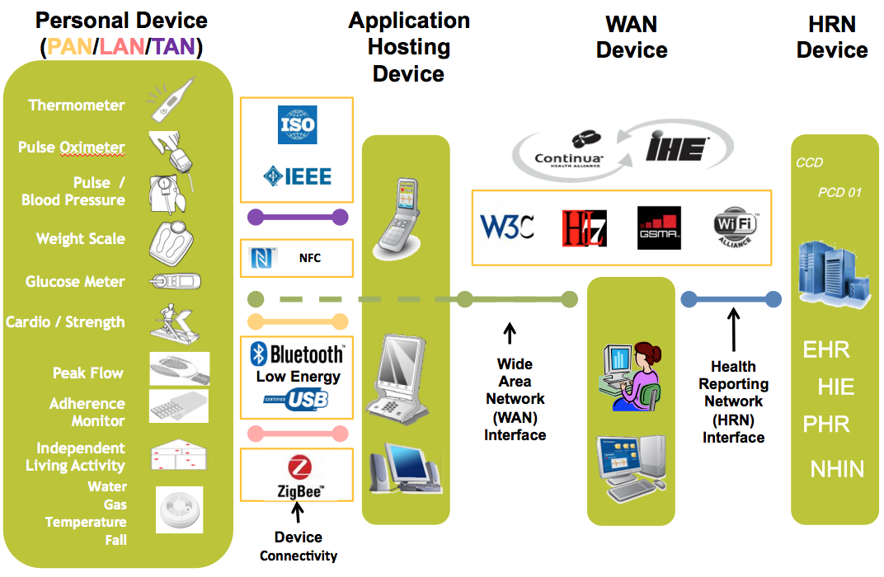
Figure 1: Current Continua architecture

Local area networks interface
Data collected by a personal health device is shared with application hosting devices (e.g., personal computers, gateways, tablets, phones). When Continua launched in 2006, there were two primary transport technologies for moving data: USB and Bluetooth; however, there was also an expectation that other transports may be needed in the future. Thus, the architecture was designed to separate data representation and exchange from the underlying transport as shown in Figure 1. This common representation isolates details about the transports from all software on the personal health device and any devices that access that device.
Later use cases required the addition of other solutions so additional transports interactions were standardized. NFC was added for the touch area network (TAN) interface, Bluetooth low energy for the PAN interfaces, and ZigBee for the local area network (LAN) interface. The following sub-sections describe the common data format and exchange standards and the transport standards and how they were selected.

Common interface considerations
Continua has chosen the IEEE 11073 personal health device family of standards for common data format and exchange. Continua investigated several excellent standard bodies: Health Level 7 (HL7), American Society for Testing and Materials (ASTM) E31 on healthcare informatics, ISO/IEEE 11073, Clinical and Laboratory Standards Institute (CLSI), Association for the Advancement of Medical Instrumentation (AAMI). The consensus of the membership was to create a working group under ISO/IEEE 11073. Some contributing factors included:
- Respected standards body with open participation at a low cost.
- Harmonized with ISO for international standards.
- Also harmonized with NCCLS/CLSI, HL7, CEN TC251, ISO TC 215, IHE, FDA, and NIST.
- The sponsor group was already formed and active with clinical standards.
- The sponsor group charter contained health care devices and was a broad charter that was able to support the three primary Continua categories: 1) Disease management, 2) Health and fitness, and 3) Independent living.
- The clinical standards were structured to be transport agnostic / portable.
Continua members created a new IEEE working group with a charter to create the IEEE 11073 personal health device family of standards. The IEEE 11073-20601 data format and exchange protocol standard was crafted as a broad standard that supported all common types of data needed by personal health devices. Then the "device specializations" (i.e., the IEEE 11073-104zz standards) tailored the broad standard to specific device types (e.g., blood pressure monitors) to ensure interoperability. The IEEE 11073 PHD team collaborated with the transport teams while the transport standards were under development. This cooperation allowed most of the transports to carry the IEEE 11073 data packets directly. Bluetooth low energy was the one exception. Due to the structure of the low energy data access protocol, the data is transcoded from the low energy structures into the IEEE 11073 data structures once the data is received by the application hosting device. However, this still allows all software above this point in the architecture to treat the data in a common fashion. Figure 2 provides an overview of the protocol stack for the different interfaces.
Figure 2: TAN/PAN/LAN interface stack diagram

Touch area network interface
A TAN enables a Continua device to batch communicate bi-directionally with a Continua AHD with a short touch. The NFC Forum personal health device communication specification is used in ITU-T H.810 for transport and the IEEE 11073 personal health device family of standards for data exchange. Security relies primarily on the user touching two devices and therefore encourages the designers to ensure a robust physical design.
NFC was selected as the underlying standard for the TAN interface due to the robust design of the standard derived from implementations in the financial and travel industries and the increasing adoption in mobile devices.

Personal area network interface
The PAN interface provides connectivity to allow bi-directional sensor control and information exchange between a PAN device and an application hosting device (i.e., a gateway). The transports selected support immediate communication of a single data point, continuous communication of several data points, and communication of collected data points at a later time.
For the PAN transport, the consensus of the membership was to concentrate first on Bluetooth and USB given the popularity of the two transports. In making this decision Continua considered the possible transports that were available at the time. The desire was to select one wired transport and one wireless transport. The Continua membership was surveyed to understand the transport preferences. The transports that surfaced were: 6LoWPAN, Bluetooth, Infrared (IrDA), Insteon, medical data service, medical implant communication system, power line communication, serial, USB, wired Ethernet, wireless Ethernet, wireless medical telemetry, wireless USB, ZigBee, and Z-Wave. Later when Bluetooth low energy was released, support for that was added.
Message exchange protocols for both Bluetooth HDP and USB employ the IEEE 11073 personal health device family of standards. These transport protocols were proposed and selected by the Continua membership due to their broad deployment in the consumer electronics marketplace.
The Continua wireless PAN transport utilizes conventional Bluetooth device discovery, pairing, and security mechanisms. It employs service discovery utilizing a baseband connection to a specific device to discover details about the services offered on that device and ensure a user-friendly pairing procedure.
The Continua low power wireless PAN transport utilizes the Bluetooth low energy protocol with data types compatible to the IEEE 11073-10101 nomenclature and the IEEE 11073-20601 domain information model. It also employs conventional Bluetooth low energy discovery, pairing, authentication, date and time mechanisms. Data exchanged using the Bluetooth low energy protocols is transcoded by the client device (device manager) into IEEE 11073 data structures [1].
The Continua wired PAN transport is based on the USB personal healthcare device class (PHDC). It sends only IEEE 11073 data messages over the USB PHDC. A Continua-certified USB PHDC device has only one USB PHDC interface for Continua functionality, regardless of whether it exposes a single device specialization or multiple device specializations.

LAN interface
The sensor-LAN interface enables sensors (or actuators) to send their measured data to (or to be controlled by) one or many Continua AHDs. The transport selected supports wireless connectivity in an area around a location (e.g. throughout a facility, or campus), scalable to hundreds of, potentially mobile, sensors and devices being part of the network.
For the local area network transport, Continua adopted ZigBee given its combined properties of enabling low-power and large area connectivity, while supporting a large amount of devices simultaneously in the network. In making this decision, Continua investigated several transport standards and technologies available at that time: ANT, Bluetooth low energy, body LAN, Sensium, ZigBee, and Z-Wave. A dedicated task force was established to evaluate the suitability of the different transport candidates.
The ZigBee health care profile has been designed to support IEEE 11073 PHD standards, which have been selected for sensor-LAN message exchange. In addition to one-to-many connectivity, the Continua sensor-LAN interface supports one-to-many connectivity, i.e., the simultaneous connection of a sensor-LAN device to multiple AHDs at the same time.
The sensor-LAN transport utilizes different ZigBee network commissioning scenarios, ranging from pure consumer network setup to service provider setups, different ZigBee pairing methods, as well as ZigBee 128-bit AES based security.

Wide area network interface
The Continua WAN Interface section of the design guidelines focus on one-way, point-to-point transmission of simple IEEE-based episodic and batch transmissions between a WAN observation sender (in an AHD) and a WAN observation receiver (on a back-end server) (see Figure 3). They are formatted to IHE PCD-01 and transported via SOAP over HTTP across a WAN using industry standard TCP/TLS transport/security. The interface is defined in terms of data payload, message exchange framework, and security. Work is underway to develop an architecture that is more suitable for mobile phones. This is an example of how the design guidelines are evolving with the needs of the market.
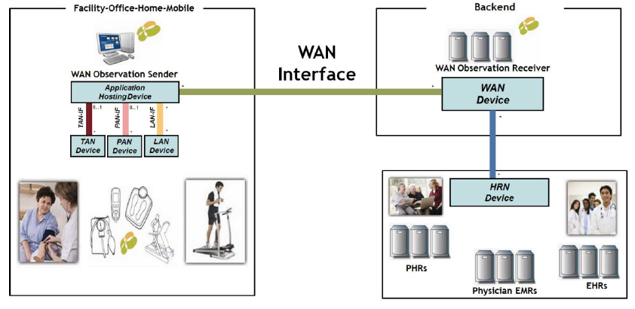
Figure 3: WAN scope

Data payload
The information contained in the data payload is formatted in accordance with the IHE PCD-01 transaction: Communicate PCD data specification. This PCD technical framework constrains the use of HL7 V2.6 messages, requiring that observations be exchanged using an unsolicited observation result message. The payload portion of the WAN interface is based on the PCD-01 transaction of the device enterprise communication (DEC) profile sponsored by IHE PCD. It uses HL7 V2.6 messaging and the IEEE 11073 nomenclatures, including the nomenclature extensions that support personal health devices (PHD).
The IHE patient care device technical framework volume 2 defines specific implementations of established standards to achieve integration goals for the patient care domain (PCD). The PCD-01 communicate PCD data transaction defines how to transmit patient care device data between systems.
IHE's PCD-01 transaction was chosen for a number of considerations. It allows the use of common nomenclature, defined by the ISO/IEEE 11073 committee, for all devices across all interfaces. This common nomenclature has the added benefit of simplifying FDA approvals of devices carrying this data. It is capable of supporting personal health devices for all three market segments in remote health monitoring targeted by Continua: health and fitness, aging independently, and disease management. Use of PCD-01 leveraged IEEE's observation reporting interface, savings years of work to translate CEN ISO/IEEE 11073-based messaging and data representation to HL7. The PCD-01 unsolicited observation result provides a well-defined, self-contained message uniform for transmitting one or more observations enabling less state-full message exchange between the WAN observation sender and receiver, which improves scalability.
HL7 version 2.6 was chosen over HL7 version 3.0 in part for its compact messaging structure that minimizes bandwidth. HL7 V2.6 currently addresses the interfaces among various healthcare IT systems that send or receive patient admissions/registration, discharge or transfer (ADT) data, queries, resource and patient scheduling, orders, results, clinical observations, billing, master file update information, medical records, scheduling, patient referral, patient care, clinical laboratory automation, application management and personnel management messages. It works to standardize the exchange of this information to eliminate or substantially reduce the custom interface programming and program maintenance that may otherwise be required [7].
The unsolicited observation result message is a segment of the PCD-01 message used to transmit a single observation or observation fragment in a very specific structured format (see Figure 4 [21]). It represents the smallest indivisible unit of a report. This observation report (OBX) segment can also contain encapsulated data such as a CDA document or a DICOM image [7]. IEEE nomenclature code 59408-5 "Oxygen Saturation in Arterial Blood by Pulse Oximetry" called out in the first OBX segment illustrates how IEEE nomenclatures are maintained in the PCD-01 message structure to ensure accurate and comprehensive understanding of the measured data to upstream interfaces. IHE PCD technical framework volume 2 defines each segment of the PCD-01 message.
The device enterprise communication (DEC) profile provides an optional "Publish/Subscribe" mechanism for applications to negotiate which IHE PCD pre-defined messages are communicated to a given application based on negotiated predicates.
The IEEE 11073 nomenclature defines an architecture and a series of standards for point-of-care (POC) medical device communication (MDC). As stated earlier, the continued use of the IEEE nomenclature over the WAN interface simplifies the operation of the gateway.
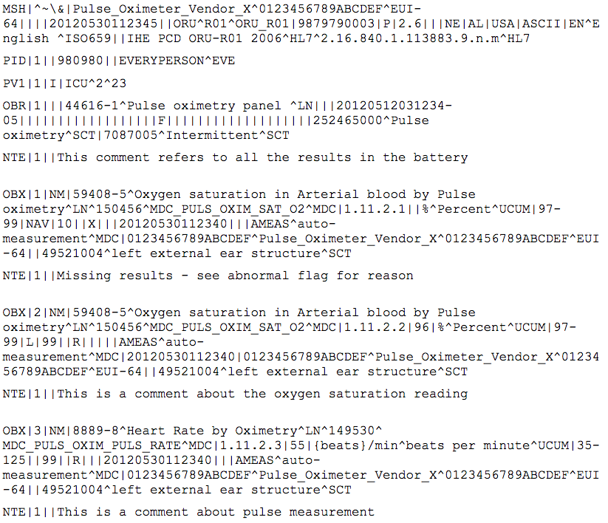
Figure 4: Sample PCD-01 message [21]

Message exchange framework
The Continua WAN interface uses a web services transport layer defined by IHE IT infrastructure technical framework volume II, appendix V, which specifies the usage of SOAP over HTTP and otherwise conforms to the Web Services Interoperability Organization's basic profile (WS-I BP) and basic security profile (WS-I BSP). This maintains Continua's alignment with the IHE family of profiles.
The IHE technical framework defines specific implementations of established standards to achieve effective systems integration, facilitate appropriate sharing of medical information, and support optimal patient care. It identifies a subset of the functional components of the healthcare enterprise, called IHE actors, and specifies their interactions in terms of a set of coordinated, standards-based transactions. Volume 2 of the IT infrastructure technical framework provides detailed technical descriptions of each IHE transaction used in the IT infrastructure integration profiles [11 (pp.8-9)]. Appendix V of volume 2 provides the guidelines for specifying the use of SOAP-based web services as the messaging infrastructure and transport mechanism for IHE transactions [12 (p. 126)].
As Continua has adopted the IHE family of standards, it employs SOAP 1.2 over HTTP version 1.1 per IHE's IT infrastructure technical framework.
The Web Services Interoperability Organization (WS-I) is an open industry organization chartered to establish best practices for web services interoperability for selected groups of Web services standards, across platforms, operating systems, and programming languages. Continua incorporates WS-I basic profile version 1.1 (WS-I BP) and basic security profile 1.0 (WS-I BSP) in alignment with IHE's IT Infrastructure Technical Framework.

Security
The Continua WAN security guidelines are based on ISO 27000 concepts of confidentiality, integrity, availability, accountability, authentication, authorization, and access control. The scope is limited to a single session-oriented, synchronous, and point-to-point communication. The tools used to provide the secure communication are selected from the WS-I BSP. These guidelines use mechanisms similar to IHE cross enterprise user assertion (XUA) profile. The IHE XUA profile uses WS-security header only with the SAML assertions. The guidelines constrain the WS-security profile from the WS-I BSP by using only the WS-security header with the SAML 2.0 assertion as security token and allowing the use of any other token for providing the identity information. The implementation guide for HL7 CDA R2 consent directive is used to express patient consent preferences. The XML encryption standard is used to enable consent enforcement through encryption.
An IHE XUA profile provides a means to communicate claims about the identity of an authenticated principal (e.g., user, application, system) in transactions that cross enterprise boundaries. To provide accountability in these cross-enterprise transactions there is a need to identify the requesting principal in a way that enables the receiver to make access decisions and generate the proper audit entries.
The HL7 CDA R2 consent directive documents a bilateral agreement between the patient and an individual or organization, which grants or withholds authorization to access individually identifiable health information about the patient. HL7 has produced a draft standard for trial use for implementing consent directives using CDA [20 (p. 9)].
The selection of these industry standards and frameworks meet the security requirements of its members and is in alignment with Continua's decision to base their guidelines on HL7 and IHE families of standards and specifications.

Health records network interface
The health records network (HRN) Interface is a term coined by Continua to describe the exchange of information between a telehealth service and a third party electronic health record, which might be a clinician's own record system or a patient-owned personal health record (see Figure 5). The HRN interface is defined in terms of messaging infrastructure and transport standards, messaging standards, data standards, security, transport security, document integrity and authentication, consent management, and consent enforcement. The HL7 CDA R2 CCD-based PHMR was selected as the basis for the interface messaging and has further extended the requirements as defined within the ITU-T H.810 HRN interface.
Figure 5: HRN scope
Continua's HRN interface is based on a set of IHE profiles providing for document registries and repositories (XDS), point-to-point transmission (XDR and XDM), and security (XUA). Continua assumes IP connectivity employing SOAP over HTTP/TLS. Messaging and data is based on HL7 CDA R2 as constrained by CCD and CCR and extended by PHM and PHMR. Continua uses IHE PIX and XDS for cross-referencing patient identifiers and document sharing. Security is left largely to industry standard SAML and transport layer encryption.

Messaging infrastructure and transport
ITU-T H.810 employs IHE's cross-enterprise document reliable interchange (XDR) profile as the transport method when communicating directly between a WAN device and a HRN device. Per the XDS.b guidelines, Continua utilizes standard SOAP over HTTP for information exchange, ebXML for document registry, and MTOM for handling MIME encoded messages. When it communicates between the WAN and HRN devices via the cloud, Continua adds the IHE's cross-enterprise document media interchange (XDM) profile, which uses current standards such as ZIP and S-MIME.
The XDR provides a reliable and automatic transfer of documents and metadata for one patient between EHR systems in the absence of a full XDS infrastructure. Transfer is direct from source to recipient, no repository or registry actors are involved. XDR is document format agnostic, supporting the same document content as XDS and XDM. It uses web-service-based point-to-point push network communications [20 (p. 195)].
The ebXML registry information model (RIM) V3.0 standard defines what metadata and content can be stored in an XDS registry. The XDS document registry is a profile of the ebXML registry standard (ISO 15000). As Continua has adopted the IHE family of standards, it employs ebXML for encoding and decoding metadata that is stored in the top-level directory of SOAP file packages.
The XDM integration profile facilitates interchange of electronic patient related medical documents across health enterprises, using media or email. It complements the XDS integration profile by providing for the use of XDS defined formats and metadata in a simpler environment to transfer documents and related metadata over CD-R, USB memory devices, and email using a ZIP attachment [14 (p. 4)]. As Continua has adopted the IHE family of standards, it employs the IHE XDM profile for secure indirect communication of patient records using standards such as ZIP and S-MIME.

Messaging and transport
Continua messaging and transport is based on the IHE XDS family of profiles, which explicitly target a simple point-to-point exchange of documents. When combined with IHE patient identifier cross-reference (PIX) profile, these profiles enable the safe transfer of a single document set against the correct patient identity.
IHE XDS is the core specification of a constellation of related IHE specifications and profiles. The core XDS.b profile has been refined to support special requirements for DICOM images, HL7 CDA medical summaries, and structured laboratory reports [20 (pp. 194-195)]. XDS enables healthcare documents to be shared over a WAN, between hospitals and primary care providers. XDS shares documents held by different healthcare organizations using XDS registries to store metadata that is used to retrieve documents from any number of XDS repositories [20 (p. 187)].
IHE PIX provides cross-referencing of patient identifiers from multiple patient identifier domains to support federated patient identification management. The PIX server provides cross-referencing from local patient identifiers to the single identifier used within the XDS system. PIX feeds are either HL7 V2 or V3 ADT messages [20 (p. 190)]. As Continua has adopted the IHE family of standards, it employs the standards-based IHE PIX profiles to ensure that HRN senders and receivers can correctly associate personal health data with the proper patient.

Data and transport
Data transport over Continua's HRN interface is structured based on HL7's clinical document architecture R2, which is an XML-based markup standard that specifies the encoding, structure, and semantics of clinical documents for exchange between healthcare providers and patients. This is constrained by CCD, which is a reference information model (RIM)-based implementation guide for sharing patient summary data (e.g., continuity of care record, or CCR).
As Continua has decided to standardize around HL7, it employs the CDA R2 standards that builds on the HL7 reference information model, which is at the core of HL7 version 3. The CCD is an implementation of the CDA R2 standards that establishes a set of templates representing typical sections of a medical record.

Security
Continua Design Guidelines call out five high-level requirements: authorization, accountability, availability, administration, and assurance. ITU-T H.810 relies on the transport layer security to implement security and authentication. Document-level integrity, data origin authentication and non-repudiation are realized through the use of IHE document digital signature content profile.
Transport layer security provides communication security over the Internet below the application layer using cryptography for authentication, encryption for confidentiality, and authentication codes for message integrity. IHE audit trail and node authentication (ATNA) creates a secured domain by assuming users are authenticated by local systems (e.g., X.509) before allowing network access [20 (p. 196)]. Integrity, data origin authentication and non-repudiation are important security properties for PHMR documents exchanged over the HRN-IF. Through the use of transport security (TLS, IHE ATNA) basic integrity and node authentication is realized.
The document digital signature content profile provides a means of attesting that a document is a true copy of original to ensure integrity, nonrepudiation, and accountability. A digital signature is a separate XDS document and uses X.509 certificates [20 (p. 197)]. As Continua has adopted the IHE family of standards, it employs DSG as it is one of the profiles developed by IHE to address security concerns.

Consent management and enforcement
Consent management at the HRN-IF is based on the HL7 CDA R2 consent directive to capture patient consent in a CDA consent document. Two types of interaction are provided to exchange consent documents. The first extends the existing IHE XDR transaction to exchange the PHMR document by including the consent document in the submission set. The second interaction follows a request/response structure to obtain the consent document separate from the PHMR document. A IHE document encryption (DEN) profile is used to enable consent enforcement through encryption.
The IHE DEN profile addresses encryption mechanisms to support confidentiality by providing a means to encrypt any kind of document (or XDM media content) in a transport independent way. Its approach enables access to documents to be targeted to specific recipients [15 (p. 5)]. Continua chose DEN as it is part of the IHE family of profiles.

Continua test & certification program
Continua's test and certification program ensures that Continua-certified products conform to the standards and specifications defined in the Continua Design Guidelines and its underlying standards. Devices featuring the Continua logo indicate that they meet Continua conformance requirements as well as basic interoperability requirements with other Continua devices. The Continua test and certification program includes conformance and interoperability testing.

Conformance testing
Conformance testing ensures that Continua-certified products conform to Continua standards and specifications when connected in a personal health system. It further ensures those Continua-certified products implement all Continua interoperability guidelines required for their certified device class. Conformance testing verifies certification from other SIGs/SDOs and conformance to Continua interoperability guidelines and foundational standards that have no certification programs.
Continua devices are certified across the interface(s) that they support. A device must pass all tests in the test specification in order to become certified. If a device includes optional features, it must pass the set of compliance tests that apply to these features.

Interoperability testing
Interoperability testing ensures that Continua devices are able to interoperate with each other or with Continua reference devices when connected. Interoperability testing for the purposes of certification is limited to procedures that run the device though the normal behaviors expected for the device type. The device being certified is paired against up to three reference devices which have already achieved certification. These devices are selected from a list of pre-approved certified devices by the testing lab.
___________________

ITU-T H.810 (2013) is the transposition of the 2013 Continua Design Guidelines ("Endorphin"), with its errata.
http://www.hl7.org/about/index.cfm?ref=nav
http://wiki.ihe.net/index.php?title=PCD_Profile_DEC_Overview
http://ws-i.org/about/
http://wiki.ihe.net/
http://wiki.ihe.net/index.php?title=Cross-enterprise_Document_Reliable_Interchange

