Intelligent Transport
Systems and CALM

ITU-T Technology Watch Report 1
October 2007

Intelligent Transport Systems make it possible to imagine a future in which cars will be able to foresee and avoid collisions, navigate the quickest route to their destination, making use of up-to-the-minute traffic reports, identify the nearest available parking slot and minimize their carbon emissions. A new set of standards –Continuous Air-interface for Long- and Medium-range communications (CALM) – promise to provide the underlying glue to make all this happen, and are the subject of this report.

ITU-T Technology Watch Reports are intended to provide an up-to-date assessment of promising new technologies in a language that is accessible to non-specialists, with a view to:
- Identifying candidate technologies for standardization work within ITU.
- Assessing their implications for ITU Membership, especially developing countries.
Other reports in the series include:
#1 Intelligent Transport System and CALM
#2 Telepresence: High-Performance Video-Conferencing
#3 ICTs and Climate Change
#4 Ubiquitous Sensor Networks
#5 Remote Collaboration Tools
#6 Technical Aspects of Lawful Interception
#7 NGNs and Energy Efficiency

Acknowledgements
This report was prepared by Dr Tim Kelly (tsbtechwatch@itu.int) with Young-Han Choe. It has benefited from contributions and comments from Reinhard Scholl and Bob Williams.
The opinions expressed in this report are those of the authors and do not necessarily reflect the views of the International Telecommunication Union or its membership.
This report, along with other Technology Watch Reports can be found at
www.itu.int/ITU-T/techwatch.
Please send your comments to tsbtechwatch@itu.int or join the Technology Watch Correspondence Group, which provides a platform to share views, ideas and requirements on new/emerging technologies and to comment on the Reports.
The Technology Watch function is managed by the ITU-T Standardization Policy Division.

© ITU 2008
All rights reserved. No part of this publication may be reproduced, by any means whatsoever, without the prior written permission of ITU.
Intelligent Transport
Systems and CALM

Intelligent Transport Systems
Imagine a future in which cars will be able to foresee and avoid collisions, navigate the quickest route to their destination, making use of up-to-the-minute traffic reports, identify the nearest available parking slot and minimize their carbon emissions. Indeed, imagine a future where cars can largely drive themselves, leaving their passengers to use the free time to watch the sports game on live TV.
All of these possibilities already exist within the laboratories of car manufacturers and some are already available commercially. But they rely on communications links that must be increasingly high-capacity and long range to deal with the full range of requirements of future transport users. The generic technology they use is called Intelligent Transport Systems (ITS). ITS may be defined as systems utilizing a combination of computers, communications, positioning and automation technologies to use available data to improve the safety, management and efficiency of terrestrial transport, and to reduce environmental impact. ITS incorporates four essential components, as illustrated in Figure 1:
- Vehicles, which can be located, identified, assessed and controlled using ITS;
- Road users, who employ ITS, for instance, for navigation, travel information and their monitoring capabilities;
- Infrastructure, for which ITS can provide monitoring, detection, response, control, road management and administration functions.
Communications networks, to enable wireless transactions amongst vehicles and transport users.
The main motivation for ITS is the improvement of road safety. It is a startling fact that some 1.25 million people are estimated to die on the world’s roads each year, and over 30 million are injured. How long can we allow such carnage on our roads to continue when adequate technology already exists to prevent it? Many governments of the world have embarked on programmes to halve road deaths and injuries within a decade. ITS will provide a major means to achieve this.
There are already many different applications of ITS around the world, as illustrated in Box 1. Currently, the most commercially important application of ITS is in satellite navigation systems. These use signals from Global Positioning Satellites (GPS) combined with street maps to offer suggested routes to drivers. However, for other services – like collision detection and avoidance, which need an instant response – two-way communication links are required, especially for time-critical safety communications, and so additional ITS-specific network platforms are required.
The standards challenge
The requirement for future standards in the ITS field is to be able to provide multiple services, over multiple different platforms, that will work in different countries (as vehicles can easily cross borders), while maintaining a simple-to-use interface that requires minimum intervention from the driver. Indeed, these challenges are similar to those faced by Next-Generation Networks (NGN). However, the safety requirements associated with fast-moving vehicles make this challenge all the more rigorous.

Figure 1: CALM in a multi-platform, multimedia environment
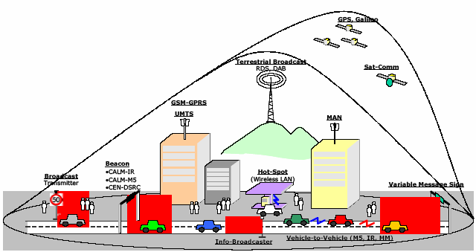
Source: The CALM Forum/ISO TC 204, reprinted in ITU-R Land Mobile Handbook, Vol 4: Intelligent Transport Systems (2006), available at: www.itu.int/pub/R-HDB-49-2006/en.

Box 1: Sample ITS applications
Across the world there are multiple different applications of Intelligent Transport Systems (ITS) in action, which could be supported by CALM. These include:
- eCall, an automatic in-vehicle emergency call service developed within the EU.
- Parking Guidance Systems, to guide motorists to the most appropriate parking space, as employed, for instance, in Frankfurt.
- Octopus, a contactless ticketing system, used on the Hong Kong metro since 1997, and subsequently extended to buses, parking meters etc
- Adaptive Traffic Management, allowing for automatic changing of traffic signals, for instance to give priority to public buses in Geneva.
- Real-time bus information at the stop, allowing passengers to see the estimated arrival time of the next service, as implemented, for instance, in Paris.
- Automatic Vehicle License Plate Recognition (AVLPR) System, used for instance to administer speeding fines. In London, the system is used for congestion charging. License plates observed within London each day are compared with a separate database of daily payments made.
- A Telematics Pilot, applying new transport management techniques within a limited area, such as on the island of Cheju-Do, as part of Korea’s IT839 Strategy
- GPS Taxi Dispatching, launched in Singapore in 1996 to raise efficiency in taxi use.
- 911 enhanced, a regulatory ruling in the USA to require mobile operators to provide location finding for distress calls from mobiles.
Adapted from various sources.

Standards work in ITS has been ongoing for more than 30 years, including in ITU (see Box 2), and a number of families of standards already exist, notably:
- Dedicated Short-Range Communications (DSRC), which are mainly used for electronic toll collection;
- 802.11p/WAVE (Wireless Access for a Vehicular Environments), in the popular IEEE 802 family of wireless standards, where work is ongoing on to provide support in the 5.9 GHz band which has been allocated for ITS in the USA and is under consideration in Europe and Australia; and a 5.8 GHz allocation in Japan.
- Cooperative research projects, such as the EU projects CVIS, SAFESPOT, COOPERS, and commercial projects being progressed by ERTICO (European Road Telematics Implementation and Coordination Organization). Other organizations, such as the Car-to-Car Communications Consortium (C2C-CC), which is a vehicle manufacturers’ consortium (initially European only), are working mainly on short-range communications for driver advisory warning, and eventually collision avoidance, and are preparing requirements for standards, based on the results of their research and development work.
However, systems in use in different parts of the world remain incompatible and fragmented, particularly for 5 GHz systems for which North America, Europe and Japan have different implementations using different frequencies. This problem is being addressed within ITU-R (see Box 2).

Box 2: ITU work on intelligent transport systems
ITU has been working on the spectrum requirements of ITS in the Radiocommunication Sector since the early-1980s and on standardization aspects, in cooperation with ISO and IEC, through the Advisory Panel on Standards Cooperation: Telecommunications related to Moving Vehicles (APSC-TELEMOV) since 2003. Specific activities relevant to ITS include:
- The From/In/To Car Focus Group (FITCAR), established by ITU-T Study Group 12 (Performance and QoS) in June 2006, which is initially looking at specifications for narrowband hands-free terminals and later at broadband ones;
- Three ITS-related workshops have been held, the latter two in conjunction with the Geneva Motor Show, one of the world’s leading car shows. The most recent of these was the “Fully Networked Car”, workshop and exhibition in March 2007, organized jointly with ISO/IEC. The next workshop will be held 5-7 March 2008.
Within ITU-R, work on ITS is coordinated by Working Party 2 of Study Group 8A, which has been looking at spectrum requirements for ITS, including for DSRC and for short-range vehicle radar. Other ITU-R activities include work on ultra wideband (UWB), which is used for collision avoidance and is handled by Study Group 1, and for multimedia ITS applications used in broadcasting, handled by Working Party 6M. Ongoing work on millimetre wave and microwave band for ITS depend on the rate of progress on CALM. A handbook on ITS was produced in 2006 as Volume 4 in the Land Mobile series.

CALM characteristics

This, then, is the rationale behind an ongoing effort, launched by the International Organisation for Standardization (ISO) in 2003, and promoted by the more recently created industry association – The CALM Forum – to develop a new family of ITS standards with the overall branding of “Continuous Air-interface, Long and Medium range” (CALM). The aim of CALM is to provide wide area communications to support ITS applications that work equally well on a variety of different network platforms, including Second Generation (2G) mobile (e.g., GSM/GPRS), 3G (IMT-2000 e.g., W-CDMA/CDMA 1x EV-DO) 4G (IMT-Advanced), as well as satellite, microwave, millimetre wave, infrared, WiMAX and short-range technologies like Wi-Fi. The decision on which platform to use in a particular country or for a given application would then be based on logical selection of pre-set criteria (e.g., what platform is cheapest, offers highest-performance, has the greatest level of coverage, and what communication equipment is available in the vehicle) to make the best use of resources. Thus, CALM is intended to be platform-independent, and therefore to avoid the battles over regional standards that have dogged existing ITS standards like DSRC.
CALM is being developed by Working Group 16 of Technical Committee 204 of the ISO, chaired by Russ Shields (Ygomi LLC, USA). The work is closely coordinated with other standards development organizations including ETSI and IEEE as well as ITU. Working Group 16 has 7 sub-working groups and is currently working on nearly 20 different CALM-related standards (see www.calm.hu, the rapporteur’s website). The main characteristics of CALM are:
- Allows for continuous (or quasi-continuous) communications, in three main modes of operation: Vehicle-Infrastructure; Vehicle-Vehicle; and Infrastructure-Infrastructure.
- Inter-operability and seamless handover between networks and applications.
- Based on Internet Protocol. In its initial specification, CALM used Internet Protocol version 6 (IPv6) exclusively. However, in order to meet the requirement for very fast short communications in time-critical safety situations, such as C2C applications (e.g., collision avoidance), a non-IP solution with lower processing overhead and lower latency may be more suitable, and this is incorporated in the new specification (CALM Fast).
- A single global architecture which is compatible with existing ITS standards (e.g., DSRC) and wireless standards (e.g., GSM/GPRS) and which can anticipate future ones.
Platform-independent support for multiple radiocommunication network platforms. For instance, the basic CALM system architecture (ISO 27217) foresees support for 10 main categories of network, and 22 different sub-categories (see Box 3) each of which would need a different Service Access Protocol (SAP).
While it is evident that not every CALM implementation would need to support all of these different network platforms, the intention is to develop SAPs for each of them within the overall architecture. This multi-platform support is essential if the standard is to be global, to permit roaming and to permit seamless interworking. Specific implementations of the standard may be customized by manufacturers to suit local conditions, market segment (e.g., compacts cars vs. luxury models), and with pre-set usage profiles (e.g., using lowest-cost network for high bandwidth applications), and the possibility for seamless roaming between different service environments (e.g., urban/rural, high-speed/slow-speed/stationary) as well as between countries. CALM may be implemented in a specific device (e.g., a receiver and screen, as illustrated in Figure 2) or as a support for a particular service. The typical life cycle of a car, at 10-20 years, is much longer than that of a mobile phone, which can be as little as 18 months. For that reason, a technology- and service-neutral approach is essential for CALM.
Implications for ITU
Given the broad scope of the CALM project, which interfaces with virtually all commercially-available wireless interfaces, it is likely that it will have much wider ramifications for ITU’s work notably touching upon ITU-T Study Groups 13 (NGN) and 16 (Multimedia) as well as Study Group 12 (Performance and QoS) to which the FITCAR Focus Group reports (See Box 2).
The automotive sector represents a huge opportunity for ITU-T because the annual value of R&D in the sector was around USD 70 billion in 2005 compared with just USD 5.4 billion in telecommunications; thus
the standardization expenditure is likely to be correspondingly higher. However, key players in the field are not yet members of ITU. For instance, out of the 28 companies that sent representatives to the most recent meeting of ISO TC 204 WG16, only three (Arraycomm, Microsoft and NEC) are ITU Sector Members. Although many companies, including car manufacturers, did participate in the joint ITU/ISO/IEC Fully Networked Car workshop, they represent a different community from those that usually participate in ITU meetings.

Figure 2: Example of a two-part solution for in-vehicle implementation of CALM
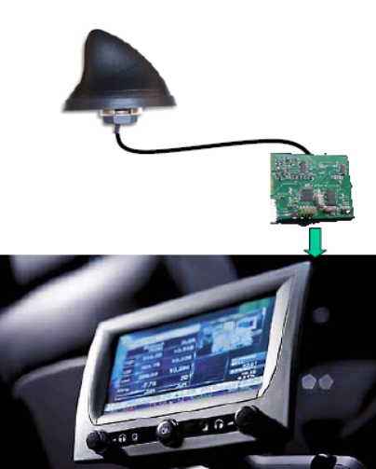

Source: Knut Evensen, presentation to ITU/ISO/IEC workshop “The fully-networked car” at: www.itu.int/dms_pub/itu-t/oth/06/05/T06050000130001PDFE.pdf

Implications for developing countries
For developing countries, the potential benefits offered by ITS applications are huge, especially in the areas of road safety, reduction of congestion and related productivity loss, and reduction in pollution. The cumulative negative impact of cars worldwide, including their unintended contribution to climate change, is estimated to be in excess of US 1.5 trillion dollars per year, and this is likely to fall disproportionately on developing countries when measured in relation to car ownership. Furthermore, as well as reducing losses, judicious use of ITS in fields like road pricing and congestion charges could provide a source of income for investment in infrastructure. Use of ITS in public transport systems can also have positive benefits for developing countries where ownership of private transport means is low.
Because developing countries, for the most part, have not yet invested heavily in ITS, there is a good chance that they will avoid the standards battles that currently reign in this area. Where compatible standards are in use, the unit price—to consumers as well as to manufacturers—will tend to fall. Thus CALM represents an important opportunity for developing countries to plan their ITS strategies around international standards. Although it may not be feasible for many developing countries to develop their own indigenous car manufacturing sectors, there is scope for them to break into the market for ITS, which tends to be dominated by small and medium-sized enterprises, and by services rather than devices. In addition, there is a genuine possibility for technological leapfrogging in this field because developing countries generally do not have legacy transport management systems. A good example, in this respect, is provided by the city of Beijing where systematic transport planning is an important element of preparation for the Olympics (see Box 4).

Box 3: A closer look at CALM
CALM is intended to provide a standardized set of air interface protocols for ITS applications, using multiple network platforms. These include:
- 2G mobile systems, including GSM/GPRS, which are the most widely deployed mobile network worldwide
- 3G (IMT-2000) mobile systems, including W-CDMA and CDMA 1x EVDO
- Infrared
- Wireless LAN systems, including the IEEE 802.11 series
- Millimetre wave systems, including radar
- DSRC, including national and regional implementations
- Wireless MAN systems, including WiMAX
- Broadcast signals, including GPS and Digital Audio Broadcasting (DAB)
- Personal Area Networks (PAN) including UWB and Bluetooth
- Fixed-line networks (for infrastructure to infrastructure communications), including Fibre and Ethernet.
The main criticism of CALM is that, because it tries to support so many different networks, it ends up with a bewildering array of possibilities and an over-complex management stack. However, if CALM is to reconcile the North American-originated WAVE standards, the European C2C-CC standards and the Japanese implementation of DSRC, then it will have to accommodate, for instance, non-IP communications for short-range use. But while the overall enabling architecture for CALM is complex, only a subset will be implemented in any given vehicle, so it is not as daunting as perhaps it first seems. The likely future direction seems to be a flexible CALM architecture and a division of labour among different organizations, with ETSI, for instance, working on test suites while basic research and testing is being carried out by an EU-financed research project, Cooperative Vehicular Infrastructure Systems (CVIS), together with sister projects SafeSpot and Coopers. This is reflected in the new (2007) merged CALM architecture.
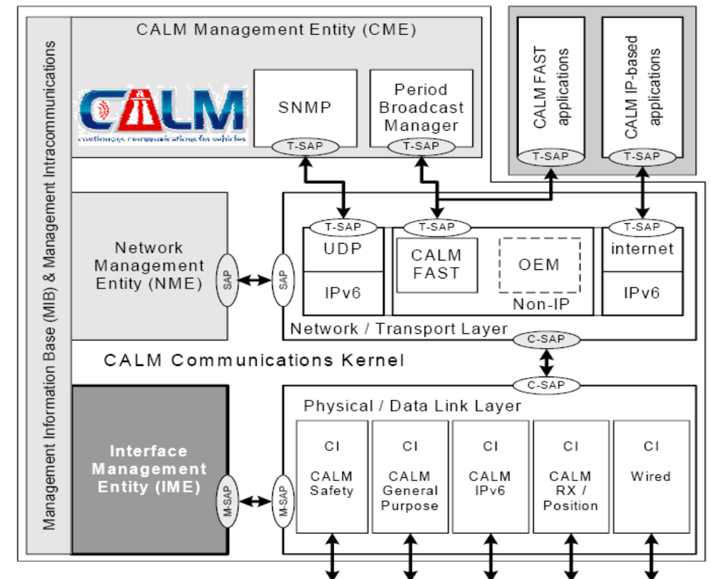
Source: ISO TC 204 (see: www.itu.int/dms_pub/itu-t/oth/06/05/T06050000130001PDFE.pdf).

Conclusion
CALM represents an ambitious attempt to provide a platform for a wide range of future communications requirements for intelligent transport systems. As such it cuts across several ongoing standards-making efforts, including those of the ITU, such as NGN. While the work is still ongoing, it is hard to judge the likely level of commercial acceptance and, for the moment at least, not all the major car manufacturers are engaged in the project. Nevertheless, the commercial success of satellite navigation systems suggests that this could become a major future market opportunity.

Box 4: Intelligent Transport Systems at the Beijing Olympics
Although the basic design for transport systems at the 2008 Beijing Olympics was elaborated at the time of the winning bid in the early 2000s, the plan has continued to evolve to make the best use of emerging technologies and good practice. The plan foresees catering for some 1.5 million visitors, and infrastructure investment includes 150 km of new rail network, a total subway length of 191 km, and 318 km of new or improved urban streets. An IP-based ticketing scheme has been introduced and parking guidance systems have been installed. However, to meet the commitment made in the bid document—to deliver Olympic participants to the stadia within 30 minutes—it is necessary also to develop traffic management systems, to create priority lanes for buses etc. For this purpose a Transport Supervision and Coordination Centre is being created and an accident reporting system established.
Source: Adapted from Beijing Olympics site at: www.en.beijing2008.cn/ and “ITS in Hong Kong” at: www.hkitf.org/download/its_policy_paper.pdf.

Glossary of acronyms

APSC-TELEMOV Advisory Panel on Standards Cooperation: Telecommunications related to Moving Vehicles
AVLPR Automatic Vehicle License Plate Recognition
C2C-CC Car-to-Car Communications Consortium
CALM Continuous Air-interface, Long and Medium Range
CDMA Code-Division Multiple Access
CDMA 1x EV-DO CDMA 1x EVolution Data Optimised (3G mobile standard)
CME CALM Management Entity
DAB Digital Audio Broadcasting
DSRC Dedicated Short-Range Communications
ERTICO European Road Telematics Implementation and Coordination Organization
ETSI European Telecommunication Standards Institute
EU European Union
FITCAR From/In/To Car Focus Group (ITU-T)
GHz Gigahertz
GPRS General Packet Radio Service
GPS Global Positioning by Satellite
GSM Global System for Mobile communications (2G mobile standard)
IEC International Electrotechnical Commission
IEEE Institute of Electrical and Electronic Engineers
IME Interface Management Entity
IMT-2000 International Mobile Telecommunications-2000 (family of 3G mobile standards)
IP Internet Protocol
ISO International Organization for Standardization
ITS Intelligent Transport Systems
ITU International Telecommunication Union
ITU-R ITU Radiocommunication Sector
ITU-T ITU Telecommunication Standardization Sector
NGN Next-Generation Networks
NME Network Management Entity
OEM Original Equipment Manufacturer
PAN Personal Area Network
QoS Quality of Service
R&D Research and Development
SAP Service Access Protocol
SNMP Simple Network Management Protocol
TC Technical Committee
UWB Ultra wideband
WAVE Wireless Access for a Vehicular Environment
W-CDMA Wideband CDMA (3G mobile standard)
WiMAX Worldwide Interoperability for Microwave Access

Notes, sources and further reading

See ITU-R (2006) “Intelligent Transport Systems: Handbook on Land Mobile Vol 4”, 109 pp, available at: www.itu.int/pub/R-HDB-49-2006/en
More information on the FITCAR Focus Group can be found at: www.itu.int/ITU-T/studygroups/com12/fgfit/index.html. See also presentation on FITCAR by Hans Gierlich and Jena-Yves Monfort at the ITU/ISO/IEC workshop “The fully-networked car”, Geneva, March 7-9, 2007, available at: www.itu.int/dms_pub/itu-t/oth/06/05/T06050030030001PDFE.pdf.
Information on the ITU/ISO/IEC “Fully Networked Car” workshop and exhibition can be found at: www.itu.int/ITU-T/worksem/ict-auto/200703/index.html. See also the ITU News article at: www.itu.int/itunews/manager/display.asp?lang=en&year=2007&issue=03&ipage=fullyNetworked&ext=html.
See ITU-R Recommendation M.1453-2 “Dedicated short range communications (DRSC) at 5.8 GHz” (June 2005) at: www.itu.int/rec/R-REC-M.1453/en
See ITU-R Recommendation M.1452 “Low power short-range vehicular radar equipment at 60 GHz and 76 GHz” (May 2000), at: www.itu.int/rec/R-REC-M.1452/en.
For more information on ITU-R work on ITS, see presentation by Colin Langtry at the ITU/ISO/IEC “Fully Networked Car” workshop, available at: www.itu.int/dms_pub/itu-t/oth/06/05/T06050030050001PDFE.pdf.
Figures from Booz Allen Hamilton Global Innovation 1000, at: www.strategy-business.com/media/file/resilience-12-14-06.pdf.
Figures from CISCO, Marc Girardot “Connected Vehicle: A Cisco perspective and experience”, presentation at ITU/ISO/IEC workshop “The fully-networked car”, Geneva, March 7-9, 2007, available at: www.itu.int/dms_pub/itu-t/oth/06/05/T06050070060001PDFE.pdf.

