PRACTICAL INFORMATION

ITU Regional Forum 2012: “Bridging the standardization gap for RCC countries (2 April 2012);
followed by
RCC Regional Preparatory Meeting for the World Telecommunication Standardization Assembly (WTSA-12) (3 April and 4 April (am) 2012); and
RCC Regional Preparatory Meeting for the World Conference on International Telecommunications (WCIT-12) (4(pm)-6 April 2012) – (Tashkent, Uzbekistan)

Event Venue
Hotel “Dedeman Silk Road Tashkent ”
Conference room “Silk Road”, 1st floor
Amir Temur Str.,C 4, No 7/8, Tashkent, 700000, Uzbekistan
Tel: +(998) 71 120 37 00, +(998) 71 134 85 85
Fax: +(998) 71 134 42 42
www.dedeman.com

Registration
Registration will be conducted exclusively online at: http://www.itu.int/en/ITU-T/wtsa-12/prepmeet/Pages/rcc.aspx . To enable us to make the necessary arrangements concerning the organization of the Forum, the RCC WTSA-12 Preparatory Meeting and the RCC WCIT-12 Preparatory Meeting, we should be grateful if you would register as soon as possible, but not later than 2 March 2012.

On-site registration will begin on Tuesday, 2 April 2012, at 8.30 am at the Forum venue, on the 1st floor, Conference room “Silk Road”, Hotel “Dedeman Silk Road Tashkent ”.

Working languages
The Meeting will be held in English and Russian with simultaneous interpretation.

Accommodation
Hotel “Dedeman Silk Road Tashkent ” ****
Amir Temur Str., C 4, No 7/8, Tashkent
700000, Uzbekistan
Tel: +(998) 71 120 37 00, +(998) 71 134 k85 85
Fax: +(998) 71 134 42 42
www.dedeman.com

Accommodation of the fellowship holders is envisaged in this hotel.
Located 8 km from Tashkent International Airport, in the city center of Tashkent, this is also the venue of the Forum itself.

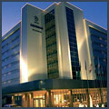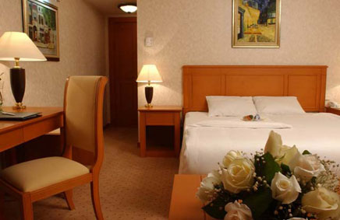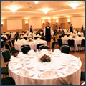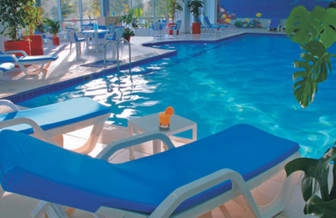

Room Type | Special Rates
Standard Room | USD 120.00/135.00
Double Room | USD135 .00/165.00
Deluxe | USD 150.00/180.00
Junior Suite | USD 400.00

Rich Open Buffet Breakfast and all local taxes are inclusive of single or double occupancy.
Free Usage of Life Style Health Center (indoor & outdoor swimming pools, sauna, gym).
Free Unlimited Wireless Internet service in all Guest Rooms.
Free Wireless Internet service on the Public Area.
InterContinental Tashkent *****
107A, A. Temur Street,
Tashkent, 100084, Uzbekistan
Tel.: (998 71) 1207000 ext. 4229
Fax: (998 71) 1206459
www.ihg.com

Opened in 1997, established 5 star hotel is ideally located within a business park near the National Bank of Uzbekistan, Shopping Centre and the Telecommunication Center, adjacent to a lake and near the main trade fair site, close to city center. Distance from International airport: 10 km or 20 minutes drive. Distance to city center: 5 km.

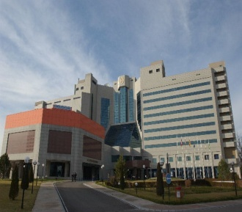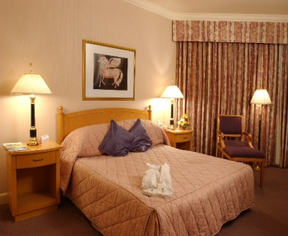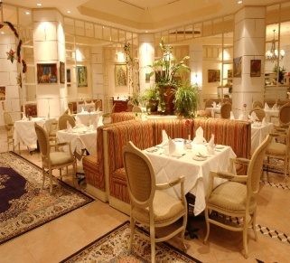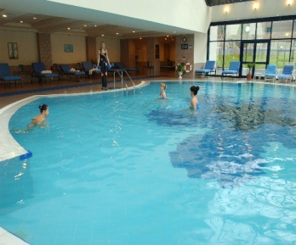

Room Type | Special Rates
Standard Room | USD 190.00
Superior Room | USD 210.00
Junior Suite | USD 528.00
Room rate includes one Full American Buffet breakfast. And also free of charge: Instant check-in/check-out, Luggage storage, in-room-safe, 24 hours security, 24 hours services of Fitness Center, 24 hours services of Gymnasium; use of Swimming Pool, Steam and Sauna during working hours, Wireless internet access in the Hotel Lobby. Also available Currency exchange office and Ticket Office of “Lufthansa” Airlines.
Payment for the services shall be made by guest's credit card (American Express /Visa/ EuroMaster card) or by bank transfer.

Radisson SAS Hotel Tashkent ****
88, A. Temur Street,
Tashkent, 100084, Uzbekistan
Tel.: +998 71 1204900
Fax: +998 71 1204902
www.radissonsas.com

The Radisson SAS Hotel in Tashkent is on the Amir Temur road, in the heart of the banking and business district. The hotel is just 15 minutes from the international airport and has 111 beautifully designed rooms with all modern amenities: individually controlled heating and air-conditioning system, direct-dial telephones and Internet port, electronic safe, TV Set with 24 worldwide channels, bathroom with bath-tub, mini-bar and hair-drier. The Hotel has 2 Bars, 2 Restaurants, Fitness center (swimming pool, sauna and gym), 24 hours open Business Center with all facilities, laundry & dry-cleaning service, outdoor parking lot, currency exchange office.

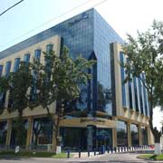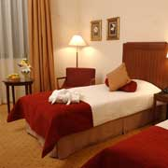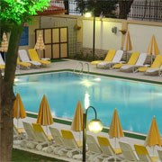

Room Type | Special Rates
Standard Single | 135 USD (Friday-Sunday 116 USD)
Junior Suite | 250 USD
The above rates include:
- open Buffet breakfast;
- fitness center use: swimming pool, sauna and gym;
- complimentary Internet in the room & wireless internet use in all public areas;
- V.A.T.
Check-in time at the hotel is 14:00 and check-out is 12:00 (noon)
Accounts can be settled by major credit cards: Visa, AmEx, MasterCard, Diners Club, JCB or Cash.
Participants who require hotel reservation, are kindly asked to complete and return the HOTEL RESERVATION AND TRANSFER FORM in Annex 1 below to the National Coordinator
Mrs. Umida Musayeva, Senior Specialist of International Relations Coordination Department of the Communications and Information Agency of Uzbekistan by fax: + 998 71 239-87-82 or e-mail: u.musaeva@aci.uz by 2 March 2012 at the latest. (for enquiries: Tel: +998 71 238-41-41,
Mobile: +998 97 340-54-03).

Transportation
Transportation will be available for delegates from the airport to their respective hotels, as well as from the hotels to the venue of the meetings. Participants who need transfer from the airport to the hotel upon arrival and from the hotel to the airport on departure are requested to provide all relevant information in Annex 1.
Airport
There are currently twelve airports in Uzbekistan that are operated by Uzbekistan Airways National Air Company. Five of them: Tashkent, Samarkand, Bukhara, Urgench and Termez airports are international.
Tashkent International Airport completely meets international standards and the ICAO requirements and receives all the types of aircraft. Following a complete overhaul the passenger terminal for international flights provides a maximum level of convenience and services for passengers.

Distance from city center 15-30 minutes, Ground transportation options Taxi, Route-taxi, bus.
Entry Requirements and Visa Information for Republic of Uzbekistan
Those participants requiring entry visa to the Republic of Uzbekistan are requested to contact their local Embassy/Consulate of the Republic of Uzbekistan for information well in advance and to fill in a form http://evisa.mfa.uz/registration.aspx.

Visas are issued to foreign citizens in the diplomatic and consular missions of the Republic of Uzbekistan abroad on the basis of the Visa Support Letter (permission from the Ministry of Foreign Affairs of Uzbekistan).
Consular Bureau visas can only be issued, upon arrival at Tashkent International Airport, to those foreign citizens arriving from countries that do not have diplomatic or consular missions of the Republic of Uzbekistan. In this case visa support from the hosting administration is required.
Participants requiring visa support are kindly asked to complete and return the following: the Visa Support Form (in Annex 2 below), the relevant visa application form from the web-site of the Ministry of Foreign Affairs of Uzbekistan and a copy of their passport to the National Coordinator
Mrs. Umida Musayeva, by fax: + 998 71 239-87-82 or e-mail: u.musaeva@aci.uz by 2 March 2012 at the latest. (for enquiries: Tel: +998 71 238-41-41; Mob: +998 97 340-54-03).

There is a bilateral Visa Free Regulation with Azerbaijan, Armenia, Belarus, Georgia, Kazakhstan, Moldova, Russia, Ukraine and Kyrgyzstan.

General Information
The Republic of Uzbekistan is situated between the rivers of Amudarya and Syrdarya and occupies 447,400 square meters. The span of the territory from the west to the east is 1,425 km and from the north to the south - 930 km. The territory borders on Kazakhstan in the north, on Kyrgyzstan and Tajikistan in the east and southeast, on Turkmenistan in the west, and on Afghanistan in the south.
Uzbekistan is the oldest land in Central Asia having a twenty-five centuries long history, the country with the arranged specific historical and cultural community different from that of other regions. Lately, tourism interests in Uzbekistan have been noticeably raised and accordingly, the range of travel facilities and services of local tour operators are being increased year by year for attracting more travelers to explore this wonderful place.
On the spaces of Uzbekistan there are many cities where hundreds of architectural monuments of different epochs are located. Among them are Samarkand, Bukhara, Khiva, Shakhrizabs, Termez and Kokand. These cities were the centers of science and the art.
The Great Silk Road, one of the most significant achievements in history of the World civilization has also passed through these cities.

Insurance
Insurance is not necessary for coming to Uzbekistan.
Vaccination requirements and medical facilities
No need for vaccination. A Medical Service will be available on-site, with immediate transportation and admission to a hospital for emergencies. During the Meetings first medical aid will be provided.
Climate
The climate of Uzbekistan is sharply continental, characterized by high amplitude of day and night, summer and winter temperatures. The temperature varies rather considerably with respect to the seasons. Average temperature in January falls below -6 C, while the average temperature in March may rise above +20-+24 C. Average annual atmospheric precipitation on the plains is 120-200 mm, in mountainous areas - 1000 mm. The amount of precipitations is low, which is why the agriculture relies on irrigation to a great degree.

Time Zone
Uzbekistan is 5 hours ahead of Greenwich Mean Time (GMT+5)
Currency
The national currency of the Republic of Uzbekistan is the Uzbek Sum. All payments must be made in the national currency. Currency exchange offices are available in every city of Uzbekistan. Also currency can be exchanged at “bureaux de changes” in hotels and at banks.

Banks are open from 09:00 am till 19:00 pm from Monday to Saturday.

Changed on 18.02.2012.

№ | Currency |  | CB | Buy | Cell
1 | US dollar | 1 UZS | 1804.31 | 1815.00 | 1820.00 | USD
2 | EURO | 1 UZS | 2301.37 | 2302.00 | 2317.00 | EUR

Telecommunications
Among the Fixed Line Operators there are three companies namely: JS “Uzbektelecom”, JV “Est Telecom”, JV “Buzton”. Mobile operators are Uzdunrobita - trade mark “МТS” (GSM), Unitel - trade mark “Beeline” (GSM), Ucell (GSM), Rubicon Wireless Comm. (CDMA 800), UzbekTelecom-Mobile (CDMA 450).
Participants of the Meetings can get Internet access in the respective hotels and at the venue of the meeting. High-quality and cheap telephone services are possible through IP-telephony cards. Tashkent code is +998 71. A local call from a regular phone will cost you around 5,20 Sum per minute. For international calls from Tashkent you should dial 8 10 + code of the country and city) or follow the instructions on telephone card.

Safety:
Security will be guaranteed.

Electricity
The standard supply is 220 volt, 50 Hz, C.A. Outlets for 220 volts are available at the hotels.

ANNEX 1
ITU Regional Forum 2012;
followed by
RCC WTSA-12 Regional Preparatory Meeting; and
RCC WCIT-12 Regional Preparatory Meeting
(Tashkent, Uzbekistan, 2-6 April 2012)

HOTEL RESERVATION AND TRANSFER FORM
To ensure booking of hotel and transfer to and from the airport, participants are requested to complete and return this form to Mrs. Umida Musayeva, by fax: + 998 71 239-87-82 or
e-mail: u.musaeva@aci.uz by 2 March 2012 at the latest. (for enquiries, tel: +998 71 238-41-41,
mob: +998 97 340-54-03).

Family name -----------------------------------------------------------------------------------------------------------

First name -----------------------------------------------------------------------------------------------------------

Address ------------------------------------------------------------------------ Tel: ------------------------

----------------------------------------------------------------------------------------- Fax: -------------------------

----------------------------------------------------------------------------------------- E-mail: -----------------------

Name of Hotel ------------------------

------------ single/double room(s) at preferential rate

from________________________ April 2012 to ________________________April 2012

Date---------------------------------------------------- Signature ---------------------------------------------

TRANSFER INFORMATION

Transportation will be provided from the airport to the hotels and to the meeting venue

Date of Arrival |  |  | Time of Arrival |  | FLIGHT NO.
Date of Departure |  |  | Time of Departure |  | FLIGHT NO.

ANNEX 2
ITU Regional Forum 2012;
followed by
RCC WTSA-12 Regional Preparatory Meeting; and
RCC WCIT-12 Regional Preparatory Meeting
(Tashkent, Uzbekistan, 2-6 April 2012)
Visa Support Form (Deadline 2 March 2012)
Please use CAPITAL letters.

Surname & first name(s):
Sex:
Position:
Organization:
Address:
Telephone:
Fax:
Nationality:
Passport number:
Date of issue:
Date of expiry:
Country & city where you will obtain visa to Uzbekistan:
Date of birth:
Place of birth:
Date of arrival:
Date of departure:
XEROCOPY OR SCANNED COPY OF YOUR NATIONAL PASSPORT IS TO BE ENCLOSED
Please fax or e-mail this form duly completed by 2 March 2012, at the latest, to the following person:
Mrs. Umida Musayeva, by fax: + 998 71 239-87-82, or e-mail: u.musaeva@aci.uz
(for enquiries: Tel: +998 71 238-41-41, Mobile: +998 97 340-54-03).

