HOTEL ACCOMMODATION

ITU Regional Forum 2012: “Bridging the standardization gap for RCC countries (2 April 2012);
followed by
RCC Regional Preparatory Meeting for the World Telecommunication Standardization Assembly (WTSA-12) (3 April and 4 April (am) 2012); and
RCC Regional Preparatory Meeting for the World Conference on International Telecommunications (WCIT-12) (4(pm)-6 April 2012) – (Tashkent, Uzbekistan)

Hotel “Dedeman Silk Road Tashkent ” **** (Note: It is also the meeting venue)
Amir Temur Str., C 4, No 7/8, Tashkent
700000, Uzbekistan
Tel: +(998) 71 120 37 00, +(998) 71 134 k85 85
Fax: +(998) 71 134 42 42
www.dedeman.com

Accommodation of the fellowship holders is envisaged in this hotel.
Located 8 km from Tashkent International Airport, in the city center of Tashkent, this is also the venue of the Forum itself.
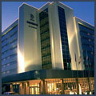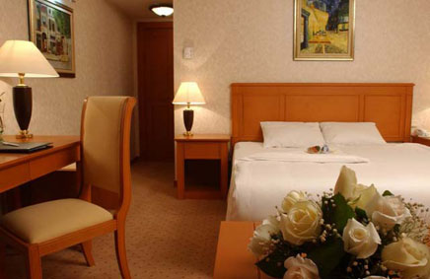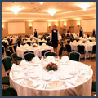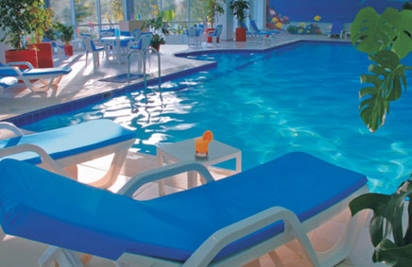

Room Type | Special Rates
Standard Room | USD 120.00/135.00
Double Room | USD135 .00/165.00
Deluxe | USD 150.00/180.00
Junior Suite | USD 400.00

Rich Open Buffet Breakfast and all local taxes are inclusive of single or double occupancy.
Free Usage of Life Style Health Center (indoor & outdoor swimming pools, sauna, gym).
Free Unlimited Wireless Internet service in all Guest Rooms.
Free Wireless Internet service on the Public Area.
InterContinental Tashkent *****
107A, A. Temur Street,
Tashkent, 100084, Uzbekistan
Tel.: (998 71) 1207000 ext. 4229
Fax: (998 71) 1206459
www.ihg.com

Opened in 1997, established 5 star hotel is ideally located within a business park near the National Bank of Uzbekistan, Shopping Centre and the Telecommunication Center, adjacent to a lake and near the main trade fair site, close to city center. Distance from International airport: 10 km or 20 minutes drive. Distance to city center: 5 km.

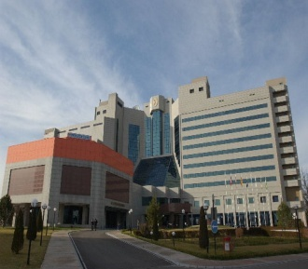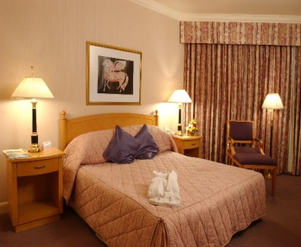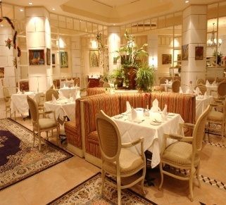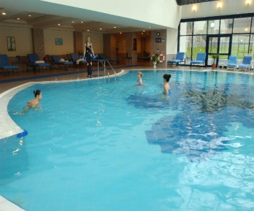

Room Type | Special Rates
Standard Room | USD 190.00
Superior Room | USD 210.00
Junior Suite | USD 528.00
Room rate includes one Full American Buffet breakfast. And also free of charge: Instant check-in/check-out, Luggage storage, in-room-safe, 24 hours security, 24 hours services of Fitness Center, 24 hours services of Gymnasium; use of Swimming Pool, Steam and Sauna during working hours, Wireless internet access in the Hotel Lobby. Also available Currency exchange office and Ticket Office of “Lufthansa” Airlines.
Payment for the services shall be made by guest's credit card (American Express /Visa/ EuroMaster card) or by bank transfer.

Radisson SAS Hotel Tashkent ****
88, A. Temur Street,
Tashkent, 100084, Uzbekistan
Tel.: +998 71 1204900
Fax: +998 71 1204902
www.radissonsas.com

The Radisson SAS Hotel in Tashkent is on the Amir Temur road, in the heart of the banking and business district. The hotel is just 15 minutes from the international airport and has 111 beautifully designed rooms with all modern amenities: individually controlled heating and air-conditioning system, direct-dial telephones and Internet port, electronic safe, TV Set with 24 worldwide channels, bathroom with bath-tub, mini-bar and hair-drier. The Hotel has 2 Bars, 2 Restaurants, Fitness center (swimming pool, sauna and gym), 24 hours open Business Center with all facilities, laundry & dry-cleaning service, outdoor parking lot, currency exchange office.

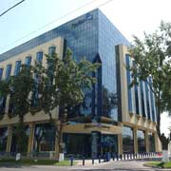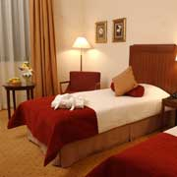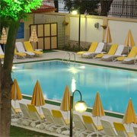

Room Type | Special Rates
Standard Single | 135 USD (Friday-Sunday 116 USD)
Junior Suite | 250 USD
The above rates include:
- open Buffet breakfast;
- fitness center use: swimming pool, sauna and gym;
- complimentary Internet in the room & wireless internet use in all public areas;
- V.A.T.
Check-in time at the hotel is 14:00 and check-out is 12:00 (noon)
Accounts can be settled by major credit cards: Visa, AmEx, MasterCard, Diners Club, JCB or Cash.
Participants who require hotel reservation, are kindly asked to complete and return the HOTEL RESERVATION AND TRANSFER FORM in Annex 1 below to the National Coordinator
Mrs. Umida Musayeva, Senior Specialist of International Relations Coordination Department of the Communications and Information Agency of Uzbekistan by fax: + 998 71 239-87-82 or e-mail: u.musaeva@aci.uz by 2 March 2012 at the latest. (for enquiries: Tel: +998 71 238-41-41,
Mobile: +998 97 340-54-03).

ANNEX 1
ITU Regional Forum 2012;
followed by
RCC WTSA-12 Regional Preparatory Meeting; and
RCC WCIT-12 Regional Preparatory Meeting
(Tashkent, Uzbekistan, 2-6 April 2012)

HOTEL RESERVATION AND TRANSFER FORM
To ensure booking of hotel and transfer to and from the airport, participants are requested to complete and return this form to Mrs. Umida Musayeva, by fax: + 998 71 239-87-82 or
e-mail: u.musaeva@aci.uz by 2 March 2012 at the latest. (for enquiries, tel: +998 71 238-41-41,
mob: +998 97 340-54-03).

Family name -----------------------------------------------------------------------------------------------------------

First name -----------------------------------------------------------------------------------------------------------

Address ------------------------------------------------------------------------ Tel: ------------------------

----------------------------------------------------------------------------------------- Fax: -------------------------

----------------------------------------------------------------------------------------- E-mail: -----------------------

Name of Hotel ------------------------

------------ single/double room(s) at preferential rate

from________________________ April 2012 to ________________________April 2012

Date---------------------------------------------------- Signature ---------------------------------------------

TRANSFER INFORMATION

Transportation will be provided from the airport to the hotels and to the meeting venue

Date of Arrival |  |  | Time of Arrival |  | FLIGHT NO.
Date of Departure |  |  | Time of Departure |  | FLIGHT NO.
______________

