|  |
| --- |
| **Annex 3**  ITU Centres of Excellence Network for Asia-Pacific Region  Training on  **Green ICTs and Smart Grids**  15-18 September 2015  Bangkok, Thailand  INFORMATION NOTE |

1. **Introduction**

The ITU Asia-Pacific CoE training on “Green ICTs and Smart Grids” will be held in Bangkok, Thailand from 15-18 September 2015. This face-to-face training is organized jointly by the International Telecommunication Union, National Broadcasting and Telecommunications Commission and the Ministry of ICT, Thailand as part of the policy and Regulation programme under the auspices of the ITU Centres of Excellence for Asia-Pacific region. The training will be delivered in English.

This training will build skills on the required actions for Climate Change mitigation and adaptation and the role that ICT plays in tackling it. It will explain the underlying concepts and the role that a wide range of stakeholders must play in developing the policies, regulations, technologies and standards that will improve energy efficiency and reduce GHG emissions through a range of mitigating technologies with a focus on smart grids, and enable countries and societies to better adapt to climate change

1. **Venue of the Training**

TOT Academy, Nonthaburi, Thailand

1. **Coordinators**

|  |  |
| --- | --- |
| **INSTITUTE COORDINATOR**  Mrs. Sudaporn Vimolseth  TOT Academy  Nonthaburi,Thailand  Tel: +66 2 580 1076  Fax: +66 2 591 8087  E-mail:[sudaporv@tot.co.th](mailto:sudaporv@tot.co.th) | **ITU COORDINATOR**  Mr. Ashish Narayan  ITU Regional Office for Asia Pacific Bangkok, Thailand  Tel. +66 2 575 0055  Fax +66 2 575 3507  E-mail:[ashish.narayan@itu.int](mailto:ashish.narayan@itu.int) |

1. **ON-SITE REGISTRATION AND Working Hours**

* Venue : TOT Academy, Nonthaburi,Thailand
* Date : 15 September 2015
* Time : 0800 AM Onwards

1. **Visa Formalities**

All participants entering Thailand must possess valid passports or accepted travel documents and need to check visa requirements before entering the country. Please check the visa with the nearest Thai Embassy. For more information please visit the website [http://www.mfa.go.th](http://www.mfa.go.th/).

1. **ACCOMMODATION**

Participants can book the proposed hotel through the organizer for special rate and confirm the availability or if preferred other hotel for their convenient but be aware of the Bangkok traffic to the training venue in the morning. Reservation form is attached in Annex 2

1. **LIST OF PROPOSED HOTELS**

The list of recommended hotels are situated near the training venue in order to be easier for travelling in the morning. The lists are as follows

***Richmond Hotel***

Richmond is an elegant 4-star convention venue and hotel located in northern Bangkok, **approximately 15 minutes by car to the training venue** or just half an hour drive from the city centre through express way. RICHMOND features 455 luxury rooms and suites. Pick up from the airport can be requested by paying for airport transfer.

***TOT Academy***

**TOT Academy** is located at NgamWong Wan Soi 17, Ngam Wong Wan Road, Nonthaburi, near the expressway from the airport to Chaeng Wattana and Bang Pra-in. **The hotel is in the training venue just 1 minute walk to the training room.** All 75 hotel rooms are beautiful atmosphere and amenities with complimentary wireless hi speed internet. For hotel guests, the hotel offers fitness and sauna. Three Shopping malls are located nearby, viz. Pantip, The Mall, and Esplanade Shopping Center with Tesco Lotus. from Airport is approximately 45 minutes.

**Mida Hotel**

Mida Hotel Ngamwongwan is a comfortable 3-star property located 13.3km from the centre of Bangkok. Dining facilities at Mida Hotel Ngamwongwan include a restaurant. Breakfast is available.The hotel has a 24-hour front desk service complimentary newspapers in lobby, concierge services, dry cleaning/laundry service, elevator/lift and roll-in shower. Mida Hotel Ngamwongwan offers transportation to/from the airport for an additional fee. from Airport is approximately 40 minutes.

1. **DETAILS OF ARRIVAL AND TRANSPORT**

Participants are recommended to arrive at Suvarnabhumi International Airport, which is located 45 kilometres from the centre of Bangkok. More detailed information can be found on the following web site <http://www.suvarnabhumiairport.com/>

For your arrival at Suvarnabhumi International airport, **airport taxis and public taxis** can be easily find from point of entry to hotels. Airport taxis will cost more than public one with more convenient car. **All participants are requested to make their own travel arrangements** from airport and place of stay (if different from the training venue) to the venue.

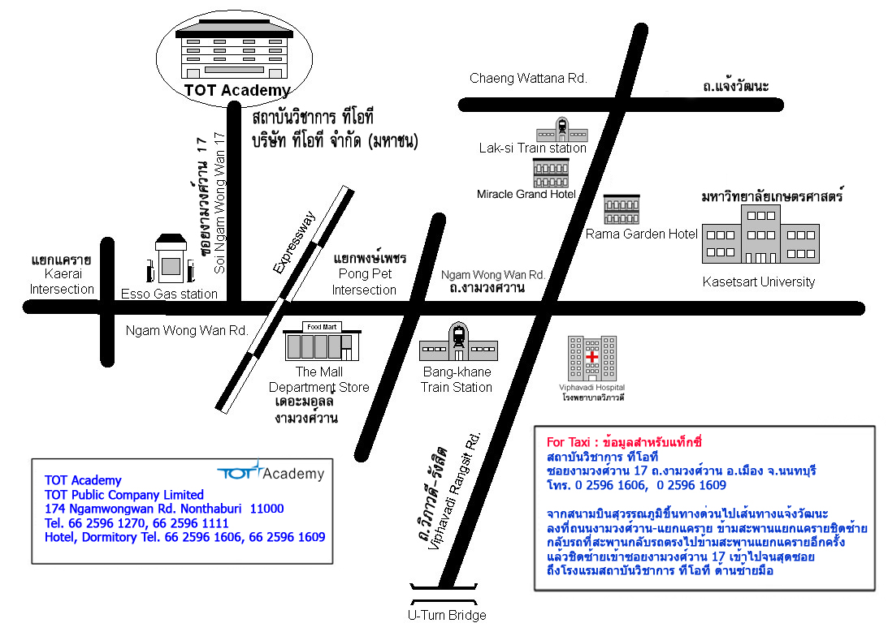

1. **CURRENCY**

The currency exchange for Thai Baht is 1$ USD (currently approximately 31 baht). Government and business offices are open from 8.30 to 16:30 hrs, Monday to Friday. Bank opens Monday to Friday from 9.00-15.30 hrs while the department stores open daily from 10.00-20.00 hrs.

1. **ELECTRICAL APPLIANCES**

The electric current is 220 volt AC throughout the country.

Power Plug

For Thailand, the picture/diagram shows the type of main power plug used in Thailand so participants can bring the right adaptor for their electrical appliances. This plug and receptacle are technically known as NEMA 5-15 (North American 15 A/125 V grounded).

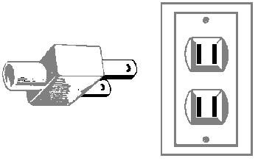

1. **LANGUAGES**

English is spoken in most hotels, shops and restaurants as well as in major tourist destinations

1. **SECURITY**

It is safe in Bangkok but however to travel at night time alone is sometime not recommended.

1. **MEDICAL AND HEALTH**

All participants are requested to ensure medical and travel insurance covering the whole period of the training course and overseas travel. Neither ITU nor the NBTC or MICT will be able to meet any expenses relating to injury, accident or medical treatment of the participant.

Drinking water in the country should not be drink from the tab even though it is clean.

1. **WEATHER**

The time in Bangkok is 7.00 ahead of Greenwich Mean Time (+7.00 GMT). In September, the temperature is between 28 -35oC.

**15.INTERNET**

All internet Access will be provided during training. For staying in the hotel ,please contact the reception desk for access.

**Have a safe trip**