CURRICULUM VITAE
<Name>
MR. MASANORI KONDO
< Present Title >
Deputy Secretary General,
Asia-Pacific Telecommunity (APT)
<Education>
Keio University (BS in Economics)
Master in The The London School of Economics and Political
Science (MSc in Economics)
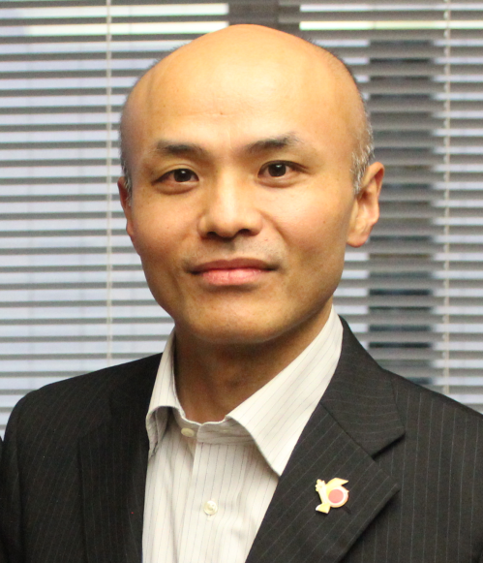
PROFESSIONAL CAREER
2015  2014 | Deputy Secretary General, Asia-Pacific Telecommunity (APT)  Assistant Director General for International Affairs, MIC, Japan
2011 | Senior Director, International Economic Affairs, MIC, Japan
2010 | Director, International Policy Affairs, Ministry of Internal Affairs and Communication (MIC), Japan
1996 | First Secretary, Embassy of Japan in Hashemite Kingdom of Jordan

ACADEMIC CAREer
2013 | Lecturer, Keio University, Japan
2006-2007 | Visiting Scholar, Rikkyo University, Japan
2006-2007 | Visiting Scholar, Ohbirin University, Japan
2005 | Lecturer, Waseda University, Japan
2004-2005 | Associate, Harvard University (Weatherhead Center), U.S.A

