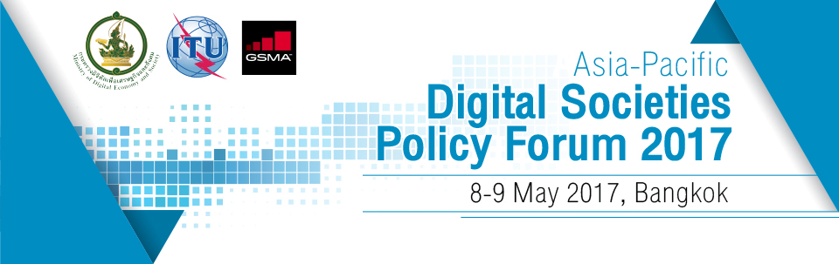

Registration Form
Asia-Pacific Digital Societies Policy Forum 2017
Centara Grand at Central World, Bangkok, Thailand
8 – 9 May 2017

Personal Information
Title | ☐ Mr. ☐ Ms. ☐ Mrs. ☐ Dr. ☐ Prof. ☐ Other:
First Name
Family Name
Organisation
Position
Contact Information
Address
City/Town
Postcode
Country
Phone No.
Mobile No.
Email
How did you hear about this event?

