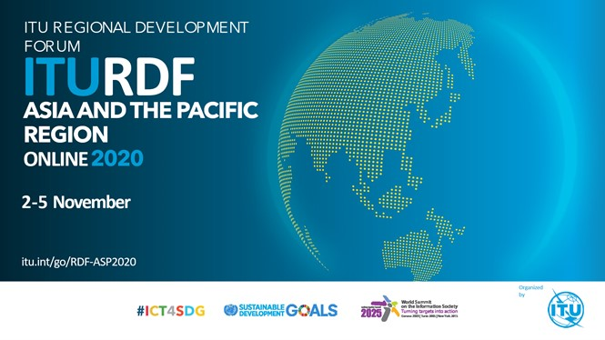

TEMPLATE OF CONTRIBUTION
CONTRIBUTION BY [Include name of entity / country]
TITLE: [Include title of the submission]
Expected duration of presentation: [XX minutes]
CONTACT: [Name, e-mail, phone]
- Asia and the Pacific (ASP) Regional Initiatives: [Select the Regional Initiative(s) relevant for your contribution]
[Yes/No] ASP Regional initiative 1 − Addressing special needs of least developed countries, small island developing states, including Pacific island countries, and landlocked developing countries.
[Yes/No] ASP Regional initiative 2 − Harnessing ICTs to support the digital economy and an inclusive digital society
[Yes/No] ASP Regional initiative 3 − Fostering development of infrastructure to enhance digital connectivity
[Yes/No] ASP Regional initiative 4 − Enabling policy and regulatory environments
[Yes/No] ASP Regional initiative 5 − Contributing to a secure and resilient environment
- Related ITU development thematic: [Select the thematic area(s) relevant for your contribution]
[Yes/No] Networks and digital infrastructure
[Yes/No] Cybersecurity
[Yes/No] Emergency telecommunications
[Yes/No] Environment
[Yes/No] Digital policy and regulation
[Yes/No] Capacity development
[Yes/No] Digital services and applications
[Yes/No] Digital inclusion
[Yes/No] Digital innovation ecosystems
[Yes/No] Statistics and data for evidence-based decision making
- Year(s) of implementation: [Select the year(s) for which your action/project/initiative is relevant]
[Yes/No] 2018 | [Yes/No] 2019 | [Yes/No] 2020 | [Yes/No] 2021 | [Yes/No] Others
- COVID-19 response related initiative: [Please indicate if your action/project/initiative is relevant for COVID-19 response]
[Yes/No] COVID-19 response related initiative
Background [max 300 words]
[Add text here on background to the initiative, including partnership and funding aspects, if applicable] ………………………………………………………………………………………………………………………………………………..…….
………………………………………………………………………………………………………………………………………………..…….
………………………………………………………………………………………………………………………………………………..…….
………………………………………………………………………………………………………………………………………………..…….
………………………………………………………………………………………………………………………………………………..…….
………………………………………………………………………………………………………………………………………………..…….
………………………………………………………………………………………………………………………………………………..…….

Proposal [max 400 words]
[Add text here on details of the proposal] ………………………………………………………………………………………………………………………………………………..…….
………………………………………………………………………………………………………………………………………………..…….
………………………………………………………………………………………………………………………………………………..…….
………………………………………………………………………………………………………………………………………………..…….
………………………………………………………………………………………………………………………………………………..…….
………………………………………………………………………………………………………………………………………………..…….
………………………………………………………………………………………………………………………………………………..…….

PLEASE SUBMIT THE CONTRIBUTION BY 27 October 2020 TO ITUASIAPACIFICREGION@ITU.INT

