Test Report:

Performance assessment of vehicle-mounted mobile phones in conjunction with hands-free terminals based on Recommendations ITU-T P.1100 and ITU-T P.1110

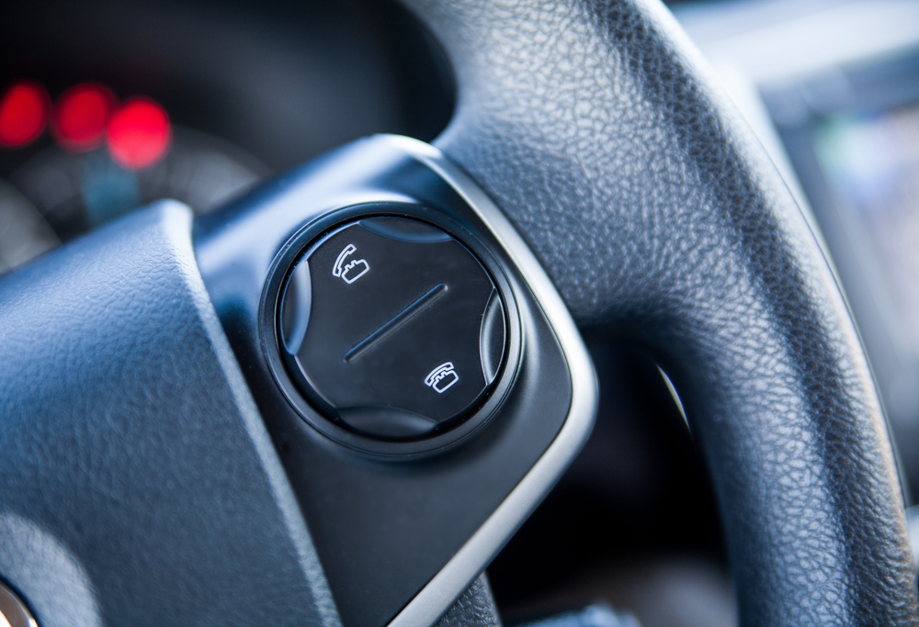

© ITU 2014


Background
ITU organized a test event “Performance assessment of vehicle-mounted mobile phones in conjunction with hands-free terminals based on Recommendations ITU-T P.1100 and ITU-T P.1110”
The test event, held at ITU Headquarters, 12-16 May 2014, analysed the behaviour of a representative sample of mobile phones available today and capable of connecting to hands-free systems.
The tests were performed by HEAD acoustics GmbH, based on the ‘Chapter 12 tests’ of Recommendations ITU-T P.1100 and ITU-T P.1110, standards for narrow-band and wideband communications involving motor vehicles. The tests’ requirements were adapted and applied to real-world scenarios. The methodology and results of the tests event will feed into an ongoing process to refine the standards.
This report was written by HEAD acoustics which is responsible for the test conduction and the analysis of the test results. Test results have been anonymized in this report.

Contact persons:
Mr Denis Andreev, denis.andreev@ITU.int, Tel. +41 22 730 5780


Mr Marc Lepage, marc.lepage@head-acoustics.de, Tel. +49 2407 577 105
Mr Frank Kettler, frank.kettler@head-acoustics.de, Tel. +49 2407 577 68

Table of Contents
1. Motivation 1
2. Summary 2
3. Cascaded Algorithms 3
4. Test Description 5
4.1 Test Setup 5
4.2 Tests Adaptations for the Test Event 6
4.3 Selection and Designation of Mobile Phones 13
4.4 Result Representation and User Experience 13
5. Analyses Results 16
5.1 Overview - Narrowband 16
5.2 Overview - Wideband 19
5.3 Individual Summary – Narrowband 22
5.4 Individual Summary – Wideband 29
5.5 Cross Connection Tests 33
6. References 37

Motivation
“From a speech quality aspect, we need to regard the whole system, including the mobile phones, and not only the hands-free unit.” This conclusion from intensive discussions among car manufacturers, hands-free suppliers and test laboratory during the ITU-T Test Event best reflects the motivation for this event: ITU-T initiated and hosted the Short Range Wireless Test Event in May 2014 in Geneva [1] in order to verify the influence of mobile phones on speech communication quality of vehicle mounted hands-free systems.
In the most common use case for hands-free communication, a driver’s mobile phone is linked via wireless communication to the vehicle’s hands-free system which provides the mobile network access. Here the mobile phone acts as an “audio gateway” and should provide fully transparent voice transmission in uplink and downlink. The relevant signal processing is performed solely by the vehicle’s hands-free system; therefore mandating that the signal-processing functionality of a mobile phone be disabled while the phone is mounted on a hands-free system.
Experience has shown, however, that the internal signal processing in mobile phones is often not disabled – despite the hands-free unit sending the appropriate control command (AT command) to the mobile phone. In this situation, the mobile phone may significantly degrade the quality of the whole system, and car manufacturers have received complaints from customers having experienced speech quality shortfalls.
Corresponding tests to verify the performance of mobile phones in conjunction with vehicle-mounted hands-free terminals are described in Chapter 12 (“Verification of the transmission performance of short-range wireless (SRW) transmission enabled phones”) of Recommendations ITU-T P.1100 [2] and ITU-T P.1110 [3]. These tests have been used for testing during the event.
The Test Event took place between May 12th and 16th at ITU-T headquarters in Geneva. 40 tests were carried out on a total number of 30 “state-of-the-art” mobile phones of 12 different phone vendors in narrowband and wideband mode. The devices were selected and provided by 5 participating companies. For all tested devices the SRW transmission was realized using the BluetoothTM wireless technology standard.
The most important findings are summarized in Chapter 2 of this report. Chapter 3 gives a brief insight into the influence of cascaded algorithms. The setup together with a short introduction of the tests itself including adaptations for the Test Event, an overview about the selected mobile phones and the result representation is given in Chapter 4. Chapter 5 analyses the results. References can be found in Chapter 6.

Summary
The most important findings can be summarized as follows:
- 30 different mobiles from 12 different vendors were selected from the participating companies. A total number of 40 tests were conducted in narrowband and wideband mode.
- The tests are based on Recommendations ITU-T P.1100 and P.1110 Chapter 12 together with adaptations for the Test Event. The results and the most important findings will be fed back into the standardization process during the next ITU-T SG 12 meeting.
- All tested mobile phones in narrowband and wideband mode respond with “ok” to the “AT+NREC=0” command, indicating that the internal signal processing (noise reduction, echo cancellation) is disabled.
- Approximately 30% of the tested phones violate the adapted round trip delay requirement of ≤ 210 ms. The maximum round delay was determined to nearly 500 ms for one phone in narrowband mode.
- Approximately 30% of the devices tested in narrowband mode do not disable noise reduction and echo cancellation, although they responded with “ok” on the AT command. Customer complaints can be expected for these devices.
- Also other influences on the transmitted signals, such as active volume control on the BluetoothTM link, signal amplification of up to 12 dB in sending direction (highest measured amplification) or active equalizers were detected during the tests.
- Only approximately 40% of the tested mobile phones can be regarded as fully transparent, as required.
- All -except one- devices tested in wideband mode disable noise reduction and echo cancellation. However, other signal influences like signal amplification of up to 17 dB in sending direction (highest measured amplification in wideband mode, which will definitely lead to signal saturation and distorted voice) or active equalizers were detected.
- Cross connection tests in narrowband BluetoothTM connection in combination with wideband network access (or vice versa) indicate unexpected inband level contrasts in both transmission directions in case of 4 wideband capable devices. Since dynamic codec switching between wideband and narrowband mode can occur in the mobile networks these level contrasts are directly perceivable by the user and might lead to customer complaints.
- Additional tests without sending the “AT+NREC=0” command to the mobile phones (relevant for BluetoothTM headsets communicating with mobile phones also via the hands-free profile), pointed out, that approximately 25% of the mobile phones disable internal signal processing, although it is not (!) requested by the accessories. This is an important issue for BluetoothTM headsets without own implemented signal processing. In this case, the mobile phone should keep the algorithms active.

Cascaded Algorithms
According to the Hands-free Profile V1.6 [4], a vehicle mounted hands-free system may request the mobile phone to disable the internal signal processing, such as echo cancellation and noise reduction. This is necessary in order to avoid cascaded algorithms which may significantly impair conversational quality either in receiving direction in the vehicle or in sending direction, i.e. at the far end side.
The block diagram in figure 3.1 indicates the two transmission directions and shows the different components, i.e. mobile network, the mobile phone, which acts as audio gateway between network and hands-free system, the hands-free telephone system, the audio playback system and the hands-free microphone system in the vehicle. Note that the connection between hands-free telephone system and mobile phone is today typically realized via BluetoothTM.
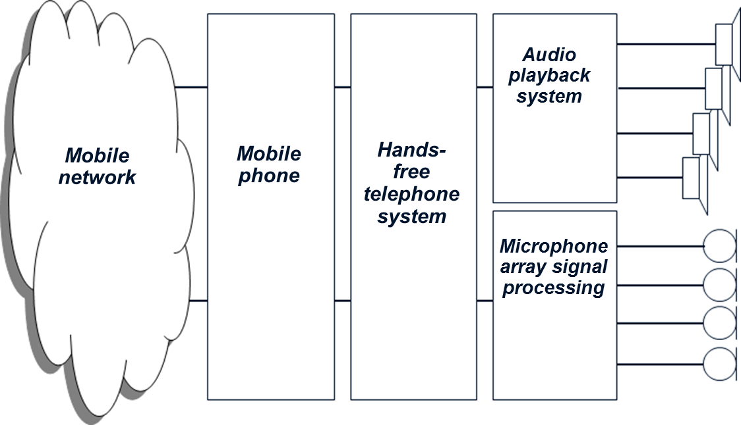  Sending direction | Receiving direction  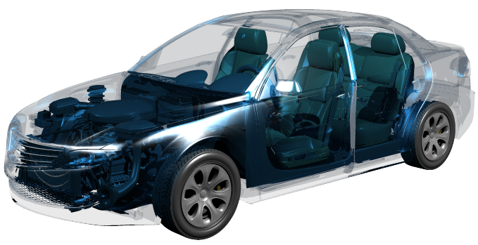
Fig. 3.1: Principle block diagram and definition of transmission directions
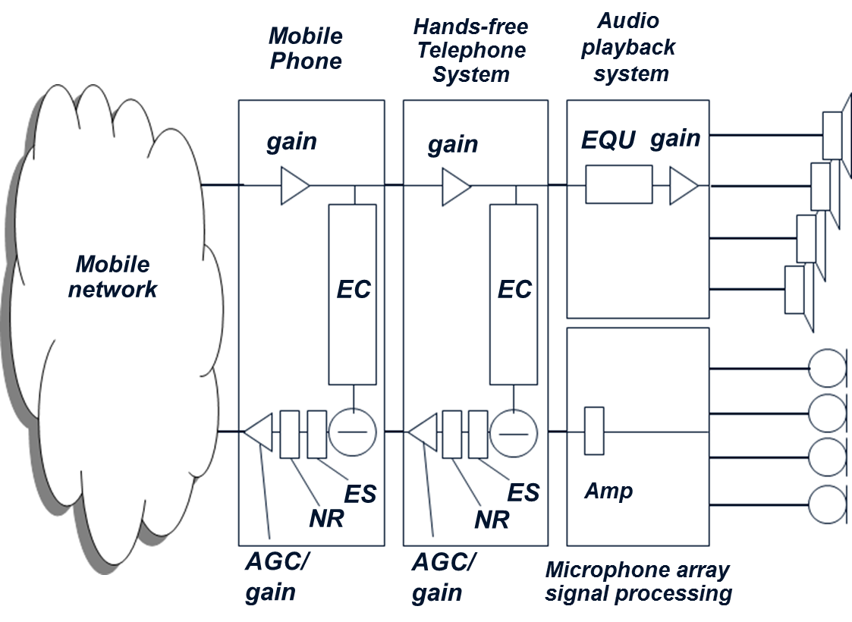 | Figure 3.2 shows the typical signal processing components in this set-up. The hands-free algorithms provide the echo cancellation functionality (“EC”), the additional processing to suppress residual echo components (echo suppression “ES”), noise reduction algorithm (“NR”) and gain adjustment including possible automatic gain control (“AGC”).  Today’s mobile phones provide the same kind of algorithms (see fig. 3.2) which may lead to cascaded signal processing, if they are not bypassed or disabled.
Fig. 3.2: Cascades signal processing
This should, under all circumstances, be avoided. The components in the hands-free telephone system are already optimized on the acoustic environment in each vehicle.
Experience shows that cascaded algorithms lead to degradations in conversational quality:
- Additional echo cancellation and echo suppression significantly hamper the very important double talk performance. The echo suppression unit (“ES” in figure 3.2) typically introduces attenuation in the microphone path under single talk conditions, if only the far end subscriber is talking and his voice is played back via the loudspeakers in the car. In this situation the driver hears the far end talkers’ voice in the car. The implemented signal processing (EC, ES) suppress the echo, which would be audible and annoying for the person speaking at the far end side.
If the driver interacts (both persons talk at the same time, designated as “double talk”) any attenuation in the microphone path, introduced by the echo suppression unit, needs to be quickly removed. Cascaded echo suppression units (in case they are not disabled in the mobile phone) hamper the conversation. Driver’s voice may be significantly attenuated or even partly suppressed (speech gaps in driver’s voice, “chopped” speech), which is very annoying for the far end subscriber.
- On the other hand, cascaded noise reduction algorithms (“NR” in Figure 3.2) degrade speech transmission quality, especially if the driver is talking from the driving car. In this case his voice is transmitted together with background noise from the vehicle. The noise reduction algorithm shall lower the transmitted background noise without impairing driver’s voice. However, due to technical limitations quality degradation occurs. Driver’s voice sounds artificial, unnatural and “metallic” and perhaps disturbed by other artifacts known as “musical tones”. This is audible and annoying for the far end conversational partner. The degradation is even worse, if two cascaded noise reduction algorithms are active in such a connection.
- Other cascaded signal processing like additional gain or automatic gain control introduced by the mobile phone may lead to signal saturation either in receiving direction (in this case the voice sounds distorted in the car) or in the microphone path (distorted driver’s voice audible at the far end side).

4. Test Description
The short range wireless connection was realized as a BluetoothTM connection during the test event, representing the most common use case connecting a mobile phone to a vehicle hands-free system today.

4.1 Test Setup
The principal test setup is described in figure 4.1. The tests are carried out on a mobile phone between two electrical interfaces, i.e. a mobile network simulator on the network side and a BluetoothTM reference interface on the near end side. The BluetoothTM reference interface MFE XI (measurement frontend provided by HEAD acoustics) communicates via the hands-free profile to the mobile phone under test. A narrowband and wideband BluetoothTM connection can be setup depending on the capability of the mobile phone, in particular if the mobile phone supports the wideband BluetoothTM connection using the mSBC codec. Tests in a narrowband BluetoothTM connection use the CVSD speech codec.
On the network side a network simulator (CMU 200, Rohde & Schwarz) was used providing the capability of establishing a narrowband or wideband connection to the mobile phone.
In narrowband mode, the AMR codec operated at 12.2 kbit/s was used, the AMR-WB codec at 12.65 kbit/s was used in WB mode.  The BluetoothTM reference interface MFE XI is directly connected to the test system ACQUA. The network simulator is connected via 600 Ohm analog input and output connectors to the MFE VI.1 to the ACQUA measurement system (see test setup in figure 4.1). The clocks between both frontends, MFE XI and MFE VI.1 are synchronized via a digital AES/EBU connection. | 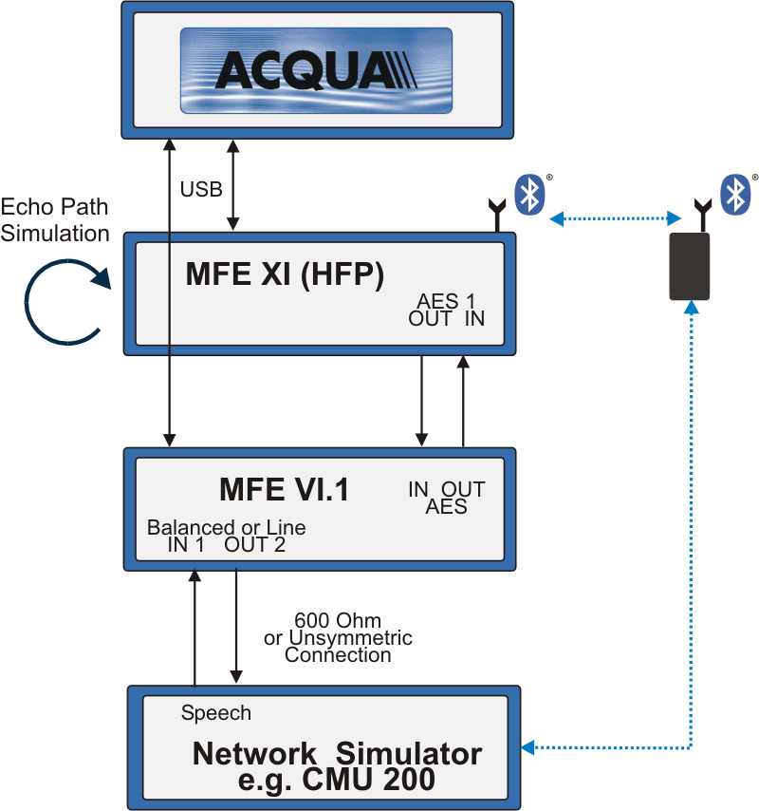
 | Fig. 4.1: Test setup, mobile phone connected to BluetoothTM reference frontend MFE XI and network simulator
Definition of transmission directions:
- Sending direction (see also fig. 3.1): The sending direction (uplink) represents the transmission from the BluetoothTM interface (representing the car hands-free unit) via the mobile phone to the network simulator.
- Receiving direction (see also fig. 3.1): The receiving direction (downlink) is defined as the transmission from the network simulator through the mobile phone to the BluetoothTM interface representing the hands-free unit in a vehicle.
In order to verify the echo performance of the mobile phones in such a simulated BluetoothTM connection, an echo path can be simulated in the MFE XI. This is indicated in figure 4.1. In this case, the downlink signal received via BluetoothTM at the MFE XI is coupled back in sending direction of the BluetoothTM connection with defined echo attenuation. These settings are stored in the appropriate frontends. The test setup guarantees an automatic test run for all devices under all test conditions.
The tests can be separated to verify the performance of the different communication aspects:
- Tests in sending direction covering Junction Loudness Rating tests, frequency response tests, Automatic Gain Control (AGC) tests, …
- The corresponding tests in receiving direction also cover these sensitivity tests, i.e. Junction Loudness Rating, frequency response, Automatic Gain Control tests,…
- Echo performance tests are realized by simulating an echo path on the BluetoothTM side. These tests are implemented in order to verify if the implemented echo cancellation signal processing in the mobile phone is disabled as required.
- Background noise transmission tests are analyzed in sending direction. The main purpose is the verification, whether noise reduction is disabled, as required.
- Double talk performance tests are carried out applying test signals in both directions (receiving and sending direction) simultaneously. The most critical use case, signal attenuation in sending direction caused by the implemented (and possibly active) echo suppression units in the mobile phones, is analyzed.

4.2 Tests Adaptations for the Test Event
The following test updates and extension of tests were proposed and agreed to be performed during the Test Event. The main motivation for these test adaptations is to provide realistically achievable quality of service requirements. Furthermore some test signals are selected and adapted to guarantee time-efficient test conduction during the Test Event. Both, the test updates and the extended test cases are described in detail and a motivation for the proposed modifications/extensions is given in the following sections.
Updates of Existing Tests in Recommendations ITU-T P.1100 / P.1110
Section 12.1.1/2: SRW delay in SND/RCV
The current delay measurement as described in Recommendation ITU-T P.1100/1110 is inapplicable since the described interfaces are not accessible. The given limit of ≤ 10 ms for the delay tests in sending (SND) and receiving (RCV) direction can therefore not be verified.
Proposal: The terminal one-way delays in both transmission directions T_{AG},_{UL} (audio gateway uplink) and T_{AG,DL} (audio gateway downlink) are informatively determined using the measurement interfaces as described in 3GPP TS 26.132 [5] and the round-trip delay of the audio gateway T_{AG,RT} is calculated as T_{AG,RT} = T_{AG,UL} + T_{AG,DL}. A requirement of T_{AG,RT} ≤ 210 ms is applied and verified during the test event.
Additional remarks:
The delay measurement is based on the methodologies described in 3GPP TS 26.132 [5] and investigated in more detail in 3GPP TSG-SA4#68 document S4-120403 [6]. The delay definitions for a system under test (T_{S}) and the test system used for determining these delays (T_{TES}) are given as follows for mobile phones operated in handset mode:
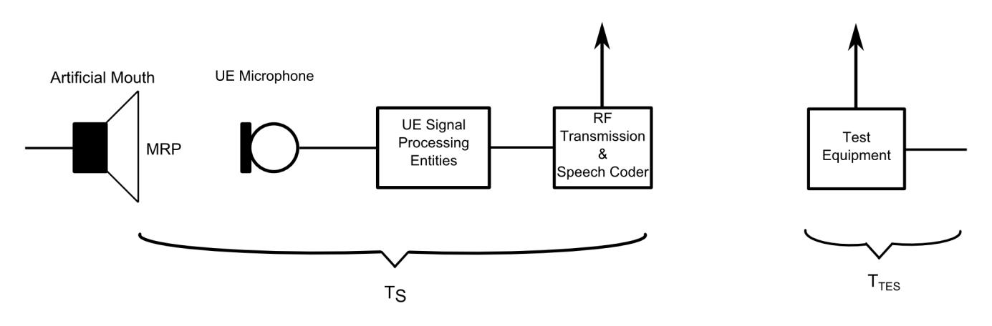
The considerations in S4-120403 lead to a requirement of T_{S} ≤ 185 ms for this operating mode.
For SRW/BT tests the setup needs to be modified as follows and the requirement has to be adapted:
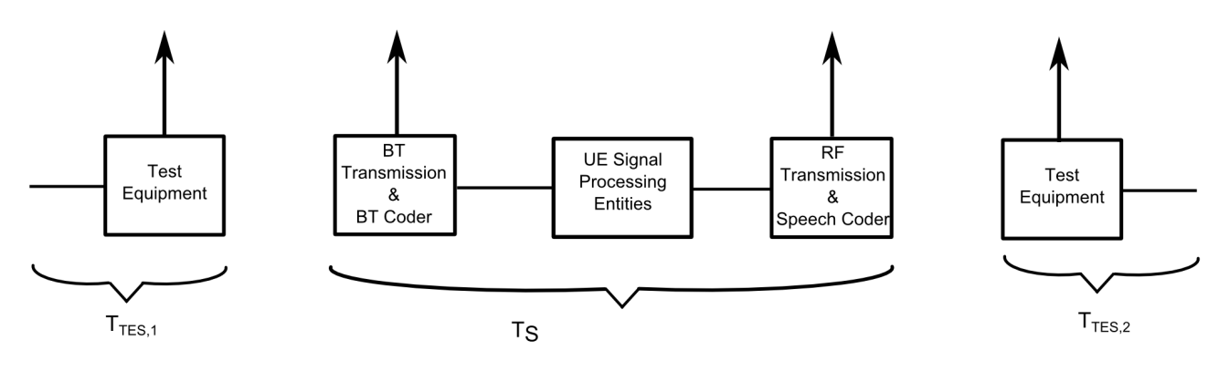
On one side the latencies for A/D and D/A conversion in handset mode can be neglected and delays of the implementation’s specific speech processing algorithms need to be considered only in a reduced form since EC and NR are expected to be deactivated. It is proposed to use a reduced value of 170 ms to cover these aspects.
On the other side additional processing delay for the BT Transmission and coder block needs to be considered. These latencies are assumed to be in a range from 20 to 30 ms for each transmission direction.
In sum this leads to the proposed requirement of T_{S} = T_{AG,RT} ≤ 210 ms which was verified during the ITU-T Test Event to be achievable by modern state-of-the-art mobile phones.
Section 12.2.1: SRW loudness ratings (Requirements)
The given requirement of 0 ± 0.5 dB in P.1100 and P.1110 is too narrow and too severe. The limit may already be violated by level loss caused by transcoding between AMR or EFR and CVSD (and vice versa) in todays’ narrowband BluetoothTM connection or AMR-WB and mSBC (and vice versa) in todays’ wideband BluetoothTM connections in the audio gateway.
Proposal: The requirement of 0 ± 3 dB may be better suited and reflect todays signal processing more accurately.
Section 12.2.2/3: SRW loudness ratings SND/RCV (Test)
The current loudness rating tests use a periodical repetition of CSS bursts for analysis. It should be considered that the speech like characteristics of the CSS are limited, it was originally designed to reproduce the characteristics of real speech applied to echo cancellers. Concerns are given that the signal characteristics are not sufficient especially considering more complex aspects of speech signals, as it may be necessary in order to evaluate e.g. transcoding effects.
Proposal: A sequence of real speech signals taken from Recommendation ITU-T P.501 [7] is used as test signal. Two sentences (1 male, 1 female voice) from the Recommendation ITU-T P.501 single talk sequences are concatenated in order to cover the low pitch frequency of male voices and the typically higher energy in the high frequency range for female voices:
“The last switch cannot be turned off” (sentence 1).
“The hogs were fed chopped corn and garbage” (sentence 6).
Section 12.2.4/5: SRW linearity in SND/RCV
The current linearity test uses an artificial voice sequence in Recommendation ITU-T P.1100 and CSS in Recommendation ITU-T P.1110. Although these test signals reproduce certain spectral and temporal characteristics of real speech, they are only artificial speech-like test signals. Concerns are given that the signal characteristics are not sufficient especially considering more complex aspects of speech signals, as it may be necessary in order to evaluate e.g. transcoding effects. Furthermore the requirement for the deviation from the loudness ratings determined under nominal conditions of not more than ± 0.5 dB is too narrow and too severe.
Proposal: A sequence of real speech signals taken from Recommendation ITU-T P.501 is used as test signal. Two sentences (1 male, 1 female voice) from the Recommendation ITU-T P.501 single talk sequences are concatenated in order to cover the low pitch frequency of male voices and the typically higher energy in the high frequency range for female voices:
“The last switch cannot be turned off” (sentence 1).
“The hogs were fed chopped corn and garbage” (sentence 6).
Furthermore, in order to limit the test duration, only three different level adjustments relative to the nominal test signal level are considered: -20 dB, -10 dB and +5 dB. The deviation from the nominal test case should not exceed ± 2 dB. It should be noted that higher signal levels might lead to codec saturation. It was observed that signal saturation may already occur for the +5 dB test case. This test condition was therefore not considered in the further analyses and mighty be replaced by a -30 dB test case.
Section 12.3.1/2: SRW sensitivity frequency response SND/RCV
The current frequency response test uses an artificial voice sequence. Although this test signal reproduces certain spectral and temporal characteristics of real speech it is only an artificial speech-like test signal. Concerns are given that the signal characteristics are not sufficient especially considering more complex aspects of speech signals, as it may be necessary in order to evaluate e.g. transcoding effects.
Furthermore the currently used tolerance schemes are too narrow and too severe. The limit may already be violated by level loss caused by transcoding between AMR or EFR and CVSD (and vice versa) in todays’ narrowband BluetoothTM connection or AMR-WB and mSBC (and vice versa) in todays’ wideband BluetoothTM connections in the audio gateway.
Proposal: A sequence of real speech signals taken from Recommendation ITU-T P.501 is used as test signal. Two sentences (1 male, 1 female voice) from the Recommendation ITU-T P.501 single talk sequences are concatenated in order to cover the low pitch frequency of male voices and the typically higher energy in the high frequency range for female voices:
“The last switch cannot be turned off” (sentence 1)
“The hogs were fed chopped corn and garbage” (sentence 6)
The tests are performed with an AMR bitrate of 12.2 kbit/s respectively an AMR-WB bitrate of 12.65 kbit/s.

Furthermore, modified tolerance schemes for narrowband and wideband transmissions are proposed as follows (applicable in both directions, sending and receiving):

Narrowband |  |  | Wideband
Frequency [Hz] | Upper Limit | Lower Limit | Frequency [Hz] | Upper Limit | Lower Limit
200 | 0 | -3 | 100 | 0 | -3
2000 | 0 | -3 | 2000 | 0 | -3
3000 | 0 | -4 | 3000 | 0 | -4
3400 | 0 | -4 | 3400 | 0 | -4
4000 | 0 | Not def. | 6800 | 0 | -4
 |  |  | 7000 | 0 | Not def.
The proposed tolerance masks were verified to be realistically achievable during the Test Event.
Section 12.4.2: SRW noise cancellation test in SND
The original test signal consists of three pink noise bursts with a duration of 5 s each followed by a pause of 3 s each. It should be considered that noise reduction algorithms may need longer adaptation times than 5 s and thus might not be detected by this test only due to the temporal structure of the test signal.
Original P.1100/1110 test signal | Continuous car noise signal

Proposal: A continuous band limited inside car driving noise is applied with a level of -20 dB_{m0} averaged over the frequency range from 200 Hz to 3.9 kHz (NB) respectively 50 Hz to 8 kHz (WB) and a minimum duration of 15 s.

Section 12.5.1/3: SRW speech quality during single talk SND/RCV
The determination of the perceptual analytical listening speech quality is currently performed using the P.862 PESQ [8], [9], [10] method.
Proposal: The more recent POLQA algorithm as described in Recommendation ITU-T P.863 [11] is used instead of PESQ. The British English speech sequence from Recommendation ITU-T P.501 is used and the POLQA scores are calculated based on sentence pairs. The current requirement of MOS-LQOn,w ≥ 4.0 is kept and was verified during the Test Event. However, especially the wideband analyses in chapter 5.2 indicate, that the application of the POLQA analysis method together with this suggested limit, needs to be discussed. None of the tested devices meets this limit.
Substitution for Section 12.5.2/4: Speech quality stability SND/RCV
The test procedures for the speech quality stability described in Recommendation ITU-T P.1100 and P.1110 are not realistic to be performed in a laboratory environment since different test positions in a vehicle and different combinations of SRW links cannot accurately and reproducibly be simulated.
Proposal for test substitution in laboratory environments: Since the POLQA test result provides quality scores for each pair of sentences it is proposed to replace the original P.1100/1110 test by repetitions (3 runs in total incl. the run covered by section 12.5.1/3) of the previously described test.
Section 12.5.5: Verification of disabled echo control
The current test signal consists of an artificial voice adaptation sequence with a level of -16 dB_{m0} followed by a pn sequence of 250 ms and a high level of -3 dB_{m0}. Only the pn part of the signal is used for the analysis. This test signal is especially designed for the test of acoustic echo cancellers e.g. for mobile phones operated in handset mode. For the verification of disabled echo control using a simulated echo path a test signal with a longer duration is preferable since it will lead to more reproducible results. Also a high signal level of -3 dB_{m0} is not necessary since it can be expected that the echo control is disabled.
For wideband connections it is furthermore recommended to use a test signal which provides more energy in the higher frequency range above 4 kHz than the artificial voice sequence.
Proposal: A real speech signal from Recommendation ITU-T P.501 is used. Two sentences (1 male, 1 female) from the Recommendation ITU-T P.501 single talk speech sequence are concatenated in order to cover the full frequency spectrum:
“The last switch cannot be turned off” (sentence 1)
“The hogs were fed chopped corn and garbage” (sentence 6)
The test signal consists of two repetitions of this sequence. The first one is to ensure that the echo canceller, if it remains active, is fully adapted. The analyses are then performed during the second repetition.
The test signal is applied with an active speech level of -16 dB_{m0} in receiving direction. Only the 20 dB artificial echo path is considered on the SRW reference interface side since 40 dB reduced signals are more likely to be affected by an AGC active in the audio gateway. The analyzed echo loss (TCL_{w}) is corrected by the previously determined JLR values in SND and RCV. Since the influence of an AGC modifying the measured signal levels cannot be 100% excluded the echo path spectrum should additionally be analyzed in order to judge if the echo control is active or not.
For wideband connections the echo attenuation for the frequency range from 100 Hz to 7 kHz (source signal level - level of the measured echo) corrected by the JLR in SND and RCV is calculated instead of the TCL_{w} since the TCL_{w} is defined only from 300 Hz to 6.7 kHz.
Additional Tests for Recommendation ITU-T P.1100 and P.1110
Proposal: AGC and switched level tests
The linearity tests described in Recommendation ITU-T P.1100 are extended by an AGC test and three switched level tests in order to further analyze whether an AGC is active in the audio gateway.
AGC test signal | Switched level test signal

Proposal: Verification of volume control activity
The volume control of the audio gateway should not affect the sensitivity in receiving direction. Therefore the loudness rating test in RCV is repeated with maximum and minimum volume setting adjusted in the audio gateway (if adjustable). The loudness rating difference for those two settings (and in principal for any other setting) shall be ≤ 0.2 dB.
This test procedure should be repeated in two independent service level connections. One with the “remote volume control” feature enabled at the reference interface and one without this feature. Analysis results have shown that the volume control activity often depends on the availability of this feature.
It was found out during the event, that the proposed requirement of ≤ 0.2 dB is too severe for wideband connections. A wider range of ≤ 0.5 dB is suggested for further tests.
Proposal: Double talk test in SND
In addition to the echo control test an automatic double talk type test according to ITU-T P.502 Amendment 1 Appendix 3 is informatively performed in SND in order to double check the disabled state of the echo control signal processing.
Proposal: Repetition of tests with new service level connection and without sending the “AT+NREC=0” command.
In order to verify that the deactivation of the NR and EC signal processing is really triggered by the dedicated AT command “AT+NREC=0” a subset of tests is repeated after setting up a new service level connection and WITHOUT sending the “AT+NREC=0” command. The tests to be repeated are:
- Delay SND/RCV
- JLR SND/RCV
- Sensitivity frequency response SND/RCV
- Noise reduction test in SND
- Verification of disabled echo control
- Automatic DTT test in SND
These tests are of special importance for accessories like headsets using the hands-free profile to connect to mobile phones but relying on the phones’ signal processing.
Additional Tests for Recommendation ITU-T P.1110 only
Codec negotiation mechanisms between the SRW (BluetoothTM) side and the mobile network side of mobile phones are not clearly defined. Thus NB/WB or WB/NB cross-connections are possible which may lead to unwanted level contrasts.
Proposal: Additional tests are performed under the following conditions:
- SRW connection in wideband and mobile network connection in narrowband mode.
- SRW connection in narrowband and mobile network connection in wideband mode.
Following the discussions during the Test Event it was concluded to analyze and compare the sensitivities based on 3rd octave frequency responses, which is also used for loudness rating calculations. The comparison of frequency response curves provides more information than loudness rating values. These tests are performed in send and receive directions. The results are compared for both cross-connection types as well as for the previously determined results according to chapter 1 of this document (no cross-connection).

4.3 Selection and Designation of Mobile Phones
The mobile phones were selected by the participating companies in the Test Event. The participation fee for each company covered eight tests in narrowband or wideband mode. Thus, a company could select eight different mobile phones to be tested in wideband mode or split the test modes between the mobile phones depending on the transmission capability, e.g. six tests on selected mobile phones in narrowband mode and two tests in wideband mode.
The motivation for the choice of mobile phones for each participant depended on individual needs. The verification of state-of-the-art phones typically used by customers today was mentioned, other motivations were the verification of reported customer complaints, the suitability of a mobile phone for tuning hands-free performance and even the intention to make known issues of phones public through the Test Event.
In total, devices of twelve different mobile phone vendors have been tested during the event, thus representing a major part of vendors worldwide. All devices are commercially available. 27 mobile phones were tested in narrowband mode, 13 mobile phones were wideband capable and tested accordingly.
Designation used for the tested devices (example): 1-WB
…tested in wideband mode
Mobile phone No.1…

4.4 Result Representation and User Experience
A two page test report was generated for each test run including a “Quality Pie” chart representation according to Recommendation ITU-T P.505 [12] of the most important results, the designation of the mobile phone including manufacturer, brand name, IMEI and software version, a summary of the most important findings, additional graphs for the sending and receiving frequency responses, the noise reduction performance and the spectral echo attenuation tested with a 20 dB simulated echo path.
One example for the “Quality Pie” chart according to Recommendation ITU-T P.505 together with a short description of the selected parameters and requirements is shown in figure 4.2. The “Quality Pie” slices represent the following parameters and requirements (clock wise):
- The “AT+NREC=0” pie slice indicates the reply of the mobile phone on this command from the reference BluetoothTM interface. The pie slice is scaled between “OK” and “Error”.
- The pie slice “VCC” is also digitally scaled between “Not active” and “Active”. It is recommended that the volume control on the mobile phone should not influence the sensitivity of the BluetoothTM connection, independent if the remote volume control feature is supported by the hands-free unit or not. In case the hands-free unit supports this feature, it is expected, that the volume control adjustment on the mobile phone may control the hands-free unit playback volume. However, it is not recommended that the mobile phones’ volume control influences the sensitivity of the BluetoothTM link itself.
- The “AGC” pie slice indicates the gain adjustment (amplification or attenuation) introduced in sending or receiving direction by the mobile phone. This pie slice is scaled in dB, the inner red circle represents the minimum requirement of ± 3 dB.
- The very important verification, if the implemented noise reduction in the mobile phone is in the BluetoothTM connection after sending the “AT+NREC=0” command, is indicated by the “NR” pie slice. The slice represents two possible states, the noise reduction being disabled as expected (“off” in the Quality Pie) or being enabled (“on”).
Fig. 4.2: Quality Pie Chart according to Recommendation ITU-T P.505
- The verification of the active echo cancellation algorithm in the mobile phone after receiving the “AT+NREC=0” command from the BluetoothTM reference interface is scaled in a similar way. Again two different stages, “off” (as required) or “on” are represented in the corresponding pie slice (“EC”).
- The influence of implemented signal processing on double talk performance is represented by the “DT” pie slice. Again two different stages are possible, the pie slice is scaled between “transparent” (as recommended) or “not transp.”.
- The sending sensitivity expressed by the measured Junction Loudness Rating (“JLR (SND)”) is scaled in dB. The limit, given by the inner red circle, represents an attenuation or amplification of 3 dB (JLR range 0 ± 3 dB).
- The Quality Pie slice “SFR” is also scaled in dB. It represents the violation of the suggested tolerance by the measured sending frequency response (SFR) in dB.
- Listening speech quality measured in sending direction using the POLQA algorithm described in Recommendation ITU-T P.863 is used for scaling of the “MOS-LQO SND” pie slice. The scale directly represents the measured MOS-LQO_{n} or MOS-LQO_{w} scores. The limit represented by the inner red circle is given by the numerical value 4.
- The receiving sensitivity (Junction Loudness Rating (“JLR (RCV)”) is scaled in dB. The inner red circle represents an attenuation or amplification of 3 dB (JLR range 0 ± 3 dB).
- The Quality Pie slice “RFR” (receiving frequency response) is scaled in dB and indicates the violation of the suggested tolerance by the measured curve.
- Listening speech quality in receiving direction is given by the “MOS-LQO RCV” pie slice. The limit represented by the inner red circle is given by the numerical value 4 as described above (see Chapter 4.2).
In addition to these results that were analyzed after sending the AT+NREC=0 command some tests were repeated without sending the command. In this case it is expected that the internal signal processing in the mobile phone is enabled as this control mechanism may be used by the headset industry relying on the signal processing in the mobile phones. The most important results are summarized in a short table in the test report.

Test Report example:
Summary in ITU-T P.505 “Quality Pie” Chart
DUT information, and identification (incl. IMEI, SW)
Analysis curves and numbers:
SFR, RFR, noise reduction, echo attenuation

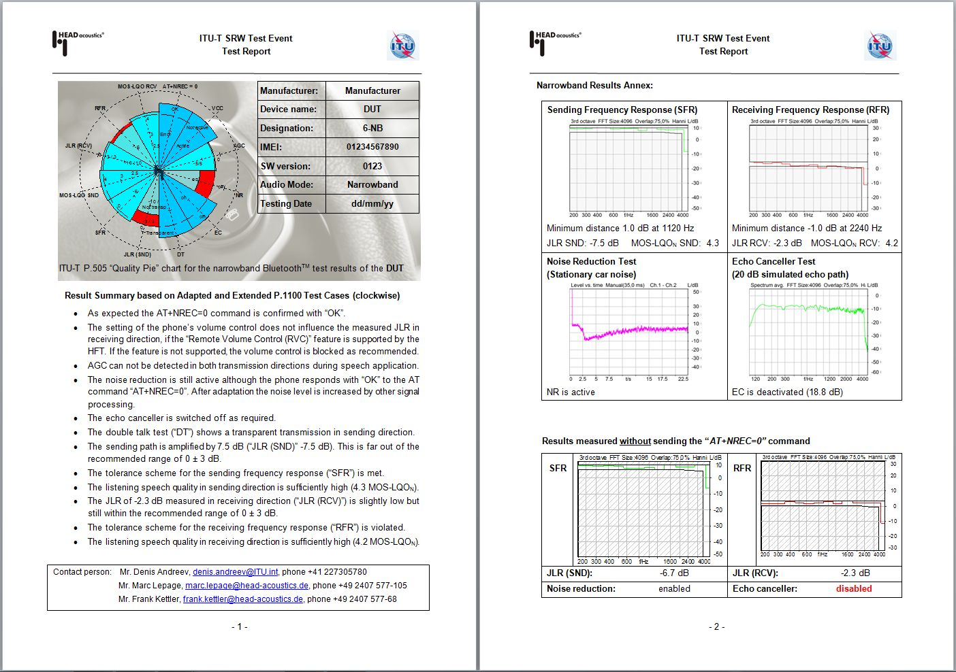
Additional test results without sending the ”AT+NREC=0“ command
Description of analysis parameter displayed in the “Quality Pie” Chart

5. Analyses Results

5.1 Overview - Narrowband
The measured round-trip delay values in sending direction (uplink, UL), receiving direction (downlink, DL) and the round-trip delay (RT) are analyzed in figure 5.1a to 5.1c. The delay introduced by the test setup (frontend delay, network simulator) is considered and subtracted already. Both one-way delays are informative only, a limit of 210 ms is verified in figure 5.1c for the round trip delay as proposed in chapter 4.2 (red dotted line).
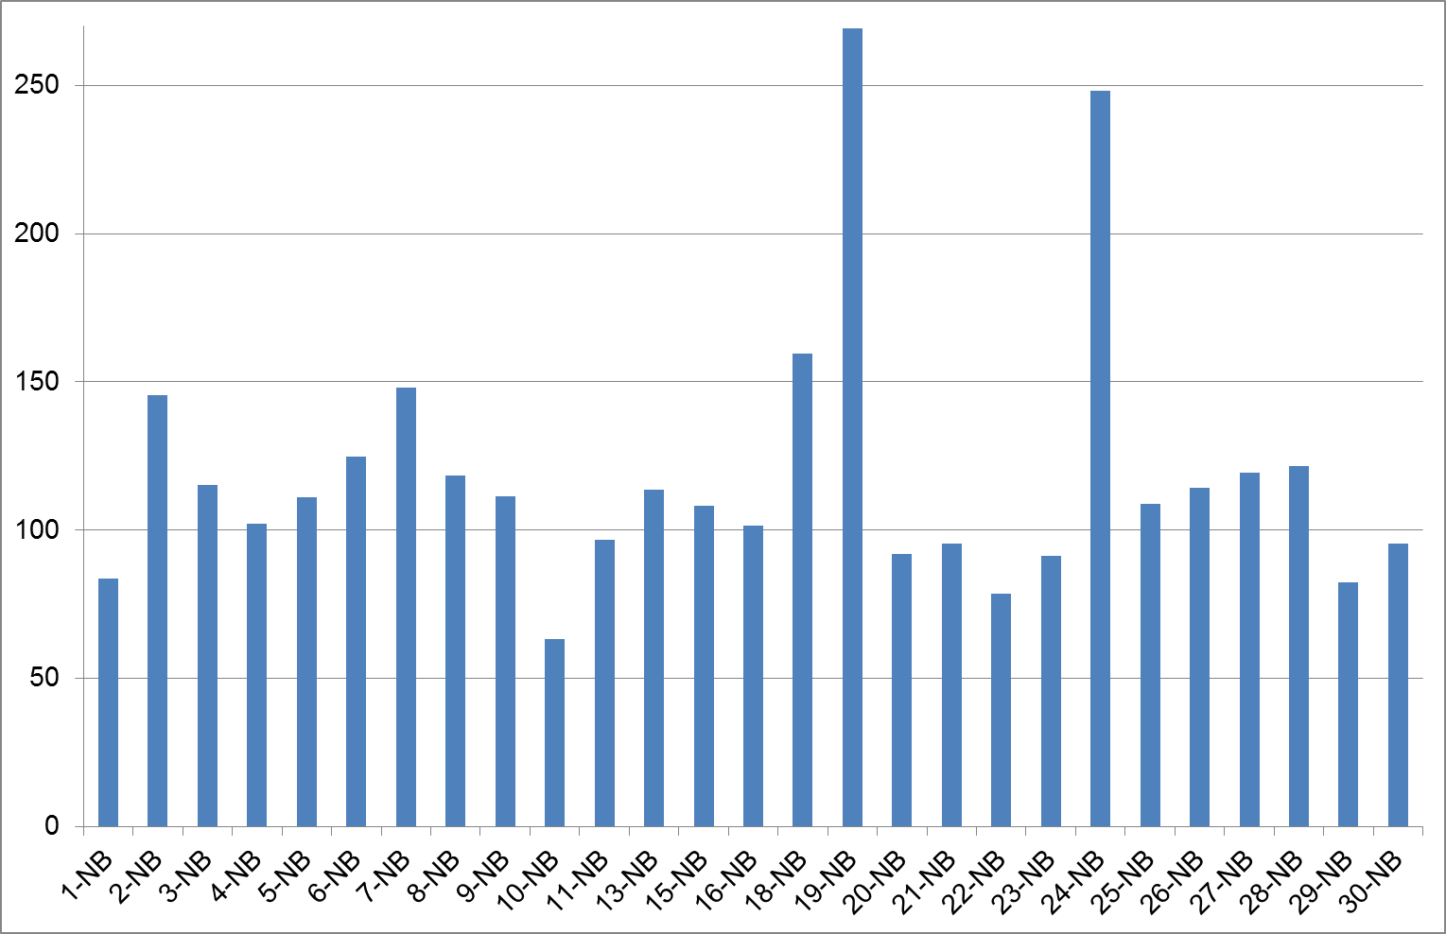 | 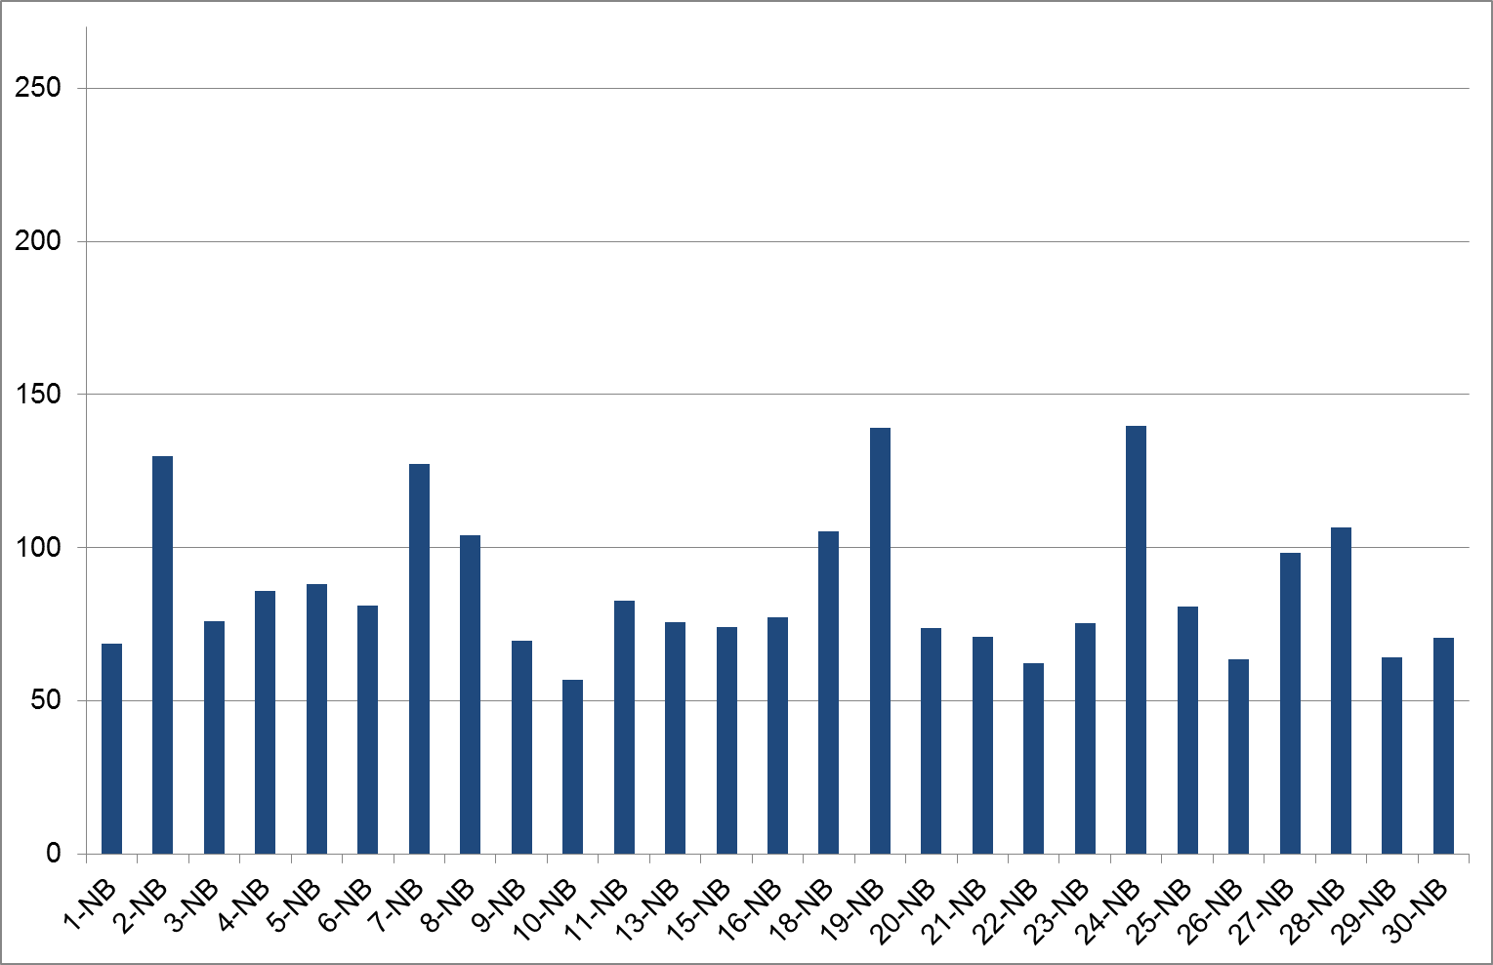
Fig. 5.1a: Sending (uplink) delay T_{AG,UL}, narrowband | Fig. 5.1b: Receiving (downlink) delay T_{AG,DL}, narrowband
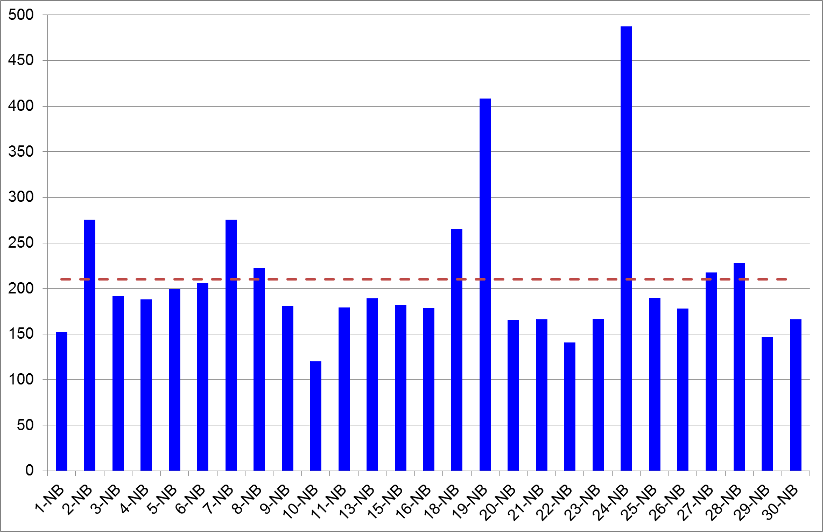
Fig. 5.1c: Round trip delay T_{AG,RT}, narrowband, 27 tested mobile phones
8 out of 27 devices violate the round trip delay requirement of 210 ms in narrowband mode. 3 devices (DUT 8, 27 and 28) show a slight violation, 3 implementations (DUT 2, 7 and 18) show delay values exceeding 260 ms. The maximum delay for the two devices 19 and 24 was determined between 400 ms and 500 ms, which is unexpectedly high. It needs to be noted, that this round trip delay does not consider the network delay. Such high delays will significantly hamper the conversation between both subscribers in a telephone conversation.
Figure 5.2 analyzes the 12 parameters used in the Quality Pie charts in order to provide a first overview about all 27 tested devices in narrowband mode. The green segments of each bar represent the number of mobile phones meeting the limits for each specific parameter. Vice versa the red segments indicate the number of limit violations. The requirements itself are either taken from Recommendation ITU-T P.1100, Chapter 12 or from the proposed adaptations in Chapter 4.2 of this report.

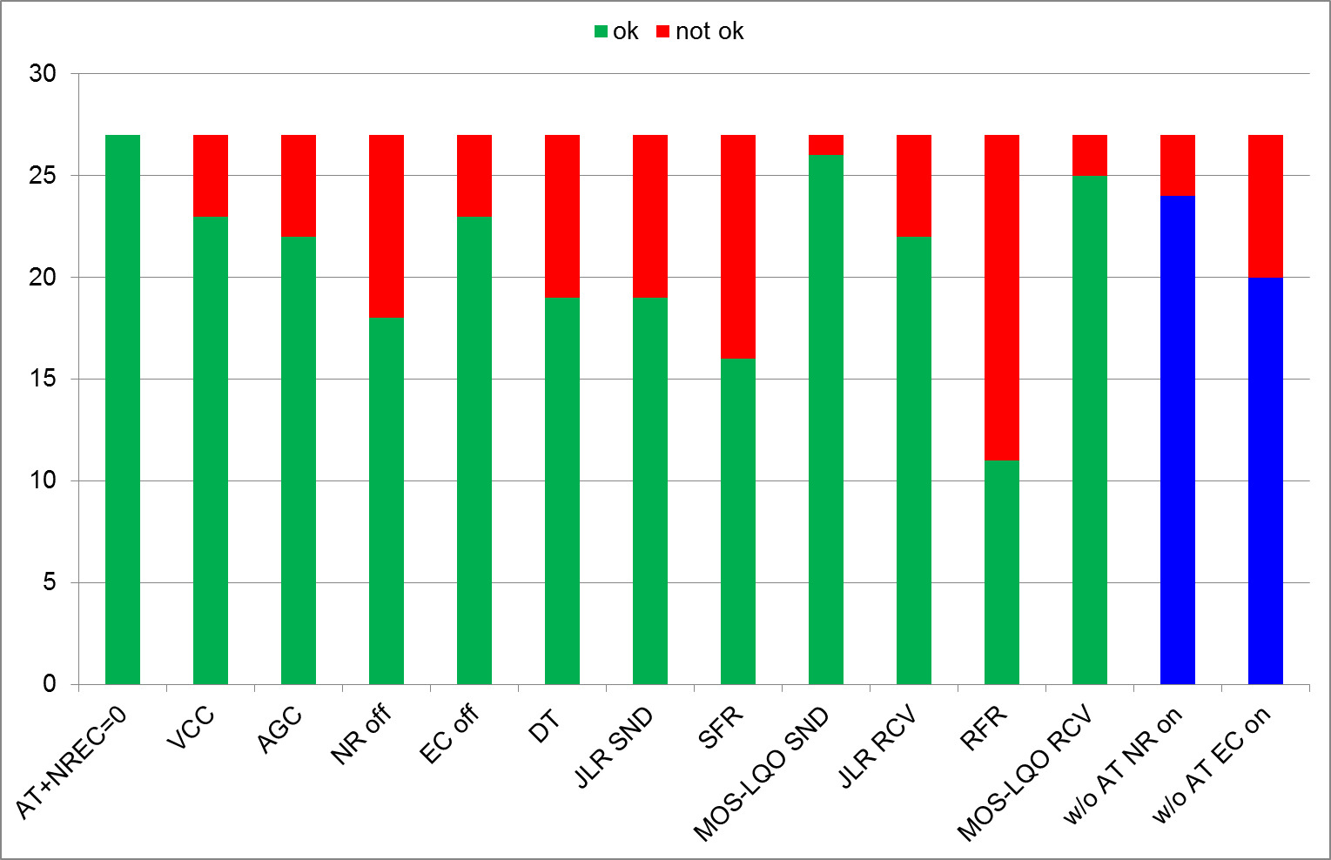
Fig. 5.2: Narrowband test result overview, 27 tested mobile phones

The last two bars on the right-hand side represent the additional tests carried out without sending the AT+NREC=0 command. The bars represent the verification of enabled noise reduction or echo cancellation (“NR on”, “EC on”). It should be noted that, without sending the AT+NREC=0 command, both algorithms are supposed to be enabled.
The following conclusions can be drawn:
- All 27 phones tested in narrowband mode respond with “Ok” to the AT+NREC=0 command.
- 4 out of 27 devices keep the volume control active on the mobile phone (“VCC”). This means that the actual adjusted playback level on the mobile phone directly influences the sensitivity on the BluetoothTM link. This is, in general, not recommended. In case the hands-free telephone system supports the “Remote Volume Control” feature the head unit allows the mobile phone to send appropriate commands to the head unit in order to remotely adjust the playback volume on the head unit. However, it is not recommended to change the sensitivity on the BluetoothTM link within the mobile phone. This could worsen the signal to noise ratio in the digital transmission. Furthermore the playback volume in the vehicle during a phone call depends on the volume setting of the phone, which is hard to control without drivers’ distraction.
- Automatic gain control (“AGC”) either in receiving or sending direction is active in 5 of the 27 tested devices.
- 30 % of the implementations (9 devices) keep the noise reduction (“NR”) enabled, although they responded with “Ok” to the AT command to disable the signal processing.
- 4 out of the 27 devices keep the implemented echo cancellation (“EC”) active.
- The double talk performance is hampered by 8 of the 27 devices. Surprisingly, these are twice as much compared to the 4 devices keeping the echo cancellation algorithm active. This also indicates that the double talk performance is not only influenced and degraded by the echo suppression feature but also by other gain control in the microphone path.
- The range of 0 ± 3 dB for the sending sensitivity (“JLR SND”) is violated by 8 devices and met by 19 implementations. It is worth to mention, that the strongest amplification in the sending signal path was more than 12 dB, which most likely leads to distorted drivers voice.
- 11 implementations do not meet the adapted tolerance for the sending frequency responds (“SFR”).
- The listening speech quality limit expressed by the MOS-LQO_{N} (“MOS-LQO SND”) is violated only by one device.
- The sensitivity in receiving direction (“JLR RCV”) with a recommended range of 0 ± 3 dB is violated by 5 of the 27 tested implementations.
- The receiving frequency response is violated by 16 of the 27 test devices.
- Listening speech quality in receiving direction with the preliminary limit of ≥ 4.0 MOS-LQO_{N} is violated by only 2 devices.
The two additional test results in figure 5.2 measured without sending the AT command can be summarized as follows:
- 3 out of 27 devices disable the implemented noise reduction, although the AT command is not sent.
- 7 devices disable the implemented echo canceller in the BluetoothTM connection without having received the AT command.
These devices obviously disable the internal signal processing in a BluetoothTM link independent if the AT command is received or not. This is definitely another issue that should be verified for each implementation. Some BluetoothTM headsets without own implemented signal processing may rely on the algorithms in the paired mobile phone. If the mobile phone automatically disables these algorithms, echo disturbances and a low communication quality in noisy environment may occur.

5.2 Overview - Wideband
The measured delay values in wideband mode are analyzed in figure 5.3a to 5.3c. Again both one-way delays are informative only and the suggested limit of 210 ms is indicated in figure 5.3c by the red dotted line. Again the delay introduced by the test setup is considered in these analyses.
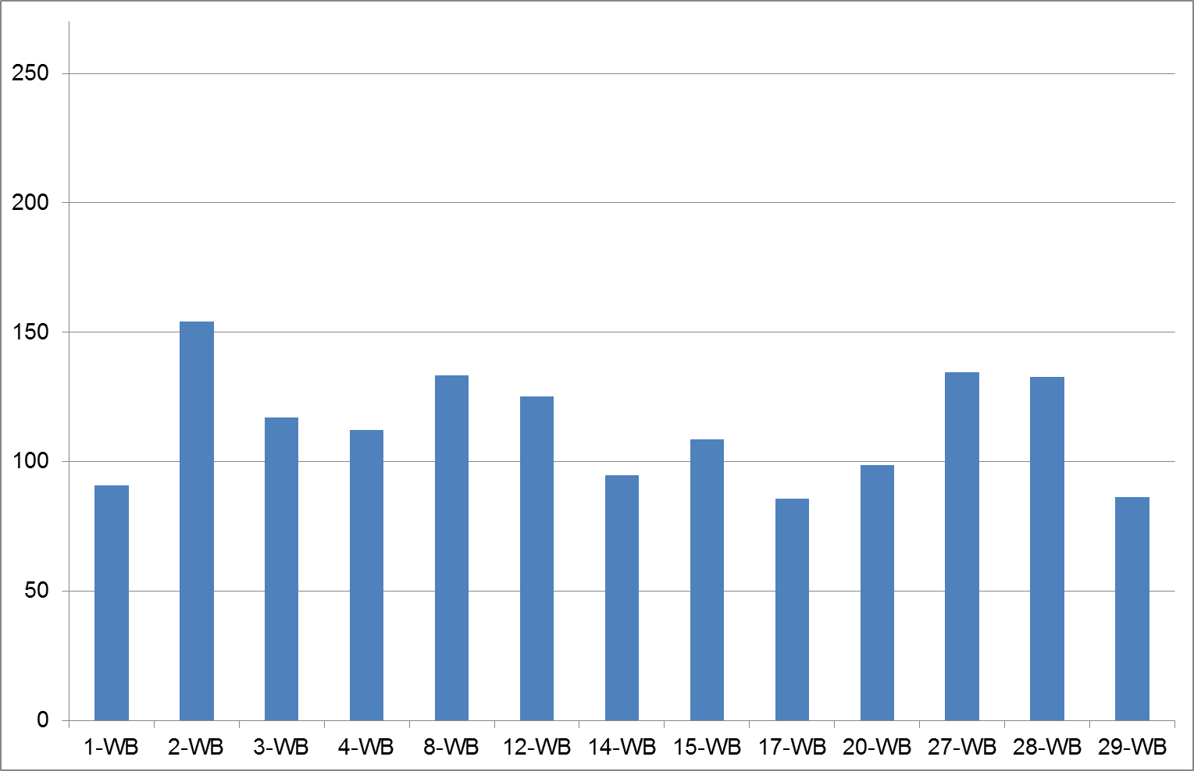 | 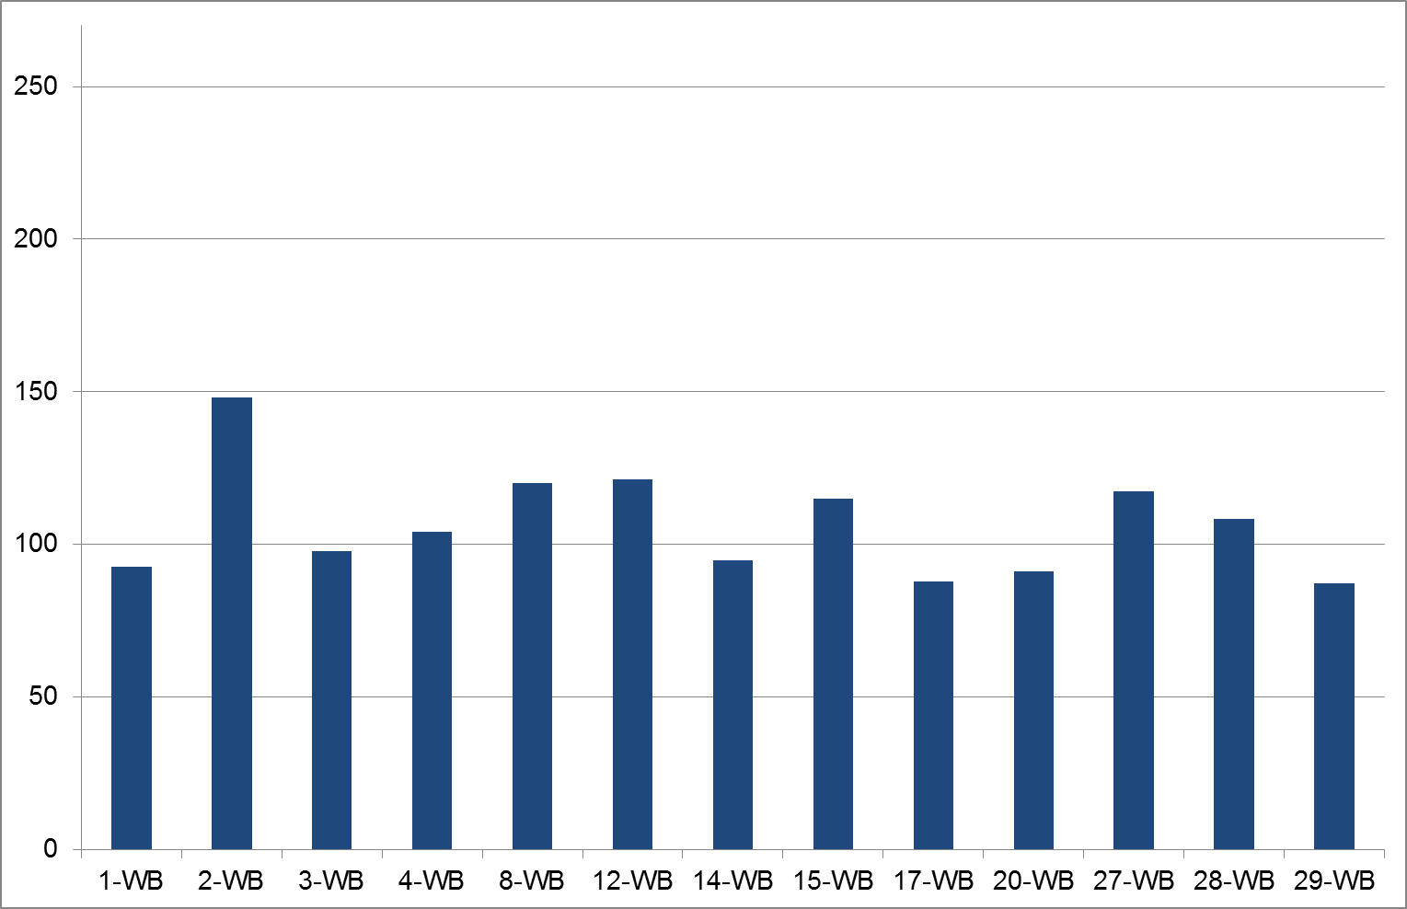
Fig. 5.3a: Sending (uplink) delay T_{AG,UL}, wideband | Fig. 5.3b: Receiving (downlink) delay T_{AG,DL}, wideband
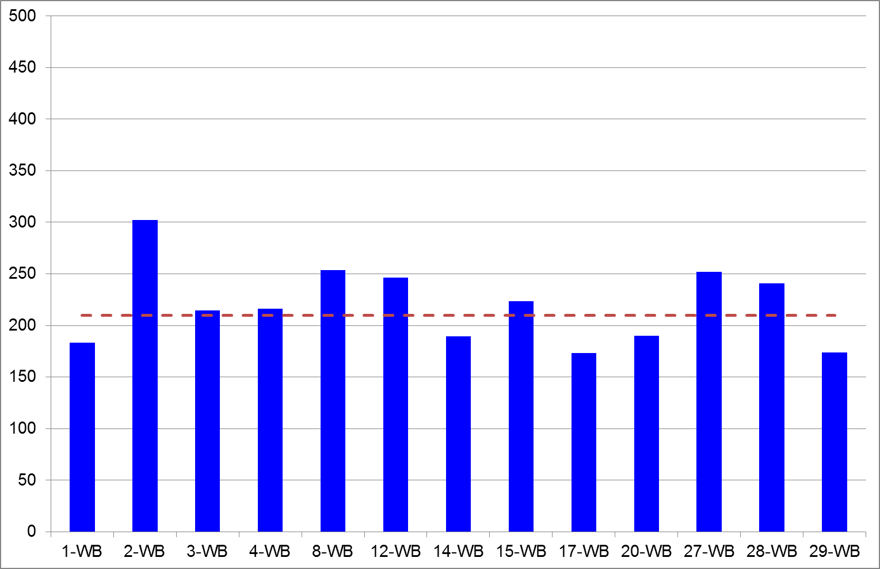
Fig. 5.3c: Round trip delay T_{AG,RT}, wideband, 13 tested mobile phones

The round trip delay limit of 210 ms is violated for 8 of the 13 tested wideband connections. The highest delay was determined to 300 ms for device 2. The devices 8, 12, 27 and 28 show round trip delays of approximately 250 ms.

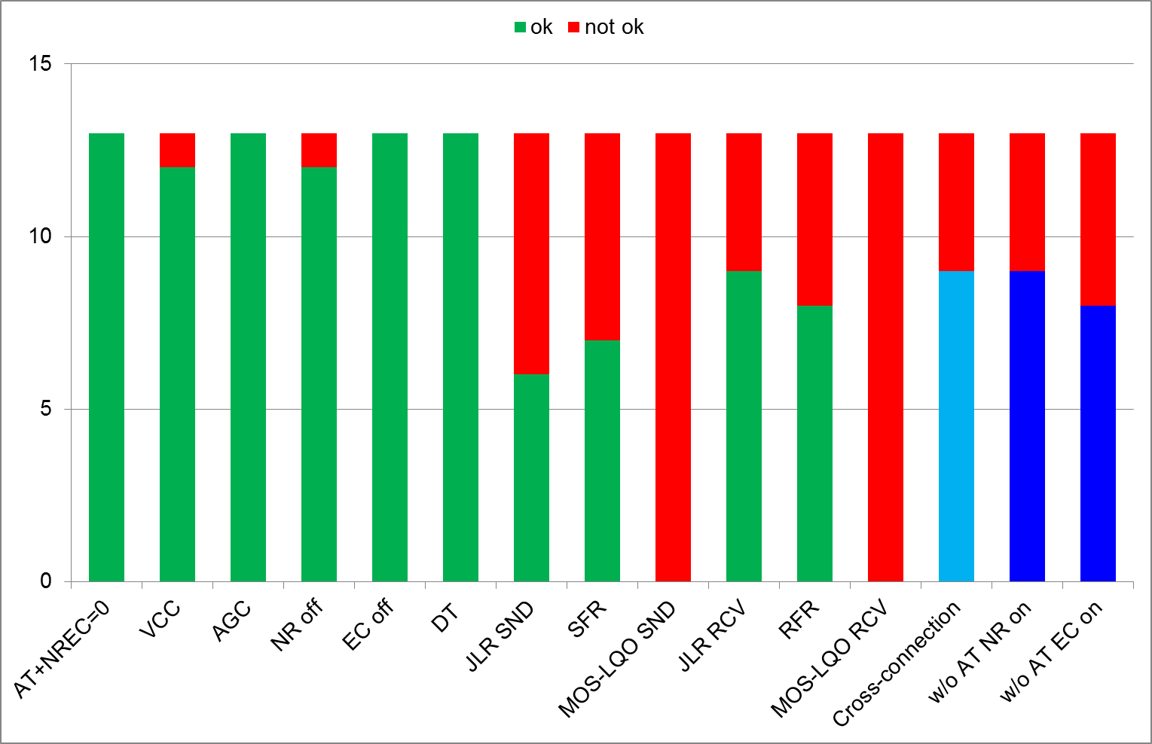
Fig. 5.4: Wideband test result overview, 13 tested mobile phones

The wideband results shown in figure 5.4 can be summarized as follows:
- All 13 wideband devices respond with “Ok” to the AT+NREC=0 command.
- Only 1 device keeps the volume control active (“VCC”), the other 12 tested devices do not influence the sensitivity on the BluetoothTM link by the volume control.
- None of the tested devices showed an automatic gain control (“AGC”), neither in receiving nor sending direction.
- The noise reduction was enabled in one of the 13 tested implementations (“NR”).
- The implemented echo cancellation (“EC”) was disabled in all wideband tests.
- None of the tested mobile phones influenced double talk performance. The sending path can be regarded as transparent in all tests.
- The range of 0 ± 3 dB for the sending sensitivity (“JLR SND”) is violated by 7 devices, 6 implementations showed the expected sensitivity. The maximum amplification was determined up to 17 dB, which definitely distorts drivers’ voice.
- 6 implementations violate the adapted tolerance for the sending frequency response (“SFR”).
- None of the mobile phones meets the listening speech quality limit of ≥ 4.0 MOS-LQOw using the P.863 recommended POLQA analysis method, neither in sending (“MOS-LQO SND”) nor in receiving direction (“MOS-LQO RCV”). The verification of the transmitted and recorded speech samples used for the POLQA analysis does not indicate strong disturbances. It is therefore necessary to verify the application of the P.863 analysis method together with suggested limits in the wideband test case.
- The Junction Loudness Rating range of 0 ± 3 dB in receiving direction (“JLR RCV”) is violated by 4 devices. These 4 devices amplify the signal on the BluetoothTM link by approximately 5 dB.
- The receiving frequency response is violated by 5 of the 13 tested devices.
The cross-connection tests can be summarized as follows:
- From the 13 tested wideband capable devices 4 show unexpected sensitivity differences up to 10 dB in cross-connection scenarios (BT-NB - WB / BT-WB - NB) compared to the corresponding non-cross-connection case (BT-NB - NB / BT-WB - WB). This may lead to audible level contrasts e.g. if the mobile network codec dynamically switches from wideband to narrowband mode during an ongoing audio connection.
The test results without sending the AT command can be summarized as follows:
- Approximately 1/3 of the devices disable either noise reduction (4 devices) or echo cancellation (5 devices), although “AT+NREC=0” has not been sent to the mobile phones. Again this may be critical in conjunction with BluetoothTM enabled headsets without own implemented signal processing. Disabled algorithms in this setup may lead to echo disturbances and a low communication quality, e.g. if the headset is used in noisy environment.
5.3 Individual Summary – Narrowband
Device: 1-NB
Volume control disabled, no AGC influence
NR and EC disabled, transparent double talk performance
All sensitivities within the recommended range
- Transparent device, no speech quality degradation for customers.
 | w/o sending “AT+NREC=0” | Noise reduction: enabled Echo canceller: enabled

Device: 2-NB
Volume control disabled, no AGC influence
NR and EC disabled, transparent double talk performance
Uplink sensitivity significantly out of range (7 dB)
- No influence on conversation, but risk of distorted drivers’ voice.
 | w/o sending “AT+NREC=0” | Noise reduction: enabled Echo canceller: enabled

Device: 3-NB
Volume control disabled, slight AGC influence
NR enabled, EC disabled, transparent double talk performance
Sensitivities in sending far out of range (12 dB)
- Strongly distorted drivers voice, low quality of drivers’ voice in uplink, audible at the far end side.
 | w/o sending “AT+NREC=0” | Noise reduction: enabled Echo canceller: disabled

Device: 4-NB
Volume control enabled, phones’ volume setting affects in vehicle playback level (up to 14 dB), no AGC influence
NR and EC disabled, transparent double talk performance
All sensitivities within the recommended range
- Transparent device, but playback level in vehicle depends on current phone volume control
 | w/o sending “AT+NREC=0” | Noise reduction: enabled Echo canceller: enabled

Device: 5-NB
Volume control disabled, no AGC influence
NR and EC disabled, transparent double talk performance
Receiving sensitivity out of range (4 dB), limited transmission range
- Transparent device, speech sound in vehicle slightly “thin”
 | w/o sending “AT+NREC=0” | Noise reduction: enabled Echo canceller: disabled

Device: 6-NB
Volume control disabled, no AGC influence
NR enabled, EC disabled, transparent double talk performance
Uplink sensitivity far out of range (7 dB)
- risk of distorted drivers’ voice, low quality of drivers’ voice in uplink, audible at the far end side.
 | w/o sending “AT+NREC=0” | Noise reduction: enabled Echo canceller: enabled

Device: 7-NB
Volume control disabled, slight AGC influence
NR and EC disabled, transparent double talk performance
Sending sensitivity slightly out of range (3 dB)
- Even though not a completely transparent device, no significant speech quality degradation for customers.
 | w/o sending “AT+NREC=0” | Noise reduction: enabled Echo canceller: enabled

Device: 8-NB
Volume control disabled, negligible AGC influence
NR and EC disabled, transparent double talk performance
Sending and receiving sensitivities out of range (4 dB)
- Even though not completely transparent, no significant speech quality degradation for customers.
 | w/o sending “AT+NREC=0” | Noise reduction: enabled Echo canceller: enabled

Device: 9-NB
Volume control disabled, no AGC influence
NR and EC enabled, double talk performance is not transparent if subscribers both talk at the same time
Sensitivities ok, but limited transmission range
- Not transparent device, customer complaints can be expected, speech sound in vehicle slightly “muffled”
 | w/o sending “AT+NREC=0” | Noise reduction: enabled Echo canceller: enabled

Device: 10-NB
Volume control disabled, slight AGC influence
NR and EC disabled, transparent double talk performance
Sending sensitivity just within recommended range
- Even though not a completely transparent device, no significant speech quality degradation for customers
 | w/o sending “AT+NREC=0” | Noise reduction: enabled Echo canceller: enabled

Device: 11-NB
Volume control disabled, no AGC influence
NR and EC disabled, transparent double talk performance
Sensitivities within recommended range
- Even though not a completely transparent device, speech sound in vehicle slightly “muffled”
 | w/o sending “AT+NREC=0” | Noise reduction: enabled Echo canceller: enabled

Device: 13-NB
Volume control disabled, no AGC influence
NR and EC enabled, double talk performance is not transparent if subscribers both talk at the same time
Sensitivities ok, but limited transmission range in receiving
- Not transparent device, customer complaints can be expected, speech sound in vehicle slightly “muffled”
 | w/o sending “AT+NREC=0” | Noise reduction: enabled Echo canceller: enabled

Device: 15-NB
Volume control disabled, no AGC influence
NR and EC disabled, transparent double talk performance
All sensitivities within the recommended range
- Transparent device, no speech quality degradation for customers.
 | w/o sending “AT+NREC=0” | Noise reduction: enabled Echo canceller: enabled

Device: 16-NB
Volume control enabled, slight AGC influence
NR and EC disabled, double talk performance is not transparent if subscribers both talk at the same time
Sending sensitivity out of range (4 dB)
- Not completely transparent device, playback level in vehicle depends on current phone volume setting
 | w/o sending “AT+NREC=0” | Noise reduction: disabled Echo canceller: disabled

Device: 18-NB
Volume control disabled, strong AGC influence
NR enabled, EC disabled, double talk performance is not transparent if subscribers both talk at the same time
Sensitivities out of range, limited transmission range in both directions
- Not completely transparent device, customer complaints can be expected, limited sound quality
 | w/o sending “AT+NREC=0” | Noise reduction: enabled Echo canceller: disabled

Device: 19-NB
Volume control disabled, no AGC influence
NR enabled, EC disabled, transparent double talk performance
Sensitivities ok, but limited transmission range in sending
- low quality of drivers’ voice in uplink, audible at the far end side.
 | w/o sending “AT+NREC=0” | Noise reduction: enabled Echo canceller: disabled

Device: 20-NB
Volume control disabled, no AGC influence
NR and EC disabled, transparent double talk performance
All sensitivities within the recommended range
- Transparent device, no speech quality degradation for customers.
 | w/o sending “AT+NREC=0” | Noise reduction: enabled Echo canceller: enabled

Device: 21-NB
Volume control enabled, strong AGC influence
NR and EC disabled, double talk performance is not transparent if subscribers both talk at the same time
All sensitivities within the recommended range
- Not completely transparent device, playback level in vehicle depends on current phone volume setting
 | w/o sending “AT+NREC=0” | Noise reduction: enabled Echo canceller: enabled

Device: 22-NB
Volume control disabled, no AGC influence
NR and EC disabled, transparent double talk performance
All sensitivities within the recommended range
- Transparent device, no speech quality degradation for customers.
 | w/o sending “AT+NREC=0” | Noise reduction: disabled Echo canceller: disabled

Device: 23-NB
Volume control disabled, no AGC influence
NR and EC disabled, transparent double talk performance
All sensitivities within the recommended range
- Transparent device, no speech quality degradation for customers.
 | w/o sending “AT+NREC=0” | Noise reduction: enabled Echo canceller: enabled

Device: 24-NB
Volume control disabled, no AGC influence
NR enabled, EC disabled, transparent double talk performance
Sensitivities ok, but limited transmission range in sending
- low quality of drivers’ voice in uplink, audible at the far end side.
 | w/o sending “AT+NREC=0” | Noise reduction: enabled Echo canceller: disabled

Device: 25-NB
Volume control disabled, no AGC influence
NR and EC enabled, double talk performance is not transparent if subscribers both talk at the same time
Sensitivities ok, limited transmission range in sending
- Not transparent device, customer complaints can be expected
 | w/o sending “AT+NREC=0” | Noise reduction: enabled Echo canceller: enabled

Device: 26-NB
Volume control disabled, no AGC influence
NR and EC enabled, double talk performance is not transparent if subscribers both talk at the same time
Sensitivities ok, limited transmission range in sending
- Not transparent device, customer complaints can be expected
 | w/o sending “AT+NREC=0” | Noise reduction: enabled Echo canceller: enabled

Device: 27-NB
Volume control disabled, no AGC influence
NR and EC disabled, transparent double talk performance
Sensitivities slightly out of range, in sending 4 dB
- Even though not completely transparent device, no significant speech quality degradation for customers.
 | w/o sending “AT+NREC=0” | Noise reduction: enabled Echo canceller: enabled

Device: 28-NB
Volume control disabled, no AGC influence
NR and EC disabled, transparent double talk performance
All sensitivities within the recommended range
- Transparent device, no speech quality degradation for customers.
 | w/o sending “AT+NREC=0” | Noise reduction: enabled Echo canceller: disabled

Device: 29-NB
Volume control disabled, no AGC influence
NR and EC disabled, transparent double talk performance
All sensitivities within the recommended range
- Transparent device, no speech quality degradation for customers.
 | w/o sending “AT+NREC=0” | Noise reduction: disabled Echo canceller: disabled

Device: 30-NB
Volume control enabled, strong AGC influence
NR and EC disabled, but double talk performance is not transparent if subscribers both talk at the same time
Sensitivities ok, limited transmission range in sending
- Not transparent device, playback level in vehicle depends on current phone volume setting
 | w/o sending “AT+NREC=0” | Noise reduction: enabled Echo canceller: enabled

5.4 Individual Summary – Wideband
Device: 1-WB
Volume control disabled, no AGC influence
NR and EC disabled, transparent double talk performance
All sensitivities within the recommended range
- Transparent device, no speech quality degradation for customers.
 | w/o sending “AT+NREC=0” | Noise reduction: enabled Echo canceller: enabled

Device: 2-WB
Volume control disabled, no AGC influence
NR and EC disabled, transparent double talk performance
Sending sensitivity out of range (5 dB), limited transmission range in receiving
- Transparent device, risk of distorted drivers’ voice
 | w/o sending “AT+NREC=0” | Noise reduction: enabled Echo canceller: enabled

Device: 3-WB
Volume control disabled, no AGC influence
NR enabled, EC disabled, transparent double talk performance
Sensitivities far out of range (13 dB in sending direction), very limited transmission range in sending
- Strongly distorted drivers voice, low quality of drivers’ voice, customer complaints expected
 | w/o sending “AT+NREC=0” | Noise reduction: enabled Echo canceller: disabled

Device: 4-WB
Volume control enabled, no AGC influence
NR and EC disabled, transparent double talk performance
Sensitivities within recommended range
- Transparent device, playback level in vehicle depends on current phone volume setting
 | w/o sending “AT+NREC=0” | Noise reduction: enabled Echo canceller: enabled

Device: 8-WB
Volume control disabled, no AGC influence
NR and EC disabled, transparent double talk performance
Sensitivities in both directions out of range (app. 5 dB)
- Transparent device, no speech quality degradation for customers, risk of distorted drivers’ voice
 | w/o sending “AT+NREC=0” | Noise reduction: enabled Echo canceller: enabled

Device: 12-WB
Volume control disabled, no AGC influence
NR and EC disabled, transparent double talk performance
Sensitivities in both directions out of range (app. 5 dB)
- Transparent device, no speech quality degradation for customers, risk of distorted drivers’ voice
 | w/o sending “AT+NREC=0” | Noise reduction: enabled Echo canceller: enabled

Device: 14-WB
Volume control disabled, no AGC influence
NR and EC disabled, transparent double talk performance
Sending sensitivity slightly high (4 dB), limited transmission range in both directions
- transparent device, limited transmission range in both directions
 | w/o sending “AT+NREC=0” | Noise reduction: enabled Echo canceller: enabled

Device: 15-WB
Volume control disabled, no AGC influence
NR and EC disabled, transparent double talk performance
All sensitivities within the recommended range
- Transparent device, no speech quality degradation for customers.
 | w/o sending “AT+NREC=0” | Noise reduction: disabled Echo canceller: disabled

Device: 17-WB
Volume control disabled, no AGC influence
NR and EC disabled, transparent double talk performance
Sensitivities in both directions within recommended range, negligible limitation of transmission range
- Transparent device, no speech quality degradation for customers
 | w/o sending “AT+NREC=0” | Noise reduction: disabled Echo canceller: disabled

Device: 20-WB
Volume control disabled, no AGC influence
NR and EC disabled, transparent double talk performance
All sensitivities within the recommended range
- Transparent device, no speech quality degradation for customers.
 | w/o sending “AT+NREC=0” | Noise reduction: disabled Echo canceller: disabled

Device: 27-WB
Volume control disabled, no AGC influence
NR and EC disabled, transparent double talk performance
Sensitivities in both directions out of range (app. 5 dB)
- Transparent device, no speech quality degradation for customers, risk of distorted drivers’ voice
 | w/o sending “AT+NREC=0” | Noise reduction: enabled Echo canceller: enabled

Device: 28-WB
Volume control disabled, no AGC influence
NR and EC disabled, transparent double talk performance
Sensitivity in sending out of range (5 dB)
- Transparent device, no speech quality degradation for customers, risk of distorted drivers’ voice
 | w/o sending “AT+NREC=0” | Noise reduction: enabled Echo canceller: enabled

Device: 29-WB
Volume control disabled, no AGC influence
NR and EC disabled, transparent double talk performance
All sensitivities within the recommended range
- Transparent device, no speech quality degradation for customers.
 | w/o sending “AT+NREC=0” | Noise reduction: disabled Echo canceller: disabled

5.5 Cross Connection Tests
The sending and receiving sensitivities and possible level contrasts are additionally analyzed in cross connection scenarios (BluetoothTM connection in wideband mode (BT WB) combined with narrowband network connection (NB), BluetoothTM connection in narrowband mode (BT NB) combined with wideband network connection (WB)). Note that these tests can only be carried out for wideband BluetoothTM capable phones. The following figures compare four curves each:
- the two red curves represent the sensitivities for a narrowband BluetoothTM connection in combination with NB network connection (solid red line) and a WB network connection (dashed red line, “cross connection”).
  - Consequently, both red curves show the same NB bandwidth limitation. The BT NB connection limits the transmission range to approximately 4 kHz even in case of a WB network connection.
  - Both curves should further indicate a comparable sensitivity; the network connection (NB or WB) should not influence the narrowband inband signal level.
- The two blue curves represent the sensitivities for a wideband BluetoothTM connection in combination with WB network connection (solid blue line) and in combination with a NB network connection (dashed blue line, “cross connection”).
  - The comparison of both curves should indicate the band limitation introduced by the network side.
  - However, the sensitivity in the NB transmission range below 4 kHz should be comparable for both curves.
The following devices show comparable sensitivities.
An approximately 2 dB higher inband level between 300 Hz and 3.4 kHz can be analyzed for mobile phone 1 in sending direction, if a BT NB connection is used (red curves) compared to a BT WB connection (blue curves). | Device 1-NB / 1-WB (sending) | Device 1-NB / 1-WB (receiving)
The kind of network connection (NB: red solid line; WB: red dashed line) does not influence the sensitivity. The receiving direction of device 1 shows very comparable sensitivities independent of the BluetoothTM connection.

The devices 4, 8, 12, 15, 20, 27 and 29 show comparable sensitivities in the narrowband transmission range.  Note that device 12 was only tested in wideband mode. The measured curve in a complete narrowband connection (BT NB to NB network, solid red curve) is missing.  All four curves in the diagrams for each device indicate at least similar narrowband sensitivities. This can be stated for both directions, i.e. sending and receiving.  In all diagrams, the two red curves (BT NB) indicate a slightly lower sensitivity in the higher frequency range compared to the two blue curves (BT WB). This may be caused by the influence of the different coders.  The two red curves in each diagram are measured via NB BT connections and are nearly identical for each device. | Device 4-NB / 4-WB (sending) | Device 4-NB / 4-WB (receiving)
 | Device 8-NB / 8-WB (sending) | Device 8-NB / 8-WB (receiving)
 | Device 12-WB (sending) | Device 12-WB (receiving)
 | Device 15-NB / 15-WB (sending) | Device 15-NB / 15-WB (receiving)

The band limitation introduced by the NB network connection can be seen from the differences between the blue curves (solid lines: WB network connection; dashed lines: NB network connection).  These measured curves show the expected result:  The narrowband signal sensitivity is independent of the connection, both on the BluetoothTM side and on the network side (except the slight deviation of 2 dB for device 1 in sending direction). | Device 20-NB / 20-WB (sending) | Device 20-NB / 20-WB (receiving)
 | Device 27-NB / 27-WB (sending) | Device 27-NB / 27-WB (receiving)
 | Device 29-NB / 29-WB (sending) | Device 29-NB / 29-WB (receiving)
In principle a similar conclusion can be drawn from the results for device 3. But the measured curves in both directions and in all connections are dominated by a very distinct high pass below approximately 300 Hz.
Furthermore, as stated already in chapter 5.4, the measured curve in sending direction in a complete wideband connection (BT WB and WB network, blue solid curve) is very limited in the higher frequency range. | Device 3-NB / 3-WB (sending) | Device 3-NB / 3-WB (receiving)
Unexpected results are measured for the devices 2, 14, 17 and 28 in these cross connection tests: Sensitivity differences up 10 dB in the narrowband frequency range occur in sending direction of device 2.
A BluetoothTM NB connection (red curves) leads to very high level differences in the narrowband frequency range, if the mobile is in a narrowband or wideband connection in the network. This was measured in both direction, but in diverse combinations.  The measured curves of device 14 (tested only in WB mode) also show a strong high pass characteristic in both transmission directions.  Furthermore the curves in receiving direction indicate a noticeable attenuation in the frequency range around 1 kHz, if a wideband network connection is established.  Device 17 (tested only in wideband connections) shows different high pass characteristics, especially in a NB network connection (dashed blue curves). Apart from this, the narrowband sensitivities are comparable.  Sensitivity differences between approximately 3 and 4 dB occur in both transmission directions for device 28. | Device 2-NB / 2-WB (sending) | Device 2-NB / 2-WB (receiving)
 | Device 14-WB (sending) | Device 14-WB (receiving)
 | Device 17-WB (sending) | Device 17-WB (receiving)
 | Device 28-NB / 28-WB (sending) | Device 28-NB / 28-WB (receiving)

6. References

[1] Performance assessment of vehicle-mounted mobile phones in conjunction with Hands-free Terminals according to Recommendations ITU-T P.1100 and ITU-T P.1110; http://www.itu.int/en/ITU-T/C-I/Pages/test_event_Feb14.aspx
[2] Recommendation ITU-T P.1100; Narrowband hands-free communication in motor vehicles, 03-2011
[3] Recommendation ITU-T P.1110; Wideband hands-free communication in motor vehicles, 12-2009
[4] BluetoothTM Telephony Working Group: Hands-free Profile 1.6
[5] 3GPP TS 26.132 v12.0.0, 3rd Generation Partnership Project, Technical Specification Group Services and System Aspects; Speech and video telephony terminal acoustic test specification; Release 12, 06-2013
[6] 3GPP TSG-SA4#68 document S4-120403, Re-examining the Delay Budget in 43.050, 16-20 April 2012, Kyoto, Korea
[7] Recommendation ITU-T P.501; Test signals for use in telephonometry, 01-2012
[8] Recommendation ITU-T P.862; Perceptual evaluation of speech quality (PESQ): An objective method for end-to-end speech quality assessment of narrow-band telephone networks and speech codecs, 02-2001
[9] Recommendation ITU-T P.862.1; Mapping function for transforming P.862 raw result scores to MOS-LQO, 03-2011
[10] Recommendation ITU-T P.862.2; Wideband extension to Recommendation P.862 for the assessment of wideband telephone networks and speech codecs, 11-2005
[11] Recommendation ITU-T P.863; Perceptual objective listening quality assessment, 01-2011
[12] Recommendation ITU-T P.505; One-view visualization of speech quality measurement results, 11-2005

