|  |  |  |
| --- | --- | --- |
| itu_logo | ****Joint ITU-UNIDO Forum on “Sustainable Conformity Assessment for Asia-Pacific Region” (25-27 November 2013) and****  ****ITU Regional Bridging the Standardization Gap Workshop****  ****(28-29 November 2013) –****  Yangon, Republic of Union of Myanmar | D:\Documents and Settings\MPT\Desktop\mcit2.tif |

**PRACTICAL INFORMATION**

1. **About Myanmar**

Myanmar is located at the Indochina peninsular of South East Asia region which is a place not only to see the social and culture of the people, but also the place to explore the nature environment beauty .It is a land of different nationalities and tribes. The country has a total land area of 677000 square kilometres. The country comprises 14 States and Division Regions. The largest city and seaport is Yangon. Mandalay, last royal capital in heart of Myanmar is an important trade centre. Nay Pyi Taw (literally means Royal Capital), the administrative capital is located in central Myanmar 320 km north of Yangon.

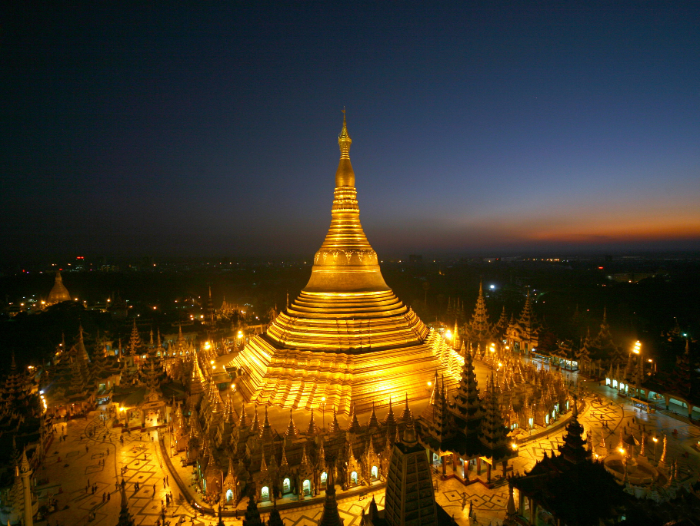Yangon the commercial city is the main gateway to Myanmar. It was founded by King Alaungpaya in 1775 on the site of a small settlement called Dagon. The name Yangon means “End of Strives”. In the time of being present, Yangon covers an area of about 350 km2 with a population of nearly 6 million. Almost all International Airlines serving Myanmar fly to Yangon International airport. Yangon is also a growing bustling business centre. The city today still maintains its colonial charm and gracious turn of the century architecture.

1. **Weather**

The climate of Myanmar follows a monsoon pattern and a year is more or less equally divided into three weather patterns namely summer, rainy and winter. The month of November marks the beginning of the winter season. Average temperature is between 30 and 35 degree Celsius.

1. **Hotel Accommodation**
2. **MiCasa Hotel (also meeting venue for the events)**

MiCasa “My Home” in Spanish lives up to its motto; “Convenience of a Hotel, Comfort of Home” was opened on 1st December 1998. The concept of apartment is a perfect retreat that offers the cosiness and privacy of apartment style accommodation complemented with caring service, exclusive facilities for the expatriates away from their home.

MiCasa Hotel LTD is 100% owned by Malaysian companies, namely, IGB Corporation Berhad the majority shareholder, MASSCORP and IJM Corporation Berhad. MiCasa is located along Kaba Aye Pagoda Road, one of the two main arterial roads leading out of the city centre to Inya Lake and the Airport.

* **Website:** [www.myanmar.micasahotel.com](http://www.myanmar.micasahotel.com)
* **Address: 17, Kaba Aye Pagoda Road, Yankin Township, Yangon, Myanmar**
* **Room reservation:** 
  + **Ms. Khin Kaythi San, Director of Sales and Marketing,**
  + **Tel: 95-1-650933 (Ext: 153)**
  + **Fax 95-1 650960**
  + **E-mail:** [micdos@myanmar.com.mm](mailto:micdos@myanmar.com.mm)

**Room Rates**

Room type : Deluxe (Sq-m 32)

Room rate : US$ 175 nett per night (Stay for 1 person)

: US$ 188 nett per night (Stay for 2 persons)

Room type : One bedroom Suite Apartment (Sq-m 48)

Room rate : US$ 185 nett per night (Stay for 1 person)

: US$ 198 nett per night (Stay for 2 persons)

Check In Time : 14:00 hours

Check Out Time : 12:00 noon

Credit Cards Accepted : JCB & Visa

1. **Inya Lake Hotel**

Inya Lake hotel is also close to the meeting venue. The Inya Lake Hotel, surrounded by 37 acres of verdant gardens, a serene lake resplendent with lotus, leafy trees and a free-shaped swimming pool offers the perfect retreat for guests to simply sit back and relax. Exploration of Yangon and the surrounding area is also a must and we would be delighted to arrange a variety of tours and excursions for you during your stay with a private guide.

A 50-minute drive from the city centre, and 20 minutes from Yangon International Airport, the colonial styled hotel with its teakwood floors and oriental feel evokes charming memories of a by-gone era. The 239 guestrooms are decorated in retro style offering guests astonishing views over the city of Yangon and the Inya Lake.

* **Website:** [www.inyalakehotel.com](http://www.inyalakehotel.com)
* **Address : No.37,Kaba Aye Pagoda Road, Mayangone Township, Yangon, Myanmar**
* **Room reservation**
  + **Ms. Khin Thet Mar and Ms. Ni Ni Htet Hlaing**
  + **Tel: 95-1-9662866,9662857-59**
  + **Fax: 95-1-9665537**
  + **E-mail:** [reservation@inyalakehotel.com](mailto:reservation@inyalakehotel.com) **;** [nini@inyalakehotel.com](mailto:nini@inyalakehotel.com)

|  |  |  |  |  |
| --- | --- | --- | --- | --- |
| **ROOM RATES** | **SINGLE/DOUBLE** |  |  |  |
| Superior Room | US$ 188 net per night |  |  |  |
| Deluxe Room | US$ 211 net per night |  |  |  |
| Junior Suite Room | US$ 260 net per night |  |  |  |

**Settlement of Accounts**

Before vacating the Hotel, guests are expected to settle directly with the respective hotels all accounts, including room charges and other expenses, such as for local and long-distance telephone calls, Internet use, business center use, laundry, room and hotel transportation services, mini-bar items, as well as restaurant and bar services. Guests are also responsible for settling any charges incurred with respect to rooms remaining vacant owing to their late arrival or rescheduled departure for which inadequate prior notice has been given.

1. **Visa Information**

Visa requirement to Myanmar may vary for citizens of different countries. Please check the visa requirements with your nearest Myanmar Embassy or consulate general. You can also consult the website <http://www.mofa.gov.mm> for more details. Your request for issuing a visa supporting letter should be sent by e-mail to the following contact person below, **at least 4-5 weeks before the date of the event** to issue timely delivery of the visa and a scanned copy of your passport should also accompany your request:

**Mr Win Min Aung,**

**Staff Officer**

**Ministry of Communications and Information Technology**

**Posts and Telecommunications Dept**

**E-mail :** [**dg.ptd@mptmail.net.mm**](mailto:dg.ptd@mptmail.net.mm) **;** [**winminaung01@gmail.com**](mailto:winminaung01@gmail.com)

**Tel: +95 9 448 0000 98;**

**Fax: +95 67 407 216**

1. **Insurance**

The ITU is not able to bear the cost of insurance for the participants, any medical expenses or any other expenses. Therefore, we request your administration/organization to kindly make necessary arrangements for obtaining insurance and medical cover for your members’ i.e prospective participants before travel.

1. **Transportation From Airport to Hotel**

For your general information the following transportation are available from Yangon International Airport to the downtown area

Arrangements can be made to pick up delegates at the airport. Participants should fill out the arrival and transportation form in Annex 1 of the document and send the form by e-mail to Mr Win Min Aung ([dg.ptd@mptmail.net.mm](mailto:dg.ptd@mptmail.net.mm) ; [winminaung01@gmail.com](mailto:winminaung01@gmail.com))**.** This is provided free of charge.

Public Taxi Meter is also located in front of the arrival hall, entrance no.3 and 4. It takes about 45 minutes by car from airport to hotel where the meeting will take place.

1. **Time zone**

GMT + 6:30 hours

1. **Banking facilities**

Myanmar’s official currency is Myanmar Kyats (MMK). The exchange rate is roughly 973 Kyats equivalent to 1 USD. Foreign currency can be exchanged at any authorized money changer counter. Normal banking hours are 09:00am to 16:30pm on weekdays. Credit cards including Visa and Master Cards are accepted in many major hotels, shops and restaurants.

1. **Electricity (voltage used)**

Supply voltage is 220V, 50Hz (see picture). Please bring the right adapter for your equipment.



**ANNEX 1 : ARRIVAL AND TRANSPORTATION TO HOTEL FORM**

|  |  |  |  |  |
| --- | --- | --- | --- | --- |
|  | **ITU-UNIDO Workshop on** **Conformity and Interoperability (25-27 November 2013) and ITU Regional Bridging the Standardization Gap Workshop (28-29 November 2013)** | | |  |
|  | | |  |  | |
| **To ensure transfer to and from the airport, participants are requested to complete and return this form to Mr Win Min Aung by 15 November 2013 at the latest  by e-mail** [winminaung01@gmail.com](mailto:winminaung01@gmail.com) For inquiries, Tel: +95 9 448 000 98 | | | | |

Family name…………………………………………………………………………………

First name……………………………………………………………………………………

Job Title ……………………………………………………………………………………..

Organization……………………………………………………… Country …………..........

Telephone : :……………………………………………….

Email:………………………………………………………

Hotel where you are residing:

Hotel Name ……………………………………………………………

Address …………………………………………………………

**Transportation will be provided from the airport to the hotels and to the meeting venue. Please provide your arrival and departure flight information to facilitate arrangements for transportation.**

|  |  |  |  |  |  |  |
| --- | --- | --- | --- | --- | --- | --- |
| Date of Arrival |  |  | Time of Flight Arrival |  | FLIGHT NO. |  |
| Date ofDeparture |  |  | Time of Flight Departure |  | FLIGHT NO. |  |

# \_\_\_\_\_\_\_\_\_\_\_\_