Managed remote participation
Annex for persons with hearing impairments
Contents
Introduction 1
Captions Pod 1
Features 1
Chat pod 3

Introduction

The URL for each meeting room is created based on the host sector and on which physical room the event will take place. For information on upcoming meetings with remote participation please refer to the Remote participation page or contact the event’s focal point.
When you enter the online meeting room, various pods are made available to enhance interaction and accessibility to all attendees. In this document we explore mainly the features of the captions pod, a pod made available especially to aid persons with hearing impairments. We finish by also mentioning the chat pod and a guide on how to use it.

Captions Pod
If the captioning service is provided on site, the online meeting rooms will also be equipped with this service. You can find first look at the features provided by the pod in the following pages.

Features

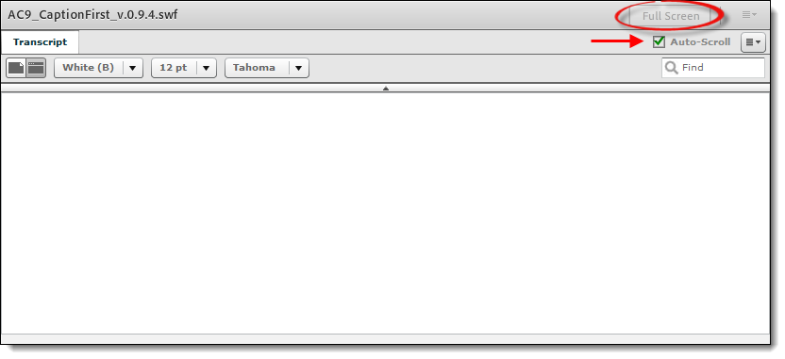
The remote participant has the option to view the captioning window in Full Screen mode and to choose the pace at which the captioning rolls on the screen.
- Auto-Scroll means that the captioning will follow the meeting’s pace
- If you wish to read it in your own time, you can uncheck the “Auto-Scroll’’ box and scroll up and down the captioning at your own pace
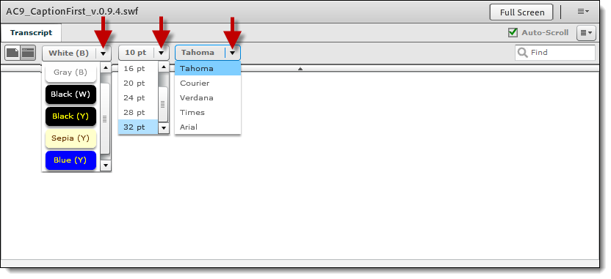
You can also choose among six types of background for the captioning, plus size and theme of the fonts. Your choice will remain if the layouts change during the meeting and will not affect any other participants.
Lastly, you are able to save the meeting’s transcript on your computer in two formats: HTML and Text. To do so, click on the button on the right of the ‘’Auto-Scroll’’ option and you will see the option ‘’Save transcript as…’’ on the dropdown menu.

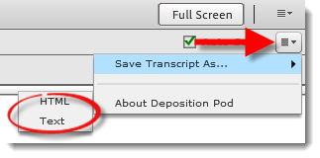

Chat pod
The chat pod allows you to have both private and public chats with all remote participants. It is used by the remote participation moderator to communicate important meeting events and to talk to all participants.
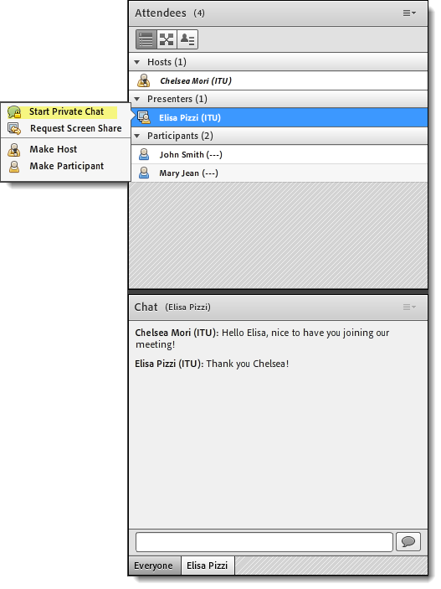
In case you wish to start a private chat with any of the attendees, you can scroll over the person’s name in the attendees pod and you click on the option to “Start Private Chat’’ – as shown below.

