How Communications Will Change Vehicles
  - Meeting of the Collaboration on ITS Communication Standards; and
  - Workshop on Vehicle Communications and Automated Driving
  - 7-8 December 2015, Arlington, VA, USA
Practical Information for Participants

1 Event venue
Telecommunications Industry Association
Address: 1320 North Courthouse Road, Suite 200, Arlington, VA 22201, United States
Tel.: +1 703 907 7701
Fax: +1 703 907 7727
E-mail: mwaters@tiaonline.org
Website: http://www.tiaonline.org/

2 Hotels
The list of proposed hotels may be found in Annex A.
Preferential rates have been obtained with Hilton Garden Inn.

3 Arrival and transportation
Arrival
Local airport: Ronald Regan National Airport (DCA), Washington Dulles International Airport (IAD)
Transportation to/from the airport
- Taxi
It is about a 7-minute drive from Ronald Regan National Airport ($20 US) and 30-minute drive from Washington Dulles International Airport ($50 US) to TIA depending on traffic conditions. Taxis are always available.
- Subway (Metro)
Take the Metro Blue Line toward Largo Town Center at Ronald Regan National Airport and transfer to the Orange Line toward the Vienna Station and then exit at the Courthouse Station.

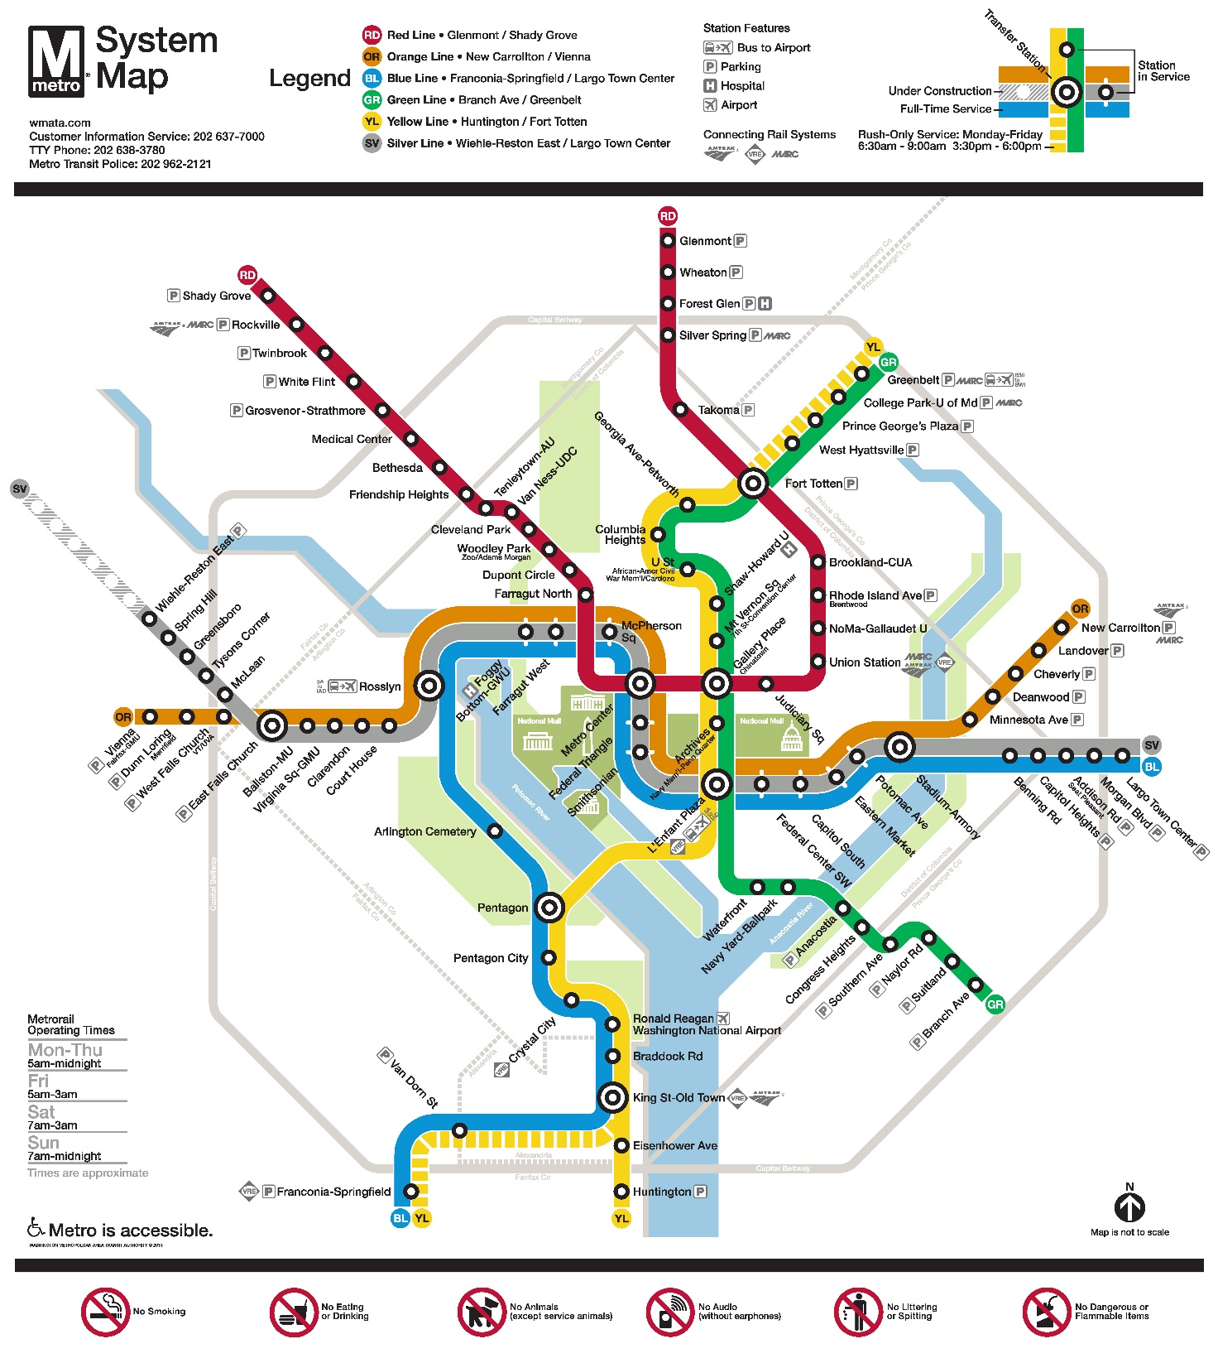

4 Visa – Formalities for entering the United States
For United States Visa information, please visit website http://travel.state.gov/content/visas/english.html

5 Currency exchange
The currency in the United States is the $ or USD. Businesses accept most major credit cards. Only United States Dollar (USD) is accepted at stores and restaurants.

6 Language
The meeting official working language will be in English.

7 Climate
http://www.weather.com/weather/today/l/22201:4:US

8 Local time
Standard time zone: UTC/GMT -5.

9 Telecommunications
The country code for the United States is +1. The main frequency bands used in the United States of America in communications are GSM850, GSM1900, 3G (850/1900 and 1700/2100) and 4G (Verizon USA 4G, Sprint Clearwire WiMAX and T-Mobile 4G). For you to better understand what frequencies are used by what standard here is some data for you:
700MHz – this band is used with 3G and 4G technologies and 698-806MHz frequencies. It is planned to be used for GSM frequency in the future as well
GSM800 – not exactly a GSM but SMR iDEN technology that uses 806-824MHz and 851-869MHz frequencies. Though soon it may also be used for CDMA
GSM850 – main cellular band in USA used with GSM, CDMA and 3G technologies. Uses 824-849MHz and 869-894MHz frequencies
GSM1900, or PCS – secondary cellular band in USA used with the same GSM, CDMA and 3G technologies but with 1850–1910MHz and 1930–1990MHz frequencies
AWS – used for 3G and 4G technologies on 1710–1755MHz and 2110–2155MHz frequencies
BRS/EBS – used for 4G technology with 2496–2690MHz frequencies
Although the main frequency band that was used in USA in the first place was 800MHz (AMPS), it is now replaced with GSM850 as the new primary cell phone call band. Now let’s look at each of those frequency bands more closely.

10 Electricity
Mainly used in the USA, 2 pins, Type A (not grounded) and Type B (grounded) 15 A, almost always 100 – 127 V, and socket compatible with plug type A/B
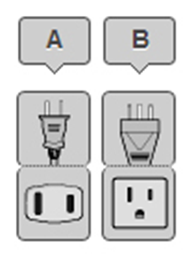
Please be sure you have the right adapter.

11 Health
For medical emergencies, there is a major hospital named Virginia Hospital Center near the TIA Headquarters in Arlington, VA. If you have any emergency, please dial 911.

12 Internet connectivity
Free WLAN will be available at the meeting venue. Payment may be required at certain hotels.

13 Contact
For any questions, please contact:
Mr. Scott Belcher
Tel: +1 703 907 7702
Mobile: +1 703 447 0263
Email: sbelcher@tiaonline.org
Fax: +1 703 907 7727

Note:
General information about the Washington DC area: http://washington.org/

Annex A

How Communications Will Change Vehicles
  - Meeting of the Collaboration on ITS Communication Standards; and
  - Workshop on Vehicle Communications and Automated Driving
  - 7-8 December 2015, Arlington, VA, USA
List of Hotels

HILTON GARDEN INN
1033 North Courhouse road
arlington, va 22201
703.528.4444
Discounted Rate
For reservations by phone, please use Corporate ID: N2841868.

Inns Of Virginia-Arlington
3335 Lee Hwy, ARLINGTON, VA 22207

Best Western Rosslyn/Iwo Jima
1501 Arlington Boulevard, Arlington, VA 22209-3001

Holiday Inn Ballston
4610 N. Fairfax Dr, Arlington, VA 22203

Residence Inn by Marriott Arlington Courthouse
1401 North Adams Street, Arlington, VA 22201

The Westin Arlington Gateway
801 North Glebe Road, Arlington, VA 22203

Hilton Arlington
950 North Stafford Street, Arlington, VA 22203
Annex B

How Communications Will Change Vehicles
  - Meeting of the Collaboration on ITS Communication Standards; and
  - Workshop on Vehicle Communications and Automated Driving
  - 7-8 December 2015, Arlington, VA, USA
Invitation Letter Request Form
To enter the United States for the meetings indicated above, you may need a letter of invitation from the host, which you will need to present to the Embassy/Consulate of the United States in your area in order to obtain your visa. In order to obtain the invitation letter, please:

- Fill out the form below
- Send it to (please reference “Invitation letter request for ITS meeting” as the subject):
Mr. Scott Belcher
Telecommunications Industry Association (TIA)
sbelcher@tiaonline.org
(It’s recommended to scan your passport page and email to us so that it’s discernible and can be used.)
Fax number: +1 703 907 7727 (if your passport page is photocopied and enlarged)

Company
Applicant  information |  |  |  | Mr Ms Mrs
 | Date of birth :
 | Is this your first visit to United States? |  |  | __ Yes ___ No
 | If the country in which you'll obtain your visa is different from your nationality, please indicate it here:
Address
Place to visit after entry | In this case, it is Washington, DC by default.
Date of arrival in the  United States |  |  | Date of departure from the  United States
(Please do not forget to attach a copy of your passport photograph page before sending.)
Your information should be sent out before 1 November 2015.
________________________________

