ITU-T Focus Group Digital Financial Services (FG DFS) Collaboration Site Guide
Site: https://extranet.itu.int/ITU-T/focusgroups/fgdfs/SitePages/Home.aspx
NOTE: Access to the FG DFS Site
- ITU members may access the FG DFS Site using a TIES account.
- Non-members may access the FG DFS site using a Guest account.

PRACTICAL INFORMATION FOR USERS/PARTICIPANTS

- TIES and Guest Accounts
- What is TIES?
TIES (Telecommunication Information Exchange Service) is a set of networked information resources and services offered by ITU without any charge to ITU Members (Member States, Sector Members, Associates, and Academia) to support their participation in the activities of the Union.
- How do I register for a TIES account?
TIES is available without any charge to ITU Members (Member States, ITU Sector Members, Associates and Academia) If you qualify for a TIES account, please complete the TIES Online Registration form.
- What is a Guest account?
A Guest account is an account allowing access to a limited number of resources available from ITU. While TIES accounts enjoy facilities such as automatic subscription to Study Group mailing lists and access to the ITU-T's Study Group documentation and informal FTP areas, guest accounts have access only to public resources (for example, newsletter subscriptions). Anyone can create a Guest account, but access to services reserved to members may be granted on a case-by-case basis.
- How can I register for a Guest account?
You can register for a Guest account using the ITU-T Electronic Registration and Subscription Service.

- Using the Sort and Filter Functions on the documents

- To sort on the Name of the documents, click Name and choose Ascending or Descending order.
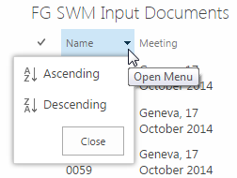
- To filter via Meetings, click on Meeting and select the Meeting/s you wish to be filtered. Only the documents from the Meetings you selected will be displayed. To reset, click on Clear Filters from Meeting.
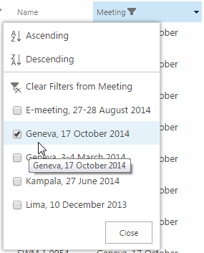
- To filter and/or sort via Source, click on Source and apply the sorting and filtering you need. To reset, click on Clear Filters from Meeting.
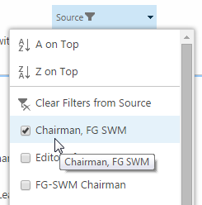
Office Client Minimum Software Requirements
- Office 2010 or Office 2013
For full offline and integrated experience
- FG DFS Community Forum
- To access the FG DFS Community Forum, log in with your TIES or Guest account to the FG DFS Collaboration site at: https://extranet.itu.int/ITU-T/focusgroups/fgdfs/SitePages/Home.aspx
- To join in the FG DFS Community Forum discussions, just select a discussion category you are interested in post a reply to an existing discussion or create a new discussion topic. The discussion categories currently available for FG DFS are shown:
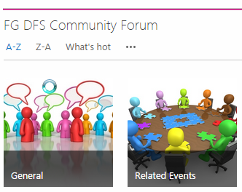
- To create a new discussion, select a discussion category where you want to create the new discussion topic and click on “new discussion”. Type in the subject and fill in the body with the corresponding text and click on Save to post your message.
