 |  | International Telecommunication Union
 |  | ITU-T | FG-SSC
 |  | TELECOMMUNICATION  STANDARDIZATION SECTOR  OF ITU |  | (05/2015)
 | ITU-T Focus Group on Smart Sustainable Cities
 | Master plan for smart sustainable cities
 | Focus Group Technical Report

FOREWORD
The International Telecommunication Union (ITU) is the United Nations specialized agency in the field of telecommunications, information and communication technologies (ICTs). The ITU Telecommunication Standardization Sector (ITU-T) is a permanent organ of ITU. ITU-T is responsible for studying technical, operating and tariff questions and issuing Recommendations on them with a view to standardizing telecommunications on a worldwide basis.
The procedures for establishment of focus groups are defined in Recommendation ITU-T A.7. ITU-T Study Group 5 set up the ITU-T Focus Group on Smart Sustainable Cities (FG-SSC) at its meeting in February 2013. ITU-T Study Group 5 is the parent group of FG-SSC.
Deliverables of focus groups can take the form of technical reports, specifications, etc., and aim to provide material for consideration by the parent group in its standardization activities. Deliverables of focus groups are not ITU-T Recommendations.
SERIES OF FG-SSC TECHNICAL REPORTS/SPECIFICATIONS
Technical Report on "Smart sustainable cities: a guide for city leaders"
Technical Report on "Master plan for smart sustainable cities"
Technical Report on "An overview of smart sustainable cities and the role of information and communication technologies"
Technical Report on "Smart sustainable cities: an analysis of definitions"
Technical Report on "Smart water management in cities"
Technical Report on "Electromagnetic field (EMF) considerations in smart sustainable cities"
Technical Specifications on "Overview of key performance indicators in smart sustainable cities"
Technical Report on "Information and communication technologies for climate change adaptation in cities"
Technical Report on "Cybersecurity, data protection and cyber resilience in smart sustainable cities"
Technical Report on "Integrated management for smart sustainable cities"
Technical Report on "Key performance indicators definitions for smart sustainable cities"
Technical Specifications on "Key performance indicators related to the use of information and communication technology in smart sustainable cities"
Technical Specifications on "Key performance indicators related to the sustainability impacts of information and communication technology in smart sustainable cities"
Technical Report on "Standardization roadmap for smart sustainable cities"
Technical Report on "Setting the stage for stakeholders’ engagement in smart sustainable cities"
Technical Report on "Overview of smart sustainable cities infrastructure"
Technical Specifications on "Setting the framework for an ICT architecture of a smart sustainable city"
Technical Specifications on "Multi-service infrastructure for smart sustainable cities in new-development areas"
Technical Report on "Intelligent sustainable buildings for smart sustainable cities"
Technical Report on "Anonymization infrastructure and open data in smart sustainable cities"
Technical Report on "Standardization activities for smart sustainable cities"

© ITU 2015
All rights reserved. No part of this publication may be reproduced, by any means whatsoever, without the prior written permission of ITU.

Master plan for smart sustainable cities

About this Report
This Technical Report has been been prepared as a contribution to the International Telecommunication Union's (ITU) Focus Group on Smart Sustainable Cities.
Acknowledgements
This Technical Report was researched and principally authored by Silvia Guzmán Araña, FG-SSC Chairman. The author would like to first thank ITU for providing such an exciting opportunity to work and research under the ITU-T Focus Group on Smart Sustainable Cities (FG-SSC).
Special thanks goes also to Ziqin Sang (Fiberhome Technologies), Mythili Menon (University of Geneva), Daniela Torres (Spain), Ramy Ahmed Fathy (NTRA, Egypt), Lei Gu (China Telecom), Michael Mulquin (IS Communications Ltd), Sabrina Coccia (Smart Metropolis), John Devaney (BSI) and Angelica Ospina (University of Manchester).
Additional information and materials relating to this report can be found at: www.itu.int/itu-t/climatechange. If you would like to provide any additional information, please contact Cristina Bueti at tsbsg5@itu.int.

Master plan for smart sustainable cities
Table of Contents
Page
1 Introduction 3
2 SSC definition 5
3 Building a master plan: towards an integrated management in SSC 7
3.1 Phase 1: Setting the basis for a SSC 7
3.2 Phase 2: Strategic Planning 10
3.3 Phase 3: Action Plan 11
3.4 Phase 4: Management Plan 23
4 Conclusions and key considerations 24
Annex 1 – FG-SSC List of Deliverables 26
References 27

Master plan for smart sustainable cities
Executive Summary
This Technical Report has been developed within the Focus Group on Smart Sustainable Cities (FG-SSC) of the International Telecommunication Union (ITU). It aims to foster the design and implementation of an integrated management scheme on Smart Sustainable Cities (SSC), proposing feasible phases to develop a City Master Plan that can be followed by any municipality interested in utilizing Information and Communication Technologies (ICTs) as enablers of urban transformation.
Defined as "an innovative city that uses ICTs and other means to improve quality of life, efficiency of urban operation and services, and competitiveness, while ensuring that it meets the needs of present and future generations with respect to economic, social and environmental aspects", the notion of SSC is becoming crucial to overcome the challenges and benefit from the opportunities that characterize complex urban environments.
Amidst the challenges posed by rapid urbanization and multiple/concurrent vulnerability dimensions (e.g., economic, social, political and environmental), decision-makers are facing the pressing need to re-think and re-define the way in which infrastructure is built, services are offered, citizens are engaged, and systems linked, with the aim of transforming cities into more sustainable and robust living environments.
Based on the work conducted by FG-SSC members and contributing organizations, this technical report suggests that SSC Master Plan is a dynamic process that involves four inter-connected phases.
The starting point of the proposed Master Plan is the recognition that, while technology is an essential component of strategies to develop and implement SSC, cities are about people. Therefore, any strategy aimed at making urban systems smarter and more sustainable, should be focused on ultimately improving the quality of life of the city's inhabitants through novel, more efficient, and increasingly inclusive ICT-enabled approaches.
In order to follow the suggested phases of the Master Plan, it is very important to start by defining a baseline of the actual city status; "Phase 1: Setting the Basis for a smart sustainable city". This baseline will provide municipalities with valuable information about the strengths and weaknesses of the city. This information allows the design of specific projects, aimed at improving the weaker aspects of the city.
The "Phase 2: Strategic Planning" for a SSC, including the governance, leadership and citizen engagement is required to move SSC's vision forward in short, medium and long term. The early identification of inclusive stakeholder and citizen engagement mechanisms (to be implemented throughout the process) is seen as a key component of the SSC Master Plan.
It is also extremely important to reach a consensus among local authorities and other stakeholders during the definition of the priorities and objectives of a smart sustainable city. Becoming a smart sustainable city is a long-term path that can be slowed down and/or hindered by political disagreements. Hence, SSC cannot be used as a "political tool" and instead should be fostered as a long-term strategy to improve the quality of life in the city.
The "Phase 3: Action Plan", has to do with the planning and development of strategic lines of action of the city, the identification of SSC initiatives to be developed, and the establishment of the ICT technology plan.
Focus on identifying the ICT infrastructure that can be used to increase the smartness and sustainability of the city, as well as the strategic planning is required for the deployment (and integration) of ICT infrastructure at the national level. This includes mechanisms for municipalities to incentivize supply and demand of SSC infrastructure, as well as to access the necessary funding.
Additionally, this phase consists of the identification and promotion of SSC services that should be part of a city's integrated planning, in order to address complex urban challenges. Key SSC services include smart water management, smart energy management, smart transportation, smart waste management, smart healthcare, smart education, physical safety and security, smart buildings, as well as city services for climate change mitigation and adaptation.
The activities conducted as part of this phase, will provide the basis of a smart sustainable city Security System, including the minimum requirements for its implementation, and the technologies that are needed to achieve it.
The "Phase 4: Management Plan" includes the definition of the city governance and the setting of the monitoring dashboard to evaluate city performance in the future, in order to assess the improvement achieved. This activity will be carried in parallel and in alignment with the KPIs assessment process.
The development and implementation of 'Key Performance Indicators' (KPIs) is also essential to provide a basic set of criteria to evaluate existing cities and to measure the results of different projects, with the aim of increasing smartness and sustainability. The use of KPIs is critical to measure and to quantify efficiency improvements in city services through the implementation of SSC services.
Each of the stages and technical requirements described as part of this Master Plan are based on a series of detailed technical reports and specifications that have been produced as part of the FG-SSC's mandate. These reports and specifications are freely available for consultation for interested parties.
The analysis also identifies some of the key factors that can influence the effectiveness of the Master Plan implementation. These key factors need to be taken into account by municipal stakeholders and city decision-makers for building their SSC.

1 Introduction
Within an increasingly inter-connected world, rapid urbanization constitutes one of the most challenging facets of the 21st century. 54% of the world's population resides in urban areas, a percentage that is expected to reach 66% by 2050. The growth of the world's urban population is evidencing the need to re-think traditional approaches to sustainable development and urban planning, in both developed and developing countries. During the period between 1950-2010, small cities have grown in population (1.3 billion) much more than medium cities (632 million) or large cities (570 million). According to the United Nations Population Fund (UNFPA), in 2007, for the first time in the history, people living in cities were more than those in rural areas.
Due to migration flows, the natural population growth and certain policies, among other factors, urban areas are becoming more congested. Rapid urbanization is adding pressure to the existing resource base, while increasing the demand for energy, water, sanitation, and public services such as education and health care. In parallel to the rising demand for services, cities are developing into vast consumers of energy and major producers of greenhouse gas (GHG) emissions, and have been estimated to represent three quarters of the global energy consumption and 80% of CO₂ emissions worldwide.
In order to meet the growing needs and the opportunities associated with an increasing urban population, cities require innovative approaches to achieve sustainable development. This involves an improvement in the efficiency of all aspects of a city's operation (e.g., public services, construction, transportation), which are crucial to ensure more inclusive development pathways, and a higher quality of life (QoL) for its inhabitants.
Smart Sustainable Cites (SSC) are key enablers for the achievement of these goals. Despite the recent emergence of SSC initiatives around the globe, efforts to realize an integrated vision based on the notions and implications of 'smartness' and sustainability, including the standardization efforts needed to assess their efficiency, are still in the early stages.
As the momentum of SSC continues to grow, there is an increasing need to better understand and foster the use of new technologies, particularly of rapidly diffusing Information and Communication Technologies (ICTs). Addressing this need is at the core of the Focus Group on Smart Sustainable Cities' (FG-SSC) mandate.
The efforts conducted by this group have been rooted on the recognition of the city as a complex system that is continuously evolving, and one that is formed by a wide variety of stakeholders that need to be involved in any strategy leading to a more sustainable future. In line with this understanding, efforts to develop 'smart' technological innovations, and to integrate physical infrastructures, are not enough. The role of ICTs within SSC strategies needs to be articulated with broader, more holistic visions of the city, in synchrony with its identity and urban development goals, supported by appropriate governance structures, and being responsive to the needs of the citizens, who are at the core of the city's functioning.
Building on this basis, the report suggests a stage-based, action-oriented process or 'Master Plan Phases' to develop an integrated management scheme for SSC, to help inform the work of city decision makers, as they tackle the challenge of transforming their cities into Smart Sustainable Cities.
Scope
This document seeks to provide municipalities and interested stakeholders with a general overview of the stages and technical specifications that need to be considered to effectively apply the notion of SSC to their respective cities. It provides a guide for the implementation of SSC based on intensive use of ICTs, and refers the reader to a series of thematic reports, prepared by the FG-SSC, that address the specific technical aspects involved in the design and operation of SSC strategies (Annex 1).
While building upon expertise available in the field, this document is intended to be as general and inclusive as possible. It aims to inform the design of SSC strategies of any city irrespective of its size, location or resource availability, both in developed and developing countries.
The concepts and definitions presented in the document are in alignment with the technical reports and specifications produced by the FG-SSC as part of its contribution to the work of ITU-T Study Group 5 (SG5) on Environment and Climate Change.
The composition and scope of work of the FG-SSC are summarized in Box 1.
Box 1 – FG-SSC: Composition and Scope of Work
Established in February 2013 by ITU-T Study Group 5, the Focus Group on Smart Sustainable Cities provides a platform to share views, develop a series of deliverables, showcase initiatives, projects, policies and standard related activities that are taking place in the area of smart and sustainable cities. It also analyzes ICT solutions and projects that promote environmental sustainability in cities. It is composed of four Working Groups (WG), focussing on the following tasks:
– Working Group 1 is focused on providing an overview of current state-of-art of SSC. The most important results of this group is the proposed definition of SSC and an overview which define the different parameters which currently outline a smart sustainable city and the role of ICT in this urban environment, as the glue which integrates all the other elements as a foundational platform.
– Working Group 2 is responsible for identifying the technologies and city service infrastructures needed in the city, specially focused on ICT. It aims to look into future trends and to identify standardization gaps. This working group has developed several technical reports focused on the infrastructure and ICT based services needed in SSC, including: smart buildings, smart water management systems, security and resilience structures, among others.
– Working Group 3 focuses on defining the Key Performance Indicators (KPIs) that will allow the evaluation of the city's transformation into a smart sustainable city, using a new integration model of technology vis-à-vis city services. This working group has also identified the standardization roadmap gaps which is helpful for the standardization activities related to the development of SSC.
– Working Group 4 is responsible for identifying all the stakeholders that need to be involved in a smart sustainable city, as well as identifying the major challenges that they could face in its implementation. This group also has the task to identify key stakeholders within the SSC standardization and non-standardization activities worldwide, in order to disseminate and share the outcomes of the focus group.
Source: ITU (2014). Further information is available at: http://www.itu.int/en/ITU-T/focusgroups/ssc

2 SSC definition
The emergence of the 'Smart City' notion has been accompanied by a plethora of definitions and terminology related to smartness, sustainability and innovation within urban settings. Recognizing the need for a standardized definition of SSC, the FG-SSC commissioned the preparation of a technical report aimed at exploring available literature on the subject, analysing existing definitions of smart cities and sustainable cities from academic, private sector, government, and NGO sources, and identifying the factors that lay at the core of the SSC's concept.
Based on the analysis of more than one hundred definitions of what constitutes a smart sustainable city, the Technical Report on "Smart sustainable cities – an analysis of definitions" identifies a series of key attributes that are intrinsic to this notion, most notably:
a) Sustainability – This is related to the city's infrastructure, governance, energy and climate change, pollution and waste management, socio-economic aspects and health provision.
b) Quality of Life – A crosscutting issue, the quality of life of the citizens and the initiatives in place to continuously improve it, are vital to the strategic vision and identity of SSC.
c) Intelligence or Smartness – A "smart" city exhibits implicit or explicit ambition to improve economic, social and environmental standards. Commonly quoted aspects in definitions reviewed in the report include: Smart Economy, Smart People, Smart Governance, Smart Mobility, Smart Living and Smart Environment.
These attributes are present across four intersecting dimensions of complex urban systems, where SSC functionalities take place:
- Societal: The city is for its inhabitants (i.e., the citizens).
- Economic: The city must be able to thrive – create and sustain jobs, growth, finance.
- Environmental: The city must be sustainable in its functioning for future generations.
- Governmental: The city must be robust in its ability to administer and implement policies, and bring together different actors.
Ultimately, the review conducted in the report identifies a series of key issues that should be considered a part of a comprehensive understanding of SSC's role, namely its ability to:
- Improve the quality of life of its citizens.
- Ensure tangible economic growth, including higher standards of living and employment opportunities for its citizens.
- Improve the wellbeing of its citizens including medical care, welfare, physical safety, education, social inclusion and culture.
- Establish an environmentally responsible and sustainable approach, which "meets the needs of the present generation without sacrificing the needs of future generations".
- Streamline physical infrastructure-based services, including those related to the transportation (mobility), water, utilities (energy), telecommunications, and manufacturing sectors.
- Reinforce prevention, resilience capacities and handling functionality for natural and man-made disasters, including the ability to address the impacts of climate change.
- Provide an effective and well-balanced regulatory, as well as compliant governance mechanisms with appropriate and equitable policies and processes in a standardized manner.
Based on the outcomes of this research, numerous contributions from FG-SSC members and collaborating institutions, as well as on extensive discussions, held as part of the focus group's meetings, the following SSC definition was proposed and agreed:
“A Smart Sustainable City is an innovative city that uses Information and Communication Technologies (ICTs) and other means to improve quality of life, efficiency of urban operation and services, and competitiveness, while ensuring that it meets the needs of present and future generations with respect to economic, social and environmental aspects”.

Source: ITU-T FG-SSC, 2014.

Having established a comprehensive working definition of SSC, the following section identifies the key technical specifications that provide an enabling environment for the design and implementation of SSC strategies.

3 Building a master plan: towards an integrated management in SSC
Emerging experiences aimed at the design and realization of SSC have evidenced that there is no single approach to make a city smarter and more sustainable. Each city constitutes a unique system, where different actors and city agencies, undertaking a range of activities, interact at multiple scales, using different facilities and infrastructures. Recognizing the particular environmental and societal contexts of the city, its purposes priority actions, as well as its history and characteristics, has become crucial not only to ensure effective governance, but also to determine the most appropriate path towards becoming smart and sustainable.
Local administrations need to prepare municipal strategic plans as frameworks for the implementation of Smart Cities initiatives; optimise urban services and tailor them towards citizens; move away from standardised and uniform service models to models that involve the provision of personalised services; develop transparent tariff systems, which reflect the real cost of providing services to citizens; create small big data with useful information about KPIs and develop integrated technological platforms that enable the management of intelligent cities.

Building on the work conducted by the FG-SSC, the SSC Master Plan presented in Figure 1 provides an overview of the key components and stages involved in the process of building “an integrated management scheme for SSC.
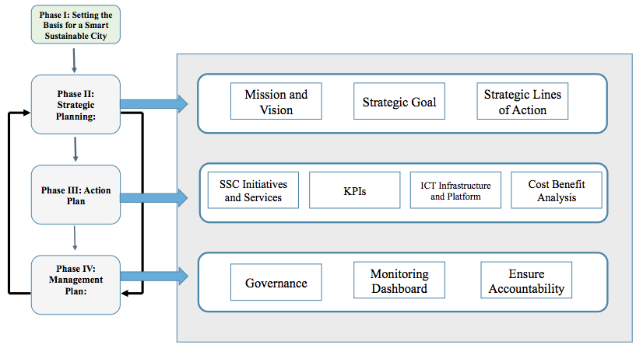
Figure 1 – Stages of Action: SSC Master Plan

3.1 Phase 1: Setting the basis for a Smart Sustainable City
Cities that decide to become smart and sustainable have to start by determining their motivations and priorities, including the identification of the stakeholders that need to be involved, the implications of this transformation on the city's governance, as well as the mechanisms needed to ensure continuous citizen participation and feedback throughout the process (in the short, medium and long-term, and across scales).
Setting the basis for a smart sustainable city, is largely based on gaining a clear, yet in-depth understanding of what it means to become a 'smart sustainable city', and what the process would entail (e.g., basic FG-SSC technical specifications).
As stated in the preceding sections of the analysis, the concept of SSC is extremely broad, and there are multiple and often competing approaches on how to achieve goals related to 'smartness' and 'sustainability' within urban settings. The concept of a 'smart city' also varies significantly in different regions. For instance, Latin American SSC perspectives are strongly focused on the improvement of security, local government management and mobility, Asian SSC initiatives emphasize the importance of infrastructure and services provided to the citizens with the trend of urbanization, while European SSC approaches often concentrate on the improvement of public services' efficiency to strengthen citizens' well-being.
Seeking to address this lack of consensus in the understanding of SSC, the FG-SSC – WG 1 worked on the identification of a comprehensive definition of SSC, presented in section 2 of this report. This definition recognizes the pivotal role played by ICTs as enablers of sustainable and efficient city services.
Further information on the notion and attributes of SSC, and the role of ICTs are available at:
- FG-SSC deliverable (2014), Technical Report on “An overview of SSC and the role of ICT”.
- FG-SSC deliverable (2014), Technical Report on “Smart sustainable cities: an analysis of definitions”.

Also involved in this first stage of implementation, is the definition of a baseline identifying the city’s strengths and weaknesses, and defining clearly the priorities and objectives, as the city moves towards the obtaining of smart sustainable city status. This baseline must be defined in an empirical and standardized way through the use of indicators.
In this regard, it is important to recognize that for SSC strategies to succeed over time, they need to be well articulated and aligned with existent approaches to urban planning, so as to ensure that smart technologies, infrastructures and city services respond to a broader, more holistic vision of the city. Understanding the urban system, its goals, operation, gaps and opportunities, is a necessary step that should precede, and serve as a foundation for, the implementation of SSC strategies.
Identifying the city's purposes and existing urban planning goals, will help determine the priority actions in their path towards becoming a smart sustainable city – i.e., the common solutions the city would want to implement first, the areas of focus in the short, medium and long term.
Thus, the identification of city purposes/priorities of action, governance and stakeholders are closely interlinked, and are vital to form a robust basis for the design of SSC. Along with the set of stakeholders and their roles and responsibilities within the SSC framework, decision makers need to define a governance model and leadership strategies required for the city's transformation.
Thus, the establishment of a cross-sectorial body that can provide continuous support to city council officials and decision makers could contribute to a coherent design and implementation of smart and sustainable cities over time. This body could help ensure the articulation of SSC strategies and the city's urban planning goals, as well as facilitate collaboration and strategic alignment between the multiple stakeholders (including city-level departments and structures at local, municipal and national levels) that need to be involved in the realization of SSC.
The ITU-T FG-SSC – WG 4 have developed a technical report that identifies key SSC stakeholders, as summarized in Box 2.
Box 2 – SSC Key Stakeholders
- Municipalities: City Council and city administration: They are responsible for city management, and therefore they are the main promoters of SSC initiatives for each specific city.
- National and regional governments: They have remit on policies that can affect SSC implementation.
- City services companies: They would be implementing SSC solutions to increase the efficiency of city services.
- Utility providers: They are responsible for the deployment of some of the features of SSC such as smart grid or smart water management.
- ICT Companies (Telecom Operators, Start-ups, Software Companies): They are the providers of the global and integrated solutions, the city platforms, as well as the ICT infrastructure to support SSC deployment.
- NGOs: These NGOs are involved in all initiatives that can influence society and therefore are considered a stakeholder in SSC, especially on the axis of social sustainability.
- International, Regional and Multilateral Organizations: They include UN agencies and multilateral organizations. They can be promoters of initiatives towards human development, environmental sustainability and improvement of quality of life worldwide. They can offer funding opportunities, and are promoters of SSC initiatives.
- Industry associations: As industries are interested in the deployment of SSC, industry associations also work towards the success of this new model.
- Academia, research organizations and specialized bodies. They study SSC and associated trends, including its impacts and contributions to sustainable development.
- Citizens and citizen organizations: As inhabitants of cities, citizens are affected both directly and indirectly by SSC deployment.
- Urban Planners: The expertise of these urban planners is important to better understand how to include ICTs into medium and long term city planning, as well as to consider urban complexities.
- Standardization bodies: These organizations are critical to ensure a common terminology and minimum characteristics of a smart sustainable city, as well as to define measurement methods to assess the performance and sustainability of city services based on ICT technologies.

Source: ITU-T FG -SSC, ITU (2014)
A crucial step for setting an inclusive and sustainable basis for SSC consists of identifying and implementing effective mechanisms for citizen engagement. Citizens are the ultimate beneficiaries of SSC functionalities, as these are aimed at increasing the access to and boosting efficiency of city services, in order to improve citizens' well-being.
While these mechanisms should be set up at the onset of the SSC's strategy, they should be maintained, monitored and adjusted throughout the process of implementation to ensure flexibility, as well as the provision of up-to-date information about the features and benefits that SSC can provide to its citizens.
Without relevant and timely information, citizens can perceive SSC projects as an unnecessary use of their taxes. It is, therefore, important to demonstrate transparency and accountability in terms of the investments made in SSC service provision, and the way in which these investments are having an impact on the citizens' quality of life.
A smart sustainable city needs to promote participation in crucial aspects of the city's functioning, like participatory budgets. Citizenry can also play a key role in the provision of data to inform city-level decision-making processes (e.g., citizen as a sensor, real-time reporting/monitoring using social media), as well as in the provision of innovative ideas to improve city services, or to tackle emerging challenges through cost-effective approaches. In addition, it is very important to involve the companies in the design of the city in order to better understand their needs and facilitate investments made on their behalf.
SSC must be inclusive and enable access to those sectors of the population that may not have access to technology. To address this challenge, municipalities can offer training programs targeting marginalized populations (e.g., vulnerable women, the elder), equip public zones with technologies to broaden the user base, and implement other programs aimed at raising awareness and encouraging citizen engagement in the realization of the SSC strategy.
Further information on the role of SSC stakeholders is available at:
- FG-SSC deliverable (2015), Technical Report on “Setting the stage for stakeholder's engagement in smart sustainable cities”.

3.2 Phase 2: Strategic Planning
Progress needs to be made through holistic visions and transversal policies that strengthen the integrated approach, which should prevail in all SSC. Therefore, initiatives for SSC should consider metropolises from a global perspective; otherwise, the effectiveness and scope of such initiatives may be severely reduced.
In the first step of the cycle, local governments identify a SSC vision and assess the city's situation in order to establish the relevance and feasibility of becoming a SSC. This step includes, among others:
- To define, what kind of city it should be. What are the overall aims of the initiative and what is the main idea to achieve specific targets?
- Identifying a SSC vision that is line with the city's identity, political priorities and long-term development strategy;
- The vision establishes the connection between the SSC components and its guiding principle. This is necessary to provide a deeper understanding of the vision of a smart sustainable city;
- Document the detailed business process of the main existing city services along with their inter-relationships and dependencies;
- Gathering relevant data on the status of ICT infrastructure and usage at the city-level, including the status of the city in regards to the SSC technical specifications;
- Identifying the existing governance and organizational conditions that would allow an efficient and effective management of SSC solutions;
- Identifying mechanisms for multi-stakeholder involvement, citizen engagement, communication and information sharing throughout the SSC process. Assurance of the participation of citizens and relevant stakeholders in SSC is essential for the transformation process into a smart sustainable city; and
- Encourage the two ways of participation; top-down or a bottom-up approach. A top-down approach promotes a high degree of coordination, whereas a bottom-up approach allows more opportunity for common people to participate directly.
In this phase, it is crucial to understand the city as an ecosystem. This ecosystem should be created by entities which are involved in the process of development of SSC strategies, including universities, research centers, companies, public agencies and society
In this phase, local governments should achieve the necessary political approval and legitimization to ensure that the SSC strategic program is pursued. It consists of the adoption of the SSC program/targets by the local council through a political decision, thus becoming an agreed document that has widespread support. This would also serve as a reference for the strategic planning of the local authority.
Any SSC initiative should have a strong political leadership from the local government. Additionally, it will be necessary to identify within institutions, organisms and/or businesses involved, the people with greater level of leadership. Such leadership should be conveyed through the initiative of project administration, the constant co-ordination between the relevant actors, the decision-making, the overcoming of challenges and any other action to guarantee the continuous development of the project.

3.3 Phase 3: Action Plan

An action plan involves turning a suggested project into something tangible. This in turn requires a clearly defined plan for integrating technology solutions into an action plan. Important considerations can include: timing of the action; the costs related for implementation; the identification of who are individuals or agencies responsible for implementation; progress indicators; procedures for reporting and evaluation.
In this phase, local governments work in close collaboration with the various SSC stakeholders to design the overall plan for the SSC's implementation (e.g., objectives, priorities, initiatives and actions needed in the short, medium and long term, including SSC infrastructure investments, setting measurable SSC targets and time frames for their achievement). This step involves, the identification of SSC targets and major milestones with regards to:
- SSC services;
- SSC Key Performance Indicators (KPIs);
- SSC architecture;
- SSC infrastructure and integrated platform;
- SSC data security, EMF and
- SSC projected cost benefit analysis.
A plan of action must be elaborated which proposes a series of realistic development measures. Such measures will be hierarchized and studies will be done with regards to associated costs and the appropriate period when investment should take place. A clearly established plan of action will be the guide for development of actions and strategies. A strategy will be designed which has quick-wins, which will be instrumental in the creation of public and private support needed for the success of SSC initiatives and systems such as:
a) Smart Sustainable Cities Services
Cities provide many different services to its citizens, including water management, energy, transport, waste management, healthcare, education and security. The efficiency of these services can be significantly improved with the use of ICT technologies, creating a new set of "smart services" which will lead to improved efficiency and sustainability.
Every municipality should evaluate the different services that their city might need. The work conducted by the FG-SSC working groups, have allowed the identification of several ICT services that contribute to the efficiency of city services, as summarized below:
- Smart Water Management Systems: These systems promote the sustainable management of water (water supply and distribution, water and wastewater treatment and other municipal related services like raw water services, drainage services or reclaimed water services) through coordinated water management by the integration of ICT infrastructure (products, solutions and systems) in order to maximize the socioeconomic welfare of a society without compromising the environment.
- Smart Energy Management Systems: These systems use sensors, advanced meters, digital controls and analytic tools to automate, monitor and control the two way flow of energy, optimizing grid operation and usage, to ensure reliability, self-healing, interactivity, compatibility, energy saving, safety, optimal use of energy from renewable sources and minimum carbon footprint. ITU-T Focus Group on Smart Grids has developed several documents in this field.
- Smart Transportation Management Systems: These systems need to move people (and goods) in an efficient, timely and cost effective, safe and environmentally sustainable way. With that aim in mind, they need to use technology (e.g., M2M communication, Wi-Fi and RFID technologies, Global Positioning Systems, sensors) and collect information (e.g., real-time traffic flow information, data analytics, prediction techniques) about mobility patterns. Some added benefits of these systems include the capability to locate and identify vehicles, and monitor and control infrastructures like roads. As a result, it is possible to reduce travel times, incident duration and traffic accidents.
- Smart Waste Management Systems: These systems will empower the implementation of waste tracking systems based on their ability to monitor the movement of different kinds of waste, optimize collection routes, connect various smart waste management systems with local service providers, leverage technology to collect and share data from waste sources, to waste transportation, disposal and sorting. These upgrades will help to convert waste into a resource and create closed loop economies, fostering more sustainable and productive uses of waste.
- Smart Healthcare Management: These management systems can convert health related data into clinical and business insights, and enable secure communications and information sharing in order to improve the productivity of the service provided to citizens. Examples of smart healthcare systems include the availability and improvement of remote diagnosis, remote treatment, on-line medical services, health management systems and remote patient monitoring systems. To achieve these goals, M2M communications will be crucial.
- Smart Education: Education, for adults and children, may be the most important smart city service. The use of ICT can improve education by providing the student with a personalized learning environment (e.g., tailored to his progression level, interests, learning style), as well as by providing educators with new tools to design learning activities or opening new communication channels with student, parents and community members. At the city level, the use of ICT in education can generate other economic and social benefits, including the improvement of tourism services.
- Smart Security: Ensuring physical safety and security required, the use of ICTs responds to the need of resolving incidents, providing criminal identification, as well as conducting predictive analysis and criminal pattern identification to improve the citizen safety. Command and control systems shared across multiple city departments like energy, waste, transport and security will be needed to provide a holistic city-wide view of safety patterns and trends. New ICT infrastructure also has to be protected from security threats.
- Smart Buildings Systems: These systems can use data to improve building energy efficiency, reduce wastage and optimize water usage, without affecting the occupants' satisfaction. These systems may include building automation, life safety, and telecommunications, among others.
Further information on ICTs and Smart City Services is available at:
- FG-SSC Technical Report on “Overview of SSC infrastructure”
- FG-SSC Technical Report on “Intelligent sustainable buildings for smart sustainable cities”.

The analysis conducted thus far suggests that ICT use can improve the efficiency of city services and, ultimately, strengthen the quality of life of its citizens. To assess these benefits, Key Performance Indicators (KPIs) are needed to quantify and evaluate the transformation of a city into a smart sustainable city. Other KPIs that are specifically designed for each city service, are also needed to monitor performance and assess, quantitatively, the efficiency gained through the implementation of SSC solutions.
While the list of smart services provided earlier reflects the standard/most common city services, municipalities can integrate different services according to their own needs and priorities.
b) Key Performance Indicators, Standards.
Key Performance Indicators (KPIs) are not only useful to evaluate the performance of city services, but can also be used to assess, empirically, how one or a set of modifications contribute to the city's transformation into a smart sustainable city, providing ground for standardization. KPIs can also allow comparisons between different cities to determine which one is 'smarter' or more sustainable in the face of particular challenges. Evaluating these indicators can help cities as well as their stakeholders understand to what extent they may be perceived as Smart Sustainable Cities (SSC).
In order to provide a complete list of KPIs that can be used for city and municipal administrations, city residents, development and other organizations of operating in SSC (e.g., producers, service providers, planning units), as well as evaluation or ranking agencies, the FG-SSC has developed a series of documents:
- Technical Specifications on “Overview of key performance indicators in smart sustainable cities”.
- Technical Specifications on “Key performance indicators related to the use of information and communication technology in smart sustainable cities”.
- Technical Specifications on “Key performance indicators related to the sustainability impacts of information and communication technology in smart sustainable cities”.
- Technical Report on “Key performance indicators definitions for smart sustainable cities”.
The Technical Specifications define standardized KPIs with the aim to provide criteria to evaluate existing cities (e.g., single cities from the administrative point of view, or the union of small cities in the same area that share some services), but not to compare them. It will enable cities and municipal administrations to understand the progress of SSC development and design suitable strategies, city residents to know the details of development of SSC, and development and operation organizations of SSC to fulfil the tasks related to information provision.
The evaluation principles chosen to define dimensions, sub-dimensions and indicators are the following: comprehensiveness (i.e., should cover all SSC aspects), comparability (i.e., should be able to compare scientifically different phases of urban development and different cities), availability (i.e., quantitative data must be accessible and scientific), independency (i.e., the indicators in the same dimension must be independents), simplicity (i.e., concepts and calculation must be simple and intuitive) and timeliness (i.e., ability to produce KPIs with respect to emerging issues in SSC construction). The dimensions of KPIs can be categorized as follows (shown in Figure 2):
- Information and Communication Technology
- Environmental sustainability
- Productivity
- Quality of life
- Equity and social inclusion
- Physical infrastructure
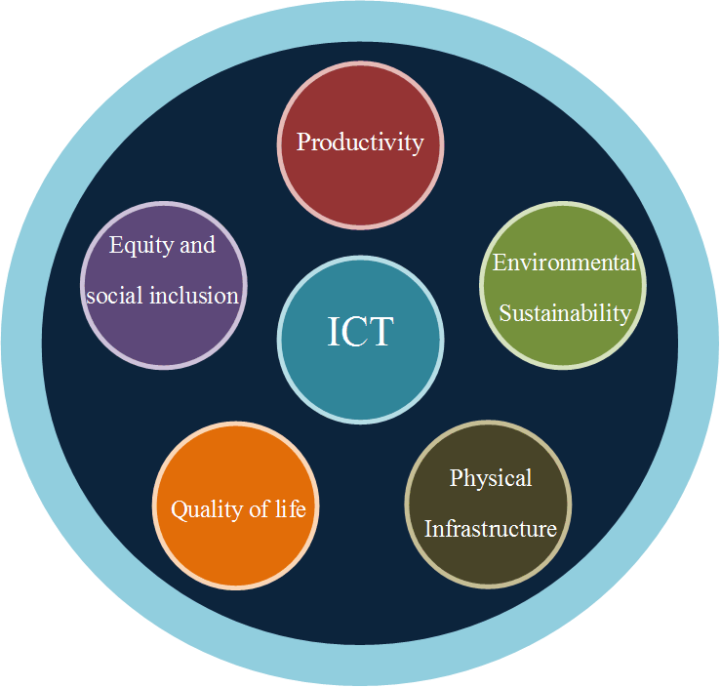
Figure 2 – Dimensions of evaluation of SSC
Source: FG-SSC
Using the evaluation principles explained before, the key performance of SSC can be categorized into six dimensions, each with their respective sub-dimensions and indicators, as follows:
Table 1 – SSC: KPIs, Dimensions and Sub-dimensions
Overview of key performance indicators in smart sustainable cities
Dimension label | Dimension | Sub-dimension label | Sub-dimension
D1 | Information and Communication Technology | D1.1 | Network and access
 |  | D1.2 | Services and Information platforms
 |  | D1.3 | Information security and privacy
 |  | D1.4 | Electromagnetic field
D2 | Environmental sustainability | D2.1 | Air quality
 |  | D2.5 | Water, soil and noise
D3 | Productivity | D3.1 | Capital investment
 |  | D3.4 | Trade
 |  | D3.8 | Innovation
 |  | D3.9 | Knowledge economy
D4 | Quality of life | D4.1 | Education
 |  | D4.2 | Health
 |  | D4.3 | Safety/security public place
D5 | Equity and social inclusion | D5.3 | Openness and public participation
 |  | D5.4 | Governance
D6 | Physical infrastructure | D6.1 | Infrastructure/connection to services – piped water
 |  | D6.2 | Infrastructure/ connection to services – sewage
 |  | D6.3 | Infrastructure/ connection to services – electricity
 |  | D6.8 | Infrastructure/connection to services – road infrastructure
 |  | D6.11 | Building
Source: ITU-T FG-SSC (2014)
The corresponding indicators for each sub-dimension are detailed in the "Technical Specifications on key performance indicators related to the use of information and communication technology in smart sustainable cities" and "Technical Specifications on key performance indicators related to the sustainability impacts of information and communication technology in smart sustainable cities".
c) Setting the framework for ICT architecture of smart sustainable cities

The architecture of smart sustainable cities has been defined in the corresponding FG-SSC Technical Specification on “Setting the framework for an ICT architecture of a smart sustainable city” (fg-ssc-0345), At a high level, a Meta-Architecture consists of 5 layers (as depicted in Figure 3.1), which focus on the integration between natural environment and soft infrastructure of urban spaces, while SSC services run across these layers.

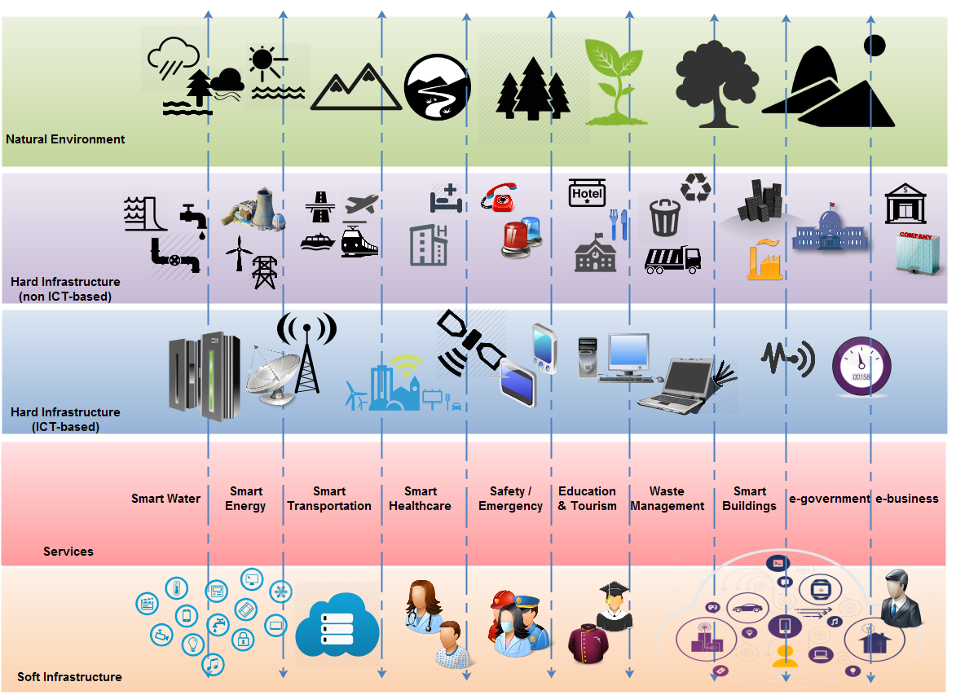
Figure 3.1 – Multi-tier SSC ICT meta-architecture
A smart sustainable city can also be considered a system of subsystems. With regard to its technical definition, it can be viewed from different perspectives. Figures 3.2 and 3.3 demonstrate the communications view of the SSC ICT architecture, based on a physical and an information flow perspective respectively. Both perspectives of this view are multi-tier.
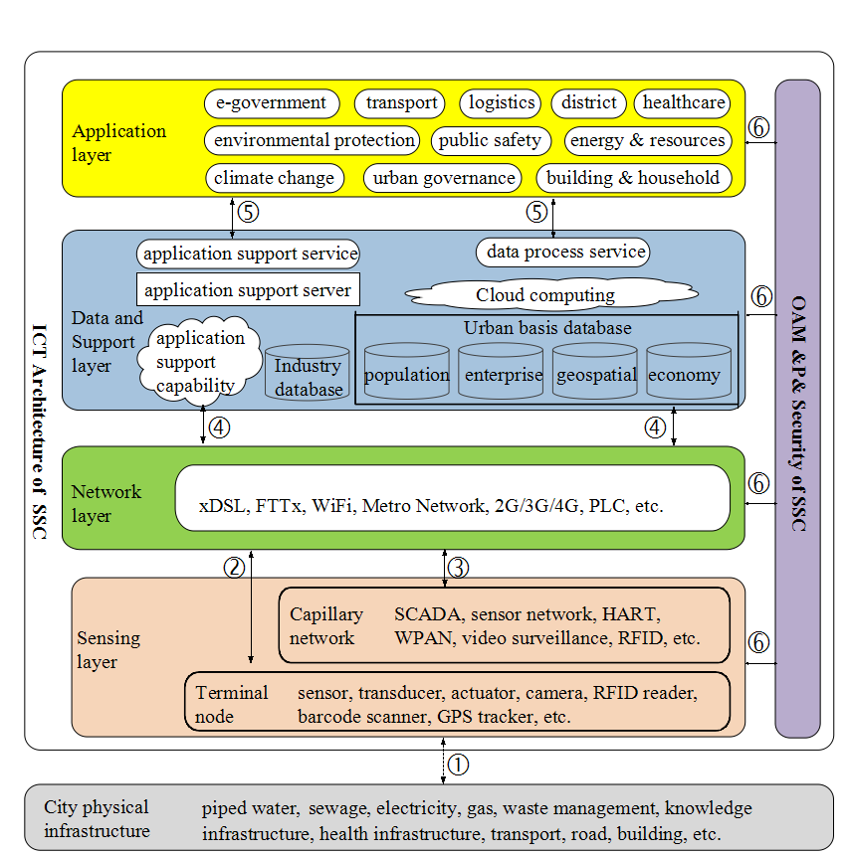
Figure 3.2 – A multi-tier SSC ICT architecture from communications view, emphasizing on a physical perspective

Figure 3.3 – A multi-tier SSC ICT architecture from communications view, emphasizing on an information flow perspective
Both the given figures concern valid representations of the same architecture view, one closer to the language of infrastructure developers and the second more in line with the information system developer’s context. The architecture view contains the following layers (as depicted in Figure 3.2):
- Sensing layer: This layer consists of terminal node and capillary network. Terminals (sensor, transducer, actuator, camera, RFID reader, barcode symbols, GPS tracker, etc) sense the physical world. They provide the superior “environment-detecting” ability and intelligence for monitoring and controlling the physical infrastructure within the city. The capillary network (including SCADA, sensor network, HART, WPAN, video surveillance, RFID, GPS related network etc.) connects various terminals to network layer, providing ubiquitous and omnipotent information and data.
- Network layer: The network layer indicates various networks provided by telecommunication operators, as well as other metro networks provided by city stakeholders and/or enterprise private communication network. It is the information superhighway (infobahn), the network layer data and support layer. The data and support layer makes the city “smarter”, its main purpose is to ensure the support capabilities of various city-level applications and services. Data and support layer contain the data centers from industries, departments, enterprises, as well as the municipal dynamic data center and data warehouse (etc), established for the realization of data process and application support.
- Application layer: The application layer includes various applications that manage SSC and deliver the SSC services.
- OAM & P & security framework: This layer provides the operation, administration, maintenance and provisioning, and security function for the ICT systems of SSC.
The multi-tier SSC ICT architecture from communications view, emphasizing on an information flow perspective (illustrated in Figure 3.3) contains the following layers:
- Users layer: It organizes SSC service end-users into groups from both the demand and the supply sides;
- Presentations layer: It contains the user interfaces (web, apps, voice commands etc.), which stand between end-users and SSC services;
- Applications layer: It contains all corresponding software applications that realize the SSC services;
- Business layer: It consists of the business processes, which lie behind each smart sustainable city service execution;
- Communications layer: It contains the above mentioned networks, over which the SSC services are performed and transactions and data flow are realized;
- Data layer: It contains the data and file repositories, where data are created or retrieved;
- Sensing layer: This layer consists of terminal node and capillary network. The terminals (sensor, transducer, actuator, camera, RFID tag, barcode symbols etc.) sense the natural environment where the smart sustainable city is located and the corresponding hard infrastructure and utilities (water, transport etc.). It provides the superior 'environment-detecting' ability and intelligence for monitoring and controlling the physical infrastructure within the city. The capillary network connects various terminals to communication layer, or directly to data layer and/or application layer providing ubiquitous and omnipotent information and data.
Detailed discussions on ICT Architecture and Architecture Framework, as well as security aspect of Smart Sustainable Cities is available in deliverables SSC-0345 “Setting the framework for an ICT architecture of a smart sustainable city” and SSC-0090 "Technical Report on ICT Infrastructure for Cyber-Security, Data Protection & Resilience", respectively of the Focus Group on Smart Sustainable Cities (FG-SSC).

d) Smart Infrastructure and Integrated Platform
Investing in ICT infrastructure constitutes a critical component of a city's transformation into a SSC. This technology can provide crucial information for city managers to increase the efficiency in urban services, improve the quality of life of citizens, ensure a tangible economic growth, strengthen prevention and management of natural disasters, simplify physical infrastructure used in some services (e.g., mobility, energy), and improve the city's sustainability.
In order to reduce as much as possible, this initial investment, cities can adopt the notion of "convergence", by using pre-existing networks to establish new ICT infrastructure.
The first step for introducing ICT technologies in cities is to consider all stakeholders involved in this process. In terms of interconnected infrastructure, the most relevant stakeholders will be the telecom operators, ICT providers, financial institutions, utility providers, emergency services, local institutions, NGOs, regulators, funding bodies, universities, as well as Research and Development (R&D) institutes.
The ICT infrastructure of SSC contains a vast array of technologies. The most important ones, grouped in three categories, are listed in Table 2:
Table 2 – Technologies and Categories of SSC ICT
Network Facilities | Data Layer
 | Data/Content Center
 | Communication Layer
 | Transport Networks
 | Access Networks
ICT Facilities | Network Management Software
 | ICT Integrated Services Capacity
 | Data Management
 | Cloud Computing and Data Platform
 | Geographic Information Infrastructure
 | Augmented Reality
Terminals, Sensing & Multi-device layer | Terminals & Gateways
 | Sensors
 | Internet of Things
Source: ITU-T FG-SSC, 2014
FG-SSC WG 2 defines two different aspects related with the strategic planning required for the national deployment of ICT infrastructure.
The first one is the deployment of ICT infrastructure itself, including the formulation and implementation of related policies and strategies. It requires the involvement of all the stakeholders identified before. The second aspect refers to improving the infrastructure deployed in order to reduce defects like perception (e.g., the infrastructure is not able to automatically perceive themselves running), cleverness (e.g., the operation and application of facilities use a fixed configuration and it is unable to judge the situation automatically), lack of sharing mechanisms(e.g., lack of horizontal integration that prevents synergies) and communication restrictions (e.g., the bandwidth and reach of various branded communication facilities are uneven).
Decision makers must consider that during the implementation of ICT infrastructure there is the risk of creating a polarization effect in zones that have more investment than others, creating (or accentuating existing) digital divides in the city. Strategies aimed at addressing these risks can include the use of public funds to invest in zones with the least development infrastructure.
Municipalities can adopt different strategies for the development of ICT infrastructure. These include the provision of supply incentives, using existing infrastructure for the deployment of ICT, or the adoption of strategies to incentivize demand (e.g., using ICT to improve local service management, or to improve the relationship with citizens). It must be noted that supply and demand stimulate each other. An adequate supply will often push the demand, while the growth of demand can increase and improve the supply, fostering a virtuous circle. With that in mind, local governments should focus on both strategies.
All ICT infrastructure implementation must fulfil the applicable laws and regulations. In cases of municipal infrastructure and deployment of projects, financing strategies tend to be very heterogeneous.
Some of the main funding mechanisms that can be used to support the activities involved in this stage are summarized in Table 3.
Table 3 – ICT infrastructure funding methods
Funding Mechanism | Description
Taxes | Pay using taxes
Redemption from taxes (tax or rates) | Local government taxing rights are exchanged for infrastructure or services
Loans + Free Cash Flow | Initial capital comes from financial leverage from partners. After that the project can try to sustain itself
Local Government as a Major Customer | Funds provided by city government
Advertising | Funds generated by advertising
Utilities Allowance | Funds collected from other public services used to maintain infrastructures. Some regulations prevent this system
Corporate Donations | Some corporations can donate funds
Agreements with Private Companies | Agreement with private companies to offer funds free of charge to the public
National or Multinational Subsidies | Funds coming from national or multinational organizations.
Cooperative Projects | Local government ends up with a project originally created as a cooperative and community project
Source: ITU-T FG-SSC, 2014
Further information on the role of SSC infrastructure is available at:
- FG-SSC Technical Report on “Overview of SSC infrastructure”.

e) Data Security and EMF
All cities need to consider two fundamental topics in order to protect their citizens in a new context of smartness and sustainability; cybersecurity and data security, to protect the citizen data, and electromagnetic fields (EMF), to address existing concerns of the public around this topic.
Data Security
SSC apply the use of technologies in many different areas of the city (e.g., infrastructure, resource management, public services, industrial systems, social aspects, security). They do this in more extensive and intensive ways than traditional cities, and thus generate larger amounts of valuable data. This information is needed to improve the efficiency of cities. However, its management can be challenging.
One of the principal objectives of any city is to become a safe place to live for its citizens. In a smart sustainable city, citizens' security must be expanded to data security (i.e., cyber-security and data protection) in order to protect one of its most important resources.
Considering the growing importance of this area, the FG-SSC developed the Technical Report on “Cyber-security, data protection and cyber-resilience in smart sustainable cities" to identify ways of improving cyber-security and cyber-resilience (defined by the Information Security Forum as the capacity to withstand negative impacts due to known or unknown, predictable or unpredictable, uncertain and unexpected threats from activities in cyberspace).
In order to protect the city from these threats, SSC shall be provided with security systems that offers protection in four dimensions: physical and environmental security (e.g., equipment security, disaster recovery prevention), system security (e.g., anti-virus technology, host security reinforcement and operating system security), network security (e.g., gateway anti-virus, firewall and intrusion detection) and data and application security (e.g., database encryption and database backup technologies).
As a result of their complexity and significance within the city's operation, the security of some smart city services and infrastructures must be prioritized (e.g., smart grids, intelligent transportation, connected healthcare, public safety and security or wireless communications and hotspots).
The information security infrastructure constitutes the technical foundation of the entire system, and as such, it provides a large number of security functions. The tasks of the information security infrastructure canters include disaster recovery, emergency monitoring, key management, security management, security evaluation and identity management.
Further information on the technologies and actions that can be implemented to achieve the SSC's security is available at:
- FG-SCC Technical Report on “Cybersecurity, data protection and cyber resilience in smart sustainable cities”.
EMF Considerations
SSC are based on the extensive use of wired and wireless ICTs, to provide city services in a more efficient way. Scientific research over many decades has enabled national and international health authorities to establish safety limits for human exposure to electromagnetic fields. Exposure limits vary depending on the EMF frequency and EMF source and incorporate conservative safety margins for added protection.
ICTs devices and networks should be designed and deployed ensuring EMF compliance, while supporting the maximum efficiency of ICTs' utilization.
Further information on the basic principles that SSC will need to consider when defining EMF policies is available at:
- FG-SCC Technical Report on “Electromagnetic field (EMF) considerations in smart sustainable cities”.
f) SSC Projected Cost Benefit Analysis
Given the massive expected amounts of investments needed to realize the SSC concept, it is of extreme importance to conduct cost benefit analysis to analyze the feasibility of deploying such systems. Not only does the sustainability concept addressed environmental and societal challenges, but also includes issues related to the economic feasibility and long-term break-even on the micro and macro levels.
In the process of analyzing the different possibilities to achieve the set strategic targets, it is important to develop a technology market adoption model which would be capable of estimating the needed investments using different SSC technologies combinations or options. The model should estimate the needed investments per SSC service sector, in addition to its financial viability and foreseen macro-economic impact. This quantitative analysis enables policy makers to establish the right combination of policy tools and strategic directives to create a robust SSC ecosystem.

3.4 Phase 4: Management Plan
This last phase includes the definition of the City Governance and the setting of the Monitoring Dashboard to evaluate city performance in the future.
This stage involves close coordination and collaboration among SSC stakeholders, as well as the implementation of Key Performance Indicators (KPIs).
The execution of each initiative must be carried out in accordance with the Action Plan. The necessary information must be made available in order to realize the initiative and learn from experiences. Additionally, it is in this implementation phase, where special attention must be paid to infrastructural needs.
This phase is also focused on evaluating, reporting and learning from the SSC process and related experiences. The results must be registered, measured and analyzed in order to identify the improvements made through the different initiatives.
The level of success of the SSC initiative will arrive through the economic, social and environmental results in the long term). This evaluation contributes to informing the high-level municipal decision-makers, as well as to informing the preparation of future baseline reviews to deepen SSC plans, among others. It can involve the use of various mechanisms for knowledge and experience sharing among the different SSC stakeholders.
The implementation process is the most crucial stage of any strategic plan. During this process one may face several challenges which include: defining the skills required for those responsible for its execution, defining the budget and related financial issues, establishing progress indicators, evaluating the results and presenting the findings to the stakeholders:
- Governance of Implementation: For the purpose of implementation of the master plan, a governance committee should be set up. The members of this governance committee should be people who worked on the development of the master plan first hand. The governance committee will be in charge of reinforcing the competences in budgetary control, and should be able to specify relevant agreements, and develop a communication plan.
- Financing Model: Even though there are various methods to fund a project and these methods may vary in each city, common criteria should be included, when using such methods. These include stability, diversification, balance, and adaptability. The members of this committee should be people who worked on the development of the master plan first hand. However this should reinforce the competences in budgetary control, and should be able to specify the agreements, and develop a communication plan.
- Evaluation Model: For this model, it is important to differentiate the evaluation of specific smart sustainable city projects or examine a holistic vision of smart sustainable city developments. Furthermore, the constant monitoring of external factors, and the choice of evaluation methods of key issues is needed. By doing so, it is possible to obtain better control of the evolution of the economic execution plans, deadlines and the upgrading of existing KPIs.
- Dissemination and Communication: The master plan will be followed by a communication strategy in order to maintain interest in the process .Instruments such as the creation of a corporate image for the project, outreach publicity, publication of technical documents (etc) will support this objective.

4 Conclusions and key considerations
In order for a smart sustainable city initiative to be adopted and succeed, it is important to understand the need for such vision and ambition. Accordingly, some considerations must be taken into account.
- The SSC initiative must have a strong political leadership from the local government. Such leadership must be shown through the administration of the project, the constant co-ordination between the relevant actors, the decision-making, the change management, customize training, by overcoming challenges and any other action necessary to guarantee the development of the project. The designation of responsibilities is key in order to ensure success.
- The set of objectives must be clear and must allow for the quantifiable evaluation of results obtained.
- The continued evaluation of results is fundamental to show the value of the initiatives developed and the role of indicators (KPIs) is key and must be significant.
- Develop models of public-private collaboration, as they are powerful alliances, leading the ecosystem of innovative actors to obtain success. The planning must facilitate a scenario of mutual benefits between all agents, while the role of the administrator will be to facilitate the relationship between all agents.
- On the other hand, if SSC are about efficiency and a better quality of life, they must support important economic savings or the implementation of new services. A serious study must take place regarding the financial aspects of the initiative and also the future administration of financial resources. Here, the public-private collaboration plays a key role.
- Citizens should be recognized as the cornerstone of any smart sustainable city. They are the main beneficiaries of the SSC model that can provide valuable data, ideas and feedback to the city. Consequently, the city has to actively promote and enable citizen participation.
In any event, understanding the city as an open ecosystem, to promote open areas of collaboration, through co-working, accelerators program and urban labs, makes mechanisms become available in order to naturally incorporate the collective intelligence and the areas of co-creation.
The collaboration between the ecosystem's actors in the city as well as the collaboration between cities, can be made available and improved through the use of ICTs which allow collaboration tools and integration initiatives more realistic and efficient, reason why the public-private initiatives are key. It is very important to learn from past initiatives and experiences.
It is very important to adopt, at different levels of decision, common and shared policies of ICT tools and solutions, combined with organizational changes and the acquisition of new skills in order to generate savings and greater productivity of the city's administration that can have a positive effect on the increasingly tight budgets. Investing in ICT also produces great benefits for the city's economy, boosting productivity through incentives and the creation of new jobs.
As experiences continue to emerge around the globe, it is crucial to recognize that the effectiveness of SSC strategies requires a holistic, articulated approach that is not solely based on technological and infrastructural aspects, but primarily on improving the citizen's well-being.
Installing smart technologies alone will not improve city services. SSC are about strategic integration and articulation. New technology needs to be complemented by intelligent management. In this sense, strategists will need to define how technologies and information collected will be used, considering that a key characteristic of SSC, is the breakdown of silo-based approaches, and the integration of services to improve the quality of life of citizens. Thus, considering the different stages and components of the Master Plan presented in this report, as well as the set of technical reports produced as part of the FG-SSC's mandate, can help to guide and inform that process.

Annex 1
FG-SSC List of Deliverables
1. Technical report on “Smart sustainable cities: a guide for city leaders”
2. Technical report on “Master plan for smart sustainable cities”
3. Technical report on “An overview of smart sustainable cities and the role of information and communication technologies”
4. Technical report on “Smart sustainable cities: an analysis of definitions”
5. Technical report on “Smart water management in cities”
6. Technical report on “Electromagnetic field (EMF) considerations in smart sustainable cities”
7. Technical specifications on “Overview of key performance indicators in smart sustainable cities”
8. Technical report on “Information and communication technologies for climate change adaptation in cities”
9. Technical report on “Cybersecurity, data protection and cyber resilience in smart sustainable cities”
10. Technical report on “Integrated management for smart sustainable cities”
11. Technical report on “Key performance indicators definitions for smart sustainable cities”
12. Technical specifications on “Key performance indicators related to the use of information and communication technology in smart sustainable cities”
13. Technical specifications on “Key performance indicators related to the sustainability impacts of information and communication technology in smart sustainable cities”
14. Technical report on “Standardization roadmap for smart sustainable cities”
15. Technical report on “Setting the stage for stakeholders' engagement in smart sustainable cities”
16. Technical report on “Overview of smart sustainable cities infrastructure”
17. Technical specifications on “Setting the framework for an ICT architecture of a smart sustainable city”
18. Technical specifications on “Multi-service infrastructure for smart sustainable cities in new-development areas”
19. Technical report on “Intelligent sustainable buildings for smart sustainable cities”
20. Technical report on “Anonymization infrastructure and open data in smart sustainable cities”
21. Technical report on “Standardization activities for smart sustainable cities”
For additional information, please visit the FG-SSC website at http://www.itu.int/go/fgssc

References
Fernández Güell, J.M. (2006) – Planificación estratégica de ciudades: Nuevos instrumentos y procesos, Barcelona: Editorial Reverté.
Greenfield, A. (2013) – Against the smart city, New York: Do projects.
Iván Tosics January 2011, Governance challenges and models for the cities of tomorrow, Directorate-General for Regional and Urban Policy, Brussels
Kooiman, J. 1990, Modern Governance, Sage. London.
Manville, e.a. 2014, Mapping Smart Cities in the EU, Policy Department Economic and Scientific Policy, European Parliament, Brussels.
Kauffman, S. (1995) – At home in the Universe: The search for the laws of self-organization and complexity, Nueva York: Oxford University Press.
Townsend, A. (2013) – Smart Cities. Big data, civic hackers and the quest for new utopia, New York: W. W. Norton & Co.
Von Bertalanffy, L. (1968) – General Systems Theory: Foundations, Development and Applications, New York: Braziller.
Waldrop, M. (1992) – Complexity: The Emerging Science at the Edge of Order and Chaos, New York: Simon & Schuster.

Please find the FG-SSC Technical Reports and Specifications at: http://www.itu.int/en/ITU-T/focusgroups/ssc/Pages/default.aspx
UNDESA (2014), 'World Urbanization Prospects: The 2014 Revision, Highlights', United Nations, Department of Economic and Social Affairs, Population Division. http://esa.un.org/unpd/wup/Highlights/WUP2014-Highlights.pdf
UNDESA (2013),'World Economic and Social Survey 2013: Sustainable Development Challenges Overview', United Nations Department of Economic and Social Affairs (UNDESA), http://www.un.org/en/development/desa/policy/wess/wess_current/WESS%20Overview%202013%20E.pdf
UNFPA (2007) 'State of the World Population 2007: Unleashing the Potential of Urban Growth', United Nations Population Fund (UNFPA), http://www.unfpa.org/swp/2007/english/introduction.html
Provoost, R. (2013), 'Smart Cities: Innovation in Energy will Drive Sustainable Cities', The Guardian Professional, 13 November, http://www.theguardian.com/sustainable-business/smart-cities-innovation-energy-sustainable
See for example the Partnership for Smart and Sustainable Cities, http://www.urbanknowledge.org/smartsustainablecities.html
Further information on the work of ITU-T SG5 is available at: http://www.itu.int/en/ITU-T/studygroups/2013-2016/05/Pages/default.aspx
FGSSC (2014). 'Smart sustainable cities – an analysis of definitions'. Focus Group on Smart Sustainable Cities Working Group 1, International Telecommunications Union (ITU). http://www.itu.int/en/ITU-T/focusgroups/ssc/
ITU FG-SSC (2014) Technical Report on "Smart water management in cities".
http://www.itu.int/en/ITU-T/focusgroups/smart/Pages/Default.aspx
ITU FG-SSC (2014) Technical report on "Key performance indicators definitions for smart sustainable cities".
ITU FG-SSC (2014), Technical report on "Key performance indicators definitions for smart sustainable cities".
Technical Specification on “Setting the framework for an ICT architecture of a smart sustainable city” (fg-ssc-0345)
Ibid.
Ibid.
https://www.securityforum.org/
eMisr, National Broadband Plan, Egypt, 2011 available at: http://www.tra.gov.eg/emisr/Documents.aspx
Fernández Güell, J.M. (2006) – Planificación estratégica de ciudades: Nuevos instrumentos y procesos, Barcelona: Editorial Reverté.

