PRACTICAL INFORMATION

Meeting of Study Group 20 and
related events

(Arusha, Tanzania, 12-22 September 2023)

ABOUT ARUSHA
Arusha is located in Northern Tanzania at the foot of the Mount Meru on the Eastern edge of the Eastern branch of the Great Rift Valley. Arusha Region as a whole is a popular tourist destination and the heart of the Northern Tanzania Safari Circuit. It offers a pleasurable climate and is surrounded by internationally renowned attractions, including game parks like the Serengeti, Ngorongoro, Lake Manyara, Olduvai Gorge, Tarangire National Park, Mount Kilimanjaro and Arusha National Park, where Mount Meru stands. The city is known for its vibrant markets, bustling streets, and diverse cultural offerings, including traditional Maasai dance performances and handicrafts.
In addition to hosting numerous International Organizations, including the International Residual Mechanism for Criminal Tribunals (IRMCT), the Pan African Postal Union, among others, Arusha is the headquarters of the East African Community, which comprises seven-member countries namely Burundi, Democratic Republic of the Congo, Tanzania, Kenya, Rwanda, Uganda and South Sudan. Over the years, the City has earned a solid reputation as a preferred venue for hosting high-profile international meetings, including summits of Heads of State and Government.
Arusha is therefore a major conference hub in the sub-region with a cosmopolitan population. It is reputed as one of the most pleasant cities in the world, due to its picturesque countryside, cultural heritage Centers and lively local music by Tanzanian groups.
Arusha city is relatively safe for visitors. However, it is advisable to take precautions especially during late hours.

CLIMATE – DURING THE SEPTEMBER
The average minimum temperature in Arusha in September is 10.0°C (50.0°F), which is usually noted during the night. September is a dry month with an average of 20mm (0.8in) rain. The average maximum daytime temperature lies around 24.0°C (75.2°F). September is known as one of the best months to visit Arusha. More updated information can be obtained from Tanzania Meteorological Authority at http://www.meteo.go.tz/

MEETING VENUE

The Meeting will be held at the Gran Meliá Arusha in Arusha, Tanzania.
Address of the Venue: TZ, Simeon Road, 1184, Tanzania
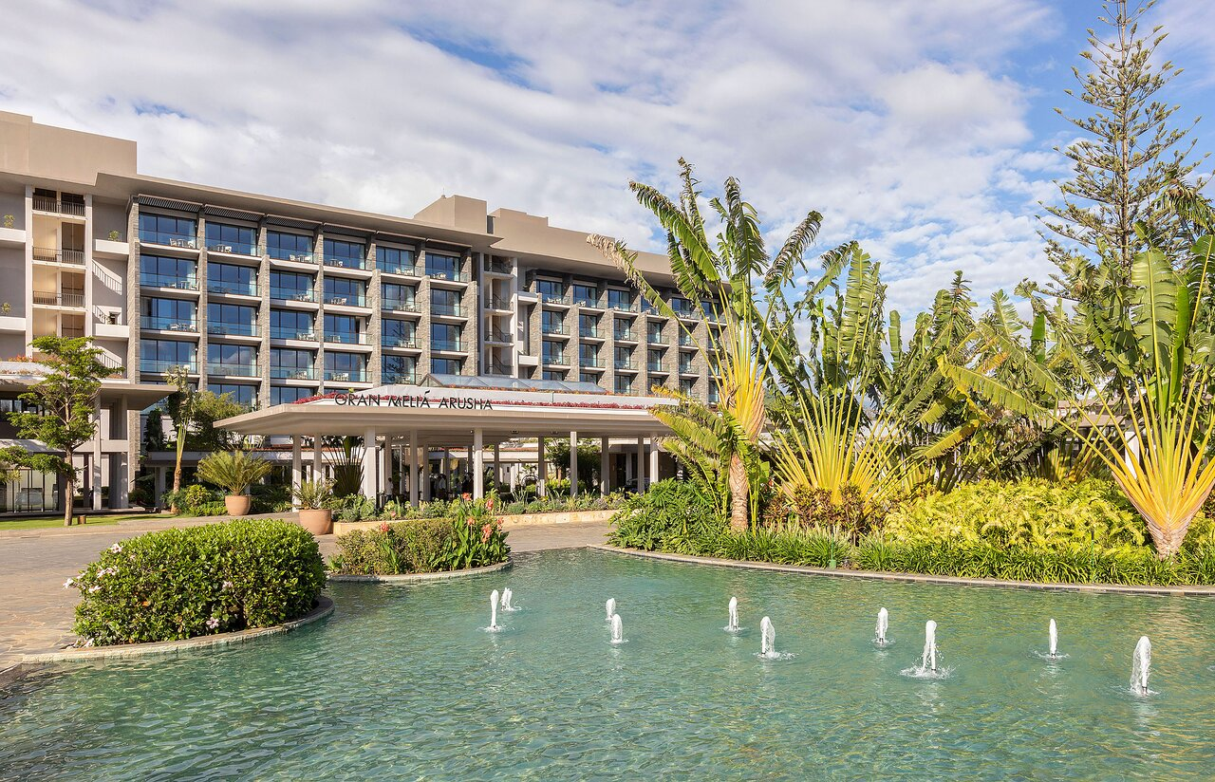

TRAVEL LOGISTICS
The final destination is Kilimanjaro International Airport (KIA), which is 45 kilometers from Arusha city. We are encouraging all delegates from outside Tanzania to travel through Kilimanjaro International Airport or Julius Nyerere International Airport (JNIA) in Dar es Salam as their main port of entry into Tanzania.
Visitors can jet into Dar es Salaam (Julius Nyerere Airport), and Kilimanjaro International Airports via direct or one-stop flights. Here are some airlines that operate in Tanzania:
- Air Tanzania
- Kenya Airways
- Ethiopian Airlines
- Precision Air
- KLM
- Qatar Airways
- Emirates
For delegates traveling through Julius Nyerere International Airport (JNIA) in Dar es Salaam, they can fly to Arusha through domestic flights operated by Precision Air and Air Tanzania to Kilimanjaro International Airport or Arusha Airport.
The Government of the United Republic of Tanzania (URT) will provide transport to delegates as follows:
- On arrival and departure from Kilimanjaro International Airport / Arusha Airport; and
- Recommended hotels to/from the venue.
Note: Delegates are advised to look for the paging boards or signage with the name of meeting (ITU-T SG20).
Delegates are requested to provide all travel information, including flight number, arrival and departure dates and time should they need pick-up from and to the airport.

VISA REQUIREMENTS
Foreigners seeking to enter the United Republic of Tanzania should be in possession of a valid passport. The passport is to be presented to the Immigration Control Officer at any entry point: border station, airport, harbour. The passport must be presented along with a valid visa.
Citizens from Southern Africa Development Community (SADC) and East African Community (EAC) do not require a visa. However, you are advised to consult the nearest Tanzanian Embassy well in advance for visa requirements. Information on Visa and online application can be accessed at https://eservices.immigration.go.tz/online/pass/home
Please submit the visa request form (found in Annex A) to Imelda Salum (e-mail: imelda.salum@tcra.go.tz) and Clara Fuko (clara.fuko@tcra.go.tz), by 14 August 2023, at the latest.

HEALTH REQUIREMENTS
- Yellow fever vaccination certificate
In order to comply with the International Health Regulations, United Republic of Tanzania requires a valid International Certificate of Vaccination from travelers from countries with infected areas. In addition, certificates are required from those who have been in transit through those areas.
- COVID-19 health check
All delegates are advised to check current information and guidance regarding COVID-19 restrictions before travelling to Tanzania.

HOTELS
A list of recommended hotels near the venue is as shown in the table below:
HOTEL NAME | CATEGORY | LOCATION | ROOM TYPE | RATES PER NIGHT BB (USD) | CONTACTS
Gran Melia Arusha | Five Star | Simeon Road | Delux City View | 195 | gran.melia.arusha@melia.com  255 746 982 400
 |  |  | Delux Mount View | 250
 |  |  | RedLevel Delux Mount View | 315
 |  |  | RedLevel Junior Suite | 500
 |  |  | RedLevel Grand Suite | 830
 |  |  | RedLevel Presidential Suite | 1715
Mount Meru Hotel | Four Star | Moshi - Namanga Road | Standard Room Single | 131.5 | info@mountmeruhotel.co.tz  255 27 297 0266  255 784 108 200
 |  |  | Standard Room Double/Twin | 163
 |  |  | Executive Room Single | 181.5
 |  |  | Executive Room Double/Twin | 213
 |  |  | Triple Executive Room | 290
 |  |  | Junior Suite Single | 310
 |  |  | Junior Suite Double | 143.5
 |  |  | Executive Suite Single | 365
 |  |  | Presidential Suite | 510
Kibo Palace Hotel | Four Star | Uzunguni Area, Old Moshi Road | Single | 126.8 | info@kibopalacehotel.com  sales@kibopalacehotel.com  255 753 36 444
 |  |  | Double | 148.0
 |  |  | Deluxe Suite | 186.8
 |  |  | Executive Suite | 312.8
Four Points by Sheraton | Four Star | Clock Tower Roundabout | Traditional Queen/Twin | 145 | afom@fourpointsthearushahotel.com  255 27 297 7777
 |  |  | Deluxe King/Twin | 165
 |  |  | Deluxe Premium King | 175
 |  |  | Club King/Twin | 195
 |  |  | Club Premium King | 215
 |  |  | Suite Club King | 335
 |  |  | Suite Premium Queen | 385
Corridor Springs | Three Star | Uzunguni Area, Ingira Road | Standard Single | 30 | info@corridorspringshotel.com  255 787 545 075  255 746 582 896
 |  |  | Executive room | 52
 |  |  | Double/Twin | 52
 |  |  | Deluxe Suite | 64
Gold Crest Hotel | Four Star | Uzunguni Area, Old Moshi Road | Executive Single Room | 100 | info@goldcresthotel.com  255 677 014 957  255 677014958
 |  |  | Executive Double Room | 120
SG Premium Resort | Three Star | Moshi - Namanga Road | Standard Single Room | 73 | reservations@sgresorttz.com  info@sgresorttz.com  255 784 227 777
 |  |  | Standard Double Room | 94
 |  |  | Deluxe Suite | 127.5
 |  |  | Executive Suite | 170
The African Tulip | Three Star | Serengeti Road | Single | 120 | info@theafricantulip.com  255 699 799 873
 |  |  | Double/Twin | 150
 |  |  | Suite Single | 213
 |  |  | Suite Double | 312
Silver Palm | Three Star | Makao Mapya Road | Single Standard | 60 | info@silverpalmhotel.com  255 767 286 630
 |  |  | Double Standard | 60
 |  |  | Twin room | 65
 |  |  | Triple room | 100
 |  |  | Executive Suite | 110
New Safari Hotel | Three Star | Boma Road | Single | 80 | reservation@newsafarihotel.com  255 27 2545940
 |  |  | Double | 110
 |  |  | Triple room | 120
Palace Hotel | Three Star | Uzunguni Area | Standard | 85 | marketing@palacehotelarusha.com  reservations@palacehotelarusha.com  255 754 885 762  255 27 5545800
 |  |  | Superior | 85
 |  |  | Deluxe | 85
 |  |  | Executive | 110
 |  |  | Suite | 127.5
Green Mountain Hotel | Three Star | Kijenge Area | Standard Single | 60 | info@greenmountainhotel.co.tz  reservations@greenmountainhotel.co.tz  255 767 111 119
 |  |  | Deluxe | 80
 |  |  | Executive | 100
 |  |  | Executive Suite | 120

INTERNET ACCESS AND MOBILE TELEPHONY SERVICES
Internet Access will be provided at the venue, through WiFi. Delegates who wishes to have local SIM Card; they can obtain the same at the venue or at the Operators’ shops. The recommended Mobile Network Operators are Vodacom, Tigo, Airtel and Halotel all offering (2G, 3G & 4G).

ELECTRICITY
Tanzania standard electricity voltage is at 220 - 240V, and the frequency is 50/60Hz with power plugs and sockets of type G: square type three pins
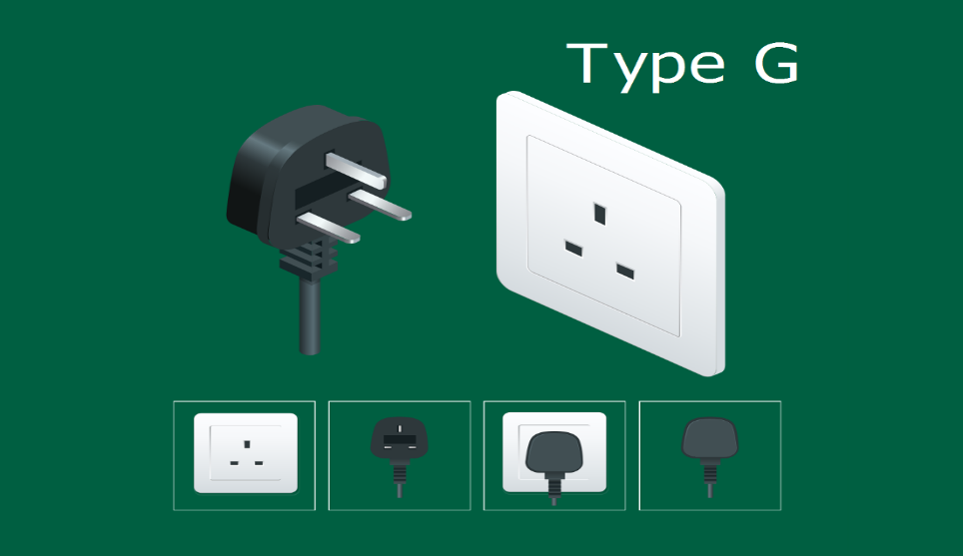

CURRENCY
The Official currency is Tanzanian Shilling (TZS). Other commonly acceptable currencies (for exchange to Tanzania Shillings) include:
1USD = 2324 TZS
1EUR = 2563.83 TZS
1GBP = 2901.28 TZS
*Take note that the exchange rate may change at any time. For the latest exchange rates please visit www.bot.go.tz *.
Online exchange rates can also be obtained from http://www.xe.com/

Additional Information
Time Zone: Tanzania Standard Time is 3 hours ahead of Greenwich Mean Time (GMT+3).
Emergency Number: In case of police emergency please dial 112
Fire Emergency: 114
Banking: Monday to Friday 0830-1530 and Saturday: 0830-1200
Shops: Monday to Friday: 0800-1700 and Saturday: 0800-1300
Languages: English and Swahili are the official languages of the United Republic of Tanzania

HOST CONTACT PERSONS
The name of a contact person in Tanzania to assist with the invitation letter for Visa purpose and any technical assistance are:
- Eng. Imelda Salum; Email address: imelda.salum@tcra.go.tz Mob: +255 754 710716
- Ms Clara Fuko; Email address: clara.fuko@tcra.go.tz; Mob +255 713 041 300

ITU Focal point
- Secretariat of ITU-T SG20: tsbsg20@itu.int

Welcome to Arusha, Welcome to Tanzania.

ANNEX 1
LETTER OF INVITATION FOR VISA REQUEST
For the Meeting of Study Group 20 and related events
(Deadline for sending is 14 August 2023)
[Note: Visa approval might take time. Please send your request as soon as possible]
Please use CAPITAL letters.
Surname & first name(s):
Gender:
Position:
Organization:
Address:
Telephone:
Fax:
Nationality:
Passport number:
Date of issue:
Place of issue:
Date of expiry:
Country & city where you will obtain the visa:
Date of birth:
Place of birth:
Date of arrival:
Date of departure:
All requests for letter of invitation for visa purposes must be addressed to Imelda Salum (e-mail: imelda.salum@tcra.go.tz) and Clara Fuko (clara.fuko@tcra.go.tz) with copy to ITU: ​tsbsg20@itu.int, bearing the words “Letter of support for visa” as subject and should be sent by 14 August 2023 at the latest.
Note: the email should also include as attachments the present form duly completed specifying the name as written in the passport, date of birth, passport number, dates of issue and expiry of the passport of the individual(s) for whom the visa(s) is/are requested, scanned copy of the passport and a copy of the notification of confirmation of registration for the SG20 meeting.

