Home Network Transport

Standards Overview and Work Plan

April 2023 Q1/15 meeting

Contact persons for project updates:

Study Group 15 Advisor:  Mr. Hiroshi Ota  International Telecommunication  Union (ITU)  Place des Nations  1211 Geneva 20  Switzerland  Tel.: +41 22 730 6356  E-mail: hiroshi.ota@itu.int | Study Group 15 Chairman  Mr. Glenn Parsons  Ericsson  349 Terry Fox Drive  Ottawa - ON K2K 2V6  Canada  Tel: +1 514 379 9037  E-mail:  glenn.parsons@ericsson.com | Question 1/15 Rapporteur  Mr. Jean-Marie Fromenteau  Corning Incorporated  Corning, NY 14831  USA  Tel: +49 9561 42 74 20  E-mail:  fromentejm@corning.com

Home Network Transport is an ITU-T Project dealing with studies and Recommendations on the Home Network. The present Home Network Transport (HNT) Standards Overview and Work Plan is part of ITU-T SG15 Lead Study Group activities on coordination of Home Network Transport standards.

Home Network Transport Standards Overview and Work Plan
Issue 15, April 2023

Revision Status Report: Major Updates of Version 15, April 2023
In this version 15, following changes, additions and updates have been made.
1) Section “Introduction” has been revised.
2) A new section 1 - Existing Home Network Transport (HNT) Standards - has been created with a chapter 1.1 that introduces the web-based HNT Standards Overview, and a chapter 1.2 that describes the taxonomy of the web-based HNT Standards Overview.

3) Section 2 has been redefined - Home Network activities within ITU-T SG15 - with a chapter 2.1 - List of published Recommendations within ITU-T SG15 - and a chapter 2.2 - Ongoing standardization activities in the area of Home Network Transport within ITU-T SG15.
4) Section 3 has been redefined - Home Network activities in other ITU Study Groups

5) Section 4 has been redefined - Home Network activities in other Standards Development Organizations
6) The web-based HNT Standards Overview has been updated with following new or revised Standards, Recommendations, Amendments and Corrigenda, Supplements, Technical Reports and other technical documents from ITU-T SG15, other ITU Study Groups and other SDOs that have been approved and published since the last ITU-T SG15 September 2022 plenary meeting:

- General on Home Network
> Home Network architecture and functions: ETSI GS F5G 009 V1.1.1 (2021-06);
ITU-T G Suppl. 78 (09/2022)
> Home Network security: ITU-T X.1352 (09/2022)
- Wireline home networking
> Over phoneline: ITU-T GSTP-OPHN (09/2022)
> Over powerline - Power Line Communications (PLC): ITU-T G.9901 (2017) Cor.1 (11/2023), G.9903 (2017) Amd2 (03/2023), G.9903 (2017) Cor.1 (03/2023)
- Wireless home networking
> ETSI DECT (Digital Enhanced Cordless Telecommunications): ETSI TS 103 636-1, TS 103 636-2, TS 103 636-03, TS 103 636-4, TS 103 636-5 (all V1.4.1 (2023-01))
> Optical wireless communications: ITU-R SM.2422-2 (07/2022), SM.2152.0 (09/2022)
- G.hn technology (and all Topics related to G.hn): GSTP-OPHN (09/2022)
- Home gateways: BBF TR-124 - Issue 8 (12/2022); ITU-T F.746.15 (12/2022), ITU-T J.1611 (10/2022)

- Home Network applications
> General on Smart Home Network: ITU-T J.1611 (10/2022)
> Cable-based video services and IPTV: BBF TR-124 - Issue 8 (12/2022); ITU-T J.1611 (10/2022)

- Internet connectivity
> Internet connectivity over wireless networking: ITU-R SM.2422-2 (07/2022)

- Personal and close proximity connectivity: ITU-R SM.2422-2 (07/2022); ETSI TS 103 636-1, TS 103 636-2, TS 103 636-03, TS 103 636-4, TS 103 636-5 (all V1.4.1 (2023-01))
- IoT / Domotics applications
> IoT / Domotics over wireless networking: ITU-R SM.2422-2 (07/2022); ETSI TS 103 636-1, TS 103 636-2, TS 103 636-03, TS 103 636-4, TS 103 636-5 (all V1.4.1 (2023-01))
- Home Network cabling: ITU-T L.76 (05/2008), L.109.1 (11/2022), L.210 (11/2022); IEC 61156-1:2023
- Environment and power supply of Home Network equipment: ITU-T L.1470 (01/2020), L.1023 (09/2020), L.1333 (09/2022), L.1035 (02/2022)
- Safety and protection of Home Network equipment: ITU-R SM.2503 (07/2022)
7) Work programme update from ITU-T SG15: see in chapter 2.2
The list of ongoing standardization activities in the area of Home Network Transport within ITU-T SG15 has been updated.
- The table of Q3/15 work items has been updated with the latest Q3/15 activities resulting from April 2023 ITU-T SG15 - WP1 plenary meeting.
- The list of Q5/15 and Q7/15 work items related to Home Network infrastructures (e.g., fibre and cable, optical node) has been updated with the latest Q5/15 and Q7/15 activities resulting from ITU-T SG15 - WP2 April 2023 plenary meeting.
8) Work programme update from other ITU Study Groups
- See in section 3 - LSs from ITU-T SG5, ITU-T SG9 and ITU-D SG1
9) Work programme update from other SDOs
- See in section 4 – LSs from Broadband Forum
10) Section 5 - Overview of Home Network applications - has been updated.
11) Section 6 - List of Contacts - has been updated.
12) Section 7 – Lead Study Group activities related to the HNT Standards Overview and Work Plan - has been updated.
13) Annex 1 - Guide on the use of the web-based HNT Standards Overview – has been created.

Home Network Transport Standards Overview and Work Plan

Issue 15, April 2023

General… 5
Introduction 5
1. Existing Home Network (HNT) Transport Standards 6
1.1 Web-based HNT Standards Overview 6
1.2 Taxononmy of the HNT Standards Overview 7
2. Home Network activities within ITU-T SG15 13
2.1 List of published Recommendations within ITU-T SG15 13
2.2 Ongoing standardization activities in the area of Home Network Transport
within ITU-T SG15……………………………………………….. 17
3. Home Network activities in other ITU Study Groups 21
[ITU-T SG5; SG9; SG13; SG16; SG17; SG20] [ITU-R SG1; SG5; SG6] [ITU-D SG1]
4. Home Network activities in other Standards Development Organizations 32
[Broadband Forum; Bluetooth SIG; ETSI; HomeGrid Forum, CENELEC; IEC;
IEEE 802.3; IEEE 802.11; Wi-Fi Alliance®; IEEE 802.15; IEEE 1901; IEEE 1905;
ISO/IEC; MoCA®; TIA; TTC; Thread Group; CSA (ex. Zigbee Alliance);
Z-Wave Alliance]
5. Overview of Home Networks applications 62
6. List of Contacts 65
7. Lead Study Group activities related to the HNT Standards Overview and Work Plan 70
Annex 1 - Guide on the use of the web-based HNT Standards Overview 72

HOME NETWORK TRANSPORT STANDARDS OVERVIEW AND WORK PLAN
Issue 14, SEPTEMBER 2022

General
As home networks become more sophisticated, and as their interactions with the access network become more complex, coordination between access network standards and home network standards becomes of increasing importance. WTSA-20 reaffirmed Study Group 15 as Lead Study Group on Home Network Transport (HNT) within ITU-T and Study Group 15 entrusted Working Party 1/15 (Transport aspects of access, home and smart grid networks), under Question 1/15, with the task to manage and carry out the Lead Study Group activities on Home Network Transport.
Using a process similar to the access network transport (ANT) standards coordination, a Home Network Transport (HNT) Standards Overview and Work Plan has been developed.
The HNT Standards Overview and Work Plan is a living document. The current version is available at https://www.itu.int/en/ITU-T/studygroups/Pages/sg15-hnt.aspx.

Introduction
The continuing customer demand for ever higher bit rate data services, high-speed Internet access and other innovative services, and the ongoing needs of network operators to leverage in-premises connectivity for distributing within the home IPTV and other services and applications, require the development of new Recommendations and enhancements to existing Recommendations covering all aspects of in-premises networking transceivers. These studies include, but are not limited to, the transport of higher layer protocols, the management and test of the in-premises systems, spectral management aspects and energy saving techniques.
Given the interdisciplinary nature of Home Network applications, it is expected that a high degree of cooperation with other ITU Sectors (ITU-R, ITU-D), ITU-T Study Groups, Questions, Focus Groups (FGs), Joint Coordination Activities (JCAs), Global Strategic Initiatives (GSIs), as well as other international standards bodies will be required.
Within the ITU-T, the study and development of Recommendations related to transport in the Home Network is being carried out in Study Group 15 - see in Section 2 below, and in several other Study Groups - e.g. SGs 5, 9, 13, 16, 17, 20 as well as in ITU-R - see in Section 3 below. Other standards bodies, forums and consortia are also active in this area - see in Section 4 below for the lists of such activities.
Recognizing that without a strong coordination effort there is the danger of duplication of work as well as the development of incompatible and non-interoperable standards, the ITU-T designated Study Group 15 as the Lead Study Group on Home Network.
A web-based HNT Standards Overview has been created to classify the existing HNT standards and to represent the multitude of home networking technologies and services offered to the customer. This web presentation of the existing HNT standards is part of the present document and is available in the web-based ITU-T Standards Landscape – Topic/Root “Home Network Transport Standards“ at https://www.itu.int/itu-t/landscape/?topic=tx153&group=g&search_text= on the ITU-T SG15 website.
The description and the taxonomy of the web-based HNT Standards Overview are provided in the Sections 1.1 and 1.2 respectively of the present document and Table 5 in Section 5 shows an overview of Home Network applications and related Home Network technologies.
A critical part of the HNT standardization work is the network of contacts for the development of relevant standards and the tracking of correspondence, usually in the form of liaisons, to guide the work. The list of contacts in Section 6 provides an overview of the other relevant Study Groups in the ITU and other Standardization Groups corresponding through liaisons with Study Group 15 about matters related to the HNT Standards Overview and Work Plan.

1. Existing Home Network Transport (HNT) Standards
1.1 Web-based HNT Standard Overview
A web-based HNT Standards Overview was developed to classify the existing HNT standards using inputs and published standards lists from ITU-T Study Group 15 and other ITU Study Groups, as well as from other standards development organizations (SDOs), Forums & consortia.
The web-based HNT Standards Overview replaces the lists of published Standards and Recommendations shown in tables of the previous versions of the present document.

The web-based HNT Standards Overview is part of the web-based ITU-T Standards Landscape
- Topic/Root “Home Network Transport Standards” and is available on the ITU-T SG15 website at https://www.itu.int/itu-t/landscape/?topic=tx153&group=g&search_text=
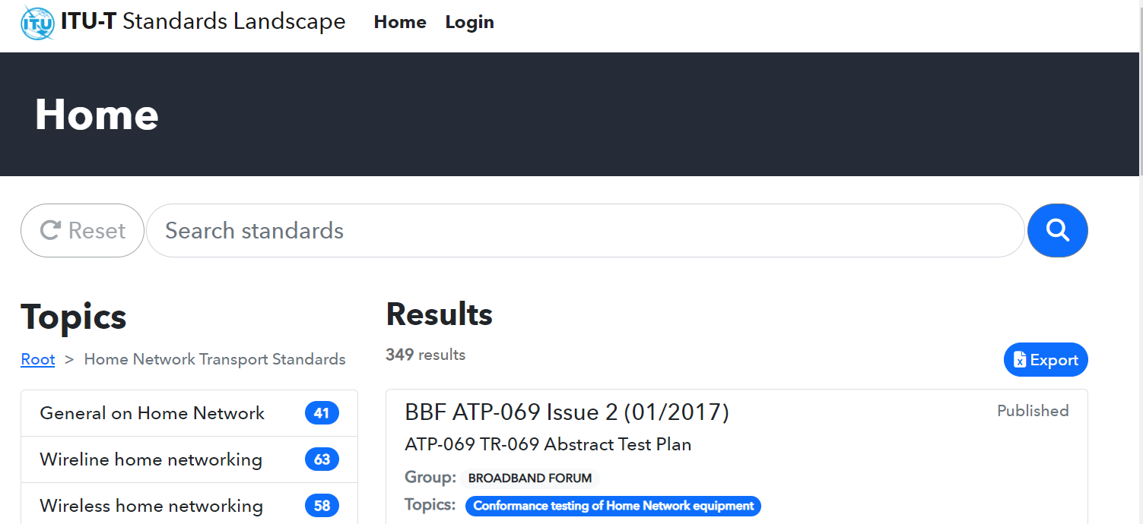

The web-based HNT Standards overview is organized by topics representing the home network technologies, the various systems generations of each technology and related technical matters as well as their applications in the home. It enables an easy identification and download of the publicly available Standards, Recommendations, Technical Specifications and other technical documents related to each topic. The web-based HNT Standards Overview focuses on the most relevant published and updated documents related to Home Network Transport.

The items listed within each topic represent Standards, Recommendations, Technical Specifications or other technical documents and are identified by their responsible ITU Sector or SDO, their individual reference number, publication date and title. The items are also searchable on number, title and description and are alphanumerically listed within each topic; this is inherent in the data base system.
Lists of Standards, Recommendations, Technical Specifications and other documents (items) can be generated from the web-based HNT Standards Overview as needed for each topic or groups of topics and responsible Group (ITU Sector or ITU-T SGs or SDOs) and exported on an excel table.
The taxonomy used for the web-based HNT Standards Overview is described in the Section 1.2 below and a guide on how to use the web presentation is provided in Annex 1.

1.2 Taxonomy of the web-based HNT Standards Overview

Topics of “Home Network Transport Standards” representing the home networking technologies and applications
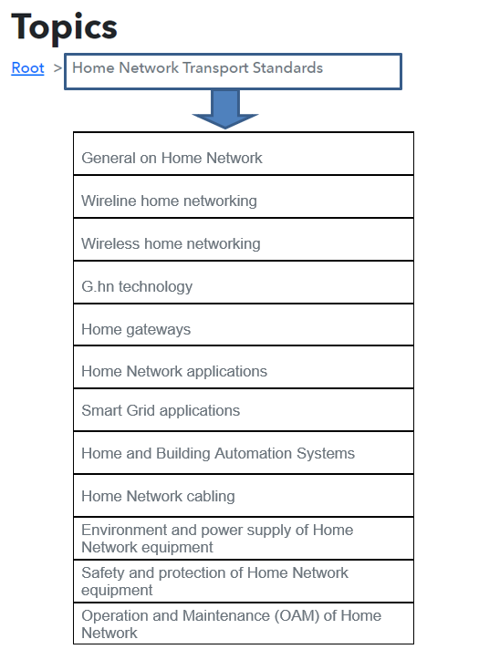

Each of the above topics is further described on the next pages
Topics of “General on Home Network” providing general information on home network architecture and function as well as on the security aspects
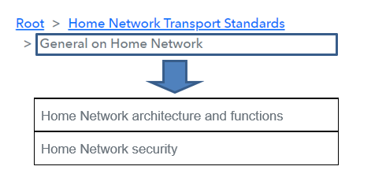
Topics of the “Wireline home networking” representing the various wire based home networking systems and transceiver generations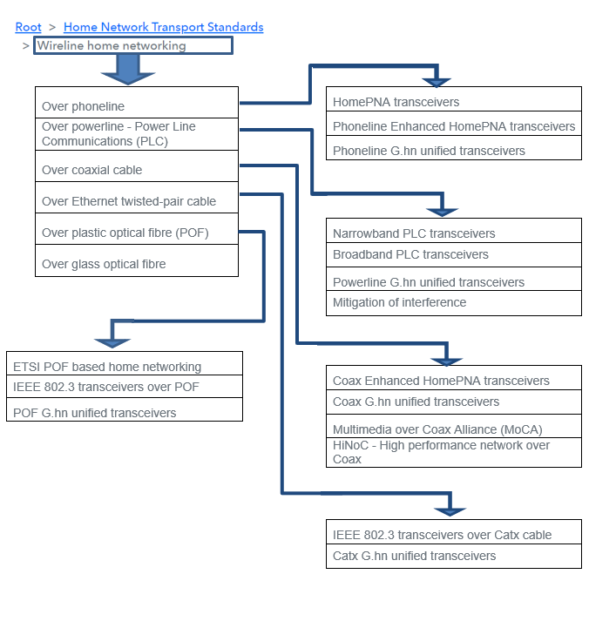

Topics of the “Wireless home neworking” representing the various wireless based home networking systems and transceiver generations
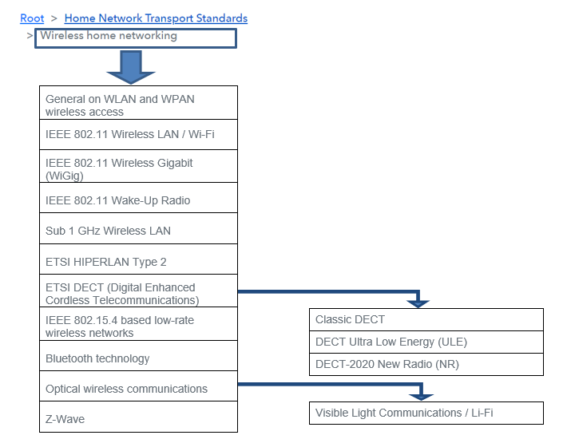
Topic “G.hn technology” providing the G.hn transceiver specifications and information on G.hn applications
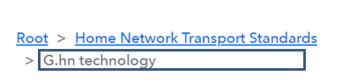

Topic “Home gateways” providing the specifications of various home gateways

Topics of “Home Network applications” representing the various types of connectivities in the home and related home networking transceivers
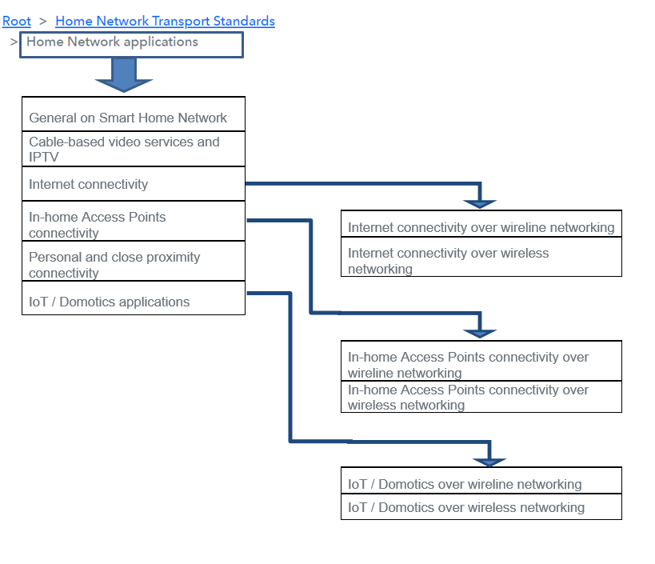

Topic “Smart Grid applications” representing the related home transceivers and technical matters

Topics of “Home and Building Automation Systems” representing HBES (CENELEC) and HES (ISO/IEC) general requirements, terminology, architecture and applications as well as other related technical matters
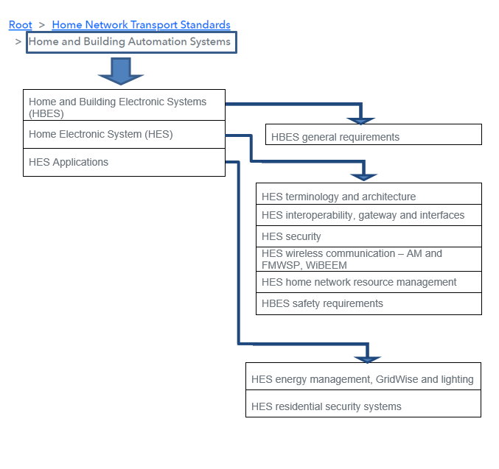

Topic “Home Network cabling” providing the standards related to home cabling

Topic “Environment and power supply of Home Network equipment” providing standards related to power supply of customer premises equipment
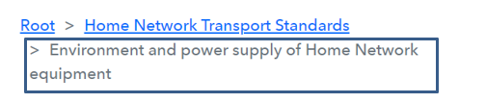

Topic “Safety and protection of Home Network equipment” providing standards related the safety aspects of customer premises equipment

Topics of “Operation and maintenance (OAM) of Home Network” providing standards related to management and testing of customer premises equipment
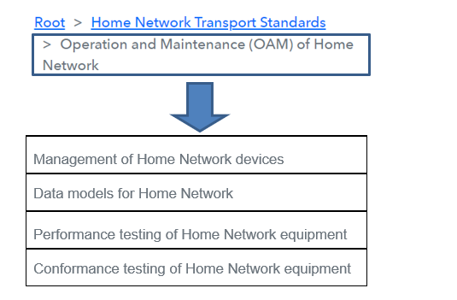

2. Home Network activities within ITU-T SG15

2.1 List of published Recommendations within ITU-T SG15
Question 3 of ITU-T SG15 – WP1/15 is responsible for the Home Network standardization activities.
Q3/15 addresses “Technologies for in-premises networking and related access applications”
(Note: Starting from the new ITU-T Study Period 2022-2024, Question 18 “Technologies for in-premises networking and related access applications” from the last Study Period has been renumbered to become Question 3 with the same title).
The technologies developed by Q3/15 are summarized below.
Wireline Home Network Transceivers
  - Narrowband PLC transceiver [ITU-T G.990x-series]
  - HomePNA transceiver [ITU-T G.995x-series]
  - G.hn transceiver [ITU-T G.996x-series]
Wireless Home Network Transceivers
  - Sub 1 GHz wireless / Z-wave transceiver [ITU-T G.9959]
  - Visible light transceivers [ITU-T G.9991 and G.9992]
Cable modems and home networking [ITU-T J.190 through J.192]
The topics of the web-based HNT Standards Overview containing Recommendations, Supplements and other documents (items) published by Question 3 of ITU-T SG15 are listed below.
Lists of Standards, Recommendations, Technical Specifications and other documents (items) can be generated from the web-based HNT Standards Overview as needed for each Topic or groups of Topics or for each responsible standardization Group (ITU Sector or ITU-T SGs or SDOs) indicated below and exported on an excel table.

TOPICS ITU Sectors and SDOs
- General on Home Network
> Home Network architecture and functions Broadband Forum, ETSI, IEC, IEEE 1905,
ITU-T SG15, SG16 and SG20
> Home Network security ISO/IEC, ITU-T SG15 and SG17
- Wireline home networking
> Over phoneline
> HomePNA transceivers ITU-T SG15
> Phoneline Enhanced HomePNA transceivers ITU-T SG15
> Phoneline G.hn unified transceivers ITU-T SG15
> Over powerline - Power Line Communications (PLC)
> Narrowband PLC transceivers IEEE 1901, ITU-T SG15
> Powerline G.hn unified transceivers ITU-T SG15
> Mitigation of interference ITU-T SG15
> Over coaxial cable
> Coax Enhanced HomePNA transceivers ITU-T SG15
> Coax G.hn unified transceivers ITU-T SG15
> Over Ethernet twisted-pair cable
> Catx G.hn unified transceivers ITU-T SG15
> Over plastic optical fibre (POF)
> POF G.hn unified transceivers ITU-T SG15
> Over glass optical fibre ETSI, ITU-T SG15

- Wireless home networking
> Optical wireless communications
> Sub 1 GHz Wireless LAN IEEE 802.11, ITU-T SG15
> Visible Light Communications / Li-Fi IEEE 802.15, ITU-T SG15, ITU-R
> Z-Wave Z-Wave Alliance, ITU-T SG15

- G.hn technology ITU-T SG15
- Home gateways Broadband Forum, IEC, ISO/IEC, ITU-T SG15, SG9 and SG16

- Home Network applications
> General on Smart Home Network ITU-T SG15, SG9 and SG20
> Cable-based video services and IPTV Broadband Forum, ETSI, ITU-T SG15, SG16 and SG9
> Internet connectivity
> Internet connectivity over wireline networking ETSI, IEEE 1901, IEEE 802.3, ITU-T SG15 and SG9, MoCA
> Internet connectivity over wireless networking IEEE 802.11, IEEE 802.15, ITU-T SG15, ITU-R
> In-home Access Points connectivity
> In-home Access Points connectivity over wireline networking ETSI, IEEE 1901, IEEE 802.3, ITU-T SG15 and SG9, MoCA
> Personal and close proximity connectivity Bluetooth, ETSI, IEEE 802.11, IEEE 802.15, ITU-T SG15, ITU-R
> IoT / Domotics applications
> IoT / Domotics over wireline networking IEEE 1901, IEEE 802.3, ITU-T SG15
> IoT / Domotics over wireless networking Bluetooth, Connectivity Standards Alliance, ETSI, IEEE 802.11, IEEE 802.15, ITU-T SG15 and SG20, ITU-R, Thread,
Z-Wave Alliance

- Smart Grid applications CENELEC, Connectivity Standards Alliance, ETSI, IEEE 1901,
ISO/IEC, ITU-T SG15, SG17 and SG20, ITU-R, Z-Wave Alliance

Question 5 and Question 7 of ITU-T SG15 – WP2/15 are responsible for the standardization of components for the optical physical infrastructure (e.g., fibre and cable, optical node) of the Home Network.
Q5/15 addresses “Characteristics and test methods of optical fibres and cables, and installation guidance” and Q7/15 the “Connectivity, operation and maintenance of optical physical infrastructures”.
The topics of the web-based HNT Standards Overview containing Recommendations, Supplements and other documents (items) published by Question 5 and Question 7 of ITU-T SG15 are listed below.
Lists of Standards, Recommendations, Technical Specifications and other documents (items) can be generated from the web-based HNT Standards Overview as needed for each Topic or groups of Topics and responsible Group (ITU Sector or ITU-T SGs or SDOs) below and exported on an excel table.

TOPICS ITU Sector and SDOs
- Home Network cabling CENELEC, ETSI, IEC, ISO/IEC, ITU-T SG15 and SG5
- Safety and protection of Home Network equipment IEC, ISO/IEC, ITU-T SG15 and SG5, ITU-R
- Operation and Maintenance (OAM) of Home Network
> Management of Home Network devices Broadband Forum, IEEE 802.3, ISO/IEC, ITU-T SG15

2.2. Ongoing standardization activities in the area of Home Network Transport within ITU-T SG15

Recommendations “Under Study” related to “Technologies for in-premises networking and related access applications” from Question 3 are listed here for convenience in Table 1.
Table 1 – Recommendations “Under Study” related to Home Network within ITU-T SG15 Question 3
The table of Q3/15 work items has been updated with the latest Q3/15 activities resulting from April 2023 SG15 WP1 plenary meeting
Work item | Question | Status | Timing | Approval process | Subject / Title | Base  Text | Editor(s)
G.9901 (2017) Amd 1 | Q3/15 | Approved | 2023-04 | TAP | Narrowband orthogonal frequency division multiplexing power line communication transceivers Power spectral density specification Amendment 1 |  | C餲ic LAVENU (Enedis)
G.9960 (2023) | Q3/15 | Consented | 2023-04 | AAP | Unified high-speed wireline-based home networking transceivers – System architecture and physical layer specification (2023) |  | Les Brown (Huawei)
G.9961 (2023) | Q3/15 | Consented | 2023-04 | AAP | Unified high-speed wire-line based home networking transceivers – Data link layer specification (2023) |  | Les Brown (Huawei)
G.9962 (2023) | Q3/15 | Approved | 2023-04 | AAP | Unified high-speed wire-line based home networking transceivers - Management Specification |  | Marcos Martinez (Maxlinear)
G.9962 (2023) Amd1 | Q3/15 | Under Study | 2024 | AAP | Unified high-speed wire-line based home networking transceivers - Management Specification (2023): Amendment 1 | TD134/WP1 | Marcos Martinez (Maxlinear)
G.9963 (2023) | Q3/15 | Consented | 2023-04 | AAP | Unified high-speed wireline-based home networking transceivers –  Multiple input/multiple output specification (2023) |  | Marcos Martinez (Maxlinear)
G.9964 (2023) | Q3/15 | Determined | 2023-04 | TAP | Unified high-speed wireline-based home networking transceivers – Power spectral density specification (2023) |  | Les Brown (Huawei)
G.fin-DLL | Q3/15 | Under study | 2024 | AAP | High speed fibre-based in-premises transceivers data link layer |  | Wu Jia (China Unicom), Xinrui Shi (China Telecom)
G.fin-NM | Q3/15 | Under study | 2024 | AAP | High speed fibre-based in-premises transceivers network management | TD156/WP1 | Qiang Cheng (CAICT), Yue Sun (China Unicom)
G.fin-PHY | Q3/15 | Under study | 2024 | AAP | High speed fibre-based in-premises transceivers physical layer | TD155/WP1 | Junwei Li (China Mobile), Xuming Wu (Huawei Technologies Co., Ltd)
G.9940 | Q3/15 | Consented | 2023-04 | AAP | High speed fibre-based in-premises transceivers - system architecture |  | Qiang Cheng, Xinrui Shi (China Telecom)
G.p2pf | Q3/15 | Under study | 2024 | AAP | Point-to-Point Fibre in the Premises |  | Ronald Heron (Nokia)
G.hetnet | Q3/15 | Under study | 2024 | AAP | Terminology & overview of the architecture of Heterogeneous Home Networks | TD135/WP1 | Marcos Martinez (Maxlinear), Tony Zeng (Huawei)
G.hn2 | Q3/15 | Under study | 2024 | AAP | Evolution of unified high-speed wire-line based home networking transceivers |  | Tony Zeng (Huawei)
G.IoT | Q3/15 | Under study | TBD | AAP | System architecture, PHY layer and DLL layer for IoT Smart Home over PLC | TD120/WP1 | Yue Sun (China Unicom), Yan Chen (HiSilicon)
G.uvs-xR | Q3/15 | Under study | 2024 | AAP | Technical requirements of extended reality service over in-premises networks | TD141/WP1 | Wu Jia (China Unicom)
SUP-FTTR-4H | Q3/15 | Under study | 2024 | Agreement | Use case and Requirements of Fibre-to-The-Room for Residential Applications (FTTR4H) | TD157/WP1 | Hai Ding, Qizheng Li
TP-UC-HN | Q3/15 | Under study | 2024 | Agreement | Technical paper on the use of ITU-T G.hn technology for in-home networking | TD138/WP1 | Marcos Martinez (Maxlinear)
TP-VLC | Q3/15 | Under study | 2024 | Agreement | Technical paper on the use of ITU-T Visible Light Communication technology | TD139/WP1 | Marcos Martinez (Maxlinear)
GSTP-HNSG | Q3/15 | Under study | 2024 | Agreement | GSTP-HNSG - Technical paper on the use of G.hn technology for smart grid |  | Xiao Ming Shi (Corinex); Cedric Lavenu (EDF)
G.Sup.Edge4Home | Q3/15 | Under Study | 2024 | Agreement | Enhanced on-premises networking with computing functions |  | Wu Jia (China Unicom); Mr. Haomian Zheng (Huawei)
Work item: Short name identifying a (draft or approved) Recommendation or other text. It may be a provisional name or the final publication designation (e.g. H.264)
Question: Number of the Question responsible for the development of a work item
Status: Current Approval state of a work item
Timing: Best current estimate of the expected year and month of Determination (TAP), Consent (AAP), or Agreement (non-normative materials) of a work item
Approval process: One of: Traditional Approval Process (TAP); Alternative Approval Process (AAP); or Agreement
Subject / Title: Best current expectation of the full name of a work item
Base text(s): Previous published version of a work item and/or its latest draft. It may also include reference to A.5 justification documentation.
Editor(s): Person(s) responsible for coordinating development of a work item
ITU-T Q3/15 Project FTTR (Fibre to the room)
Question 3 of ITU-T SG15 organised a first Joint ETSI ISG F5G (European Telecommunications Standards Institute – Industry Specification Group - Fifth Generation Fixed Network), BBF (Broadband Forum), CCSA TC6 (China Communications Standards Association – Technical Committee 6) and ITU-T SG15 Workshop on “FTTR” (Fibre to the room) on 14 June 2021.
For more information see workshop programme and presentations at
https://www.itu.int/en/ITU-T/Workshops-and-Seminars/2021/0614/Pages/default.aspx
Question 3/15 of ITU-T SG15 organised a second Joint ETSI ISG F5G, BBF, CCSA TC6 and ITU-T SG15 Workshop on “FTTR” (Fibre to the room) on 28 June 2022.
For more information see workshop programme and presentations at
https://www.itu.int/en/ITU-T/Workshops-and-Seminars/2022/0628/Pages/default.aspx.
Question 3/15 of ITU-T SG15 is planning a third Joint ETSI ISG F5G, BBF, CCSA TC6 and ITU-T SG15 Workshop on “FTTR” (Fibre to the room) in May-June 2023 timeframe, (date is under discussion).

Question 5 and Question 7 of ITU-T SG15 – WP2/15 are responsible for the standardization of components for the optical physical infrastructures (e.g., fibre and cable, optical node) of the Home Network.
Q5/15 addresses “Characteristics and test methods of optical fibres and cables, and installation guidance” and Q7/15 the “Connectivity, operation and maintenance of optical physical infrastructures”.

The list of Q5/15 and Q7/15 work items related to Home Network infrastructures (e.g., fibre and cable, optical node) has been updated with the latest Q5/15 and Q7/15 activities resulting from ITU-T SG15 - WP2 April 2023 plenary meeting.
Q5/15
- Revision of G.650.1: Definitions and test methods for linear, deterministic attributes of single-mode fibre and cable
- Revision of G.657: Characteristics of a bending-loss insensitive single-mode optical fibre and cable
- Amendment 1 of L.100: Optical fibre cables for duct and tunnel application
- Revision of L.109: Construction of optical/metallic hybrid cable
Q7/15:
- Revision of L.250: Optical access network topologies for broadband services
- Revision of L.340: Maintenance of cable tunnels
- Revision of L.312: Optical fibre cable maintenance support, monitoring and testing system for optical fibre cable networks carrying high total optical power
- Questionnaire on optical infrastructure sharing
- New work item under study on pre-connectorized cabling components for FTTx infrastructures
- Revision of LSTP-GSLR - Guide on the use of ITU-T L-series Recommendations related to optical technologies for outside plant
Work Programme of ITU-T SG15 can be found at https://www.itu.int/ITU-T/workprog/wp_search.aspx?sg=15
More information about ITU-T SG15 can be found at https://www.itu.int/en/ITU-T/studygroups/2022-2024/15/Pages/default.aspx

3. Home Network activities in other ITU Study Groups
This section provides an overview of the existing Home Network related activities within other ITU Study Groups.
Table 2 below gives an updated overview of such activities.
3.1 Home Network related activities in other ITU-T Study Groups
Table 2 – Home Network related activities in other ITU-T Study Groups
ITU-T SGs | SGs activities related to Home Network and other information
ITU-T SG5 | ITU-T SG5: Electromagnetic fields (EMF), environment, climate action, sustainable digitalization, and circular economy  WP1/5 - EMC, lightning protection, EMF  WP2/5 - Environmental efficiency, e-waste, circularity and sustainable ICT networks  The topics of the web-based HNT Standards Overview containing Recommendations, Supplements and other documents (items) published by ITU-T SG5 are listed below.  - Home Network cabling CENELEC, ETSI, IEC, ISO/IEC, ITU-T SG5  and SG15  - Environment and power supply of Home Network equipment ETSI, ITU-T SG5 and SG9  - Safety and protection of Home Network equipment IEC, ISO/IEC, ITU-T SG5 and SG15, ITU-R  ITU-T SG5 work programme update related to Home Network  SG15 TD 87 WP1 April 2023  ITU-T SG5 informs ITU-T SG15 that with respect to the information sent on 2020, under Q2/5, a relatively new development is the expansion of automotive single twisted-pair Ethernet (SPE) into domestic and industrial environments.  Single twisted pair power over Ethernet (SPoE) is currently standardized by the IEEE 802.3 to supply up to 50 W to network powered devices (NPD) such as video cameras with pan and tilt. Industrially there is an SPE variant with a design reach of 1 km.  To keep members updated on SPE, an informative document ITU-T K Suppl. 25 (05/2021) - Long reach single twisted-pair Ethernet resistibility testing has been published – see in web-based HNT Standards Overview – Topic “Safety and protection of Home Network equipment”.  ITU-T SG5 is monitoring this SPE evolution for stability before revising any Recommendations or creating new Recommendations.  Regarding the SG5 work items covering environmental aspects, SG5 provided an updated list of their Recommendations related to the Topic “Environment and power supply of Home Network equipment”. The web-based HNT Standards Overview has been updated with the SG5 listed work items – published and under study.  The SG5 work items under study are:  - Revision of ITU-T L.1410: Methodology for environmental life cycle assessments of information and communication technology goods, networks and services  - ITU-T L.GDSPP: Requirements for a global digital sustainable product passport to achieve a circular economy  - ITU-T L.GPSIM: Good practices for the sanitization of the information media in end-of-life ICT devices  - Revision of ITU-T L.1023: Assessment method for circular scoring  Work programme of ITU-T SG5 can be found at following URL  https://www.itu.int/ITU-T/workprog/wp_search.aspx?sg=5  More information about ITU-T SG5 can be found at following URL  https://www.itu.int/en/ITU-T/studygroups/2022-2024/05/Pages/default.aspx
ITU-T SG9 | ITU-T SG9: Audiovisual content transmission and integrated broadband cable networks  WP1/9 - Cable transport and terminals, including video and data  The topics of the web-based HNT Standards Overview containing Recommendations, Supplements and other documents (items) published by ITU-T SG9 are listed below.  - Wireline home networking  > Over coaxial cable  > HiNoC – High performance network over Coax ITU-T SG9  - Home gateways Broadband Forum, IEC, ISO/IEC, ITU-T SG9, SG15  and SG16  - Home Network applications  > General on Smart Home Network ITU-T SG9, SG15 and SG20  > Cable-based video services and IPTV Broadband Forum, ETSI, ITU-T SG9, SG15 and SG16  > Internet connectivity  > Internet connectivity over wireline networking ETSI, IEEE 1901, IEEE 802.3, ITU-T SG9 and SG15,  MoCA  > In-home Access Points connectivity  > In-home Access Points connectivity over wireline  networking ETSI, IEEE 1901, IEEE 802.3, ITU-T SG9 and SG15,  MoCA  - Environment and power supply of Home Network equipment ETSI, ITU-T SG9 and SG5  ITU-T SG9 work programme update related to Home Network  SG15 TD 86 WP1 April 2023  ITU-T SG9 informs ITU-T SG15 that during its meeting held on 6-14 September 2022, SG9 initiated two new work items ITU-T J.HiNoC3-PHY “Physical layer specification for third-generation HiNoC” and ITU-T J.HiNoC3-MAC “MAC layer specification for third-generation HiNoC”.  Work programme of ITU-T SG9 can be found at following URL  https://www.itu.int/ITU-T/workprog/wp_search.aspx?sg=9  More information about ITU-T SG9 can be found at following URL  https://www.itu.int/en/ITU-T/studygroups/2022-2024/09/Pages/default.aspx
ITU-T SG11 | ITU-T SG11: Signalling requirements, protocols, test specifications and combating counterfeit telecommunication/ICT devices  Work Programme of ITU-T SG11 can be found at following URL  https://www.itu.int/ITU-T/workprog/wp_search.aspx?sg=11  More information about ITU-T SG11 can be found at following URL  https://www.itu.int/en/ITU-T/studygroups/2022-2024/11/Pages/default.aspx
ITU-T SG13 | ITU-T SG13: Future networks and emerging network technologies  WP3/13 - Network Evolution, Trust and Quantum Enhanced Networking  Work Programme of ITU-T SG11 can be found at following URL  https://www.itu.int/ITU-T/workprog/wp_search.aspx?sg=13  More information about ITU-T SG13 can be found at following URL  https://www.itu.int/en/ITU-T/studygroups/2022-2024/13/Pages/default.aspx
ITU-T SG16 | ITU-T SG16: Multimedia and related digital technologies​  WP1/16 - Multimedia content delivery  The topics of the web-based HNT Standards Overview containing Recommendations, Supplements and other documents (items) published by ITU-T SG16 are listed below.  - General on Home Network  > Home Network architecture and functions Broadband Forum, ETSI, IEC, IEEE 1905, ITU-T SG16,  SG15 and SG20  - Home gateways Broadband Forum, IEC, ISO/IEC, ITU-T SG16, SG15  and SG9  - Home Network applications  > Cable-based video services and IPTV Broadband Forum, ETSI, ITU-T SG16, SG15 and SG9  SG15 TD 642 WP1 December 2021  ITU-T SG16 informs ITU-T SG15 on its ongoing work and recommends to await the finalization of two recent draft recommendations related to HNT:  - H.IPTV-TDES.6 "IPTV Terminal Device: Virtualized model"  - H.IPTV-TDES.7 "IPTV Terminal Device: Home gateway integrated model"  Work programme of ITU-T SG16 can be found at following URL  https://www.itu.int/ITU-T/workprog/wp_search.aspx?sg=16  More information about ITU-T SG16 can be found at following URL  https://www.itu.int/en/ITU-T/studygroups/2022-2024/16/Pages/default.aspx
ITU-T SG17 | ITU-T SG17: Security  WP2/17 - 5G, IoT and ITS security  The topics of the web-based HNT Standards Overview containing Recommendations, Supplements and other documents (items) published by ITU-T SG17 are listed below.  - General on Home Network  > Home Network security ISO/IEC, ITU-T SG17 and SG15  Work programme of ITU-T SG17 can be found at following URL  https://www.itu.int/ITU-T/workprog/wp_search.aspx?sg=17  More information about ITU-T SG17 can be found at following URL  https://www.itu.int/en/ITU-T/studygroups/2022-2024/17/Pages/default.aspx
ITU-T SG20 | ITU-T SG20: Internet of things (IoT) and smart cities and communities (SC&C)  WP1/20 - Interoperability, Applications and Digital Services  The topics of the web-based HNT Standards Overview containing Recommendations, Supplements and other documents (items) published by ITU-T SG17 are listed below.  - General on Home Network  > Home Network architecture and functions Broadband Forum, ETSI, IEC, IEEE 1905,  ITU-T SG20, SG15 and SG16  - Home Network applications  > General on Smart Home Network ITU-T SG20, SG15 and SG9  Work programme of ITU-T SG20 can be found at following URL  https://www.itu.int/ITU-T/workprog/wp_search.aspx?sg=20  More information about SG20 can be found at following URL  https://www.itu.int/en/ITU-T/studygroups/2022-2024/20/Pages/default.aspx

3.2 Home Network related activities in the ITU-R and ITU-D Sectors

Table 3 – Home Network related activities in ITU-R and ITU-D
ITU-R SGs | SGs activities related to Home Network and other information
ITU-R  ITU-R SG1 | ITU-R overall activities related to Home Network  The topics of the web-based HNT Standards Overview containing Recommendations, Supplements and other documents (items) published by ITU-R Sector are listed below.  - Wireless home networking  > General on WLAN and WPAN wireless network ETSI, ITU-R  > ETSI DECT (Digital Enhanced Cordless Telecommunications)  > Classic DECT ETSI, ITU-R  > Optical Wireless Communications  >Visible Light Communication / Li-Fi IEEE 802.15, ITU-T SG15, ITU-R  - Home Network applications  > Internet connectivity  > Internet connectivity over wireless networking IEEE 802.11, IEEE 802.15, ITU-T SG15, ITU-R  > Personal and close proximity connectivity Bluetooth, ETSI, IEEE 802.11, IEEE 802.15,  ITU-T SG15, ITU-R  > IoT / Domotics applications  > IoT / Domotics over wireless networking Bluetooth, Connectivity Standards Alliance, ETSI,  IEEE 802.11, IEEE 802.15, ITU-T SG15 and SG20,  ITU-R, Thread, Z-Wave Alliance  - Smart Grid applications CENELEC, Connectivity Standards Alliance, ETSI, IEEE 1901,  ISO/IEC, ITU-T SG15, SG17 and SG20, ITU-R, Z-Wave Alliance  - Safety and protection of Home Network equipment IEC, ISO/IEC, ITU-T SG15 and SG5, ITU-R  ITU-R SG1: Spectrum Management  WP1A - Spectrum engineering techniques  More information about ITU-R WP1A can be found at following URL  https://www.itu.int/en/ITU-R/study-groups/rsg1/rwp1a/Pages/default.aspx  More information about ITU-R SG1 can be found at following URL  https://www.itu.int/en/ITU-R/study-groups/rsg1/Pages/default.aspx
ITU-R SG5 | ITU-R SG5: Terrestrial Services  WP5A - Land mobile service above 30 MHz (excluding IMT); wireless access in the fixed service; amateur and amateur-satellite services  - Guide to the use of ITU-R texts relating to the land mobile service, including wireless access in the fixe service (last update: 8 March 2023: see at https://www.itu.int/oth/R0A06000001/en  Radio Local Area Networks (RLANs) and Multiple Gigabit Wireless Systems (MGWS)  WP 5A conducts work on radio local area networks (RLANs) and Multiple Gigabit Wireless Systems (MGWS) under Question ITU-R 212-4/5 (Nomadic wireless access systems including radio local area networks).  LANs/MGWS could be used to implement a home network. For a description of this work refer to:  - section 8.2 “Nomadic Wireless Access” of the Guide to the use of ITU-R texts relating to the land mobile service, including wireless access in the fixed service, and in particular Recommendation ITU-R M.1450-5, which recommends characteristics of broadband radio local area networks,  - section 8.4 “Multiple Gigabit Wireless Systems” of the Guide to the use of ITU-R texts relating to the land mobile service, including wireless access in the fixed service, and in particular Recommendation ITU-R M.2003-2, which provides general characteristics and radio interface standards for MGWS in frequencies around 60 GHz and Report ITU-R M.2227-2 which describes applications, deployment scenarios and technical characteristics of MGWS.  - section 11: Cordless Telecommunication Systems of the Guide, and in particular Recommendation ITU-R M.1033-1 and Report ITU-R M.1025-1 which provides technical and operational characteristics of cordless telephones and cordless telecommunication systems.  More information about ITU-R WP5A can be found at following URL  https://www.itu.int/en/ITU-R/study-groups/rsg5/rwp5a/Pages/default.aspx  More information about ITU-R SG5 can be found at following URL  https://www.itu.int/en/ITU-R/study-groups/rsg5/Pages/default.aspx
ITU-R SG6  continuation of ITU-R SG6 | ITU-R SG6: Broadcasting Service  SG15 TD 12 GEN September 2022  ITU-R SG6 informs ITU-T SG15 that it has established a Rapporteur Group - Future of Broadcasting (RG-FOB) at its November 2021 meeting to develop draft new ITU-R texts giving a Vision for the Future of Broadcasting.  The RG-FOB members agreed to work on following topics:  Section 1 – Introduction  Section 2 – User Experience  Section 3 – Production Experience  Section 4 – Delivery Experience  Section 5 – Accessible Experience  Section 6 – Sustainable Experience  Publication of the final text is targeted in Q2 2023.  WP6A - Terrestrial broadcasting delivery  SG15 TD 547 WP1 April 2021  In its liaison in TD 547 WP1 from April 2021, ITU-R WP6A Rapporteur on “Power Line Telecommunications (PLT) and General EMC-Related Potential Interference Issues” reports that it has analysed the work plan of ITU-T SG15 Question 3 (ex Question 18) (Table 3 in the “Home Network Transport Standards Overview and Work Plan- Issue 11, September 2020”) and provides a compilation of its work in the document “Update on recent EMC related issues” attached below.  ITU-R WP6A Rapporteur notes that no issues have been identified that would need an immediate response on possible concerns, but issues with PLT (in Q18 projects G.9904.1, G.Iot and G.uvs) have been identified where further monitoring, supported by studies by the broadcasting community, is essential.  More information about ITU-R WP6A can be found at following URL  https://www.itu.int/en/ITU-R/study-groups/rsg6/rwp6a/Pages/default.aspx  WP6B - Broadcast service assembly and access  More information about ITU-R WP6B can be found at following URL  https://www.itu.int/en/ITU-R/study-groups/rsg6/rwp6b/Pages/default.aspx  More information about ITU-R SG6 can be found at following URL  https://www.itu.int/en/ITU-R/study-groups/rsg6/Pages/default.aspx
ITU-D SG1 | ITU-D SG1: Enabling environment for meaningful connectivity  Question 1/1: Strategies and policies for the deployment of broadband in developing countries  Question 5/1: Telecommunications/ICTs for rural and remote areas  SG15 TD 91 WP1 April 2023  ITU-D Q1/1 thanks ITU-T SG15 for the LS on the new versions of the HNT Standards overview and work plan and provides the link 1/REP/1 to its report of meeting 29 November 2022.  The date of next ITU-D Q1/1 meeting is 8-19 May 2023.  More information on the ITU-D Sector can be found at following URL  https://www.itu.int/en/ITU-D/Pages/default.aspx  More information about ITU-D SG1 can be found at following URL  https://www.itu.int/en/ITU-D/Pages/New-ITU-D-Study-Group-Questions.aspx

4. Home Network activities in other Standards Development Organizations
This following list is intended to improve understanding and communication of the on-going work related to Home Network in other Standardization Developing Organizations and may help identify possible gaps or overlaps.
Table 4 below gives an updated overview of such activities
Table 4 – Home Network related activities in other Standards Development Organizations
SDOs | SDOs activities related to Home Network and other information
Broadband Forum  continuation of Broadband Forum | Broadband Forum  https://www.broadband-forum.org  SG15 TD 90 WP1 April 2023  Broadband Forum informs ITU-T SG15 that it has currently no feedback to convey concerning the HNT Standards overview and work plan.  Broadband Forum refers ITU-T SG15 to its published specification work on the Broadband Forum website and its specification work in progress on the Broadband Forum Work in Progress Wiki which will provide more detailed information on Broadband Forum work.  Information about Broadband Forum Projects “Connected Home” can be found at following URL  https://www.broadband-forum.org/projects/connected-home  Broadband Forum Test Plans related to HNT can be found at following URL  https://www.broadband-forum.org/test-plans  Broadband Forum Work in Progress related to HNT can be found at following URL  https://www.broadband-forum.org/broadband-forum-resources/work-in-progress  The topics of the web-based HNT Standards Overview containing Technical Reports and Test Plans (items) published by Broadband Forum are listed below.  - General on Home Network  > Home Network architecture and functions Broadband Forum, ETSI, IEC, IEEE 1905,  ITU-T SG15, SG16 and SG20  - Home gateways Broadband Forum, IEC, ISO/IEC, ITU-T SG15, SG9  and SG16  - Home Network applications  > Cable-based video services and IPTV Broadband Forum, ETSI, ITU-T SG15, SG16 and SG9  - Operation and Maintenance (OAM) of Home Network  > Management of Home Network devices Broadband Forum, IEEE 802.3, ISO/IEC, ITU-T SG15  > Data models for Home Network Broadband Forum, IEEE 802.3  > Performance testing of Home Network equipment Broadband Forum  > Conformance testing of Home Network equipment Broadband Forum, HomeGrid Forum, TTC
Bluetooth SIG | Bluetooth® Technology  https://www.bluetooth.com/  The topics of the web-based HNT Standards Overview containing Technical Specifications (items) published by Bluetooth Special Interest Group (SIG) are listed below.  - Wireless home networking  > Bluetooth technology Bluetooth  - Home Network applications  > Personal and close proximity connectivity Bluetooth, ETSI, IEEE 802.11, IEEE 802.15,  ITU-T SG15, ITU-R  > IoT / Domotics applications  > IoT / Domotics over wireless networking Bluetooth, Connectivity Standards Alliance, ETSI,  IEEE 802.11, IEEE 802.15, ITU-T SG15 and SG20,  ITU-R, Thread, Z-Wave Alliance  Bluetooth® Classic  Bluetooth® Low Energy (LE)  More information on Bluetooth technology can be found au following URL  https://www.bluetooth.com/learn-about-bluetooth/tech-overview/  Information on Bluetooth Specifications can be found at following URL  https://www.bluetooth.com/specifications/specs/  Bluetooth is a IEEE 802.15.1 based wireless system.  More information about Bluetooth specifications in development can be found at following URL  https://www.bluetooth.com/specifications/in-development/
ETSI  continuation of  ETSI | ETSI  https://www.etsi.org/  The topics of the web-based HNT Standards Overview containing Standards, Technical Specifications and other documents (items) published by ETSI are listed below.  - General on Home Network  > Home Network architecture and functions Broadband Forum, ETSI, IEC, IEEE 1905,  ITU-T SG15, SG16 and SG20  - Wireline home networking  > Over plastic optical fibre (POF)  > ETSI POF based home networking ETSI  > Over glass optical fibre ETSI, ITU-T SG15  - Wireless home networking  > General on WLAN and WPAN wireless network ETSI, ITU-R  > ETSI HIPERLAN Type 2 ETSI  > ETSI DECT (Digital Enhanced Cordless Telecommunications)  > Classic DECT ETSI, ITU-R  > DECT Ultra Energy (ULE) ETSI  > DECT-2020 New Radio (NR) ETSI  - Home Network applications  > Cable-based video services and IPTV Broadband Forum, ETSI, ITU-T SG15, SG16 and SG9  > Internet connectivity  > Internet connectivity over wireline networking ETSI, IEEE 1901, IEEE 802.3, ITU-T SG15 and SG9,  MoCA  > In-home Access Points connectivity  > In-home Access Points connectivity over wireline networking ETSI, IEEE 1901, IEEE 802.3, ITU-T SG15  and SG9, MoCA  > Personal and close proximity connectivity Bluetooth, ETSI, IEEE 802.11, IEEE 802.15,  ITU-T SG15, ITU-R  > IoT / Domotics applications  > IoT / Domotics over wireless networking Bluetooth, Connectivity Standards Alliance,  ETSI, IEEE 802.11, IEEE 802.15, ITU-T SG15  and SG20, ITU-R, Thread, Z-Wave Alliance  - Smart Grid applications CENELEC, Connectivity Standards Alliance, ETSI, IEEE 1901, ISO/IEC,  ITU-T SG15, SG17 and SG20, ITU-R, Z-Wave Alliance  - Home Network cabling CENELEC, ETSI, IEC, ISO/IEC, ITU-T SG15 and SG5  - Environment and power supply of Home Network equipment ETSI, ITU-T SG9 and SG5
ETSI TC ATTM | ETSI TC ATTM “Access, Terminals, Transmission and Multiplexing”  https://www.etsi.org/committee/1390-attm  More information about ETSI ATTM can be found at following URL  https://portal.etsi.org/TB-SiteMap/ATTM/ATTM-ToR  Work Programme of ETSI ATTM can be found at following URL  https://portal.etsi.org/tb.aspx?tbid=689&SubTB=689,693,851,706,694,695#/
ETSI TC  BRAN | ETSI TC BRAN “Broadband Radio Access Networks”  https://www.etsi.org/committee/1389-bran  More information about ETSI BRAN can be found at following URL  https://portal.etsi.org/TB-SiteMap/bran/bran-tor  Work Programme of ETSI BRAN can be found at following URL  https://portal.etsi.org/tb.aspx?tbid=287&SubTB=287#/
ETSI TC  DECT | ETSI TC DECT “Digital Enhanced Cordless Telecommunications”  https://www.etsi.org/committee/1394-dect  ETSI Classic DECT  ETSI DECT Ultra Low Energy (ULE)  ETSI DECT-2020 New Radio (NR)  DECT-2020 NR is a Radio Interface Technology (RIT) designed to provide a slim but powerful technology foundation for wireless applications deployed in various use cases and markets. This radio technology includes, but is not limited to Cordless Telephony, Audio Streaming Applications, Professional Audio Applications, consumer and industrial applications of Internet of Things (IoT) such as industry and building automation and monitoring, and in general solutions for local area deployments for Ultra-Reliable Low Latency Communication (URLLC) and massive Machine Type Communication (mMTC) as envisioned by ITU-R for IMT2020.  The roadmap of DECT can be seen in Technical Report TR 103 513 V1.1.1 (2019-11): Digital Enhanced Cordless Telecommunications (DECT); DECT Technology Roadmap  More information about ETSI DECT can be found at following URLs  https://portal.etsi.org/TB-SiteMap/dect/dect-tor and https://www.etsi.org/technologies/dect  Work Programme of ETSI DECT can be found at following URL  https://portal.etsi.org/tb.aspx?tbid=19&SubTB=19,894#/
ETSI TC  EE | ETSI TC EE “Environmental Engineering”  https://www.etsi.org/committee/1395-ee  More information about ETSI EE can be found at following URL  https://portal.etsi.org/TB-SiteMap/ee/ee-tor  Work Programme of ETSI EE can be found at following URL  https://portal.etsi.org/tb.aspx?tbid=28&SubTB=28,29,30,635,853#/
ETSI ISG F5G  continuation of  ETSI ISG F5G | ETSI ISG - Fifth Generation Fixed Network (F5G)  https://www.etsi.org/committee/1696-f5g  SG15 TD 137 GEN April 2023  Extract from Liaison Report from ETSI ISG F5G Liaison Rapporteur of ITU-T SG15 and ETSI ISG F5G Liaison Officer  F5G group published three white papers:  - F5G Vision: Fibre to everywhere and everything (https://www.etsi.org/images/files/ETSIWhitePapers/etsi_wp_41_FSG_ed1.pdf)  - Global Fibre Deployment Index (https://www.etsi.org/images/files/ETSIWhitePapers/WP_47_GFDI.pdf)  - Fixed 5th Generation Advanced and Beyond  (https://www.etsi.org/images/files/ETSIWhitePapers/ETSI-WP-50-F5G-Advanced-and-Beyond.pdf)  Use cases of F5G and F5G Advanced  The use cases as described in ETSI GR F5G 008 document are driving the three dimensions of characteristics (i.e. eFBB, FFC and GRE) of F5G. Depending on the use case, one or more dimensions are particularly important. All dimensions of the F5G system architecture are implemented by the use cases.  There are total 32 use cases defined, leveraging the fibre optical network to benefit multiple segments including residential applications, business applications, network internal topics such as network optimizations plus the use of F5G for mobile xHaul, and finally vertical industries oriented use cases. The use cases are shown in Figure 5. ETSI GR F5G 002 initially defined the use case 1-16 while use cases 17-32 are newly added and the previous use cases are updated in ETSI GR F5G 008.  ETSI GR F5G 020 currently is initiated and under development, collecting new use cases for F5G Advanced. F5G Advanced is assumed to rely on various ITU-T SG15 technologies of the different Questions. Therefore, the topic how those technologies could be used is of interested to different questions of SG15.  To implement the use case in Release 2, F5G expect that the ITU-T SG15 group could help develop new technologies or technology features. For example, to adapt to new fibre infrastructure and in-premises scenarios. In general, the use cases are looked at from an end-to-end perspective and might have aspects for various ITU SG15 questions for consideration, however, a few considerations are given here:  - Q3 may consider: 1. define low optical link budget for home networking and small building; 2. specify a high priority channel for signalling in fibre networks; 3. define a mechanism to recognize network signalling and protocols, etc.  - Q11 may consider: 1. specify finer granularity OTN; 2. define OTN container with flexible granularity; 3. Optimize OTN to support mixed traffic of ODUs and OSUs, 4. Support for cloudification and multiple cloud access, etc.  - Q2 may consider: 1. supporting TSN features on PON system; 2. Increase in PON throughput via new technologies such as high-order modulation and wavelength-division multiplexing; 3. Improved DBA to support low-latency upstream transmission with latency below 100 µs.  - Q6 may consider: 1. Digitalization of cabling and fibre monitoring  - Q14 may consider: 1. Optimization of fibre network operation through telemetry, 2. Customer interactions and 3. Automation  Work Programme of ETSI F5G can be found at following URL  https://portal.etsi.org/tb.aspx?tbid=885&SubTB=885#/  More information about ETSI ISG F5G can be found at following URL  https://portal.etsi.org/Portals/0/TBpages/F5G/ISG_F5G_ToR_D-G_APPROVED_20191210.pdf  ​​
HomeGrid Forum | HomeGrid Forum  http://www.homegridforum.org/  HomeGrid Forum (HGF) is an industry alliance formed to support the development and deployment of a unified coaxial, phoneline, powerline, and plastic optical fiber home networking technology called G.hn (Gigabit Home Networking).  HomeGrid Forum G.hn Certification Testing  More information about G.hn Certification can be found at following URL  https://homegridforum.org/certification-overview/  SG15 TD 650 WP1 December 2021  In its liaison TD 650 WP1 from December 2021, HomeGrid Forum informs about the recent developments on the GiGAWire VB™ technology for broadband access applications, based on ITU-T G.hn family of Recommendations and provides details on the G.hn Access standardization profiles addressing broadband access network topologies, as well as the acceleration of the deployments with the GiGAWire VB™ open-source code program.  Additional information about GiGaWire can be found at following URL  https://homegridforum.org/giga-wire-access/  The topics of the web-based HNT Standards Overview containing documents (items) published by HomeGrid Forum are listed below.  - Operation and Maintenance (OAM) of Home Network  > Conformance testing of Home Network equipment Broadband Forum, HomeGrid Forum, TTC
CENELEC | CENELEC  https://www.cencenelec.eu/  The topics of the web-based HNT Standards Overview containing Standards and other documents (items) published by CENELEC are listed below.  - Smart Grid applications CENELEC, Connectivity Standards Alliance, ETSI, IEEE 1901, ISO/IEC,  ITU-T SG15, SG17 and SG20, ITU-R, Z-Wave Alliance  - Home and Building Automation Systems  > Home and Building Electronic Systems  > HBES general requirement CENELEC  - Home Network cabling CENELEC, ETSI, IEC, ISO/IEC, ITU-T SG15 and SG5
CENELEC  TC 86BXA | CENELEC TC 86BXA: Fibre optic interconnect, passive and connectorised components  General information, structure, work programme and published Standards can be found at following URL  https://standards.cencenelec.eu/dyn/www/f?p=305:7:0:25:::FSP_ORG_ID,FSP_LANG_ID:1258371  Business Plan of TC 86BXA: see https://standards.cencenelec.eu/BPCLC/BP_TC_86BXA.pdf
CENELEC  TC 205 | CENELEC TC 205: Home and Building Electronic Systems (HBES)  General information, structure, work programme and published Standards can be found at following URL  https://standards.cencenelec.eu/dyn/www/f?p=305:7:0:25:::FSP_ORG_ID,FSP_LANG_ID:1258281  Business Plan of TC 205: see https://standards.cencenelec.eu/BPCLC/BP_TC_205.pdf
CENELEC  TC 215 | CENELEC TC 215: Electrotechnical aspects of telecommunication equipment  General information, structure, work programme and published Standards can be found at following URL  https://standards.cencenelec.eu/dyn/www/f?p=305:7:0:25:::FSP_ORG_ID,FSP_LANG_ID:1258297  Business Plan of TC 215: see https://standards.cencenelec.eu/BPCLC/BP_TC_215.pdf
IEC  CISPR | International special committee on radio interference - EMC requirements  https://www.iec.ch/emc/iec_emc/iec_emc_players_cispr.htm
IEC | IEC  https://iec.ch/homepage  The topics of the web-based HNT Standards Overview containing Standards, Technical Reports and other documents (items) published by IEC are listed below.  - General on Home Network  > Home Network architecture and functions Broadband Forum, ETSI, IEC, IEEE 1905,  ITU-T SG15, SG16 and SG20  - Home gateways Broadband Forum, IEC, ISO/IEC, ITU-T SG15, SG16 and SG9  - Home Network cabling CENELEC, ETSI, IEC, ISO/IEC, ITU-T SG15 and SG5  - Safety and protection of Home Network equipment IEC, ISO/IEC, ITU-T SG5 and SG15, ITU-R
IEC  TC 46/SC 46C | IEC TC 46/SC 46C: Wires and symmetric cables  Scope, structure, projects and publications can be found at following URL  https://www.iec.ch/dyn/www/f?p=103:7:::::FSP_ORG_ID:1366
IEC TC 76 | IEC TC 76: Optical radiation safety and laser equipment  Scope, structure, projects and publications can be found at following URL  https://www.iec.ch/dyn/www/f?p=103:7:::::FSP_ORG_ID:1264
IEC  TC 86/SC 86A | IEC TC 86/SC 86A: Fibres and cables  Scope, structure, projects and publications can be found at following URL  https://www.iec.ch/dyn/www/f?p=103:7:::::FSP_ORG_ID:1398  SG15 TD 140 GEN April 2023  Following documents from IEC SC86A WG1 (Fibres) that are relevant to the HNT are in ballot process (or in preparation for ballot) (CD, CDV, or FDIS) since the last ITU-T SG15 September 2022:  - Revision of IEC 60793-2-50, Optical fibres – Part 2-50: Product specifications – Sectional specification for class B single-mode fibres  - Comments received on CD were resolved. Main change is the inclusion of 200-micron outer coating diameter category of B-654 fibres. CDV to be circulated.  Following documents from IEC SC86A WG3 (Cables) that are relevant to the HNT are in ballot (or in preparation for ballot) since the last ITU-T SG15 September 2022 meeting:  - IEC 60794-1-1 ED5: Optical fibre cables - Part 1-1: Generic specification – General (FDIS)
IEC  TC 100/TA 18 | IEC TC 100/TA 18: Multimedia home systems and applications for end-user networks  Scope, structure, projects and publications can be found at following URL  https://www.iec.ch/dyn/www/f?p=103:7:::::FSP_ORG_ID:22351
IEEE 802.3  continuation of  IEEE 802.3  continuation of  IEEE 802.3 | IEEE 802.3 Ethernet Working Group  https://www.ieee802.org/3/  The topics of the web-based HNT Standards Overview containing Standards (items) published by IEEE 802.3 Ethernet Working Group are listed below.  - Wireline home networking  > Over Ethernet twisted-pair cable  > IEEE 802.3 transceivers over Catx cable IEEE 802.3  > Over plastic optical fibre (POF)  > IEEE 802.3 transceivers over POF IEEE 802.3  - Home Network applications  > Internet connectivity  > Internet connectivity over wireline networking ETSI, IEEE 1901, IEEE 802.3, ITU-T SG15 and SG9,  MoCA  > In-home Access Points connectivity  > In-home Access Points connectivity over  wireline networking ETSI, IEEE 1901, IEEE 802.3, ITU-T SG15 and SG9,  MoCA  > IoT / Domotics applications  > IoT / Domotics over wireline networking IEEE 1901, IEEE 802.3, ITU-T SG15  - Operation and Maintenance (OAM) of Home Network  > Management of Home Network devices Broadband Forum, IEEE 802.3, ISO/IEC, ITU-T SG15  > Data models for Home Network Broadband Forum, IEEE 802.3  The current revision is IEEE Std 802.3-2022, Standard for Ethernet: https://standards.ieee.org/ieee/802.3/10422/  SG15 TD 150 WP1 April 2023  IEEE 802.3 Working Group communicates following update:  The following provides an update on the current status of HNT related documents and work within the IEEE 802.3 working group (HNT Standards Overview and Work Plan, Section 6/IEEE/IEEE802.3):  IEEE Std 802.3-2022, Standard for Ethernet is the current revision. This revision has seven approved amendments: IEEE Std 802.3dd-2022, IEEE Std 802.3cs-2022, IEEE Std 802.3db-2022, IEEE Std 802.3ck-2022, IEEE Std 802.3de-2022, IEEE Std 802.3cx-2023, and  IEEE Std 802.3cz-2023 (the last two expected to be published in 2023).  The following are example HNT applicable technologies in IEEE Std 802.3-2022 (including its amendments):  - The 10BASE-T, 100BASE-TX and 1000BASE-T specifications for operation over various grades of twisted pair cabling have long been used as a home networking technology, and they continue to be applicable.  - Home gateways typically include both IEEE Std 802.11 specified capabilities and either 10/100 Mb/s or 10/100/1000 Mb/s Ethernet ports.  - 2.5GBASE-T, 5GBASE-T and 10GBASE-T provide a migration path for higher bandwidth home networks.  - 1000BASE-RHA is a plastic optical fiber port type targeted for home networks.  - Fiber optic Ethernet port types would be applicable to HNT especially in cases where a non-conductive medium is required. It is appropriate to note that BASE-T port types are not specified for outdoor cable installations.  - For access to the home, the approved standard includes various speeds of operation for Ethernet Passive Optical Networks.  - The standard also includes DTE Power via the MDI (also called Power over Ethernet) capabilities applicable to HNT (e.g., to provide power to security equipment). These specifications include multiple options for BASE-T cabling also providing options for amount of power provided to the Powered Device.  Other optional Ethernet capabilities have relevance to HNT including:  - Time Sensitive Networking related functions appropriate to support applications running over HNT, and Energy-Efficient Ethernet specifications for many port types to reduce energy consumption. The IEEE Std 802.3cx-2023 Improved PTP Timestamping Accuracy approved draft is expected to be published in 2023. This amendment improves the precision of delay and jitter measurements, for data carried over Ethernet, capabilities that are leveraged by some time sensitive HNT applications.  - Two additional standards provide SNMP and YANG management capabilities for Ethernet. Projects have been initiated to revise (update) the current standards. These projects are IEEE P802.3.1, Standard for Ethernet Structure of Management Information version 2 (SMIv2) Data Model Definitions, and IEEE P802.3.2, Standard or Ethernet - YANG Data Model Definitions  None of the current work within the IEEE 802.3 Working Group is targeted to HNT (current activities are listed on the 802.3 home page: http://ieee802.org/3). Approved amendments to IEEE Std 802.3-2022 and current projects enhance capabilities for many other Ethernet application areas. The single pair port types and power over Ethernet enhancements though not targeted for HNT use may nevertheless find HNT use.
IEEE 802.11  continuation of  IEEE 802.11  continuation of  IEEE 802.11 | IEEE 802.11 Working Group for Wireless Local Area Networks  http://www.ieee802.org/11/  More information about 802.11-2020 can be found at following URL  https://standards.ieee.org/standard/802_11-2020.html  Wireless LAN / Wi-Fi (branded as Wi-Fi 4, 5, 6 and 6E by Wi-Fi Alliance)  Wireless Gigabit / WiGig (mmWave Wi-Fi)  Wake-Up Radio (WUR)  Low-power Wi-Fi Sub 1GHz  The topics of the web-based HNT Standards Overview containing Standards (items) published by IEEE 802.11 Working Group are listed below.  - Wireless home networking  > IEEE 802.11 Wireless LAN / Wi-Fi IEEE 802.11  > IEEE 802.11 Wireless Gigabit (WiGig) IEEE 802.11  > IEEE 802.11 Wake-Up Radio IEEE 802.11  > Sub 1 GHz Wireless LAN IEEE 802.11, ITU-T SG15  - Home Network applications  > Internet connectivity  > Internet connectivity over wireless networking IEEE 802.11, IEEE 802.15, ITU-T SG15,  ITU-R  > In-home Access Points connectivity  > In-home Access Points connectivity over wireless networking IEEE 802.11  > Personal and close proximity connectivity Bluetooth, ETSI, IEEE 802.11, IEEE 802.15,  ITU-T SG15, ITU-R  > IoT / Domotics applications  > IoT / Domotics over wireless networking Bluetooth, Connectivity Standards Alliance,  ETSI, IEEE 802.11, IEEE 802.15,  ITU-T SG15 and SG20, ITU-R, Thread,  Z-Wave Alliance  New IEEE 802.11 standardization projects applicable to Home Network  IEEE P802.11be is a new task group to work on a major amendment for next generation wireless LAN to Enable Extremely High Throughput (EHT) and Low Latency for Wi-Fi. The new amendment will define Extreme High Throughput (EHT) physical (PHY) and medium access control (MAC) layers capable of supporting a maximum throughput of at least 30 Gbps.  IEEE P802.11be - Standard for Information technology--Telecommunications and information exchange between systems Local and metropolitan area networks--Specific requirements - Part 11: Wireless LAN Medium Access Control (MAC) and Physical Layer (PHY) Specifications Amendment: Enhancements for Extremely High Throughput (EHT)  Branded as future Wi-Fi 7 by the Wi-Fi Alliance  More information about IEEE P802.11be can be found at following URLs  https://standards.ieee.org/ieee/802.11be/7516/  https://beyondstandards.ieee.org/ieee-p802-11be-to-enable-extremely-high-throughput-eht-and-low-latency-for-wi-fi/  https://www.ieee802.org/11/Reports/tgbe_update.htm  IEEE P802.11bf is a new Task Group about WLAN sensing within the IEEE 802.11 working group.  IEEE P802.11bf - Standard for Information Technology -- Telecommunications and Information Exchange Between Systems Local and Metropolitan Area Networks -- Specific Requirements - Part 11: Wireless LAN Medium Access Control (MAC) and Physical Layer (PHY) Specifications Amendment: Enhancements for Wireless Local Area Network (WLAN) Sensing  More information about IEEE P802.11bf can be found at following URLs  https://standards.ieee.org/ieee/802.11bf/10365/ and https://www.ieee802.org/11/Reports/tgbf_update.htm  IEEE P802.11bb is a new Task Group on Light Communications that is focused on introducing necessary changes to the base IEEE 802.11 Stds to enable communications in the light medium – access.  IEEE P802.11bb - Standard for Information Technology--Telecommunications and Information Exchange Between Systems Local and Metropolitan Area Networks--Specific Requirements - Part 11: Wireless LAN Medium Access Control (MAC) and Physical Layer (PHY) Specifications Amendment: Light Communications  More information about IEEE P802.11bb can be found at following URLs  https://standards.ieee.org/ieee/802.11bb/10823/  https://www.ieee802.org/11/Reports/tgbb_update.htm
Wi-Fi Alliance® | Wi-Fi Alliance®  https://www.wi-fi.org/  Information about the Wi-Fi generation names and user interface visuals can be found at following URL  Generational Wi-Fi User Guide  Information about Wi-Fi Alliance work areas can be found at following URL  https://www.wi-fi.org/who-we-are/current-work-areas  Information about Wi-Fi Certification can be found at following URL  https://www.wi-fi.org/certification
IEEE 802.15  continuation of  IEEE 802.15 | IEEE 802.15 Working Group for Wireless Specialty Networks (WSN)  http://www.ieee802.org/15/  Low-Rate Wireless Networks  https://standards.ieee.org/ieee/802.15.4/7029/  - IEEE Std 802.15.4-2020 - IEEE Standard for Low-Rate Wireless Networks  Short-Range Optical Wireless Communications  https://standards.ieee.org/standard/802_15_7-2018.html  - IEEE Std 802.15.7-2018 - IEEE Standard for Local and metropolitan area networks--Part 15.7: Short-Range Optical Wireless Communications  The topics of the web-based HNT Standards Overview containing Standards (items) published by IEEE 802.15 Working Group are listed below.  - Wireless home networking  > IEEE 802.15 based low-rate wireless networks IEEE 802.15, Connectivity Standards Alliance, Thread  > Optical wireless communications  > Visible Light Communications / Li-Fi IEEE 802.15, ITU-T SG15, ITU-R  - Home Network applications  > Internet connectivity  > Internet connectivity over wireless networking IEEE 802.11, IEEE 802.15, ITU-T, ITU-R  > Personal and close proximity connectivity Bluetooth, ETSI, IEEE 802.11, IEEE 802.15, ITU-T SG15,  ITU-R  > IoT / Domotics applications  > IoT / Domotics over wireless networking Bluetooth, Connectivity Standards Alliance, ETSI,  IEEE 802.11, IEEE 802.15, ITU-T SG15 and SG20, ITU-R  Thread, Z-Wave Alliance  Project of Task Group 13 (TG13) Multi-Gigabit/s Optical Wireless Communications  https://ieeexplore.ieee.org/document/9682664  - 802.15.13: IEEE Approved Draft Standard for Multi-Gigabit per Second Optical Wireless Communications (OWC), with Ranges up to 200 meters, for both stationary and mobile devices:  More information can be found at following URL https://standards.ieee.org/ieee/802.15.13/10269/  P802.15.13 is mainly designed for industrial application.
IEEE PLSC  continuation of  IEEE PLSC | IEEE Power Line Communications Standards Committee  https://sagroups.ieee.org/plcsc/  The list of published standards of the Power Line Communications Standards Committee is available at following URL  https://sagroups.ieee.org/plcsc/published-standards/  The topics of the web-based HNT Standards Overview containing Standards (items) published by IEEE PLSC are listed below.  - Wireline home networking  > Over powerline - Power Line Communications (PLC)  > Narrowband PLC transceivers IEEE 1901, ITU-T SG15  > Broadband PLC transceivers IEEE 1901, ISO/IEC, TIA  - Home Network applications  > Internet connectivity  > Internet connectivity over wireline networking ETSI, IEEE 1901, IEEE 802.3, ITU-T SG15  and SG9, MoCA  > In-home Access Points connectivity  > In-home Access Points connectivity over wireline  networking ETSI, IEEE 1901, IEEE 802.3, ITU-T SG15  and SG9, MoCA  > IoT / Domotics applications  > IoT / Domotics over wireline networking IEEE 1901, IEEE 802.3, ITU-T SG15  - Smart Grid applications CENELEC, Connectivity Standards Alliance, ETSI, IEEE 1901, ISO/IEC,  ITU-T SG15, SG17 and SG20, ITU-R, Z-Wave Alliance
IEEE PLCSC  IEEE 1901 | IEEE 1901  IEEE Standard for Broadband over Power Line Networks: Medium Access Control and Physical Layer Specifications  https://sagroups.ieee.org/1901/  The scope of the IEEE 1901 Working Group is to maintain and advance the IEEE 1901 standard “IEEE Standard for Broadband over Power Line Networks: Medium Access Control and Physical Layer Specifications” originally approved in 2010. Recent activities included the development of IEEE 1901a-2019 “Amendment 1: Enhancement for Internet of Things Applications” and the revision of IEEE 1901-2010. This has resulted in the publication of IEEE Std 1901-2020 - IEEE Standard for Broadband over Power Line Networks: Medium Access Control and Physical Layer Specifications.  More information about IEEE 1901-2020 can be found at following URL  https://standards.ieee.org/standard/1901-2020.html  Most recent activities of the Working Group include the work on the P1901b project “Standard for Broadband over Power Line Networks: Medium Access Control and Physical Layer Specifications - Amendment 2: Enhancements for Authentication and Authorization”. The Draft Standard has been approved by SA ballot on 2 October 2021 and the Standard published on 18 February 2022.  1901b-2021 - IEEE Standard for Broadband over Power Line Networks: Medium Access Control and Physical Layer Specifications Amendment 2: Enhancements for Authentication and Authorization  More information about IEEE 1901b-2021 can be found at following URL  https://standards.ieee.org/ieee/1901b/10362/  In May 2022, the Working Group started a new P1901c project: Amendment to IEEE Standard 1901-2020: Enhanced Flexible Channel Wavelet (FCW) physical and media access control layers for use on any media  More information about P1901.c can be found at following URL  https://sagroups.ieee.org/1901/
IEEE PLCSC  IEEE 1901.1 | IEEE 1901.1  IEEE Standard for Medium Frequency (less than 12 MHz) Power Line Communications for Smart Grid Applications https://standards.ieee.org/standard/1901_1-2018.html  - IEEE Std 1901.1-2018 - IEEE Standard for Medium Frequency (less than 12 MHz) Power Line Communications for Smart Grid Applications
IEEE PLCSC  IEEE 1901.2 | IEEE 1901.2  IEEE Standard for Low-Frequency (less than 500 kHz) Narrowband Power Line Communications for Smart Grid Applications  https://standards.ieee.org/standard/1901_2-2013.html  - IEEE Std 1901.2-2013 - IEEE Standard for Low-Frequency (less than 500 kHz) Narrowband Power Line Communications for Smart Grid Applications  and amendment  - IEEE Std 1901.2a-2015 - IEEE Standard for Low-Frequency (less than 500 kHz) Narrowband Power Line Communications for Smart Grid Applications - Amendment 1
IEEE 1905.1 | IEEE Standard for a Convergent Digital Home Network for Heterogeneous Technologies  https://standards.ieee.org/standard/1905_1-2013.html  - IEEE Std 1905.1-2013 - IEEE Standard for a Convergent Digital Home Network for Heterogeneous Technologies  - IEEE Std 1905.1a-2014 - IEEE Standard for a Convergent Digital Home Network for Heterogeneous Technologies Amendment 1: Support of New MAC/PHYs and Enhancements  The topics of the web-based HNT Standards Overview containing Standards (items) published by IEEE 1905.1 Working Group are listed below.  - General on Home Network  > Home Network architecture and functions Broadband Forum, ETSI, IEC, IEEE 1905,  ITU-T SG15, SG16 and SG20
ISO/IEC  JTC 1  continuation of  ISO/IEC JTC1 | ISO/IEC JTC 1 - Information technology  IEC - ISO/IEC JTC 1 Dashboard> Scope  The topics of the web-based HNT Standards Overview containing Standards, Technical Reports and other documents (items) published by ISO/IEC JTC1 are listed below.  - General on Home Network  >Home Network security ISO/IEC, ITU-T SG17 and SG15  - Wireline home networking  > Over powerline - Power Line Communications (PLC)  > Broadband PLC transceivers IEEE 1901, ISO/IEC, TIA  - Home gateways Broadband Forum, IEC, ISO/IEC, ITU-T SG9, SG15 and SG16  - Smart Grid applications CENELEC, Connectivity Standards Alliance, ETSI, IEEE 1901, ISO/IEC,  ITU-T SG15, SG17 and SG20, ITU-R, Z-Wave Alliance  - Home and Building Automation Systems  > Home Electronic Systems (HES)  > HES terminology and architecture ISO/IEC  > HES interoperability, gateway and interface ISO/IEC  > HES security ISO/IEC  > HES wireless communication – AM and FMWSP, WIBEEM ISO/IEC  > HES home network resource management ISO/IEC  > HBES safety requirements ISO/IEC  > HES applications  > HES energy management, GridWise and lighting ISO/IEC  > HES residential security systems ISO/IEC  - Home Network cabling CENELEC, ETSI, IEC, ISO/IEC, ITU-T SG15 and SG5  - Safety and protection of Home Network equipment IEC, ISO/IEC, ITU-T SG15 and SG5, ITU-R  - Operation and Maintenance (OAM) of Home Network  > Management of Home Network devices Broadband Forum, IEEE 802.3, ISO/IEC, ITU-T SG15
ISO/IEC  JTC 1/SC 6 | ISO/IEC JTC 1/SC 6: Telecommunications and information exchange between systems  https://www.iso.org/committee/45072.html
ISO/IEC  JTC 1/SC 25  continuation of  ISO/IEC JTC 1/SC  25 | ISO/IEC JTC 1/SC 25: Interconnection of Information Technology Equipment  https://www.iso.org/committee/45270.html  All information related to ISO/IEC JTC 1/SC 25 is available on the IEC web site  Scope of ISO/IEC JTC 1/SC 25  The scope of SC 25 is to provide technologies for interconnection of information technology equipment in Customer premises – see also ISO/IEC JTC 1/SC 25 Scope  ISO/IEC JTC 1/SC 25 Subcommittee(s) and/or Working Group(s) responsible for home networks:  - SC 25/WG 1 “Home Electronic System (HES)” develops IoT (Internet of Things) standards for the interconnection of electrical and electronic equipment and products for homes and small buildings.  - SC 25/WG 3 “Customer Premises Cabling” develops standards for customer premises cabling systems including test procedures, planning and installation guide.  SG15 TD 546 WP1 April 2021  In its liaison ISO/IEC JTC 1/SC 25 attaches a summary “Home Electronic System (HES) Overview” dated September 2020 prepared by Dr. Kenneth Wacks - Convener of ISO/IEC JTC 1/SC 25/WG 1 – see attached below.  This summary provides an overview of the more than 50 standards and technical reports published and under development originated in SC25/WG1. This document served as reference for the update of the “List of HES standards and technical reports” below as well as Part 6 of the “Web-Based Home Network Transport (HNT) Standards Overview” - see Section 3 - of the present document.
MoCA®  continuation of  MoCA®  continuation of  MoCA®  continuation of  MoCA® | MoCA® Multimedia over Coax Alliance  http://www.mocalliance.org/  SG15 TD 82 WP1 September 2022  MoCA provided a complete update of the section “MoCA home networking MAC/PHY specifications” as below.  The Multimedia over Coax Alliance, MoCA®, supports three versions of its MoCA home networking MAC/PHY specifications (MoCA Home™ 2.0/2.0 Bonded, MoCA Home™ 2.5 and MoCA Home™ 3.0).  MoCA 1.0 and 1.1 specifications are sunset and the Alliance no longer certifies products using these protocols.  MoCA Home™ 2.0/2.0 Bonded  - Up to 1 Gbps MAC data rate  - Deterministic (scheduled) media access with 3.6 ms average latency  - Two packet error modes: Very low Packet Error Rate (1e-8) and Nominal Packet Error Rate (1e-6)  - Single or dual 100 MHz channels operating in the frequency range of 400…1650MHz  - Power states: active, low power, standby and sleep mode  - Backward interoperable with MoCA 1.1  MoCA Home™ 2.5  - Up to 2.5 Gbps MAC data rate  - MoCA protected setup (MPS)  - Management Proxy  - Enhanced Privacy  - Network wide Beacon Power  - Bridge detection  - MoCA Home 2.5 is backward interoperable with MoCA Home 2.0/2.0 Bonded.  NOTE: MoCASec™ is a peer-to-peer security feature accessible for MoCA Home™ 2.0/2.0 Bonded and MoCA Home™ 2.5 via firmware download. Peer-to-peer security is embedded in MoCA Home™ 3.0.  MoCA Home™ 3.0  - Up to 10 Gbps MAC data rate with a channel bandwidth of up to 1600 MHz and 5 Gbps with a channel bandwidth of up to 800 MHz  - Less channel bandwidth required to achieve 2.5 Gbps of MAC data rate (300 MHz ~ 400 MHz)- Low latency (as low as 1.4 ms)  - Provides peer-to-peer security capability  - Strong security and privacy features (support for IEEE Std 802.1X, 128-bit AES-CTR)  - Up to four 400 MHz channels operating in the frequency range of 200…2075MHz  - Support for network-wide reduced power mode  - Support for remote password provisioning without user intervention  - MoCA Home 3.0 is backward interoperable with MoCA Home 2.0/2.0 Bonded and MoCA Home 2.5.  More details on MoCA Home™ networking technology can be found at: https://mocalliance.org/technology/index.php  MoCA Access™ 2.5 MAC/PHY Specification is a network access standard capable of 2.5 Gbps data rates over coaxial cable.  MoCA Access™ 2.5  - Fiber extension technology using in-building coaxial cabling.  - Based on MoCA 2.5 specification.  -Throughput is 2.5 Gbps downstream and 2 Gbps upstream.  - Latency is less than 5ms.  - Point-to-multipoint serving up to 16 modems (clients).  - Works over existing in-building coaxial wiring.  - Operating frequency range of 400MHz - 1675MHz.  - Co-exists with TV, and cellular (4G/5G) technologies.  - Supports standard traffic shaping and QoS up to eight (8) traffic classes.  - Strong security support.  - Three transmission power modes with 45dB, 55dB or 65dB link budgets and power saving modes.  - Included in TR-419 by Broadband Forum: Fiber to the extension point, Technical Report TR-419  Applications include:  - Fiber to the building (FTTB)  - MDUs, MTEs, Affordable Housing Units, Social and Affordable Housing  - Wired backhaul for 4G/5G  - Hotels, hospitals, restaurants, offices  MoCA Access supports standard traffic shaping and QoS up to eight (8) traffic classes. It also provides strong security, three transmission power modes with 45dB, 55dB or 65dB link budgets and power saving modes.  More details on MoCA Access can be found at following URL: http://www.mocalliance.org/access/index.htm  MoCA Link™ 2.5 MAC/PHY specification provides a multi-gigabit solution especially designed for sub-millisecond low-latency point to point links over coaxial cabling for fiber extension, satellite, and 5 G connectivity.  MoCA link™ 2.5 shares the physical characteristics of MoCA Home™ 2.5.  - Point to point connection for 5G, Fiber PON and Satellite  - Ultra-low latency of less than 1 millisecond  - Allows low-cost access termination on the street, roof, or outside wall of the premises  - Enables reverse power feed  - Based on MoCA Home™ 2.5 technology  - 2.5 Gbps, Multi-Gigabit speeds  - Will be extended to MoCA Link™ 3.0 (10 Gbps)  - Ease of deployment using existing coaxial cabling  - Ease of deployment reusing deployed coaxial cabling  - Operating frequency range of 400MHz - 1675MHz.  - Coexists with TV, DOCSIS and cellular (4G/5G) technologies.  - Supports standard traffic shaping and QoS up to four (4) queue in actual applications.  - Strong security support.  - Three transmission power modes with 45dB, 55dB or 65dB link budgets and power saving modes.  The topics of the web-based HNT Standards Overview containing Standards and other documents (items) published by MoCA are listed below.  - Wireline home networking  > Over coaxial cable  > Multimedia over Coax Alliance (MoCA) MoCA  - Home Network applications  > Internet connectivity  > Internet connectivity over wireline networking ETSI, IEEE 1901, IEEE 802.3, ITU-T SG15 and SG9,  MoCA  > In-home Access Points connectivity  > In-home Access Points connectivity over  wireline networking ETSI, IEEE 1901, IEEE 802.3, ITU-T SG15 and SG9,  MoCA  More details on MoCA Link™ can be found at following URL  https://mocalliance.org/mocalink/index.php  Note: MoCA emphasizes true and realized data rates and has conducted numerous field tests to verify MAC rates.
TIA | TIA (Telecommunications Industry Association)  http://standards.tiaonline.org/  -TIA-1113 - 2008 Edition, May 2008: Medium-Speed (up to 14 Mbps) Power Line Communications (PLC) Modems using Windowed OFDM  The topics of the web-based HNT Standards Overview containing Standards and other documents (items) published by TIA are listed below.  - Wireline home networking  > Over powerline - Power Line Communications (PLC)  > Broadband PLC transceivers IEEE 1901, ISO/IEC, TIA
TTC | TTC (The Telecommunication Technology Committee)  https://www.ttc.or.jp/e  - TTC JJ-300.00 – Version 3.0 – May 25, 2017: Home-network Topology Identifying Protocol (HIP)  The topics of the web-based HNT Standards Overview containing Standards and other documents (items) published by TTC are listed below.  - Operation and Maintenance (OAM) of Home Network  > Conformance testing of Home Network equipment Broadband Forum, HomeGrid Forum, TTC
Thread Group  continuation of  Thread Group | Thread Group  https://www.threadgroup.org/  Thread Specifications can be found at following URL  https://www.threadgroup.org/support#specifications  Thread is a IEEE 802.15.4 based wireless system.  The topics of the web-based HNT Standards Overview containing Standards and other documents (items) published by the Thread Group are listed below.  - Wireless home networking  > IEEE 802.15 based low-rate wireless networks IEEE 802.15, Thread, Connectivity Standards Alliance  - Home Network applications  > IoT / Domotics applications  > IoT / Domotics over wireless networking Bluetooth, Connectivity Standards Alliance, ETSI,  IEEE 802.11, IEEE 802.15, ITU-T SG15 and SG20,  ITU-R, Thread, Z-Wave Alliance  More information on Thread solution can be found at following URLs  https://www.threadgroup.org/What-is-Thread/Overview  https://www.threadgroup.org/What-is-Thread/Developers
CSA  (ex. Zigbee Alliance)  continuation of  CSA | Connectivity Standards Alliance (CSA)  https://csa-iot.org/  In May 2021 Zigbee Alliance rebranded as Connectivity Standards Alliance.  The topics of the web-based HNT Standards Overview containing Standards and other documents (items) published by CSA are listed below.  - Wireless home networking  > IEEE 802.15 based low-rate wireless networks IEEE 802.15, Thread, Connectivity Standards Alliance  - Home Network applications  > IoT / Domotics applications  > IoT / Domotics over wireless networking Bluetooth, Connectivity Standards Alliance, ETSI,  IEEE 802.11, IEEE 802.15, ITU-T SG15 and SG20,  ITU-R, Thread, Z-Wave Alliance  Zigbee is a IEEE 802.15.4 based wireless system  Zigbee Specifications can be found at following URL  https://csa-iot.org/all-solutions/zigbee/  More information about the Zigbee solution and developer resources can be found at following URL  https://csa-iot.org/resources/developer-resources/
Z-Wave  Alliance | Z-Wave Alliance  https://z-wavealliance.org/  Z-Wave PHY and MAC layers are defined by ITU-T Recommendation G.9959 .  Z-Wave Specifications can be found at following URL  https://z-wavealliance.org/z-wave-specifications/  The topics of the web-based HNT Standards Overview containing Standards and other documents (items) published by Z-Wave Alliance are listed below.  - Wireless home networking  > Optical wireless communications  > Z-Wave Z-Wave Alliance, ITU-T SG15  - Home Network applications  > IoT / Domotics applications  > IoT / Domotics over wireless networking Bluetooth, Connectivity Standards Alliance, ETSI,  IEEE 802.11, IEEE 802.15, ITU-T SG15 and SG20,  ITU-R, Thread, Z-Wave Alliance  More information about Z-Wave technology can be found at following URL  https://z-wavealliance.org/about_z-wave_technology/  More information on Z-Wave Smart home control can be found at following URL  https://www.z-wave.com/

5. Overview of Home Networks applications
Table 5 – Examples of Home Network applications and related Home Network technologies

Technology | Standards | Internet connectivity | In-home Access Points connectivity  (Note 1) | Personal and close proximity connectivity  (Note 2) | IoT /  Domotics applications (Note 3) | Smart Grid /  Energy  Management
Wireline home networking
HomePNA (Phoneline) | G.9951  G.9952  G.9953  G.9954 | X
G.hn  (Phoneline) | G.9960  G.9961  G.9962  G.9963  G.9964 | X | X |  | X
Narrowband  PLC  (Powerline) | G.9901  G.9902  G.9903  G.9904  G.9905 |  |  |  | X | X
 | IEEE 1901.1  IEEE 1901.2  IEEE 1901.2a |  |  |  |  | X
G.hn  Broadband  PLC  (Powerline) | G.9960  G.9961  G.9962  G.9963  G.9964 | X | X |  | X | X
Other  Broadband  PLC  (Powerline) | IEEE 1901  IEEE 1901b | X | X |  | X | X
 | IEEE 1901.1 |  |  |  |  | X
MoCA (Coax) | MoCA Alliance | X | X
HiNoC (Coax) | J.195 series  J.196 series  J.198.1 | X | X
HomePNA  (Coax) | G.9954 | X | X
G.hn  (Coax) | G.9960  G.9961  G.9962  G.9963  G.9964 | X | X |  | X
IEEE 802.3  Ethernet  (Catx) | 1000BASE-T  2.5GBASE-T  5GBASE-T  10GBASE-T | X | X
 | 10BASE-T1L  10BASE-T1S |  |  |  | X
G.hn  (Catx) | G.9960  G.9961  G.9962  G.9963  G.9964 | X | X |  | X
ETSI (PoF) |  | X | X
IEEE 802.3 (PoF) | 1000BASE-RHA | X | X
G.hn  (PoF) | G.9960  G.9961  G.9962  G.9963;  G.9964 | X | X |  | X
Over glass optical fibre | G.fin series  (Under study) | X | X |  | X
Wireless home networking
IEEE 802.11 | Wi-Fi 4, 5, 6, 6E | X | X |  | X
 | WiGig  mmWave Wi-Fi |  |  | X
IEEE 802.11  Low power  Wi-Fi | Sub-1 GHz  IEEE 802.11ah  Wake-Up Radio  IEEE 802.11ba |  |  |  | X
IEEE 802.15.4  based Low-Rate Wireless Networks | IEEE 802.15.4  Thread |  |  |  | X
 | Zigbee |  |  |  | X | X
Bluetooth | Bluetooth Classic Bluetooth Low Energy (LE) |  |  | X | X
ITU-T G.9959  Sub-1 GHz  based Wireless Networks | G.9959  Z-Wave |  |  |  | X | X
DECT | DECT ULE |  |  |  | X
 | Classic DECT DECT-2020 NR |  |  | X | X
LiFi | G.9991  IEEE 802.15.7 | X |  | X | X
CENELEC “HBES” and ISO/IEC JTC 1/SC 25 “Home Electronic System”
HBES and HES |  |  |  |  | X | X
Note 1: Access Point connectivity to provide e.g. in-home Wi-Fi backhauling.
Note 2: Personal connectivity for Personal Area Network (PAN) and close proximity connectivity e.g. cordless communication and multiple gigabit links typically at ranges of around 10 m for in-room use.
Note 3: Connectivity to IoT and domotics applications e.g. to support Smart Home.

6. List of Contacts

Body | Contact person |  | Link to the Web-Site | Status of contact  Notes  Liaison Tracking
Broadband Forum | Lincoln Lavoie  Broadband Forum Technical Committee Chair  lylavoie@iol.unh.edu |  | www.broadband-forum.org/ | SG15 TD 90 WP1  April 2023  Liaison Rapporteur  Frank Van der Putten  frank.van_der_putten@nokia.com
CENELEC CLC/TC 205,  "Home and Building Electronic Systems (HBES)" |  |  | https://standards.cencenelec.eu/dyn/www/f?p=305:7:0:25:::FSP_ORG_ID,FSP_LANG_ID:1258281
CENELEC CLC/TC215,  "Electrotechnical aspects of telecommunication equipment” |  |  | https://standards.cencenelec.eu/dyn/www/f?p=305:7:0:25:::FSP_ORG_ID,FSP_LANG_ID:1258297
IEC TC 86 SC 86A  Fibres and cables |  |  | https://www.iec.ch/dyn/www/f?p=103:7:0::::FSP_ORG_ID:1398 | SG15 TD 140 GEN  April 2023  Liaison Rapporteur  Sudipta Bhaumik  Sterlite Technologies Ltd, India  sudipta.bhaumik@stl.tech
ETSI TC ATTM  Access Terminals, Transmission and Multiplexing | Chairman: ATTM  Dominique Roche  eG4U  dominique.roche@eg4u.org  ATTM Technical Secretary  Pat O’Keeffe  eG4U  Pat.okeeffe@eg4u.ie  ATTM AT2  Olivier Bouffant  ATTM/AT2 Chairman  olivier.bouffant@orange.com |  | https://www.etsi.org/committee/1390-attm | SG15 TD 580 WP1  April 2021
ETSI TC DECT  Digital Enhanced Cordless Telecommunications |  |  | https://www.etsi.org/committee/1394-dect
ETSI ISG F5G  5th Generation Fixed Network |  |  | https://www.etsi.org/committee/1696-f5g | SG15 TD 137 GEN  April 2023  Liaison Rapporteur  Tony Zeng  Huawei  China  tony.zengyan@huawei.com
ETSI TC EE  Environmental Engineering |  |  | https://www.etsi.org/committee/1395-ee
ETSI BRAN  Broadband Radio Access Networks |  |  | https://www.etsi.org/committee/1389-bran
IEEE 802.3 | David Law  Chair, IEEE 802.3 Ethernet Working Group  dlaw@hpe.com |  | http://www.ieee802.org/3/ | SG15 TD 151 WP1  April 2013  SG15 TD 139 GEN  April 2023  Liaison Rapporteur  Tom Huber  Nokia USA  tom.huber@nokia.com
IEEE 802.11 |  |  | https://www.ieee802.org/11/
IEEE 802.15 |  |  | http://www.ieee802.org/15/
IEEE 1901  Working Group on Power Line Communications (COM/PLC) | Chair,  Jean-Philippe Faure  jean-philippe.faure@progilon.com |  | https://sagroups.ieee.org/1901/ | SG15 TD 639 WP1  April 2021
MoCA®  Multimedia over Coax Alliance | Roberta Silverstein, Managing Director Multimedia over Coax Alliance, MoCA (R)  robertas@mocalliance.org |  | www.mocalliance.org  www.mocainyourhouse.com | SG15 TD 82 WP1  September 2022
HomeGrid Forum |  |  | http://www.homegridforum.org/ | SG15 TD 650 WP1  December 2021
ITU-R WP1A | John Shaw  Chairman, Correspondence Group on EMC Related Interference and  Coexistence of wired telecommunication systems with radiocommunication systems  shawzone@gmail.com |  | www.itu.int/en/ITU-R/study-groups/Pages/default.aspx | SG15 TD 704 WP1  December 2021  SG15 TD 554 WP1  April 2021
ITU-R WP5C |  |  | www.itu.int/en/ITU-R/study-groups/rsg5/rwp5c/Pages/default.aspx
ITU-R WP5D |  |  | www.itu.int/en/ITU-R/study-groups/rsg5/rwp5d/Pages/default.aspx
ITU-R WP6 | Yukihiro Nishida  Chairman ITU-R Study Group 6  nishida.y-fe@nhk.or.jp |  | https://www.itu.int/en/ITU-R/study-groups/rsg6/Pages/default.aspx | SG15 TD 12 GEN  September 2022
ITU-R WP6A | John Shaw  Rapporteur on Power Line Telecommunication (PLT) and general EMC-related potential  shawzone@gmail.com |  | http://www.itu.int/en/ITU-R/study-groups/rsg6/Pages/default.aspx | SG15 TD 547 WP1  April 2021
ITU-R WP6B | Paul Gardiner  Chairman, WP6B  paul.gardiner@eu.sony.com |  | https://www.itu.int/en/ITU-R/study-groups/rsg6/rwp6b/Pages/default.aspx
ITU-T SG5 | Dominique Würges  SG5 Chairman  dominique.wurges@orange.com  Fryderyk Lewicki  WP1/5 Chairman  Orange Polska  fryderyk.lewicki@orange.com  Paolo Gemma  WP2/5 Chairman  paolo.gemma@huawei.com  Qi Shuguang  WP3/5 Chairman  qishuguang@caict.ac.cn |  | http://www.itu.int/en/ITU-T/studygroups/2017-2020/05/Pages/default.aspx | SG15 TD 87 WP1  April 2023
ITU-T SG9 | Satoshi Miyaji  Chairman SG9  KDDI Corporation, Japan  sa-miyaji@kddi.com  Kei Kawamura  Rapporteur for Q1/9  KDDI Corporation  ki-kawamura@kddi.com  Jingyi Xue  Rapporteur of Q10/9  ABP, NRTA  China  xuejingyi@abp2003.cn  TaeKyoon Kim  Rapporteur for Q7/9  ETRI  Broadcasting and Telecommunications Convergence Research Lab. Broadcasting System Research Dept./Digital CATV System Research Team  138 Gajeongno, Yuseong-gu, Daejeon  305-700  Korea (Rep. of)  tkkim@etri.re.kr |  | http://www.itu.int/en/ITU-T/studygroups/2017-2020/09/Pages/default.aspx | SG15 TD 86 WP1  April 2023
ITU-T SG11 | Andrey Kucheryavy  SG11 Chairman  akouch@mail.ru |  | http://www.itu.int/en/ITU-T/studygroups/2017-2020/11/Pages/default.aspx | SG15 TD 471 GEN  April 2021
ITU-T SG13 |  |  | http://www.itu.int/en/ITU-T/studygroups/2017-2020/13/Pages/default.aspx
ITU-T SG16 | Sarra Rebhi  Office National de la télédiffusion  Tunisia  rebhi.sarra@telediffusion.net.tn |  | http://www.itu.int/en/ITU-T/studygroups/2017-2020/16/Pages/default.aspx | SG15 TD 4 WP1  September 2022  SG15 TD 642 WP1  December 2021
ITU-T SG17 | Jonghyun Baek  Rapporteur of Q6/17  jhbaek@kisa.or.kr |  | http://www.itu.int/en/ITU-T/studygroups/2017-2020/17/Pages/default.aspx | SG15 TD 483 WP1  September 2020
ITU-T SG20 |  |  | http://www.itu.int/en/ITU-T/studygroups/2017-2020/20/Pages/default.aspx
ITU-D SG1 | Ahmed Gad  Rapporteur for Question 1/1, Egypt  ahmed.abdelaziz.gad@gmail.com  Aminata Amadou  BDT Focal Point for Question 1/1  aminata.amadou-garba@itu.int |  | https://www.itu.int/en/ITU-D/Pages/New-ITU-D-Study-Group-Questions.aspx | SG15 TD 91 WP1  April 2023
ITU-D SG2 |  |  | https://www.itu.int/en/ITU-D/Pages/New-ITU-D-Study-Group-Questions.aspx
ISO/IEC JTC 1/SC 25 | Marco Peter  Secretary ISO/IEC JTC 1/SC 25  peter@zvei.org |  | https://www.iso.org/committee/45270.html | SG15 TD 546 WP1  April 2021
TIA = Telecommunication Industry Association  TR-41, TR-42 |  |  | https://standards.tiaonline.org/

7. Lead Study Group activities related to the HNT Standards Overview and Work Plan
This list of Lead Study Group activities should be used to identify work items, to show the current status and should be taken as a permanent living document that will accompany the work through the Study Period.
Status: April 2023
Work Item | Title | Meeting results | Work during interim period
1 | Maintain and update the HNT Standards Overview and Work Plan document together with other ITU-T Study Groups and in conjunction with ITU-R and other relevant standards organizations. | The new web-based HNT Standards Overview replaces the lists of HNT Relevant Standards in the previous versions of the HNT Standards Overview and Work Plan document. This web-based presentation of the HNT Standards, as well as the HNT Standards Work Plan have been both updated based on received liaison statements (LS) from other ITU-T and ITU-R Study Groups, other SDOs, new approved documents and work plan from ITU-T SG15 WP1 Q3, WP2 Q5 & Q7, LS from ITU-T SG15 liaison Rapporteurs and new published documents observed on the web-sites of other relevant SDOs. The HNT Standards Overview and Work Plan document has been entirely redesigned to incorporate the web-based HNT Standards Overview features. These changes have been incorporated in the new version 15 of the HNT Standards Overview and Work Plan from April 2023. | Maintain existing correspondence relationships with appropriate groups
2 | Maintain and update the web-based HNT Standards Overview. | The new web-based HNT Standards Overview has been accordingly updated: see at https://www.itu.int/itu-t/landscape/?topic=tx153&group=g&search_text=
3 | Identify "gaps, overlaps and conflicts" by observing on-going standardization activities. | ITU-T SG15 Q1/15 noted the activities of ETSI new group on 5th Generation Fixed Network (F5G) activities “shifting the paradigm from Fibre to the Home to Fibre to Everything Everywhere”. | To follow up ETSI F5G activities with Q2/15 and Q3/15.
4 | Communicate with other groups, inside and outside ITU-T as needed for coordination purposes and serve as focal point to provide ITU inter-Sector coordination with other ITU-R and ITU-D Study Groups. | The new version of the HNT Standards Overviews and Work Plan document has been provided via LS for action to ITU-T TSAG, ITU-T SG5, SG9, SG13, SG16, SG17, ITU-R SG1, SG5, SG6, ETSI TC ATTM, ISO/IEC JTC 1/SC 25, IEEE 802.3, Broadband Forum, MoCA and via LS for information to ITU-T SG20 as well as ITU-D SG1 and SG2. | Maintain existing correspondence relationships with the appropriate groups.
5 | Maintain and update a living list of the conformance and interoperability testing (CIT) activities in other organizations related to technologies based on ITU-T Recs. from WP1/15. | Updated list (SG15-TD113/WP1): Version 16 of living list of CIT activities related to technologies based on ITU-T Recommendations from WP1/15) has been provided via LS for information to ITU-T SG11. | Maintain existing correspondence relationships with the appropriate groups

Annex 1

Guide on the use of the web-based HNT Standards Overview

Search of a list of standards using the Topics structure:
for example, search the list of all ITU-T SG15 Recommendations on “Wireline home networking over coaxial cable”
Step 1 – starting from https://www.itu.int/itu-t/landscape/?topic=t&group=g&search_text=
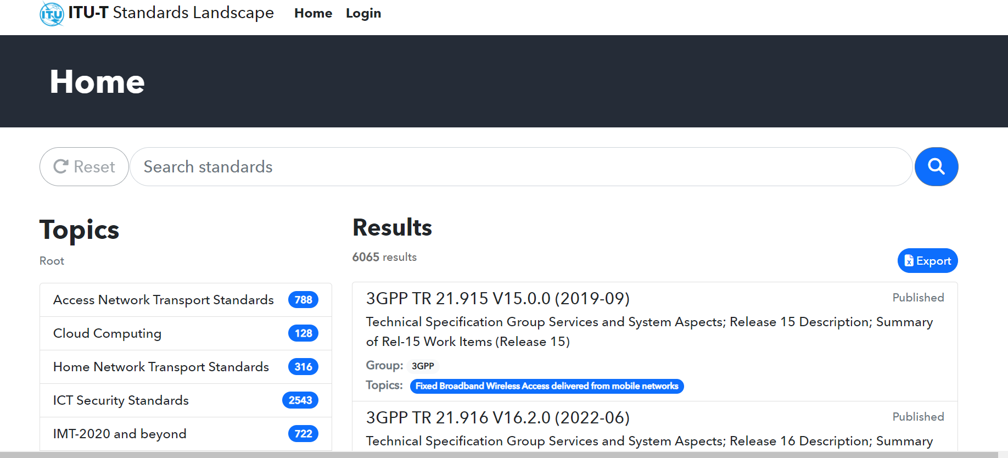
Click on
Step 2 – or starting from https://www.itu.int/itu-t/landscape/?topic=tx153&group=g&search_text=
Click on
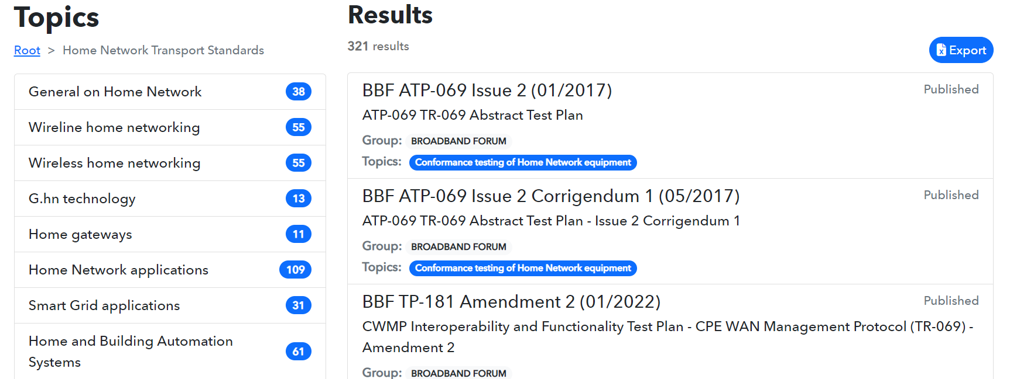
Step 3
Click on
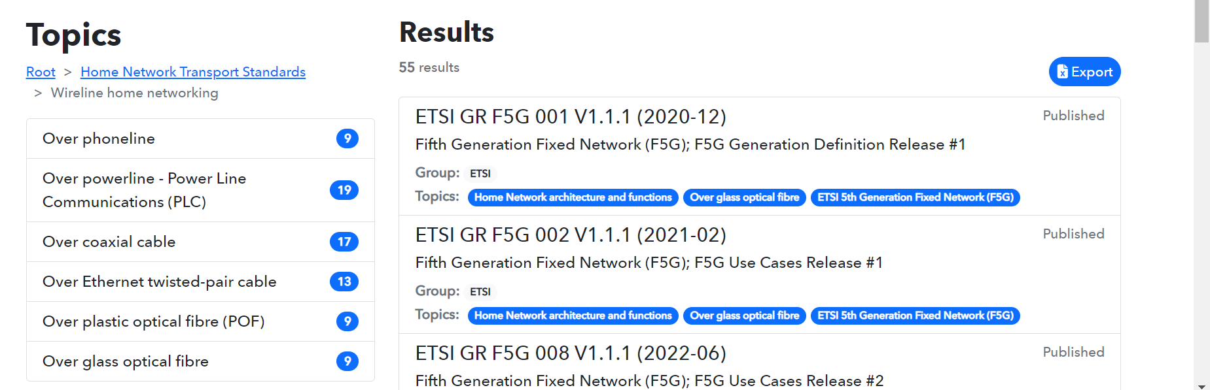

Step 4
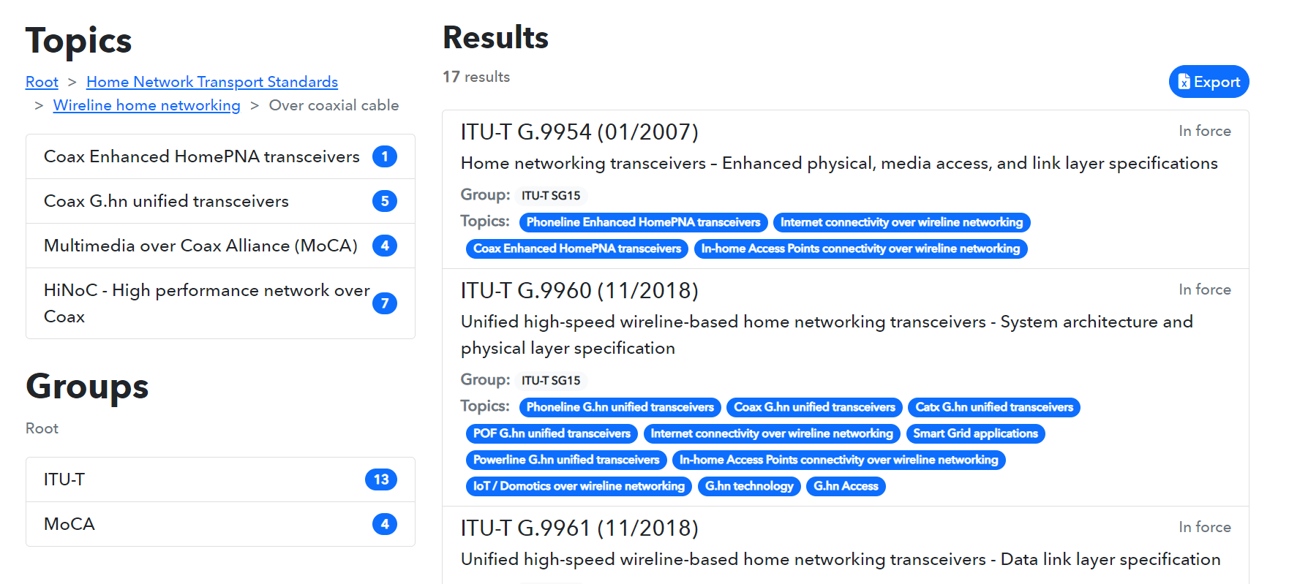
Click on

Step 5
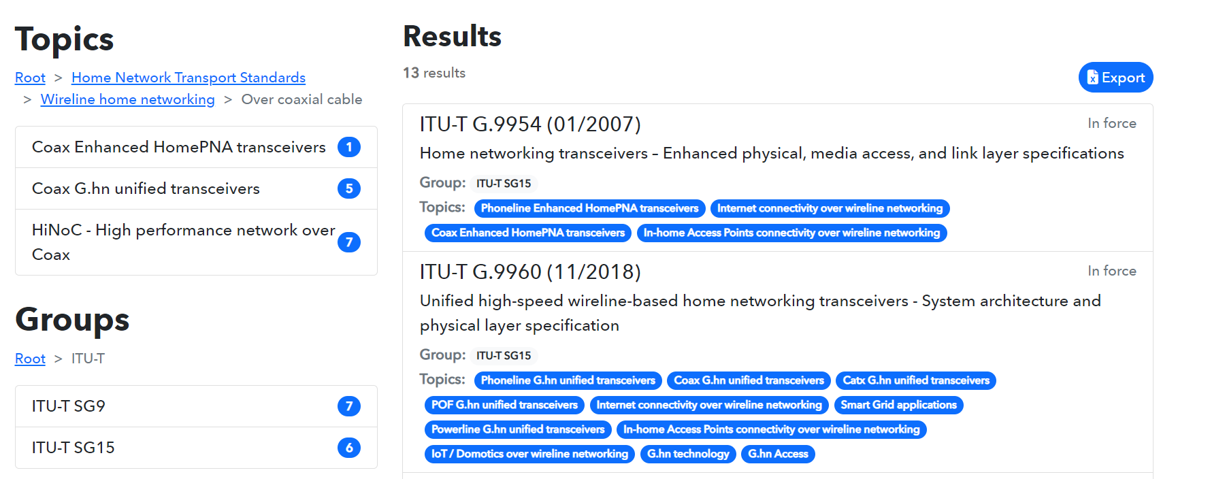
Click on

Step 6
The list of all ITU-T SG15 Recommendations, including Supplements related to “Wireline home networking over coaxial cable” is displayed. The list can be exported on an excel table.

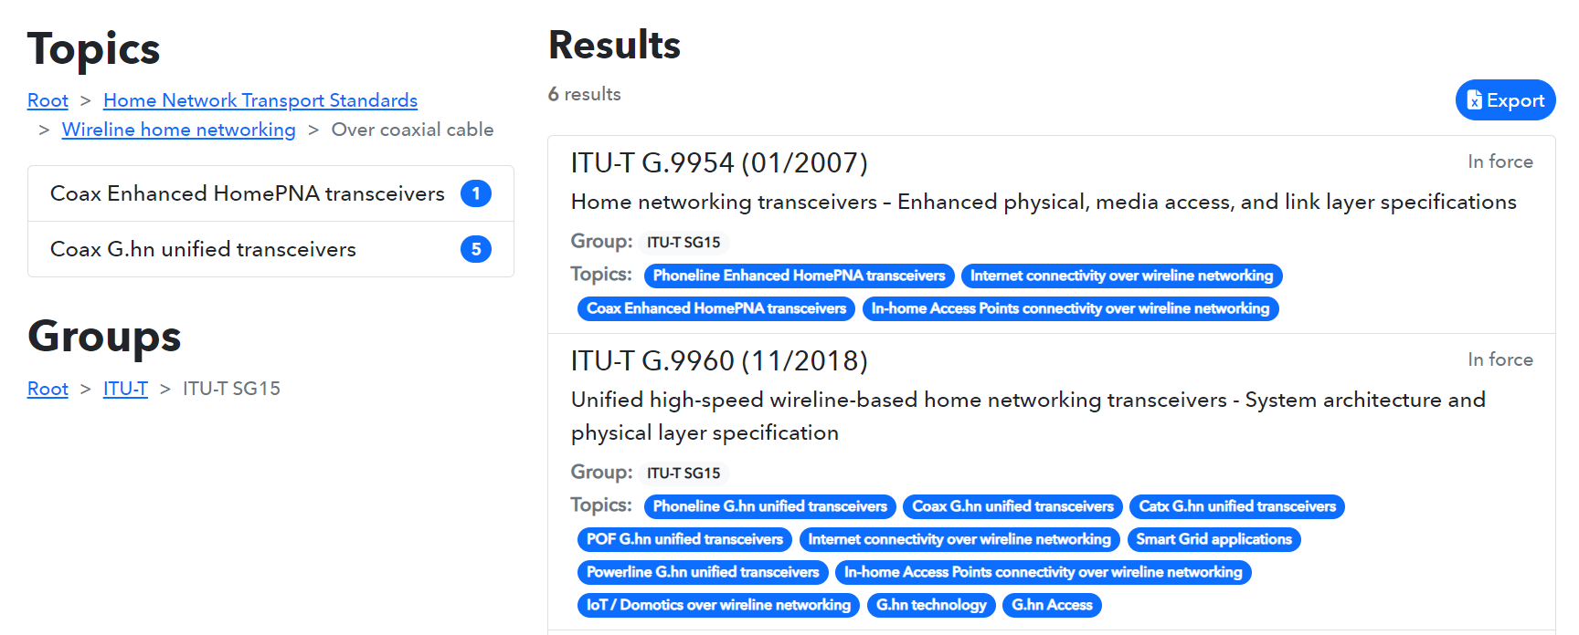
Click on

Step 7: “DocumentsExport…..xlsx” is ready for download, the list of all ITU-T SG15 Recommendations on “Wireline home networking over coaxial cable” can be displayed in excel.
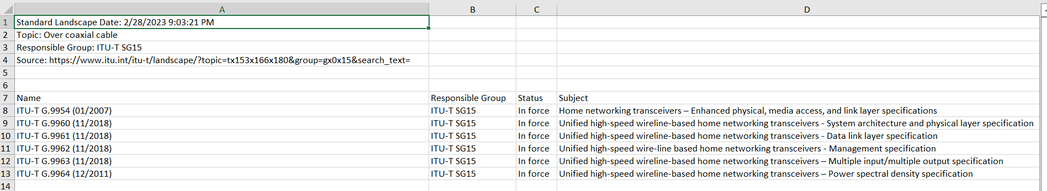

Search of a selected standard using the Topics structure:
for example, search Recommendation ITU-T G.9960
Proceed with steps 1 to 5 as in above search example 1
Step 6: Click on item ITU-T G.9960
Click on
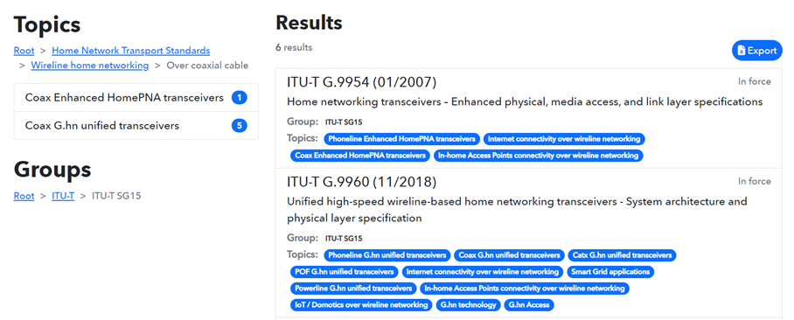

Step 7: See the displayed information on ITU-T G.9960 (11/2018) and click on the link to access to the ITU-T SG15 webpage of Recommendation G.9960
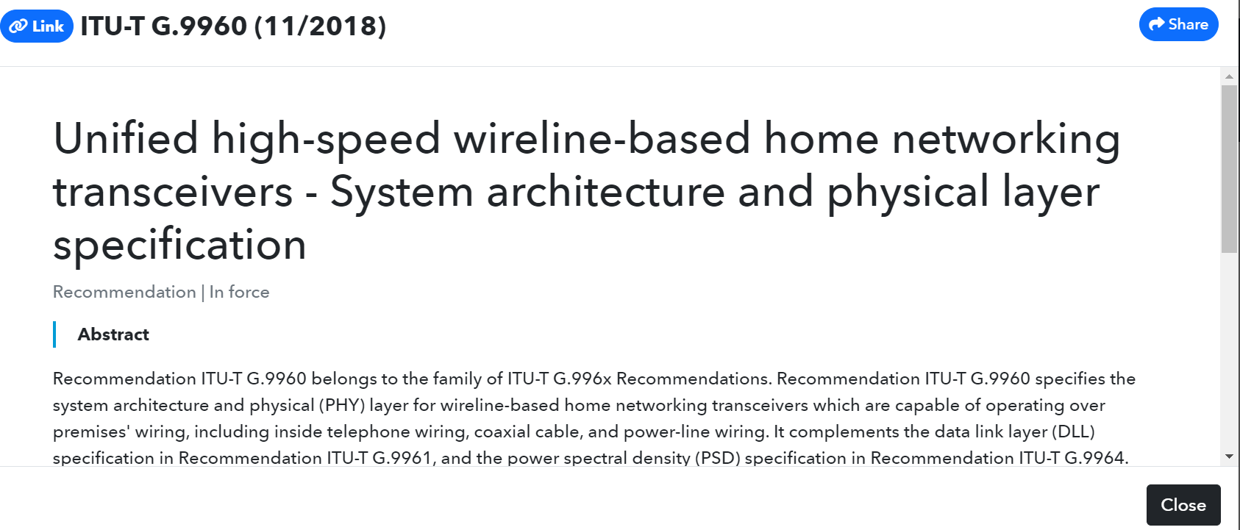
Click on Link

Step 8: The ITU-T SG15 webpage of Recommendation G.9960 (11/2018) including its
Amendments is displayed, and the searched document can be downloaded.
Click on “here” to download the document.
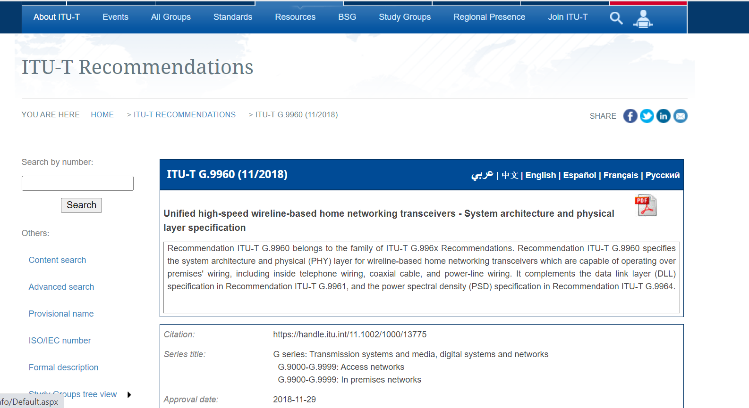
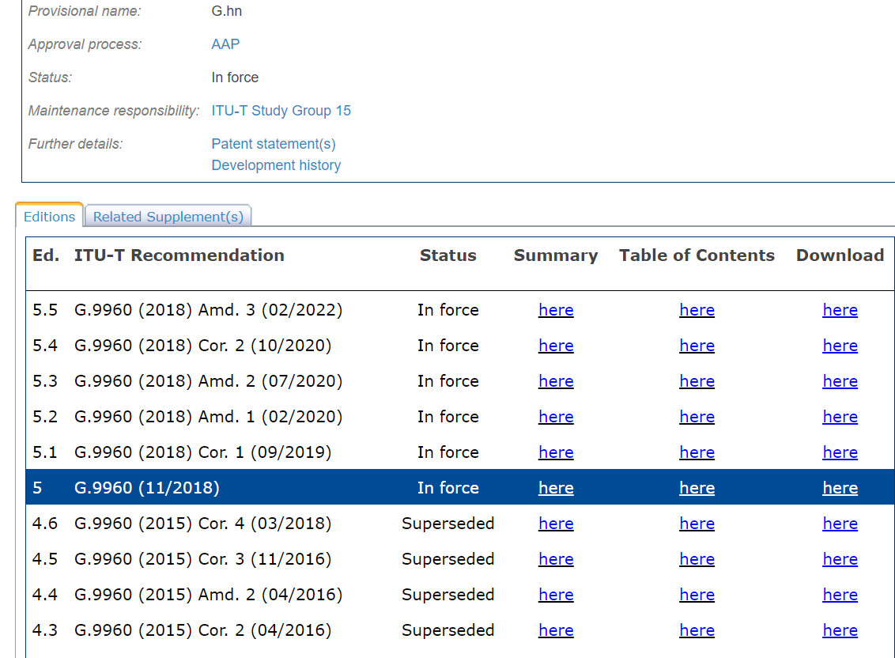
Click on here
to download the document

- Search of a standard using the search function of the ITU-T Standards Landscape:
for example, search Recommendation ITU-T G.9991

Step 1: Enter G.9991 in the “Search standards” window of the ITU-T Standards Landscape
and launch the search. The items are also searchable on title or descriptive terms.
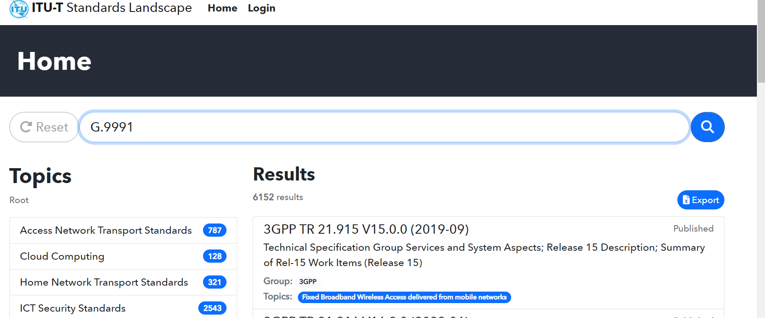

Step 2: See displayed Results and continue as for steps 6, 7 and 8 in above search example 2.
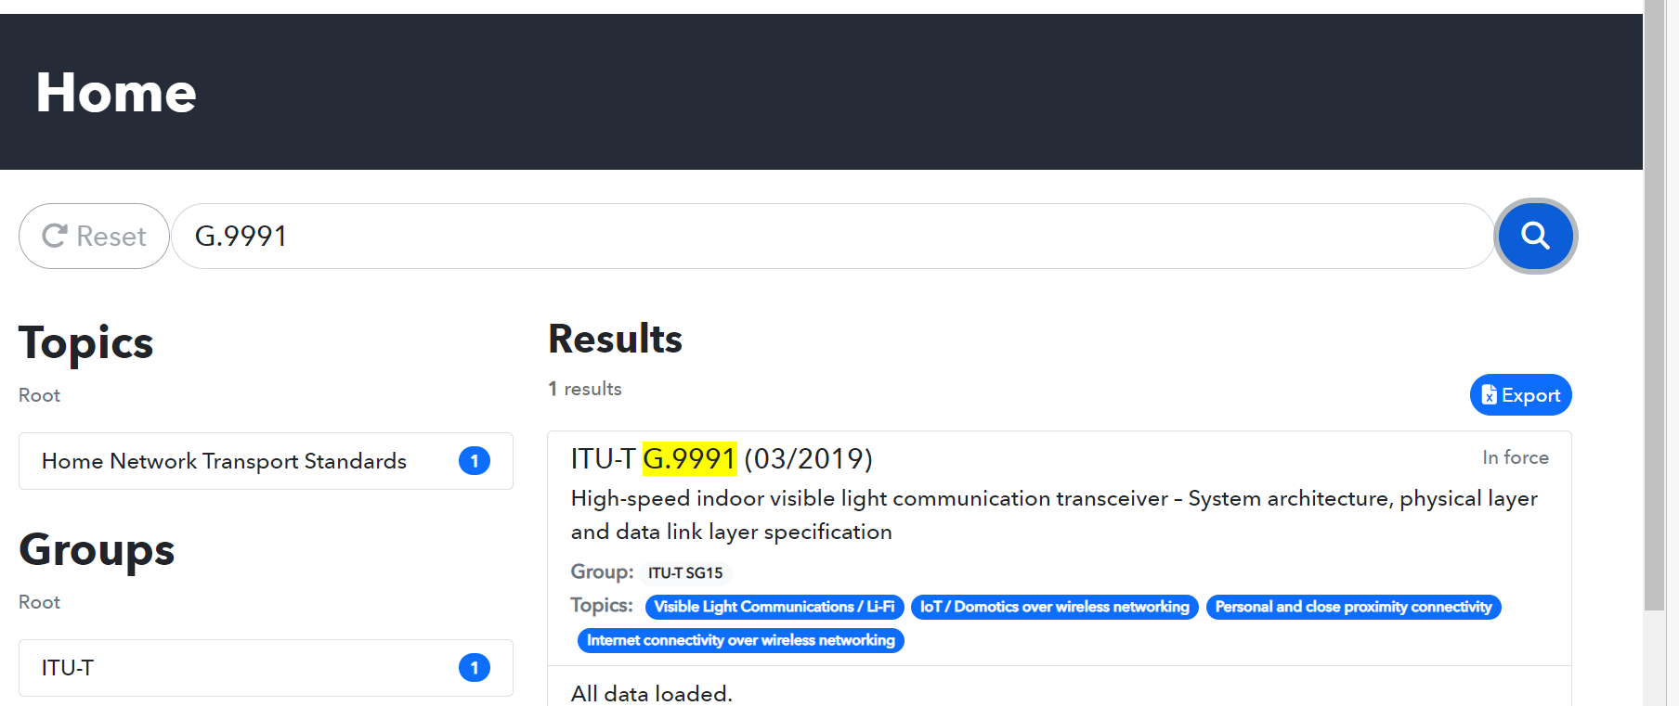
Click on

- Search of a list of standards using the Groups structure:
for example, search the list of all ITU-T SG15 Recommendations related to “Smart Grid applications”
Proceed with step 1 as above in section 1
Step 2
Click on
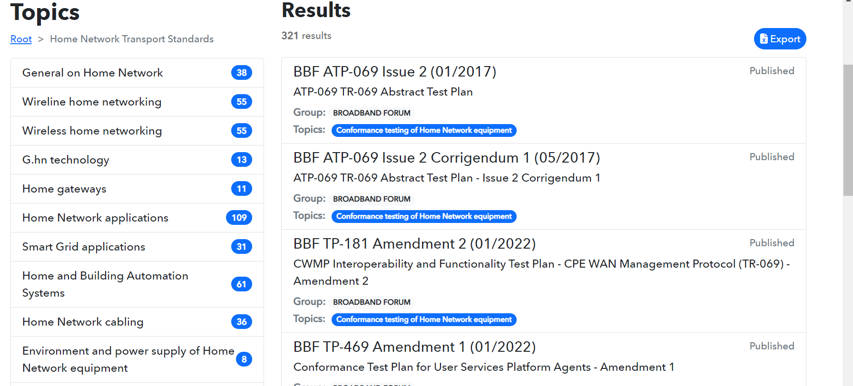
Step 3: click on the Groups ITU-T
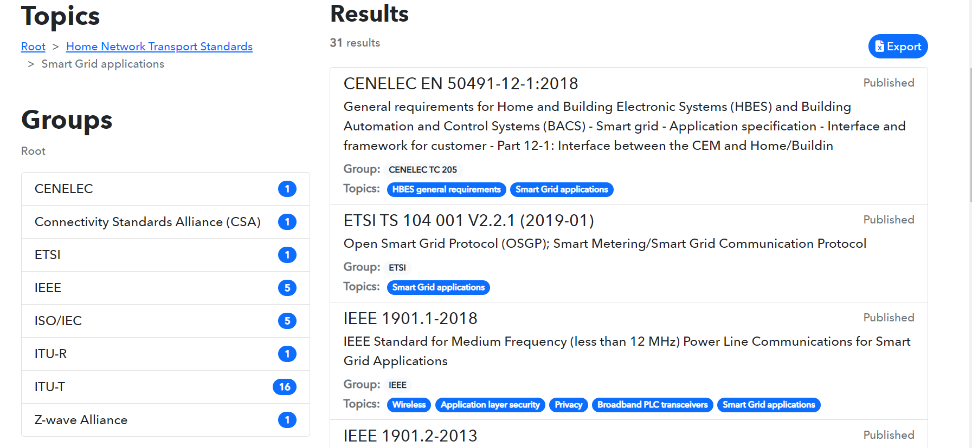
Click on
Step 4
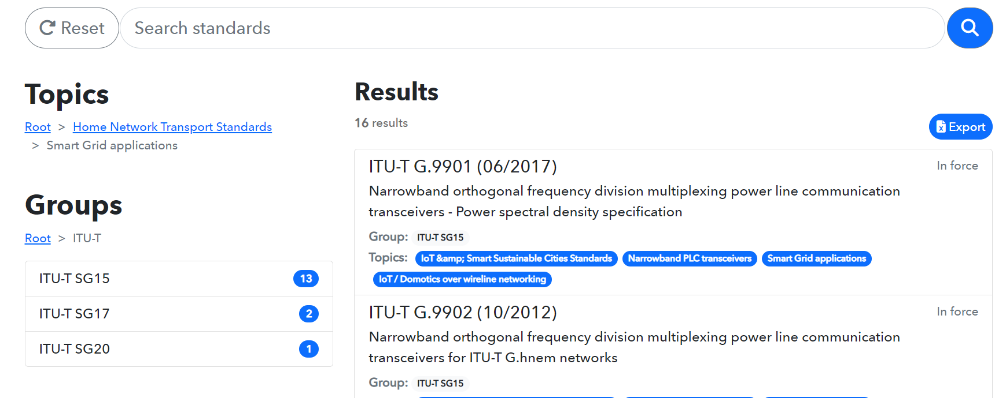
Click on

Step 5: The list of all ITU-T SG15 Recommendations related to “Smart Grid applications” is displayed. The list can be downloaded and exported on an excel table.
Proceed as for steps 6 and 7 in above search example 1 to download the list in excel.



