|  |  |
| --- | --- |
| **NAME ORGANIZATION** | **NAME ORGANIZATION** |

WSIS Forum 2019 | Information and Communication Technologies for achieving the Sustainable Development Goals

8–12 April 2019, Geneva, Switzerland

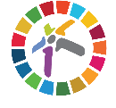

WSIS Forum 2019 | Information and Communication Technologies for achieving the Sustainable Development Goals

8–12 April 2019, Geneva, Switzerland

