INTERNATIONAL TELECOMMUNICATION UNION
TELECOMMUNICATION  DEVELOPMENT BUREAU  ITU-D STUDY GROUPS | Document 2/266-E  30 August 2001  Original: English only  DELAYED
FOURTH MEETING OF STUDY GROUP 1: CARACAS (VENEZUELA), 3 - 7 SEPTEMBER 2001
FOURTH MEETING OF STUDY GROUP 2: CARACAS (VENEZUELA), 10 - 14 SEPTEMBER 2001

FOR INFORMATION

Question 12/2: Examine broadband communications over traditional copper wires on aspects of technologies, systems and applications

STUDY GROUP 2

Source: Rapporteur for Question 12/2
Title: Digital Subscriber Line market development

________

Introduction
During the recent DSL Forum meeting in New Orleans, August 27 –31, the growing market for DSL systems has been illustrated. ADSL, HDSL and SHDSL equipment can be considered to be technically mature. VDSL equipment is in development. It is obvious that efforts have to be made to establish prediction and testing methods to evaluate in advance if subscriber loops can be used for DSL. Further efforts are made
- to permit interoperability of DSL systems made by various vendors
- to simplify the installation of DSL equipment
- to permit in the near future “of the shelf buying” of DSL customer terminals.
In the long run HDSL will be replaced by SHDSL and asymmetrical DSL systems might be replaced by symmetrical ones.
VoDSL
Voice signals can be transmitted in the access network as
- Plain Old Telephone Service (POTS)
- Voice over ATM using the AAL2 protocol (VoDSL)
- Voice over Internet using the ATM AAL5 protocol (VoIP)
VoDSL and VoIP lead to advantages such as:
- With the utilization of e.g. the multiplexing function of Integrated Access Devices (IAD) one single DSL link can transport a number of parallel telephone services together with data services
- Splitting filters are not required
- Voice and signalling informations are transmitted integrated.
The following figure illustrates the projected VoDSL market in the US.
DSL
The DSL market is growing fast, end of March 2001
- About 3 Million lines were used in the USA
- About 600 000 lines were used in Canada and
- More than 3 Million lines installed in Korea !
- More than 1.5 Million lines installed in Europe
The following figure shows the projected USA market for DSL.
Proposals
The marketing information given in this document and comments received during discussions with DSL Forum delegates could be included in an updated edition of the Reference Book on DSL. Doc 2/082 (Rev.2)
The updated edition of the Reference Book could be sent as liaison information to the DSL Forum to activate the information exchange between ITU-D and the Forum. Next DSL Forum meetings are planned in Dec. 2001 and March 2002.

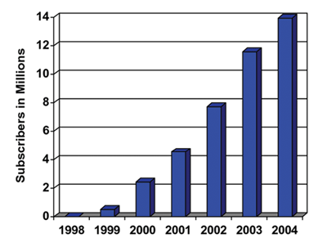
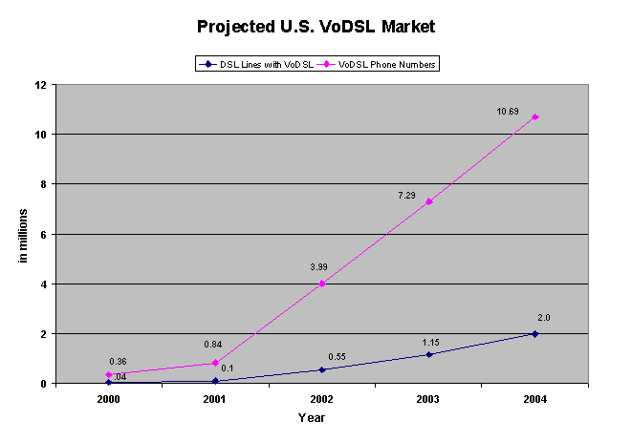

Projected U.S. DSL Market

Projected U.S. DSL Market

