TSAG Restructuring Meeting
5-7 April 2004 - Ottawa, Canada
INVITATION AND SOME PRACTICAL INFORMATION
FOR PARTICIPANTS
Invitation to TSAG Restructuring Face-to-face Meeting 2
Contacts for Information and Assistance 2
Event Hotel 2
Registration 3
Welcome Dinner 3
Documentation 3
Meeting Times 3
Refreshments 3
Lunch Arrangements 3
Business Hours 3
Taxes (a favourite subject) 4
Tipping (Gratuities) 4
Airport Transfers 4
Some Information about Ottawa 4
Weather and Clothing 5
Medical Services 5
Passports and Visas 5
Customs Information 6
General 6
Firearms and weapons 6
Gifts 6
Foreign Exchange, Banking, Credit and Debit Cards 6
Mobile Telephones 6
Electrical Supply 7
General Tourist Information 7
Appendix 1 - OC Transpo Route 97 Map 8
Appendix B - Mackenzie King Bridge to Westin Hotel 9

Invitation to TSAG Restructuring Face-to-face Meeting
Nortel Networks is very pleased to invite you to participate in the TSAG Restructuring Meeting to be held in Ottawa, Canada, 5 - 7 April 2004.
This document attempts to provide all the relevant details. Should we have overlooked anything, please do not hesitate to contact us.

Contacts for Information and Assistance
Questions prior to the event may be addressed to either of:
John Visser: +1-613-763-7028 (office)
+1-613-276-6096 (mobile)
jvisser@nortelnetworks.com
Jim MacFie: +1-613-765-6641 (office)
jmacfie@nortelnetworks.com
In Ottawa, only the last seven digits need to be dialled. Outside the Ottawa service area, a long distance call is indicated by prefix “1” followed by ten digits. (This makes the dialled digit string exactly as shown above, with no international prefix needed to replace the “+”.)
During the meeting, voice messages may be left at the above numbers, or John can be reached on his mobile.

Event Hotel
The event will be at the Westin Hotel, Ottawa. A block of guest rooms at CAD$135.00 has been set aside until one month before the event. The reference for the block booking is 'Nortel'.
The meeting will be in the Québec Room of the Westin Hotel.
Information on the hotel may be found by going to http://www.starwood.com/westin/index.html and using the "find a hotel" feature for Ottawa, Ontario, Canada. (The URL for the resulting page is not provided here as it is about 600 characters!) Select "more" for further information specific to the hotel.

Registration
Badges will be prepared for all pre-registered participants. You will be able to pick them up at the back of the meeting room.

Welcome Dinner
A welcome dinner hosted by Nortel Networks will be provided on Monday evening. Details will be provided on the first day.

Documentation
Participants are reminded that the meeting will be entirely paperless. Delegates wishing paper copies of documents will need to print them at home and bring them.

Meeting Times
We are planning on the usual ITU-T meeting timings:
0900-1030
1100-1230
1400-1530
1600-1730 except Wednesday when we will wrap up at approx. 1600.
Earlier start times on Tuesday and Wednesday are possible if the meeting wishes.
The Québec Room is available in the evenings if the need arises.

Refreshments
Continental breakfast will be provided in the mornings. Coffee, etc., will be provided for the morning and afternoon breaks.

Lunch Arrangements
Lunch will not be provided. However, there are numerous restaurants in the immediate vicinity, including a food court in the adjacent Rideau Centre shopping complex connected to the hotel, as well as the Byward Market area, also adjacent to the hotel.

Business Hours
Regular banking hours are Monday to Friday, 10:00 to 17:30. Most shops in Ottawa are open from 0900 or 1000 to 1730 or 1800. Stores in the “Downtown Rideau” area (where we are) generally have longer hours.

Taxes (a favourite subject)
The federal tax (GST) of 7% is levied on most goods and services in Canada. In addition, an 8% provincial tax (PST) is levied on products and services. The taxes are not cumulative, that is, each tax is calculated separately on the base amount for a total of 15%, not 15.56%.
Non-residents can apply for a GST rebate on most goods purchased for use outside Canada as well as on short-term accommodation (there are exceptions.) Details are available at http://www.ccra-adrc.gc.ca/visitors/..

Tipping (Gratuities)
Restaurant gratuities are left to individual discretion, but the customary (and expected) amount is 15 per cent on the pre-tax amount. PST and GST are added to the menu prices. Alcoholic beverages are charged a provincial tax of 10% instead of 8%. Gratuities are not expected at fast food outlets. Note also that many restaurants automatically add the gratuity to the bill for larger groups (typically six to eight or more.
If the above is clear, congratulations. If not, just remember that the actual cost of an item ordered in a restaurant is a nominal 30% more than the price listed in the menu.

Airport Transfers
There are three primary means of travel between the airport and the downtown core:
- OC Transpo (transit bus: http://www.octranspo.com/) is inexpensive: CAD$2.50, but awkward with luggage. The airport is served by Route 97, every 15 minutes, and it takes about 30 minutes to reach the MacKenzie King Bridge. From there, you will need to walk to the hotel. Appendices 1 and 2 provide additional details.
- The Airport Shuttle Bus departs the airport every half hour at 10 and 40 minutes after the hour. The cost is CAD$12.00 one-way, CAD$20.00 return. It stops at the Westin lobby as well as other downtown hotels.
- Airporter Taxi provides service outbound from the airport only. Typical fare to the Westin Hotel is approx. CAD$20.00 plus a nominal 15% gratuity. There is a Blue Line taxi stand at the Westin to take you back to the airport.

Some Information about Ottawa
Ottawa’s metropolitan area is the fourth largest in Canada with a regional population of about one million people. Ottawa is in the province of Ontario. Gatineau is Ottawa’s twin city across the Ottawa River in the province of Québec. Canada has two official languages, English and French. English is more common on the Ontario side of the Ottawa River, and French on the Québec side of the Ottawa River.
Ottawa is a very pleasant and very safe city to visit and offers many advantages as a national capital. These include excellent museums and galleries, facilities for the arts and a very diverse choice of restaurants with nearly every style of cuisine available. A wide range of restaurants is within walking distance of the hotel. Participants are encouraged to take advantage of the many fine facilities Ottawa has to offer.
Particularly recommended are the Museum of Civilization (http://www.civilization.ca/cmc/cmce.asp, nominal walking distance but you may want to take a bus or taxi) and the National Gallery (http://www.national.gallery.ca/, easy walking distance.) Also recommended are the Aviation Museum (http://www.aviation.technomuses.ca/eng/english_home.html, taxi or bus), Nature Museum (http://www.nature.ca/nature_e.cfm, moderate walking distance or taxi), War Museum (http://www.civilization.ca/cwm/cwme.asp, easy walking distance), and the Science and Technology Museum (http://www.sciencetech.technomuses.ca/, taxi or bus.) There are excellent cultural programs at the National Arts Centre across the Rideau Canal (http://www.nac-cna.ca/.)
For more information about Ottawa, visit http://www.ottawa.com/about/faq_e.shtml#whatIs.

Weather and Clothing
In early April, the weather in Ottawa can be quite variable. The average temperature for the month of April is 5.1 C (average maximum: 10.7 C, average minimum: 0.3 C) while the temperature extremes on record are +30 C and -15 C. The average April rainfall is 59.9 mm, and some of this can fall as snow! The Canadian approach is to dress in layers so that adjustments can be made as necessary. A sweater, a good coat, and an umbrella are recommended.
Current Ottawa weather information may be obtained at http://www.theweathernetwork.com/weather/cities/can/pages/CAON0512.htm and general Canadian weather information and trivia may be obtained at http://members.tripod.com/~MitchellBrown/almanac/index.html.

Medical Services
Participants travelling to Canada are strongly advised to obtain medical insurance before leaving their home country. Medical services in Canada are of great quality but may be expensive. We recommend that you procure medical insurance that covers medical and hospital treatment as well as repatriation expenses. We do not assume responsibility for these services.

Passports and Visas
Participants coming to Canada need a valid passport. In some cases, a visa is also required. Participants are advised to determine, before travelling, whether they will require an entry visa into Canada and they are responsible for obtaining any other visa they may require for countries through which they may be transiting.
If assistance is required to obtain a visa, please contact either John Visser or Jim MacFie.

Customs Information

General
Like most countries, Canada has requirements and restrictions on certain goods such as firearms, animals and animal products, plants and plant products, and fresh fruit and vegetables, as well as certain food and drug products. You can get more information from the Canadian embassy, consulate, or mission nearest you.

Firearms and weapons
In Canada, it is against the law to bring firearms or other weapons such as Mace and pepper spray into the country for your personal protection.

Gifts
You can bring gifts for relatives and friends into Canada, duty free, if each gift is valued at CAN$60.00 or less. If the value of the gift is more than CAN$60.00, you may have to pay duties and taxes on the excess amount. You cannot bring in tobacco and alcohol products as gifts but may bring in limited quantities for personal use. Further details may be obtained at http://www.cbsa-asfc.gc.ca/travel/visitors-e.html.

Foreign Exchange, Banking, Credit and Debit Cards
The official currency in Canada is the Canadian dollar. Traveller’s cheques are accepted in most major foreign currencies by banks, which are usually open from 10:00 to 16:00 hours on weekdays. Currency exchange facilities are available at the airport and downtown foreign exchange offices. US currency is accepted virtually everywhere but the exchange rate will not be as good as at a bank.
ATMs are available everywhere and will allow you obtain Canadian dollars drawn against your home account with exchange rates and fees as charged by your home bank.
Visa and MasterCard are accepted in essentially all restaurants and stores, as is Interac direct debit payment. AmEx is accepted in most places but not all. Fast food outlets generally require cash but some also accept Interac direct payment. (Please check whether you can use your non-Canadian direct debit card before finding yourself in a position where you have a purchase that you cannot pay for!)

Mobile Telephones
In Canada, there are four national mobile telephone network operators. These operators have roaming agreements with other operators in North America and in other countries.
Microcell is the only GSM network operator in Canada. North American GSM mobiles operate in the 1.9GHz band.
If the mobile operator in your home country has a roaming agreement with Microcell, you should be able to take your GSM smart card and insert it into a North American GSM1900 phone upon your arrival. Calls made to your home mobile phone will be forwarded to your Canadian phone.

Electrical Supply
The main power supplies in Canada are 110 volts, 60 Hz.

General Tourist Information
For more information about Canada, please visit: www.canadatourism.com.
For more information about Ottawa please visit: http://www.capcan.ca.

Appendix 1 - OC Transpo Route 97 Map
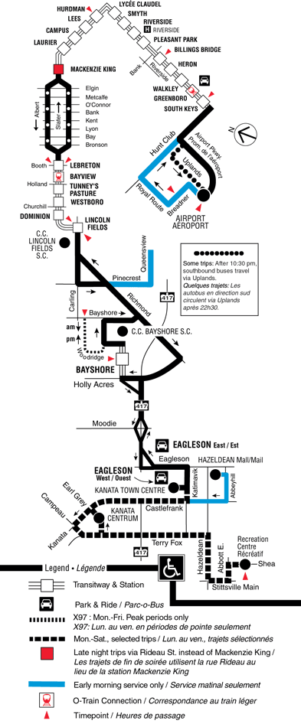

Appendix B - Mackenzie King Bridge to Westin Hotel
The red star indicates the Westin Hotel. The MacKenzie King Bridge crosses Rideau Canal immediately above “Confederation Park”. “Rideau Centre” contains both the Ottawa Congress Centre and the Rideau Shopping Centre. The Byward Market area is immediately north of the Rideau Centre.
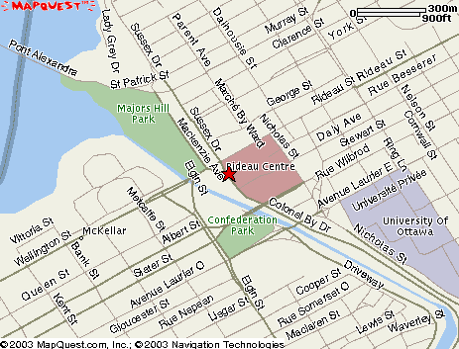
Route 97 comes north on Nicholas Street, then follows the Transitway. Daly Avenue goes underneath the Congress Centre.
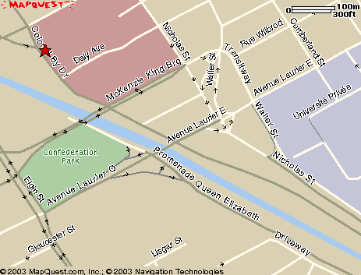
________________

US citizens living in the USA: please note that a valid drivers license is not sufficient ID and that an original or certified copy of a birth certificate is required. Government issued photo identification is strongly recommended. A passport is best.

