Biographical Profile of Paul Coverdale

Candidate for Vice Chair - SG G “Performance and Quality of Service”

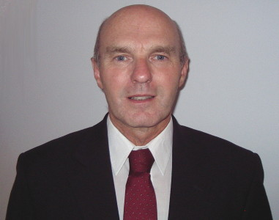
Paul Coverdale has a proven track-record in Standards having been active for many years in both national and international Forums dealing with voice quality and performance, including ITU-T, TIA, ETSI and IEEE. In particular, he has been participating in ITU-T SG12 since 1983. From 1985 to 1996 he was Rapporteur for Questions in SG12 dealing with evaluating the effects of non-linear distortion on voice quality and specifications for wideband audio. From 1997 to 2000 he was Chairman of Working Party 2/12 “Objective and Subjective Methods” where he was instrumental in introducing a number of important new Recommendations now widely used throughout the industry, including the G.107 E-model for transmission planning and P.862 for objectively assessing voice quality. He is currently Chairman of Working Party 3/12 “QoS over IP”, a new Working Party pioneered by Paul to provide a focus within SG12 on multimedia end to end performance and QoS in IP networks, and under his leadership several new Recommendations have already been introduced in this area in the P.1000 and G.1000-series. He is also Rapporteur for Q.13/12 “Multimedia QoS/performance requirements”. He has been Chairman of Canadian National Study Group 12 since 1984, and is the Canadian Head of Delegation for ITU-T SG12.

Paul graduated with an Honours B. Sc. in Electrical and Electronic Engineering in 1971 from the University of Leeds (England), and joined the British Post Office (now British Telecom) Research Department to work on telephony transmission performance assessment. In 1974 he joined Bell-Northern Research (now Nortel Networks), in Ottawa, Canada, where he has held a number of engineering and management positions related to the specification, design, verification and standardisation of voice quality and performance in wireline and wireless products. Since 1998 he has been focusing on multimedia performance aspects of wireless systems, and is currently Senior Advisor – Multimedia Wireless Performance. He is a member of the IEE, IEEE, and is a registered Professional Engineer in the Province of Ontario, Canada. He has authored and co-authored several papers and holds five patents.

Contact information:

Nortel Networks email: paulcov@nortelnetworks.com
3500 Carling Avenue Tel: +1 613 763 4277
Nepean Fax: +1 613 765 7723
Ontario K2H 8E9
Canada

