ITU-T/ ATIS Workshop

“Next Generation Technology and Standardization”

BIO
BIO |  |  | Las Vegas, 19-20 March 2006
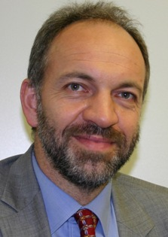 |  | Reinhard Scholl  Deputy to the Director of the ITU-T
Session coordinator and moderator for Session: |  | Session 1: ITU-T/ATIS, update on NGN activities

Reinhard Scholl is Deputy to the Director of the ITU-T Secretariat (the so-called Telecommunication Standardization Bureau) since September 2002. Previously he has been with Siemens in Munich, Germany and with ETSI (European Telecommunications Standards Institute). He is the founder of the ETSI PlugtestsTM Service, a professional service that organizes “interoperability events” where competing companies get together to test their implementations with the goal to debug the specifications as well as their implementations.

He received a Ph.D. in physics from the University of Illinois at Urbana-Champaign, USA.

