ITU-T/ ATIS Workshop

“Next Generation Technology and Standardization”

BIO
BIO |  |  | Las Vegas, 19-20 March 2006
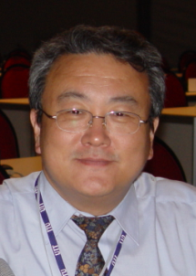 |  | Chae Sub LEE  ETRI
Session coordinator and moderator for Session: |  | 2: An Implementable NGN Architecture and its Capabilities

Chae Sub LEE has been working in the telecoms standardisation field for over 20 years. He has actively involved in regional standards in ASTAP, APT, TTA and CJK in the area of network standards. He has been involved in ITU-T standards development for the ISDN, GII, IP-based networks and NGN. He was mainly involved in Study Group XVIII (currently SG13) as a rapporteur on Architecture and Interworking areas. He is a vice-chairman of ITU-T Study Group 13 and Chairman of WP2/13 on Architectural study. He also shared his role as Chairman of NGN Focus Group from June 2004 till November 2005.
After a career of twenty years with KT as a senior researching engineer, he built a venture company called HiSPOT S.A. And he has been an invited researching staff to ETRI on International Standard acitivities.

