ITU-T/ ATIS Workshop

“Next Generation Technology and Standardization”

BIO
BIO |  | Las Vegas, 19-20 March 2006
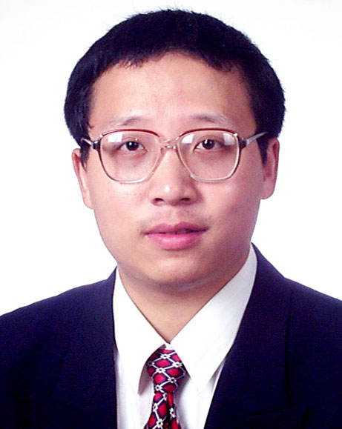 | Mr.Noah Luo  Huawei Technologies
Session: | NGN Service Enablers (incl Mobility, Fixed-Mobile Convergence)
Title of Presentation: | Next Generation of Multimedia Terminals

Mr.Noah Luo

Received the Bachelor of Engineering degree in Industrial Electrical Automation from Xi’an Jiaotong University,China, in 1991,and the Doctor of Engineering degree in Automatic Control Theory and Application from Xi’an Jiaotong University,China,in 1996.

He worked as postdoctoral research scientist at the Institute of Remote Sensing,Chinese Academy of Sciences,in Beijing,China,from 1996 to 1998.He joined Huawei Technologies Co., Ltd. where he has been working as a senior technical and research manager and a research scientist.He is currently the rapporteur of Question 22 “Multimedia Services and Applications”of SG 16 of ITU-T.

His research interests include multimedia communications,image and video processing,and NGN.He has authored and co-authored over 40 technical publications.He is responsible for over 30 patents in multimedia communications and related areas.

