ITU-T/ ATIS Workshop

“Next Generation Technology and Standardization”

BIO
BIO |  | Las Vegas, 19-20 March 2006
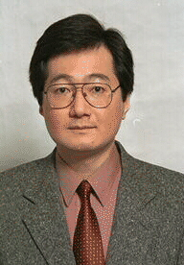 | Hiroshi Ohta, NTT
Session: | 3: NGN Service Enablers
Title of Presentation: | Ethernet OAM and Protection Switching

Hiroshi Ohta received his B.S. degree in Electrical Engineering and his M.S. and Dr. Eng. degrees in Electronics Engineering from Kyoto University, Kyoto, Japan in 1985, 1987 and 2000 respectively. He joined Electrical Communication Laboratories of Nippon Telegraph and Telephone Corporation (NTT), Kanagawa, Japan in 1987. Since 1987 to 1999 he was engaged in research and development of ATM based transport systems, in particular, optical subscriber loops, cell loss analysis/recovery, OAM functions and protection switching as well as development of an ATM cross-connect system. Since 2000, he has been engaged in development of services for corporate users such as IP-VPN and metro Ethernet services and in development of services for consumers such as content delivery services (CDS). Since 1992, he actively participates in standardization meetings of ITU-T SG13, SG15, IEEE 802 LAN/MAN Standards Committee and IETF. Currently, he is a rapporteur for Question 3/15 (General characteristics of optical transport networks) of ITU-T SG15.

