ITU-T/ ATIS Workshop

“Next Generation Technology and Standardization”

BIO
BIO |  | Las Vegas, 19-20 March 2006
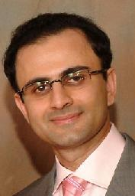 | Viqar Shaikh (Telcordia)
Session: | 4: Signaling and Control
Title of Presentation: | ATIS: Signaling Architecture
Viqar Shaikh is a Senior Systems Engineer at Telcordia Technologies with eleven years of extensive systems engineering background in telecommunications. He specializes in the area of Next Generation Network/Voice over Internet Protocol (NGN/VoIP) and Common Channel Signaling/Signaling System No. 7 (CCS/SS7) architecture, requirements, and protocol. In addition, his expertise also lies in the area of ATM/MPLS architecture, requirements, and protocol. He has also provided leadership in the development of the broadband signaling requirements and protocols in both the national and international standards organizations.
Viqar has been active in standardization activities for over ten years. In particular, he actively participates in ITU-T (SG11 and SG13), ATIS Packet Technologies and Systems Committee (PTSC), and the MFA Forum. He has been editor of several Technical Reports and Standards/Recommendations in both ITU-T and ATIS PTSC. He has provided standards contributions in areas such as VoIP, IP-IP Interconnection (SIP based interconnection), Session Border Controller, Security, Emergency Telecommunications Service, and NGN architecture, requirements, and protocols. In addition, he has held leadership positions in ITU-T and PTSC.
Viqar holds a BS and MS in Electrical Engineering specializing in the area of telecommunications engineering.

