ITU-T/ ATIS Workshop

“Next Generation Technology and Standardization”

BIO
BIO |  |  | Las Vegas, 19-20 March 2006
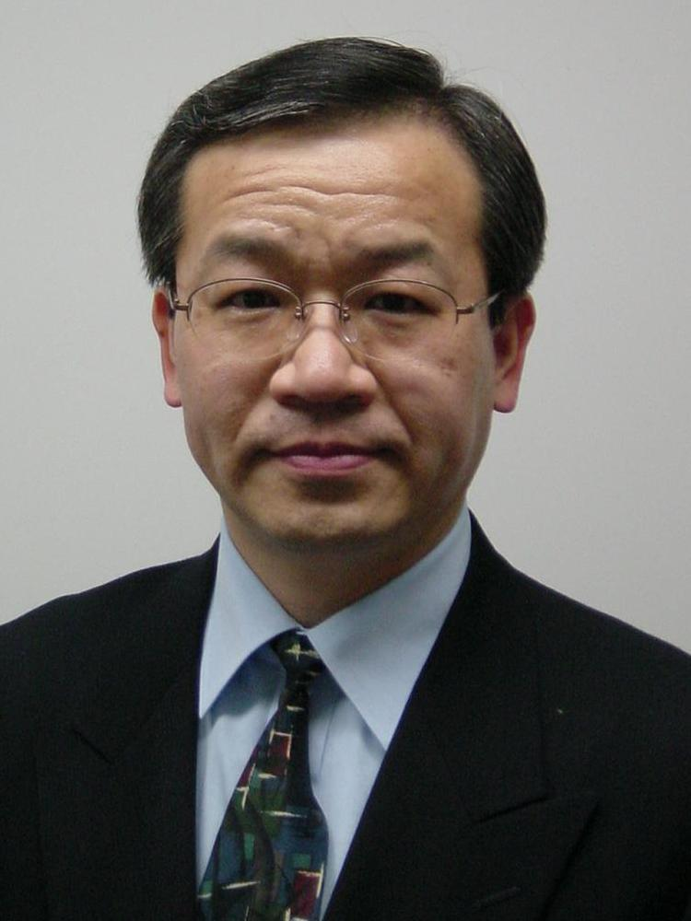 |  | Yoichi MAEDA, NTT
Session Moderator: |  | NGN Market Drivers: A Carrier’s perspective

Yoichi Maeda received the B.E. and M.E. degrees in electronic engineering from Shizuoka University, Japan in 1976 and 1978, respectively. Since joining NTT in 1980, he has been engaged in research and development on access network transport systems for broadband communications including SDH, ATM and IP. From 1988 to 1989, he worked for British Telecom Research Laboratories, UK, as an exchange research engineer.

He is a senior manager and currently leads the Global Strategy and the Full Service Access Groups in NTT Access Network Service Systems Laboratories. Since 1989, he has been an active participant in ITU-T Study Groups 13 and 15.

He is currently serving as chairman of ITU-T SG15. He is a member of the IEEE and IEICE of Japan. He is a feature editor on standards of IEEE Communications Magazine.

