Statistical Overview of the Telecommunications Sector in Sri Lanka

A S W Bandusiri

Statistical Officer
TRCSL
Tel: +94 11 2675988 Fax: +94 11 2689341
E-mail: bandusiri@yahoo.com,
bandusiri@hotmail.com
Web : http://www.trc.gov.lk

Our Vision

TO BE AT THE FOREFRONT OF TELECOMMUNICATIONS REGULATION

Our Mission

To Create The Optimum Conditions for the Telecommunications Industry in Sri Lanka by serving the public interest in terms of quality, choice and value for money; The service providers with equitable access to spectrum and other common resources; and the nation in its drive for socio- Economic advancement through a skilled and ethical workforce.

Sri Lanka Country Profile

- The Democratic Socialist Republic of Sri Lanka is an Island in the Indian Ocean, off the southern tip of the peninsula of India.
- Capital – Colombo
- Area – 65,610 sq km
- Population :-19.252 Million
- GDP – 1760 Billion
- GDP per Capital – US$ 870
- Currency –Sri Lankan Rupees (1 US$ =>98 LKR)
- Land Area:- 65,610 sq km
- Agriculture based
- 78% out side the urban area
- 91% literacy
- Infant Mortality rate 11.0 per 1‘000 live births
- Population growth 1.3%

Overview of Telecommunications Regulations

- The Telecommunications Regulatory Commission of Sri Lanka (TRCSL) is a statutory body established under the Sri Lanka Telecommunications Act, No. 25 of 1991, as amended by the Sri Lanka Telecommunications (amendment) Act, No.27 of 1996.
- TRCSL is carrying out its role as a regulator in the field of Telecommunications.
TRCSL Presently functions under the Ministry of Posts, Telecommunications and Up Country Development for the purpose of regulating the telecommunications sector.
* One of the functions of TRC is to create a level playing environment for all the telecommunication service providers and to enhance and ensure the accessibility of telecommunication facilities to all the citizens in the country.

Ministry of Posts, Telecommunications and Up Country Development

Telecommunications Regulatory Commission of Sri Lanka

Licensed Operators:
• Fixed (Wireline,Wireless) => 3
• Cellular Mobile => 4
• Data Operators (Facility based) => 6
• Data Operators (Non facility based ISPs’) => 23
• Infrastructure facility Provider => 1
• Trunk Mobile Radio Operator => 2
• External Gateway Operators => 32
• Payphone => 2 Paging => 4
& Frequency Users.

The Telecommunications market in Sri Lanka has become relatively competitive, especially in the areas of cellular mobile services, Wireless, Wire line fixed access services and Data Communication Services.

Fixed telephone subscriber growth

Mobile subscriber growth

- While mobile has contributed to the bulk of Sri Lanka’s telecommunications progress over the last 4 years, Fixed lines also increased considerably.

End of 2002, the number of mobile subscribers surpassed that of fixed subscribers.

Today there are over 2 million Cellular Mobile subscribers.

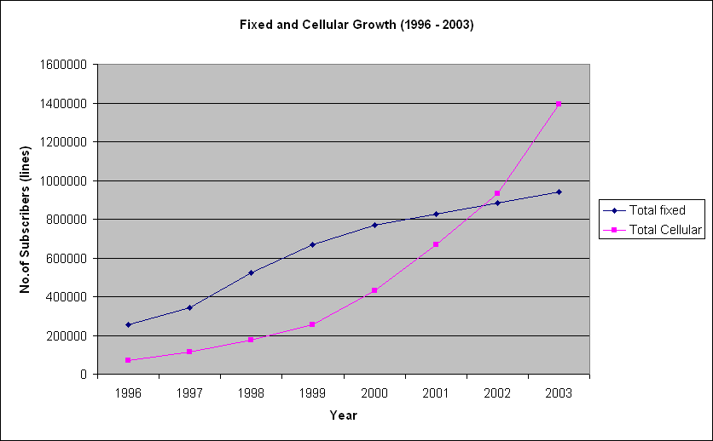

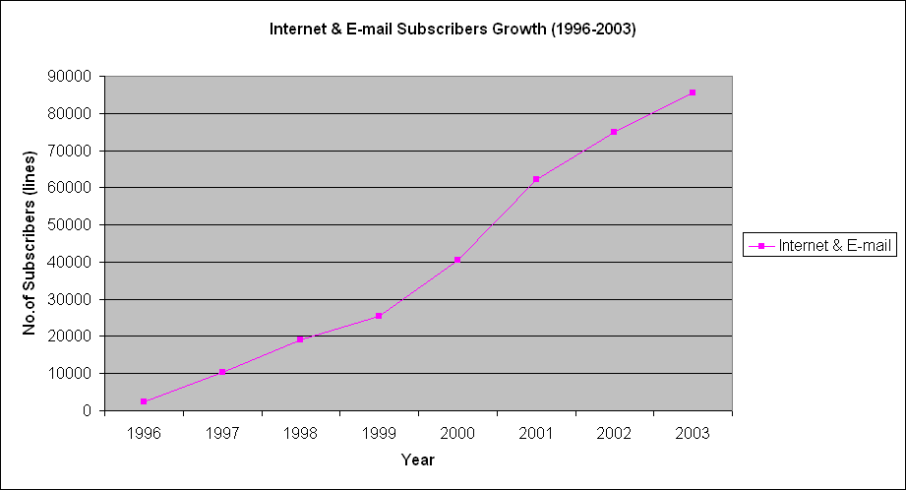

- Data Collection
* Collection of Internal Data
To prepare progress reports and action plans for the organization data is collected from all internal divisions
* Prepare formats for questionnaires

* Send the questionnaire

* Reminders ?
* Collect, enter & analyse data

* Prepare Reports.
- Collection of External Data
- Preparation of a questionnaire for the collection of data
- Analyse the data received & prepare aggregated values
*Calculate estimated values for each sector
* When data is not sent by an operator check with previous values sent by operator and to estimate a value.
* review the formats every year
* Analysis of Data – Graphs, bar charts, etc..
- Prepare & Send reports
- Update Web-site

Operator details

Operator type

2004

Fixed Access Telephone service

3

Cellular Mobile phones

4

Data Communications (facility based)

6

Data Communications (non-facility based) & ISP’s

23

Radio Paging

4

Trunk Mobile Radio

2

Leased Circuit Providers

1

Licensed Payphone Service Providers

2

External Gateway Operator

32

Sub Total

77

Indicators

• Teledensity (Fixed) - 5.0 (As at September 2004)

• Mobidensity – 10.2 (As at September 2004)

• Internet Lines 0.46 per 100 inhabitants

• Revenue per Fixed Line per month US $ 22 (Average)

• Number of Fixed Phones per Employee 77

• Number of Fixed Phones per Mobile Phone 2.1

Digital Access Index (DAI) - 2002 (ITU)
South Asia

Statistical Overview of the Telecommunication Sector as at end of 3rd Quarter 2004

Number of System Licenses 77
Total number of Fixed phones 974,261
Teledensity (Fixed Phones per 100 inhabitants) 5.0
Teledensity (Fixed) in Colombo District – 2003 20.02
Total Switching Capacity of Fixed Operators-2004Jun 1,209,795
Waiting list (fixed) 391,851
Number of Cellular Mobile Subscribers 2,008,355
Mobidensity 10.3
Total Telephone Subscribers (Fixed & Cellular) 2,974,261
Total Teledensity (Fixed & Cellular) 15.3
Internet & Email Subscribers 87,500*
Number of Public Pay Phone Booths 5,938
Number of Paging Subscribers 1,700*
Trunk Mobile Radio Subscribers –2003 144

* - Provisional

        
Fixed Access Subscriber base as at Sep 2004

Province Cumulative

Centra l87,506
East 33,329
North 15,576

North Central 21,596
North West 56,559
Sabaragamuwa 42,171
Southern 67,005
Uva 26,487
Western 624,032

Total 974,261

Fixed Access Subscriber base as at Sep 2003

Fixed Access Subscriber base as at Sep 2003

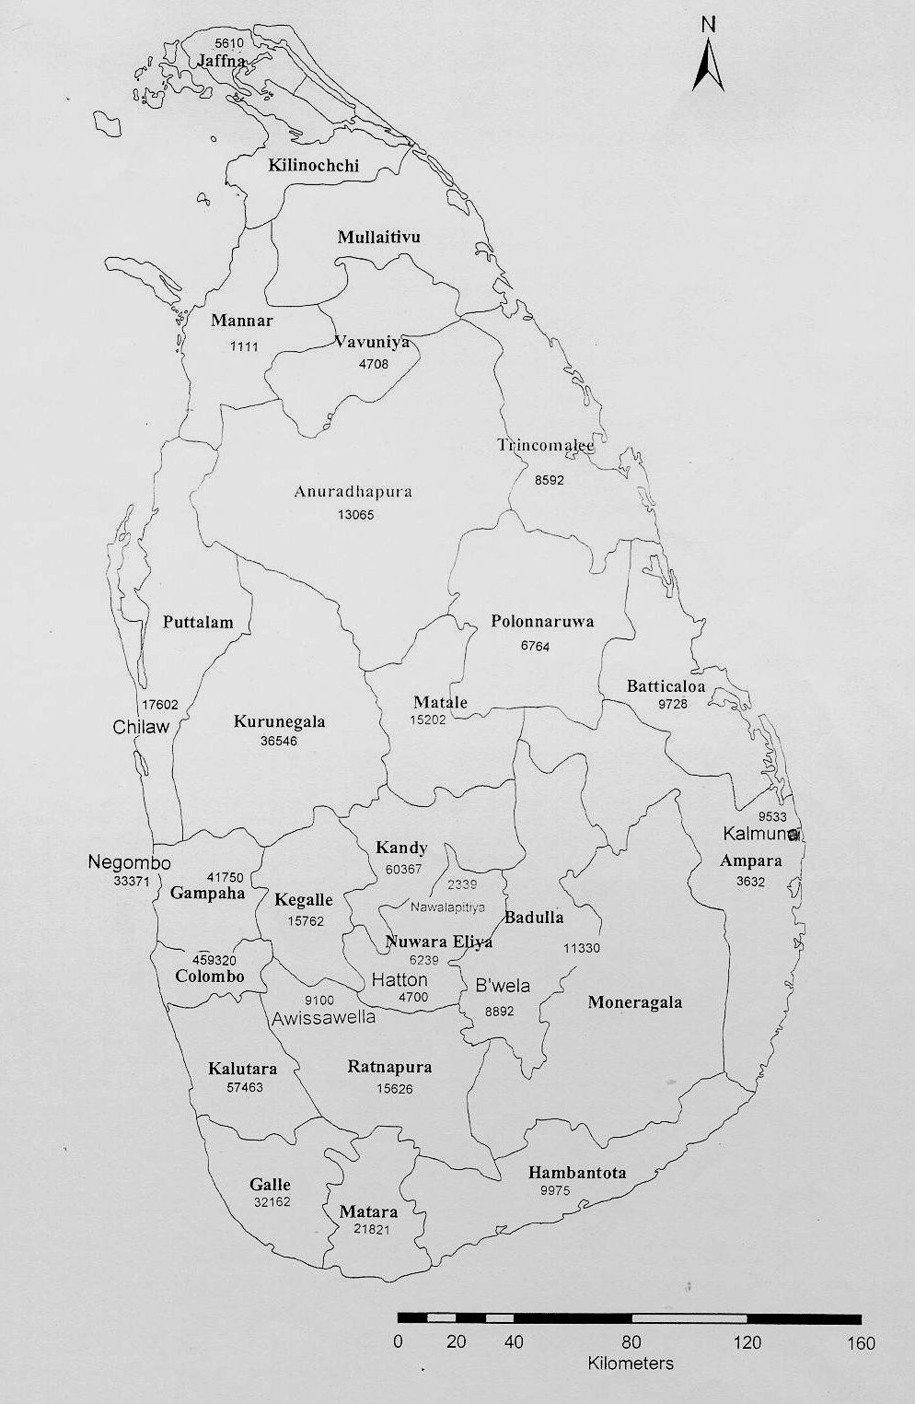

Category of Service

Operator

Subscriber Base

1996

1997

1998

1999

2000

2001

2002

2003

2004 September

Fixed Access Telephone

Wireline
(SLTL)

254,522

315,241

455,598

580,199

653144

708,200

768620

822,992

847,731

WLL (Suntel+LankaBell)

527

26,381

67,931

88,914

114,267

118,995

114,488

116,021

126,530

Total (Fixed)

255,049

341,622

523,529

669,113

767,411

827,195

883,108

939,013

974,261

Cellular

(Celltel, Mobitel,
Hutchison, Dialog)

71,079

114,888

174,202

256,655

430,202

667,662

931,580

1,393,403

2,008,355

Total telephone
(Fixed+Cellular)

326,128

456,510

697,731

925,768

1,197,613

1,494,857

1,814,688

2,332,416

2,982,616

Data Communications

Internet & Email

2,504

10,195

18,984

25,535

40,497

62,159

75,000*

85,500*

87,500*

Public Payphone Booths

3,002

3,682

4,761

5,799

8,222

6,801

6,681

6,440

5,938

Radio Paging

10,721

10,829

10,511

10,300

7,009

6,178

3,541

2,851

1,700*

Trunk Mobile Radio

504

579

144*

144*

Thank you
END

