|  |  |  |
| --- | --- | --- |
| C:\Users\ponder\AppData\Local\Microsoft\Windows\Temporary Internet Files\Content.Word\BDT-25th_anniversary_2017-Logo_411959-3_transparent.png | **Telecommunication Development Advisory Group (TDAG)**  **22nd Meeting, Geneva, 9-12 May 2017** | C:\Users\murphy\AppData\Local\Microsoft\Windows\Temporary Internet Files\Content.Outlook\PQ94T9LJ\bd_E_25Years_Horizontal-411959 (003).jpg |
|  | |  |
|  | | **Revision 2 to Document** **TDAG17-22/****13-E** |
|  | | **8 June 2017** |
|  | | **Original:** **English** |
| Chairman, ITU-D Study Group 1 | | |
| ITU-D Study Group 1 Activities for the SIXTH study period between WTDC-14 and WTDC-17 | | |
|  | | |
| **Summary:**  This report summarizes the activities carried out by Study Group 1 for the sixth study.  **Action required:**  TDAG is invited to take note of this document and provide any guidance as deemed appropriate.  **References:**  [TDAG16-21/5](https://www.itu.int/md/D14-TDAG21-C-0005/), [TDAG15-20/32](https://www.itu.int/md/D14-TDAG20-C-0032/), [1/REP/10](https://www.itu.int/md/D14-SG01-R-0010/) (2014), [1/REP/20](https://www.itu.int/md/D14-SG01-R-0020) (2015), [1/REP/30](https://www.itu.int/md/D14-SG01-R-0030) (2016), [1/REP/40](https://www.itu.int/md/D14-SG01-R-0040) (2017) | | |

# Introduction

The report covers the sixth study period of three years for ITU-D Study Group 1, between WTDC-14 and WTDC-17.

## Mandate and outcomes

Study Group 1 (SG1) was established in accordance with Resolution 2 (Rev. Dubai, 2014) to examine, through Questions adopted by the ITU Membership at the World Telecommunications Development Conference (Dubai, 2014) (WTDC-14), issues relating to the enabling environment for telecommunications/ICT development. The Group is responsible for nine substantive topics, which can be broadly described as: policy, technical, and implementation strategies for migrating to broadband networks, services and applications, including m-services, OTT and IPv6; universal access to broadband technologies and services, including for those in rural and remote areas, those with disabilities and with specific needs; access to cloud computing; economic policies and tariffs for telecommunication/ICT networks; ICT policies for consumer protection; strategies to migrate to digital terrestrial broadcasting; and spectrum management issues.

The formal titles of the Study Group Questions and Resolution 9 are as follows:

* **Question 1/1**: Policy, regulatory and technical aspects of the migration from existing networks to broadband networks in developing countries, including next-generation networks, m-services, OTT services and the implementation of IPv6
* **Question 2/1**: Broadband access technologies, including IMT, for developing countries
* **Question 3/1**: Access to cloud computing: challenges and opportunities for developing countries
* **Question 4/1**: Economic policies and methods of determining the costs of services related to national telecommunication/ICT networks, including next-generation networks
* **Question 5/1**: Telecommunications/ICTs for rural and remote areas
* **Question 6/1**: Consumer information, protection and rights: Laws, regulation, economic bases, consumer networks
* **Question 7/1**: Access to telecommunication/ICT services by persons with disabilities and with specific needs
* **Question 8/1**: Examination of strategies and methods of migration from analogue to digital terrestrial broadcasting and implementation of new services

**Resolution 9** (Rev. WTDC-14) on the “Participation of countries, particularly developing countries, in spectrum management,” a joint group with ITU-R Study Group 1

SG1 concluded its work at its fourth and final meeting held in Geneva from 27 to 31 March 2017, approving final reports for all nine questions, and producing close to 80 guidelines for ITU Membership.

## Study Group 1 management

WTDC-14 designated the SG1 leadership for the sixth cycle (2014-2017): Mrs Roxanne McElvane Webber, (United States) served as Chairman, and was ably assisted by eleven Vice-Chairmen representing the six regions of the world:

* Mrs Regina Fleur Assoumou Bessou (Côte d’Ivoire)(AFR)
* Mr Peter Ngwan Mbengie (Cameroon) (AFR)
* Mrs Claymir Carozza Rodriguez (Venezuela) (AMS)
* Mr Victor Martinez (Paraguay) (AMS)
* Mr Wesam Al-Ramadeen (Jordan) (ARB)[[1]](#footnote-1)
* Mr Ahmed Abdel Aziz Gad (Egypt) (ARB)
* Mr Yasuhiko Kawasumi (Japan) (ASP)
* Mr Nguyen Quy Quyen (Viet Nam) (ASP)
* Mr Vadym Kaptur[[2]](#footnote-2) (Ukraine) (CIS)
* Mr Almaz Tilenbaev (Kyrgyz Republic) (CIS)
* Ms Blanca Gonzalez (Spain) (EUR)

***Study Group 1 Vice Chairs***

The SG1 Vice-Chairs actively followed the work assigned by WTDC-14, consistently providing sound and valuable advice to the Chair on all issues related to the Study Group including personnel matters, working methods, and all substantive outcomes called for by WTDC-14. In the latter regard, the Vice-Chairs particpated in an organized peer review exercise to prepare the final outputs covering all nine final reports from the Questions and Resolution 9 according to their declared principal areas of interest:

Mrs Regina Bessou (tariffs, rural communications, and accessibility);

Mr Peter Mbengie (cloud computing and Resolution 9 spectrum issues);

Mrs Claymir Rodriguez (migration to broadband, broadband technology, rural comunications and DTV transition);

Mr Victor Martinez (migration to broadband, broadband technology, rural communications and Resolution 9 spectrum issues);

Mr Ahmed Gad (migration to broadband, broadband technology and Resolution 9 spectrum issues);

Mr Yasuhiko Kawasumi (broadband technology and rural communications);

Mr Nguyen Quyen (consumer issues, DTV transition and rural communications);

Mr Vadym Kaptur (migration to broadband, cloud computing and tariffs);

Mr Almaz Tilenbaev (rural communications and accessibility);

Ms Blanca Gonzalez (ITU Council issues, languages and interpretation, and DTV transition).

Some Vice-Chairs also corresponded with ITU regional offices and with Administrations in their regions to encourage relevant contributions to the work. Other Vice-Chairs prepared and contributed to surveys including through translation during informal SG1 managment team working groups

Finally, in addition to serving as a Vice-Chair from the CIS Region, Mr Vadym Kaptur served as Co-Rapporteur for Question 1/1 on strategies for migrating to broadband networks, services and applications, which received the highest number of contributions during 2014-2017.

The Chair notes that all engagements with the SG1 management team during 2014-2017 period exhibited collegiality, cooperation, and a high degree of professionalism reflecting each member’s sincere dedication to the mission and objectives of the study group and its participants.

The team of Rapporteurs, Co-Rapporteurs, Vice-Rapporteurs, and BDT Focal Points responsible for the SG1 Questions and Resolution 9 can be found in **Annex 1**. The full text of the Questions adopted including, inter alia, a statement of the Question’s context, a description of the expected output, and an initial work plan with the required timing for the output, etc., is available on the Study Group 1 website in document [1/2](http://www.itu.int/md/D14-SG01-C-0002)[[3]](#footnote-3).

## Participation and written contributions (2014-2017)

A total of 599 delegates participated in at least one Study Group 1 meeting (**Graph 1**). The highest number came from Africa, followed by Asia and Pacific, then the Americas, Europe, Arab States and the Commonwealth of Independent States (CIS). Annual SG1 meetings average a little more than 160 participants from more than 57 countries.

Graph 1

Number of individual participants (per region) for Study Group 1 meetings  
(September 2014 – March 2017)

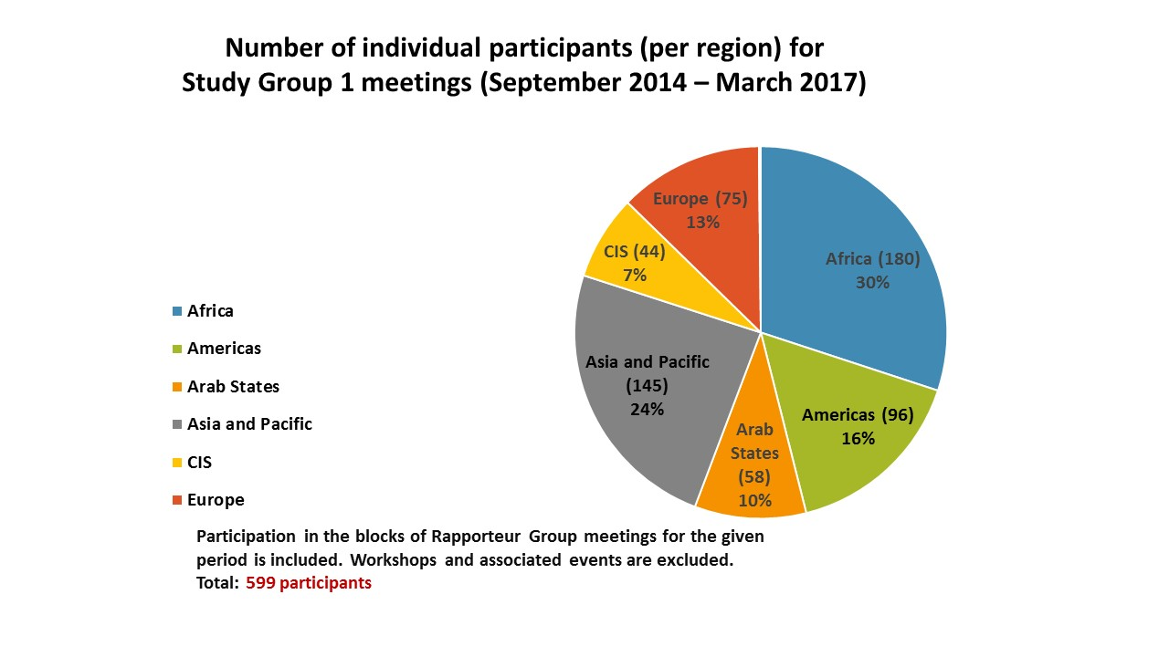

Graph 2

Aggregate number of participants (per region) for Study Group 1   
and Rapporteur Group meetings[[4]](#footnote-4)  
(September 2014 – March 2017)

**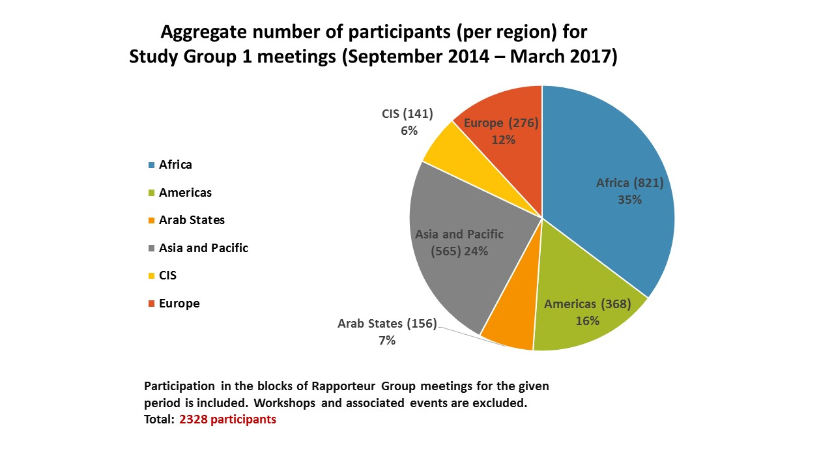**

Study Group 1 received a total of 698 documents of which 476 were contributions (**Graph 3**). The majority of the contributions came from Asia and Pacific, followed by Africa, then Americas, Europe, CIS and Arab States.

Graph 3

Number of contributions received (per region) for Study Group 1   
and Rapporteur Group meetings  
(September 2014 – March 2017)

**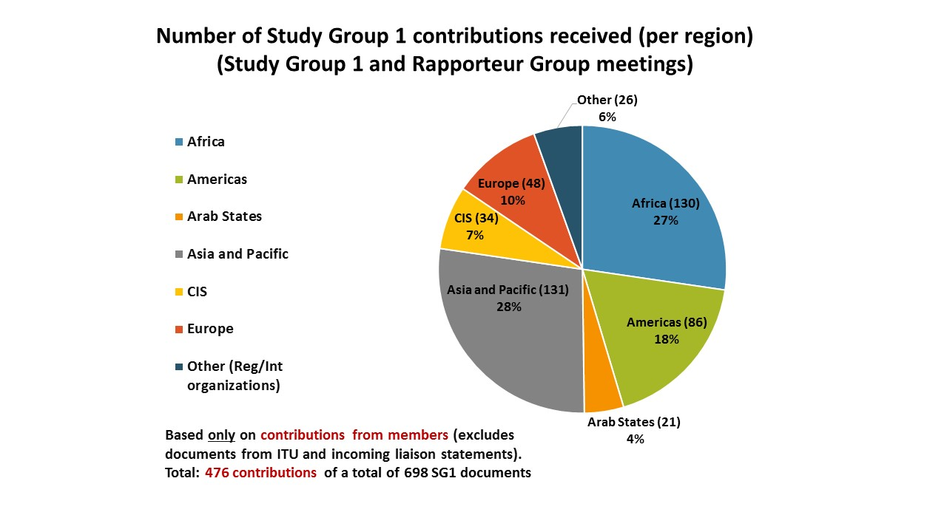**

As illustrated in **Table 1** each Question received a satisfactory number of written contributions, including liaison statements, to complete its deliverables for the study period. The three Questions receiving the highest number are: Question 1/1 with 143, Q7/1 with 108 and Q5/1 with 99 contributions respectively (**Graph 4**). Contributions that were addressed to all SG 1 Questions and liaison statements received by SG 1 are included in the total reflected in **Table 1**, as this is highly representative of the relevance and interest in a particular Question. **Table 2** shows the number of contributions received per year for ITU-D Study Group 1 and Rapporteur Group meetings. The number of incoming and outgoing liaison statements for the study period are also included in **Table 2**.

Graph 4

Number of contributions received for Study Group 1 and Rapporteur Group meetings per Question (with source) (September 2014 – March 2017)

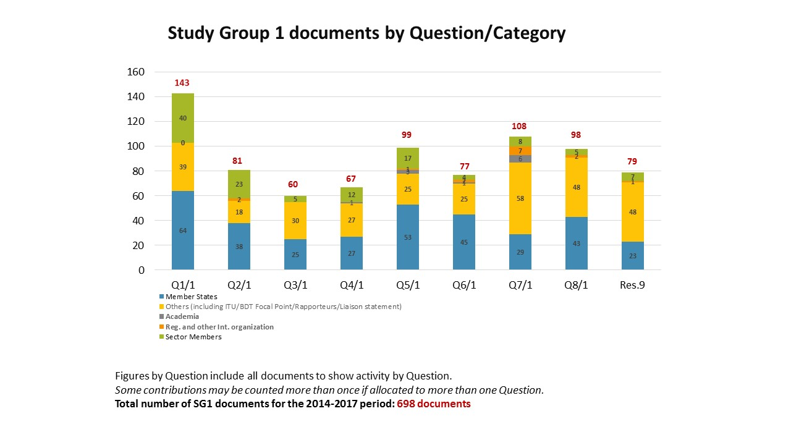Table 1

Number of contributions received per Study Group 1 Question  
(September 2014 – March 2017)

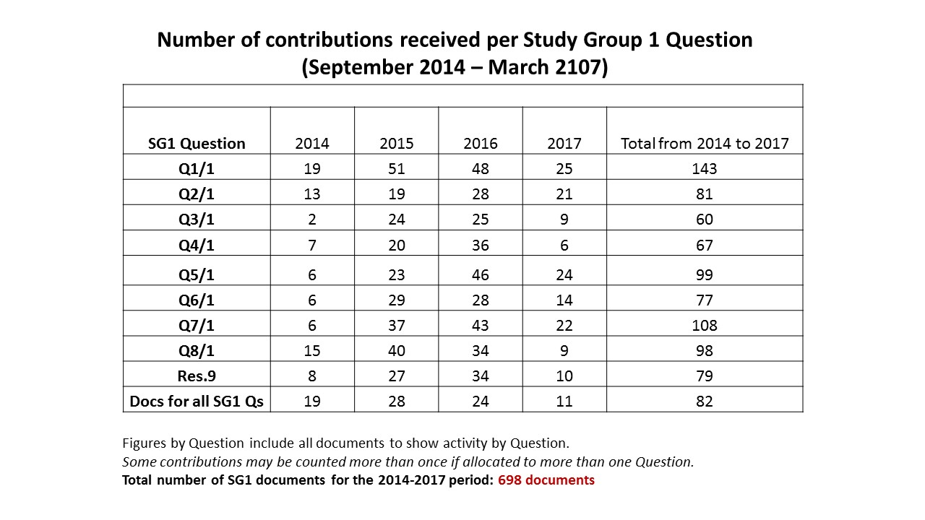

Table 2

Number of contributions received for Study Group 1 and Rapporteur Group meetings each year  
(September 2014 – March 2017)

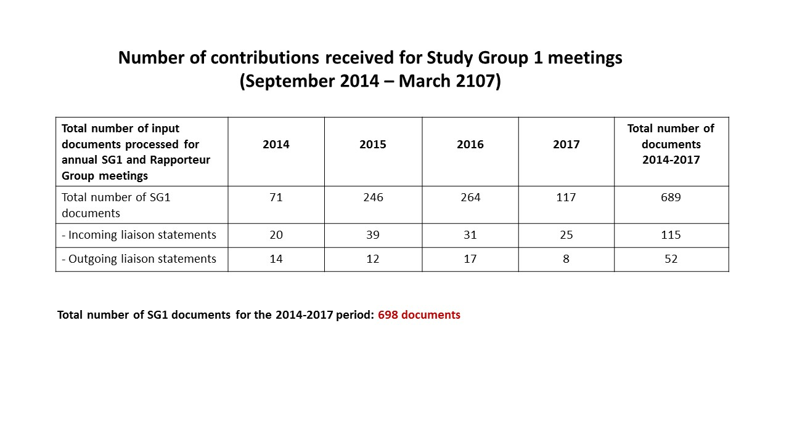

The Rapporteur Groups for Questions 5/1 and 6/1 prepared and circulated questionnaires to gather specific information on telecommunications/ICTs for rural and remote areas and telephone numbering misuse and misappropriation respectively for use in their reports. Other groups included information provided by the BDT Focal Points from the BDT annual regulatory survey, and reviewed the results of other ongoing ITU work in their analysis. Using data obtained by the BDT through the annual survey, case studies, regional initiatives, projects, and other ongoing activities can provide comprehensive and current information to the Study Groups while helping to avoid duplication.

Drawing from their expertise and work in the Telecommunication Development Sector, and in keeping with past practice in the previous study period (2010-2014), at least one of the BDT Focal Points assigned to work with the nine SG1 questions made substantive, written contributions to each of the Questions at every meeting. Crucial statistical information, objective and anecdotal examples from the regions, materials presented at regional seminars, and illustrative charts and graphs supplied by the focal points enhance and appear in the SG 1 final reports. In addition, Study Group participants received consistent and critical support from the BDT Secretariat throughout the period.

# Meetings

## Management team meetings

Following the appointment of the Chairman and Vice-Chairmen at WTDC in Dubai, four management team meetings were held on the eve of each annual Study Group 1 meeting. These meetings permitted the Chairman, Vice-Chairmen, Rapporteurs, Vice-Rapporteurs, BDT Focal Points and Secretariat to prepare for the meeting: i.e. review the progress of each Question under study, discuss planned and on-going activities, propose ways to manage the work product and personnel, and discuss ideas to enhance the Study Group output and procedures.

## Study Group 1 meetings

During the course of the study period, Study Group 1 met four times: three times in the month of September each year (2014, 2015, 2016) and the fourth and final meeting was held in March 2017. Notably, the 2014 Plenipotentiary conference decided to hold only one major ITU Conference each year, WTDC-14 was moved from 2018 to 2017 giving the ITU-D study groups less time to complete their work this period.

Notwithstanding this abbreviated schedule, because of the dedication and tenacity of many leaders of Questions, Resolution 9, and BDT Focal Points, the generosity of several Administrations and the support of the BDT Director and Staff, SG1 participants were also able to benefit from three expert group meetings and four workshops during the period. These events were held in Budapest, Hungary (spectrum management and DTV), Chongqing, China, Cotonou Benin (consumer protection) and Geneva Switzerland (international mobile roaming).[[5]](#footnote-5)

* + 1. **The first meeting** was held in Geneva from 15 to 19 September 2014. The meeting reviewed and discussed the 69 contributions received and made the following decisions:
* Appointed Rapporteurs and Vice-Rapporteurs for the nine study Questions;
* Agreed to detailed work plans for all Questions and Resolution 9 prepared by the associated management teams.

The report of this meeting is available at: https://www.itu.int/md/D14-SG01-R-0010/.

* + 1. **The second meeting** was held in Geneva from 14 to 18 September 2015. The meeting reviewed the 154 contributions received and made the following decisions:
* Appointed Mr Vadim Kaptur (ONAT, Ukraine) and Mr Yahya Nasser Mohammed Al Hajri (TRA, Oman) as Co-Rapporteurs for Question 1/1. Appointed Mr Christopher Banda (Malawi) as Vice-Rapporteur for Question 5/1, and Ms Amela Odobašić (Bosnia-Herzegovina) as Co-Rapporteur for Q7/1 (accessibility).
* Agreed on preliminary draft outlines for all WTDC expected outputs for all Questions and Resolution 9;

With ITU-T, SG1 held a successful event titled “Let’s Roam the World, the ITU Global Dialog on International Mobile Roaming.”

The report of this meeting is available at: <https://www.itu.int/md/D14-SG01-R-0020/>.

* + 1. **The third meeting** was held in Geneva from 19 to 23 September 2016. The meeting reviewed the 147 contributions received and made the following decisions:
* Appointed Ms Tharalika Livera (Telecommunications Regulatory Commission, Sri Lanka), as Vice-Rapporteur for Question 2/1 and Question 5/1; Ms Zhang Li (People’s Republic of China) as Vice-Rapporteur for Question 5/1 to replace Ms Chunxia Bai (People’s Republic of China), Mr Arseny Plossky (Russian Federation), as Vice-Rapporteur for Question 8/1, and Ms LiChing Sung (United States of America) as Co-Chair for Resolution 9 to replace Mr Scott Kotler (Lockheed Martin Corporation, United States of America);
* Agreed to include **guidelines** in all revised drafts of final outputs for all Questions and Resolution 9;

The report of this meeting is available at: <https://www.itu.int/md/D14-SG01-R-0030/>.

* + 1. **The fourth meeting and final meeting** was held in Geneva from 27 to 31 March 2017. The meeting reviewed the 66 contributions and made the following decisions:
* Approved 9 reports containing the outputs called for by WTDC-14 for all SG1 Questions and Resolution 9.

The meeting also undertook constructive discussion on the future of the existing study Questions and future SG1 work. The meeting dates for Study Group 1 during the next study period (2018 –2021) were also considered.

The report of this meeting is available at: <https://www.itu.int/md/D14-SG01-R-0040/>.

**Annex 2** presents a table showing the dates the Study Group and Rapporteur Groups met during the period. A substantial amount of the work is carried out electronically and by correspondence in between the physical meetings, notably as this relates to finalizing the deliverables.

# Summary of the key results achieved

## Question 1/1 – Policy, regulatory and technical aspects of the migration from existing networks to broadband networks in developing countries, including next-generation networks, m-services, OTT services and the implementation of IPv6

The approved report of the March 2017 Rapporteur Group meeting for Question 1/1 can be found in [1/REP/31](https://www.itu.int/md/D14-SG01-R-0031/en). The Output Report available in document [1/412](https://www.itu.int/md/D14-SG01-C-0412/en), and temporary document [1/TD/14](https://www.itu.int/md/D14-SG01-170327-TD-0014) which includes the requested modifications requested during the Rapporteur Group meeting, were agreed.

Regarding the future of Question 1/1, the results of the two surveys carried out by the ITU-D Study Groups on the current work and the future of the Q1/1 indicate that this Question should continue, however, the current focus is considered too broad. Two documents presented to ITU-D SG1 at the final meetings ([1/432](https://www.itu.int/md/D14-SG01-C-0432/en), [1/454](http://web.itu.int/md/D14-SG01-C-454/en)) with proposals for the future of the study Question were considered. The Q1/1 Co-Rapporteur asked for a group of volunteers to work on these proposals and come up with a common proposal before the meeting Telecommunication Development Advisory Group (TDAG) in May 2017. *No agreed way forward was reached by the Rapporteur Group.*

* 1. **Question 2/1 – Broadband access technologies, including IMT, for developing countries**

The approved report of the March 2017 Rapporteur Group meeting for Question 2/1 can be found in [1/REP/32](https://www.itu.int/md/D14-SG01-R-0032/en). The Output Report and guidelines available in document [1/413](https://www.itu.int/md/D14-SG01-C-0413/en), was agreed with a number of changes to be made.

When discussing the future of Q2/1 one proposal focused on expanding the current Question to policies for allocation and access technologies. Another proposal ([1/463](https://www.itu.int/md/D14-SG01-C-0463/)) asked to reflect the importance of IMT-2020 (5G) and relevant work during the next period. A summary table on the present situation of the all Questions dealing with broadband issues was also presented. *No agreed way forward was reached by the Rapporteur Group.*

* 1. **Question 3/1 – Access to cloud computing: challenges and opportunities for developing countries**

The approved report of the March 2017 Rapporteur Group meeting for Question 3/1 can be found in [1/REP/33](https://www.itu.int/md/D14-SG01-R-0033/en). The Output Report and guidelines available in document [1/414](https://www.itu.int/md/D14-SG01-C-0414/en) was agreed with a few changes to be made.

According to the results of the surveys, the topics studied under Question 3/1 were considered relevant for the future and encouraged that Q3/1 continue its work during the next study period. The Q3/1 Rapporteur noted that the scope of the Question needs to be revised, suggesting that the focus could be on the following three aspects: 1) Specific applications within Cloud Computing, including digital and environmental aspects. 2) Cloud computing within states: indicators and country's readiness for Cloud implementation. 3) Economic issues of integrating Cloud technologies into existing business models. *The Rapporteur Group proposed to continue the study Question.*

* 1. **Question 4/1 – Economic policies and methods of determining the costs of services related to national telecommunication/ICT networks, including next-generation networks**

The approved report of the March 2017 Rapporteur Group meeting for Question 4/1 can be found in [1/REP/34](https://www.itu.int/md/D14-SG01-R-0034/en). The Output Report and guidelines available in document [1/415](https://www.itu.int/md/D14-SG01-C-0415/en) was agreed with a number of changes to be made.

Regarding the future of Question 4/1, participants expressed the view that while the scope would need to change, Q4/1 should continue its work. Comments included the view that the task is no longer to compare bottom-up and top-down models but to move on to reflect reality at the regulatory level, e.g., how to help regulators apply principles in a new tariffing environment focusing more on contracts and packages. Emphasis should be put on tariff methods and remaining mindful of new costing and tariff methods, others noted. Beyond that, the group noted that it is important to address this issue in the context of emergent new services and concepts such as OTTs and Internet of Things (IoT). A proposed title for the new study period: ***“Policies, economics and tariff methods for applications and services on communication networks****.”* Other specific issues proposed were to include spectrum pricing, tax and other fiscal incentives and their impact on telecommunications/ICTs, as well as the needs of people with specific needs. *The Rapporteur Group proposed to continue the study Question.*

* 1. **Question 5/1 – Telecommunications/ICTs for rural and remote areas**

The approved report of the March 2017 Rapporteur Group meeting for Question 5/1 can be found in [1/REP/35](https://www.itu.int/md/D14-SG01-R-0035/en). The Output Report and guidelines available in document [1/416](https://www.itu.int/md/D14-SG01-C-0416/en), and temporary document [1/TD/2](https://www.itu.int/md/D14-SG01-170327-TD-0002), were agreed with a few changes to be made.

Regarding the future of Question 5/1, the participant survey highlights the importance of continuing to study different aspects of ICTs for rural and remote areas as the majority of people in developing countries still live in these areas and thus access, innovation and capacity building must be ensured. Drawing on earlier discussion, a contribution ([1/423](https://www.itu.int/md/D14-SG01-c-0423)) presented some views on the future of Q5/1. A continued interest in and need for further studies into topics related to telecommunications/ICTs for rural and remote areas was indicated. *The Rapporteur Group proposed to continue the study Question.*

* 1. **Question 6/1 – Consumer information, protection and rights: Laws, regulation, economic bases, consumer networks**

The approved report of the March 2017 Rapporteur Group meeting for Question 6/1 can be found in [1/REP/36](https://www.itu.int/md/D14-SG01-R-0036/en). The Output Report and guidelines available in document [1/417](https://www.itu.int/md/D14-SG01-C-0417/en) was agreed with a few changes to be made.

Regarding the future of Question 6/1, the participant survey points out the cross-cutting nature of consumer protection and also draws attention to the need to revise Q6/1 to take into account changing consumer needs. During the Rapporteur Group meeting participants agreed on the need to continue to explore the Question with the understanding that the description of the Question and its title requires refinement to reflect a changing ecosystem. A proposal for the title was: ***“Consumer protection, challenges and opportunities in the digital economy/era”****.* Other ideas for future study: more emphasis should be put on collaboration mechanisms as well as on capacity building mechanisms, more coordination among regulatory organizations, operators and consumer groups. In emphasizing coordination and collaboration the next study period could address how collaboration mechanisms in the new ecosystem could be improved. Tools for consumers could be addressed to enable them to be better informed of market offers and supply and thus make more informed choices. *The Rapporteur Group proposed to continue the study Question.*

* 1. **Question 7/1 – Access to telecommunication/ICT services by persons with disabilities and with specific needs**

The approved report of the March 2017 Rapporteur Group meeting for Question 7/1 can be found in [1/REP/37](https://www.itu.int/md/D14-SG01-R-0037/en). The Output Report available in document [1/418](https://www.itu.int/md/D14-SG01-C-0418/en), was agreed with a few changes to be made.

Regarding the future of Question 7/1, the participant survey underscores the role of the ITU-D Study Groups as a global platform that enables Members to work on ICT accessibility for persons with disabilities (PwD). Commenters suggested that in the next study period Q7/1 could work to help Members to implement the guidelines that have been developed this cycle. Additionally, the meeting agreed that, based on a contribution received ([1/469](https://www.itu.int/md/D14-SG01-C-0469/en)), Q7/1 should also focus on accessible telecommunications/ ICT access for the aging population. A proposal for the title was: ***“ICT accessibility for persons with disabilities, including age related disabilities and with specific needs”****. The Rapporteur Group proposed to continue the study Question.*

* 1. **Question 8/1 – Examination of strategies and methods of migration from analogue to digital terrestrial broadcasting and implementation of new services**

The approved report of the March 2017 Rapporteur Group meeting for Question 8/1 can be found in [1/REP/38](https://www.itu.int/md/D14-SG01-R-0038/en). The Output Report available in document [1/419](https://www.itu.int/md/D14-SG01-C-0419/en), and communication guidelines in [1/421](https://www.itu.int/md/D14-SG01-c-0421) were agreed with a number of changes to be made.

Regarding the future of Question 8/1, it was noted in the participant survey that many transition deadlines for analogue to digital terrestrial television had passed, many countries are still in the experimental phase with new digital sound/radio services. New topics proposed during the Rapporteur Group meeting included broadening the scope of Q8/1 to include the evolution of the digital transition in broadcasting and digital radio/sound broadcasting, and how to use the released frequencies for new services and applications; to include economic aspects of the deployment of new broadcasting services and applications, and to study the impact of other television distribution platforms. Collecting countries’ experiences on interference mitigation between broadcasting and new service and the implementation of new services and applications (Community and regional TV on DTV and new Broadcasting services: 3D, 4K, 8K, etc.) were also deemed important. Including relevant issues related to people with disabilities was also supported. *The Rapporteur Group proposed to continue the study Question.*

* 1. **Resolution 9 –Participation of countries, particularly developing countries, in spectrum management**

The approved report of the March 2017 meeting of the ITU-D/ITU-R Joint Group for WTDC Resolution 9 can be found in [1/REP/39](https://www.itu.int/md/D14-SG01-R-0039/en). The Output Report available in document [1/420](https://www.itu.int/md/D14-SG01-C-0420/en), and in temporary document [1/TD/18](https://www.itu.int/md/D14-SG01-170327-TD-0018/), were agreed with a number of changes to be made.

The discussion on the future of the Resolution 9 addressed both the preferred method of work and the topics to study for the next study period.

* Working methods: Mechanisms to strengthen the collaboration between the ITU-D and ITU-R sectors. One suggestion was to hold regular meetings jointly with the ITU-R SG1 meetings to allow for more interaction between experts and attendees of the two sectors. Another issue is how to re-envision the Resolution 9 outputs of e.g., the type of report and guidelines, holding a series of workshops, and the topics to be discussed.
* Study topics supported: spectrum fees, software for fees calculations, harmonization of licenses and the role of spectrum management in achieving the 2030 SDGs, effective utilization of spectrum and IoT applications, and Short Range Devices. *The joint group proposed to continue the study during the next study period.*

# Surveys on the ITU-D Study Groups: Questions, working methods, and future activities[[6]](#footnote-6)

In keeping with Section 11.4.3 of Resolution 1 (Rev. Dubai 2014), the ITU-D Study Groups issued two surveys to seek feedback both from ITU Members and from individual study group participants on the work conducted by the Groups, its future work, and on participant’s specific experiences.

## 4.1 Global survey to ITU Membership (6th study period, 2014-2017)

The **“Global survey on the work of ITU-D Study Groups (6th study period, 2014-2017)”** was initiated by ITU-D Study Group 2 Question 9/2 and in November 2016 was sent to the appointed focal points in ITU Member States, Sector Members, Associates, Academia and members of the ITU-D Study Group 1 and 2 Management Teams through a Circular Letter ([BDT/IP/CSTG-14](http://www.itu.int/md/D14-CA-CIR-0014)). This survey aimed primarily to gather feedback on the usefulness of the outputs of ITU-D Study Group 1 and 2 studies, understand the relevance of the topics under study, and seek input for future priority areas. 40 responses were received. Representatives from Administrations, Administration-related entities and Ministries made up 57.5 per cent of the respondents. Some results include:

* Regarding the **structure** and the **number of ITU-D Study Groups**, the current two were considered appropriate. However, some of the comments received revealed that the Members feel that some **study Questions are allocated to the wrong study group[[7]](#footnote-7)** (). Ambiguity concerning the **current mandates of the study groups** was mentioned. The **large number of study Questions** was also mentioned by several respondents. Merging Questions would make sense to some respondents in order to strengthen the ITU-D Study Groups. None of the respondents wanted to increase the number of Questions under each study group.
* The need to **avoid duplication** in the study groups was noted.

The respondents also rated **their satisfaction with the ITU-D Study Group 1 and Study Group 2 Questions’ deliverables** in terms of their relevance and the outputs that they are producing for the study period. [[8]](#footnote-8) In this regard, respondents indicated that they were “Very satisfied” with Questions 5/1, 7/1, 8/1. Res.9 and Q1/2 (tied with “Satisfied”), Q3/2, and Q5/2, and that they were ‘Satisfied’ with Questions 1/1, 2/1, 3/1, 4/1, 6/1, Q2/2, Q4/2, Q6/2, Q7/2, Q8/2, and Q9/2. In no cases did a majority of the respondents indicate that they felt ‘Neutral’ or ‘Not satisfied’ with the deliverables produced by the Questions.

Full details of the survey can be found in document[1/447](https://www.itu.int/md/D14-SG01-C-0447/en) + Annexes.

## 4.2 Survey to ITU-D Study Group Participants

Initiated by ITU-D Study Group 1, the purpose of the “**Survey on ITU-D Study Group Questions, procedures, and proposals on future activities**” was to seek the views of ITU-D Study Group 1 and 2 participants on the groups’ activities and outputs for the 2014 – 2017 study period, and on future activities for the next study period. The aim of the survey was to gather information from actual participants so their views could benefit and inform those who may seek to formulate proposals on these issues at Regional Preparatory Meetings (RPMs) and at WTDC-17. The survey results were also intended to complement the feedback obtained from Member States through the survey initiated by ITU-D Study Group 2 Question 9/2 on these issues.

A total of 28 responses were received from 22 countries. Regional participation: Africa (29%), the Americas (19%), Asia and Pacific (19%), CIS (9%) and Europe (24%).

Participants were asked to comment on the future of each Question in ITU-D Study Group 1 and 2. There were four possibilities: Continue, Merge, Revise or Suspend. The results revealed that all the Questions should continue. Several respondents proposed revising or merging r some of the Questions, particularly to merge Questions 1/1 and 2/1. The need to avoid duplication and overlap was also emphasized.

Full details of the survey can be found at: [1/458](https://www.itu.int/md/D14-SG01-C-0458/en) + Annex.

The findings of the surveys can be useful for the Membership as it prepares for WTDC-17.

# Study Group 1 participants views expressed during innovation exercises 2014-2017

Reflecting the ‘culture of innovation’ encouraged by the BDT Director and staff initiated during 2010-2014, at each of the three annual SG1 meetings, discussions were held on ways to innovate for continuous improvement. A summary of suggestions follows for further consideration:

**Ways to increase time**

* Add additional meetings or workshops in the regions for several days where issues can be discussed at length;
* Hold regional meetings; increase the role of regional offices;
* Make greater use of technology (e.g., video conference); add virtual meetings to the annual schedule to increase the number and frequency of outputs;
* Use correspondence groups
* Post draft output reports on SharePoint in advance of meeting so SG participants can begin comment
* Resolution 1 could be modified to direct Rapporteur to determine the order of documents presented so that those directly relevant to the WTDC output could be presented before others; avoid multiple presentations of the same document
* Present all documents on days one and two; use the balance of the time to discuss and analyze, hold drafting groups;
* Add additional days or a third week and overlap SG1 and 2;
* Hold parallel meetings within and between groups, include captioning;
* 5 questions per study group maximum

**Contributions**

* On the Resolution 1 template for contributions, add a place indicating where the contribution should be placed in the expected output;
* Resolution 1 can be modified to encourage the Rapporteur to define contributions needed to complete the expected output;
* At the final meeting of the study period, limit (most) contributions to text or track changes for the final output report.
* BDT trains Rapporteurs and their teams to use appropriate tech tools, e.g., SharePoint, etc. to advance additional communications with the team for the final output and so that drafting could proceed between and in advance of physical meetings; use with all groups;

**Other**

* Use regions, regional offices, and study groups to obtain feedback on the workability or success of implementing existing guidelines
* Create and implement a monitoring and feedback system so that the SG can determine whether the work throughout the cycle and the final output was useful.
* Consider outputs other than reports
* Explore innovative ways to increase financial resources for translation, interpretation, fellowships, workshops, and other SG activities.
* Gather feedback from Rapporteurs through short, informal reports describing their individual experiences over the study period. Rapporteurs could present these reports to support their teams and flag any issues during the cycle.
* To arrange seating at certain meetings according to topic/issues or Rapporteur Group to easily identify others with similar interests and stimulate further discussion.

# Conclusion

Study Group 1 has successfully carried out its mandate – in this abbreviated study period which saw an increase in the number of delegates and e in the number and quality of contributions submitted – because of the hard work, dedication, perseverance, flexibility, and expertise of all the parties concerned: the SG1 Management Team, Vice-Chairmen, Rapporteurs, Vice-Rapporteurs, Focal Points, BDT Secretariat, active contributors, in person and remote meeting participants, interpreters, translators and IT support staff. With strong and consistent support from the BDT Director and his staff, the Group has fulfilled its mission.

Annex 1  
List of Study Group 1 Chairman, Vice-Chairmen, Rapporteurs,  
Vice-Rapporteurs, and BDT Focal Points

**Sixth study period (2014-2017)**

Study Group 1 Chairman and Vice-Chairmen

| **Role** | **Name** | **Country** | **Region** |
| --- | --- | --- | --- |
| **Chairman** | **Ms Roxanne MCELVANE WEBBER** | **United States** | **AMS** |
| Vice-Chairman | Ms Regina Fleur ASSOUMOU-BESSOU | Côte d'Ivoire | AFR |
| Vice-Chairman | Mr Peter Ngwan MBENGIE | Cameroon | AFR |
| Vice-Chairman | Mr Víctor MARTÍNEZ | Paraguay | AMS |
| Vice-Chairman | Ms Claymir CAROZZA RODRÍGUEZ | Venezuela | AMS |
| Vice-Chairman | Mr Wesam AL-RAMADEEN | Jordan | ARB |
| Vice-Chairman | Mr Ahmed Abdel Aziz GAD | Egypt | ARB |
| Vice-Chairman | Mr Nguyen Quy QUYEN | Viet Nam | ASP |
| Vice-Chairman | Mr Yasuhiko KAWASUMI | Japan | ASP |
| Vice-Chairman | Mr Vadym KAPTUR | Ukraine | CIS |
| Vice-Chairman | Mr Almaz TILENBAEV | Kyrgyz Republic | CIS |
| Vice-Chairman | Ms Blanca GONZÁLEZ | Spain | EUR |

**Study Group 1 Rapporteurs, Vice-Rapporteurs, and BDT Focal Points**

|  |  |  |  |  |
| --- | --- | --- | --- | --- |
| **Question** | **Title of the Question** | | | |
| **Q1/1** | **Policy, regulatory and technical aspects of the migration from existing networks to broadband networks in developing countries, including next-generation networks, m-services, OTT services and the implementation of IPv6** | | | |
| **Title** | **Name** | | **Represented entity** | **Region** |
| Co-Rapporteur | Mr Yahya Nasser Mohammed AL HAJRI | | Oman Telecommunications Regulatory Authority (TRA), Oman | ARB |
| Co-Rapporteur | Mr Vadym KAPTUR | | A.S. Popov Odessa National Academy of Telecommunications (ONAT), Ukraine | CIS |
| Vice-Rapporteur | Dr William Kyoungyong JEE | | Korea (Rep. of) | ASP |
| Vice-Rapporteur | Mr Rachid OUTEMZABET | | Algeria | ARB |
| Vice-Rapporteur | Mr Serge Edgard KOUDJO | | Benin | AFR |
| Vice-Rapporteur | Mr Abdoulaye OUEDRAOGO | | Burkina Faso | AFR |
| Vice-Rapporteur | Mr Albert KAMGA | | Cameroon | AFR |
| Vice-Rapporteur | Mr Gilbert BALEKETTE | | Central African Republic | AFR |
| Vice-Rapporteur | Mr Chunfei ZHANG | | China (P.R. of) | ASP |
| Vice-Rapporteur | Mr Luc MISSIDIMBAZI | | Congo (Rep. of) | AFR |
| Vice-Rapporteur | Mr Patrick H.B. ZEBOUA | | Côte d'Ivoire | AFR |
| Vice-Rapporteur | Mr Joseph Bruno YUMA UTCHUDI | | Democratic Republic of the Congo | AFR |
| Vice-Rapporteur | Mr Mamadou Pathé BARRY | | Guinea | AFR |
| Vice-Rapporteur | Mr Satya N. GUPTA | | ITU-APT Foundation, India | ASP |
| Vice-Rapporteur | Ms Jane COFFIN | | United States of America | AMS |
| Vice-Rapporteur | Mr Turhan MULUK | | Intel Corporation, United States of America | AMS |
| **Focal Points** | | | | |
| BDT Focal Point | Mr Vladimir Daigele | | ITU/BDT | Headquarters |
| BDT Focal Point | Nancy Sundberg | | ITU/BDT | Headquarters |
| BDT Focal Point | Mr Marcelino TAYOB | | ITU/AFR | AFR |
| BDT Focal Point | Ms Chali TUMELO | | ITU/AFR | AFR |
| BDT Focal Point | Mr Sylvester CADETTE | | ITU/AMS | AMS |
| BDT Focal Point | Mr Sameer SHARMA | | ITU/ASP | ASP |
| BDT Focal Point | Mr Farid NAKHLI | | ITU/CIS | CIS |
| **Question** | **Title of the Question** | | | |
| **Q2/1** | **Broadband access technologies, including IMT, for developing countries** | | | |
| **Title** | **Name** | | **Represented entity** | **Region** |
| Rapporteur | Mr Luc MISSIDIMBAZI | | Congo (Rep. of) | AFR |
| Vice-Rapporteur | Mr Yuki UMEZAWA | | Japan | ASP |
| Vice-Rapporteur | Mr Philip KELLEY | | Alcatel-Lucent International, France ; Nokia France, France | EUR |
| Vice-Rapporteur | Ms Laboni PATNAIK | | United States of America | AMS |
| Vice-Rapporteur | Mr Turhan MULUK | | Intel Corporation, United States of America | AMS |
| Vice-Rapporteur | Ms Tharalika LIVERA | | Sri Lanka | ASP |
| Vice-Rapporteur | Mr Farid NAKHLI (Resigned) | | Belarus | CIS |
| **Focal Points** | | | | |
| BDT Focal Point | Mr Désiré KARYABWITE | | ITU/BDT | Headquarters |
| BDT Focal Point | Mr Ali Drissa BADIEL | | ITU/AFR | AFR |
| BDT Focal Point | Ms Chali TUMELO | | ITU/AFR | AFR |
| BDT Focal Point | Mr Sameer SHARMA | | ITU/ASP | ASP |
| BDT Focal Point | Mr Farid NAKHLI | | ITU/CIS | CIS |
| **Question** | **Title of the Question** | | | |
| **Q3/1** | **Access to cloud computing: challenges and opportunities for developing countries** | | | |
| **Title** | **Name** | | **Represented entity** | **Region** |
| Rapporteur | Mr Nasser KETTANI | | Microsoft Corporation, United States of America | AMS |
| Vice-Rapporteur | Mr Abdoulaye OUEDRAOGO | | Burkina Faso | AFR |
| Vice-Rapporteur | Mr Jules ESSOH KAMBO | | Cameroon | AFR |
| Vice-Rapporteur | Mr Henri-Dodo Numbi ILUNGA | | Democratic Republic of the Congo | AFR |
| **Focal Points** | | | | |
| BDT Focal Point | Ms Youlia LOZANOVA | | ITU/BDT | Headquarters |
| BDT Focal Point | Ms Ida JALLOW | | ITU/AFR | AFR |
| BDT Focal Point | Mr Emmanuel KAMDEM | | ITU/AFR | AFR |
| BDT Focal Point | Mr Slaheddine MAAREF | | ITU/ARB | ARB |
| **Question** | **Title of the Question** | | | |
| **Q4/1** | **Economic policies and methods of determining the costs of services related to national telecommunication/ICT networks, including next-generation networks** | | | |
| **Title** | **Name** | | **Represented entity** | **Region** |
| Rapporteur | Mr Amah Vinyo CAPO | | Togo | AFR |
| Vice-Rapporteur | Mr Luc BOKO | | Benin | AFR |
| Vice-Rapporteur | Mr Gilbert BALEKETTE | | Central African Republic | AFR |
| Vice-Rapporteur | Mr Denis R. VILLALOBOS ARAYA | | Instituto Costarricense de Electricidad (ICE), Costa Rica | AMS |
| Vice-Rapporteur | Mr Alexandre IPOU | | Côte d'Ivoire | AFR |
| Vice-Rapporteur | Mr Romain CIZA | | Democratic Republic of the Congo | AFR |
| Vice-Rapporteur | Mr Mamadou Pathé BARRY | | Guinea | AFR |
| Vice-Rapporteur | Dr James Ngari NJERU | | Kenya | AFR |
| Vice-Rapporteur | Mr Mohamed Abdullah Suliman AL-KHARUSI | | Oman Telecommunications Regulatory Authority (TRA), Oman | ARB |
| Vice-Rapporteur | Mr Saad ALSHAMMARI | | Saudi Arabia | ARB |
| Vice-Rapporteur | Mr Seyni Malan FATY | | Senegal | AFR |
| **Focal Points** | | | | |
| BDT Focal Point | Ms Carmen PRADO-WAGNER | | ITU/BDT | Headquarters |
| BDT Focal Point | Mr Jean-Jacques MASSIMA | | ITU/AFR | AFR |
| BDT Focal Point | Ms Anne Rita SSEMBOGA | | ITU/AFR | AFR |
| **Question** | **Title of the Question** | | | |
| **Q5/1** | **Telecommunications/ICTs for rural and remote areas** | | | |
| **Title** | **Name** | | **Represented entity** | **Region** |
| Rapporteur | Mr Shuichi NISHIMOTO | | Japan | ASP |
| Vice-Rapporteur | Ms Zhang LI | | China (P.R. of) | ASP |
| Vice-Rapporteur | Mr Joseph Bruno YUMA UTCHUDI | | Democratic Republic of the Congo | AFR |
| Vice-Rapporteur | Ms Tharalika LIVERA | | Sri Lanka | ASP |
| Vice-Rapporteur | Mr Edva ALTEMAR | | Haiti | AMS |
| Vice-Rapporteur | Mr Ibrahim A. KONE | | Mali | AFR |
| Vice-Rapporteur | Mr Yuriy Sergeevich AVANESOV | | Russian Federation | CIS |
| Vice-Rapporteur | Mr Christopher BANDA | | Malawi | AFR |
| Vice-Rapporteur | Ms Chunxia BAI  (Resigned) | | China (P.R. of) | ASP |
| **Focal Points** | | | | |
| BDT Focal Point | Mr Désiré KARYABWITE | | ITU/BDT | Headquarters |
| BDT Focal Point | Mr Marcelino TAYOB | | ITU/AFR | AFR |
| BDT Focal Point | Mr Wisit ATIPAYAKOON | | ITU/ASP | ASP |
| **Question** | **Title of the Question** | | | |
| **Q6/1** | **Consumer information, protection and rights: Laws, regulation, economic bases, consumer networks** | | | |
| **Title** | **Name** | | **Represented entity** | **Region** |
| Co-Rapporteur | Mr Romain Abilé HOUÉHOU | | African ICT Consumers Network / Réseau des Consommateurs Africains des TIC (RéCATIC), Benin | AFR |
| Co-Rapporteur | Dr Jinqiao CHEN | | China (P.R. of) | ASP |
| Vice-Rapporteur | Ms Cristiana Camarate Leäo QUINALIA | | Brazil | AMS |
| Vice-Rapporteur | Ms Suzy OWONA NOAH | | Cameroon | AFR |
| Vice-Rapporteur | Mr Stanislas KANVOLI KAKOU BIDJE | | Côte d'Ivoire | AFR |
| Vice-Rapporteur | Mr Romain CIZA | | Democratic Republic of the Congo | AFR |
| Vice-Rapporteur | Mr Edva ALTEMAR | | Haiti | AMS |
| Vice-Rapporteur | Mr Ahmadou TRAORÉ | | Mali | AFR |
| Vice-Rapporteur | Mr Majid Khalid AL BALUSHI | | Oman Telecommunications Regulatory Authority (TRA), Oman | ARB |
| Vice-Rapporteur | Mr Yawo Sitsofé Mawuéna GAMO | | Togo | AFR |
| Vice-Rapporteur | Mr Carl Adams KOPATI GBADI | | Agence de régulation des télécommunications, Central African Republic) | AFR |
| **Focal Points** | | | | |
| BDT Focal Point | Ms Sofie MADDENS | ITU/BDT | | Headquarters |
| BDT Focal Point | Ms Anne Rita SSEMBOGA | ITU/AFR | | AFR |
| BDT Focal Point | Mr Farid NAKHLI | ITU/CIS | | CIS |
| **Question** | **Title of the Question** | | |  |
| **Q7/1** | **Access to telecommunication/ICT services by persons with disabilities and with specific needs** | | |  |
| **Title** | **Name** | | **Represented entity** | **Region** |
| Co-Rapporteur | Ms Amela ODOBASIC | | Bosnia and Herzegovina | EUR |
| Co-Rapporteur | Mr Abdoulaye DEMBELE | | Mali | AFR |
| Co-Rapporteur | Dr Miran CHOI | | Korea (Rep. of) | ASP |
| Vice-Rapporteur | Ms Joëlle Géraldine ZOPANI YASSENGOU | | Central African Republic | AFR |
| Vice-Rapporteur | Ms Lyliane KALUBI | | Democratic Republic of the Congo | AFR |
| Vice-Rapporteur | Dr Mitsuji MATSUMOTO | | Japan | ASP |
| Vice-Rapporteur | Mr Godfrey MUHATIA MUTSOTSO | | Kenya | AFR |
| **Focal Points** | | | | |
| BDT Focal Point | Ms Roxana WIDMER-ILIESCU | | ITU/BDT | Headquarters |
| BDT Focal Point | Ms Ida JALLOW | | ITU/AFR | AFR |
| BDT Focal Point | Mr Karim ABDELGHANI | | ITU/ARB | ARB |
| BDT Focal Point | Ms Aurora RUBIO | | ITU/ASP | ASP |
| BDT Focal Point | Mr Farid NAKHLI | | ITU/CIS | CIS |
| **Question** | **Title of the Question** | | | |
| **Q8/1** | **Examination of strategies and methods of migration from analogue to digital terrestrial broadcasting and implementation of new services** | | | |
| **Title** | **Name** | | **Represented entity** | **Region** |
| Rapporteur | Mr Roberto HIRAYAMA | | Brazil | AMS |
| Vice-Rapporteur | Mr Fabrice DJOUMESSI DONTSA | | Cameroon | AFR |
| Vice-Rapporteur | Mr Mamadou Pathé BARRY | | Guinea | AFR |
| Vice-Rapporteur | Mr Jean-Marie MAIGNAN | | Haiti | AMS |
| Vice-Rapporteur | Mr Peter Martin IKUMILU | | Kenya | AFR |
| Vice-Rapporteur | Ms Jinane KARAM | | Telecommunications Regulatory Authority (TRA) of Lebanon, Lebanon | ARB |
| Vice-Rapporteur | Mr Arseny PLOSSKY | | Russian Federation | CIS |
| **Focal Points** | | | | |
| BDT Focal Point | Mr István BOZSOKI | | ITU/BDT | Headquarters |
| BDT Focal Point | Mr Jean-Jacques MASSIMA | | ITU/AFR | AFR |
| BDT Focal Point | Ms Rouda ALAMIR ALI | | ITU/ARB | ARB |
| BDT Focal Point | Mr Wisit ATIPAYAKOON | | ITU/ASP | ASP |
| BDT Focal Point | Mr Farid NAKHLI | | ITU/CIS | CIS |
| **Question** | **Title of the Question** | | |  |
| **Resolution 9** | **Participation of countries, particularly developing countries, in spectrum management** | | |  |
| **Title** | **Name** | | **Represented entity** | **Region** |
| ITU-D Co-Chairman | Dr Fadel DIGHAM | | Egypt | ARB |
| ITU-R Co-Chairman | Mr Sergey PASTUKH | | ITU-R SG1, Russian Federation | CIS |
| Co-Chairman | Ms LiChing SUNG | | United States of America | AMS |
| Vice-Chairman | Mr Richard KIMASI | | Democratic Republic of the Congo | AFR |
| Vice-Chairman | Dr Amer HASSAN | | United States of America | AMS |
| Vice-Chairman | Mr Scott KOTLER  (Resigned) | | United States of America | AMS |
| **Focal Points** | | | | |
| BDT Focal Point | Mr István BOZSOKI | | ITU/BDT | Headquarters |
| BR Focal Point | Mr Philippe AUBINEAU | | ITU/BR | Headquarters |
| BDT Focal Point | Mr Jean-Jacques MASSIMA | | ITU/AFR | AFR |
| BDT Focal Point | Mr Aamir RIAZ | | ITU/ASP | ASP |
| BDT Focal Point | Mr Farid NAKHLI | | ITU/CIS | CIS |

Annex 2  
ITU-D Study Group 1: Study Group, Rapporteur Group, and Expert Group meetings and associated workshops  
(2014-2017)

| **Study Group/ Rapporteur Group meeting** | **Date and location** |
| --- | --- |
| **Study Group 1 meetings** |  |
| [Fourth meeting of ITU-D Study Group 1](https://www.itu.int/net4/ITU-D/CDS/sg/blkmeetings.asp?lg=1&sp=2014&blk=16861) | 27-31 March 2017, Switzerland [Geneva] |
| [Third meeting of ITU-D Study Group 1](https://www.itu.int/net4/ITU-D/CDS/sg/blkmeetings.asp?lg=1&sp=2014&blk=14384) | 19-23 September 2016, Switzerland [Geneva] |
| [Second meeting of ITU-D Study Group 1](https://www.itu.int/net4/ITU-D/CDS/sg/blkmeetings.asp?lg=1&sp=2014&blk=14029) | 14-18 September 2015, Switzerland [Geneva] |
| [First meeting of ITU-D Study Group 1](https://www.itu.int/net4/ITU-D/CDS/sg/blkmeetings.asp?lg=1&sp=2014&blk=13708) | 15 to 19 September 2014, Switzerland [Geneva] |
| **Rapporteur Group meetings** |  |
| [Rapporteur Group meetings for Study Group 1 Questions 1/1, 2/1, 3/1, 4/1, 5/1, 6/1, 7/1, 8/1, Res. 9](https://www.itu.int/net4/ITU-D/CDS/sg/blkmeetings.asp?lg=1&sp=2014&blk=16863) | 9-18 (am) January 2017, Switzerland [Geneva] |
| [Rapporteur Group meetings for Study Group 1 Questions 1/1, 2/1, 3/1, 4/1, 5/1, 6/1, 7/1, 8/1, Res. 9](https://www.itu.int/net4/ITU-D/CDS/sg/blkmeetings.asp?lg=1&sp=2014&blk=15702) | 4-15 April 2016, Switzerland [Geneva] |
| [Rapporteur Group meetings for Study Group 1 Questions 1/1, 2/1, 3/1, 4/1, 5/1, 6/1, 7/1, 8/1, Res. 9](https://www.itu.int/net4/ITU-D/CDS/sg/blkmeetings.asp?lg=1&sp=2014&blk=14210) | 13-24 April 2015, Switzerland [Geneva] |
| **Expert Group meetings** |  |
| [Expert Group meeting for Question 6/1](http://www.itu.int/net4/ITU-D/CDS/sg/blkmeetings.asp?lg=1&sp=2014&blk=17141) | 9 November 2016, Chongqing [People’s Republic of China] |
| [Expert Group meeting for Question 8/1](https://www.itu.int/net4/ITU-D/CDS/sg/blkmeetings.asp?lg=1&sp=2014&blk=15729) | 15-16 February 2016, Budapest [Hungary] |
| [Expert Group meeting for Resolution 9](https://www.itu.int/net4/ITU-D/CDS/sg/blkmeetings.asp?lg=1&sp=2014&blk=15729) | 18-19 February 2016, Budapest [Hungary] |
| **Associated topical workshops** |  |
| [ITU Regional Forum on Consumer Information, Protection and Rights for Africa](http://www.itu.int/en/ITU-D/Regulatory-Market/Pages/Events2016/Benin/Home.aspx) | 14-16 March 2017, Cotonou [Benin] |
| [ITU workshop on consumer protection in a digital collaborative economy](http://www.itu.int/net4/ITU-D/CDS/sg/blkmeetings.asp?lg=1&sp=2014&blk=17141) | 10-11 November 2016, Chongqing [People’s Republic of China] |
| [Workshop on spectrum management and digital terrestrial television broadcasting](http://www.itu.int/en/ITU-D/Study-Groups/2014-2018/Pages/meetings/hungary-feb16-schedule.aspx) | 17 February 2016, Budapest [Hungary] |
| * [ITU Global Dialogue on International Mobile Roaming](http://www.itu.int/roaming-dialogue15) | 18 September 2015, Switzerland [Geneva] |

\_\_\_\_\_\_\_\_\_\_\_\_\_\_\_

1. Mr Wesam Al-Ramadeen actively served in this capacity from 2014 to 2015. [↑](#footnote-ref-1)
2. Mr Vadym Kaptur also served as Co-Rapporteur for Question 1/1 on strategies for migrating to broadband networks, services and applications. [↑](#footnote-ref-2)
3. <http://www.itu.int/md/D14-SG01-C-0002>. [↑](#footnote-ref-3)
4. Many delegates also regularly attended Study Group and associated Rapporteur Group activities, either in person or remotely, from year to year. In this context, which includes participants who have attended more than once, the BDT hosted and accommodated a total of 2328 delegates in the 2014-2017 period. [↑](#footnote-ref-4)
5. Responsible parties include (but are not limited to): Mr Fadel Digham, Mr Sergey Pashtukh, Dr. Amer Hassan, Mr Richard Kimasi, Mr Roberto Hirayama, Dr. Jinqiao Chen, Mr Amah Capo, Mr Istvan Bozsoki, Mr Philippe Aubineau, Ms Sofie Maddens, and Ms Carmen Prado-Wagner. [↑](#footnote-ref-5)
6. We note also, the work conducted by the TDAG Correspondence Group on Rules of Procedure of ITU-D (WTDC Resolution 1) which reviewed the existing text in Resolution 1 (Rev. Dubai, 2014) during the 2014-2017 period to: (i) build upon the extensive work undertaken during WTDC-14 to revise the procedures of the Sector; (ii) give practical interpretation to the working methods; and (iii) prepare proposals for further consideration by ITU membership. [↑](#footnote-ref-6)
7. Some comments indicated that e-waste and electromagnetic field exposure should be in SG1. [↑](#footnote-ref-7)
8. It is important to note that the final outputs for all the Questions and Resolution 9 were delivered 27 – 31 March 2017 or 3-7 April 2017 at the final Study Group meetings, so responses in the survey related to Question’s outputs were considering draft reports that had not yet been finalized. [↑](#footnote-ref-8)