Telecommunication Development
Advisory Group (TDAG)
22nd Meeting, Geneva, 9-12 May 2017
Document TDAG17-22/14-E
30 April 2017
Original: English
Chairman, ITU-D Study Group 2
Report on ITU-D Study Group 2 Activities for the SIXTH study period between WTDC-14 and WTDC-17
Summary:
This report summarizes the activities carried out by Study Group 2 for the sixth study period between WTDC-14 and WTDC-17.
Action required:
TDAG is invited to take note of this document and provide any guidance as deemed appropriate.
References:
TDAG16-21/6, TDAG15-20/32, 2/REP/10 (2014), 2/REP/21 (2015), 2/REP/32 (2016), 2/REP/42 (2017)

Introduction
The report covers the sixth study period of three years for ITU-D Study Group 2, between WTDC-14 and WTDC-17.

Mandate and outcomes
Study Group 2 (SG2) was established in accordance with Resolution 2 (Rev. Dubai, 2014) to study Questions and issues relating to the services and applications supported by telecommunications/ICTs, cybersecurity, emergency telecommunications and climate-change adaptation. The Group is responsible for eight substantive topics which can broadly be seen as telecommunications/ICT services and applications, building confidence and security in the use of ICTs, conformance and interoperability testing, the safe disposal of electronic waste, the use of telecommunications/ICTs in mitigating the impact of climate change on developing countries, and for natural disaster preparedness, mitigation and relief, and human exposure to electromagnetic fields. SG2 also considers the implementation of telecommunications/ICTs, taking into account work by ITU-T and ITU-R, and the priorities of developing countries.
In addition, the work conducted by the TDAG Correspondence Group on Rules of Procedure of ITU-D (WTDC Resolution 1) which has been reviewing the existing text in Resolution 1 (Rev. Dubai, 2014) in order to (i) build upon the extensive work in this regard undertaken during WTDC-14; (ii) give practical interpretation of the working methods and (iii) prepare proposals for further consideration by ITU membership, is of importance for the functioning of SG2.
SG2 concluded its work at its fourth and final meeting held in Geneva from 3 to 7 April 2017, approving final reports for all nine questions for ITU Membership.

Study Group 2 management
WTDC-14 designated the SG 2 Leadership for the sixth cycle (2014-2017): Dr Ahmad Reza Sharafat, (Islamic Republic of Iran) served as Chairman; he was ably assisted by ten Vice-Chairmen:
- Ms Aminata Kaba-Camara (Republic of Guinea)(AFR)(Resigned)
- Mr Christopher Kemei (Republic of Kenya)(AFR)
- Ms Celina Delgado (Nicaragua)(AMS)
- Mr Nasser Al Marzouqi (United Arab Emirates) (ARB)
- Mr Nadir Ahmed Gaylani (Republic of the Sudan)(ARB)
- Ms Ke Wang (People’s Republic of China)(ASP)
- Mr Ananda Raj Khanal (Federal Democratic Republic of Nepal)(ASP)
- Mr Evgeny Bondarenko (Russian Federation)(CIS)
- Mr Henadz Asipovich (Republic of Belarus)(CIS)
- Mr Petko Kantchev (Republic of Bulgaria)(EUR)

Study Group 2 Questions
Study Group 2 was entrusted by WTDC-14 with the study of the following nine Questions and grouped them into two main group providing an indication of how possible Working Parties could be formed. After thorough consideration, WTDC-14 decided to leave the considerations of establishing Working Parties up to the two study groups. The Conference did however gather under two distinct thematic groupings eight of the nine study Questions in Study Group 2, which could be considered as guidance for the possible creation of working parties going forward.
Questions related to ICT applications and cybersecurity
- Question 1/2: Creating the smart society: Social and economic development through ICT applications
- Question 2/2: Information and telecommunications/ICTs for e-health
- Question 3/2: Securing information and communication networks: Best practices for developing a culture of cybersecurity
- Question 4/2: Assistance to developing countries for implementing conformance and interoperability programmes
Questions related to climate change, environment and emergency telecommunications
- Question 5/2: Utilization of telecommunications/ICTs for disaster preparedness, mitigation and response
- Question 6/2: ICT and climate change
- Question 7/2: Strategies and policies concerning human exposure to electromagnetic fields
- Question 8/2: Strategies and policies for the proper disposal or reuse of telecommunication/ICT waste material
Outside these topical groups is Question 9/2: Identification of study topics in the ITU-T and ITU-R study groups which are of particular interest to developing countries. Question 9/2 is of relevance for both ITU-D SG1 and SG2.
The titles of the Questions with the names of the Rapporteurs, Vice-Rapporteurs and BDT Focal Points can be found in Annex 1. The definitions of the Questions, which include, inter alia, the statement of the problem, the description of the expected output, the initial work plan with the required timing for the output, etc., is available on the Study Group 2 website in document 2/2.

Working Party 1/2
During its first meeting in September 2014, SG2 decided that one Working Party be established on an experimental basis for one year with a view to facilitating the work of ITU-D Study Group 2, and especially its Questions related to climate change, environment and emergency telecommunications. At the second SG2 meeting in September 2015 SG2 decided to continue the pilot for the full study period to be in a better position to assess its usefulness for the ITU-D study groups. As per the agreed terms of reference for Working Party 1/2,
The main purpose of the Working Party is to facilitate the work of ITU-D Study Group 2 on the Questions assigned to it by:
- identifying potential work items that may be progressed as joint activities to benefit the deliverables of more than one of the concerned Questions.
- coordinating the progress of those specific topics that are relevant to more than one of the concerned Questions.
- encouraging collaboration between the concerned Questions, with the Programmes and Regional Initiatives, and with relevant entities in the other sectors and externally.
- developing meaningful proposals concerning the Questions in line with the ITU-D Sector strategy.
- developing proposals for the Questions and Study Group for the next study period.
The Study Group selected one of its Vice-Chairmen, Mr Petko Kantchev (Bulgaria), as Chairman of the Working Party.

Participation and written contributions (2014-2017)
In total for the study period, 461 delegates have participated in at least one Study Group 2 meeting (Graph 1). Many, if not most of these delegates regularly attend Study Group and associated Rapporteur Group activities, either in person or remotely, from year to year. In this context, the BDT has hosted and accommodated a total of 1835 delegates to date (Graph 2). The highest number of participants came from Africa, followed by Asia and Pacific, then Americas, Europe, Arab States and the Commonwealth of Independent States (CIS)(Graph 2).
Study Group 2 considered a total of 604 documents of which 271 were contributions (Graph 3). The majority of the contributions have come from Asia and Pacific, Europe followed by Americas, Africa, CIS and Arab States.
As illustrated in Table 1, each Question has received a satisfactory number of written contributions, including liaison statements, to complete its deliverables for the study period. The three Questions receiving the highest number are Question 1/2 on 107, followed by Question 3/2 on 92, then Question 5/2 on 86 (Graph 4). It is to be noted that incoming liaison statements have been included in the count in Table 1 and Graph 4 as this kind of document is highly representative of the relevance and existing interest in a particular Question. Table 2 shows the number of contributions received per year for ITU-D Study Group 1 and Rapporteur Group meetings. The number of incoming and outgoing liaison statements for the study period is also included in Table 2.
In addition, several of the Rapporteur Groups have utilized questionnaires, collected case studies and used the results of other ongoing ITU work to support their analysis. In SG2 this work was to a large extent handled under Working Party 1/2 for Questions 6/2, 7/2, and 8/2.
With regards to the contributions and presentations received from specialized organizations and agencies, industry, academia and universities, Study Group 2 has noted with great satisfaction the interest shown for the work of the relevant Questions and topics under study throughout the study period.
Graph 1
Number of individual participants (per region) for Study Group 2 and Rapporteur Group meetings
(September 2014 – April 2017)
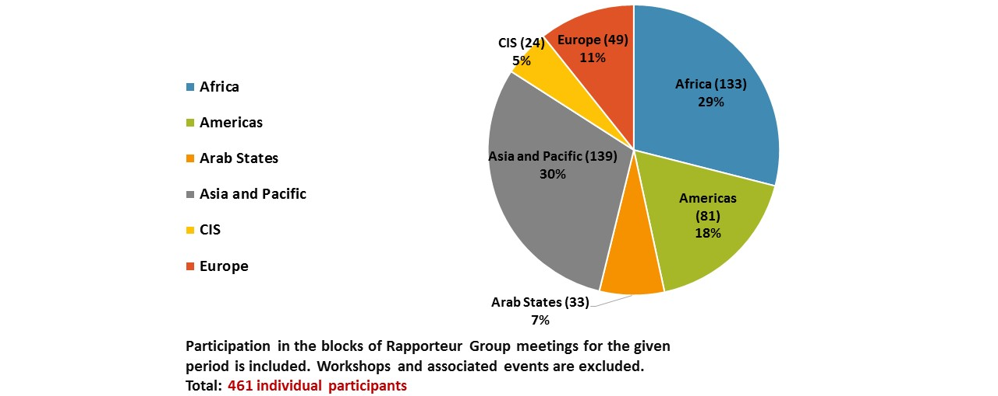
Graph 2
Aggregate number of participants (per region) for Study Group 2 and Rapporteur Group meetings
(September 2014 – April 2017)
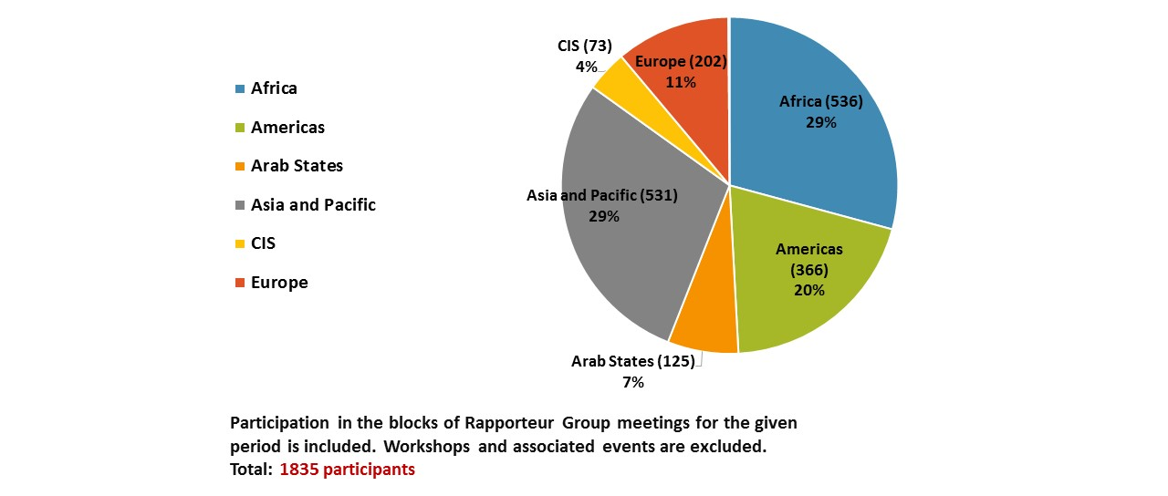
Graph 3
Number of contributions received from the membership for consideration during Study Group 2 and Rapporteur Group meetings (per region)
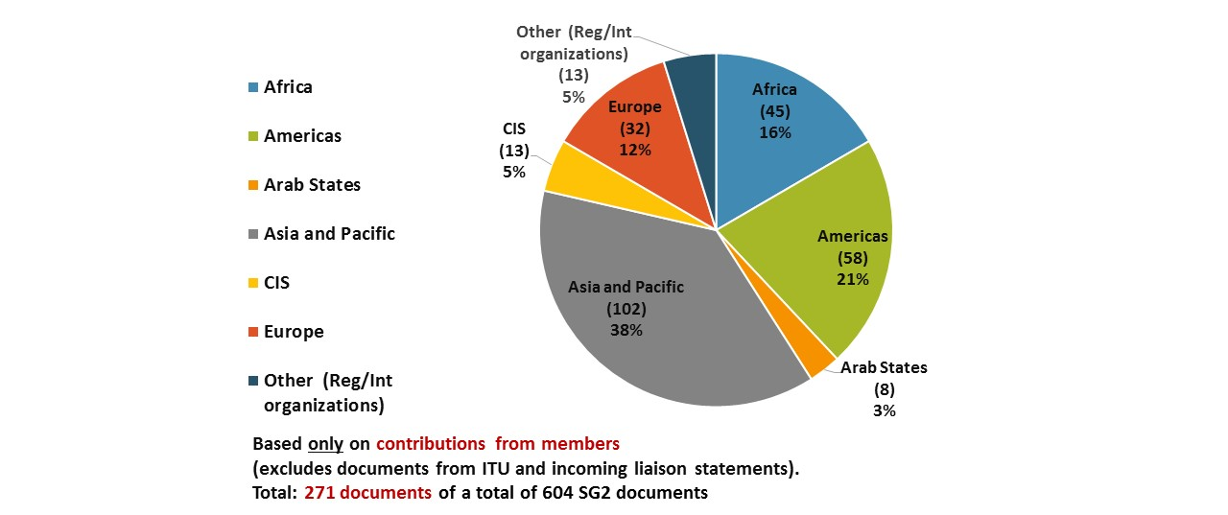

TABLE 1
Number of contributions received per Study Group 2 Question (September 2014 – April 2107)
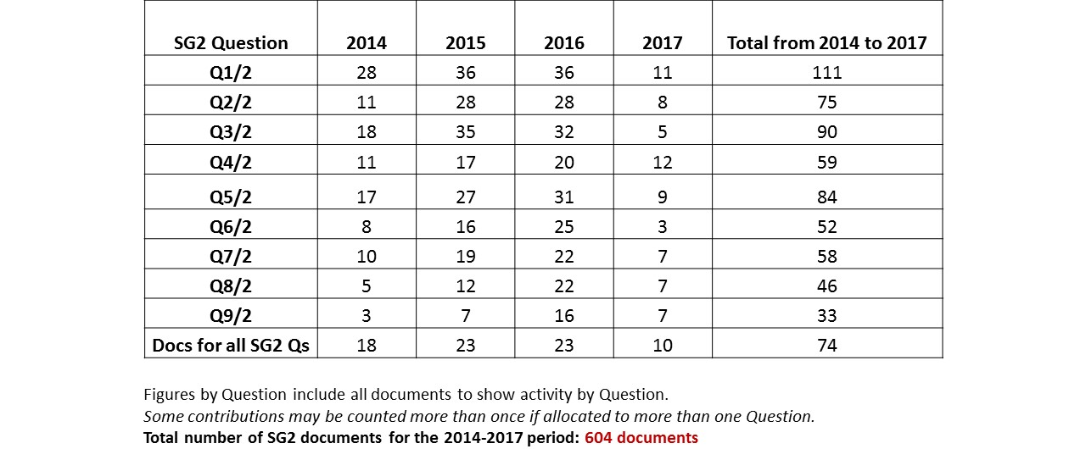
TABLE 2
Number of contributions received each year for Study Group 2 (September 2014 – April 2107)
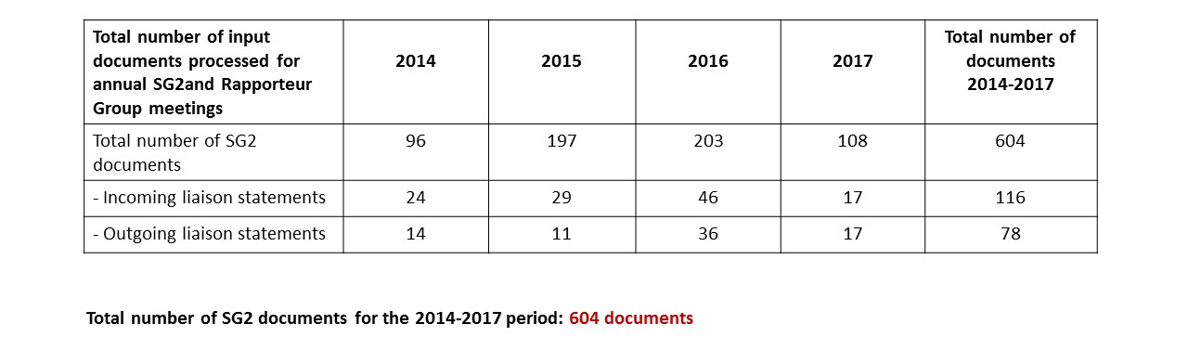
Graph 4
Number of contributions received for Study Group 2 and Rapporteur Group meetings per Question
(with source)(September 2014 – April 2107)
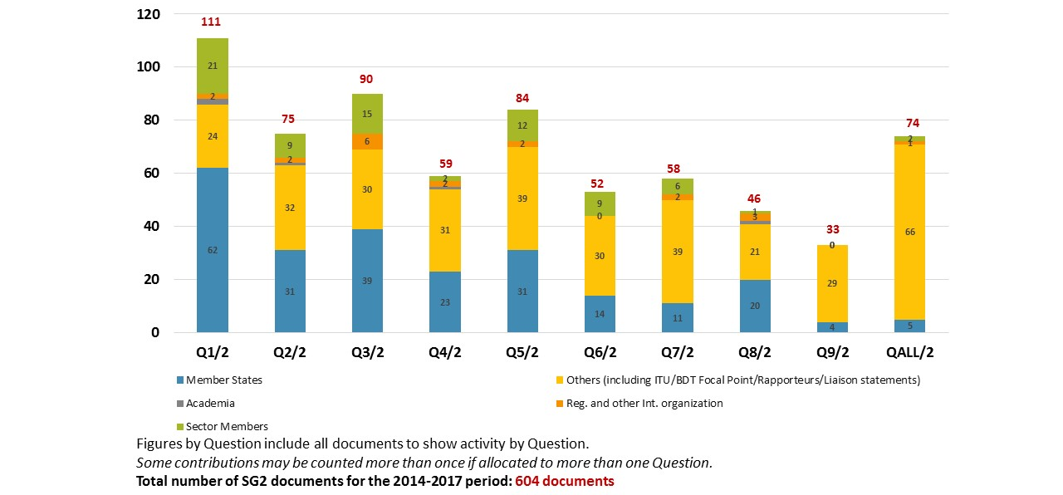

Meetings

2.1 Management team meetings
The Study Group 2 Chairman and Vice-Chairmen present met in Dubai during the WTDC. In addition to this initial meeting, four Study Group 2 management team meetings with Vice-Chairmen, Rapporteurs, Vice-Rapporteurs and BDT Focal Points were held on the eve of each annual Study Group 2 meeting, in order to prepare for the meeting, approve the time-management plan, review the progress of each Question under study, discuss planned and on-going activities and come up with proposals on further improvements to the functioning of the Study Groups.

2.2 Study Group 2 meetings
During the course of the study period, Study Group 2 met four times: three times in the month of September each year (2014, 2015 and 2016) and the fourth and final meeting was held in April 2017. Annex 2 presents the dates of the Study Group and the Rapporteur Groups meetings, taking into account that each Rapporteur Group also meets separately, as well as during the annual Study Group meeting. A substantial amount of the work is carried out electronically and by correspondence in between the physical meetings.
    - The first meeting, held in Geneva from 22 to 26 September 2014, took the following important decisions:
- Approved the Rapporteurs and Vice-Rapporteurs for the nine study Questions;
- Agreed to specific and detailed work plans for each of the nine Questions;
- Established Working Party 1/2 to facilitate the work of ITU-D Study Group 2 on the Questions assigned to it.
- Agreed on the dates for the Rapporteur Group meetings in 2015.
The report of this meeting is available online at: https://www.itu.int/md/D14-SG02-R-0010/
    - The second meeting, held in Geneva from 7 to 11 September 2015, took the following important decisions:
- Approved the Report of the last meeting;
- Approved the candidatures of the following new Vice-Rapporteurs: for Question 2/2 (e-health) Ms Malina Jordanova (Bulgaria), for Question 3/2 (cybersecurity) Mr Christopher Banda (Malawi), and for Q7/2 (EMF) Mr Dirk-Oliver Von der Emden (Switzerland).
- Agreed on the dates for the Rapporteur Group meetings in 2016.
The report of this meeting is available at: https://www.itu.int/md/D14-SG02-R-0021/.
    - The third meeting, held in Geneva from 26 to 30 September 2016, took the following important decisions:
- Approved the Report of the last meeting;
- Approved the candidatures of Mr Ananda Khanal (Nepal) and Mr Juan Pablos Ceballos Ospina as new Co-Rapporteurs for Question 8/2.
- Discussed the future work of ITU-D Study Group 2 and its study Questions during additional meetings and brainstorming sessions that were being scheduled over the course of the week.
- Discussed initial proposals about the future of Study Group 2 Questions.
- Agreed on the dates for the Rapporteur Group meetings in January 2017.
The report of this meeting is available at: https://www.itu.int/md/D14-SG02-R-0032.
    - The fourth meeting and last meeting was held in Geneva from 3 to 7 April 2017.
- Approved 9 reports containing the outputs called for by WTDC-14 for all SG2 Questions.
The meeting also undertook fruitful discussions on the future on the existing study Questions which will serve to inform Member States as they prepare for WTDC-17. Annex 3 to this report has a summary of these discussions.
The meeting dates for Study Group 2 during the next study period 2018 –2021 were also considered.
The report of this meeting is available at: https://www.itu.int/md/D14-SG02-R-0043.

Summary of the key results achieved
This section presents an overview of the deliverables of each of the Study Group 2 Questions.
Questions related to ICT applications and cybersecurity
  - Question 1/2: Creating the smart society: Social and economic development through ICT applications
The approved report of the April 2017 Rapporteur Group meeting for Question 1/2 can be found in document 2/REP/22. The Output Report and guidelines available in document 2/413, were adopted with a number of changes to be made.
Regarding the future of Question 1/2, the results of the two surveys carried out by the ITU-D Study Groups on the current work and the future of the Q1/2 indicate that this Question should continue. A contribution from the Republic of Korea (2/457 (Rev.1)) considers the importance of achieving the smart society and indicates that many initiatives and projects for achieving smart society are under progress, thus, Q1/2 should continue in the next study period. While agreeing with the adoption of the principles of SDGs in conducting Q1/2 in the next study period, it was suggested to include the issues on how ICT shall improve future oriented values such as participation of citizens, collaboration among stakeholders, openness of information, and sharing of resources and fair distribution of benefits during the next study period. The Rapporteur Group proposed to continue the study Question.
  - Question 2/2: Information and telecommunications/ICTs for e-health
The approved report of the April 2017 Rapporteur Group meeting for Question 2/2 can be found in document 2/REP/23.
The Output Report and guidelines available in document 2/414, and temporary document 2/TD/16 which includes the modifications requested during the Rapporteur Group meeting, were adopted with a number of changes to be made.
Concerning the future of Question 2/2, the participant survey highlights the importance of the topic, the need to hold related workshops and even to merge Q2/2 with Q7/2 (EMF) as a broader Question on using ICTs for attaining a healthy society. Japan presented some ideas on the continuation of the Q2/2 (2/462). Israel suggested to delete descriptions related to EMF and Intel Corporation (United States of America) proposed to include the concept of Internet of Things (IoT) and IMT-2020 applications. The Rapporteur Group proposed to continue the study Question.
  - Question 3/2: Securing information and communication networks: Best practices for developing a culture of cybersecurity
The approved report of the April 2017 Rapporteur Group meeting for Question 3/2 can be found in document 2/REP/24.
The Output Report available in document 2/415, and temporary document 2/TD/17 which includes the modifications requested during the Rapporteur Group meeting, was adopted with a number of changes to be made.
As for the future of Question 3/2, the participant survey emphasized the need to continue the study due to the continuing changes in technology and threats. Study on the protection of citizen and national critical information infrastructure protection was suggested. The need for combining the study with the release of annual reports and workshops together with other parties/organizations was highlighted. In discussing the future of the Question, the Rapporteur Group considered how the title of the Question can be revised in order to reflect the evolving nature of cybersecurity and the topics under study. The following title was shared with the SG2 plenary: “Best practices addressing emerging and evolving threats to cybersecurity”. The Rapporteur Group proposed to continue the study Question.
  - Question 4/2: Assistance to developing countries for implementing conformance and interoperability programmes
The approved report of the April 2017 Rapporteur Group meeting for Question 4/2 can be found in document 2/REP/25.
Output Report available in document 2/416, was adopted with a number of changes to be made.
On the future of Question 4/2, the surveys stress the importance of the topic and especially assistance to countries in implementing C&I regimes. The existing work within the BDT Programme was highlighted. When discussing the future of Q4/2, the Rapporteur Group considered a contribution from Mauritania (2/426 + Annex) which proposes to continue with the studies under Q4/2 with a revised scope and adapted work methodology. A contribution from CPqD (Brazil) (2/459) shares ideas on how an ITU-D SG Question on C&I could support the Sustainable Development Goals (SDGs) and where IoT with billions of connections will demand knowledge of the equipment in place. Several perspectives were suggested: technical regulation, national rules, quality, safety, interoperability, interference, sustainability, reliability, resilience, counterfeit, awareness, affordability, (through the economies of scale promoted by C&I), etc. Some Administrations, while acknowledging the importance of C&I, noted that with a focus on implementation a specific study Question may not be required. Other Administrations voiced their full support for the continuation of the study Question. A table with analysis of the work to be done by the proposed study Question and the work currently undertaken by BDT on C&I was proposed as a useful tool to assist inn understanding what study could be undertaken. The Rapporteur Group proposed to continue the study Question.
Questions related to climate change, environment and emergency telecommunications
  - Question 5/2: Utilization of telecommunications/ICTs for disaster preparedness, mitigation and response
The approved report of the April 2017 Rapporteur Group meeting for Question 5/2 can be found in document 2/REP/26.
The Question 5/2 final report available in document 2/417 was approved.
The Output Report and guidelines available in document 2/417, and temporary document 2/TD/17 which includes the modifications requested during the Rapporteur Group meeting, were adopted with a number of changes to be made.
Regarding the future of Question 5/2, the results of the participant survey revealed the importance of emergency communications, particularly for many developing countries and the ITU membership overall. Some replies noted the need to merge Q5/2 with Q6/2 (climate change). A modular approach to the study Question’s terms of reference to allow for more detailed and substantive discussion on a specific, narrow topic (2/461), was proposed during the Rapporteur Group meeting. This approach was considered as favourable while changes to the different modules were suggested. The meeting expressed a preference to keep Q5/2 separate from Q6/2, to allow for focus of the work. The Rapporteur Group proposed to continue the study Question.
  - Question 6/2: ICT and climate change
The approved report of the April 2017 Rapporteur Group meeting for Question 6/2 can be found in document 2/REP/27.
The Output Report available in document 2/418, and temporary document 2/TD/18 which includes the modifications requested during the Rapporteur Group meeting, was adopted with a few changes to be made.
While it was noted in the participant survey that this Question has been in existence in some form for several study cycles, climate change still remains a priority for most countries. There were suggestions voiced through the survey to merge Q6/2 with Q5/2 (emergency communications) and Q8/2 (e-waste) focusing also on the implementation of standards developed in ITU-T SG5. The Rapporteur Groups discussed a contribution from the Rapporteur (2/TD/15) which proposed that studies in the next cycle would focus on best practices and guidelines and in line with SDG13, the title of the Question would be changed to “Best practices and guidelines for ICT-enabled climate action”. It was further agreed to include specific focus on solutions where Small Island Developing States (SIDS), Least Developed Countries (LDCs) and other vulnerable countries will benefit from the work conducted within the Question under study. The need to engage other relevant experts, ministries of environment or organizations on national level to contribute on this topic was also noted. The Rapporteur Group proposed to continue the study Question.
  - Question 7/2: Strategies and policies concerning human exposure to electromagnetic fields
The approved report of the April 2017 Rapporteur Group meeting for Question 7/2 can be found in document 2/REP/28.
The Output Report available in document 2/419, and temporary document 2/TD/17 which includes the modifications requested during the Rapporteur Group meeting, which includes the modifications requested during the Rapporteur Group meeting, was adopted with a few changes to be made.
On the future of Question 7/2, while unanimous on the importance of the topic, the respondents to the participant survey were divided as to what the future of the Question would look like. Some noted the importance of promoting policies that support deployment of wireless technologies that comply with international standards and others indicated a need to merge Q7/2 with Q2/2 (e-health). The collaboration with WHO was praised. Contributions to the Rapporteur Group (2/410, 2/434) propose a revised Question justified by increased cellular penetration, traffic growth, increased use of data services, network coverage and capacity extension. The Rapporteur Group proposed to continue the study Question.
  - Question 8/2: Strategies and policies for the proper disposal or reuse of telecommunication/ICT waste material
The approved report of the April 2017 Rapporteur Group meeting for Question 8/2 can be found in document 2/REP/29.
The Output Report available in document 2/420 was adopted with a few changes to be made.
Concerning the future of Question 8/2, the participant survey observes the need to align Q8/2 with ITU-T Study Group 5 work, while proposing to merge Q8/2 with Q6/2 (climate change) and a revised Q7/2 (EMF). When discussing the future of Q8/2, while the scope would need to change, it was suggested that Q8/2 continue its work. A contribution from Colombia (2/432) proposes various alternatives for the next study period aligning Q8/2 with the SDGs associated with electronic and electric waste. Under Objective 1 (Poverty reduction) encouraging the creation of programs that incorporate recyclers into formal WEEE management schemes; Objective 3 (Good health and well-being) creating management WEEE programs that define, create and publish standardized guides/manuals for handling electronic waste; Objective 12 (Responsible consumption and production) generating strategies for encouraging consumers and producers to return used EEE; Objective 13 (Climate action) developing WEEE management programs that ensure a positive impact on the environment. The Rapporteur Group proposed to continue the study Question.
  - Question 9/2: Identification of study topics in the ITU-T and ITU-R study groups which are of particular interest to developing countries
The approved report of the April 2017 Rapporteur Group meeting for Question 9/2 can be found in document 2/REP/30.
The Output Report available in document 2/421 was adopted with a number of changes to be made.
In considering the future of Question 9/2, the surveys agreed on the importance of the topic and that inter-sectoral collaboration should be strengthened. Though it was noted during the Rapporteur Group meeting that the Question had not received many contributions for consideration during the study period. In this regard, other mechanisms may be more appropriate. Should this topic continue the next study period, an appropriate mechanism should be created. A possible future mechanism should consider inviting representatives from the other Sectors and the General Secretariat to share updates on their activities on a regular basis. For the future, consideration should be given to the advantages of holding Q9/2 meetings and the disadvantages that constitute the development of the Final Report, translation costs, etc. Representatives of the sectors could be invited to the opening plenaries of the two ITU-D study groups to present on their activities. It is understood that the expectations of developing countries are reflected in the ITU-D Action Plan and that a mapping between these expectations and what the sectors are providing could be useful in this regard.
On the work of the Inter-Sector Coordination Team on Issues of Mutual Interest, it was noted that the discussions there are not reaching the ITU-D study group participants. It was agreed that the topic is important but the mechanism should be re-considered. It was noted that the Question as such could be discontinued while close coordination with the Inter-Sector Coordination Team should be encouraged, and representatives from the sectors and the General Secretariat be invited to present on their activities to the ITU-D SG1 and SG2 meetings as these presentations were deemed useful not only for developing countries but also for developed countries. The Rapporteur Group proposed to discontinue the study Question and explore other alternative mechanisms.
  - Working Party 1/2
The approved report of the April 2017 Working Party 1/2 meeting can be found in document 2/REP/31.
On the future of the Working Parties within ITU-D Study Groups, the responses received to the two surveys were considered together with the feedback and food for thought from the Chairman of Working Party 1/2. The respondents to the surveys were divided on the usefulness of working parties in ITU-D. In discussing the future of Working Party 1/2, participants noted that the mandate and terms of reference of the working party must be clear for all the study Questions belonging to it, and for Rapporteurs leading these Question in order for the working party to function properly. Unless these aspects are put in place then Working Party 1/2 should be disbanded. Several meeting participants noted and agreed that in the other ITU sectors, the focus and priority is on the work of the working parties instead of the study Questions. Participants agreed that obtaining the study topics first and then determining whether a working party is required would be the preferred approach. Once the study Questions have been determined then clear terms of reference and mandate can be established.

Results of the surveys on the work of ITU-D Study Groups
During the past few months the ITU-D Study Groups has issued two surveys seeking feedback on different aspects related to the work of the ITU-D Study Groups.

4.1 Global survey on the work of ITU-D Study Groups (6th study period, 2014-2017)
The “Global survey on the work of ITU-D Study Groups (6th study period, 2014-2017)” was initiated by ITU-D Study Group 2 Question 9/2 and it was sent to the appointed focal points in ITU Member States, Sector Members, Associates, Academia and members of the ITU-D Study Group 1 and 2 Management Teams through a Circular Letter in November 2016 (BDT/IP/CSTG-14). This survey aimed primarily to gather feedback on the usefulness of the outputs of ITU-D Study Group 1 and 2 studies, understand the relevance of the topics under study, and seek input for future priority areas. When the survey was closed 40 responses had been received. Representatives from Administrations, Administration-related entities and Ministries made up 57.5 per cent of the respondents. Some results were shared:
- Regarding the structure and the number of ITU-D Study Groups, the current two were considered appropriate. However, some of the comments received revealed that the Members feel that some study Questions are allocated to the wrong study group (e-waste and electromagnetic field exposure should be in SG1). Ambiguity concerning the current mandates of the study groups was mentioned. The large number of study Questions was also mentioned by several respondents. Merging Questions would make sense to some respondents in order to strengthen the ITU-D Study Groups. None of the respondents wanted to increase the number of Questions under each study group.
- The need to avoid duplication with the work undertaken in the study groups of the other ITU sectors was reiterated. There are topics that are already being studied by ITU-T and ITU-R.
The respondents also rated their satisfaction with the ITU-D Study Group 1 and Study Group 2 Questions’ deliverables in terms of their relevance and the outputs that they are producing for the study period. In this regard, respondents indicated that they were “Very satisfied” with Questions 5/1, 7/1, 8/1. Res.9 and Q1/2 (tied with “Satisfied”), Q3/2, and Q5/2, and that they were ‘Satisfied’ with Questions 1/1, 2/1, 3/1, 4/1, 6/1, Q2/2, Q4/2, Q6/2, Q7/2, Q8/2, and Q9/2. For none of the SG1 and SG2 Question, did a majority of the respondents indicate that they felt ‘Neutral’ or ‘Not satisfied’ with the deliverables produced by the Questions.
Full details of the survey can be found in document 2/448 + Annexes.

4.2 Survey on ITU-D Study Group Questions, procedures, and proposals on future activities
The “Survey to participants on ITU-D Study Group Questions, procedures, and proposals on future activities” was initiated by the SG1 Management Team, SG1 Vice-Chair from Côte d’Ivoire, Ms Regina Fleur Assoumou-Bessou and SG1 Chair, Ms Roxanne McElvane Webber, and was aimed to all the participants in ITU-D Study Group and Rapporteur Group meetings. Ms Christine Sund presented the structure of the survey, being this divided into three sections: Section 1 contains Contact information; Section 2 provides an analysis and proposals on ITU-D Study Group 1 and 2 study Questions and Section 3 contains proposals to strengthen the activities of the ITU-D Study Groups during the next study period. A total of 28 responses were received from 22 countries. Regional participation was analysed: Africa (29%), the Americas (19%), Asia and Pacific (19%), CIS (9%) and Europe (24%).
Participants were requested to provide their opinion of the future of each Question in ITU-D Study Group 1 and 2. There were four possibilities: Continue, Merge, Revise or Suspend. The results revealed that all the Questions should continue. Nevertheless, revising or merging with other Questions were proposed for some of the Questions. One of the most relevant aspects was the request for merging Questions 1/1 and 2/1 as well as the need to avoid duplication and overlap of the work within the ITU-D Study Groups as well as with groups in the other sectors.
Full details of the survey can be found in document 2/453 + Annex.

Conclusion
Study Group 2 has successfully carried out its mandate because of the hard work, dedication, perseverance, flexibility, and expertise of all the parties concerned: the SG 2 Management Team, Vice Chairs, Rapporteurs, Vice-Rapporteurs, Focal Points, Secretariat, active contributors, meeting participants, interpreters and translators. With strong support from the BDT Director and his staff, the Group has fulfilled its mission.

Annex 1:
List of Study Group 2 Chairman, Vice-Chairmen, Rapporteurs,
Vice-Rapporteurs, and BDT Focal Points
Sixth study period (2014-2017)
Study Group 2 Chairman and Vice-Chairmen
Role | Name | Entity represented | Region
Chairman | Mr Ahmad Reza SHARAFAT | Iran (Islamic Republic of) | ARB
Vice-Chairman | Ms Aminata KABA-CAMARA | Guinea | AFR
Vice-Chairman | Mr Christopher KEMEI | Kenya | AFR
Vice-Chairman | Ms Celina DELGADO | Nicaragua | AMS
Vice-Chairman | Mr Nasser AL MARZOUQI | UAE | ARB
Vice-Chairman | Mr Nadir Ahmed GAYLANI | Sudan | ARB
Vice-Chairman | Ms WANG Ke | China (P.R. of) | ASP
Vice-Chairman | Mr Ananda Raj KHANAL | Nepal | ASP
Vice-Chairman | Mr Evgeny BONDARENKO | Russia | CIS
Vice-Chairman | Mr Henadz ASIPOVIC | Belarus | CIS
Vice-Chairman | Mr Petko KANTCHEV | Bulgaria | EUR

Question | Title of the Question
Q1/2 | Creating the smart society: Social and economic development through ICT applications
Title | Name | Represented entity | Region
Rapporteur | Dr James Ngari NJERU | Kenya | AFR
Vice-Rapporteur | Dr Cheung-Moon CHO | Korea (Rep. of) | ASP
Vice-Rapporteur | Mr Richard ANAGO | Burkina Faso | AFR
Vice-Rapporteur | Ms Joëlle Géraldine ZOPANI YASSENGOU | Central African Republic | AFR
Vice-Rapporteur | Ms Xing XIN | China (P.R. of) | ASP
Vice-Rapporteur | Mr Romain CIZA | Democratic Republic of the Congo | AFR
Vice-Rapporteur | Mr Jean-David RODNEY | Haiti | AMS
Vice-Rapporteur | Mr Seydou DIARRA | Mali | AFR
Vice-Rapporteur | Mr Evgeny BONDARENKO | Intervale, Russian Federation | CIS
Vice-Rapporteur | Mr Dominic VERGINE | ARM Holdings Plc., United Kingdom | EUR
Vice-Rapporteur | Mr Turhan MULUK | Intel Corporation, United States of America | AMS
Focal Points
BDT Focal Point | Mr Hani ESKANDAR | ITU/BDT | Headquarters
BDT Focal Point | Mr Takashi MASUMITSU | ITU/BDT | Headquarters
BDT Focal Point | Ms Ida JALLOW | ITU/AFR | AFR
BDT Focal Point | Mr Karim ABDELGHANI | ITU/ARB | ARB
BDT Focal Point | Mr Ashish NARAYAN | ITU/ASP | ASP
BDT Focal Point | Mr Farid NAKHLI | ITU/CIS | CIS
Question | Title of the Question
Q2/2 | Information and telecommunications/ICTs for e-health
Title | Name | Represented entity | Region
Rapporteur | Dr Isao NAKAJIMA | Japan | ASP
Co-Rapporteur | Dr Done-Sik YOO | Korea (Rep. of) | ASP
Vice-Rapporteur | Mr Grégory DOMOND | Haiti | AMS
Vice-Rapporteur | Mr Leonid ANDROUCHKO | Dominic Foundation, Switzerland | EUR
Vice-Rapporteur | Ms Malina JORDANOVA | Bulgaria | EUR
Focal Points
BDT Focal Point | Mr Hani ESKANDAR | ITU/BDT | Headquarters
BDT Focal Point | Mr Takashi MASUMITSU | ITU/BDT | Headquarters
BDT Focal Point | Mr Ali Drissa BADIEL | ITU/AFR | AFR
BDT Focal Point | Mr Getachew SAHLU | ITU/AFR | AFR
BDT Focal Point | Mr Karim ABDELGHANI | ITU/ARB | ARB
BDT Focal Point | Mr Ashish NARAYAN | ITU/ASP | ASP
Question | Title of the Question
Q3/2 | Securing information and communication networks: Best practices for developing a culture of cybersecurity
Title | Name | Represented entity | Region
Rapporteur | Ms Rozalin Basheer Faqeer AL-BALUSHI | Oman Telecommunications Regulatory Authority (TRA), Oman | ARB
Rapporteur | Mr Eliot LEAR | United States of America | AMS
Vice-Rapporteur | Mr Albert KAMGA | Cameroon | AFR
Vice-Rapporteur | Mr Jean-David RODNEY | Haiti | AMS
Vice-Rapporteur | Ms Miho NAGANUMA | Japan | ASP
Vice-Rapporteur | Mr Jaesuk YUN | Korea (Rep. of) | ASP
Vice-Rapporteur | Mr Damnam Kanlanfei BAGOLIBE | Togo | AFR
Vice-Rapporteur | Ms Jabin S. VAHORA | United States of America | AMS
Vice-Rapporteur | Mr Christopher BANDA | Malawi | AFR
Focal Points
BDT Focal Point | Mr Marco OBISO | ITU/BDT | Headquarters
BDT Focal Point | Mr Luc DANDURAND | ITU/BDT | Headquarters
BDT Focal Point | Ms Rosheen AWOTAR-MAUREE | ITU/BDT | Headquarters
BDT Focal Point | Mr Ali Drissa BADIEL | ITU/AFR | AFR
BDT Focal Point | Mr Serge Valéry ZONGO | ITU/AFR | AFR
BDT Focal Point | Mr Pablo PALACIOS | ITU/AMS | AMS
BDT Focal Point | Ms Rouda ALAMIR ALI | ITU/ARB | ARB
BDT Focal Point | Mr Sameer SHARMA | ITU/ASP | ASP
BDT Focal Point | Mr Farid NAKHLI | ITU/CIS | CIS
Question | Title of the Question
Q4/2 | Assistance to developing countries for implementing conformance and interoperability programmes
Title | Name | Represented entity | Region
Rapporteur | Mr Cheikh Tidjani OUDAA | Mauritania | AFR
Rapporteur | Mr Gordon GILLERMAN | United States of America | AMS
Vice-Rapporteur | Ms Lisa J. CARNAHAN | United States of America | AMS
Vice-Rapporteur | Mr Osmar MACHADO | Brazil | AMS
Vice-Rapporteur | Mr Richard ANAGO | Burkina Faso | AFR
Vice-Rapporteur | Mr Roland Yaw KUDOZIA | Ghana | AFR
Vice-Rapporteur | Mr Faryd NAKHLI  (Stepped down) | Belarus | CIS
Focal Points
BDT Focal Point | Mr Vladimir DAIGELE | ITU/BDT | Headquarters
BDT Focal Point | Ms Chali TUMELO | ITU/AFR | AFR
BDT Focal Point | Mr Bruno RAMOS | ITU/AMS | AMS
BDT Focal Point | Mr Slaheddine MAAREF | ITU/ARB | ARB
BDT Focal Point | Mr Sameer SHARMA | ITU/ASP | ASP
Question | Title of the Question
Q5/2 | Utilization of telecommunications/ICTs for disaster preparedness, mitigation and response
Title | Name | Represented entity | Region
Rapporteur | Ms Kelly O'KEEFE | United States of America | AMS
Vice-Rapporteur | Mr Jean-Marie MAIGNAN | Haiti | AMS
Vice-Rapporteur | Mr Hideo IMANAKA | Japan | ASP
Vice-Rapporteur | Mr Richard KROCK | Alcatel-Lucent USA Inc., United States of America | AMS
Focal Points
BDT Focal Point | Ms Maritza DELGADO SOLARTE | ITU/BDT | Headquarters
BDT Focal Point | Mr Jean-Jacques MASSIMA | ITU/AFR | AFR
BDT Focal Point | Mr Rodrigo ROBLES | ITU/AMS | AMS
BDT Focal Point | Mr Wisit ATIPAYAKOON | ITU/ASP | ASP
Question | Title of the Question
Q6/2 | ICT and climate change
Title | Name | Represented entity | Region
Rapporteur | Mr Philip KELLEY | France | EUR
Vice-Rapporteur | Mr Joseph Bruno YUMA UTCHUDI | Democratic Republic of the Congo | AFR
Vice-Rapporteur | Mr Naoki FUKE | Japan | ASP
Vice-Rapporteur | Mr Nasser AL MARZOUQI | United Arab Emirates | ARB
Focal Points
BDT Focal Point | Ms Maritza DELGADO SOLARTE | ITU/BDT | Headquarters
BDT Focal Point | Ms Anne Rita SSEMBOGA | ITU/AFR | AFR
BDT Focal Point | Mr Rodrigo ROBLES | ITU/AMS | AMS
BDT Focal Point | Mr Mustafa AL MAHDI | ITU/ARB | ARB
Question | Title of the Question
Q7/2 | Strategies and policies concerning human exposure to electromagnetic fields
Title | Name | Represented entity | Region
Rapporteur | Ms Dan LIU | China (P.R. of) | ASP
Vice-Rapporteur | Mr Issoufi K. MAIGA | Mali | AFR
Vice-Rapporteur | Mr Dirk-Oliver VON DER EMDEN | Switzerland | EUR
Focal Points
BDT Focal Point | Mr István BOZSOKI | ITU/BDT | Headquarters
BDT Focal Point | Mr Jean-Jacques MASSIMA | ITU/AFR | AFR
BDT Focal Point | Mr Getachew SAHLU | ITU/AFR | AFR
Question | Title of the Question
Q8/2 | Strategies and policies for the proper disposal or reuse of telecommunication/ICT waste material
Title | Name | Represented entity | Region
Co-Rapporteur | Mr Juan Pablo CEBALLOS OSPINA | Colombia | AMS
Co-Rapporteur | Mr Ananda KHANAL | Nepal Telecommunications Authority (NTA), Nepal | ASP
Vice-Rapporteur | Mr Géraud-Constant AHOKPOSSI | Benin | AFR
Rapporteur | Ms Sandra ALVARADO BARRERO (Resigned) | Colombia | AMS
Focal Points
BDT Focal Point | Mr Orhan OSMANI | ITU/BDT | Headquarters
BDT Focal Point | Mr Emmanuel KAMDEM | ITU/AFR | AFR
BDT Focal Point | Mr Mustafa AL MAHDI | ITU/ARB | ARB
Question | Title of the Question
Q9/2 | Identification of study topics in the ITU-T and ITU-R study groups which are of particular interest to developing countries
Title | Name | Represented entity | Region
Rapporteur | Mr Nasser AL MARZOUQI | United Arab Emirates | ARB
Focal Points
BDT Focal Point | Eun-Ju KIM | ITU/BDT | Headquarters
BDT Focal Point | Christine SUND | ITU/BDT | Headquarters
_______________

Annex 2:
ITU-D Study Group 2: List of Study Group and Rapporteur Group meetings as well as associated workshops (2014-2017)

Study Group/ Rapporteur Group meeting | Date and location
Study Group 1 meetings
Fourth meeting of ITU-D Study Group 2 | 3-7 April 2017, Switzerland [Geneva]
Third meeting of ITU-D Study Group 2 | 26-30 September 2016, Switzerland [Geneva]
Second meeting of ITU-D Study Group 2 | 7-11 September 2015, Switzerland [Geneva]
First meeting of ITU-D Study Group 2 | 22 to 26 September 2014, Switzerland [Geneva]
Rapporteur Group meetings
Rapporteur Group meetings for Study Group 2 Questions 1/2, 2/2, 3/2, 4/2, 5/2, 6/2, 7/2, 8/2, 9/2 | 18 (pm)-27 January 2017, Switzerland [Geneva]
Rapporteur Group meetings for Study Group 2 Questions 1/2, 2/2, 3/2, 4/2, 5/2, 6/2, 7/2, 8/2, 9/2 | 18-29 April 2016, Switzerland [Geneva]
Rapporteur Group meetings for Study Group 2 Questions 1/2, 2/2, 3/2, 4/2, 5/2, 6/2, 7/2, 8/2, 9/2 | 27 April-8 May 2015, Switzerland [Geneva]
Associated topical workshops
ITU cybersecurity workshop: Cybersecurity and risk assessments in practice | 26 January 2017, Switzerland [Geneva]
ITU emergency telecommunications and disaster relief workshop | 27 September 2016, Switzerland [Geneva]
ITU cybersecurity workshop: Running national cyberdrills and elaborating national cybersecurity strategies | 18-19 April 2016, Switzerland [Geneva]
ITU cybersecurity workshop: Global Cybersecurity Challenges - Collaborating for effective enhancement of cybersecurity in developing countries | 8 September 2015, Switzerland [Geneva]
_______________

Annex 3:
Proposal for study topics in ITU-D Study Group 2 as result of the Ad hoc Group meetings held from 3 to 6 April

An Ad hoc Group was created to put together some ideas regarding the future of each SG2 Question.
The common views of the participants on the titles of the proposed Questions for the next study period are reflected in the last column of the table below. The table also includes ideas, topics and keywords proposed by some participants as shown in its other columns, but the meeting did not discuss them. It is hoped that this table will assist Administrations in their preparations for the forthcoming WTDC.
The first meeting on Monday, 3 April 2017 (17:00-17:50) shared initial thoughts on the approach to be taken to draft proposals for ITU-D Study Group 2 study topics for the next study period.
The second meeting on Tuesday, 4 April 2017 (17:45-19:15) expressed no objection to the continuation of Questions 1/2, 2/2, 3/2, 5/2, 7/2, and 8/2. Questions 4/2, 6/2 and 9/2 require further discussion. The meeting agreed to identify SDGs that correspond to each study Question. The meeting also agreed to identify the corresponding outcomes in the ITU-D contribution to the ITU strategic plan for each Question.
The third meeting on Wednesday, 5 April 2017 (17:45-19:00) continued developing the content in the table and agreed to wait for input from the Rapporteur Groups for Questions 3/2, 4/2 and 6/2 to complete a draft for consideration in the SG2 plenary. The meeting agreed that in order to replace Question 9/2 an alternative mechanism to share information on the activities of ITU-T/ITU-R/General Secretariat throughout the study period should be implemented.
The fourth and final meeting on Thursday, 6 April 2017 (17:45-19:15) added proposed titles for Questions 3/2 and 5/2. A proposed title for Question 6/2 was also developed, however, this is pending further discussion during the forthcoming Rapporteur Group meeting on Friday, 7 April.

Existing ITU-D Study Group 2 Question | Proposal from the Rapporteur Group | Future topics as per the surveys | Proposals | Proposed future ITU-D SG2 Question
 |  |  |  | Keywords and topics | Titles
QUESTION 1/2  “Creating the smart society: Social and economic development through ICT applications” | Continue Question and revise content.  Artificial intelligence (AI), big data, social engagement, health, agriculture were mentioned as associated topics. | Internet of Things (IoT) | New study topic proposed on IoT (2/423 - Cote d’Ivoire)  AI, Big data (2/427-Intervale, Russian Federation)  Participation of citizens, openness of information (2/457R1 – Rep. of Korea) | - implementation guidelines  - IoT  - Artificial intelligence (AI)  - big data  - smart society  - smart cities and communities  - SDGs  - cloud computing  - data analytics  - open data | Continue Question but revise title and content.  “Best practices and guidelines for smart sustainable societies through ICT”
QUESTION 2/2  “Information and telecommunications for e-health” | Continue Question and revise title to “Speedy implementation of eHealth in developing countries” | Merge Questions 2/2 and 7/2. | Merge Questions 2/2 and 7/2 under Q2/2 entitled “Information and telecommunications for e-health, including human exposure to electromagnetic fields” (2/451 - Russian Federation)  New e-Health area using big data and AI (2/462 - Japan) | - best practices  - e-health  - accelerated implementation  - standardization  - mobile eHealth  - medical big data | Continue Question but revise title and content.  “Best practices and guidelines for rapid implementation of eHealth”
QUESTION 3/2  “Securing information and communication networks: Best practices for developing a culture of cybersecurity” | Focus on evolving and emerging (technical) threats and capacity building. | Continue study | Security of creating “smart” cities (2/451 - Russian Federation)  Improving GCI Index (2/458 – Rep. of Korea) | - best practices  - emerging cyberthreats  - smart society  - IoT  - security challenges  - SMS spam  - SIM box card  - awareness survey  - COP  - spam/malware  - capacity building/workshops  - GCI | Continue Question but revise title and content.  “Best practices for addressing emerging and evolving threats to cybersecurity”
QUESTION 4/2  “Assistance to developing countries for implementing conformance and interoperability programmes” | Diverging views. | Further work on C&I can be handled by the Programme (not as study Question) |  | - conformance  - interoperability  - sustainable industrialization  - resilient infrastructure  - virtual Lab  - virtual testing  - policy and regulation | The topic is very important. Providing assistance to developing countries is critical.  Continue the Question  [“Strategies, policies and innovative solutions for implementation of conformance and interoperability (C&I) programmes and combatting counterfeit ICT equipment in developing countries”]  Discontinue the Question (Continue work within the BDT and TSB Programmes (not as a study Question)).
QUESTION 5/2  “Utilization of telecommunications/ICTs for disaster preparedness, mitigation and response” | Continue the Question but revise title and content. Different topics each year, e.g. early warning, policy and regulatory barriers to implementation, disaster communication drills. | Merge with Q6/2. Develop new method. | Merge Q5/2 with Q6/2 entitled “Use of telecommunication/ICT for climate change, management of natural disasters and emergency situations” (2/424 - Côte d’Ivoire) | - implementation guidelines  - enabling policy environment  - early warning systems  - emergency communication  - exercises and drills  - technology trends  - safety confirmation | Continue the Question but revise title and content. Different topics each year, e.g. early warning, policy and regulatory barriers to implementation, disaster communication drills.  “Best practices and implementation guidelines for use of telecommunication/ICT for disaster management”
QUESTION 6/2  “ICT and climate change” | Continue the Question without merging with other Questions. Future study to focus on innovations and new country projects. | Merge 6/2 with Q5/2. Already under study in ITU-T SG5. Merge Q6/2 with Q8/2. | Continue by merge Questions 6/2 and 8/2 under Q6/2 entitled “ICT and climate change, including issues related to the proper disposal or reuse of telecommunication/ICT waste material”. (2/451 - Russian Federation)  Discontinue by merging Questions 5/2 and 6/2 under Q5/2 (2/424 - Côte d’Ivoire) | - climate change  - technology trends  - climate action  - adaptation  - mitigation  - policies  - SDG 13  - involve stakeholders external to telecommunication/  ICT | Continue the Question but revise title and content.  “Best practices and guidelines for ICT- enabled climate action”
QUESTION 7/2  “Strategies and policies concerning human exposure to electromagnetic fields” | Continue the Question and revise content. Focus on measurement and assessment, etc. | Merge with Q2/2.  Merge with Q6/1 (end user protection).  Merge with Q8/2 (e-waste).  Measurements needed. | Discontinue the Question by merging of Questions 2/2 and 7/2 under Q2/2. (2/451 - Russian Federation)  Merge Question 7/2 with 8/2 entitled “Strategies and policies for the human protection against electromagnetic fields for the disposal or adequate recycling of waste resulting from the use of telecommunications / ICT. (2/424 - Côte d’Ivoire)  Provide implementation guidelines (2/410 – ATDI (France)) and (2/434 – People’s Rep. of China) | - guidelines  - measurement and assessment  - human exposure to electromagnetic fields  - technology trends | Continue the Question but revise title and content.  “Best practices and guidelines for measurement and assessment of human exposure to electromagnetic fields”
QUESTION 8/2  “Strategies and policies for the proper disposal or reuse of telecommunication/ICT waste material” | Continue Question. | Emerging issue. Merge Q8/2 with Q6/2. Merge Q8/2 with Q7/2. | Discontinue by merging Question 8/2 into Question 6/2 (2/451 - Russian Federation)  Merge Question 7/2 and Question 8/2 (2/424 - Côte d’Ivoire)  Strategies for implementation (2/432 -Colombia) | - guidelines  - e-waste  - recycling  - protection of environment  - cost efficient procedures | Continue the Question but revise title and content. “Implementation guidelines for management of e-waste and protection of the environment in a cost-effective manner”
QUESTION 9/2  “Identification of study topics in the ITU-T and ITU-R study groups which are of particular interest to developing countries” | ? | Important topics. Relevant to both SG1 and SG2. Intersectoral in nature. | Discontinue and include scope of the intersectoral coordinating group with Telecommunication Development Advisory Group (TDAG) on issues of mutual interest. (2/451 - Russian Federation) | - ITU-R  - ITU-T  - General Secretariat | Discontinue the Question but implement an alternative mechanism to share information with developing countries on the activities of ITU-R/ITU-T/General Secretariat throughout the study period.  Invite ITU-R/ITU-T/General Secretariat to present updates to SG1 and SG2 plenaries.  Intersectoral collaboration should furthermore be strengthened.

_______________

http://www.itu.int/md/D14-SG02-C-0002

