|  |  |  |
| --- | --- | --- |
| C:\Users\ponder\AppData\Local\Microsoft\Windows\Temporary Internet Files\Content.Word\BDT-25th_anniversary_2017-Logo_411959-3_transparent.png | **Telecommunication Development Advisory Group (TDAG)**  **22nd Meeting, Geneva, 9-12 May 2017** | C:\Users\ponder\AppData\Local\Microsoft\Windows\Temporary Internet Files\Content.Word\BDT-25th_anniversary_2017-Logo_411959-1_transparent.png |
|  | |  |
|  | | **Document** **TDAG17-22/****25-E** |
| **28 February 2017** |
| **Original:**  **English** |
| Director, Telecommunication Development Bureau | | |
| RESULTS OF THE SURVEY OF SATISFACTION WITH ITU’S REGIONAL PRESENCE | | |

**Summary:**

This document presents the preliminary results of the survey of satisfaction with ITU’s regional presence.

**Action required:**

TDAG is invited to consider this report and to provide guidance as deemed appropriate.

**References:**

Resolution 25 (Rev. Busan, 2014) and its annex.

1. The purpose of this document is to present the results of the survey of satisfaction with ITU’s regional presence.
2. ITU received 129 responses to the survey, 88 from Member States and 41 from Sector Members, Associates, Academia, Regional Organizations and International Organizations, broken down as presented in tables 1 and 2 on next page.

**Table 1**

|  |  |  |  |  |
| --- | --- | --- | --- | --- |
|  | **Developed country** | **Transition countries** | **Developing country** | **Least developed country** |
| **%** | 9.52% | 16.67% | 60.32% | 13.49% |

**Table 2**

|  |  |
| --- | --- |
| **Regional Distribution** | |
| **Region** | **%** |
| Africa | 14.29% |
| The Americas | 38.88% |
| Arab States | 14.29% |
| Asia & Pacific | 8.73% |
| Europe | 7.94% |
| CIS countries | 18.87% |

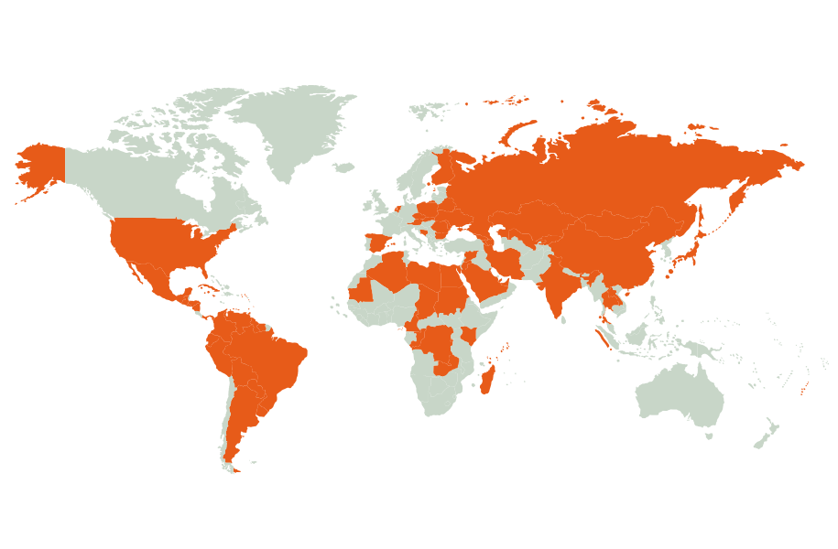3The geographical distribution of the participation to the Survey of satisfaction with ITU’s regional presence stands as follows:

4 The overall results are generally satisfactory for all the aspects of this survey. The results of the survey are presented in detail further in this document:

**4.1 Location of Regional / Area offices and quality of service provided**

The vast majority of the participants to the survey have indicated that the location of Regional and Area offices are appropriate, and that they were familiar with the activities of the ITU including at the regional level. The majority of the participants to the survey have also indicated that they were considering the staffing level of the Regional and Area offices appropriate. The charts on next pages set forth details on the results of the survey for the aspect relating to the location of Regional / Area offices and the quality of service provided:

|  |  |  |
| --- | --- | --- |
|  | **Yes** | **No** |
| Are you familiar with the activities of the ITU? | 126 | 3 |

Number of answers to this question: 129/129 (100.00%)

**Chart 1**

|  |  |  |
| --- | --- | --- |
|  | **Yes** | **No** |
| Are you aware of the regional activities of the ITU? | 121 | 8 |

Number of answers to this question: 129/129 (100.00%)

**Chart 2**

Comments:

* Location of regional/area offices could be subject to periodical rotation amid the countries of the region;
* Some issues were raised by some countries with regards to the opportunity for change of region.

|  |  |  |  |
| --- | --- | --- | --- |
|  | **Yes** | **Partially** | **No** |
| Do you consider the location of the regional / area offices optimal? | 102 | 22 | 4 |

Number of answers to this question: 128/129 (99.22%)

**Chart 3**

|  |  |  |  |
| --- | --- | --- | --- |
|  | **Yes** | **Partially** | **No** |
| Do you consider the staffing level of the regional / area offices appropriate? | 94 | 21 | 11 |

Number of answers to this question: 109/129 (84.49%)

Number of answers to this question: 126/129 (97.67%)

**Chart 4**

Comments:

* In the light of the increased number of activities, the staffing level should be increased to cope with the very high demand;
* Staff redeployment from headquarter to field offices might be considered to better respond to Membership requirements.

|  |  |  |  |  |  |
| --- | --- | --- | --- | --- | --- |
|  | **Consistent high quality** | **Generally good** | **Satisfactory** | **Quality varies depending on the request** | **Poor quality** |
| How would you rate the quality of service provided by regional /area offices ? | 46 | 60 | 14 | 5 | 1 |
|  |  |  |  |  |  |

**Chart 5**

|  |  |  |  |
| --- | --- | --- | --- |
|  | **Yes** | **Partially** | **No** |
| Are your questions / queries answered within a reasonable timeframe? | 109 | 15 | 2 |

Number of answers to this question: 126/129 (97.67%)

**Chart 6**

Comments:

* In some rare cases, there were no answers or very delayed answers.

**4.2 Regularity of contact and quality of reception / facilities**

The vast majority of the participants to the survey have indicated that they have regular contact with ITU, at least several times a month or more. The quality of the responses to queries is generally considered over higher quality. Contact points are mostly with headquarter for some 2/3 of the participants to the survey. Regional offices come second in terms of contact points.

A majority of the participants to the survey has indicated that the information received from Regional/Area offices was over higher quality.

The 3 most interesting domains of activity as per this survey are:

* Technology and network development;
* ITU events;
* Cybersecurity.

|  |  |  |  |  |
| --- | --- | --- | --- | --- |
|  | **Frequently** | **Several times a month** | **Several times a year** | **Never** |
| How often do you contact the ITU? | 50 | 26 | 48 | 3 |

Number of answers to this question: 126/129 (97.67%)

**Chart 7**

|  |  |  |  |  |
| --- | --- | --- | --- | --- |
|  | **Consistent high quality** | **Generally good** | **Satisfactory** | **Quality varies depending on the request** |
| How would you rate the quality of our responses to your inquiries? | 59 | 51 | 10 | 7 |

Number of answers to this question: 126/129 (97.67%)

**Chart 8**

|  |  |  |  |
| --- | --- | --- | --- |
|  | **Headquarters** | **Regional office** | **Area office** |
| Where are your contact points in ITU ? | 83 | 71 | 43 |

Number of answers to this question: 126/129 (97.67%)

**Chart 9**

|  |  |  |  |  |
| --- | --- | --- | --- | --- |
|  | **Frequently** | **Several times a month** | **Several times a year** | **Never** |
| Do you receive information from ITU Regional / Area offices ? | 54 | 38 | 30 | 6 |

Number of answers to this question: 126/129 (97.67%)

**Chart 10**

|  |  |  |  |  |  |
| --- | --- | --- | --- | --- | --- |
|  | **Consistent high quality** | **Generally good** | **Satisfactory** | **Quality varies depending on the request** | **Poor quality** |
| How would you rate the quality of information received from Regional/Area Offices ? | 50 | 52 | 16 | 5 | 2 |

Number of answers to this question: 126/129 (97.67%)

**Chart 11**

|  |  |  |  |  |
| --- | --- | --- | --- | --- |
|  | **Frequently** | **Several times a month** | **Several times a year** | **Never** |
| How often do you meet ITU representatives from Regional/Area Offices ? | 11 | 13 | 87 | 15 |

Number of answers to this question: 126/129 (97.67%)

**Chart 12**

**Chart 13**

Comments:

* Other domains of interest were mentioned such as: other sectors’ events (PP, WRC, ITU-T study Groups, WSIS), IoT, Smart city and e-Development, Telehealth, etc.

**4.3 Pertinence of activities or future requirements**

Most participants consider that the activities of the regional / area offices are pertinent and that there is no duplication with the activities undertaken by other international / national organizations. The majority of participants consider that the regional initiatives are properly addressed by the regional / area offices and that they positively contribute to the fulfillment of the objectives and outcomes of the strategic plan. A significant portion of the participants consider that the regional /area offices do not properly represent all the sectors of the Union.

|  |  |  |  |
| --- | --- | --- | --- |
|  | **Pertinent** | **Partially pertinent** | **Not pertinent** |
| How would you rate the pertinence of regional / area offices activities ? | 93 | 28 | 3 |

Number of answers to this question: 124/129 (96.12%)

**Chart 14**

Comments:

* Some participant have expressed reservations concerning the pertinence of the activities and the adequacy of the linkage between activities and regional initiatives;
* Many comments commanded the regional / area offices for the quality of their activities.

|  |  |  |  |
| --- | --- | --- | --- |
|  | **Yes** | **Partially** | **No** |
| Do you consider that there is duplication in the services provided by the ITU regional / area offices with other international / national organizations ? | 9 | 39 | 77 |

Number of answers to this question: 125/129 (96.89%)

**Chart 15**

Comments:

* Many comments to indicate that participants consider there is no overlap.

|  |  |  |  |
| --- | --- | --- | --- |
|  | **Yes** | **Partially** | **No** |
| Do you consider that ITU regional initiatives properly address regional needs? | 83 | 38 | 4 |

Number of answers to this question: 125/129 (96.89%)

**Chart 16**

Comments:

* The importance of annual review of the implementation of the regional initiatives was highlighted.

|  |  |  |
| --- | --- | --- |
|  | **Yes** | **No** |
| Are there any other activities you would like the ITU regional / area offices to undertake? | 62 | 59 |

Number of answers to this question: 121/129 (93.79%)

**Chart 17**

Comments:

* The main following fields of activity were identified:
  + Capacity building;
  + Standardization activities;
  + Big data, cloud computing;
  + Terrestrial Digital Television
  + IPv6;
  + Activities of the other sectors;
  + Broadband;
  + Frequency coordination;
  + Policy and regulatory activities for market development.

|  |  |  |  |
| --- | --- | --- | --- |
|  | **Yes** | **Partially** | **No** |
| Do you consider that the regional / area offices contribute to the fulfilment of the objectives and outcomes of the ITU strategic plan? | 97 | 24 | 4 |

Number of answers to this question: 126/129 (97.67%)

**Chart 18**

Comments:

* Most comments were positive and participants considered the regional initiatives contribute significantly to the fulfilment of the objectives and outcomes of the ITU strategic plan.

|  |  |  |  |
| --- | --- | --- | --- |
|  | **Yes** | **Partially** | **no** |
| Do you consider that regional / area offices properly represent all sectors / activities of the ITU? | 65 | 46 | 13 |

Number of answers to this question: 125/129 (96.89%)

**Chart 19**

Comments:

* Many participants indicated that efforts should be made to better reflect the work of the R and T sectors.

**4.4 Communication and accessibility/pertinence of information**

Only half of the participant to the survey are familiar with the ITU website for Regional Offices information and consider that the quality and pertinence of the information on ITU regional presence provided on the ITU website are over higher quality.

The majority of the participants to the survey considered that the ITU website should have specific regional focus for news and events in the relevant language. Only half of the participants to the survey considered that the communications and media activities providing sufficient visibility of the work of ITU.

|  |  |  |  |
| --- | --- | --- | --- |
|  | **Yes** | **Partially** | **No** |
| Are you familiar with the ITU website for Regional Offices information? | 73 | 42 | 13 |

Number of answers to this question: 128/129 (99.22%)

**Chart 20**

Comments:

* Many participants indicated that efforts should be made to improve the ITU website for Regional Offices and indicated that he website was not easy to find;
* Other participants indicated that the main channel of information was through the Head of the regional office.

|  |  |  |  |  |  |
| --- | --- | --- | --- | --- | --- |
|  | **Consistent high quality** | **Generally good** | **Satisfactory** | **Quality varies depending on the request** | **Poor quality** |
| How would you rate the quality / pertinence of the information on ITU regional presence provided on the ITU website ? | 25 | 55 | 36 | 7 | 2 |

Number of answers to this question: 125/129 (96.89%)

**Chart 21**

Comments:

* Some comments were made as regards to the quality and availability of the information and websites.

|  |  |  |  |
| --- | --- | --- | --- |
|  | **Yes** | **Partially** | **No** |
| Do you think that the ITU website should have specific regional focus for news and events in the relevant language ? | 88 | 21 | 15 |

Number of answers to this question: 124/129 (96.12%)

**Chart 22**

Comments:

* Many participants indicated that there is a need to provide more information in the relevant language as compared to the prevailing situation.

|  |  |  |  |
| --- | --- | --- | --- |
|  | **Yes** | **Partially** | **No** |
| Are the communications and media activities providing sufficient visibility of the work of ITU? | 65 | 51 | 10 |

Number of Answers to this question: 126/129 (97.67%)

**Chart 23**

Comments:

* Some participants indicated that there is still room for improvement in order to provide sufficient visibility of the work of ITU.

\_\_\_\_\_\_\_\_\_\_\_\_\_\_\_\_\_\_\_\_\_\_