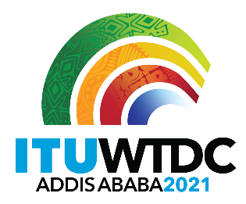 | Regional Preparatory Meeting  for WTDC-21 for the Americas (RPM-AMS)  Virtual, 26-27 April 2021
 |  | Revision 1 to
 |  | Document RPM-AMS21/1-E
 |  | 20 April 2021
 |  | Original: English
Director, Telecommunication Development Bureau
Draft agenda

1. | Opening ceremony
2. | Election of the Chairman and Vice-Chairman
3. | Adoption of the agenda and time management plan
4. | Digital Trends Americas
5. | Reporting on the implementation of the WTDC-17 Buenos Aires Action Plan (including the Regional Initiatives), and contribution to the implementation of the WSIS Plan of Action and the Sustainable Development Goals (SDGs)
6. | Report on the implementation of outcomes of other ITU Conferences, Assemblies and meetings related to ITU-D work: PP-18, WRC-19, RA-19, and WTSA-16
7. | Preparations for WTDC-21
7.1 | Report of the TDAG Working Group on WTDC Preparations (TDAG-WG-Prep)
7.2 | Report of the TDAG Working Group on WTDC Resolutions, Declaration and Thematic Priorities (TDAG-WG-RDTP)
7.3 | TDAG Working Group on Strategic and Operational Plans (TDAG-WG-SOP)
8. | Identification of regional priority areas
9. | Other business

_______________

