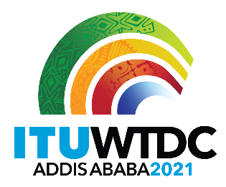 | Regional Preparatory Meeting  for WTDC-21 for the Americas (RPM-AMS)  Virtual, 26-27 April 2021
 |  | Document RPM-AMS21/3-E
 |  | 23 February 2021
 |  | Original: English
Director, Telecommunication Development Bureau
Result Based Management (RBM) implementation in BDT
Agenda item:
Item 5
Summary:
In 2019, BDT embarked on a comprehensive overhaul of its use of results-based management (RBM) to equip the Telecommunication Development Bureau (BDT) for the challenges of a rapidly changing development landscape and make it Fit4Purpose. This reform will introduce RBM for the implementation of all work programmes, as a managerial decision and monitoring tool, and to provide the evidence to demonstrate BDT’s impact. RBM will also serve as the platform to engage with internal and external partners, and to replicate and scale up successful projects and work programme initiatives.
Expected results:
RPM-AMS is invited to note this document.
References:
Buenos Aires Action Plan from World Telecommunication Development Conference 2017 (WTDC-17), Resolutions 25, 71 and 151 (Rev. Dubai, 2018) of the Plenipotentiary Conference, Resolutions 52 and 53 (Rev. Dubai, 2014) of WTDC

- The need to embark on a far-reaching RBM change initiative
Against the backdrop of a rapidly changing development landscape, and the continued requests by Member States to ensure an efficient and effective BDT, in 2019 the Telecommunication Development Bureau (BDT) embarked on a comprehensive review of its results-based management framework. In order to retain and enhance the relevance of BDT, a baseline analysis to create a Fit4Purpose BDT was carried out and demonstrated that:
- Activities had become fragmented, making it difficult to engage partners on a systematic basis, to leverage synergies across the ITU Sectors, and to track impact;
- The delivery of work programmes was happening in silos, with the operational plan work programme often disconnected from projects and regional initiatives;
- Regional initiatives, especially with similar thematic areas mandated across multiple regions, were not benefiting from the potential scaling and resource mobilization opportunities;
- ITU’s role as the UN special agency for ICTs, and in particular the BDT objective to be the “partner for digital transformation through meaningful connectivity”, was not being sufficiently recognized by other key international organizations and other Member States.
In summary, the review showed that a more coherent approach was needed to deliver on the BDT work programmes and to ensure that the Bureau was viewed as a key partner in the development landscape.
- Reform of the work programme approach
Building on earlier efforts, a renewed, comprehensive RBM approach was designed from the start:
- To move RBM in BDT beyond its limited use as a planning tool and expand its coverage to a focus on holistic programme implementation, comprising Operational Plan-budgets, projects, and regional initiatives, and raising synergies across thematic priorities and integrating seamlessly the Headquarter-based thematic and regional work programs;
- To strengthen the monitoring and reporting functions through quarterly management reviews to follow up on the progress of BDT work programmes, and address critical operational risks, which are now recorded in a risk register; and
- To stimulate learning at all stages of the RBM cycle, as this becomes an ever more decisive factor for a successful RBM implementation, given that outcomes and impact occur beyond the BDT’s direct control. For this purpose, the thematic priorities and the related networks integrating efforts form the headquarter and regions, will play an important role in reinforcing knowledge transfer & knowledge sharing, and the sector’s evaluation function will need to be built up and strengthened to provide more reliable insights on the impact achieved at different stages of the results chain.
Thus, BDT expanded its use of the RBM framework to include the following building blocks:
- Impact pathways, which follow programmatic thematic work streams (thematic priorities) to identify the outputs, target groups reached, and their capacity and behaviour changes;
- The underlying assumptions and operational risks, which systematically allow monitoring the extent to which they remain relevant, and to quickly learn and readjust the initial planning and risk assumptions to bring the work programme back on track, as needed;
- The linkages between each thematic priorities (i.e., the WTDC programmes) and the relevant ITU-D study groups, and other ITU Sectors (ITU-T and ITU-R);
- SMART key performance indicators (KPIs), which provide the qualitative or quantitative tools to measure and record achievements towards the thematic goals.
Each thematic priority has developed an RBM based theory of change (ToC) as a comprehensive and holistic approach to reflect the global and regional specificities, including all of the above building blocks and in full alignment with the Buenos Aires Action Plan.
- Changes
Using RBM as a managerial decision tool for the implementation of the BDT work programme lays the foundation for an effective, efficient, and a Fit4Purpose BDT:
- A “Delegation of Authority” (DoA) framework, adopted after extensive discussions, is a critical building block for a less centralized, thematic network-based operating model; the DoA clarifies the delegation of resources with the accompanying accountability for all BDT units; it allows tracking multiple contributions to complex programmes, which involve cross-sectoral headquarter teams, Regional Offices and other units.
- Quarterly review meetings of thematic priorities work including the regional offices and call for adjustments, where needed. Mirroring BDT’s planning approach, the quarterly reviews make use of the same holistic view, bringing together all available resources (human, financial) of the OP-budget, projects, regional initiatives and otherwise funded actions.
- Operational risk assessments are recorded in a unit-based risk register, then aggregated up to the BDT level, allowing the identification of problem areas in order to allow for a quick resolution of pending programme issues and to accelerate and escalate decision-making.
- Key performance indicators are updated continuously on a BDT dashboard, and reported regularly.
- In preparation for 2021, BDT undertook reforms to its annual planning process, whereby each thematic priority’s plan underwent multiple assessment rounds with experts who evaluated the plan from many angles, including resourcing, KPIs, risk, geographical inclusion, strategic optimization and potential for impact.
- Scaling-up of successful projects, “flagship programmes” and regional initiatives. These are regularly monitored as a critical success factor for program impact, with partners’ and membership’s concerns addressed in a more focused way;.
- Last but not least, RBM will facilitate external as well as internal communication, as the impact narratives of our work programs will be easier to understand and follow.
The above measures will result in palpable impact, the first signs of which are already visible, and the evidence of which will be tracked systematically.
Annex 1 provides an overview of the 10 BDT thematic priorities, including the main challenges to be addressed and the proposed solutions to such challenges using RBM as an operational framework.
- Toward a BDT-wide theory of change
To unleash the full potential of RBM, an additional step should be taken to achieve a close alignment between the vision and mission of the ITU-D (and consequently the BDT) and the overall BDT work programme aimed at achieving such vision and mission.
To this end, a further streamlining and consolidation of the existing thematic priorities toward the concept of a BDT-wide theory of change should be considered. This would allow a more effective delivery of the BDT mandate, and a more efficient use of available resources.
An exercise was conducted within BDT to investigate the option of developing a wider and thematically more consolidated and focused theory of change to capture the essence of the ITU-D objectives as per the ITU strategic plan in force.
The diagram below summarizes the outcomes of the discussion
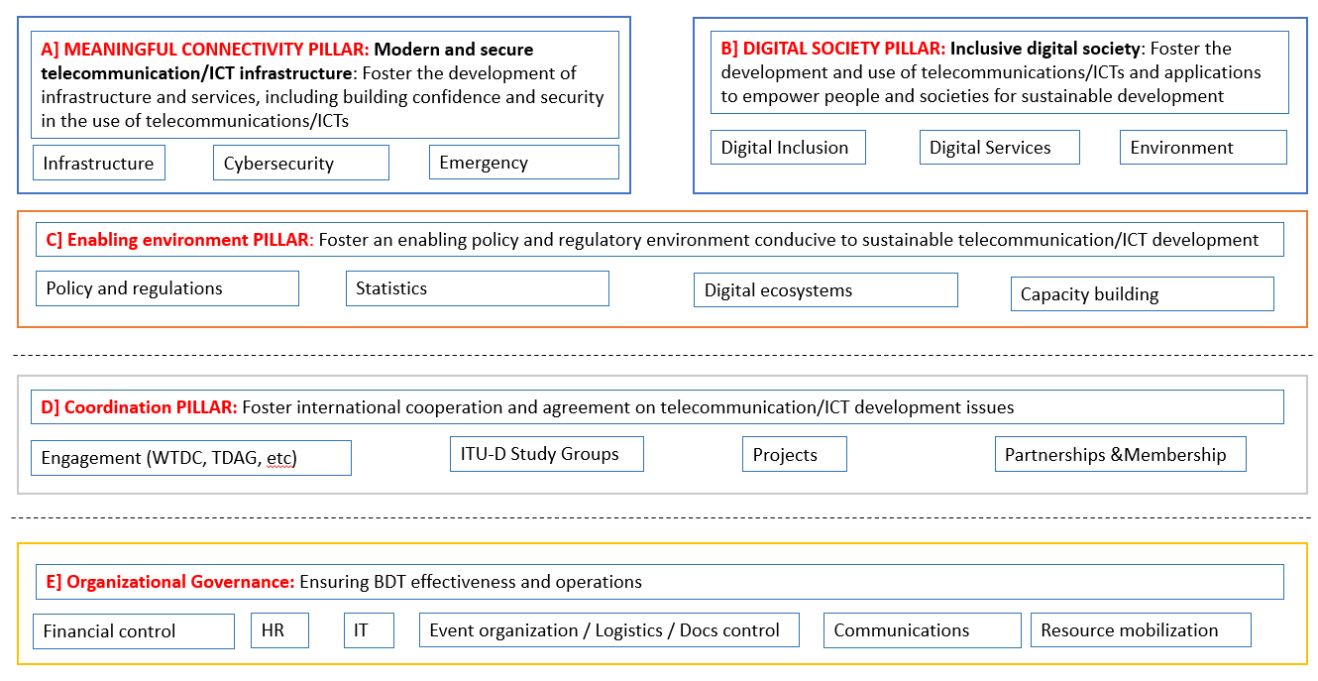
The logic applied translates the two main themes articulated in the ITU-D mission statement (above) as two, broad thematic result pillars at the core of ITU-D work, as follows:
- Meaningful connectivity
- Digital society
Several of the thematic priority objectives, as articulated in the Buenos Aires Action Plan, would directly contribute to these two core result pillars, namely: Infrastructure, Cybersecurity, and Emergency Telecom to the first results pillar about “meaningful connectivity”; while Digital Inclusion, Digital Services, and Environment deliver transformative digital services under the second core results pillar on “digital society”.
These two results pillars are supported by enabling services from a third pillar (“enabling environment”); those cross-cutting functions from thematic priority areas such as Policy & Regulation, Digital Ecosystems, Capacity Building and Statistics are enabling and supporting the impact generated by the two core result pillars.
In addition, to ensure proper engagement and project execution, as well as to support on the operations and related governance, two additional cross cutting pillars will continue to support the delivery of BDT’s thematic operations (Coordination and Organizational governance)
Successful implementation of the resulting “whole-of-BDT” results architecture would not require any reorganization of BDT’s organizational structure; it rather relies on changes in behaviour, with deeper cooperation and synergies between different thematic priorities and support functions.
Such culture and behaviour changes will be built on clarity with respect to the underpinning “delegation of authority” (DoA) and “performance agreements” (PAs) which is needed across BDT to ensure effective mutual commitments of participating partners, and for the delivery of multiple contributions to larger projects and programs. All these building blocks (DoA; PAs) have been extensively discussed and are now in place.

_______________

In particular, see Resolution 151 (Rev. Dubai, 2018) calling for the implementation of results-based management, Resolution 71 (Rev. Dubai, 2018) calling for a coordinated implementation of the ITU strategic plan, and Resolution 52 (Rev. Dubai, 2014) of WTDC calling for strengthening the executing agency role of the ITU Telecommunication Development Sector.
See in particular Resolution 25 (Rev. Dubai, 2018) calling for strengthening regional presence and Resolution 53 (Rev. Dubai, 2014) of WTDC requiring the development of a strategic and financial framework for the elaboration and implementation of the Dubai Action Plan.
This comprehensive approach will, however, also require the setting up of new systems to track implementation progress, report on the KPIs, operational risks, and expenditures incurred by deliverable, in addition to tracking the activities. This will enable direct linkages from our budget and expenditures to our work programme priorities, pending the completion of the IT systems renewal.

