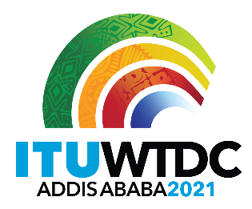 | Regional Preparatory Meeting  for WTDC-21 for the Americas (RPM-AMS)  Virtual, 26-27 April 2021 |  | 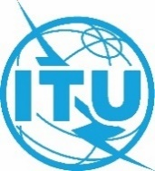
 |  | Document RPM-AMS21/8-E
 |  | 23 February2021
 |  | Original: English
Chairman, TDAG Working Group on Strategic and Operational Plans
Report on the meeting of TDAG Working Group
on Strategic and Operational Plans (TDAG-WG-SOP)
Agenda item:
Item 7.3
Summary:
This document contains a report on the activities of the TDAG Working Group on Strategic and Operational Plans (TDAG-WG-SOP) since its creation. It also contains some recommendations on the way forward, that TDAG-20/3 approved.
Expected results:
RPM-AMS is invited to note this document.
References:
TDAG-20/3/3

Introduction
The TDAG Working Group on Strategic and Operational Plans (TDAG-WG-SOP) and its terms of reference were approved (TDAG-20/DT/7) during the TDAG virtual meeting on 2-5 June 2020. The correspondence group was open to all ITU-D membership, and was convened by Ms Blanca González as Chair and Mr Christopher Kemei and Mr Wim Rullens as Vice-Chairs.
Terms of Reference
TDAG-WG-SOP operated under the following Terms of Reference:
- To review the status of implementation and impact of the Strategic Plan approved by the 2018 Plenipotentiary Conference and to prepare proposals for the draft new ITU-D contribution to the Strategic Plan for the next period (2024-2027);
- To review the status of implementation and impact of the Buenos Aires action plan and its links with the Operational Plan; and
- To review the status of implementation and impact of the four-year rolling Operational Plan, identify areas of improvement, and develop recommendations for the Draft Operational Plan prior to consideration by Council.
Summary of meetings
The group began its work after approval of its terms of reference by TDAG 2020, with two meetings held online through the Interprefy platform:
- First meeting – 17 July 2020, 1300h-1600h with the following agenda items:
  - Opening of the meeting and welcome remarks
  - Approval of the agenda
  - Working methods
    - Virtual meetings with/without interpretation
    - Document submission and publication in English
    - Language of documents: English – only reports translated
    - Email correspondence/mailing list/SharePoint Site
    - Recommendation for RTOs to designate focal points for regional coordination
  - Workplan
    - Date for submission of report to TDAG
    - Date for draft report for comments
    - Dates of meetings
    - Deadlines for submission of written contributions
  - Conclusion
  - Any other business
Link to report of first meeting
- Second meeting – 1 October 2020, 1300h-1600h with the following agenda items:
- Opening of the meeting and welcome remarks
- Approval of the agenda
- Approval of the report of the previous meeting
- Presentations of contributions received and discussion
- Framing questions and poll results
- Reference documents
- Next meeting
- Any other business
Documents provided and presentations by Secretariat
The following documents were provided to the Working Group by the Secretariat:
- 2019 Progress Report on the Implementation of the Buenos Aires Action Plan (ITU TDAG Contribution 2)
- BDT Year in Review 2019
- Connect 2030 Agenda microsite
- Four-year rolling Operational plan for the Union for 2021-2024 (C20/28)
- Global ICT Regulatory Outlook 2020
- Measuring digital development: Facts and Figures 2019
- Report on the implementation of the strategic plan and the activities of the Union for 2019-2020 (C20/35)
- Report on the meeting of the TDAG Working Group on Strategic and Operational Plans (17 July 2020)
- State of Broadband report
- UN Secretary-General’s High-level Panel on Digital Cooperation
The Secretariat provided two in-depth presentations on the process for the Strategic Plan, ITU-D Objectives, Goals and the BDT process on Results-Based Management (RBM).
- Annual Report of the Implementation of the Strategic Plan and activities for the Union: Presentation on 17 July
- Development of Strategic Plan and BDT RBM process: Presentation on 17 July
- Strategic Plan Process, Goals and ITU-D Objectives: Presentation on 1 October
Contributions (summary)
TDAG-WG-SOP received one contribution from Mexico/United States/Canada which was presented in the meeting on 1 October, entitled Proposal on WTDC Review of the Strategic Plan.
The contribution proposed to streamline the review of the SOPs and lessen the administrative tasks during the WTDC by assigning the task of reviewing ITU-D’s contribution to the ITU Strategic Plan to TDAG, in advance of the upcoming Plenipotentiary Conference in 2022, by revising provision 1.8.2 of Resolution 1. This contribution included two proposals.
- If there is consensus around the ITU-D input to the Strategic Plan being elaborated by TDAG in the lead-up to the PP-22 instead of being finalized during the WTDC itself, the TDAG-SOP ad hoc group could examine language based on Member proposals to modify the pertinent provisions in Resolution 1 and Resolution 24 to affect this change and ensure quick adoption at WTDC-21. Advance agreement in principle is needed to reduce time by spent by the Membership on finalizing the Development Sector’s input to the Strategic Plan in advance of the WTDC-21. We further propose that the TDAG WG-Prep consider this topic of revision of Resolution 1 and 24 on the agenda for the IRMs to facilitate inter-regional consensus in advance of the WTDC.
- The review of SOP implementation and contribution to the development of future SOPs allows the Development Sector to evaluate realization of its current priorities and identify and provide guidance on implementation of future priories through WTDC programs and projects. The BDT has identified 10 thematic priorities based on 11 programs in the Buenos Aires Action Plan which in turn are mapped to Plenipotentiary and WTDC Resolutions, WSIS Action Lines and Study Questions. Proposed discussion questions are outlined in Annex 1.
TDAG-WG-SOP participants agreed to the proposals and will provide these as input to the TDAG Working Groups on WTDC Preparations (TDAG-WG-PREP) and Resolutions, Declarations and Thematic Priorities (TDAG-WG-RDTP).
Poll on Members’ views on prioritization of ITU-D Goals and Objectives
An informal poll was held among TDAG-WG-SOP participants to assess their views on the prioritization of the ITU-D Objectives and Goals, for which a presentation of results was provided by the Secretariat.
As outlined below in Graph 1, participants indicated that among the four ITU-D Objectives, Objective 4 (Inclusive Information Society) was the top priority, closely followed by Objectives 3 (Enabling Environment) and 2 (Modern and Secure Infrastructure. Objective 1 (Coordination) on average was ranked significantly lower than the other three.
Graph 1: Ranking of prioritization for ITU-D Objectives
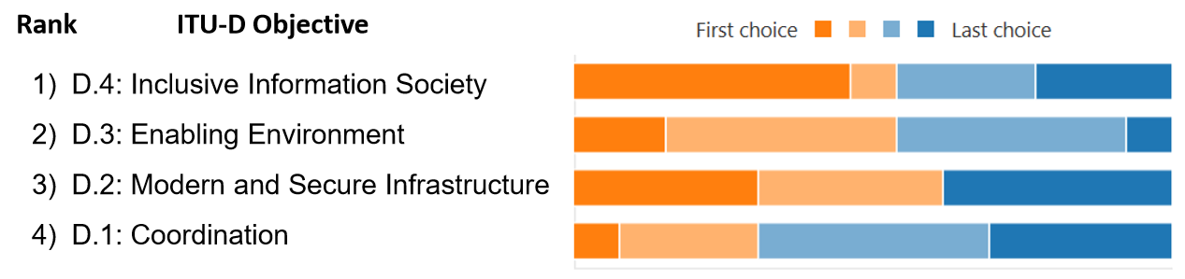
Among the Goals, Goal 1 (Growth) followed by Goal 2 (Inclusiveness) were clearly the top priorities for most respondents. The remaining three Goals (Innovation, Sustainability and Partnerships) were systematically ranked as lower priorities for most respondents. Results are further outlined in Graph 2.
Graph 2: Ranking of prioritization for Goals
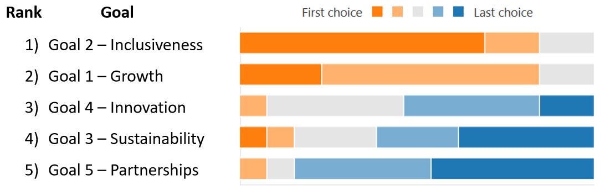
TDAG-WG-SOP participants agreed with the poll results, with a consensus to propose this prioritization of ITU-D Objectives and Goals to TDAG.
Conclusion
TDAG-WG-SOP conclusions upon the end of the second meeting on 1 October are as follows:
- One contribution on Procedure supported by the Working Group;
- Agreement on prioritization of the Goals and Objectives (poll outcome) to be provided as input towards the new Strategic Operational Plan and Action Plan; and
- Contribution discussion questions (Annex 1) and TDAG-WG-SOP Framing Questions (Annex 2) to be provided as input to TDAG for discussion.
Recommendations
TDAG-WG-SOP recommends the following:
- Input to TDAG on prioritization of ITU-D Objectives and Goals
- Input of this report into the next meetings of TDAG-WG-PREP and TDAG-WG-RDTP for discussion
- TDAG accepts this final report of TDAT-WG-SOP

Annex 1: Discussion questions from TDAG-WG-SOP contribution
- How do the objectives of the Strategic Plan relate to the BDT Thematic Priorities and associated regional initiatives, WTDC Resolutions, WSIS Action Lines and Study Questions?
- How can the new Strategic Plan objectives best support results-based management and measurement of implementation of the Action Plan?

Annex 2: Framing Questions of TDAG-WG-SOP
- Review of Strategic Plan, Buenos Aires Action Plan and 4-year rolling plan
  - Where has BDT excelled in building on the "One-ITU" framework, and where is there need for improvement?
  - How well is BDT on track quantitatively meeting objective targets?
  - Which adjustments are recommended to better align with the strategy?
  - What are the recommendations to reduce duplication with other Sectors?
  - How should we coordinate with TDAG-WG-Prep to align our position on regional initiatives?
- Proposals for ITU-D contribution to ITU strategic plan (2024-27) and draft Operational Plan
  - What products and services portfolio will help us attract and retain partners to achieve those goals set out in the Action Plan, the Connect 2030 Agenda and the ITU strategic targets, and which organizations (including UN-related agencies, industry, civil society, among others) should be targeted for multi-stakeholder cross-sectoral cooperation?
  - How should BDT streamline, consolidate and prioritize its offering to make the best use of available resources?
  - What competition is expected and how should BDT adapt strategically for a competitive advantage in this environment?
  - What specific objectives, outcomes and outputs should be envisioned to pave the way for universal, affordable, accessible and trusted connectivity by 2030?
________________

