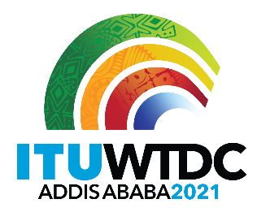 | Regional Preparatory Meeting  for WTDC-21 for Arab States (RPM-ARB)  Virtual, 7-8 April 2021 |  | 
 |  | Document RPM-ARB21/11-E
 |  | 6 April 2021
 |  | English only
Director, Telecommunication Development Bureau
Report: Crystallizing Regional Priorities in the Arab Region to prepare for the World Telecommunication Development Conference (WTDC-21)
Agenda item:
Item 8
Summary:
This document presents the report of the event Crystallizing Regional Priorities in the Arab Region to prepare for the World Telecommunication Development Conference (WTDC-21), that took place online on 30 and 31 March 2021.
Expected results:
RPM-ARB is invited to note this document.
References:
N/A

Innovation is identified as a priority area within the ITU-D Regional Initiatives and as a core objective of the 2017 Buenos Aires Action Plan. To further support the definition of regional priority areas in the Arab region for WTDC21, the International Telecommunication Union (ITU) has facilitated a special workshop series “Crystallizing Regional Priorities in the Arab Region to prepare for the World Telecommunication Development Conference (WTDC-21)”.

Objectives and background

The workshops had the following objectives:
- To support Member States to collect regional and national problem areas as a basis for potential future regional priorities
- To cluster and harmonize existing problem areas
- To prioritize key problem areas for future regional initiatives in view of their alignment with SGGs/WSIS action lines, regional needs and the potential for impactful demonstration projects and partnerships.

Process & Methodology

The 2- Day workshops integrate themselves in a 4-step process. They were preceded by an onboarding event at the beginning of March. The resulting initial list of key regional priority areas ideally serves as an input for the Regional Preparatory Meeting for the Arab Region on the 7th and 8th of April.

In a fourth step, the selected priority areas can be further detailed in deep dive sessions taking place from May to September 2021.

Workshop methodology
The workshops were conducted in two 3-hour sessions and involved both group work and deliberations in plenary. The methodological steps and their content are detailed below:
We used the following instruments to carry out the mission:
- Problem discovery (groups)
- Area Clustering (groups)
- Gallery walk (plenary)
- Regional Initiative Framing Canvas (groups)

Instruments | Content of instrument utilized | Added-value of instrument for attaining mission objectives
Problem discovery | Collection of challenge and problem areas | Allowed us to collect and identify the challenges and problems areas from a national perspective
Area Clustering | Definition of similarities and common themes | Enabled us to understand similarities between national challenges and to define common priority areas
Gallery walk | Validation of preliminary results in plenary group | Allowed us to verify findings and judgements.
Regional Initiative Framing Canvas | Status quo, beneficiaries, potential solutions and impacts | Enabled us to create a high-level overview for each of the five regional priority areas selected via the process

Participation

The 2-Day workshop had 78 participants. Approximately 65% of participants were Member States of the ITU Regional office for the Arab States, the other participants composed of ITU BDT Sector Members and other regional and international organizations. The workshops included only representatives of ITU Membership

Type | Number of participants | %
Member States | 51 | 65%
Academias | 4 | 5%
Scientific or Industrial Organizations | 2 | 3%
Recognized Operating Agencies | 6 | 8%
Other Entities | 2 | 3%
Regional and other International Organizations | 6 | 8%
Resolution 99 | 4 | 5%
REGORG | 1 | 1%
Special Guests | 2 | 3%
Total | 78 | 100%

A detailed overview of participants may be found in the Annex of this report.

In the following we will present an overview of the results of the two workshop days.

March 30th, 2021

The agenda:

10:00 Welcome & Introduction
10:10 Introduction – Trends & Drivers
10.50 Warm-up exercise & Methodology
11:10 Break
11:20 Problem Discovery (Groups)
11:40 Priority area Clustering (Groups)
12:50 Refinement and voting (Groups)
13:20 Wrap up & Outlook Day 2
13:30 End

- Welcome and high-level impulse statements

Day 1 of the workshop began with a welcome statement by Mr. Adel Darwish, Regional Director of the ITU Arab Regional Office. That was followed by impulse statements on regional drivers and gaps by 5 distinguished guests.
- Mr. Mounir Tabet, Deputy Executive Secretary of the United Nation Economic and Social Commission for Western Asia (ESCWA),
- Diego Molano Vega, former Minister of Information Technologies and Communications of Colombia
- Mr. Bocar A. BA, Chief Executive Officer of SAMENA Telecommunications Council FZ LLC
- Mr. Nasser Kettani, Managing Partner, Kettani Digital Consulting
- Mr. Salem Al Maawali, Acting Executive Manager of Executive Office Unit, International Representations Department, Telecommunication Regulatory Authority, Sultanate of Oman ,

The interventions were joined by Mrs. Doreen Bogdan-Martin, elected Director of the ITU Telecommunication Development Bureau, who addressed her welcoming words to distinguished speakers and participants of the workshop.

- Group work

The workshop proceeded by facilitating work in 4 groups. Each group started by collecting all national and problem areas. In a second step, relationships between different problem areas were discussed to establish potential overlaps and cluster them in areas for regional priorities. In a third step, the identified problem areas were further refined and finally each group voted on 3-5 areas that considered of the highest priority for the region.

Breakout Group 1 discussed problems and challenges around the availability of financial and regulatory framework to support innovation and entrepreneurship, the reliable and modern infrastructure, high speed last mile connectivity and digital government services.

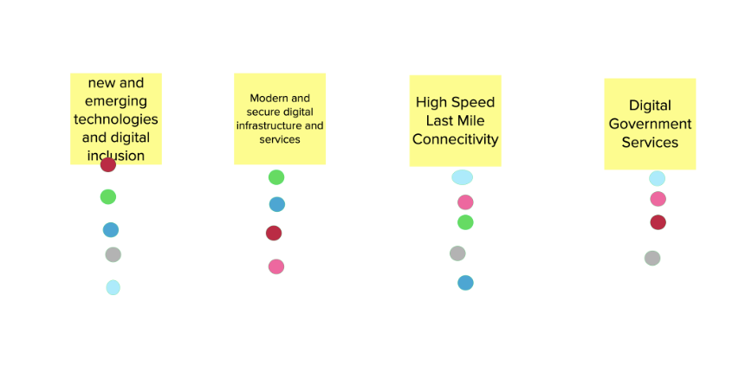
Breakout Group 2 discussed problems and challenges around the cybersecurity, policy and regulatory framework for new emerging technologies, smart cities and government, digital collaborative regulations and Regional digital skills and inclusion.

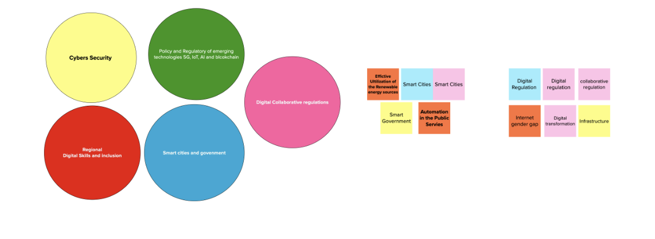

Breakout Group 2 discussed problems and challenges around the cybersecurity, policy and regulatory framework for new emerging technologies, smart cities and government, digital collaborative regulations and Regional digital skills and inclusion.

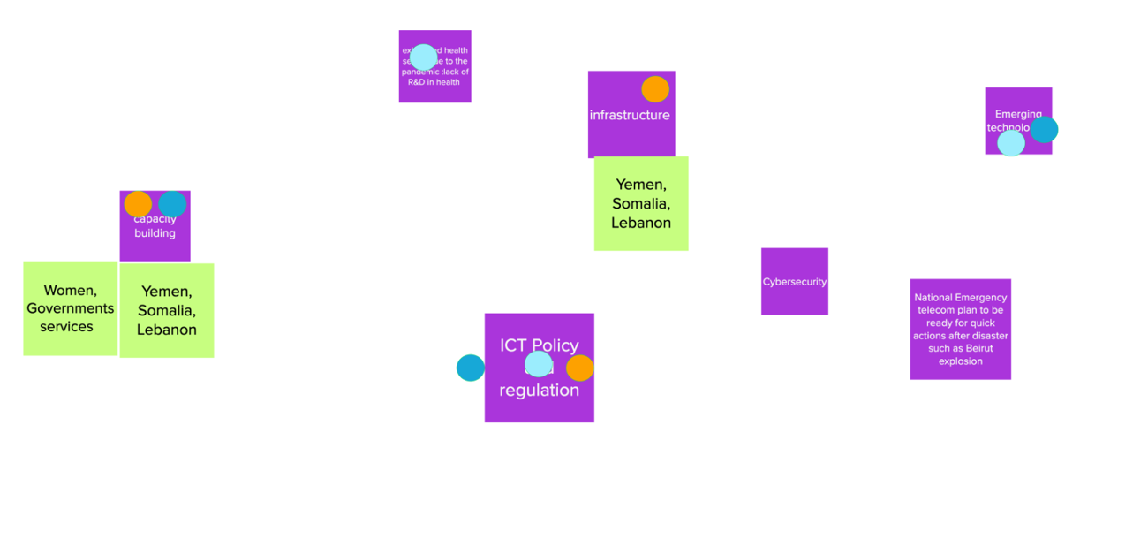

Breakout Group 4 discussed problems and challenges around universal broadband access, regulation for emerging technologies and consumer protection, privacy, cybersecurity and trust.

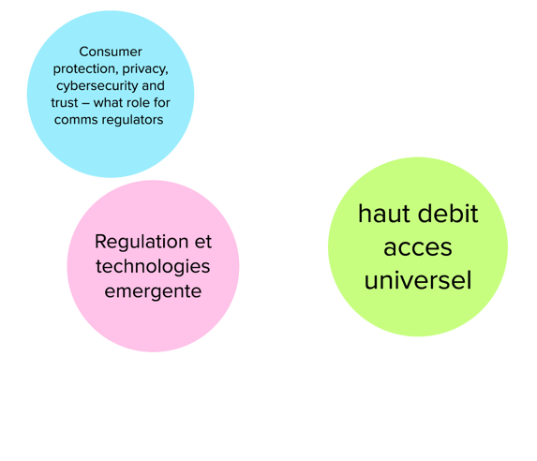

March 31st, 2021

The agenda:

10:00 Welcome & Introduction
10:15 Gallery walk and group feedback (Plenary)
10:45 Voting on 5 regional priorities area (Plenary)
11:00 Summary of results (Plenary)
11:15 Regional Priority Area Framing canvas (Groups)
11:45 Wrap up & next steps
12:00 End

The ITU team reviewed the contributions from the groups and further clustered them to illustrate commonalities for a “gallery of regional priority areas” discussed in plenary on Day 2. Participants have been invited to review areas collected and add their feedback in the plenary session. In a second step, participants were asked to vote for those areas presented that they favor most. The results were summarized, and the end of the workshop was dedicated to mapping the results per selected areas on a Regional Priority Framing Canvas.

- Gallery Walk and voting

Day 2 started with a presentation of findings and kex areas discussed per group.
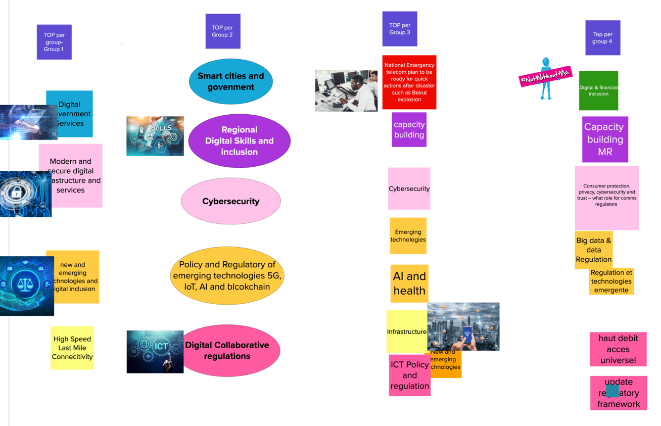

In summary 7 key common topics were distinguished, for which participants were asked to define common titles. The 7 regional priority topics are:
- Fostering new and emerging technologies
- Digital financial inclusion
- Emergency telecom plan and quick response
- Digital skills and inclusion
- Modern Digital Infrastructure & services in new and emerging technologies
- Digital Transformation
- Confidence, security and trust in the use of ICT including child online protection
- Digital collaborative regulations and policies

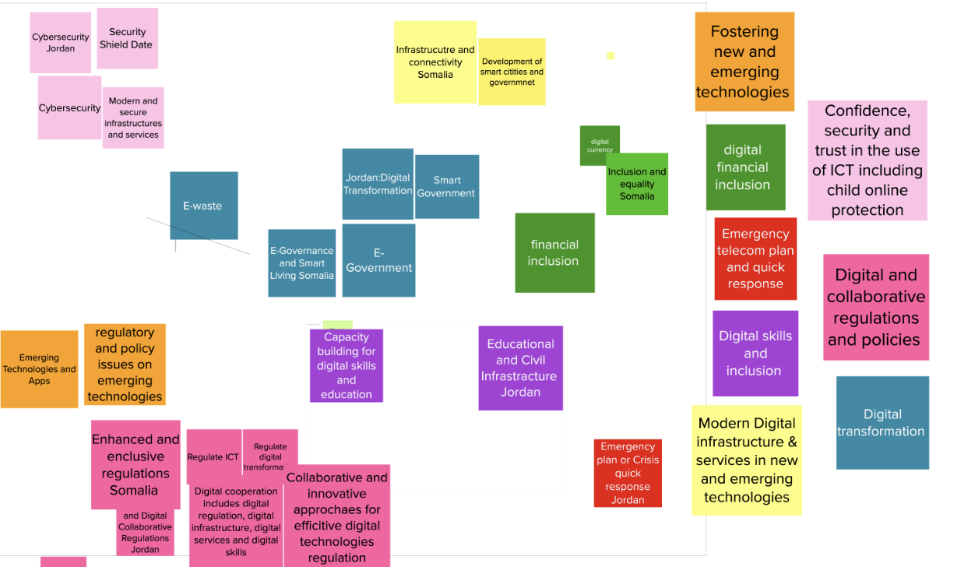

The participants proceeded to vote for the top 5 areas out of the 7 identified above. The list selected was the following:
- Digital transformation
- Digital skills and inclusion
- Modern Digital infrastructure & services in new and emerging technologies
- Digital and collaborative regulations and policies
- Emergency telecom plan and quick response

- Regional Priority Framing Canvas

Building on the selection the participants were now tasked to break out into groups again to summarize findings per priority areas discussed. In the following we provide a brief overview of canvasses per group. It is important to note that these are initial breakdowns of each of the identified regional priorities and it is proposed to have a more thorough breakdown and elaboration in the proposed deep dive workshops suggested to take place after the RPM.

Group Digital Transformation

The group on Digital Transformation defined several broad sets of challenges relevant to the topic area; the lack of harmonization and synchronization to address digital transformation with a whole of government approach; the lack of infrastructure for digital transformation and funding, as well as the lack of awareness and capacities. The challenges are particularly relevant for citizens which could expect more effective and efficient access to government services and better and improved coordination withing government.

Potential solutions to address those challenges are training and capacity building activities to support developing countries, support in developing national strategies on digital transformation including guidance on digital government architecture. Aspects related to policies and regulations were also addressed by the group.

The main impacts areas defined on a general level to accelerate the achievement of all SGDs as illustrated below.

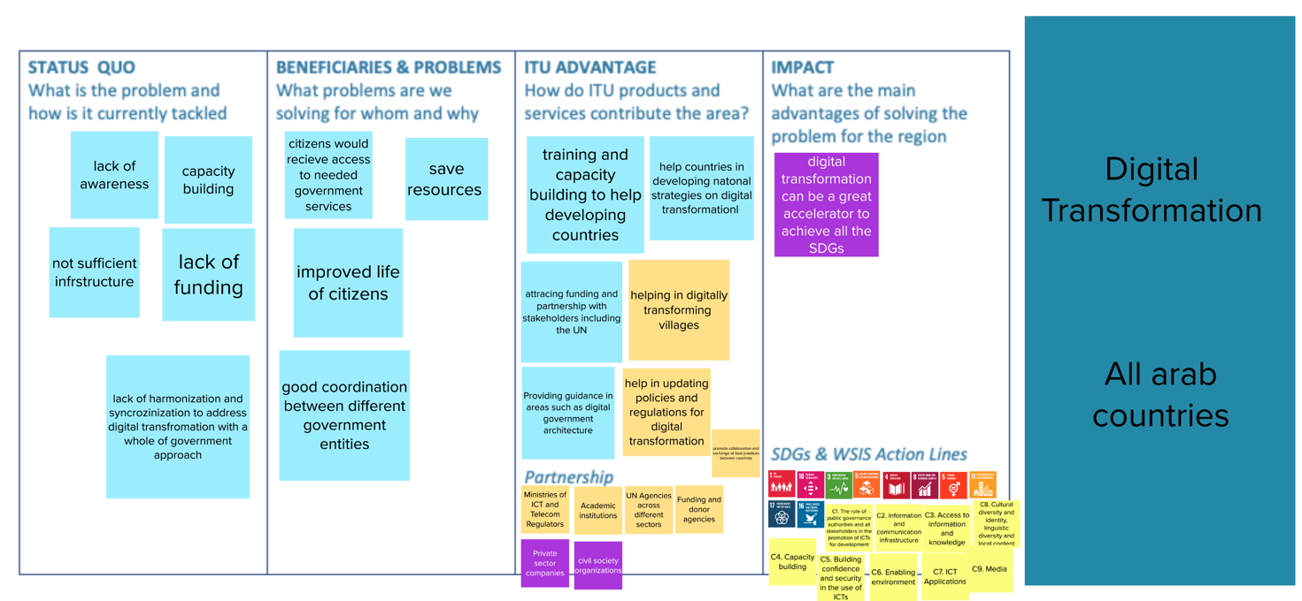

Group Digital skills and inclusion

The group on Digital skills and inclusion defined several broad sets of challenges relevant to the topic area; the lack of training, training facilities and tailored trainings for emerging technologies; the lack of policies in digital inclusion. The challenges are particularly relevant for civil society, and universities actors.

Potential solutions to address those challenges should specifically assist on policies on ICT accessibility and gender equality. These services could be delivered in cooperation with higher education and via public private partnerships.

The main impacts areas were perceived as reducing the digital divide, more qualified and trained ICT professionals available on the labor market, as well as a more inclusive ICT sector more generally. Related SGDs are 10, 9, 17, 4, 5 and 8 and related WSIS action lines are C1, C3, C4 and C8.

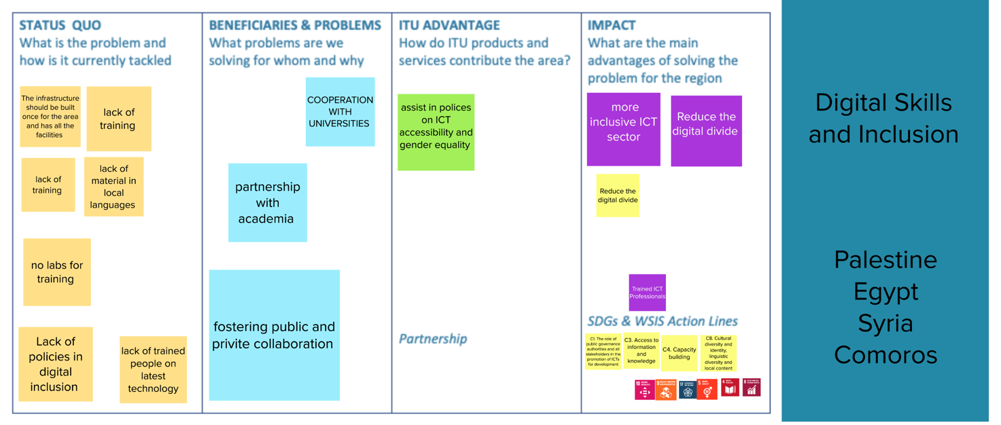

Group Modern Digital infrastructure & services in new and emerging technologies

The group on Modern Digital infrastructure & services in new and emerging technologies defined broad sets of challenges relevant to the topic area; the lack of user centered, modern infrastructure, especially in rural areas; the financing gap for infrastructure investment; the lack of inter-ministerial collaboration around infrastructure policy and design. Certain countries, such as Yemen, face particular challenges that need specific tailored policy solutions. The group perceived that many of these challenges are currently largely unaddressed for beneficiaries.

Potential solutions that could address these regional problems are knowledge and analytical products – guidelines, reports and case studies- as well as capacity building and training exercises. Areas of interest concern for instance guidelines for ICT infrastructure projects, strategic support for infrastructure policy, or procedures for developing more public-private partnerships for concrete projects.

The main impacts areas were perceived as connecting the unconnected, improve the quality of ICT as well as an enabling environment for infrastructure investment and more cost efficiency. Related SGDs are 9, and 11 and related WSIS action lines are C2.

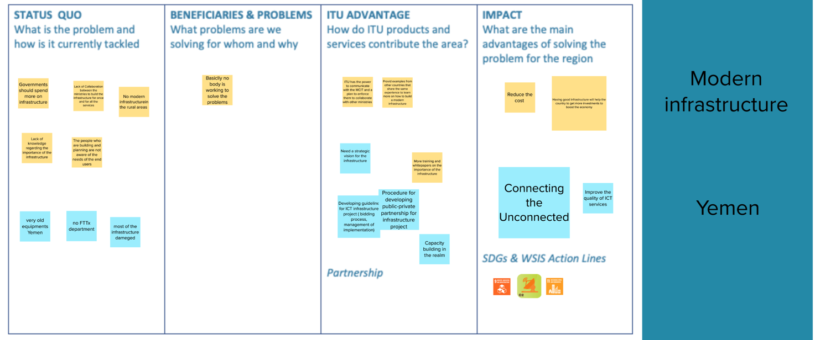

Group Digital and collaborative regulations and policies

The group on Digital and collaborative regulations and policies defined three broad sets of challenges relevant to the topic area; the lack of regulatory standards and regulation for emerging technologies and digital transformation; the broader need for harmonized and comparable legislation in the region; and finally, the lack of capacities for understanding, evaluating and addressing the impact of digital transformation on the regulatory environment. The challenges are particularly relevant for regulators, policymakers, infrastructure operators as well as industry associations, non-profits and other interest groups.

Potential solutions that could address these regional problems are knowledge and analytical products – guidelines, reports and case studies- as well as capacity building and training exercises. Areas of interest concern for instance cloud regulations, personal data regulations, OTT and online applications services as well infrastructure related regulations. Another set of activities could be in facilitating practical experiments of anticipatory regulation via regulatory sandboxes. Potential partners for delivering those products are specialized international organizations and lending banks, but also academia and digital commerce service providers.

The main impacts areas were perceived as creating regulatory capacity, an enabling environment for investment activities, private sector development as well as an enabling environment for the digital transformation of society more generally. Related SGDs are 9, 8, 11 and 17 and related WSIS action lines are C11, C4 , C2 and C6 .

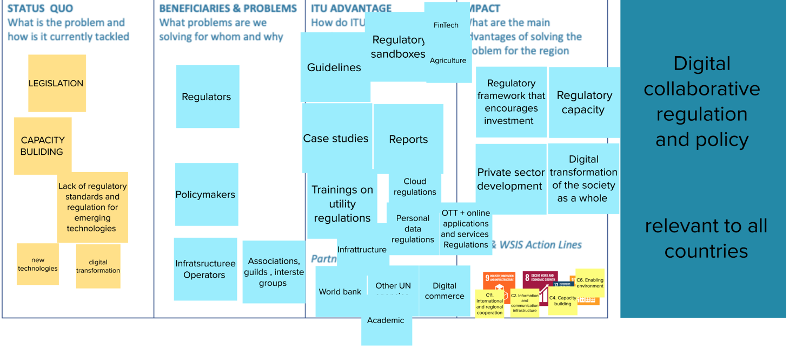

Group Emergency telecom plan and quick response

The group on Emergency telecom plan and quick response defined three broad sets of challenges relevant to the topic area; non-affordability of connectivity; the lack of a national emergency telecom plan and associated governance models; and finally, the lack of awareness and legal commitment to the Tampere convention. The challenges are particularly relevant for NRAs and disaster management entities, citizens as well as the economy/business community.

Potential solutions could address the lack of importance of ICTs in disaster communication. , the communication gap between national policymakers, and contribute to economic development via future proof and resilient infrastructures. Potential solutions are knowledge and analytical products – guidelines, reports and case studies- as well as capacity building and training exercises, building knowledge and capacities on Tampere convention particularly, support in the development of national telecom emergency plans and guidelines on ICT contingency plans for pandemic response as well as deploying MHEWS. Potential partners for delivering those products are UN agencies, the Arab red crescent and red cross.

The main impacts areas were perceived as in disaster preparedness for society and national policymakers, prevention of economic damages as well saving people’s lives more generally. The interventions are particularly important for countries such as Egypt, Jordan, Sudan, Tunisia, Somalia, Oman, Palestine Comoros and Kuwait. Related SGDs are 13, 11 and 17 and related WSIS action lines are C3, C1 , C2 and C11 .

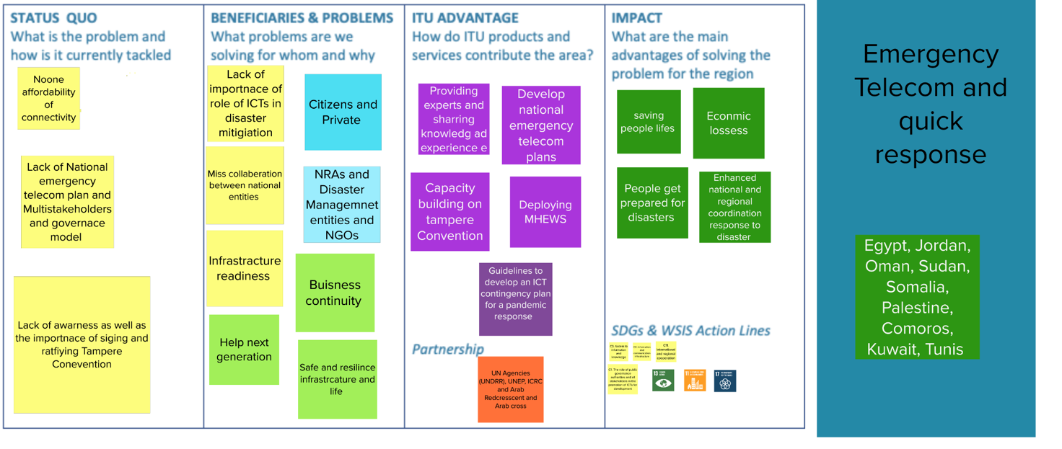

Photo documentation

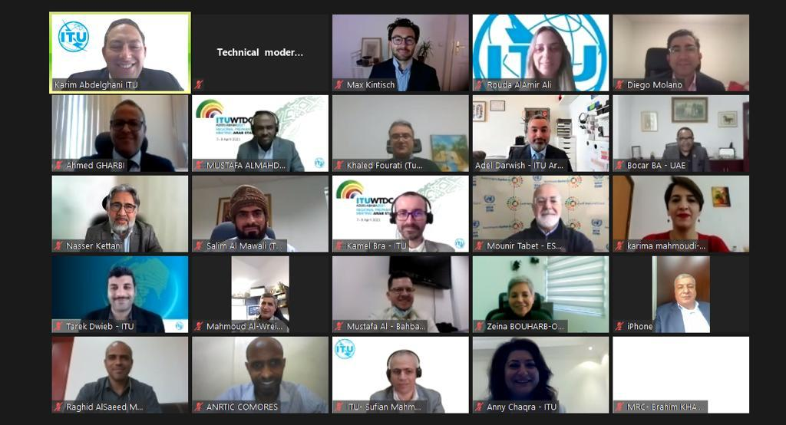

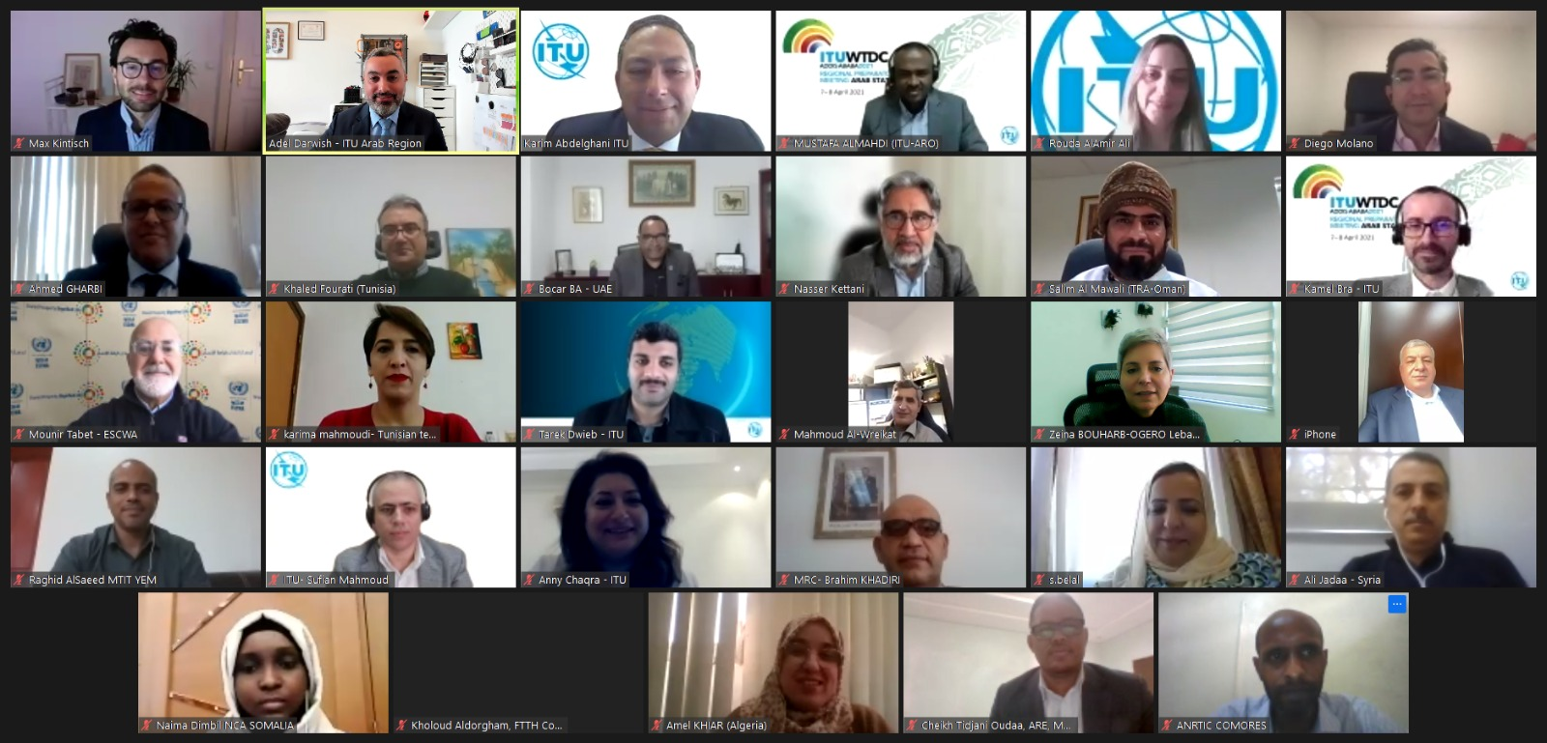

Annex
List of Participants

The list of participants available on the event’s website for TIES access rights users.

_______________

All Member States of the ITU Regional office for the Arab State were present, with the notable exception of Libya.

