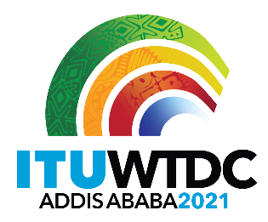 | Regional Preparatory Meeting  for WTDC-21 for Arab States (RPM-ARB)  Virtual, 7-8 April 2021 |  | 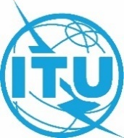
 |  | Document RPM-ARB21/INF/2-E
 |  | 7 April 2021
 |  | English only
State Minister for Innovation and Technology (Ethiopia)
Opening Remarks and talking points-
H.E. Dr. Ahmedin Mohammed, State Minister for Innovation and Technology

Ladies and Gentlemen
- I am pleased to address you at this important meeting where we set the most important regional agenda for WTDC 2021.
- In this era, most countries understand connectivity is critical. Without connectivity, we know we can’t achieve a knowledge-based economy.
- Connectivity has become a core enabler to economic development, job creation, and Poverty reduction.
- Acknowledging this, over the past decade public and private sectors have made significant investment for the development of infrastructure throughout the world.
- However, the cost has made the effort of achieving efficient and affordable ICT infrastructure and services much difficult. Also, the economic challenges have hindered developing countries from fully participating in the digital economy.
- According to the World Bank, the Africa continent, for example, needs about USD100 billion to achieve universal, affordable, and good quality internet access by 2030.
- For me and for all of us, this figure is more than mere data. It is a clear reminder that we need innovative and coordinated ways of minimizing the costs incurred to ensure connectivity- leaving no country and no one behind.
- This is why platforms such as WTDC-21 are considered great opportunities to find holistic approaches to address such critical global issues
Ladies and Gentlemen
- ICT has become a big arena and enabling factor for innovation, innovative solutions.
- Meanwhile, technological products and services significantly transform areas like health care, education, finance, commerce, governance, and agriculture.
- However, half the world's population does not use the Internet. Today, 3.7 billion people remain unconnected.
- While connecting the unconnected, we are facing one other critical challenge- time.
- Today, we cannot take up the amount of time we utilized to reach half of the world with connectivity to reach the other half.
- As a member country, Ethiopia believes WTDC-21 must be solutions-oriented, that serves the needs of all countries, of all people, and must be a means to build sound partnerships for digital transformation with a unique emphasis on connectivity.
- To this end, I urge you to actively participate and contribute by coordinating the issues of regional interest and preparing coordinated regional contribution to enrich the agenda of WTDC – 21.
- I once again would like to take this opportunity to reassure Ethiopia’s commitment to make WTDC a success despite the challenges of COVID 19, and look forward to welcoming you all to Addis Abeba at the first WTDC conference to be held on the African continent soon.
Thank You.
_______________

