|  |  |
| --- | --- |
| Digital trends in the Commonwealth of Independent States region in 2021  Information and communication technology trends and developments in the CIS region, 2017-2020 | Abstract  This document was prepared for the Regional Preparatory Meeting for the CIS region (RPM-CIS), which took place (virtually) on 21-22 April 2021. It provides an overview of trends and developments in ICT infrastructure, access and use in the CIS region, which includes 9 Member States and is home to a population of 240 million people. The document highlights changes in ICT adoption since the last World Telecommunication Development Conference in 2017 (WTDC-17) and during the COVID-19 pandemic, tracks the evolution of regulation, and reviews progress and challenges in implementing the ITU Regional Initiatives for the CIS region. Its objective is to serve as a reference for the ITU membership in reviewing progress and identifying ICT development priorities in the CIS region.  Gray, Vanessa |

Table of contents

Overview 2

Digital trends in the CIS region 4

mobile market developments 6

satellite broadband developments 8

fixed broadband market 9

internet access, use, skills, and gender 10

ict prices 14

telecommunication revenues and investment 16

developments regarding cybersecurity 17

ict infrastructure developments and integrated technologies 19

digital services trends 23

Regulatory trends in the CIS region 24

New collaborative regulatory paradigm 25

The G5 Benchmark for regulatory excellence 27

Maturity of ICT regulatory frameworks in the CIS region 28

Economic contribution of broadband, digitization and ICT regulation in the CIS region 30

Opportunities and challenges of digital transformation 34

Developments under the regional initiatives for the CIS region 34

Regional initiatives: areas of progress 36

Regional initiatives: areas of challenge 37

Conclusion 39

References 41

# Overview

While COVID-19 has dominated the headlines throughout 2020, consistent development and deployment of ICT infrastructure and its concomitant services has meant a continued trend towards digital transformation for societies, businesses and governments alike. Since WTDC‑17, information and communication technologies (ICTs) have continued to spread. ITU data show that in 2019 more than 50 per cent of individuals used the Internet (51.4 per cent globally by the end of 2019), 75 per cent of the total world population had an active mobile broadband subscription, and fixed broadband subscription had grown to just over 15 per cent. Today, over 57 per cent of households have Internet access at home. Moreover, given the rise in data demand owing to increasingly bandwidth-intensive services, international bandwidth has, on average, grown at a compound annual growth rate (CAGR) of 36 per cent between 2017 and 2020, with a CAGR for international bandwidth per Internet user of 26 per cent between 2017 and 2019. Yet the digital divide persists. While almost all urban areas in the world are covered by a mobile broadband network, many gaps remain in rural areas. The gender divide remains a reality, it still being the case that fewer women than men benefit from Internet use (Figure 1).

Figure 1: Global ICT indicators (per 100 inhabitants and per cent), 2019 and 2020, and CAGR, 2017-2019 and 2017-2020, where available

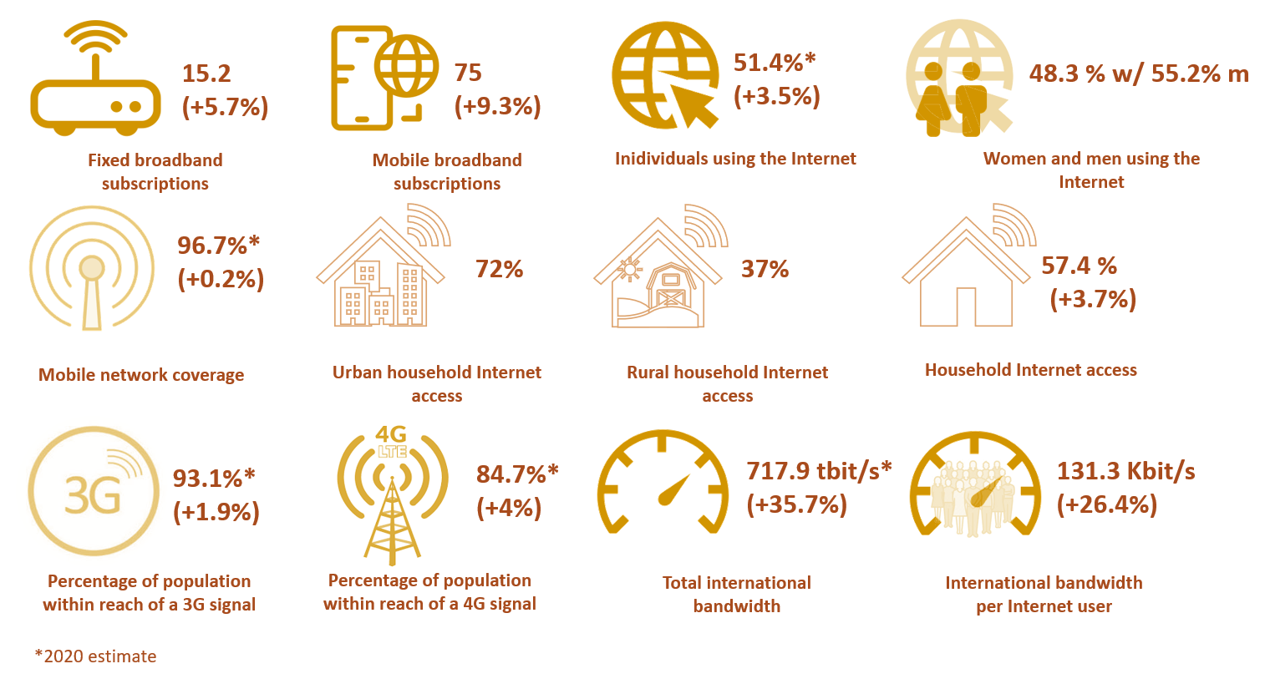

Source: Based on ITU World Telecommunication/ICT Indicators (WTI) Database from 2017, 2019 and 2020, where available.

As most countries across the world grapple with the effects of the COVID-19 pandemic, the role of ICTs and services and the digital infrastructure on which they ride and grow have become central to continued economic and societal activity and to lessening the impact of the pandemic. The Economic Experts Roundtable organized by ITU in June 2020[1] concluded that countries with top connectivity infrastructure could mitigate up to half of the negative economic shock of the pandemic. Overall, the impact of the pandemic has been to accelerate digital transformation, as businesses move towards distributed models of employment and digital service and product delivery. Individuals forego travel and socializing and turn towards digital entertainment and communication platforms and also, increasingly, to e-commerce. Schools move to online learning and digital classrooms, and governments increasingly need data on citizens, health and economic indicators to establish policies.

While research on the contribution of digitization to softening the impact of pandemics is limited, emerging evidence of their accelerating effects across all areas of people’s lives and economic sectors is compelling. For example, consumer and business surveys show that the COVID-19 pandemic has pushed consumers and businesses alike to adopt digital services and technologies, accelerating digital transformation in consumer behaviour and business activity by several years (Figure 2).

Figure 2: The accelerating impact of COVID-19 on digital transformation

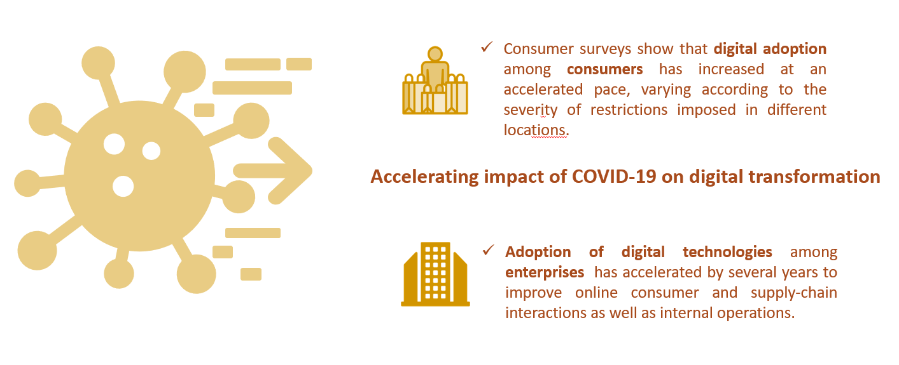

Source: ITU, based on insights from 2020 McKinsey consumer and enterprise surveys at <https://www.mckinsey.com/business-functions/mckinsey-digital/our-insights>[2]

Generally, the pandemic has forced a greater demand for digital reliance across the board, and this outcome is likely to be here to stay in the “new normal”, as the utility of more abundant data and the ever-lower cost of using those data affect how entrepreneurs, policy-makers and professionals make decisions. The pandemic, however, is just one driver of current trends. Climate responsibility, continued economic development, demographic shifts and social well-being are also key drivers in ensuring that no one is left behind.

In the light of these global trends, policy development focused on inclusion, access, security, skills and sustainability in terms of emerging technologies and their benefits is poised to become a defining characteristic of the 2020s. This is mirrored in the ITU regional initiatives for the Commonwealth of Independent States (CIS) region and the associated thematic priorities, which remain highly relevant going forward.[3] The development of ICT skills and capacities is a key priority for the region to accelerate digital transformation as a means of achieving better, more inclusive outcomes, in particular for young people. Moreover, the development of relevant content, applications and services and the fostering of an enabling environment, including fit-for-purpose institutions, policies and accompanying mechanisms for implementation and appropriate regulation, will all push consumers and businesses alike to adopt digital services and digital technologies.

Artificial intelligence (AI), the Internet of Things (IoT), cloud computing, distributed ledger technology, precision medicine, digital trade, autonomous mobility and many more evolving technological arenas will shape the future of the world and the CIS region in it. There are many examples in the region where such technologies are at work and can serve as an example towards sustainable development and inclusive growth, addressing some of the region’s most pressing challenges, in areas such as youth unemployment, natural resource management, remote health, and the smart city.

Along with fit-for-purpose policy, ICT infrastructure is ultimately at the heart of this historical transformation and the predominant enabler of the future competitiveness and prosperity of the CIS region. Robust infrastructure on which emerging technologies ride can help meet some of the region’s most pressing challenges. It is important not to lose sight of the fact that improving ICT infrastructure is more than a goal for operators and consumers. It does much more than support mobile and broadband connections: it serves as the backbone for global and regional supply chain integration; makes possible the innovative use of critical health information; creates opportunities for citizens to improve their options in the workforce; enables students to acquire previously out-of-reach skillsets; and offers many more positive externalities that are changing the course of history. Indeed, future history will look back at this early era of technological development to see how policies and governance approaches reinforced the resilience and responsiveness of societies, while assessing for risks, protecting consumers and enabling positive outcomes for citizens.

# Digital trends in the CIS region**[4]**

The CIS region[5] has a population of 240 million and consists of nine Member States, all of which are classified by the UN as economies in transition. Eight of the nine CIS countries are landlocked, and most fall into the upper-middle-income bracket,[6] namely Armenia, Azerbaijan, Belarus, Kazakhstan, the Russian Federation and Turkmenistan. Kyrgyzstan and Uzbekistan fall into the lower-middle-income bracket and Tajikistan falls into the low-income group.[7] Despite some similarities, the CIS countries exhibit significant differences and face diverging challenges in terms of population structure and dynamics, educational level, employment, and living conditions.

Eight of the nine CIS countries are landlocked, which leaves them dependent on neighbouring and coastal countries for access to undersea cables and international Internet bandwidth. In addition, some CIS countries are very rural, which makes access to connectivity and rolling out terrestrial communication infrastructure more difficult. Only two countries, namely the Russian Federation and Belarus, have relatively high urban populations, in excess of 70 per cent. Based on Eurostat data,[8] the proportion of the population that lives in rural areas exceeds 60 per cent in three countries: Tajikistan (more than 70 per cent), Kyrgyzstan and Uzbekistan; and it lies above 50 per cent in Turkmenistan. (Kazakhstan and Azerbaijan have rates above 40 per cent.)

As regards age distribution, data from CISSTAT[9] show that the share of young people (defined as 15-29 years of age) ranges between 18 per cent and 29 per cent, depending on the country. Consequently, digital development and ICT uptake across the CIS region differ with regard to some of the key ICT indicators given these differences in geographic and demographic variables. It should be noted that the percentage of young people is gradually decreasing in most countries due to significant migration. This highlights the importance to the region of retaining their young population, including by improving their quality of life and creating new opportunities for this age group. Information and communication technologies can be an important tool to develop such opportunities, in particular by creating attractive job opportunities. This requires skilled youth and highlights the importance of education and capacity and skills development, including in the area of ICTs.

Over the last four years, the CIS region has seen continued growth in most areas of ICT infrastructure, access, and use. The region’s mobile cellular coverage, taken as the percentage of the population that lives within reach of a mobile cellular signal, is estimated by ITU to be 98.6 per cent. Just under 90 per cent (88.7 per cent) of the population is now within reach of a 3G signal and 80.8 per cent is within reach of a long-term evolution (LTE) mobile broadband signal. The percentage of individuals using the Internet has increased from 66.1 per cent in 2017 to 72.8 per cent at the end of 2019, with households that have Internet access at home increasing from 73.4 per cent in 2017 to 76.4 per cent at the end of 2019. Both fixed and mobile broadband markets have shown growth over the last three years, with active mobile broadband subscriptions outpacing fixed broadband subscriptions. A relatively small gender gap but a large rural/urban divide persist: In 2019, 71.7 per cent of women and 74 per cent of men used the Internet. That year, only 49.6 per cent of rural households and 72.1 per cent of urban households had access to the Internet (Figure 3). Among 15-to-24-year-olds, 84.5 per cent used the Internet in 2019, which is higher than the regional average of Internet use of 72.8 per cent (Figure 3).[10]

The COVID-19 crisis, which unleashed multiple shocks in the CIS region, underscores the importance of digital connectivity to society and has highlighted the impact of the persistent digital divide for many people in the region who are still unable to connect to the Internet (see Box 6).

Figure 3: Key ICT statistics, ITU CIS region 2017-2020

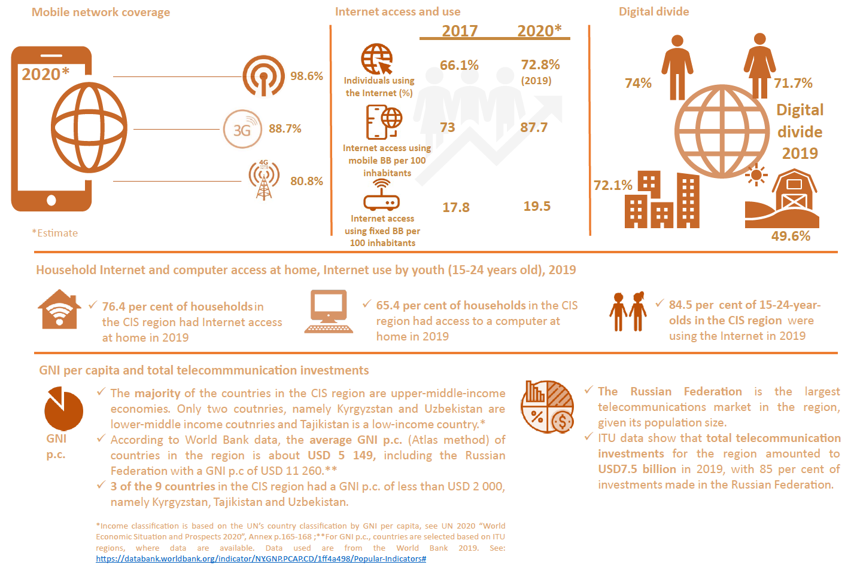

Source: ITU, WTI Database and World Bank data (for GNI data and country income classification)

## Mobile market developments

The CIS mobile market is very advanced, with mobile cellular subscriptions surpassing100 subscriptions per 100 inhabitants in all nine CIS countries. The region is led by the Russian Federation and Turkmenistan, with more than 150 subscriptions per 100 inhabitants each. For the CIS region as a whole, the 2020 average subscription rate is estimated by ITU at 148.2 per 100 inhabitants, which is well in excess of the world average of 105 subscriptions per 100 inhabitants (Figure 4).

Figure 4: Mobile cellular subscriptions 2019, nine CIS countries

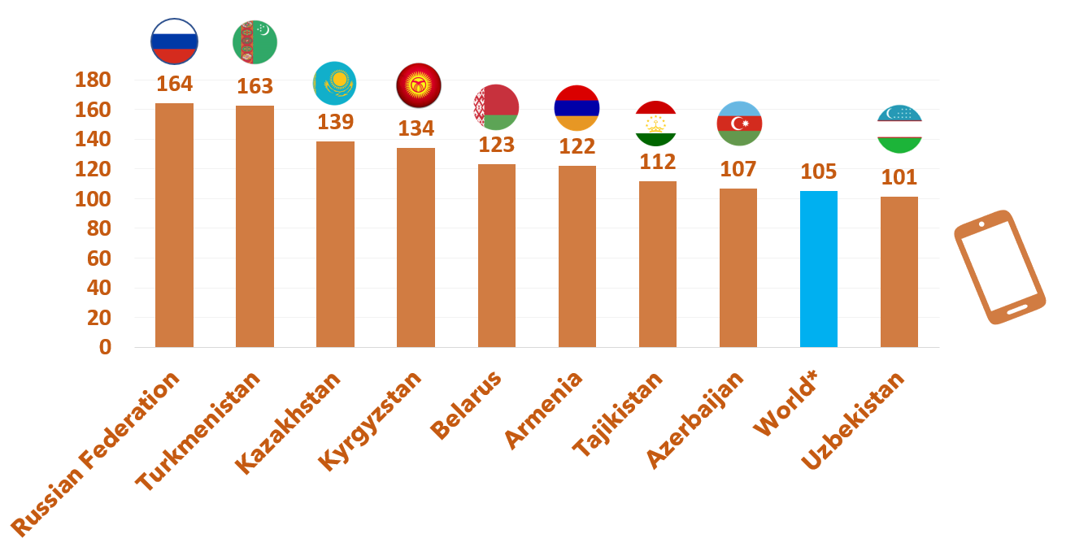

Source: Based on ITU WTI Database, December 2020 edition

Average active mobile broadband subscriptions in the CIS region are fairly high and have reached 88 per 100 inhabitants in 2019, 13 percentage points above the world average of 75. However, while four countries, namely Kyrgyzstan, the Russian Federation, Kazakhstan and Belarus lead the region in mobile broadband subscriptions with rates of 90 and well above 90 per 100 inhabitants, four countries have subscription rates below the world and CIS region averages, exhibiting great variation (Figure 5). While active mobile broadband subscriptions are very low in Turkmenistan and Tajikistan, GSMA estimates that in the period 2019-2025 the number of mobile Internet users will increase by 116 per cent in Turkmenistan and by 106 per cent in Tajikistan. For the CIS region overall, GSMA predicted growth in mobile Internet users of 24 per cent for the same period, with increases of 63 per cent in Uzbekistan, 54 per cent in Kazakhstan, and 40 per cent in Armenia.

Figure 5: Active mobile broadband subscriptions per 100 inhabitants, 2019, 9 CIS countries

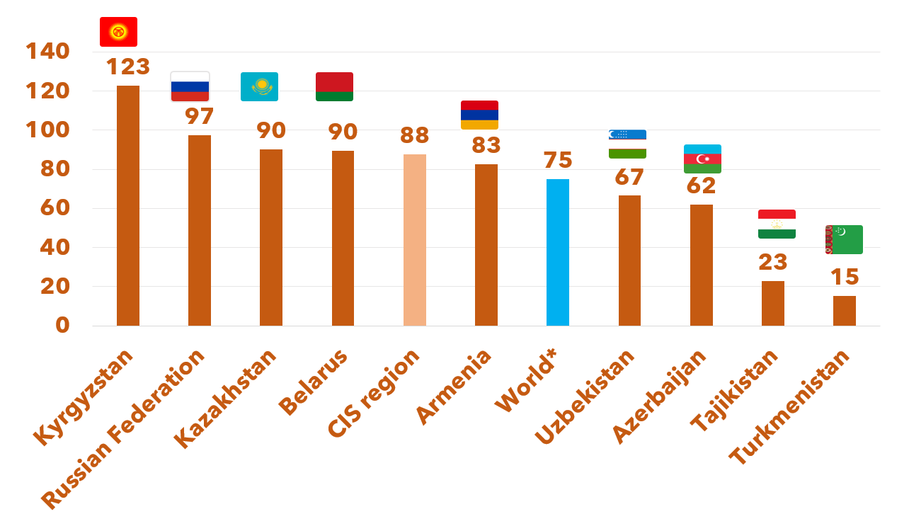

Source: Based on ITU WTI Database, *2020 estimate

## Satellite broadband developments

Satellite broadband in the CIS region, as in other regions, may offer an effective means to close the digital divide and address remaining connectivity gaps, in particular in remote or hard-to-reach areas. ITU data for satellite broadband subscriptions[11] are available for four of the nine CIS countries, with the biggest markets in terms of number of subscriptions being those of the Russian Federation and Kazakhstan. While broadband satellite subscriptions have increased in the Russian Federation and in Azerbaijan over the period 2017-2019, subscriptions have declined in Kyrgyzstan and Kazakhstan over the same period (Figure 6).

Figure 6: Satellite broadband subscriptions and CAGR 2017-2019, selected CIS countries

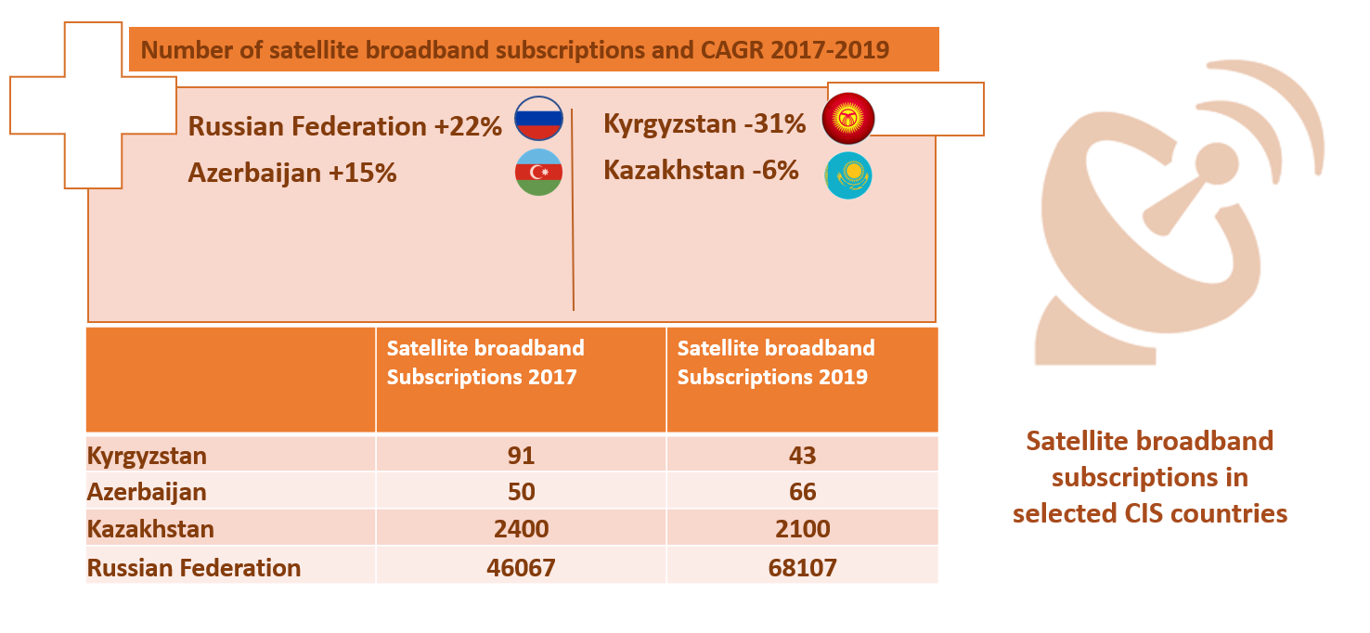

Source: ITU, based on ITU WTI Database

## Fixed broadband market

The fixed broadband market in the CIS region is very mixed, with some penetration rates as high as 34 per 100 inhabitants, well above the world average, and others as low as 0.1 per 100 inhabitants. ITU data show an average fixed broadband penetration level of 19.5 subscriptions per 100 inhabitants for the CIS region as a whole in 2020, which is above the global average of 15.2 subscriptions per 100 inhabitants. That average hides very low penetration levels in Kyrgyzstan (4.2), Turkmenistan (0.1) and Tajikistan (0.1). Within the region, only Belarus, the Russian Federation and Azerbaijan have achieved a level of fixed broadband subscriptions higher than the global average, with Uzbekistan, Kazakhstan and Armenia only 1 to 2 percentage points below the global average (Figure 7).

Figure 7: Fixed broadband subscriptions per 100 inhabitants 2019 and CAGR 2015-2019 in brackets, CIS region

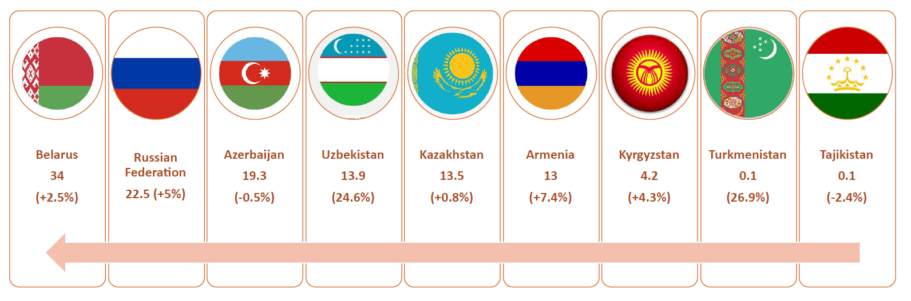

Source: ITU, based on ITU WTI Database

Given that seven out of nine CIS countries are landlocked, the availability of international bandwidth continues to be an important area for policy and investment, especially considering the rising amount of data-intensive applications and cloud-based services and the increasing numbers of Internet users desiring better international connectivity. Total international bandwidth in the CIS region has increased over the last three years from 11 Tbit/s in 2017 to 19 Tbit/s in 2020. At the individual user level, bandwidth in the CIS region amounted to 71.6 kbit/s in 2019, compared to 131.3 kbit/s globally. This shows that despite a higher than global average Internet penetration, Internet speeds across the region are much lower than globally.

At the country level, bandwidth per Internet user increased in the majority of the countries for which data were available for 2019. More than half of the countries shown in Figure 8 had bandwidth growing at a CAGR of 10 per cent or more, including Armenia, the Russian Federation, Turkmenistan, Azerbaijan and Belarus. A significant outlier is Uzbekistan, with a CAGR of 134 per cent.[12] Countries that exhibited low or no growth include Kyrgyzstan, Kazakhstan and Tajikistan, with a CAGR of 5 per cent or less (Figure 8).

Figure 8: Kbit/s per Internet user in 2019 and CAGR 2015-2019 for selected CIS countries

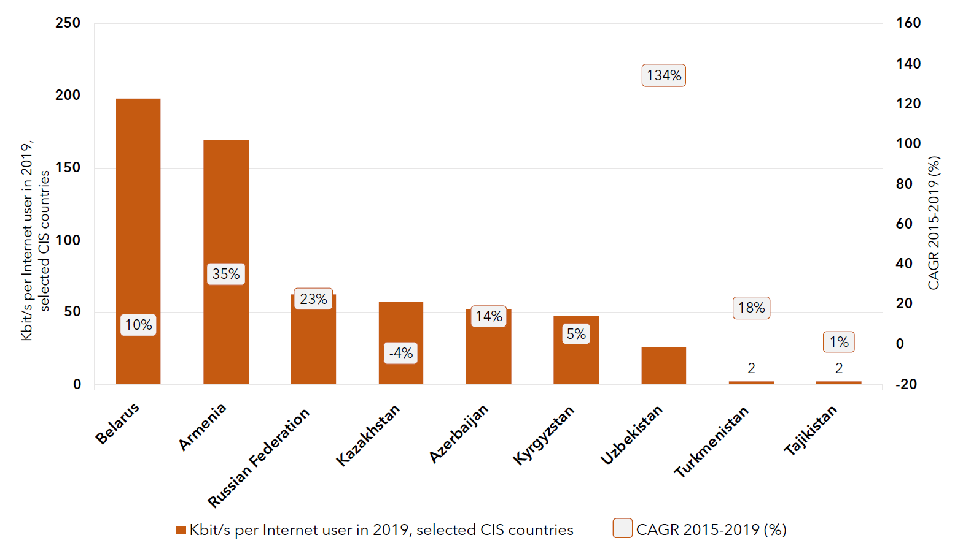

Source: ITU, based on ITU WTI Database

|  |
| --- |
| Box 1: Data traffic trends  According to GSMA, data traffic is on the rise, with widening 4G coverage and rising smartphone adoption driven by the increased engagement of consumers across the CIS region with mobile services. In its report “The Mobile Economy Russia and CIS 2020”, GSMA finds that consumers are using their devices on a more regular basis to access not only Internet-based messaging and social media (domestic platforms VK and OK are often more popular than the USA-based Facebook and Twitter) but also entertainment content (especially YouTube) and other digitally delivered services, such as health care and education. This development is particularly striking in the Russian Federation, where e-government services are increasingly accessed by smartphone users on a monthly basis. Many governments in the region prioritize digital government services within their digital agendas; an example is Uzbekistan’s “Digital Uzbekistan 2030” strategy.  Source: GSMA, “The Mobile Economy Russia and CIS 2020”, p. 16 |

## Internet access, use, skills, and gender

The CIS region is well above the world average in terms of Internet access at home, number of individuals using the Internet, and women’s and men’s use of the Internet. As shown in Figure 9, for the CIS region as a whole 76.4 per cent of households had Internet access and 72.8 per cent of individuals were using the Internet in 2019. While women still trail men in Internet use across the CIS region, the gender gap is one of the smallest globally. A more detailed examination of the Internet gender gap is presented in Figure 12, showing that on an individual country level, Internet use by women is much higher in a number of CIS countries compared to the global average, and in some countries the gender gap is reversed, with more women than men using the Internet.

Figure 9: Household access, individuals using the Internet, total and by gender, 2019, CIS region and world

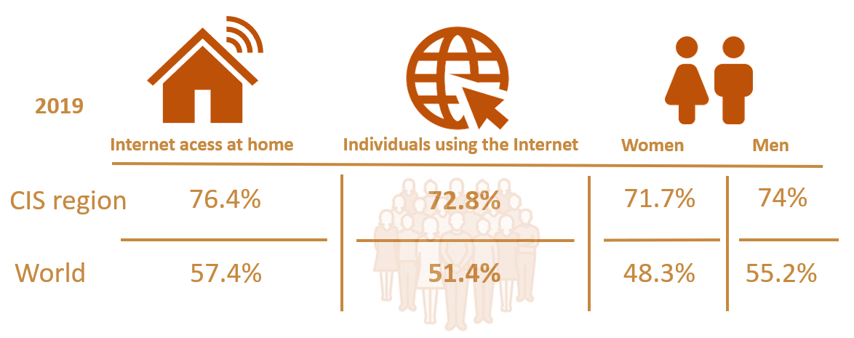

Source: Based on ITU WTI Database, *2020 estimate

The percentage of individuals using the Internet is fairly homogeneous across the CIS region, led by Belarus, the Russian Federation, Kazakhstan and Azerbaijan with percentages above 80 per cent (Figure 10). GSMA estimates in “The Mobile Economy Russia and CIS 2020” that smartphone adoption across the region is expected to reach 81 per cent by 2025, partly due to the availability of lower cost handsets, which will have a knock-on effect on mobile data consumption across the region.[13]

Figure 10: Percentage of individuals using the Internet 2019, selected CIS countries

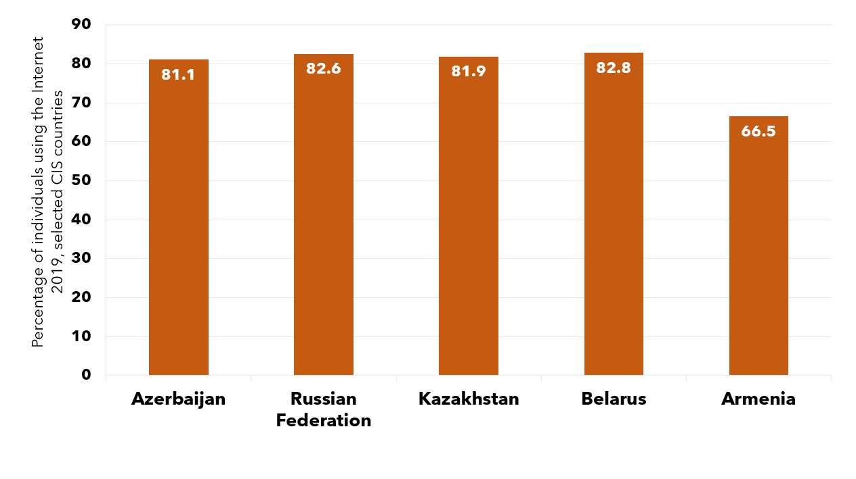

Source: ITU, based on ITU WTI Database 2020. No data were available for Kyrgyzstan, Tajikistan, Turkmenistan and Uzbekistan.

According to GSMA, although 4G has now become the leading mobile technology in the CIS region, a sizable proportion of the CIS population was not connected to the mobile Internet at the end of 2019. As ITU data show, while 98 per cent of individuals were covered by a mobile network, 88.7 per cent were within reach of a 3G signal and 80.8 per cent within reach of an LTE signal, only 72.8 per cent were using the Internet, mainly because of the high cost of smartphones, relative to average income levels, and the lack of content and apps available in local languages.[14] In addition, the Alliance for Affordable Internet (A4AI) has identified lack of quality of access, which it has termed “meaningful connectivity”,[15] as one key reason why people are not using the Internet. While GSMA’s Mobile Connectivity Index shows that infrastructure has seen the biggest improvement in the CIS region, alongside modest increases in all other categories over the period 2016-2019, more needs to be done to ensure that access to meaningful connectivity can be achieved to close the usage gap.[16]

In terms of households with Internet access, the CIS region is well above the global level, with an average penetration rate of 76.4 per cent, as compared to 57.4 per cent globally (see Figure 9). Taking a closer look at the individual countries, ITU data show that household Internet access is fairly homogeneous across the region, with Kazakhstan leading the region with 90.3 per cent, followed by Uzbekistan with 80.4 per cent. Only two countries, namely Turkmenistan and Tajikistan, are below both the regional and the global averages. Household Internet access has grown in all countries, with the most significant increases being 110 per cent in Turkmenistan and 83 per cent in Kyrgyzstan (Figure 11).

Figure 11: Proportion of households with Internet access 2019 and CAGR 2017-2019 in brackets, CIS countries

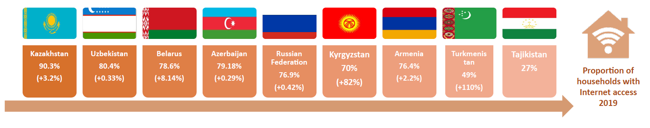

Source: ITU, based on ITU WTI Database for 2017 and 2019.

In terms of the digital divide, a small gender gap was observed in the CIS region in 2020, with a small improvement as compared to the previous year.[17] While on average 71.7 per cent of women and 74 per cent of men used the Internet in the CIS region in 2020, globally only 48.4 per cent of women and 58.5 per cent of men used the Internet that year, making the CIS region one of two regions closest to gender parity with a 2019 gender parity score[18] of 0.79 per cent. Taking a closer look at selected countries for which data were available shows that in Armenia and Belarus, more women were using the Internet than men. In Azerbaijan, the percentage difference in Internet use between men and women was highest with 6.2 percentage points difference, whereas in the Russian Federation and Kazakhstan the difference was less than 2 percentage points.

Figure 12: Individuals using the Internet by gender, CIS region and selected CIS countries, 2019

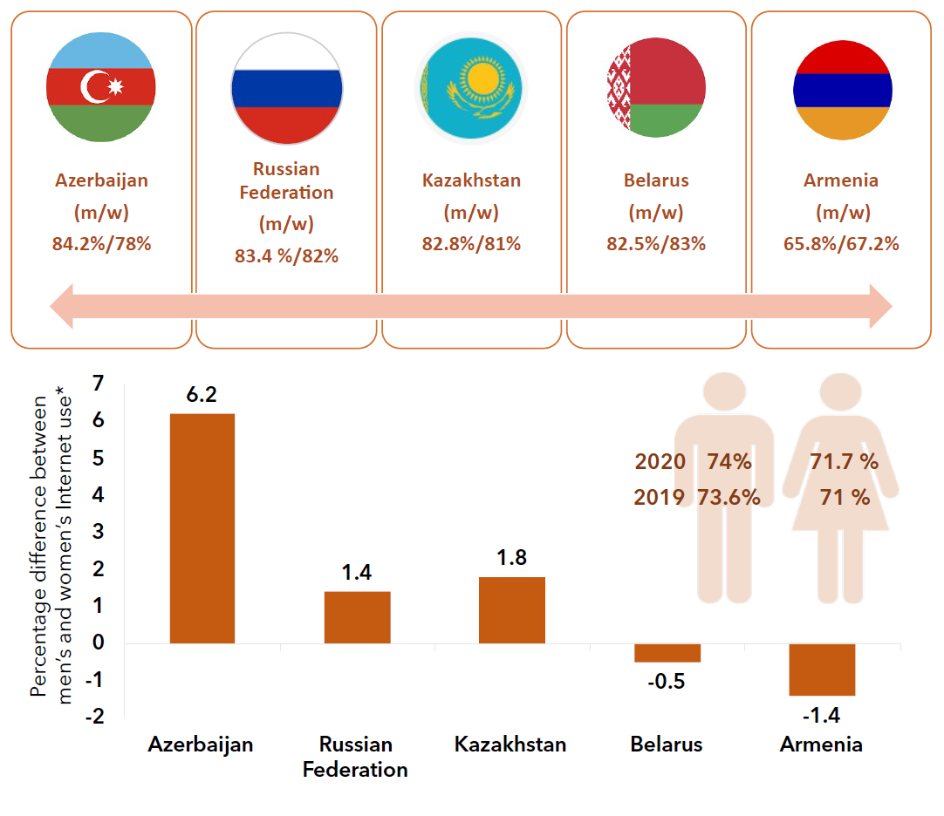

Source: Based on ITU WTI Database 2020. No data were available for Kyrgyzstan, Tajikistan, Turkmenistan and Uzbekistan. *Where the percentage difference is negative, more women than men use the Internet.

Only limited data were available for basic and standard ICT skill levels across the CIS region (see Box 2 for definitions of skill levels), with almost no data available for advanced ICT skill levels. Data available for selected countries show that the levels reached in basic, standard and advanced ICT skills vary across the different skill categories as well as countries, with Azerbaijan and Belarus leading in basic skills with levels above 40 per cent. Levels of standard skills are highest in Kazakhstan at 22.8 per cent, followed by Belarus with 18.8 per cent and the Russian Federation with 14 per cent. Uzbekistan has the lowest skill penetration for both basic (13.6 per cent) and standard (6.8 per cent) skills. The most homogeneous ICT skill levels can be found in Kazakhstan, with a basic skills level of 28.4 per cent and a standard skills level of 22.8 per cent. The data suggest that there is still significant potential for skill development, in particular as regards standard and advanced skills (Figure 13).

Figure 13: Penetration of basic, standard and advanced ICT skills as a percentage of population for selected CIS countries (%), 2019

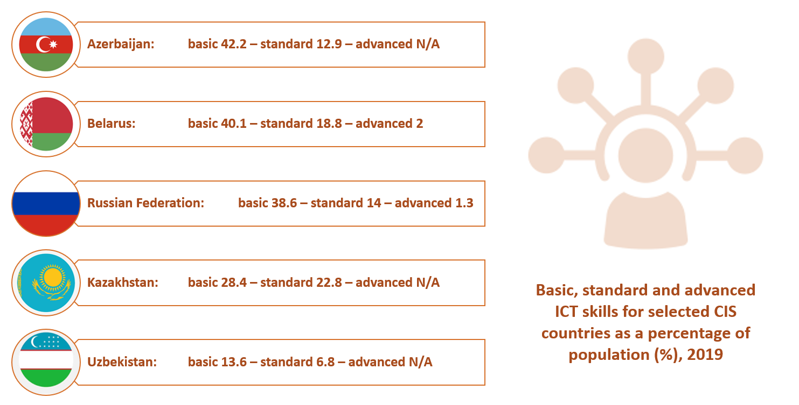

Source: Based on ITU WTI Database, figures for Uzbekistan are from 2018.

|  |
| --- |
| Box 2: ITU definition of different ICT skill levels  For each economy, the value for **basic skills** is the average value of available recent data for the following four computer-based activities: copying or moving a file or folder; using copy and paste tools to duplicate or move information within a document; sending e-mails with attached files; and transferring files between a computer and other devices.  The value for **standard skills** is the average value of available recent data for the following four computer-based activities: using basic arithmetic formula in a spreadsheet; connecting and installing new devices; creating electronic presentations with presentation software; and finding, downloading, installing and configuring software.  The value for **advanced skills** is the value for writing a computer program using a specialized programming language.  Source: ITU |

## ICT prices

ITU data show that telecommunication and ICT services are becoming more affordable and that prices have generally followed a downward trend over the last four years around the world, including for mobile voice, mobile data and fixed broadband baskets. At the regional level, the CIS is among the regions with the most affordable prices, just behind Europe with the most affordable prices. The ITU report “Measuring Digital Development: ICT Price Trends 2019”[19] provides a detailed examination and discussion of ICT price trends.

The CIS region is a relatively homogeneous region, with all countries having a mobile data basket costing less than five per cent of GNI per capita. Five CIS countries have achieved the target set by the Broadband Commission for Sustainable Development: Kazakhstan, Belarus, the Russian Federation, Armenia and Azerbaijan. The most affordable basket can be found in Kazakhstan, whereas the least affordable baskets can be found in Turkmenistan and Tajikistan.

Figure 14: Mobile data prices as a percentage of GNI p.c. and monthly data allowance, CIS region, 2019



Source: ITU Pricing data March 2020

As regards the affordability of fixed services, in most of the countries in the CIS region the fixed broadband baskets are relatively affordable, and four countries have achieved the target set by the Broadband Commission for Sustainable Development: the Russian Federation, Belarus, Kazakhstan and Azerbaijan. Except in the Russian Federation, however, the advertised download speeds are not very high. In three countries—Belarus, Uzbekistan and Tajikistan—data caps are in place ranging from 5.8 GB to 30 GB per month.

Figure 15:Fixed broadband prices as a percentage of GNI p.c., speeds and caps, CIS region, 2019

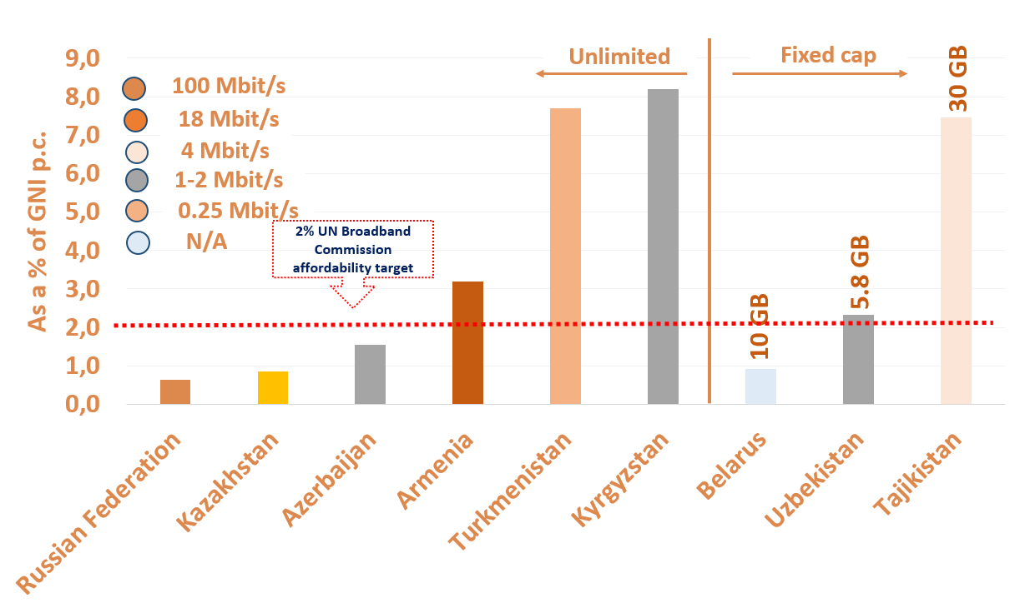

Source: ITU ICT price data March 2020

Box 3 provides an overview of how ITU measures ICT prices.

|  |
| --- |
| Box 3: Measuring ICT prices at ITU  ITU and its partners and stakeholders devote considerable time and effort to developing and refining price methodologies, in particular through the Expert Group on Telecommunication/ICT Indicators (EGTI). ITU maintains a set of different price baskets to reflect different usage patterns and behaviour. In 2017, ITU updated and adjusted its price baskets to reflect current developments in the fixed and mobile broadband markets. The price baskets cover three different technologies: mobile-voice, mobile-data and fixed-broadband.  In addition, the 2017 revision introduced combined data-and-voice baskets, as a first attempt to monitor the prices of bundled services, which is now a very common commercial practice.  The mobile-data-and-voice baskets include voice, text messages and data for two different consumption levels. The low-consumption mobile-data-and-voice basket includes 70 voice minutes, 20 SMSs and 500 MB of broadband data while the high-consumption basket includes 140 voice minutes, 70 SMSs and 1.5 GB of broadband data.  Source: From ITU, “Measuring Digital Development, ICT Price Trends, 2019” |

## 

## Telecommunication revenues and investment

ITU data, where available, show that total telecommunication investments in the CIS region amounted to USD 7.5 billion in 2019. Most investments were made in the Russian Federation, accounting for almost 85 per cent of total investments in 2019. For most countries, the levels of investments as a percentage of revenue was between 15 per cent and 25 per cent (Figure 16). Despite the economic uncertainty brought about by the COVID-19 pandemic, GSMA estimates that operators in the region will invest more than USD 25 billion in infrastructure roll-outs between 2020 and 2025, 57 per cent of which will be 5G-specific.[20]

Figure 16: Total telecommunication investments in USD equivalent and as a percentage of revenue, 2019, by CIS country (in brackets)

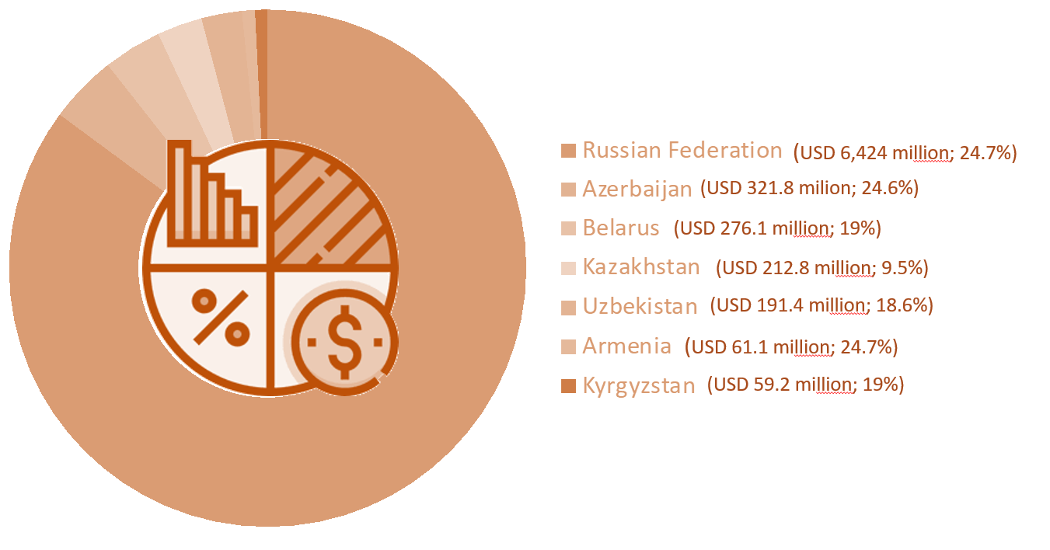

Source: Based on ITU WTI Database

## Developments regarding cybersecurity

Cybersecurity is key to ensuring a trusted and sustainable digital transformation. This is particularly evident during situations of crisis, such as the COVID-19 pandemic, where many of an organization’s activities and much of its communication move online and where cyberdefences might be lowered due to a shift of focus to the health crisis. Based on an Interpol assessment of the global landscape on COVID-19 cyberthreats, there were significant increases across all areas of cybercrime, including online scams and phishing, data-harvesting malware and disruptive malware/ransomware, as well as the exploitation of vulnerabilities of systems, networks and applications used by businesses, governments and schools to support staff who are now working remotely.[21]

McAfee estimated that in 2020, cybercrime led to a monetary loss of $1 trillion USD.[22] Therefore, fit-for-purpose cybercrime legislation, strategies and frameworks, as well as computer emergency response teams, capabilities, awareness and capacities are key to advancing sustainable economic and socio-economic development.

Since 2015, ITU has published the Global Cybersecurity Index (GCI) to measure the commitment of each ITU Member State across the five pillars of cybersecurity (see Box 4 for a description of these pillars). The GCI is an ITU initiative involving experts from different backgrounds and organizations.

The CIS region is on its way to ensuring that the use of ICTs is safe and secure, with most countries for which data were available having either started to initiate or having already developed complex commitments in cybersecurity as shown in Figure 17. In this regard, GCI 2018 shows that all of the CIS countries have cybercrime legislation and cybersecurity regulations in place (see Box 4). Moreover, two countries, namely the Russian Federation and Kazakhstan, demonstrate high commitment in all five pillars of the index, while four countries, namely Armenia, Azerbaijan, Belarus and Uzbekistan, have developed complex commitments and engage in cybersecurity programmes and initiatives. Kyrgyzstan, Tajikistan and Turkmenistan have started to initiate commitments in cybersecurity. The Russian Federation, Kazakhstan and Uzbekistan have obtained the top three scores in the CIS region across all five GCI pillars (Figure 17).[23]

Taking a closer look, the Russian Federation scores the highest in almost all the pillars except in the cooperation pillar, where Uzbekistan has the best score. Kazakhstan scores well, with a close second place in all pillars but cooperation. The Russian Federation ranks first with a good score in the legal pillar. The country has reinforced compliance and regulations for fraud prevention and management with the use of electronic payment systems. The entire financial system has been enhanced to ensure confidence in using online electronic payments. Kazakhstan ranks second, with a good score in the legal pillar. It has unified the requirements in the field of information and communication technologies and information security. Uzbekistan ranks third, with a good score in the cooperation pillar. The country has signed a memorandum of understanding (MoU) with different agencies in neighbouring countries. It has also developed a strong public-private partnership, including with foreign companies.

Figure 17: Heatmap of national cybersecurity commitment, CIS region, ITU GCI 2018

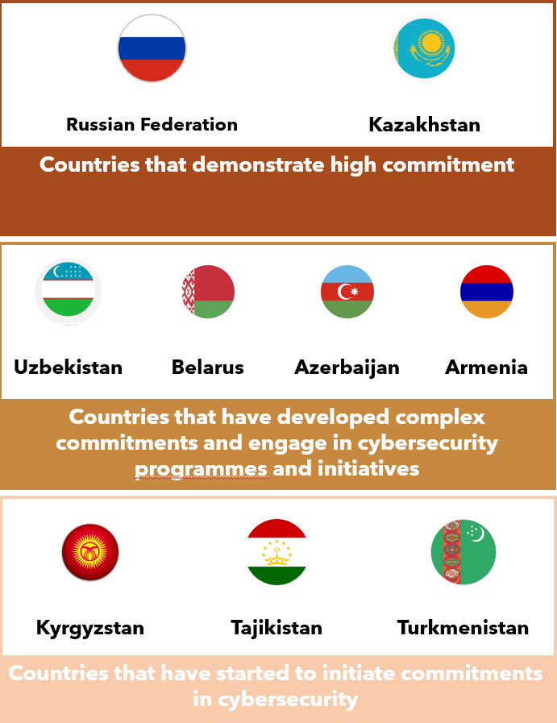

|  |
| --- |
| Box 4: ITU Global Cybersecurity Index: CIS Region – A closer look  The **objective of the GCI** is to measure the level of cybersecurity commitment of each ITU Member State in five main areas: **legal, technical, organizational, capacity building and cooperation**. The GCI can help countries identify areas for improvement, motivate action to improve relative GCI rankings, raise the level of cybersecurity worldwide, help identify and promote best practice and foster a global culture of cybersecurity.    The CIS region shows mixed GCI scores across all five pillars, as highlighted below.    Source: ITU, based on data from ITU GCI 2018 |

## ICT infrastructure developments and integrated technologies

While ITU does not, at present, collect data for indicators on emerging technologies such as the application of AI, the status of IoT (except for machine-to-machine (M2M) SIM cards)) or developments in relation to cloud technologies, such technologies form an increasingly important area of ICT development that cuts across the work of all three ITU Bureaux. As infrastructure around the world evolves, it is likely to do so in a way that accommodates co-dependent hardware and software. Figure 18 provides a brief overview of the AI, IoT and cloud technology landscape in the CIS region.

Figure 18: Landscape for AI, IoT and cloud technology in the CIS region

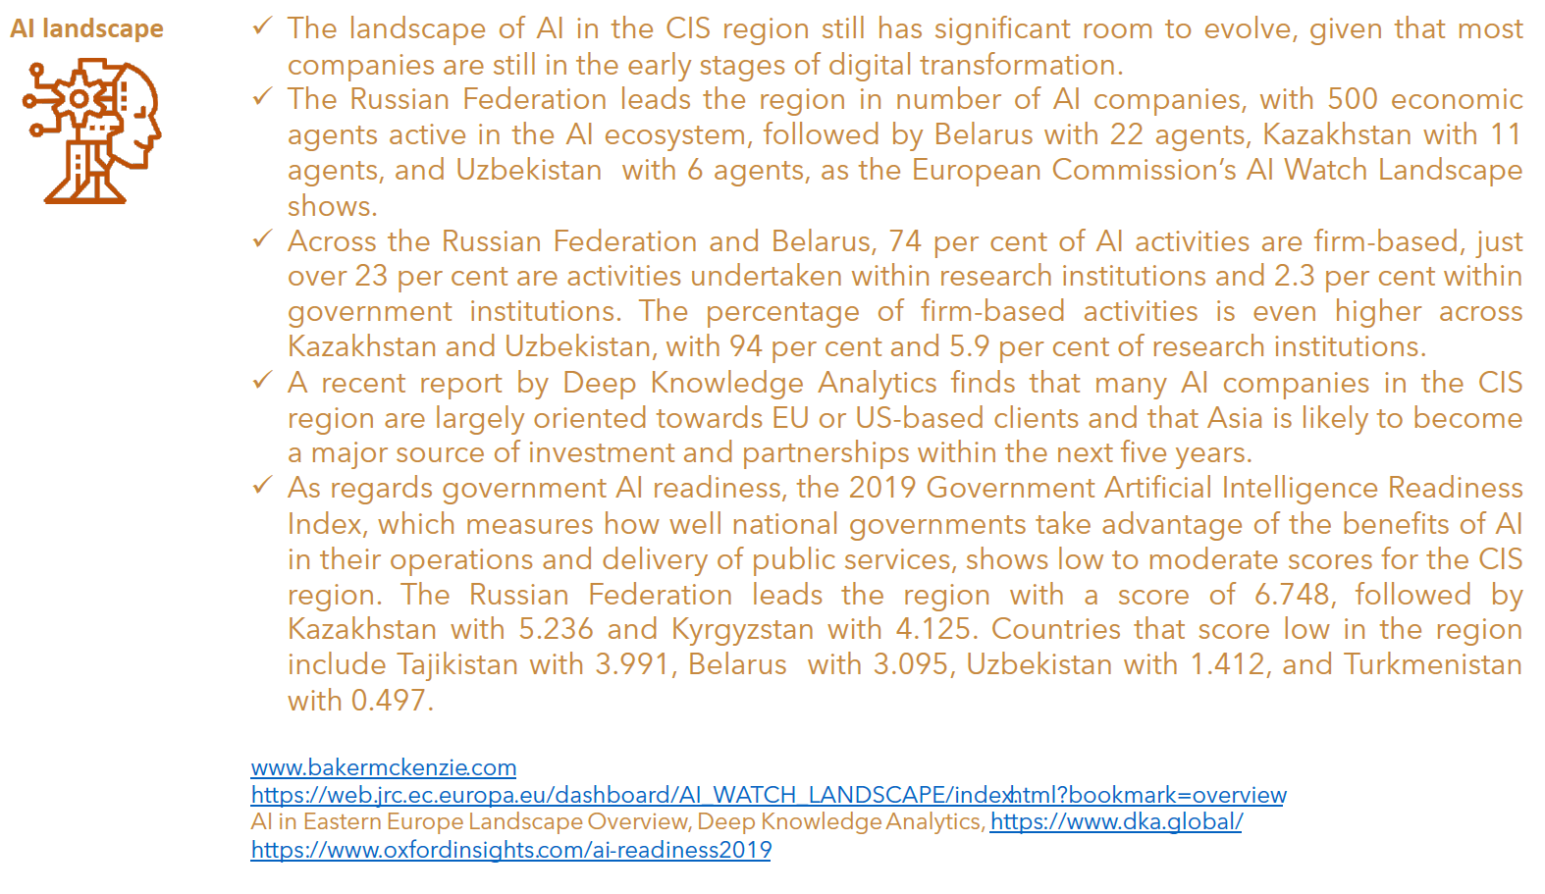

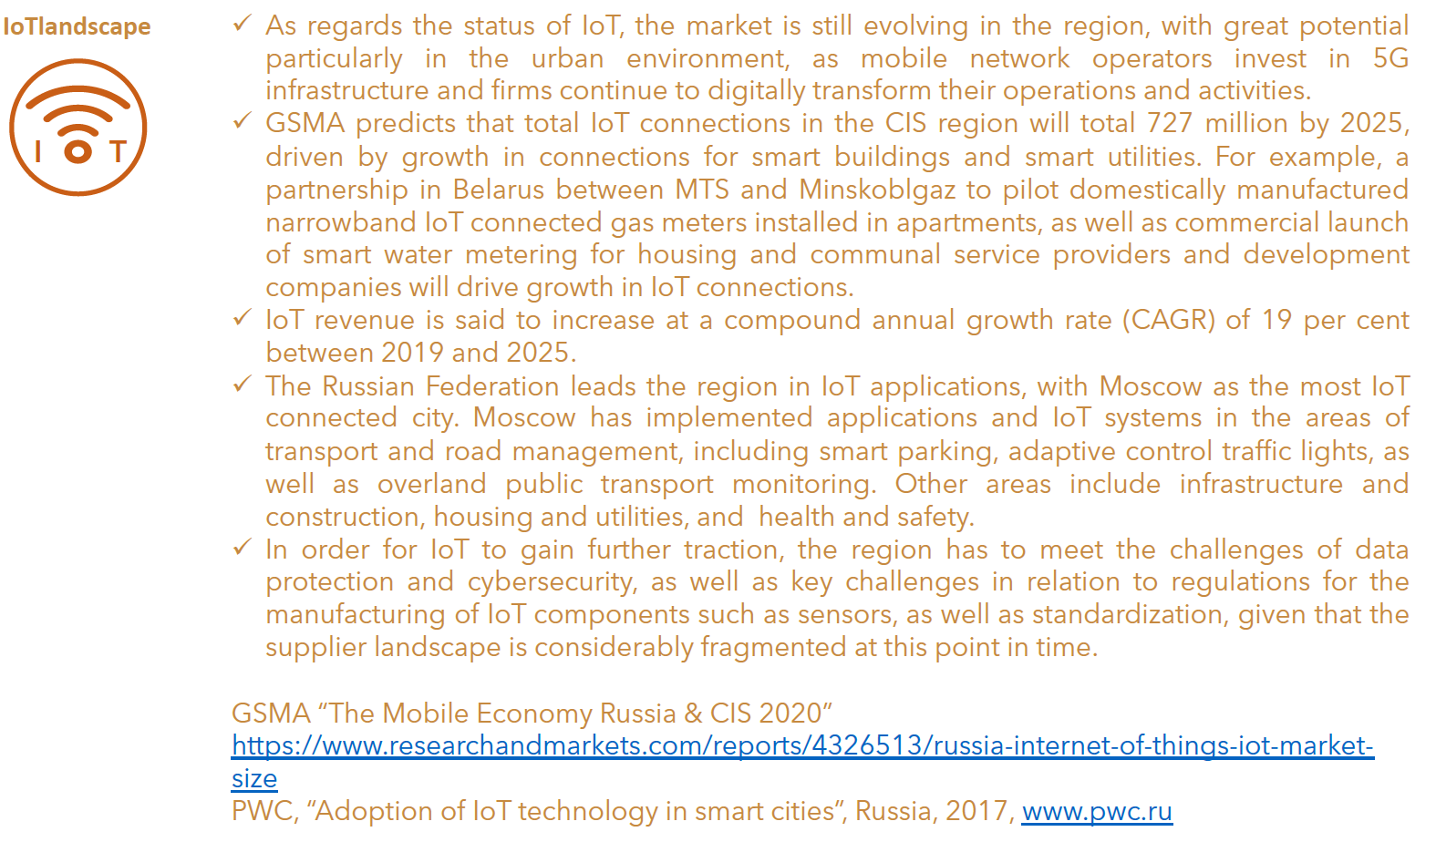

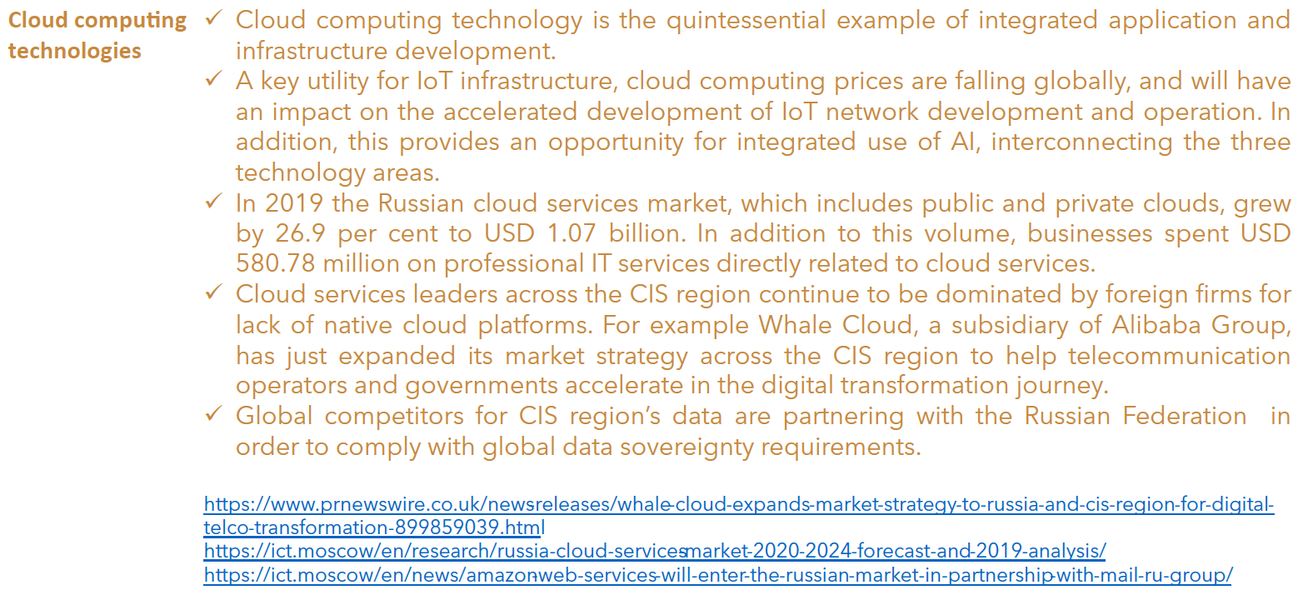

|  |
| --- |
| Box 5: 5G developments in the CIS region  One of the trends that will shape the digital landscape in the CIS region in the 2020s is the roll-out of 5G networks and the adoption of 5G services. GSMA Intelligence estimates that 5G adoption across the CIS region will reach 13 per cent (or 52 million 5G connections) by 2025. While COVID-19 may have had a slowing impact on the number of new network launches in 2020, 5G activities are envisaged to be picking up pace: with increasingly successful tests and base station deployments, commercial 5G network launches are envisaged in Belarus, Kazakhstan and the Russian Federation in 2021, in Armenia, Azerbaijan and Uzbekistan in 2023 and in Kyrgyzstan, Tajikistan and Turkmenistan in 2024. In the Russian Federation, the government has assigned 400 MHz of 24 GHz mmWave spectrum, with more potential for 5G once the 700 MHz and 3.4-3.8 GHz bands, currently still being used by other services become available.  The figure below shows planned 5G activities across the CIS States.    Source: Adapted from GSMA Mobile Economy Russia and CIS 2020 |

|  |
| --- |
| Box 6: COVID-19 impact on digital development in the CIS region  The COVID-19 Pandemic has had an accelerating impact on digital development across the CIS region in many areas and sectors, including retail, public services, education/musical education, agriculture, the cultural sector, and many more. While research on the contribution of digitization to mitigate the impact of pandemics is limited, compelling evidence is emerging as to its positive effects.  For example, in **Armenia**, a **Retail Queue Management Solution** “Earlyone”[24] was designed to help retailers control entry to stores so as to avoid exceeding the permitted maximum number of shoppers and to prevent crowding outside supermarkets, shops, pharmacies and public facilities subject to restrictions and limits on the number of people admitted. This digital app solution makes it possible to (1) control entry to premises so as to limit the number of customers allowed in, (2) limit opportunities for COVID-19 to spread by eliminating crowding outside and, (3) minimize waiting time for shoppers by scheduling their entry in advance.  In the **area of agriculture**, an online services “AgroRuqsat”[25] was developed in **Kazakhstan**, supporting farmers in their sowing and field work during lockdown, when border crossings were not permitted. AgroRuqsat is a free online service designed to address the issues of providing transportation permits for farmers and their suppliers in quarantine zones by remotely receiving applications for electronic passes, processing these applications, and maintaining a register of electronic passes.  In the **area of education**, “KIBERone”[26], the First International CyberSchool of the future for the new IT generation, was created in the **Russian Federation** to help mitigate the spread of COVID-19. The school targets children aged 6-14 and provides training in an online format, as well as a support programme for parents of students so that they can be closer to each other and spend more time together.  Another initiative in the **Russian Federation**, this one in the **area of culture**, is the Sverdlovsk Philharmonic initiative.[27] This initiative provides school children of grades 2 through 9 with access to high-quality musical educational programmes created by the Philharmonic's musicologists, along with recordings of concerts of the Philharmonic's orchestras and choir and those of guest artists and conductors.  In the **area of business support**, the **Russian** telecom provider PJSC Rostelecom has been **deploying call-centres on short notice on the basis of the Virtual Telephone Exchange service (VPBX)** [28] with allocation of a nationwide phone number, allowing millions of people to make free phone calls with the allocated number and ask questions of interest to them. Having in place a high-tech cloud-based solution, the companies are now able to handle much higher order volumes. Rostelecom has also launched a **Home Office service**. The new offering will enable entrepreneurs to maintain efficient channels of communication with employees, customers and partners, without leaving the home. The beneficiaries are B2B companies (big, small and medium-sized businesses) in the Russian Federation and other private and State-owned companies.  In **Belarus**, an **assessment by UNDP of small and medium-sized enterprises (SMEs) and digitalization and use of advanced technologies in the context of COVID-19**[29] showed that 33 per cent of SMEs would want to enter new market segments using online tools, and 24 per cent of SMEs are planning to create new digital products and services. The assessment also showed that 48 per cent of SMEs lack digitalization of internal business processes for effective functioning, with low awareness of available tools among SMEs and a shortage of resources or internal capacity to mainstream innovations into the business processes, posing important constraints on prospects for a more robust adoption of digital tools.  ITU finds in its GSR-20 discussion paper “Economic Impact of COVID-19 on Digital Infrastructure”[30] that in the medium term (e.g. 2021), countries with top connectivity infrastructure could mitigate up to half of the negative economic impact of the COVID-19 pandemic. However, there are also factors that limit the capacity of digitization to improve social and economic resilience. These include the digital divide where it still persists, and demand-side barriers, such as limited affordability and digital illiteracy. Furthermore, the paper emphasizes that the benefits of digital infrastructure for dealing with the pandemic is limited to those industries that are well on their way to digital transformation, such as logistics. To address these barriers and increase the mitigation value of digitization, the paper makes a number of recommendations, stressing that the digital infrastructure sector needs to re-examine some of the digital sector’s basic fundamental premises held before the COVID-19 pandemic, such as: :   * **concrete, actionable measures** in the telecommunication sector to enable private operators to provide universal access to quality digital infrastructure networks for all and support the development of a digital economy; * **adoption of a much broader, holistic view by governments** of investment in high-speed broadband networks, considering the economic, social and environmental/climate benefits and costs of investment; * **possible adjustment of regulatory frameworks** to stimulate investment while maintaining a sensible level of competition, shifting from a purist to pragmatic viewpoint on State aid regulations; * **harnessing the opportunity to use COVID-19 as a catalyst** for the adoption of digitization in sectors where it had not occurred before, especially in more business-oriented applications.   ITU has introduced various COVID-19 initiatives, activities and partnerships to help understand the impact of the crisis better and develop guidance for countries, including “[Connect2Recover](https://www.itu.int/en/ITU-D/Pages/connect-2-recover.aspx)”, the Global Network Resiliency Platform “[REG4COVID](https://reg4covid.itu.int/)”, the [WSIS ICT Case Repository](https://www.itu.int/net4/wsis/stocktaking/Surveys/Surveys/Submit/15863048637525604) and Cybersecurity resources for COVID-19 “[CYB4COVID](https://www.itu.int/en/action/cybersecurity/Pages/CYB4COVID.aspx).” Partnerships include the ad hoc group on digital technologies for COVID health emergency (AHG-DT4HE), AI for Health, the UN Broadband Commission’s Agenda for Action, and others. For more information see <https://www.itu.int/en/Pages/covid-19.aspx>. |

## Digital services trends

Digital economy services have been on the rise as governments and enterprises across the CIS region have adopted digital strategies, policies and plans. The UN E-Government Development Index (EGDI)[31] 2020 survey shows positive signs of accelerated advancement. For example, Kazakhstan has exhibited a more rapid increase in EGDI values within its group. In the category of landlocked developing countries, Kazakhstan has the highest EGDI value (0.8375) and is part of the second-highest (V3) rating class within the very high EGDI group. In 2018, Kazakhstan moved from the high to the very high EGDI group and has continued to accelerate the pace of e-government development within the framework of the Digital Kazakhstan programme, improving the quality and the number of public services provided online, expanding the ICT infrastructure, and enhancing the quality of education and the overall digital literacy of the population. Following Kazakhstan are Armenia and Azerbaijan, which are in the highest rating class (HV) of the high EGDI group and are therefore on the cusp of transitioning to the very high EGDI group. Azerbaijan, Kyrgyzstan and Uzbekistan have also improved their rankings.

**Figure 19: E-government development in the CIS countries, EGDI 2020**

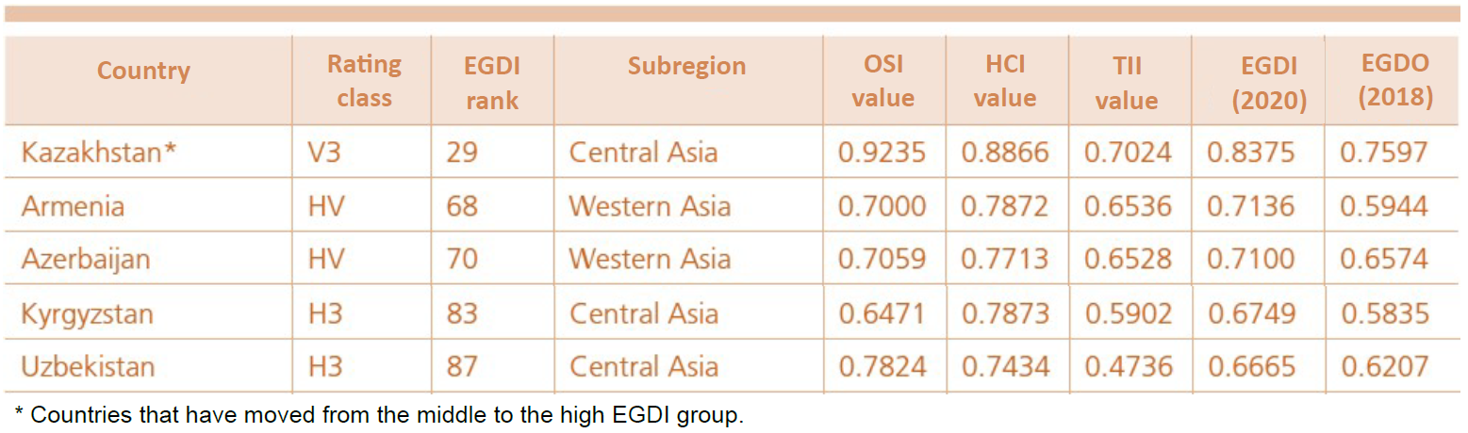

Source: Adapted from 2020 United Nations E-Government Survey

Armenia, the Russian Federation and Uzbekistan score in the very high level of the E-Participation Index (EPI). The EPI measures the provision of information (whereby the government provides information to people), consultation (whereby the government consults individuals on policy or on service delivery at different stages of the process and may provide feedback to them), and decision-making (whereby the government involves people in decision-making). One example of e-participation is the “Russian Public Initiative”.[32] In relation to consultation platforms, Armenia has created a unified website for the publication of draft legal acts.[33]

|  |
| --- |
| Box 7: Digital Kazakhstan: providing civil servants with digitalization training (taken from the 2020 UN E-Government Development Index (EGDI))  Key to the success of any government digitalization effort is building the capacities of those who train and educate the users of ICT-based programmes. **Digital Kazakhstan** coordinates ongoing training programmes that strengthen the capacities of chief digital officers and IT specialists at all levels of government to provide government employees with the ICT skills and support they need to contribute to digital government transformation. The training workshops focus on economic sectors, new technology trends and project management skills. So far, civil servants have been able to participate in training programmes at Nazarbayev University in Kazakhstan, the Academy of Public Administration under the President of the Republic of Kazakhstan, the e-Governance Academy in Estonia, and the e-Government Leadership Centre in Singapore. Central to this programme of continuing education is the commitment to building the capacities of capacity builders through public and private partnerships. The objective is to ensure that individual digital government experts and leaders internalize and are able to develop in others the strategic mindsets and competencies for today and the future. Transformational leadership must be developed at the individual level so that public servants possess the skills and strategies needed to address rapidly evolving and increasingly complex issues and can also build digital, institutional, organizational and societal capacities.  Source: Taken from UN E-Government Development Index 2020; original sources: United Nations Public Service Awards database (https://publicadministration.un.org/en/UNPSA);  Digital Kazakhstan, “About the program”(https://digitalkz.kz/en/about-the-program). |

# Regulatory trends in the CIS region

The right regulatory framework is key to successful digital transformation that is inclusive and sustainable and minimizes the emergence and manifestation of unwanted consequences for market structures and consumers alike. As the COVID-19 crisis has laid bare, inequalities are increasing within and between countries, not least because current governance and regulatory frameworks and their implementing mechanisms are failing to deliver more equitable outcomes. As the pace of digital transformation accelerates, formulating an effective regulatory approach therefore becomes a defining moment. Through complementary ITU regulatory metrics, the now established ICT Regulatory Tracker and the new [Benchmark of Fifth Generation Collaborative Regulation (G5 Benchmark)](https://itu.foleon.com/itu/global-ict-regulatory-outlook-2020/home/),[34] ITU has identified the broad tracks for regulatory reform and pinpointed how countries can accelerate progress towards the next regulatory generation.

## New collaborative regulatory paradigm

A new regulatory paradigm has emerged: the “gold standard” for collaboration among regulators and policy-makers[35] that seeks to fast forward digital transformation for all. This new paradigm is embodied in collaborative regulation (see Box 7 for a definition of the general concept), which must engage a broad and diverse range of stakeholders in informed, evidence-based rulemaking and decision making, with both social and economic impact in mind and priority given to the latter. Collaborative regulation applies readily to multiple areas of regulatory work. Infrastructure sharing and co-deployment can likewise substantially benefit from the introduction and effective use of collaborative governance and data-driven regulatory instruments.

ITU forged the concept of “collaborative regulation” in 2016 and has since tested it annually at every Global Symposium for Regulators (GSR). While the concept continues to evolve, it can best be cast in 2020 as a framework to discuss the evolution of regulatory patterns and policy while charting the way towards digital transformation for industry and regulators as one constituency.

|  |
| --- |
| Box 7: Collaborative regulation - A forward-looking concept  **What is collaborative regulation?**  Collaborative regulation, or fifth generation regulation (G5), is a broad notion that ITU has defined based on the concept of generations of ICT regulation. It marks a fundamental shift in the way regulation is executed, its holistic policy ground and the stakeholders that it brings together – from policy-makers, single-sector and cross-sector regulators to market players of any size. It also shifts regulatory focus on behaviours and impact on markets and development.  Collaborative regulation places a new emphasis on consumer benefits and protection and leverages the resources of government institutions and industry to deliver them, through organic consultation, collaboration and conciliation. Collaborative regulation is driven by leadership, incentive and evidence rather than by command-and-control schemes. The concept also refers to the set of new tools used by regulators to tackle the issues related to digital transformation and the data economy.  **Why do we need collaborative regulation?**  All roads now point to more collaboration, better channels and more bandwidth. But while the case for collaboration is irrefutable, progress has been stalled by power battles, a lack of resources and misconceptions. Good progress towards inclusive, collaborative regulation is needed for the good of all users of digital services, now and in the future – a need borne out by four fundamentals:  **•** Digital transformation is a game changer – especially in “the new normal” amid the current global pandemic  ICTs have become the foundation for every economic sector and a *sine qua non* of business performance, national growth and, more recently, resilience. Regulators need to ensure that regulation achieves its objectives in the most effective and efficient manner, in particular network resilience and enhancing both the capacity and coverage of networks without imposing a disproportionate, redundant or overlapping burden on the market.  • The new digital world needs a new vision of regulation  ICTs can dramatically transform education, healthcare, environmental management, agriculture, trade and entrepreneurship, the provision of government services and so much more. For this to happen, enabling frameworks of policy and regulation and the right networks and services need to be put in place.  • A holistic and harmonized approach can deliver greater impact  Silo-style ICT sector regulation is not viable in the digital world: collaborative regulation will mirror the interplay between digital infrastructure, services and content across industries and national borders. Furthermore, it will harmonize rules and ensure consistent implementation of policy and regulatory frameworks that have evolved independently in many sectors over the years.  • Development and inclusion have become a primary focus of regulation  Collaborative regulation is people-centred regulation: it looks at sustainability and long-term gains as opposed to industry profit maximization and exclusive economic growth. Collaborative regulation champions are also engaged in connecting marginalized individuals, persons with disabilities, low-income communities, communities challenged by educational impoverishment, and remote or isolated populations which may also lack basic infrastructure such as electricity – so there is a need to be much more innovative and collaborative in the approach to policy-making.  **The 5 Generations of ICT Regulation – conceptual framework**    Source: ITU, 2020 |

## The G5 Benchmark for regulatory excellence

To afford perspectives on the regulatory road already travelled as well as on the pathways into the future, ITU developed the [G5 Benchmark for regulatory excellence](https://itu.foleon.com/itu/global-ict-regulatory-outlook-2020/chapter-1/), which is based on [GSR Best Practice Guidelines](https://www.itu.int/en/ITU-D/Regulatory-Market/Pages/bestpractices.aspx)[36] and ITU research and analysis. First conceptualized in 2019 to set out new goals for regulatory excellence, the G5 Benchmark is built around an extensive and varied set of indicators and will soon cover all ITU Member States.[37] The indicators are clustered into three tracks, including collaborative governance, policy design principles and the G5 toolbox. The cross-sector regulatory frameworks captured through the various indicators are pivotal in creating a digital marketplace that is inclusive, sustainable and pro-development and a cornerstone of digital transformation. Box 8 provides an overview of the ITU G5 Benchmark. More in-depth information can be found in ITU’s report “Global ICT Regulatory Outlook 2020”.[38]

|  |
| --- |
| Box 8: ITU G5 Benchmark in a nutshell  **What is it?**  The G5 Benchmark is a new tool for policy-makers and regulators. It fast-tracks collaborative, cross- sector regulation as the best and quickest means to leverage digital transformation for the benefit of everyone. It uses a brand-new three-lens approach which focuses in on collaborative regulation and offers insights that are both surprising and of high value. The G5 Benchmark is the new gold standard for collaboration among regulators.  **What does the G5 Benchmark do?**  It is a powerful, straightforward tool that makes sense of shifts in regulatory frameworks as policy- makers and regulators navigate a complex digital landscape. It delivers on additional aspects of high value for policy-makers and regulators:   * Sets out new goals for regulatory excellence; * Highlights shortcomings in the pursuit of SDGs and proposes solutions; * Dives deep into policy trends; * Enriches global policy debate.   **Why is the G5 Benchmark different?**  First, it uses a brand-new three-lens approach which focuses in on collaborative regulation.  Second, three features combine to make it especially powerful:   1. *Scope:* Most ITU Member States, all regions, 2018-2019 data; 2. *Ease of use:* straightforward methodology, three regulatory tracks and easy-to-measure indicators. Policy-makers can check and update country data, compare with others and run “what-if” projections. It allows easy interplay with the ICT Regulatory Tracker and easy assessment of cross-sector regulatory frameworks and quick identification of “win” opportunities; 3. *Objectivity*: built on latest data, factual evidence.   **What is the three-track approach and why is that important?**  The G5 Benchmark is built with simplicity to cut through complexity. It uses three regulatory tracks, or lenses, which together focus in on the DNA of G5 collaborative regulation:   1. *Collaboration*:the very watermark of G5 regulation. It focuses on breadth and depth of cross-sector collaboration between ICT regulators and their peers. 2. *High-level principles*: This focuses on the use of policy principles (increasingly replacing rules in policy design). 3. *G5 regulatory toolbox*: This focuses on use of reimagined, innovative policy instruments that can switch on the digital economy.   **Why is the G5 Benchmark especially important at this time?**   1. *Regulation is changing as digital markets mature.* Economies in the course of digital transformation in this decade follow a very different path from those followed previously. 2. *Existing metrics do not tell the whole story.* The Benchmark’s three clear regulatory tracks present new perspectives and new insights, previously not apparent. 3. *High-level policy design principles are fully taken on board.* Regulation is multi-layered and complex in our digital age, and rules are increasingly giving way to principles. 4. *Collaboration among sector/multi-sector regulators.* Collaboration, the very watermark of G5 regulation, is essential for relevance, coherence and impact. 5. *A benchmark is worth a thousand words****.*** Policy-makers need a tool that simply and quickly evaluates and models regulatory set-up and tools – comparing like with like.   Source: ITU 2020 |

## Maturity of ICT regulatory frameworks in the CIS region

There is still significant potential for progress in the maturity of regulatory frameworks in the CIS region. Advances through the regulatory generation have been slower than in most other regions. Armenia leads the CIS ranking and was the only G4 country in 2019. Kyrgyzstan is the only G3 country. CIS is currently the only region without a collaborative regulation champion and still features G2 countries in its top 5. Disparity of regulatory maturity is particularly marked –despite the relatively small number of countries in the region. While the top CIS country sits in the 41st place in the world ranking, the lowest ranking CIS country ranks 191st. The region has made steady progress since 2007, when 11 of 12 countries had either G1 or G2 status, and 1 country was categorized as G3. Eleven years later in 2018, 2 countries have progressed respectively to G3 and G4 status. Overall, regulatory frameworks in CIS are moving at a slower pace, with average annual scores since 2007 consistently below the world average. Three countries remain in the G1 category, failing to adopt important reforms and move up the regulatory ladder.

Figure 20: Evolution of the generations of ICT regulation, CIS region, 2007-2019

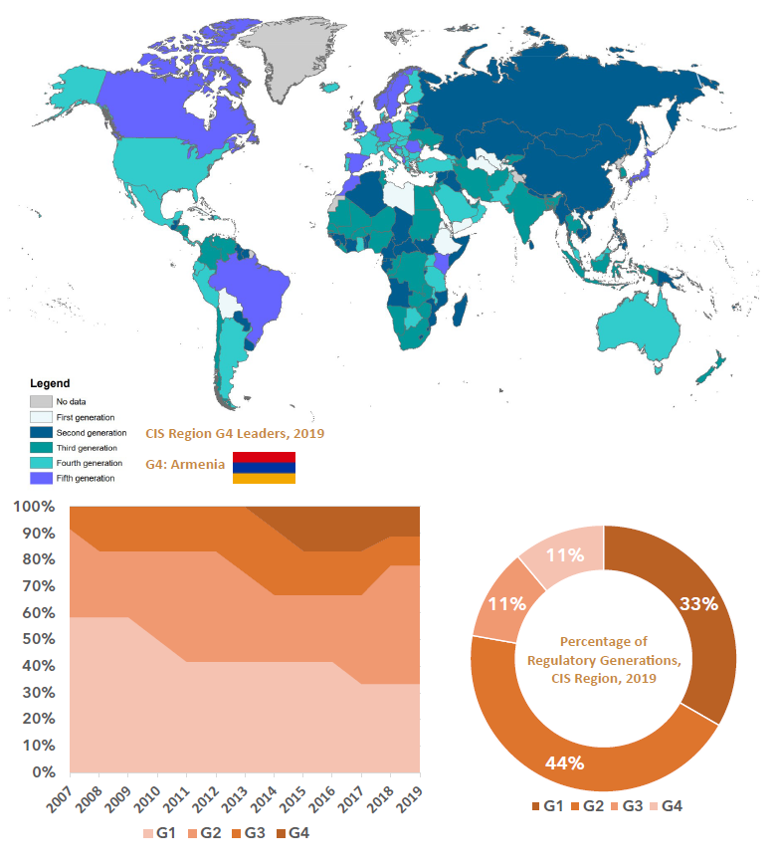

Source: Based on ITU data, 2019

At the global level, ITU analysis shows that while digital has been gaining ground and shaping regulatory response, too few countries have so far achieved the maturity needed to trigger its multiplier effect on development and digital transformation – with 9 of every 10 countries still regulating ICTs as a separate economic sector. However, a vanguard of 8 per cent of countries now have holistic, forward-looking regulatory frameworks in place, enabling digital transformation across their economies. More information and a deeper country analysis can be found in the [ICT Regulatory Tracker](https://www.itu.int/net4/itu-d/irt/#/tracker-by-country/regulatory-tracker/2018) and the [Global ICT Regulatory Outlook Report 2020](https://itu.foleon.com/itu/global-ict-regulatory-outlook-2020/home/). Further insights into regional markets, regulatory and tariff policy trends are available on the ITU data portal, the [ICT Eye](http://www.itu.int/icteye).[39]

In 2021, ITU is launching a series of country case studies on regulatory and institutional frameworks and collaborative governance in selected countries. They will highlight diverse experiences and different policy and regulatory patterns in order to explore the challenges, new ideas and lessons learnt by regulators on the path towards collaborative regulation. The case studies will also focus on developing a better understanding of the role and impact of collaboration and collaborative governance, and the use of new tools for regulating ICT markets. The library of collaborative regulation case studies will be launched at GSR-21 and featured on the ITU website. Findings and insights generated during the process will be integrated into a global project on the transition to collaborative regulation, which will be released at WTDC-21.

|  |
| --- |
| Box 9: Digital Regulation Handbook and Platform  ITU collects significant information across various domains, including regulatory governance, competition, access for all, consumer affairs, spectrum management, trust and safety, emerging technologies, emergency communications and technical regulation. To provide an easy-to-access gateway to this wealth of information, ITU together with the World Bank launched the [Digital Regulation Handbook and Platform](https://digitalregulation.org/) in 2020, which provides a repository of practical guidance and best practice for policy-makers and regulators across the globe concerned with harnessing the benefits of the digital economy and society for their citizens and businesses. The content provides an update on the basics of ICT regulation in the light of the digital transformation sweeping across sectors and also includes new regulatory aspects and tools for ICT regulators to consider when making regulatory decisions.  Source: ITU-World Bank Digital Regulation Platform, [www.digitalregulation.org](http://www.digitalregulation.org) |

## Economic contribution of broadband, digitization and ICT regulation in the CIS region

The contribution of broadband, digitization and ICT regulation to economic and socio-economic development across the CIS region is beyond doubt. A recent ITU study, “[The economic contribution of broadband, digitization and ICT regulation: Econometric modelling for the ITU Commonwealth of Independent States region](https://www.itu.int/pub/D-PREF-EF.BDT_CIS-2020)”, measures the impact of fixed and mobile broadband and digital transformation on the economy as a whole in the region, and shows the extent to which institutional and regulatory variables contribute to the development of the digital ecosystem.

The results of the study, as summarized in Figure 21, reveal that a 10 per cent increase in mobile and fixed broadband penetration in the CIS region would yield an increase of 1.2 per cent and 0.6 per cent, respectively, in GDP per capita. Moreover, the report validated the positive impact of the policy and regulatory component in the region, suggesting that an increase of 10 per cent in the ITU ICT Regulatory Tracker yields a positive increase in the CAF[40] Digital Ecosystem Development Index of 1.58 per cent.[41]

Figure 21: Economic impact of fixed and mobile broadband and digitization, 2019

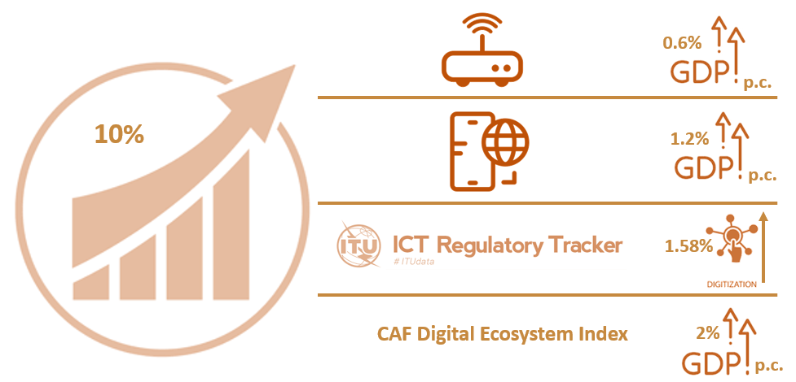

Source: Adapted from the ITU study: “The economic contribution of broadband, digitization and ICT regulation: Econometric modelling for the ITU Commonwealth of Independent States region”, 2019

|  |
| --- |
| Box 10: The impact of policy, regulation and institutions on performance in the ICT sector  Regulatory and institutional frameworks have a measurable impact on the performance of the ICT sector and its contribution to the national economy as a whole. Policy-makers and regulators increasingly base their decisions on empirical evidence in order better to address the challenges and gaps in current regulatory frameworks for digital services and applications.  ***Upgrading regulatory frameworks – what matters?***  The evidence provided by the new ITU study points to major findings that can inform governments, policy-makers, regulators and operators in formulating infrastructure investment and deployment decisions in the years ahead:   * The regulatory institutional framework is linked to a positive and significant increase in telecommunication investment. It requires having a separate, independent and autonomous ICT regulator with a wide mandate, adopting best regulatory practices with regard to licensing, service-quality monitoring, spectrum sharing and a competitive market environment. * A reduction in taxation is associated with a significant boost in capital investment, as it increases available financial resources for network deployment. * A reduction of government bureaucratic processes is linked to a significant increase in capital investment, confirming the relevance of public efficiency. This highlights the importance of reducing the required time for obtaining permits related to network deployment, addressing municipal network construction requirements and reducing other red-tape costs.   ***Regulatory power boost for mobile***  For the mobile sector, the following policies were found to have a significant positive impact on investment, leading to service coverage gains, price reductions, higher adoption levels and, consequently, a macroeconomic impact in terms of GDP per capita:   * + The introduction of a national broadband plan (complemented by a strong implementation framework and leadership), suggesting that the formulation of a digital agenda is crucial to accelerating innovation and boosting investment.   + A convergent licensing framework provides a flexible approach to ICT policies, more adapted to technological advances, and maximizes the financial return on investment.   + Allowing voluntary spectrum-sharing agreements helps operators to maximize opportunities to make investments profitable and incentivises network deployment.   + The introduction of mobile portability that removes barriers and renders the market more dynamic stimulates competition and innovation.   + Openness to foreign operators increases access to capital for network development and modernization and allows for technology and knowledge transfer.   + A national competition authority helps to monitor multiple market segments in order to avoid anticompetitiveactions.   Source: ITU, *The impact of policies, regulation and institutions on ICT sector performance* (2021) |

|  |
| --- |
| Box 11: COVID-19 regulatory framework initiatives for CIS region  The COVID-19 pandemic has caused significant disruption to economic activity, affecting all industries, albeit at differing levels. To mitigate this impact, different ICT stakeholders have undertaken a number of emergency steps and initiatives in the areas of consumer protection, traffic management and prioritization, broadband availability, affordability and accessibility, emergency telecommunications, universal service strategies and QoS and QoE, etc. These responses include increasing broadband capacity and speeds, providing free services to customers, providing COVID-19 information services, network management, allowing more flexible IMT spectrum use, free access to online learning sources, generally easing regulatory requirements on licensees, new fixed wireless access networks, addressing COVID-19 misinformation, contact tracing development and government subsidized broadband services.  To provide easy access to this information, ITU has created the Global Network Resiliency Platform (#REG4COVID), where ICT regulators, policy-makers and other interested stakeholders can [share](https://www.itu.int/net4/ITU-D/CDS/gq/generic/questionnaire.asp?ProjectID=1391)information and [view](https://reg4covid.itu.int/?page_id=59)what initiatives and measures have been introduced around the world to help ensure communities remain connected during the COVID-19 crisis. The map below provides an overview of the number of submissions made to the platform by different countries.    In the CIS region, most countries have made submissions to the platform, with Kazakhstan, Kyrgyzstan, Uzbekistan, and Armenia having submitted more than two initiatives across four different areas. This is shown in the figure below.    Source: Adapted, based on data from ITU https://reg4covid.itu.int/  Industry has been active in the implementation of emergency responses to mitigate the impact of the COVID-19 pandemic. Measures include zero-rated use of educational services and access to government websites, discounted tariffs for health-care workers, and free access to online conferencing solutions to enable business continuity and support economic recovery. For example, VEON introduced measures across its five operator brands in 10 markets (including markets in the CIS region), including free calls and data, and access to health-care professionals.[42]  The figure below is based on information taken from the GSMA report “The Mobile Economy Russia and CIS 2020” and shows some of the measures taken by operators in selected CIS countries to mitigate the impact of the pandemic:  *Selected operator response measures to the COVID-19 pandemic in CIS region*    Source: adapted from GSMA Mobile Economy CIS 2020 Report  A GSR discussion paper on “Pandemic in the Internet Age: communications industry responses”, published by ITU in June 2020, explores and summarizes types of response by industry stakeholders more generally.[43] The tables below, taken from the paper, show selected responses by operators and content and online service providers. |

# Opportunities and challenges of digital transformation

To harness the opportunities and meet the challenges of digital transformation, BDT fosters international cooperation and solidarity in the delivery of technical assistance and in the creation, development and improvement of telecommunication and ICT equipment and networks in developing countries. The ten areas of action, or thematic priorities, of ITU-D/BDT guide and shape BDT’s work and contribute to the attainment of its objectives. The areas of action include capacity building, cybersecurity, digital inclusion, digital innovation ecosystems, digital services and applications, emergency telecommunications, environment, network and digital infrastructure, policy and regulation and statistics. Across these areas, many initiatives, projects and programmes are conducted in the form of direct technical assistance to Member States or capacity building initiatives, such as events or workshops, often in collaboration with other stakeholders, including Sector Members, Academia or other international organizations.

## Developments under the regional initiatives for the CIS region

A number of initiatives have been undertaken across the CIS region in the framework of the ITU-D thematic priorities. These initiatives are fully aligned with, and implemented under, the ITU regional initiatives for the CIS region 2018-2021. As illustrated in Box 12 below, there are five regional initiatives for the CIS region: **RI 1** Development of e-health to ensure healthy lives and promote well-being for all, at all ages; **RI 2** Use of telecommunications/information and communication technology to ensure inclusive, equitable, quality and safe education, including the enhancement of women's knowledge of information and communication technologies and e-government; **RI 3** Development and regulation of infocommunication infrastructure to make cities and human settlements inclusive, safe and resilient; **RI 4** Monitoring the ecological status and the presence and rational use of natural resources; and **RI 5** Fostering innovative solutions and partnership for the implementation of Internet of Things technologies and their interaction in telecommunication networks, including 4G, IMT-2020 and next-generation networks, in the interests of sustainable development. The figure also provides an overview of the key initiatives and projects that have been undertaken in the period 2018-2020, some of which are also discussed in further detail in the sections below.

A detailed description of all initiatives undertaken by the ITU Regional Office for CIS can be found on the [ITU Regional Office for CIS](https://www.itu.int/en/ITU-D/Regional-Presence/CIS/Pages/default.aspx) website.

|  |
| --- |
| Box 12: CIS regional initiatives 2018-2021 – Definition, objectives and ongoing projects  The five CIS regional initiatives contained in the WTDC-17 Buenos Aires Action Plan set the roadmap for the ITU CIS region to follow. They provide all stakeholders with a path for ICT development, in agreement with governments. The initiatives are set out below.    Source: ITU Regional Office for CIS |

## Regional initiatives: Areas of progress

While implementing the activities listed above, the CIS region has progressed significantly in all areas covered by the regional initiatives for the CIS region and beyond. Notable improvements are listed in Figure 22.

Figure 22: Regional initiatives - Areas of progress

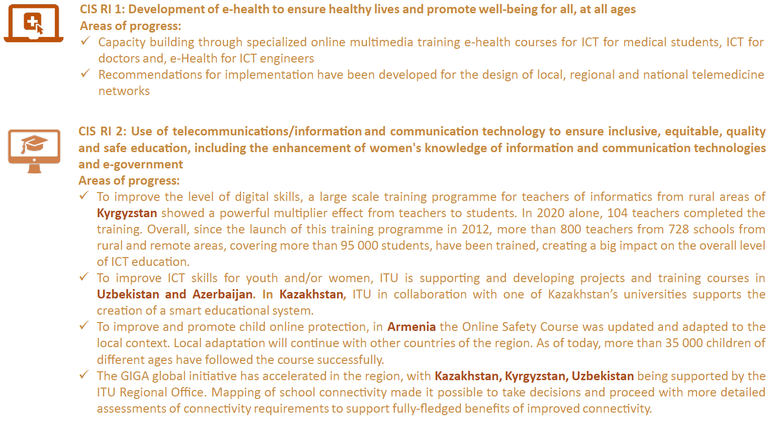

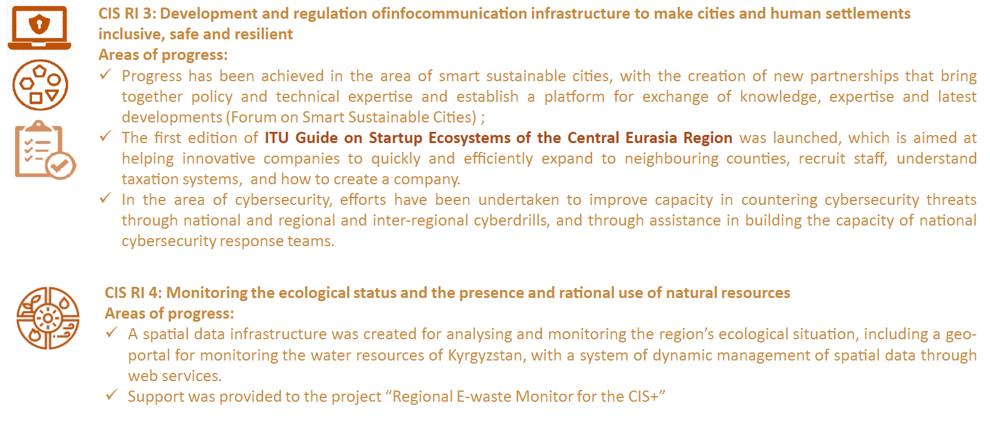

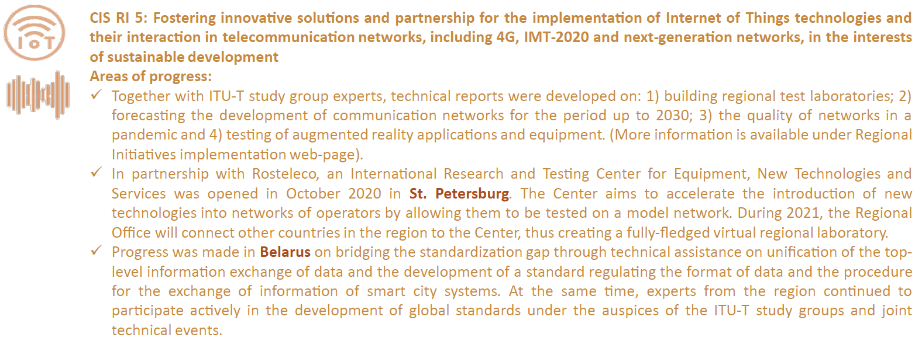

Source: ITU Regional Office for CIS

## Regional initiatives: Areas of challenge

Although there has been much progress in the region, some longstanding challenges remain, and new challenges have emerged over the past three years. In the context of each regional initiative the main challenges encountered, based on ITU experiences and research, are outlined below.

ICT infrastructure development

ICT infrastructure development remains a priority for the CIS region in the following areas:

* Future networks (pre-Network 2030)
* Efficiency and automation
* 5G
* Internet of Things
* Optical technology
* Evolving technologies
* ICT projects of social value
* Connected transport.

Digital transformation

In digital transformation, challenges persist particularly in home-grown innovations, financial services and education, and digital government services across different areas. The development of an interconnected, innovative ecosystem for start-ups and digital transformation for the countries in the CIS region therefore remains a key priority, alongside the creation of digital government services based on open innovations.

Cybersecurity

In the area of cybersecurity, significant challenges need to be overcome. For example, the national cybersecurity strategies of CIS countries need to be reviewed to address the post- COVID-19 cyberthreat landscape in the context of increased reliance on ICT infrastructure. Furthermore, human resources remain the biggest challenge with a shortage of both technical and policy personnel. Another area that requires increased focus is national computer incident response teams (CIRTs), as several CIS countries lack proper national CIRTs in operation while those with national CIRTs are consistently requesting ITU’s assistance in CIRT enhancement. Moreover, regional cooperation between national CIRTs can be further improved.

Smart sustainable cities

In the area of smart sustainable cities, while interest increases, many issues require attention. These include: (1) the development of smart sustainable city standards; (2) adaptation of the recommendations of ITU and other international organizations; (3) the development of a system of indicators and/or adaptation of existing systems in international use; (4) the development or upgrading of smart sustainable city information resources; (5) the development of a digital smart sustainable city platform.

Digital skills

In the area of digital skills, significant challenges persist that need to be addressed. Ways forward to focus efforts on improving digital skills include enshrining the term “digital skills” in the legislation, incorporating key performance indicators (KPIs), and pursuing further harmonization of standards in education and employment.

In addition, favourable conditions need to be created for remote work with digital skills, and a unit needs to be set up to promote professional digital skills on the basis of the sectoral government bodies or the civil service.

In the employment domain, increased involvement of non-governmental organizations in addition to government bodies responsible for ICTs and education should be promoted, and best practices should be studied. Courses on digital technologies and the sector need to be created in partnership with the private sector and non-governmental organizations, focusing particularly on persons with disabilities and older persons.

Vulnerable groups

The focus on vulnerable groups, especially people with disabilities, with regard to activities needs to be increased and deepened in cooperation with ITU, including:

* recommendations for the development of digital skills for people with disabilities;
* setting up information and training centres for people with disabilities;
* methodological provision of information and training centres for people with disabilities;
* training teachers for such specialized information and training centres and their remote affiliates.

# Conclusion

The CIS region has seen continued growth in most areas of ICT infrastructure, access, and use. Mobile network coverage is at 98.6 per cent, while Internet use by individuals is at 72.8 per cent, and Internet access at home is at 76.4 per cent. This shows that there is a persistent use gap, where individuals are covered by the Internet but are not using it owing to lack of affordability, relevant content, skills or meaningful/quality access. Internet access using mobile broadband stands at 87.7 per cent. The use of fixed broadband, at 19 per cent, is low but remains above the world average. The age group with the highest percentage of Internet use is that of 15 to 24-year-olds, where it stands at 84.5 per cent. In the context of increased demand for data-intensive applications, cloud-based services and growing numbers of Internet users, the availability of international bandwidth is key. Kbit/s per Internet user in the CIS region is relatively low, which may be explained by the large number of landlocked countries in the region and the lack of relevant content and services, an area that requires attention.

While a digital divide persists, rural Internet access by household has increased to 49.6 per cent and the gender gap has marginally decreased, with a gender parity score of 0.97 making the CIS region one of two regions where the gender gap is the least pronounced.

Data on achieved levels of basic, standard and advanced ICT skills are very limited, but where available they show that a significant skills gap exists in the region across all skill categories, with great variation among the selected countries. Many countries do not collect data on ICT skills and increased efforts in data collection are key to addressing the skills gap going forward.

Total telecommunication investments amounted to USD 7.5 billion in 2019, with the largest volume of investments committed in the Russian Federation.

In the area of cybersecurity, the CIS region is on its way to ensuring that the use of ICTs is safe and secure, with most countries having either started to initiate or having already developed complex commitments in cybersecurity. Advances were observed in the legal pillar, with all CIS countries having cybercrime legislation and cybersecurity regulation in place.

In terms of ICT infrastructure developments and integrated technologies, in the area of AI there is still significant room to build on AI capability and capacity development, with the Russian Federation leading the region in the number of AI companies, as well as highest scores in the government AI readiness Index. The IoT market is still evolving in the region, with great potential in urban areas in particular. The Russian Federation leads the region in IoT applications. Cloud services across the CIS region continue to be dominated by foreign firms for lack of native cloud platforms, and international partnerships are on the rise. Key challenges to be overcome to accelerate the development of AI, IoT and cloud are issues around data sharing and data hygiene.

The COVID-19 pandemic has had a profound impact on the CIS region and has pushed consumers and businesses alike towards the adoption of digital services and technologies, accelerating digital transformation of some areas of business by several years. Most network operators in the region were able to cope with the increased demand on their networks, providing a good stress test for the future and highlighting areas that require increased attention.

Regulatory frameworks have not advanced up ITU’s collaborative regulation “generation ladder” as rapidly as in most other regions, with only one country having achieved G4 status and no country in the G5 category, leaving significant room for reform and improvement.

Many projects, programmes and activities have been undertaken jointly by ITU-D and Member States across all five ITU regional initiatives for the CIS region, including development of e-health to ensure healthy lives and promote well-being for all, at all ages; use of telecommunications/ICT to ensure inclusive, equitable, quality and safe education, including the enhancement of women's knowledge of ICTs and e-government; development and regulation of infocommunication infrastructure to make cities and human settlements inclusive, safe and resilient; monitoring the ecological status and the presence and rational use of natural resources; andfostering innovative solutions and partnership for the implementation of Internet of Things technologies and their interaction in telecommunication networks, including 4G, IMT-2020 and next-generation networks, in the interests of sustainable development.

The outlook for the ICT market in the CIS is positive, and the CIS region together with the ITU Regional Office for CIS stand ready to build on the progress achieved and to address challenges where these persist.

# References

CISSTAT 2018, „Youth Buklet“, http//:www.cisstat.com/youth/rus/2018_youth_buklet_eng.pdf

Deep Knowledge Analytics “AI in Eastern Europe Landscape, Overview”

GSMA 2019, Connected Society, “The State of Mobile Internet Connectivity”.

GSMA 2020, The Mobile Economy 2020.

GSMA 2020, The Mobile Economy Russia and CIS 2020

ITU, WSIS Stocktaking, Mid-Term Report “The Coronavirus (COVID-19) Response, ICT Case Repository.

ITU, “HOW BROADBAND, DIGITIZATION AND ICT REGULATION IMPACT THE GLOBAL ECONOMY”

Global Econometric Modelling Expert Report.

GSR-20 Discussion Paper, August 2020.

ITU 2020, FIRST OVERVIEW OF KEY INITIATIVES IN RESPONSE TO COVID-19, May 2020.

ITU, “COVID-19 Initiatives, Partnerships and Activities”, 9 September 2020.

ITU, “Pandemic in the Internet Age: communications industry responses”, GSR Discussion Paper on ensuring connectivity and business continuity – key lessons learned, June 2020.

ITU Economic Experts Roundtable, “ECONOMIC IMPACT OF COVID-19 ON DIGITAL INFRASTRUCTURE”, GSR-20 Discussion Paper, 26 June 2020, <https://www.itu.int/en/ITU-D/Conferences/GSR/2020/Pages/default.aspx>

ITU, “Last Mile Connectivity in the Context of COVID-19”, REG4COVID Discussion Paper, November 2020.

ITU, The economic contribution of broadband, digitization and ICT regulation: Econometric modelling for the ITU CIS region, 2020.

ITU, Measuring Digital Development: Facts and figures 2019.

ITU, Measuring digital development: Facts and figures 2020, <https://www.itu.int/en/ITU-D/Statistics/Pages/facts/default.aspx>

ITU, Measuring digital development: ICT Price Trends, 2019, <https://www.itu.int/en/mediacentre/Pages/pr08-2020-Measuring-Digital-Development-ICT-Price-Trends-2019.aspx>

ITU, Global ICT Regulatory Outlook 2020, <https://itu.foleon.com/itu/global-ict-regulatory-outlook-2020/home/>

ITU, GSR Best Practice Guidelines 2019 “[Fast forward digital connectivity for all](https://www.itu.int/en/ITU-D/Conferences/GSR/2019/Documents/GSR19BestPracticeGuidelines_E.pdf)”, and 2020 “[The gold standard for digital regulation](https://www.itu.int/en/ITU-D/Conferences/GSR/2020/Documents/GSR-20_Best-Practice-Guidelines_Final_E.pdf)”.

ITU 2021, “The impact of policies, regulation and institutions on performance of the ICT sector”, <https://www.itu.int/pub/D-PREF-EF.ICT_SECT_PERF-2021>

ITU 2020, Report of the ITU Regional Development Forum for the Commonwealth of Independent States, December 2020

ITU Brochure, CIS Regional Initiatives, 2018-2021

ITU 2020, “Tech v COVID-29: Managing the crisis”, ITUNews03, <https://www.itu.int/en/myitu/Publications/2020/09/09/13/13/ITU-News-Magazine-No3-2020>

ITU Global Cybersecurity Index 2018, <https://www.itu.int/en/ITU-D/Cybersecurity/Pages/global-cybersecurity-index.aspx>

ITU WTI Database, ICT indicators.

ITU platforms 2020, “[Connect2Recover](https://www.itu.int/en/ITU-D/Pages/connect-2-recover.aspx)”, the Global Network Resiliency Platform “[REG4COVID](https://reg4covid.itu.int/)”, the [WSIS ICT Case Repository](https://www.itu.int/net4/wsis/stocktaking/Surveys/Surveys/Submit/15863048637525604), and [CYB4COVID](https://www.itu.int/en/action/cybersecurity/Pages/CYB4COVID.aspx).

ITU data portal, the [ICT Eye](http://www.itu.int/icteye).

ITU, ICT Regulatory Tracker.

ITU, [Benchmark of Fifth Generation Collaborative Regulation (G5 Benchmark (ITU, 2019))](https://itu.foleon.com/itu/global-ict-regulatory-outlook-2020/home/).

McKinsey 2020, “The conflicted Continent: Ten charts show how COVId-19 is affecting consumers in Europe”, November 2020, <https://www.mckinsey.com/business-functions/marketing-and-sales/our-insights/the-conflicted-continent-ten-charts-show-how-covid-19-is-affecting-consumers-in-europe> and <https://www.mckinsey.com/business-functions/marketing-and-sales/our-insights/a-global-view-of-how-consumer-behavior-is-changing-amid-covid-19>

McKinsey 2020, “How COVID-19 has pushed companies over the technology tipping point – and transformed business forever”, <https://www.mckinsey.com/business-functions/strategy-and-corporate-finance/our-insights/how-covid-19-has-pushed-companies-over-the-technology-tipping-point-and-transformed-business-forever>

McKinsey 2020, “Europe’s digital migration during COVID-19: Getting past the broad trends and averages”, July 2020, <https://www.mckinsey.com/business-functions/mckinsey-digital/our-insights/europes-digital-migration-during-covid-19-getting-past-the-broad-trends-and-averages>

Oxford Insights “AI Readiness Index 2019”, <https://www.oxfordinsights.com/ai-readiness2019>

PWC 2017, “Adoption of IoT technology in smart cities”, Russia

UN e-Government Survey 2020, <https://publicadministration.un.org/egovkb/en-us/Reports/UN-E-Government-Survey-2020>

UN 2020 “World Economic Situation and Prospects 2020”

UNDP 2021, COVID-19 and the countries of South Caucasus, Western CIS and Ukraine, https://www.eurasia.undp.org/content/rbec/en/home/library/sustainable-development/covid-19-and-the-countries-of-south-caucasus-western-cis-and-ukr.html

1. The Economic Experts Roundtable was held on 26 June 2020 and produced the following GSR Discussion Paper: <https://www.itu.int/en/ITU-D/Conferences/GSR/2020/Documents/GSR-20_Impact-COVID-19-on-digital-economy_Discussion-Paper_Final.pdf>.
2. McKinsey Digital, *Europe’s digital migration during COVID-19: Getting past the broad trends and averages* (2020), <https://www.mckinsey.com/business-functions/mckinsey-digital/our-insights/europes-digital-migration-during-covid-19-getting-past-the-broad-trends-and-averages>; and McKinsey & Company, *How COVID-19 has pushed companies over the technology tipping point—and transformed business forever* (2020), <https://www.mckinsey.com/business-functions/strategy-and-corporate-finance/our-insights/how-covid-19-has-pushed-companies-over-the-technology-tipping-point-and-transformed-business-forever>.
3. <https://www.itu.int/en/ITU-D/Regional-Presence/CIS/Pages/default.aspx>
4. Based mostly on 2019 data, with some preliminary data/estimates for 2020. Disaggregated data will be reported when available and relevant (gender, age, rural/urban). CIS averages vs global will be reported when relevant.
5. For the CIS region, this document follows the regional grouping used by ITU-D , see: <https://www.itu.int/en/ITU-D/Statistics/Pages/definitions/regions.aspx> . Where data were only available for a subset of countries, this is indicated.
6. As of 1 July 2019, low-income economies are defined by the World Bank as those with a gross national income (GNI) per capita, calculated using the World Bank Atlas method, of USD 1 025 or less in 2018; lower middle-income economies are those with a GNI per capita between USD 1 026 and USD 3 995; upper middle-income economies are those where the figure falls between USD 3 996 and USD 12 375; and high-income economies are those where it is USD 12 376 or more. (https://datatopics.worldbank.org/world-development-indicators/stories/the-classification-of-countries-by-income.html)
7. UN 2020 “World Economic Situation and Prospects 2020”, Annex p.165-168
8. <https://ec.europa.eu/eurostat/statistics-explained/index.php?title=File:Population_in_rural_areas,_by_country,_2013.png>
9. http//:www.cisstat.com/youth/rus/2018_youth_buklet_eng.pdf
10. Measuring digital development, Facts and Figures 2020, <https://www.itu.int/en/ITU-D/Statistics/Pages/facts/default.aspx>
11. Satellite broadband subscriptions refers to the number of satellite Internet subscriptions with an advertised download speed of at least 256 kbit/s. It refers to the retail subscription technology and not the backbone.
12. The response from the country regarding the reason for the high increase 2019: “The spike in kbit/s per Internet user can be explained, given that the national telecom operator Uzbektelecom implemented a project to expand the capacity of the Uzbekistani international packet switching centre. With completion of the project, the throughput of the international packet switching centre was increased to 1200 Gbit/s.”
13. “The Mobile Economy in the Russia and CIS 2020”, p. 3
14. GSMA, “The Digital Economy Russia and CIS 2020”, p.33
15. https://a4ai.org/meaningful-connectivity/
16. See pages 34 of GSMA’s “The Mobile Economy Russia and CIS 2020” report.
17. ITU Facts and Figures 2019 and ITU Facts and Figures 2020 show that the percentage difference between men and women using the Internet was 2.6 per cent in 2019 and 2.3 per cent in 2020.
18. The gender parity score is calculated as the proportion of women who use the Internet divided by the proportion of men. A value smaller than 1 indicates that men are more likely to use the Internet than women, while a value greater than 1 indicates the opposite. Values between 0.98 and 1.02 reflect gender parity.
19. <https://www.itu.int/en/mediacentre/Pages/pr08-2020-Measuring-Digital-Development-ICT-Price-Trends-2019.aspx>
20. GSMA, The Mobile Economy Russia and CIS 2020, p. 18-19
21. <https://www.interpol.int/en/content/download/15217/file/Global%20landscape%20on%20COVID-19%20cyberthreat.pdf>
22. ITU, *Global Cybersecurity Index 2018* (2019), 6, <https://www.itu.int/dms_pub/itu-d/opb/str/D-STR-GCI.01-2018-PDF-E.pdf>.
23. <https://www.itu.int/en/ITU-D/Cybersecurity/Pages/global-cybersecurity-index.aspx>, see GCI Report 2018 p.27
24. http://earlyone.com/earlyone-retail-queue-management

   
25. http://iuc.kz/

    https://ruqsat.qoldau.kz/ru/information
26. https://kiber-one.com/
27. https://sgaf.ru

    https://en.sgaf.ru/vkz
28. https://www.company.rt.ru/en/about/info/ & https://moscow.rt.ru/b2b/telephony/vats
29. <https://www.eurasia.undp.org/content/rbec/en/home/library/sustainable-development/covid-19-and-the-countries-of-south-caucasus-western-cis-and-ukr.html>
30. <https://www.itu.int/en/ITU-D/Conferences/GSR/2020/Pages/default.aspx>
31. https://publicadministration.un.org/egovkb/en-us/Reports/UN-E-Government-Survey-2020
32. www.roi.ru
33. UN E-Government Development Index 2020
34. The abbreviation “G5” used in relation to the Benchmark should not be confused with “5G”, which refers to wireless technology.
35. “ITU launches the ‘G5 Benchmark’, a ‘gold standard’ for collaboration among regulators and policy-makers” (2020), <https://www.itu.int/en/mediacentre/Pages/PR06-2020-Global-ICT-Regulatory-Outlook-G5-Benchmark.aspx>.
36. See: ITU, *GSR-19 Best Practice Guidelines - Fast forward digital connectivity for all* (2019), <https://www.itu.int/en/ITU-D/Conferences/GSR/2019/Documents/GSR19BestPracticeGuidelines_E.pdf>; and *GSR-20 Best Practice Guidelines* (2020) - *The gold standard for digital regulation* (2020), <https://www.itu.int/en/ITU-D/Conferences/GSR/2020/Documents/GSR-20_Best-Practice-Guidelines_Final_E.pdf>.
37. The G5 Benchmark will be expanded to cover all ITU Member States leveraging the new refined methodological framework and a new edition will be released ahead of WTDC-21.
38. ITU, *Global ICT Regulatory Outlook 2020 - Pointing the way forward to collaborative regulation* (2020), <https://www.itu.int/pub/D-PREF-BB.REG_OUT01-2020/en>.
39. Note that regional data are based on official national statistics provided by administrations of ITU Member States through ITU regular surveys, and include ICT statistics, institutional frameworks and governance, market structure, universal access and service policies and price regulation.
40. CAF stands for *Corporación Andina de Fomento*/Development Bank for Latin America.
41. A second set of regressions undertaken shows that of all the components of the ICT Regulatory Tracker, the regulatory regime component appears to be the main path of impact of the CAF Ecosystem Development Index. This analysis provided further evidence of the importance of the regulatory and institutional variable in driving digital ecosystem growth.
42. GSMA, The Mobile Economy CIS and Russia 2020
43. ITU, *Pandemic in the Internet Age: communications industry responses* (2020), <https://reg4covid.itu.int/wp-content/uploads/2020/06/ITU_COVID-19_and_Telecom-ICT.pdf>.