Digital trends in the Commonwealth of Independent States 2021
Information and communication technology trends and developments in the CIS region, 2017-2020

Highlights

Abstract
The “Digital trends in the Commonwealth of Independent States 2021” report provides an overview of trends and developments in information and communication technology (ICT) infrastructure, access and use in the CIS region, which includes 9 Member States and is home to a population of 240 million people. The report highlights changes in ICT adoption since the last World Telecommunication Development Conference in 2017 (WTDC-17) and during the COVID-19 pandemic, tracks the evolution of regulation, and reviews progress and challenges in implementing the ITU regional initiatives for the CIS region. Its objective is to serve as a reference for the ITU membership in reviewing progress and identifying ICT development priorities in the CIS region.
The following “Highlights” provide an overview and conclusion, along with an annex outlining the full contents of the report.

Overview
While COVID-19 has dominated the headlines throughout 2020, consistent development and deployment of ICT infrastructure and its concomitant services has meant a continued trend towards digital transformation for societies, businesses and governments alike. Since WTDC-17, information and communication technologies (ICTs) have continued to spread. ITU data show that in 2019 more than 50 per cent of individuals used the Internet (51.4 per cent globally by the end of 2019), 75 per cent of the total world population had an active mobile broadband subscription, and fixed broadband subscription had grown to just over 15 per cent. Today, over 57 per cent of households have Internet access at home. Moreover, given the rise in data demand owing to increasingly bandwidth-intensive services, international bandwidth has, on average, grown at a compound annual growth rate (CAGR) of 36 per cent between 2017 and 2020, with a CAGR for international bandwidth per Internet user of 26 per cent between 2017 and 2019. Yet the digital divide persists. While almost all urban areas in the world are covered by a mobile broadband network, many gaps remain in rural areas. The gender divide remains a reality, it still being the case that fewer women than men benefit from Internet use (Figure 1).

Figure 1: Global ICT indicators (per 100 inhabitants and per cent), 2019 and 2020, and CAGR, 2017-2019 and 2017-2020, where available
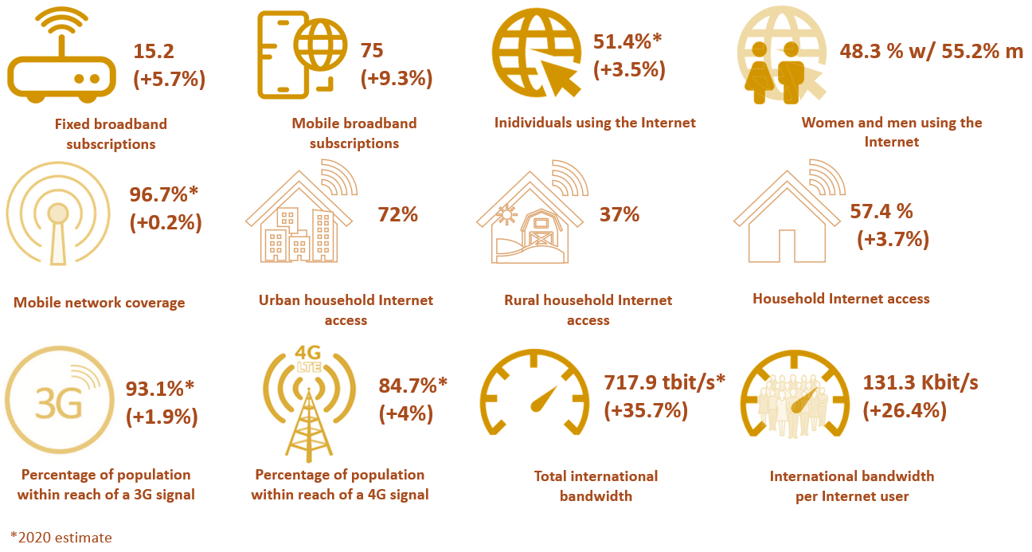
Figure 1: Global ICT indicators (per 100 inhabitants and per cent), 2019 and 2020, and CAGR, 2017-2019 and 2017-2020, where available
Source: Based on ITU World Telecommunication/ICT Indicators (WTI) Database from 2017, 2019 and 2020, where available.
As most countries across the world grapple with the effects of the COVID-19 pandemic, the role of ICTs and services and the digital infrastructure on which they ride and grow have become central to continued economic and societal activity and to lessening the impact of the pandemic. The Economic Experts Roundtable organized by ITU in June 2020 concluded that countries with top connectivity infrastructure could mitigate up to half of the negative economic shock of the pandemic. Overall, the impact of the pandemic has been to accelerate digital transformation, as businesses move towards distributed models of employment and digital service and product delivery. Individuals forego travel and socializing and turn towards digital entertainment and communication platforms and also, increasingly, to e-commerce. Schools move to online learning and digital classrooms, and governments increasingly need data on citizens, health and economic indicators to establish policies.
While research on the contribution of digitization to softening the impact of pandemics is limited, emerging evidence of their accelerating effects across all areas of people’s lives and economic sectors is compelling. For example, consumer and business surveys show that the COVID-19 pandemic has pushed consumers and businesses alike to adopt digital services and technologies, accelerating digital transformation in consumer behaviour and business activity by several years (Figure 2).

Figure 2: The accelerating impact of COVID-19 on digital transformation
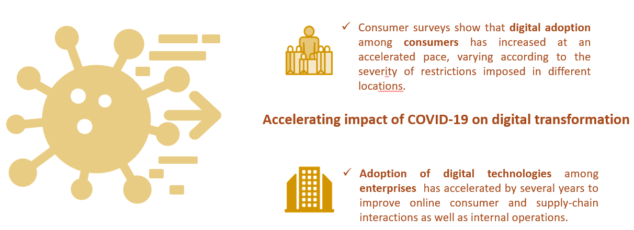
Figure 2: The accelerating impact of COVID-19 on digital transformation
Source: ITU, based on insights from 2020 McKinsey consumer and enterprise surveys at https://www.mckinsey.com/business-functions/mckinsey-digital/our-insights
Generally, the pandemic has forced a greater demand for digital reliance across the board, and this outcome is likely to be here to stay in the “new normal”, as the utility of more abundant data and the ever-lower cost of using those data affect how entrepreneurs, policy-makers and professionals make decisions. The pandemic, however, is just one driver of current trends. Climate responsibility, continued economic development, demographic shifts and social well-being are also key drivers in ensuring that no one is left behind.
In the light of these global trends, policy development focused on inclusion, access, security, skills and sustainability in terms of emerging technologies and their benefits is poised to become a defining characteristic of the 2020s. This is mirrored in the ITU regional initiatives for the Commonwealth of Independent States (CIS) region and the associated thematic priorities, which remain highly relevant going forward. The development of ICT skills and capacities is a key priority for the region to accelerate digital transformation as a means of achieving better, more inclusive outcomes, in particular for young people. Moreover, the development of relevant content, applications and services and the fostering of an enabling environment, including fit-for-purpose institutions, policies and accompanying mechanisms for implementation and appropriate regulation, will all push consumers and businesses alike to adopt digital services and digital technologies.
Artificial intelligence (AI), the Internet of Things (IoT), cloud computing, distributed ledger technology, precision medicine, digital trade, autonomous mobility and many more evolving technological arenas will shape the future of the world and the CIS region in it. There are many examples in the region where such technologies are at work and can serve as an example towards sustainable development and inclusive growth, addressing some of the region’s most pressing challenges, in areas such as youth unemployment, natural resource management, remote health, and the smart city.
Along with fit-for-purpose policy, ICT infrastructure is ultimately at the heart of this historical transformation and the predominant enabler of the future competitiveness and prosperity of the CIS region. Robust infrastructure on which emerging technologies ride can help meet some of the region’s most pressing challenges. It is important not to lose sight of the fact that improving ICT infrastructure is more than a goal for operators and consumers. It does much more than support mobile and broadband connections: it serves as the backbone for global and regional supply chain integration; makes possible the innovative use of critical health information; creates opportunities for citizens to improve their options in the workforce; enables students to acquire previously out-of-reach skillsets; and offers many more positive externalities that are changing the course of history. Indeed, future history will look back at this early era of technological development to see how policies and governance approaches reinforced the resilience and responsiveness of societies, while assessing for risks, protecting consumers and enabling positive outcomes for citizens.

Conclusion
The CIS region has seen continued growth in most areas of ICT infrastructure, access, and use. Mobile network coverage is at 98.6 per cent, while Internet use by individuals is at 72.8 per cent, and Internet access at home is at 76.4 per cent. This shows that there is a persistent use gap, where individuals are covered by the Internet but are not using it owing to lack of affordability, relevant content, skills or meaningful/quality access. Internet access using mobile broadband stands at 87.7 per cent. The use of fixed broadband, at 19 per cent, is low but remains above the world average. The age group with the highest percentage of Internet use is that of 15 to 24-year-olds, where it stands at 84.5 per cent. In the context of increased demand for data-intensive applications, cloud-based services and growing numbers of Internet users, the availability of international bandwidth is key. Kbit/s per Internet user in the CIS region is relatively low, which may be explained by the large number of landlocked countries in the region and the lack of relevant content and services, an area that requires attention.
While a digital divide persists, rural Internet access by household has increased to 49.6 per cent and the gender gap has marginally decreased, with a gender parity score of 0.97 making the CIS region one of two regions where the gender gap is the least pronounced.
Data on achieved levels of basic, standard and advanced ICT skills are very limited, but where available they show that a significant skills gap exists in the region across all skill categories, with great variation among the selected countries. Many countries do not collect data on ICT skills and increased efforts in data collection are key to addressing the skills gap going forward.
Total telecommunication investments amounted to USD 7.5 billion in 2019, with the largest volume of investments committed in the Russian Federation.
In the area of cybersecurity, the CIS region is on its way to ensuring that the use of ICTs is safe and secure, with most countries having either started to initiate or having already developed complex commitments in cybersecurity. Advances were observed in the legal pillar, with all CIS countries having cybercrime legislation and cybersecurity regulation in place.
In terms of ICT infrastructure developments and integrated technologies, in the area of AI there is still significant room to build on AI capability and capacity development, with the Russian Federation leading the region in the number of AI companies, as well as highest scores in the government AI readiness Index. The IoT market is still evolving in the region, with great potential in urban areas in particular. The Russian Federation leads the region in IoT applications. Cloud services across the CIS region continue to be dominated by foreign firms for lack of native cloud platforms, and international partnerships are on the rise. Key challenges to be overcome to accelerate the development of AI, IoT and cloud are issues around data sharing and data hygiene.
The COVID-19 pandemic has had a profound impact on the CIS region and has pushed consumers and businesses alike towards the adoption of digital services and technologies, accelerating digital transformation of some areas of business by several years. Most network operators in the region were able to cope with the increased demand on their networks, providing a good stress test for the future and highlighting areas that require increased attention.
Regulatory frameworks have not advanced up ITU’s collaborative regulation “generation ladder” as rapidly as in most other regions, with only one country having achieved G4 status and no country in the G5 category, leaving significant room for reform and improvement.
Many projects, programmes and activities have been undertaken jointly by ITU-D and Member States across all five ITU regional initiatives for the CIS region, including development of e-health to ensure healthy lives and promote well-being for all, at all ages; use of telecommunications/ICT to ensure inclusive, equitable, quality and safe education, including the enhancement of women's knowledge of ICTs and e-government; development and regulation of infocommunication infrastructure to make cities and human settlements inclusive, safe and resilient; monitoring the ecological status and the presence and rational use of natural resources; and fostering innovative solutions and partnership for the implementation of Internet of Things technologies and their interaction in telecommunication networks, including 4G, IMT-2020 and next-generation networks, in the interests of sustainable development.
The outlook for the ICT market in the CIS is positive, and the CIS region together with the ITU Regional Office for CIS stand ready to build on the progress achieved and to address challenges where these persist.

Annex - Table of contents
The full report, “Digital trends in the Commonwealth of Independent States”, covers the following areas:
Overview
Digital trends in the CIS region
Mobile market developments
Satellite broadband developments
Fixed broadband market
Internet access, use, skills, and gender
ICT prices
Telecommunication revenues and investment
Developments regarding cybersecurity
ICT infrastructure developments and integrated technologies Error! Bookmark not defined.
Digital services trends
Regulatory trends in the CIS region
New collaborative regulatory paradigm
The G5 Benchmark for regulatory excellence
Maturity of ICT regulatory frameworks in the CIS region
Economic contribution of broadband, digitization and ICT regulation in the CIS region
Opportunities and challenges of digital transformation
Developments under the regional initiatives for the CIS region
Regional initiatives: areas of progress
Regional initiatives: areas of challenge
Conclusion
References

The Economic Experts Roundtable was held on 26 June 2020 and produced the following GSR Discussion Paper: https://www.itu.int/en/ITU-D/Conferences/GSR/2020/Documents/GSR-20_Impact-COVID-19-on-digital-economy_Discussion-Paper_Final.pdf.
McKinsey Digital, Europe’s digital migration during COVID-19: Getting past the broad trends and averages (2020), https://www.mckinsey.com/business-functions/mckinsey-digital/our-insights/europes-digital-migration-during-covid-19-getting-past-the-broad-trends-and-averages; and McKinsey & Company, How COVID-19 has pushed companies over the technology tipping point—and transformed business forever (2020), https://www.mckinsey.com/business-functions/strategy-and-corporate-finance/our-insights/how-covid-19-has-pushed-companies-over-the-technology-tipping-point-and-transformed-business-forever.
https://www.itu.int/en/ITU-D/Regional-Presence/CIS/Pages/default.aspx

